Below is the London NFB UK logo -it is a line drawing of the London eye with the NFB UK name as part of its spokes to support the wheel of capsules.
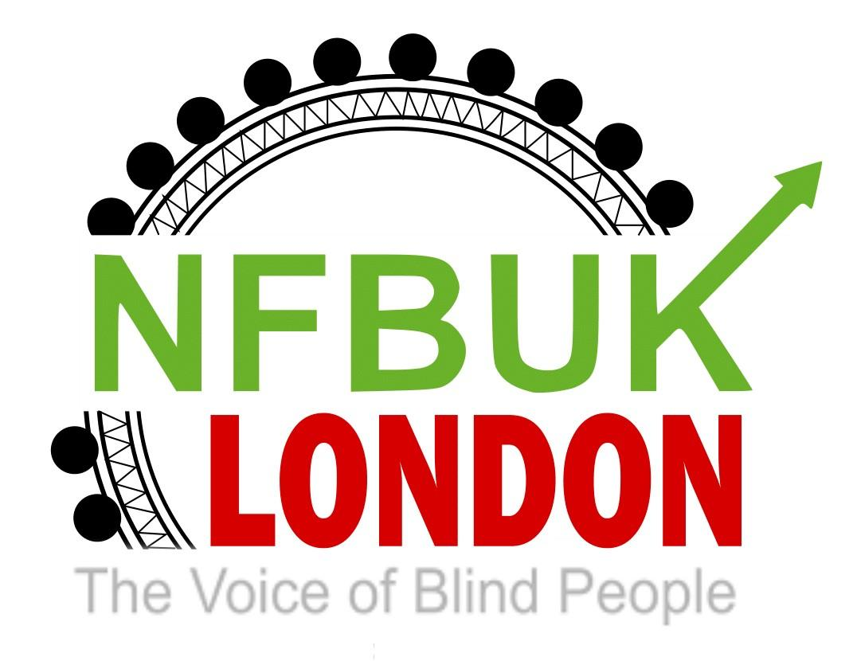
Dear London members,

Welcome to London Life.68. This edition includes information regarding a special Motion Meeting, news from you and our partners. There is also an interesting article about the campaign run by NFB UK and a message from the USA. If you have any articles or would like to submit a personal story please email: london@nfbuk.org
Please use this email, if you would like to unsubscribe from this circulation.

This edition includes:

London Branch Motions Meeting - Monday 21st August, at 7pm on Zoom.
Casting votes for positions on the EC.
Date of next branch meeting - Monday 4th September, at 7pm on Zoom.
A message from NFB USA
Important news about a scam targeting Freedom pass users.
NFB UK’s new approach to collaborative campaigning.

News from our members

Walking on sunshine, to fundraise for Aquabats.
The change in guard at Buckingham Palace.
Tandem cycle.
Banging the drums for community radio and organisations.

News from our partners

Aquabats

The Braillists Foundation
Eye Matter for September
Eye Matter’s Winter Extravaganza

Transport News
Temporary closure of Vauxhall lift.

London Branch Motions Meeting - Monday 21st August, at 7pm on Zoom.

Following a discussion at our recent branch meeting a Motions Meeting has been arranged to discuss proposed motions for this years AGM in September.

All members should have received an invitation and a document listing three potential motions. At this meeting we will debate each motion and make any agreed changes, if required, before sending them to the EC before Wednesday 23rd August.

If you have not received a copy of this invitation or would like to find out more about this meeting please email: london@nfbuk.org

Casting votes for positions on the EC.

During our next meeting, we will be voting for which candidates London Branch will send forward to the national vote.

There are three candidates for President: Karl, Karina and Kevin.

For General Secretary two candidates : Devaki and Sarah

For Ordinary members there are three candidates for two spaces: Andrew, Clive and Karina.

If you are unable to attend the September meeting, but, would like to cast your vote by email, this must be received, by our Branch Secretary, before 6pm, on Saturday 2nd September.

Janes email is: janesellers6@gmail.com

Date of next branch meeting - Monday 4th September, at 7pm on Zoom.

We are delighted to be joined, by our Jessica,from Vocaleyes, as our special guest. This will be followed by a meeting, focusing on the forthcoming AGM and other branch matters.

An agenda and link will b sent nearer the time.

A message from NFB USA

Both Simon and David expressed their gratitude at being invited to our August meeting.

Here are links to the two podcasts David works on: iCantCU https://podcasts.apple.com/us/podcast/icantcu-podcast/id1445801370

White Canes Connect https://podcasts.apple.com/us/podcast/white-canes-connect/id1592248709

People can also learn more about him at his website: https://www.iCantCU.com

The interview with Dave Williams was just released yesterday, here is the direct link to that.

http://blindabilities.com/?p=7921

Although a lot of your members would probably be familiar with this next link, here is the link to the interview I did with Ed and Steph from Bristol Braille Technologies.

http://blindabilities.com/?p=7905

Important news about a scam targeting Freedom pass users.

Kindly supplied by Deborah Chapman.

https://www.facebook.com/764943065/posts/freedom-pass-application-scam-websitethe-taxicard-scheme-colleagues-have-informe/10163185696758066/

NFB UK’s new approach to collaborative campaigning.

By Fiona Musgrove.

Following my article, in London Life.67, discussing the extension of the petition to save our ticket offices, I was contacted by two members of the National Fedeation of the Blind(NFB UK). Sarah Ledbetter and Kevin Greenan, have both, been involved in a small campaigns team, lead by,Sarah Gayton, our Street Access Campaign Coordinator.

Sarah L explained, that since Christmas last year, until January, the NFB UK had operated as a lone voice . This changed, on February 20th 2023, when they joined forces with other charities and groups including; Surrey Coalition of Disabled People, National Pensioners Confederation and WHD(Women with Hidden Disabilities)Vision. There were six groups , each representaing nine organisations invited to present the petition at Downing Street.

Before this collaboration, she continued, “we had only succeeded in making contact with the Secretary of State for Transport, Mark Harper, alongside Gloucestershire member, Bill Wardle”. This new approach to campaigning, has now, attracted members from all over the country, including, our Jane Sellers. Additionally, NFB UK, has collected the support, of over 180 similar organisations, to provide evidence, to the government, of how these closures will impact on many aspects of the community. Ellie Baker, the shadow London assembly minister, stopped to speak to Sarah, whilst she stood outside Downing Street, holding a protest placard. By encouraging, each regional organisation, to either bring their local television network, or, produce their own videos, this campaign began to attract attention and can be seen as a significant reason for the government to delay its decision.

“The closure of ticket offices puts our safety at risk”, said Kevin, as he explained, how he would have to ask a complete stranger for assistance with purchasing a ticket if he couldn’t locate a guard. This was evident in a recent ITV film, when They asked me to press a Braille button, located on a ticket machine. “The word ‘Help’, was in embossed dots and I waited, for an audio response, that it had worked.” To the amazement, of the accompanying reporter, a sign asking what assistance was required, simply flashed on the screen!

Sarah, who also, struggles with ticket machines added that other members of the community will be affected by these changes. Children under 16 years old dont have access to a debit card , people with dyslexia and other vulnerable adults will all feel overwhelmed by the lack of staff at a designated area. This will be equally confounded as there is more movement to a cash-less society, disregarding the choice by some people who prefer to use cash or cannot access the internet. Earlier this year, London Travel Watch made a video detailing these concerns, with London member, Mark Pampel. They estimated over one million people fall into this bracket and would be at disadvantage to accessing travel as a consequence.

Kevin is shown in this video delivering NFB UK’s petition to Downing Street

https://youtu.be/ON7E7kPmcTI

One rural station told me they handle at least 2-3 requests for assistance each day. These range from guiding, wheelchair assistance, luggage assistance, or, security for lone women travellers. One station guard explained how a woman, in great distress approached a guard on the platform, after being ‘up-skirted’, by another passenger.

At Tottenham Hale, where trains go towards Stratford and/or, Liverpool Street and Cambridge and or, Bishop’s Stortford, in the north, the guards, on average, handle around 5-6 assistance requests, per shift. Again, these could be a variety of duties, as this station, also, serves the Stanstead Express and links to Tottenham Hale Underground.

A few years ago, TFL changed to a ticket machine only system which allowed guards to be more visible on the platforms or at gate lines. For those in London, with Freedom passes, it didnt have as much impact as those living outside the area. The ‘Turn up and go system’ provided by TFL and the location of the emergency button on every platform provide reassurance for many travellers. At Tottenham Hale Underground a central desk is still used as a contact point.

Sarah and Kevin, spoke about their mixed experiences, of receiving passenger assistance and how it will be effected by the closure of ticket offices. Currently a booking is made either using the app or over the phone, two hours before travel. A message is relayed to the departing and arriving stations and a copy of the confirmation is sent to the traveller. Through contact made at the Ticket Office , by the assisting guard the number of the train and carriage location is passed along to the next station. Without this essential communication a guard will not be dispatched, despite the traveller making a booking. During a strike, when the offices were closed, the booked passenger assistance failed to arrive, despite calling the provided number on the confirmation email.

Both Sarah and Kevin, agreed that they often felt vulnerable using their Smart phones, in public places, as navigational tools. Across the country, and particularly different systems are being trialed including Navi-lens, Be My Eyes and Four Square as alternatives to a physical assistant. Vicky, from London, recountered, how she had to wave her phone above her head, for the person on screen, to read the overhead Station signs. In a previous London Life, Richard(also from London) told us how he couldn’t read the screen on the ticket machine due to strong sunlight and the inconsistency of purchasing, railway tickets, on-line, “ Sometimes they appear as a ticket in my in-box whilst other providers insist you use a ticket machine to retrieve them”. .

So, here we are, the government have extended the petition, until 1st September. Staff are battling against management, to ensure passengers receive a copy of the petition and protest posters, are being ripped down, according to one source at Greater Anglia railway. There’s still time for you, your family and friends to get behind this campaign.

We would encourage you, even if you are not a regular traveller, to complete this on-line form and contact your MP, to raise awareness of the effect of these proposed closures, on blind and partially sighted people:

https://www.change.org/p/save-our-railway-ticket-offices

Sarah and Kevin have promised to keep us updated with any decisions over the next few weeks. If you would like to join the NFB UK Campaign team please email: admin@nfbuk.org expressing your interest.

News from our members

Walking on sunshine, to fundraise for Aquabats.

Over the past few weeks, London members, Richard and Fiona, have walked over 75 miles from Southwark Cathedral towards Canterbury Cathedral. The route has been challenging, as the many videos on facebook illustrate.

They have just crossed over the North Downs, into Ashford, where the last leg of the adventure will take them into Canterbury. This is planned for next weekend.

All money raised will go directly towards activities, for Aquabats, from which many London members benefit. Please, support this very small charity with a fiver or two, so, they can continue to provide regular activities for blind and partially sighted people.

https://www.justgiving.com/page/fiona-musgrove-1691710960380

The change in guard at Buckingham Palace.

By Fiona Musgrove.

London members, Vicky, Fiona and Richard, squash into a guards century box.

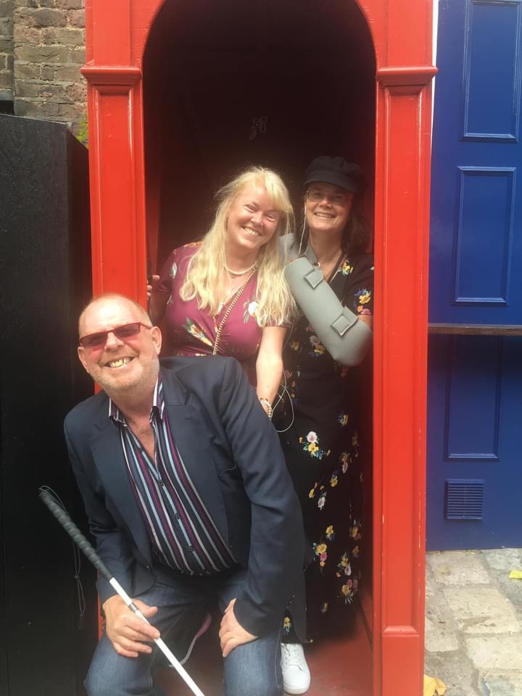

Forty five, blind and partially sighted people, including their carers, joined Aquabats, onSaturday 12th August, at Buckingham Palace. A fleet of golf buggies whisked us, from the forecourt, to the quadrangle court, beneath the private residences, for a security check before entering the palace. “It was quite impressive that one of the security assistants knew the exact amount of steps on all the staircases”, remarked one visitor.

The sheer decadence and exquisite furnishings, normally oblivious to me, were so well described through our headsets. For me, the detailed description of Queen Camilla’s Coronation gown’s embroidery, of the many specially selected flowers and personal touches, of her children and dogs names, sewn into her gown’s hem, brought it all to life.

Each room, in the Palace, was given a specific number, on our headsets. In addition, there were options , to explore more about, selected paintings, or, special exhibition pieces, by selecting different numbers. This was a real treat for those people, who love the history of art. Staff were on-hand to assist throughout the visit and there were seats where you could just sit and soak up the atmosphere. I particularly liked the design of the Music Room, with its circular walls and magnificent chandelier.

I would like to thank Pardy for arranging such a fantastic experience . Please note if you were unable to attend this time Eye Matter are providing another chance next month)see details below(.

Tandem cycle.

By jane Sellers

The below photo is of our Jane and her pilot, Katy, as they prepare for their 10km tandem adventure. .

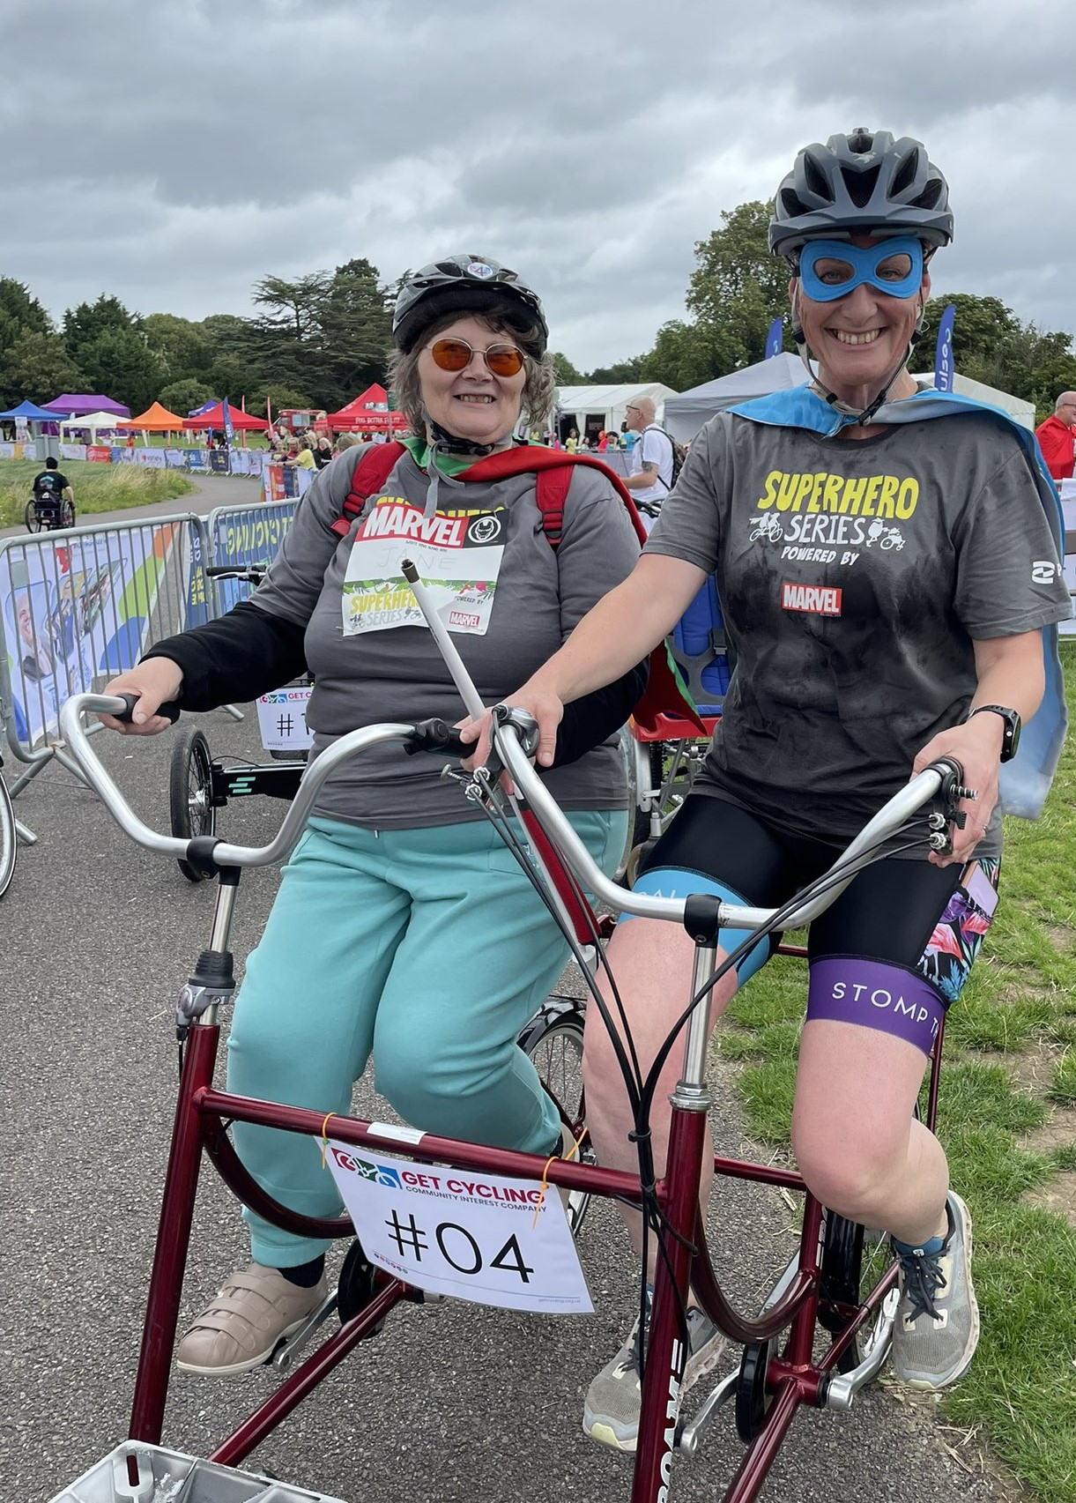

On August 12th, four teams of three people, went to Eton College near Windsor . This was a Superhero tri event including swimming, cycling and walking(or running). It was in aid of the Surrey Co-Ellison for Disabled people.

After being kindly picked up by Katy Jean and I were given matching grey t-shirts . The three of us were then provided with our numbers proudly pinned on by the new CeO, Nicky, after the 9am registration. The event was based on Superheros and I was part of the Iron Man team. We chatted to the swimmers, Katy, Charlotte and Caroline, before they went off to swim in the lake. When Katy arrived back, at the transition point, we were assigned the number four on our jackets and helmets, she exclaimed “where are the gears?” Whoops, oof course I was on the wrong side so we swapped over so she could change the gears and control the break! We cycled 10k, around Eton Dawny Lake, which was used for the rowing section, during the 2012 Olympics.

Half way around we stopped for a water break, as we were both very dry, having talked about anything and everything, including my football team Luton Town. I was pleased they had just returned to the top flight! Having taken my Walkman, with me I was able to keep up with the womens football throughout the ride. Everybody, was elated, when they reached the semi-finals. Katy and Jean, concluded the last part of the event by walking through a heavy rain shower for the last 10kn.

Under the shelter of a gazebo we collected our medals, “which is really heavy and beautiful”.On the medal it says Super hero tri on the front and on the back it says sponsored byMarvel

If you would like to support Jane, Donations can be made through the following link: Team fundraiser - Superhero Tri. If people are unable to access the online page or prefer to donate in a different way then they can also send a cheque made out to Surrey Coalition of Disabled People to the following address:

Superhero Tri Fundraiser

Surrey Coalition of Disabled People, Astolat, Coniers Way, Burpham. GU4 7HL

Banging the drums for community radio and organisations.

By Fiona Musgrove.

Below is a photo of Rasheed playing a rhythmic piece on African drums.

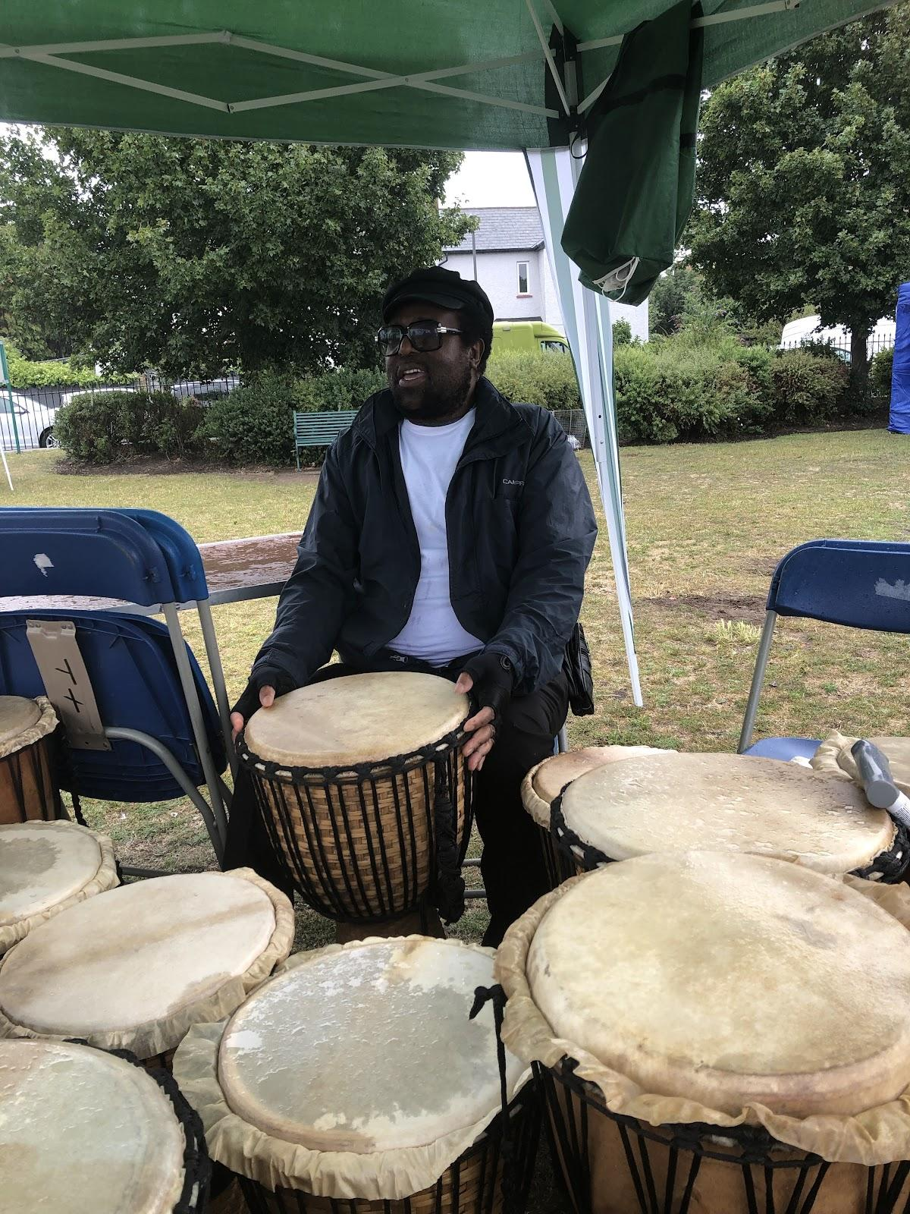

On Saturday 22nd July, I was invited to attend an event, at the Fursdown Recreational ground, near Tooting Broadway, with Riverside Radio.

Angela, a volunteer from theFursdown Residents Association, who have organised thisFun Day for the past 20years,, explained the importance of promoting local activities for residents. As a result of this fundraising they have been able to support a number of projects, such as, purchasing plants for one resident to continue to maintain a roundabout. and projects in local care homes. Sponsored by Aspire Estate Agents and Enable (a sports and leisure enterprise), hundreds of people once again enjoyed milling around the various stalls and activities, which included a cake making competition, African drums demonstrations, yoga, learning the Jive and much more. Despite the rain, people enjoyed the different bands and music, supplied by RiversideRadio.

After a successful initiative drive in 2013, Wandsworth Radio became the dynamic Riverside Radio. Today, lead by its CeO Jason Rose, it spans the four boroughs of Lambeth, Richmond, Wandsworth and Merton as its broadcasts over the internet. Amongst a team of around 200 volunteers Rasheed Bello, our Vice Chair, had been enjoying, initially learning about radio production, but, was recently, given an opportunity as a radio presenter. Withthehelpof his NFB friends, Pardy and Fiona, , he recorded his first interview with the RNLI. This was broadcast as part of ther drive-time show on Friday 28th July. In addition, I then discovered that another friend of NFB, Richard Wheatley was also involved in Riverside Radio and managed to catch up with him on Zoom.

Richard,, started his career in radio as a breakfast newsreader with Wandsworth Radio” I wanted this slot to ensure I was operating in a proper work ethic” he admitted. Then after a Christmas party, where he met other Riverside Radio presenters, pitched a quirky, news show, to Jason. As a result, on the 3rd January 2020, he gained a regular Friday evening slot Over the following 18 months, the team worked hard to ensure that every week, material was delivered,, despite the various lockdowns and uncertainty, during the pandemic.

Finding the use of a Braille reader too time consuming Richard developed a unique method, for the writing and reading, of his news articles. After, approximately, every 6 syllables, he would add a comma and line space. Adopting this unique technique, he was assured, his voice had more rhythm. Richard, also, taught himself how to edit Zoom recordings, on his phone and deliver his sketches to the studio on time each week. However he felt frustrated at not being able to operate the studio equipment independently until again he developed his own system to operate “the knobs and twiddly things” on his desk. About two years ago, Richard visited Myriad (based in Huddersfield) ,who created the mixing software. This is a package used by lots of radio stations including RNIB Connect Radio . It manages all elements of a programmes delivery. Richard explained that this latest update Version 5, not used by the RNIB, was not allowing screen readers access. Therefore he has to continue mechanical management of his programmes.

Richard continues to deliver his take on the current news on Riverside Radio every Friday from 7pm. He a is also appearing in this years Edinburg Festival with his show, ”You dont know you’re beautiful”.

Please click here: https://res.cthearts.com/event/34:3963/

Last year, whilst attending,a part-time course on radio and pod-cast production, at Morley College,, Rasheed was invited to an open day at Riverside Radio. Along with around 60 other people, he was able to share his experiences and ideas to expand the radios programmes.

More recently he has been on a radio drama script writing course . He found writing the scripts straightforward but struggled in their delivery. “I realised that my voice became less fluent as I struggled to read the large print text.” This was also confounded by needing to bring the paper closer which caused rustling sounds on the final recording”.

Rasheed has been told that he has a natural radio voice and was recently able to put this into practice, when he interviewed Mat, from the RNLI, for a Friday evening show. However, he described the difficulties of having to learn multiple software packages, used within the industry, for editing. From the experience gained, with Riverside Radio, Rasheed would like to learn more about the production behind the radio shows and producing podcasts. He is currently, part of, the Eye Beelieve team, who produce monthly pod-castsfor people with sight-loss, in minority communities..

Both, Rasheed and Richard, are at the beginning of their careers in broadcasting. Jason, founder of RiversideRadio, is very proud of everyone who has learnt their trade, with his team and have gone on to pursue various careers, in the media industry, as a result of this experience. One ofLondon Branch’s past speakers,

Sean Dilley, now the BBC’s Washington Correspondent, like Richard and Rasheed, attracted attention, by making his own content.

“radio, is just one of the platforms, we use to broadcast our content”. Sean’s dispatches have appeared on both BBC and American television channels, alongside the BBC radio network. As the Washington correspondent, he writes and delivers, his dispatches wherever required. Like Richard, Sean uses his screen reader, he admits, “my Braille, isn’t fast enough to do it with such confidence.” His content is then inserted into the script and circulated to all ‘the wires’ to use.”We’re all on Donald Trump indictment watch at the moment.”

Sean advises, “The best advice I would give any aspiring journalists to pitch ideas part of that process is finding the right platform and outlet for the idea that you have, which usually means taking time to understand the audience.”

If you would like to find out more about Riverside Radio please click here: https://www.riversideradio.com/. Alternatively, if you would like to listen, toRiverside Radio, simply ask Lady A, or, your smart speaker.

News from our partners

Aquabats

Thursday 31st August - meal social at the Devran Turkish Restaurant. The address and telephone number of the restaurant are:

The Devran Turkish Restaurant, 485-487 Green Lanes, London, N4 1AJ

Tel: 0208 340 2288

Website: https://www.devranrestaurant.co.uk/

Please meet at Manor House Underground Station on the Piccadilly Line at 6.15pm leaving at 6.30pm. We will catch a bus outside of the station. People can also make their own way. Maximum number will be 16. Please let me know if you would like to come along by Tuesday 29 August.

The Braillists Foundation

The Braillists Foundation was established in 2020 to promote the value of braille as a proven literacy tool that enriches the lives of blind people. We do this by supporting efforts to make affordable braille and tactile reading technologies available to all blind people irrespective of education and employment status and provide an open forum for the exchange of ideas about the development of future braille technology. We actively encourage braille learning through our Braille for Beginners course, improve peer support and access to expertese through our Braille Bar, Masterclasses, Book Club and podcast. Crucially most of our volunteers and trustees are braille readers. Find out more and join the community at http://www.braillists.org/

Eye Matter for September

1 September Friday Poetry Appreciation

2 September Saturday Theatre Outing – La Cage aux Folles

5 September Tuesday Audio Described Zumba with Louise

from Illuminate Freedom Health and

Well-being

8 September Friday Neurobics with Steve Wax

12 September Tuesday Audio Described Chair Yoga

14 September Thursday Outing – Katriona Taylor Launch Party

15 September Friday Inspiring Talk by Ishan at Travel Hands

19 September Tuesday BGT – Blindies got Talent

22 September Friday Drama Improv

23 September Saturday Outing - Buckingham Palace Audio

Described tour

26 September Tuesday Concert by Katriona Taylor

29 September Friday Outing - Postal Museum

7 October Saturday In person No Dramas session with Eye

Matter

Eye Matter’s Winter Extravaganza

Eye Matter is delighted to announce

our “Winter Extravaganza”- Members and friends are invited to join a day of festive fun on Thursday 14th December 2023

Our venue is: The Crown London Hotel, Cricklewood, 152 Cricklewood Broadway, Cricklewood, London NW2 3ED

The Extravaganza starts at 11:30am and finishes at 6pm. There will be a meet and greet at 11am at St. Pancras International.

About the Extravaganza- Upon arrival, you will be welcomed with a glass of sparkling wine or non-alcoholic fruit juice. This will be followed by a sumptuous three course lunch:

Starter: Duck and Orange Pate OR Leek and Potato Soup

Main course: Turkey Breast with Pigs in Blankets, Apricot and Sage Stuffing, Garlic and Rosemary roast Potatoes, Carrots, Parsnips and Brussel Sprouts, all served with delicious gravy.

OR A Spring Green and Wild Mushroom Risotto

Dessert: Christmas Pudding with Custard OR Meringue with Fruit and Cream

Additional drinks can be purchased at your table or from the bar.

The Extravaganza will also feature stunning performances from 60’s inspired band “The Beats “, wonderful choirs, quizzes, a festive raffle, and much more.

Dress to boogie, sparkle or just enjoy!

Tickets are subsidised at £40 per person.

As ever, Eye Matter never wants financial constraints to be a barrier, so please get in touch if this amount will prove prohibitive. Equally, please donate towards the Extravaganza if you are able to as this will allow more people to attend. If you have any questions, please contact Suzie on eyemattervi@gmail.com or call 07968722664

Transport News

Temporary closure of Vauxhall lift.

From Customer Information Team, Transport for London

Kindly supplied by MartinWilson.

From Monday 21 August until early September, the lift between the Vauxhall Tube ticket hall and Vauxhall Bus Station will be closed for maintenance work. Access between the bus station and Tube ticket hall will be via stairs.

Lift and escalator access between the platforms and ticket hall will be available, along with step-free access via the ramp between the ticket hall and street level at exit 4 on Wandsworth Road.

Alternatively, use these bus services to/from Vauxhall for step-free access

to/from the Victoria line at either Victoria or Brixton.

From Vauxhall To Victoria: Bus routes 2, 36 or 185 from stop A

- To Brixton: Bus route 2 from stop D, or 196 from stop G

To Vauxhall From Victoria: Bus routes 2, 36 or 185 from stop F

- From Brixton: Bus routes 2 or 196 from stop TThere is also step-free access to/from the Northern line via bus routes 77, 87, 196 or 452 between Vauxhall and Nine Elms.

Well thats it for another edition of your London Life. If you have any comments or suggestions for future editions please drop us a line.

In the meantime ‘Keep walking on sunshine’

Fiona and Jane
London NFB UK

