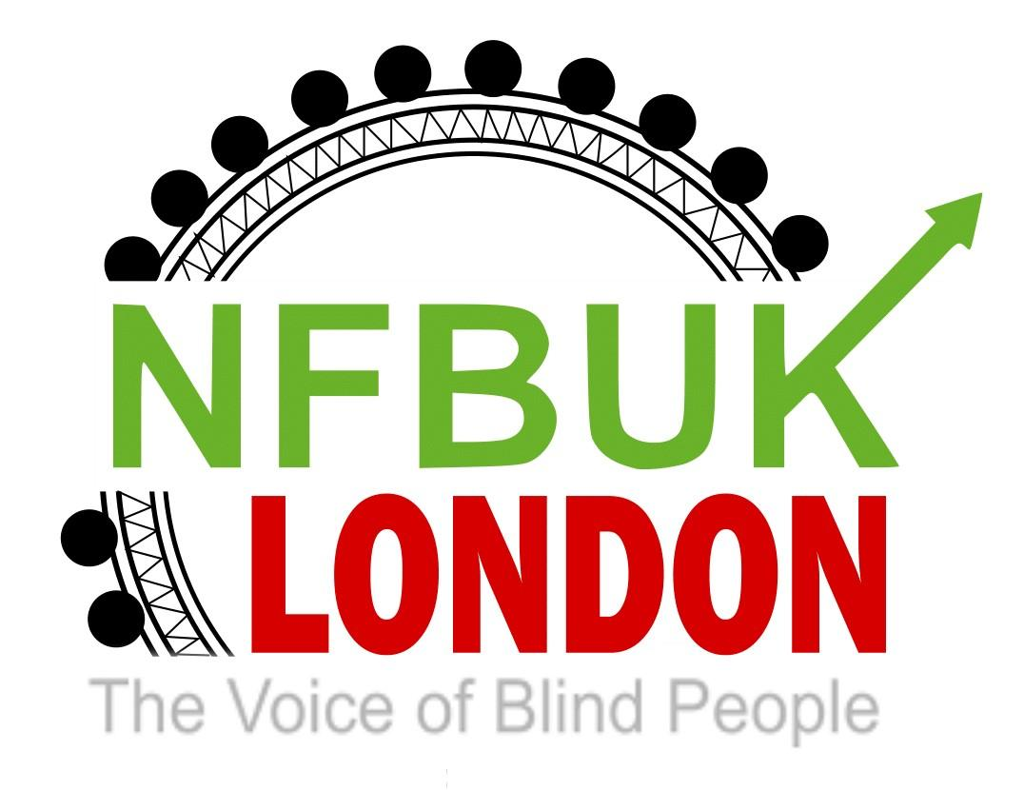
Dear London members,

Welcome to London Life.66. This edition includes experiences on travel, last chance to be nominated for roles within NFV UK and much more.If you have any articles or would like to submit a personal story please email: london@nfbuk.org
Please use this email, if you would like to unsubscribe from this circulation.
This edition includes:

Notice of specially extended August meeting 7.00-8.30pm.
Nominations from London and a chance to still submit your interest
Election of London branch delegates and observers
London Branch is looking for a new Treasurer
Last chance to book your Eastbourne weekend
Obituary - Chris Brady.

Campaigning news

The effect of the closure of ticket offices.
Campaign to save local radio.

News from our members

My new Seeing Dog.
My big adventure from Southwark Cathedral to Canterbury Cathedral for Aquabats .
A hoi there sailors from London Branch.

News from our partners

Eye Matter
Dates for Royal Collection Trust.

Transport News

Is Passenger Assistance fit for purpose?
Improving Arthur Street and changes to the 344 bus route Consultation Report from Rob Niven, Head of IDP - Major Projects

Notice of specially extended August meeting 7.00-8.30pm.

The external guest speaker will be Simon Bonenfant from NFB Pennsylvania on Monday 7th August at 7 pm. This section will be a 45 minute presentation with allowance for interaction at the end.

Simon will start with an introduction, then give a brief overview of NFB, benefiting newer members, unfamiliar with the structure of Chapters, governance etc then highlight current advocacy and campaigns priorities, such as the annual Washington Seminar.

Simon also attended the recent NFB convention in Houston and members may be interested. In hearing about this, Pardy joined some virtual sessions with keynote speakers from Congress plus others focusing on improving employment and progressing the Accessible Technology Bill. He was able to connect Simon and Dave Williams (from RNIB)physically together at Huston.

Simon may also wish to discuss his external projects, including Blind Abilities podcast.

We will also be discussing our normal branch matters during the second part of the meeting. This will include confirmation of branch Delegates and Observers, nominations for external representations and EC positions.

We will be inviting other NFB UK branches to attend the first part of the meeting.

All members will receive an invitation shortly. If you have any further queries please email: london@nfbuk.org

Nominations from London and a chance to still submit your interest

The deadline for all posts is 31 July. They should submit their biographical details with a maximum length of 250 words. They can be proposed and seconded by any NFB member regardless of which branch they come from.

Anyone can propose themselves for one of these positions, but, would need a current member to second.

As London is such a huge branch, it should be encouraged of members, to become engaged in some of these opportunities, to ensure NFB have representation, particularly in the external bodies.

For any concerns or queries please contact the Returning Officer or Head Office:

London nominations.

President: Karl Farrell

Proposer: Martin Wilson

Seconder: Darren Vickers.

The general secretary

Tesfai is proposing Devaki-No recorded seconder.

Ordinary member

Darren Vickers

Proposer: Himself

Seconder: Jane Sellers

External bodies representatives

The reps for the external bodies.

UKAF

This is currently held by Timothy.

Valerie proposed Timothy and Darren seconded.

Voice of the listener for TV.

Andrew said they hold meetings in London. At the conference they discuss issues on radio or television.

Voice of the Listener for Mark Smith.

Seconded by Andrew Hodgson.

EGDF trustee.

This is currently held by EC Trustee Carina from our Nottingham branch. The term is for three years. It would need to be a guide dog owner.

No nominations were forthcoming. Other branches with guide dogs may wish to put people forward.

Disability Benefits Consortium

This is held by Jill Allen King, from our Southend Branch. Jill can be put forward but as their meetings are held on Zoom anybody nominated can consult Jill if they are elected.

No nominations were put forward.

If you are interested in any of these positions please email: london@nfbuk.org

Election of London branch delegates and observers

Darren Vickers and Pardy Gill will be representing the London Branch as our delegates in September.

There are four positions as Observers available

The following have been selected

Hasmuck Mehta

Lynne Rennison

RasheedVello

If you would like to become an Observer please email: london@nfbuk.org -

London Branch is looking for a new Treasurer

This role involves keeping our financial records up to date and reporting to members, Officers and the Executive Committee when required.

David intends to step down towards the end of this year, to allow time for a smooth transition. If you would like to receive a copy of this role please email: london@nfbuk.org

No experience is necessary but, you will have to demonstrate some knowledge of accounts management. Training will be provided.

Last chance to book your Eastbourne weekend

For over 45 years the London Branch has organised weekends for its members in Eastbourne. This year, we have secured 30 rooms for London members at the Cumberland Hotel for the weekend of 6th-9th October 2023. Bookings are to be done direct with the hotel.

There will be evening entertainment at the hotel where the bar remains open all night for residents.

There are two options available:A dinner bed and breakfast rate of £65 per person per night or Bed and breakfast rate of £55 per person per night in their standard rooms.

The sea view supplement will be £10.00 per person per night and the balcony supplement £25.00 per person per night. Anyone wishing to have a twin/double room for single occupancy there will be a supplement of £25.00 per night.

This offer is only up to July 31st 2023.

Booking information

Hotel telephone number is: 01323 730342Please book your room type and number of nights under the name NFB for the weekend beginning 6th October 2023.

We would appreciate you dropping us a short confirmation of your booking : londoneastbourne@nfbuk.org

Obituary - Chris Brady.

From Martin Wilson.

It is with great sadness that I need to inform you of the passing of Chris Brady.

Chris was a long standing member of the branch and was indeed Chair for several years although I am not sure how many.

He passed away last Thursday 6 July at home his family were with him. He had cancer and had been very ill for some time.

This information came from his close friend, Kate Fensome, on the AVIP aelist this morning. Rest in peace Chris.

Campaigning news

The effect of the closure of ticket offices.

By Fiona Musgrove.

You cannt avoid the numerous petitions and calls for action from NFB UK and other charities concerned about the closure of ticket offices across the railway network. The impact of these changes continue to spur on the industrial action of railway unions opposed to such restrictions for the most vulnerable section of travellers.

This proposed implementation is exasperated by the inconsistency of the alternatives provided. Sitting on a platform recently in Kent, my friend purchased tickets through the LNER app. Earlier that morning he had purchased the outward tickets from his flat and received a PDF, or E:Ticket, on his phone. However, this time he was forced to walk over the bridge, to redeem his tickets from the machine., using a special code, rather than them appearing on his phone.This action resulted in him stumbling down the staircase and being faced with a virtually unreadable screen, flooded with strong sun-light, making the task almost impossible.

I spoke to another friend, about this, who too experienced poorly maintained or positioned ticket machines. Paul, from Brighton, who regularly travels into London suggested that the railway companies should provide training to blind and partially sighted people to either access these ticket machines or use their smart phones. Failure to do so could result in more people feeling unable to travel or receiving fines from less sympathetic inspectors. Paul, also, said there were plans to restrict the use of Feedom Passes, outside London, which would affect many people.

We would encourage you, even if you are not a regular traveller, to complete this on-line form and contact your MP, to raise awareness of the effect of these proposed closures, on blind and partially sighted people:

https://www.change.org/p/save-our-railway-ticket-offices

Sarah Gayton, our Street Access Campaign Coordinator, is hosting an “Emergency Invite - Film Show and Q & A Session”, On the importance of ticket offices at train stations and guards on all trains for blind, disabled, older and vulnerable passengers, on 19 July 2023, Room Q, Portcullis House. The event and room, is kindly being sponsored by Grahame Morris MP.

Our Jane, who is featured on this film, is visually impaired and is a white cane user and totally relies on her ticket office in Horley. This invitation will be sent to a number of MPs. This film was formerly, shown to Jacquline Starr the CEO of the Rail Delivery Group, on the 22 March 2023.It gives a voice to a number of different disabled peoples organisations and older people organisations, who explain their concerns over the proposed closure of all ticket offices and removal of guards off trains. The NFB UK cannot understand why concerns raised have been ignored. The event is to be held on Wednesday 19 July 2023. There are two start times and both will have Q & A at the end.

The NFBUK, have petitioned the Secretary of State on this issue on the 29 December 2022, the Prime Minister on two occasions, one on the 11 January 2023 and on 20 February 2023, and Jacqueline Starr the CEO of the Rail Delivery Group in January of this year. During the February petitioning we went with 9 other organisations and went to the door of Number 10 six times with different disabled people organisations and older people organisations. Each petitioner gave a message to the Prime Minister at the door of Number 10 which was filmed and is given below, along with the petition letters to Mark Harper, Secretary of State for Transport, the Prime Minister and to Jacqueline Starr the CEO of the Rail Delivery Group.

This link (https://we.tl/t-0oVS0MiltM) will provide you with detailed information on the digital divide in the UK, which is of critical importance in the issue of closing down ticket offices and may help provide you with use full information. The presentation is called 'Older people, digital exclusion and digital poverty in the UK’ by Dr Becky Faith - Institute of Development Studies which was presented at the National Pensioners Convention Conference. This is the General Secretary of the National Pensioners Convention raising concerns about what was being planned for the changes to the rail network back in February 2023 in Newcastle.

If you would like to know more about this campaign please contact Sarah through our head office:

Campaign by NFB UK, to save local radio.

Thanks to Martin Wilson.

The proposed closure of local radio stations has escalated in recent weeks.

For more information please click here: https://radiotoday.co.uk/2023/07/petition-delivered-to-downing-street-slamming-the-local-bbc-radio-changes/

News from our members

My new Seeing Dog.

By Darren Vickers- edited by Fiona Musgrove

Below is a picture of a golden Labrador looking expectantly at the camera.

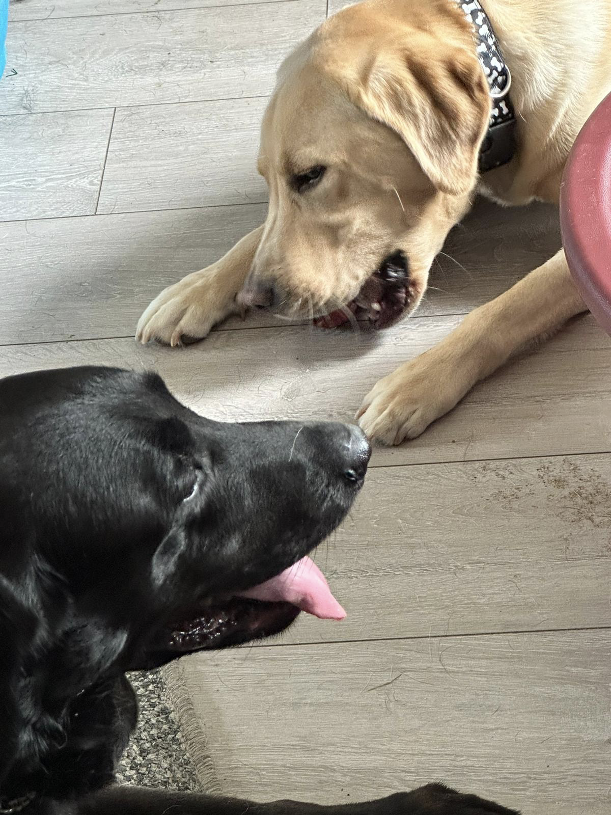

Benji,is my third Seeing Dog,he is, a bouncy 20 month old, golden Labrador. In human terms, this would be a young teenager and certainly his attempts to bark back , or push boundaries, is something to relate to teenage behaviour!

Over the next few weeks, Benji will learn to guide Darren around his local area and into London, on the train. Darren said he is a very different dog, to the chilled Milo, his previous Seeing Dog, now enjoying retirement with Darren and Noel, in Hertfordshire. The two dogs seem to have hit it off well, explains Darren, once he has, again , stopped them chasing each other, around in circles, in his front room. It will take time for Benji to accept us, as his new home, which we are very much looking forward too,. Darren concluded.

Guide Dogs have recently, been running a publicity campaign, about the need for more puppies needed to satisfy the growing demand. The waiting time is different for Seeing Dogs, an an organisation more people are turning to for support. If you would like to find out more about Seeing Dogs , please click here: https://seeingdogs.org.uk/lead-on-magazine-may-2023/
.

My big adventure from Southwark Cathedral to Canterbury Cathedral for Aquabats .

By Fiona Musgrove.

The below photo was taken of me, smiling, with a raspberry gin and tonic, at Eynesford, , after a long walk from Dartford...

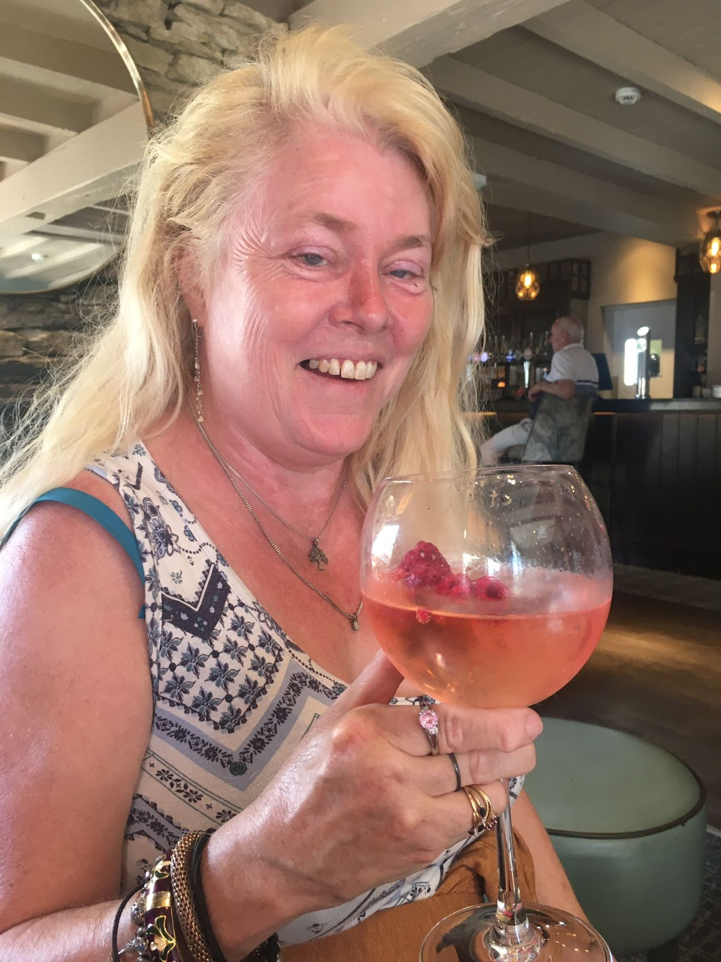

Since our meeting with Nick Dunne, Chair of the Confraternity of Pilgrims, on Wednesday 7th June, Richard and I have discussed how best to attempt The Britannia Way. The Francigena Britannica is a new walk which incorporates part of the old Canterbury Pilgrimage route and the London Loop. Starting at Southwark Cathedral , the Francigena Britannica will add a further 74 miles onto the Via Francigena and provide access to some spectacular landscapes for visitors.

On Monday 3rd July,I began this walk with my fantastic Butler Richard,, taking in the familiar sites of HMS Belfast, Tower Bridge and the unexpected appearance of several different statues of Morph. This first day saw me, sun-bathing on Bermondsey Beach, sipping a G and T where the Pilgrims set off for America and walking Past Brunel’s first tunnel under the Thames, not to mention posing in Fagin’s den(also known as Jacobs Island)! Keeping as close to the Thames, as property developers allowed, we climbed up to the Greenwich Observatory and then through, the three commons of Woolwich, Win and Plumpstead, where we ended the first days 14 miles walk.

Unlike Richard, who is a recognised, visually impaired, long distance walker, my experience is very limited. This project was to demonstrate that all abilities can be catered for, when approaching the walk,in smaller segments. Another consequence of inviting a less experienced walker was the understanding to return to a familiar base each night, by public transport, rather then having to camp.

On the second day, we emerged, from, Bostol Woods, to a sharp decline down through Abbey Woods, to discover the remains of Lesnes Abbey. I found this area, very atmospheric, as even the bus’s internal lights came on, through this gloomy woodland and I found myself imagining a vampire like character swiping down on the two blind walkers far below!

However, thankfully, the reality of these well maintained grounds showed us the ripple of the Thames again,and we continued unscathed through industrial estates fringing the river. In Belvedere, whilst Passing a newly built Sikh Temple, we were invited in to join them for lunch and visit their prayer room. Standing on Erith Pier, we were able to face where we had started, in the city of London and turn around, towards our next ending at Dartford.

Along our adventure, we are always humbled by the kindness of strangers. Walking 3 miles in the wrong direction,into the Crawfordness Marshes , through puddles and stumbling into another industrial estate, we gratefully accepted a lift from a stranger who soon brought us back on track.

The third day started at Dartford. I loved the black and white, clapper boards, of theTudor narrow lanes and then we walked into the expanse of Dartford Park through the once gravel pits, now filled with water wildlife and into the Darenth Valley,towards Shoreham.

So far, one of my most enjoyable stops was at the pretty village of Eynesford. We lay, in absolute peace, on the grass bank of a gently rippling river and had the best ever, G and T, as pictured above. Perhaps the calm before the storm! For those of you on Face Book, you can see a video, about my opinion of approaching Shoreham!

Day 4, started in Shoreham, where we first stopped for a G and T, at a country pub. We walked past a Malt House, an Oat House(or Hop House) and many beautiful houses. The people encountered were very friendly, or, prehaps a bit bemused, with the appearance of two white cane walkers! Passing what Richard perceived as a public bowls court, he encouraged me to give it a go. Despite my best attempts the balls wouldn’t budge from the ground. Looking up, we were confronted by two astonished golfers, probably wondering why we were attempting to sabotage their perfectly manicured golf-course, by trying to pull out their golf tees! Hiding behind our white canes we made a swift exit. Like before, much of this walk was done on country roads, without pavements, which was at times heart stopping!

Our next adventure begins in Kemsing, from where my butler intends to guide me towards Aylesford and eventually, Canterbury.

You can follow me on Face Book or on our Whats App group.I will also be posting on Twitter , from next week.

Aquabats Treasurer, David Banber, is setting up a fundraising page on Just Giving within a few days. Please support me in this endeavour in any way you are able to.

A hoi there sailors from London Branch.

By Pardy Gill.

The below photo is of the team taken on board one of the yachts.

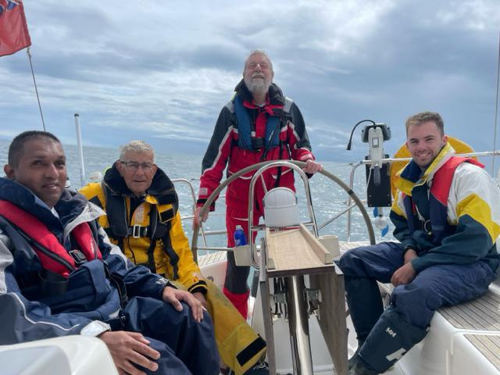

On Saturday 7th July, I set off from London for 7 days of sailing as part of the annual Blind Week organised by Sailing Vision Trust, whose motto is Empowerment at Sea. The event is rotated between Falmouth in Cornwall and Lymington. Always ready for a challenge, I was quite apprehensive how I would adapt non-visually given my last experience of VI Sailing was with much better vision in the Tall Ships Race with JST several years ago and my experience on other yachts has never been hands-on.

The five hour journey went smoothly with GWR First Class looking after us well, alongside London member, Terry White, who has joined Blind Week for many years. Volunteers assisted the group changing at Truro and arrival at Falmouth Docks station with minibus transfer to the Harbour office for registration. This year, there were 120 joining the week, including 40 VIPs, skippers and sighted crew aboard 20 private and chartered yachts of various sizes, including those owned by John Lewis Partnership and Coutts Bank.

My yacht skipper, Peter, a renowned local architect, met me on arrival, and gave me a tour of his 37 foot yacht Ardea alongside sighted crew, Nick and Ben, plus fellow VI sailor bob from Reading. After a safety and orientation, talk, we enjoyed a celebratory meal with all the other participants at the Royal Falmouth Yacht Club.

The next five days were spent sailing aboard Ardea to various beautiful locations, such as Helford and Foy. I greatly enjoyed the team based approach of learning non-visually how to hoist and winch the sails, tacking and jibing plus Helming the yacht using an audio compass app and later the wind as a guide. Enjoyed great sailing conditions witnessing dolphins, although we had to cut sailing on the Friday because of gale force winds. Life on board was very comfortable with sleeping cabins and good food, plus some opportunities during the evening to socialise with other yachts in our fleet on shore. This included a pontoon party where I met inspiring Paralympic sailors. When not sailing, we enjoyed visiting the National Maritime Museum in Falmouth which included a tactile tour of famous racing yacht’s, an immersive tour of historic Pendennis Castle built by Henry VIII to defend the Southwest from invasion, plus of course, enjoying local culinary delights, including Cornish pasties. The week culminated with a celebratory evening meal at the Royal Yacht Club with speeches and local dignitaries, where we shared our terrific experiences.

Not everyone may have sea legs but I would highly recommend London members consider Blind Sailing Week in future. I began non-visually as a beginner with great encouragement from my sighted crew who have raced around the world, along with my fellow VI sailors, who shared the same passion of empowerment and having fun singing sea shanties. The team approach, camaraderie, opportunity to upskill and peer support with other VIPs was fabulous. The week has inspired me to pursue further training, improving my non-visual saving techniques. I did lose my white cane early in the week by the dockside, but I assure you, I wasn’t a drunken sailor!

Details of how to apply for the 2024 week will be posted in the New Year.

News from our partners

Eye Matter

25 July Tuesday BGT – Blindies got Talent

28 July Friday Neurobics with Steve Wax

7 August Monday The Crucible theatre outing

9 August Wednesday Midsummer Mechanicals theatre outing

23 August Wednesday Wizard of Oz theatre outing

2 September Saturday La Cage aux Folles theatre outing

29 September Friday Postal Museum outing

For more information, please email: eyemattervi@gmail.com

Dates for Royal Collection Trust.

Our programme of Descriptive Zoom talks are for blind and partially-sighted people. Talks take place on the first Tuesday of the month, from 2pm. Join us to hear about different works in the Royal Collection, the Royal Residences and the history of the Monarchy. Talks are free and informal, and you can participate camera on or off, however you prefer.

Join the Royal Collection Trust Zoom (camera can be on or off)

Joining details:

Meeting ID: 440 773 2986

https://us02web.zoom.us/j/4407732986

Join by phone:

0208 080 6591

0131 460 1196

Dates and topics to be covered are:

Tuesday 1 August The Coronation portrait of Queen Victoria

Tuesday 5 September Fashion trends in Victorian England

Tuesday 3 October James VI & witchcraft

Tuesday 7 November Object focus – clocks in the Royal Collection

Tuesday 5 December Hans Holbein

Transport News

Is Passenger Assistance fit for purpose?

By Fiona Musgrove.

On Sunday, I had an incident with Passenger Assistance on Greater Anglia Railway,, as a result of a closed ticket office. At Cheshunt, with no-one on the platform to register my journey, my booked assistance,never appeared at my journey’s end. This was despite receiving a confirmation email, the previous day, detailing how a conductor would get on board, during the journey and inform Stratford. The next day, I subsequently, received an apologetic phone call, from the Passenger Assisttance manager, from Greater Anglia. He could not offer any alternatives, other than I should contact them directly, once on the train, to confirm my travel arrangements.

In June, we heard from Martin Burns, from AvantiWestCoast Railway, about the idea of having a fully amalgamated system across all networks supporting our journeys. Consequently, I then asked Greater Anglia Assistance, if having the Passenger Assistance App, would make this service any better?

On a late night return journey, after the staff at Tottenham Hale decided to escort me back to the unmanned Cheshunt Station I noticed they were tracking this through another version of Passenger Assist. Once delivered at Cheshunt he was directed to tap”journey completed”, on his phone’s screen.

I would be very interested to know, if anyone has tried the Passenger Assistance app, as a customer? How effective is it compared to booking over the phone and whether it offers any further reassurance? Please send your responses to: london@nfbuk.org

As the railway network moves towards more unmanned stations, we need to ensure our needs are being represented in these changes.

Improving Arthur Street and changes to the 344 bus route Consultation Report from Rob Niven, Head of IDP - Major Projects

Thanks to Andrew Hodgson.

Today we have published our report following the consultation on our proposals to improve Arthur Street for pedestrians and cyclists, and changes to the 344 bus.

Between 27 February and 12 April 2023 we consulted on improvements to Arthur Street and its junctions with Upper Thames Street and King William Street for pedestrians and cyclists. This included proposed changes to the 344 bus route. Arthur Street was closed to the public in 2015 to be used as part of a worksite for the Bank Station Capacity Upgrade project. We consulted on reopening Arthur Street for pedestrians, cyclists and emergency vehicles only, and permanently re-routing the 344 bus via London Bridge.

We received 463 responses to the consultation. The majority of responses we received supported our proposals and understood why we are proposing these improvements for pedestrians and cyclists. We received suggestions for further provisions, for example fully segregated cycleways and extension of the cycle lanes. We also received a number of responses raising concerns about the diversion of the 344 bus and the loss of a cross-river service at Southwark Bridge. Our responses to the issues raised during the consultation is included in Appendix A of the report.

We have reviewed all feedback to the consultation and are using this to help us with the next stages of design. Subject to approvals from the City of London, changes to Arthur Street and the junctions with Upper Thames Street and King William Street could be made by Spring 2024.

Regarding the change to the 344 bus, we have used feedback to the consultation to make the decision for the 344 to remain on the current routing so that it serves London Bridge (northbound) and Southwark Bridge (southbound). This means that the temporary re-routing that has been in place since 2015 would become permanent.

For further details and to view our consultation report, please visit: https://haveyoursay.tfl.gov.uk/arthur-street

That’s all for now folks! Wishing you a lovely weekend.

Keep ‘Walking on sunshine’.

Fiona and Jane
London NFB UK

