Evidence on the Rental E-scooter Trials in England and Private Use of E-scooters

Submitted to Transport Select Committee Inquiry on E-scooters by the National Federation of the Blind of the UK

Appendices Part 3
If further information is required about any of the appendices please contact the NFBUK office admin@nfbuk.org or 01924 291313.

London | Appendix F a & F b continued
Birmingham | Appendix G
Bristol | Appendix H
Liverpool | Appendix I
Rochdale | Appendix J
Kettering | Appendix K
Milton Keynes | Appendix L
Coventry | Appendix M
Appendix F a London E-scooter Trial Teir, Lime and Dott E-Scooters continued

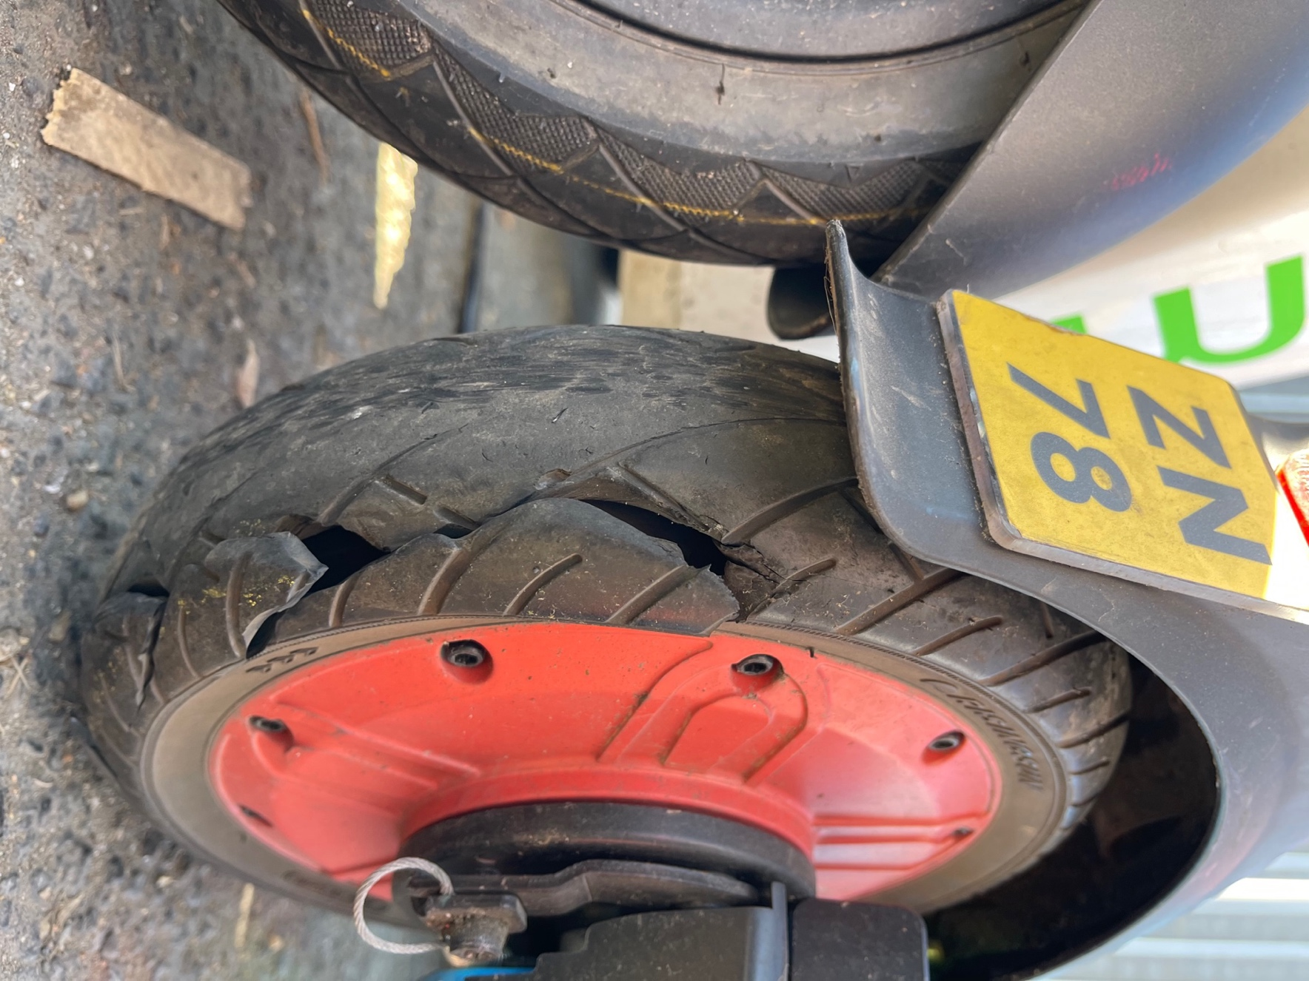
Photo 50 Split back tyre Dott e-scooter

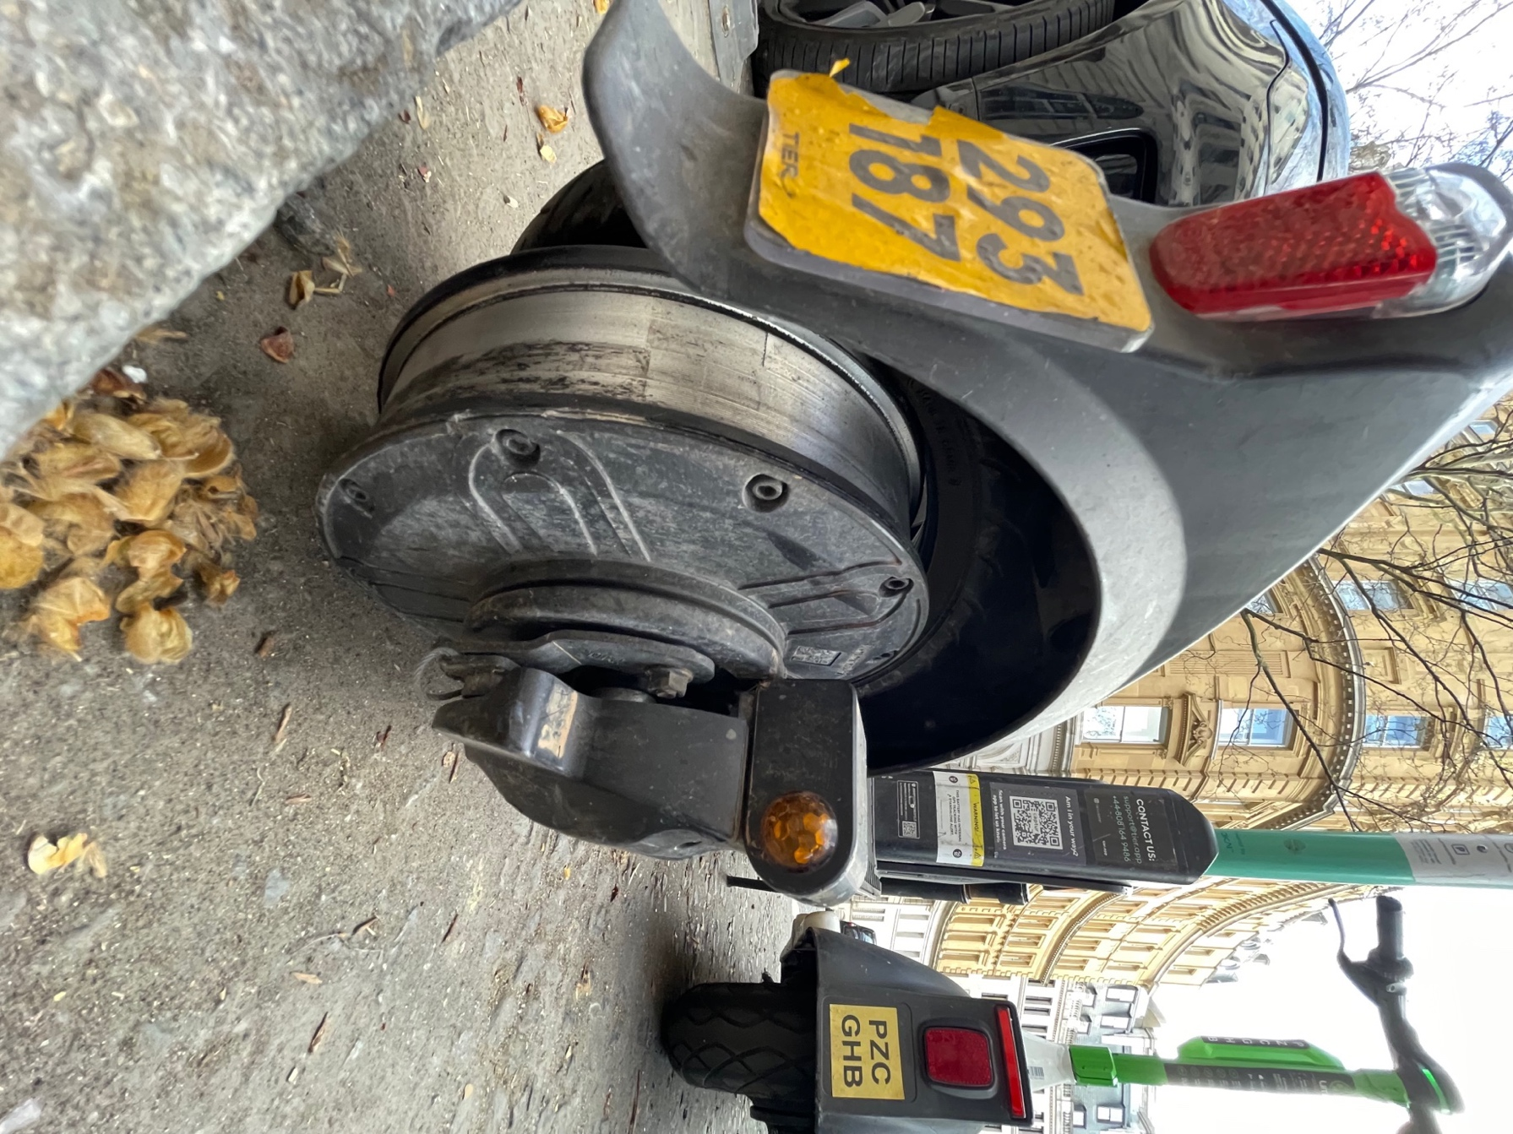
Photo 51 Tier e-scooter with back tyre come off it.
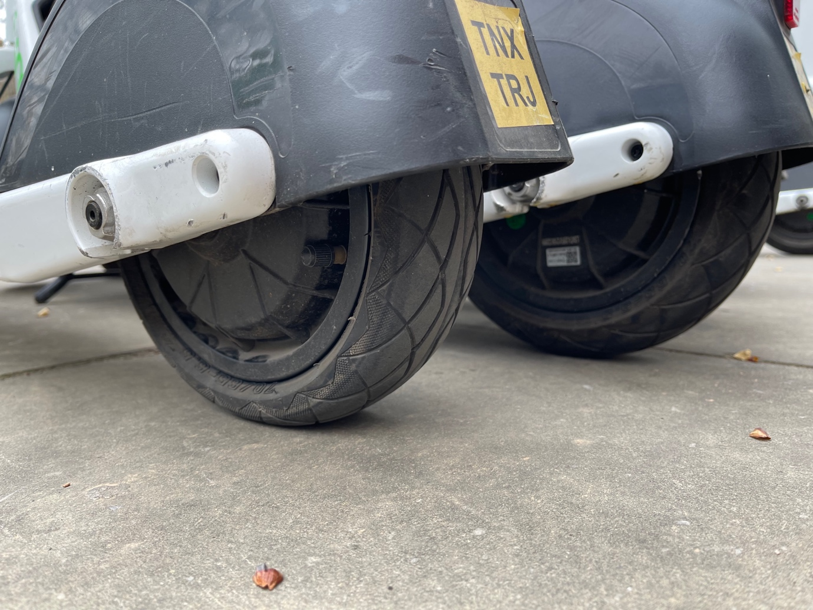
Photo 52 Lime e-scooter back tyre underinflated next to one that is not flat.

London Site Visit 12 August 2021

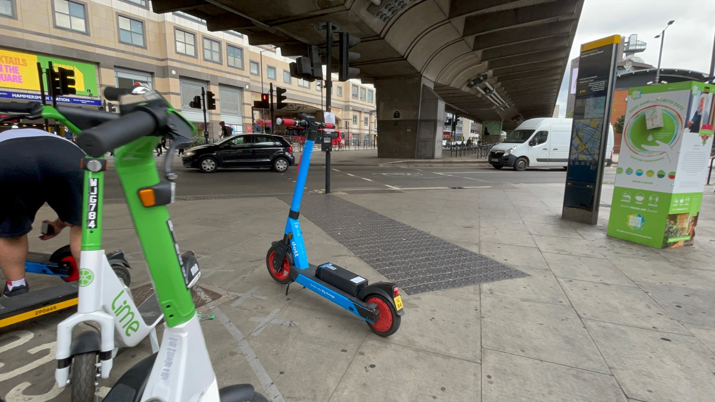
Photo 53 E-scooter left next to tactile paving leading to pedestrian crossing and e-scooters on pavement in and around painted parking bay. This is not safe, they are an obstruction and a trip hazard.

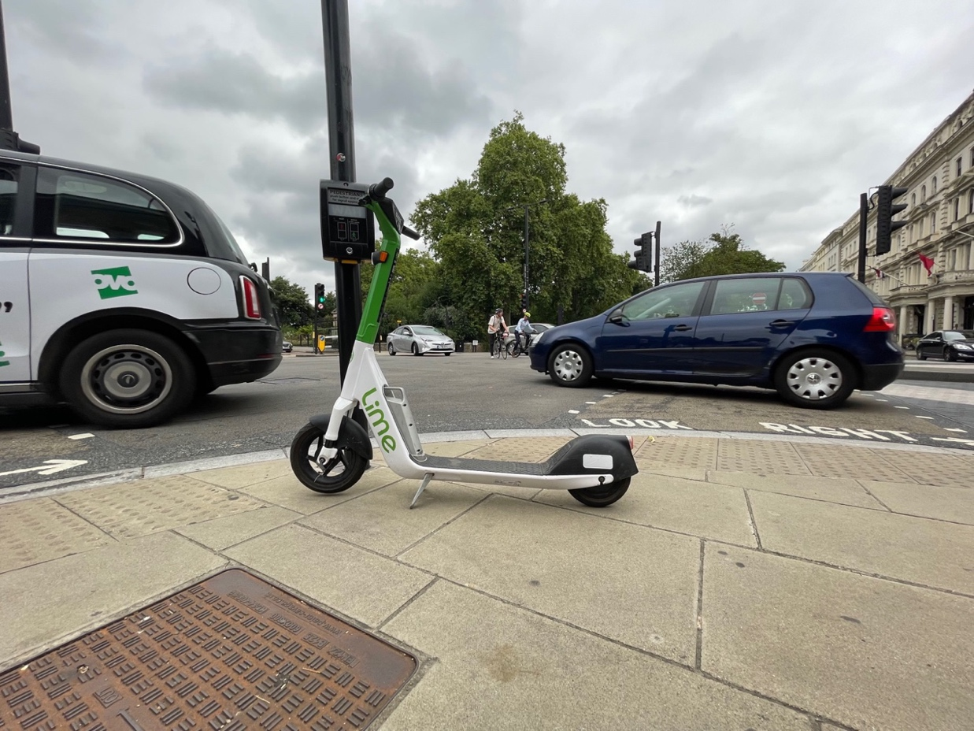
Photo 54 E-scooter left next to pedestrian crossing tactile and push button control box. This is an unsafe situation blocking safe access to the pedestrian crossing and is a trip hazard.
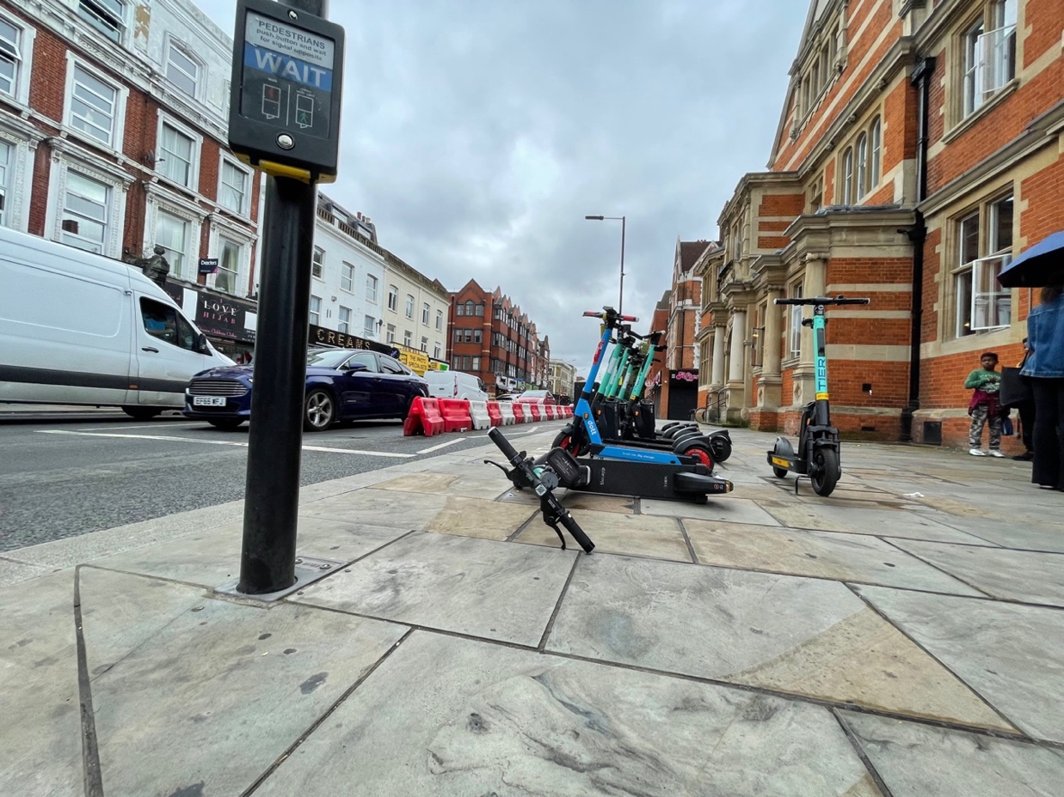
Photo 55 Knocked over e-scooter and left next to pedestrian crossing tactile and push button control box. This is unsafe situation blocking safe access to the pedestrian crossing and is a trip hazard.
June 2022

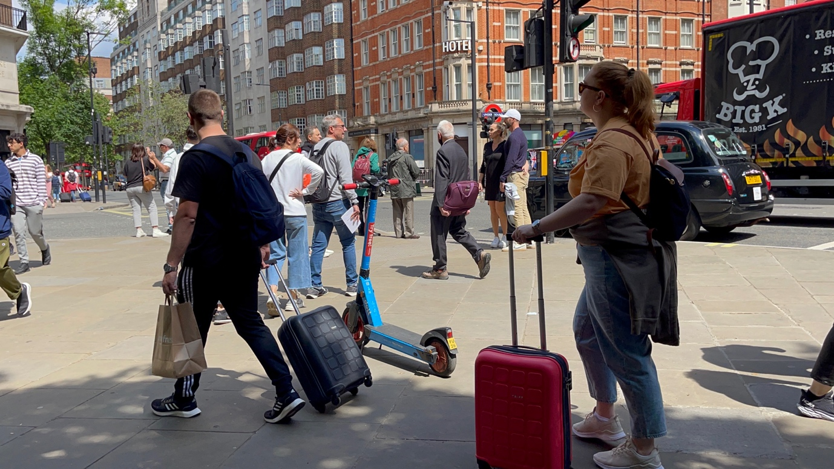
Photo 56 E-scooter left in middle of pavement in unsafe location. It is a trip hazard.
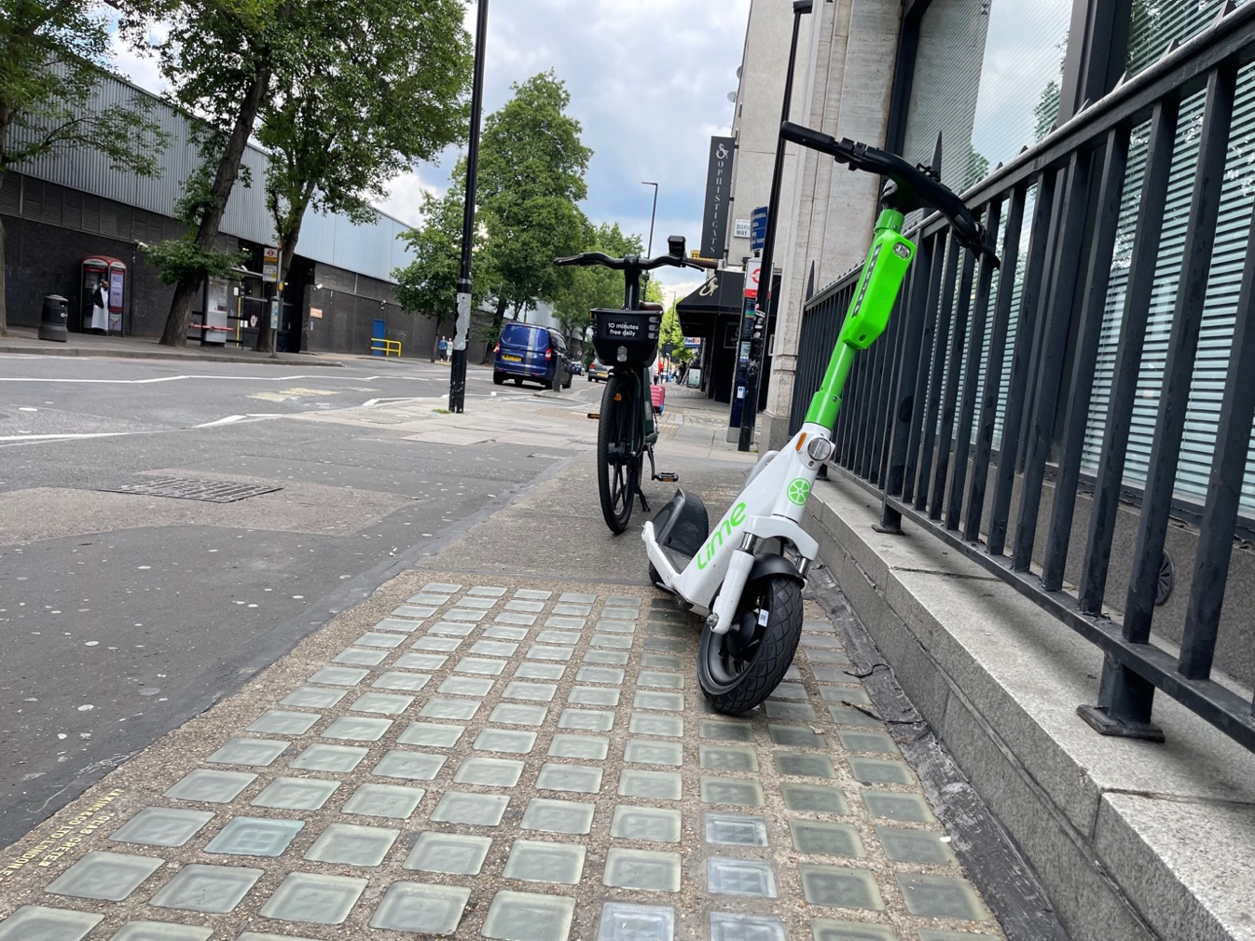
Photo 57 E-scooter left on building lune without kick stand deployed making it even more unstable.
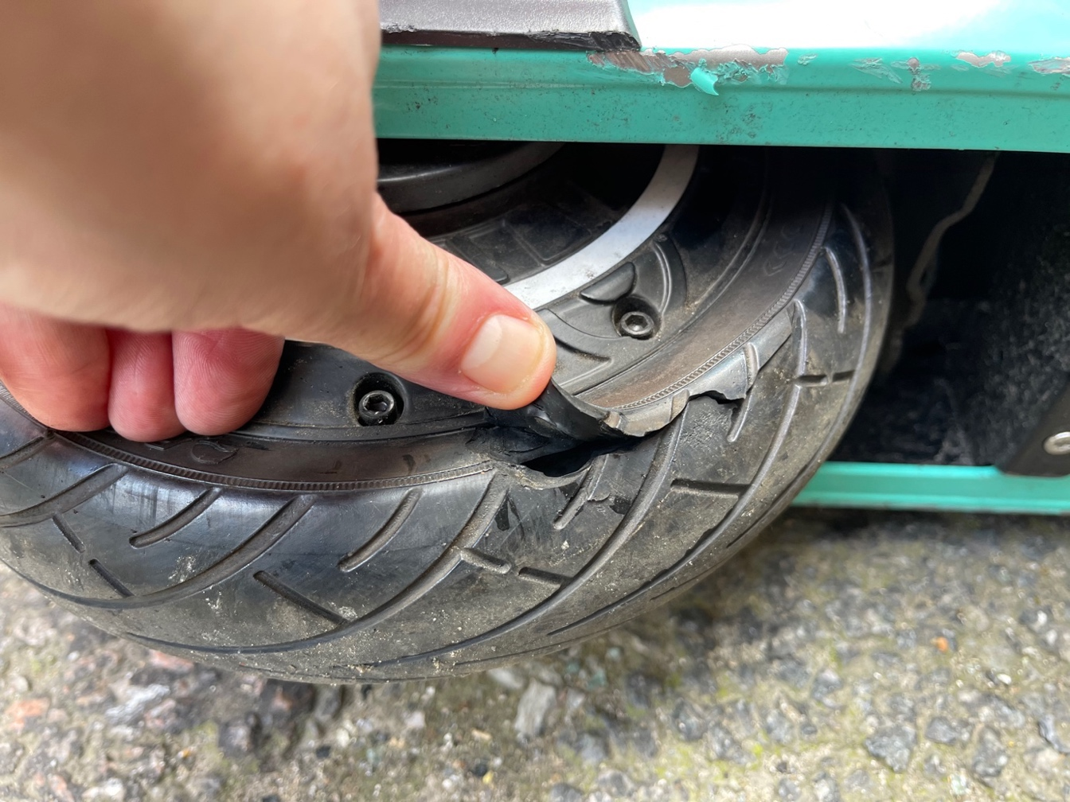
Photo 58 Tier e-scooter back tyre with rip on the side wall.

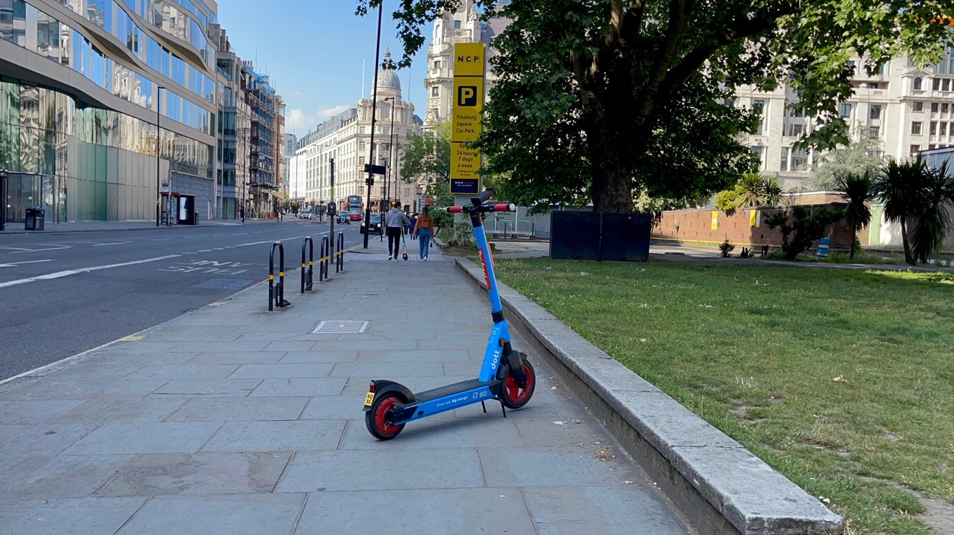
Photo 59 E-scooter on building line on the pavement in unsafe location, this is a trip hazard.

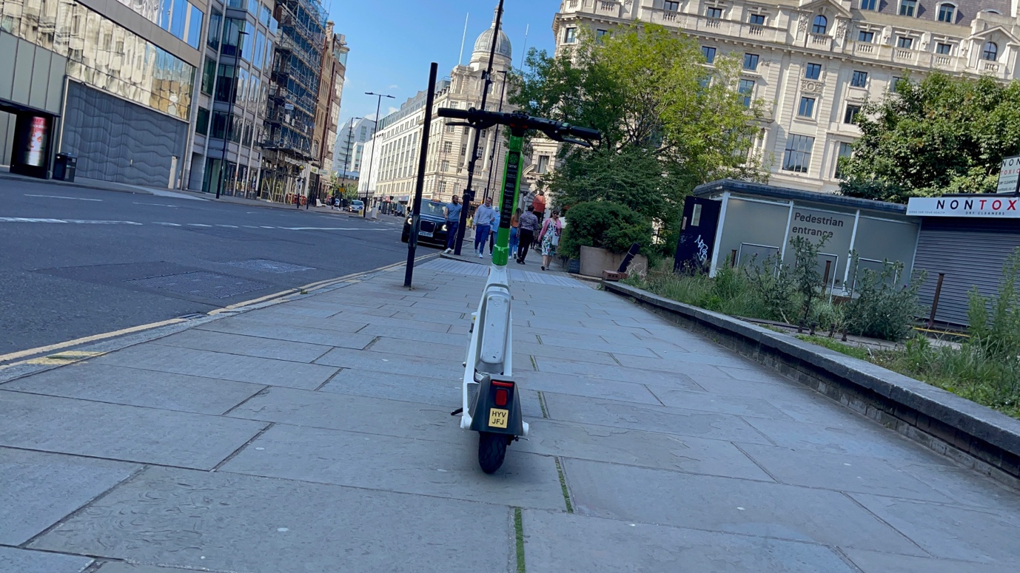
Photo 60 E-scooter in the middle of the pavement in unsafe location, this is a trip hazard.

Appendix G Birmingham E-scooter Trial Voi E-Scooters Passing through 29 November and 2 December 2022

Birmingham was visited on route to catch a bus to Edinburgh in Digbeth in the evening and early morning. The trial had not resolved key safety and accessibility concerns for riders and pedestrians. E-scooters were found dumped on the pavements and riders were still witnessed riding double, riding through pedestrian crossings while on red and on the pavements. Photos below illustrate our concerns and the NFBUK have many more photos which is can share.

Parking / Dumping of e-scooters
E-scooters were observed in unsafe locations, found in an unsafe manner causing obstructions and trip hazards on the pavement, public places and next to bus stops.
- Left on pavements, in the middle of the pavement, on the kerb line, on the building line, on dropped kerbs, leading up to pedestrian crossing points and left close to tactile paving for use by blind and visually impaired pedestrians.
- E-scooters were found knocked over.
- Two parking racks were observed however the racks posed a trip hazard for blind and visually impaired pedestrians and an e-scooter was found close to the parking rack but left on the pavement illustrating how ineffective the parking racks are for safe storage of the e-scooters when not in use. Also the rack was on the pavement meaning riders would ride to and from this area on the pavement, which is not safe or accessible for pedestrians.

Riding of e-scooters
E-scooters were observed been ridden of the pavements at speed, two people riding e-scooters, riders were not wearing helmets. Riders were riding in front of people on pedestrian crossings and on pavements.

There has always been significant serious safety concerns with the Birmingham trial which made the city a very hostile place to be a pedestrian in due to how the e-scooters were being ridden and where the e-scooters were left. Evidence was submitted to the Council and the Mayor of the West Midlands in May 2021 asking for the trial to be shut down due to these safety concerns, and to the fact young children were getting access to the e-scooters. This was ignored and the trial continued. It has only recently been shut down after the tragic death of a 12 year old child and the serious injury of a 16 year old both from riding Voi e-scooters.

Previous site visits

Short films are given in Appendix G Table 1 below which illustrate concerns over unsafe parking and dumping of e-scooters, dangerous rider behaviour and unsafe tyres of the e-scooters in Birmingham during the trial.

Appendix G Table 1: Evidence on rider behaviour, trip hazards and obstructions from dumped e-scooters on pavements and public spaces and concerns raised on the safety of the maintenance of the rented e-scooters in Birmingham trial.

Site Visit | Appendix Site Visits | Twitter Films Trip & Obstructions | Twitter films Dangerous Riding | Twitter Films E-scooter Safety Concerns
Birmingham | Appendix G | May 2022  March 2022  March 2022  October 2021  June 2021  June 2021  June 2021  June 2021  June 2021  June 2021  June 2021  June 2021  June 2021 Topple test  June 2021  June 2021  June 2021  June 2021  May 2021  May 2021  May 2021  May 2021  May 2021  May 2021  May 2021  May 2021  May 2021  April 2021  April 2021  April 2021  April 2021  April 2021 | May 2022  May 2022  October 2021  October 2021  June 2021  June 2021  June 2021  June 2021  June 2021  June 2021  May 2021 Handing over e-scooter to a mate to ride.  May 2021  May 2021  May 2021  May 2021  April 2021  April 2021  September 2020  September 2020  September 2020 | October 2021  October 2021  October 2021  September 2021  August / September 2021  May 2021 – e-scooter shoots forward with rider & slow mo.  May 2021 e-scooter shoots forward with rider

Photos
7 photos shown with parking racks on the pavement and public space, one with extendable sides one with no extendable sides. E-scooter found left close to the racks not in them, some were in them. The rack was street clutter, the e-scooters were still a trip hazard and left in an unsafe situation. Other photos show e-scooters left on pavement, knocked over, next to pedestrian crossings and left on the building causing a trip hazard.
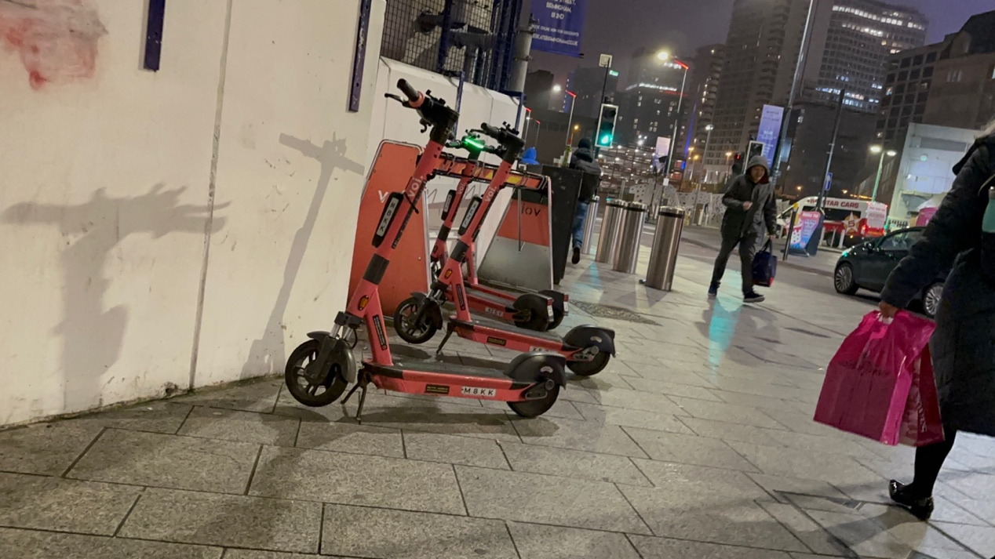

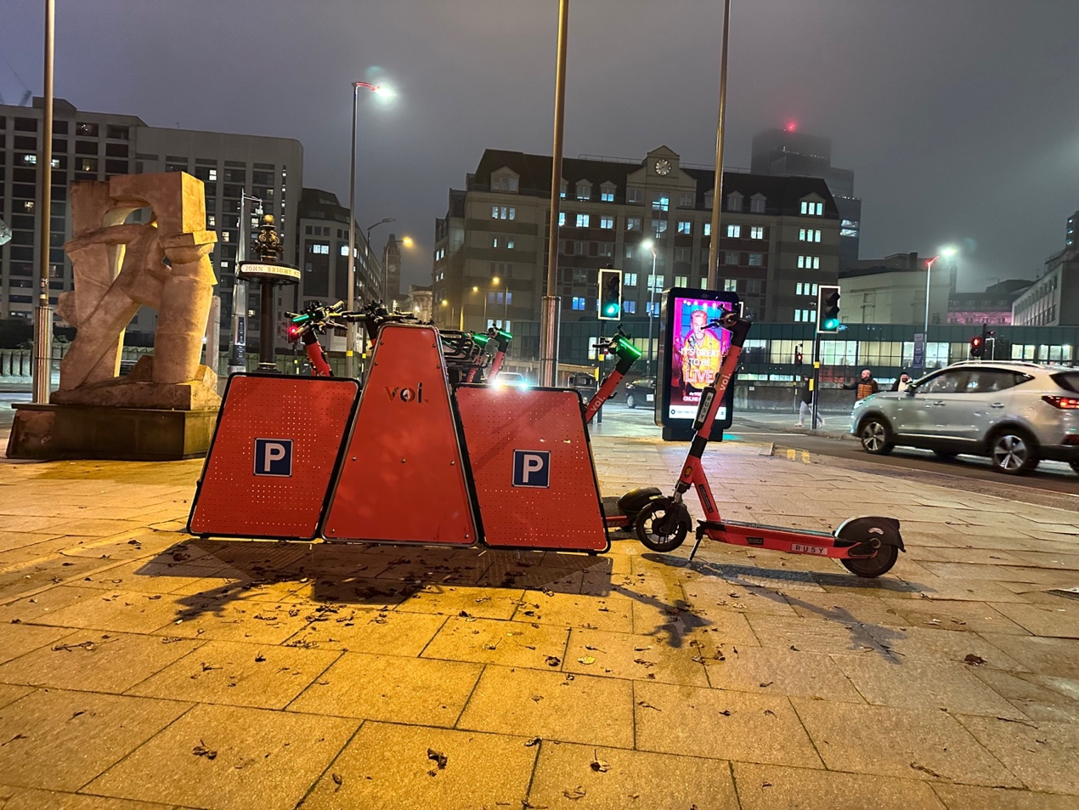

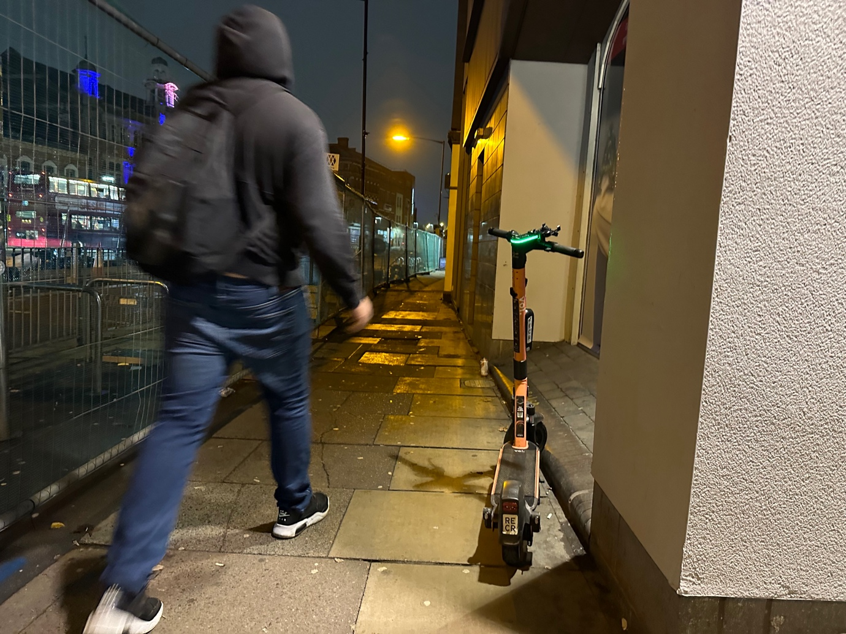

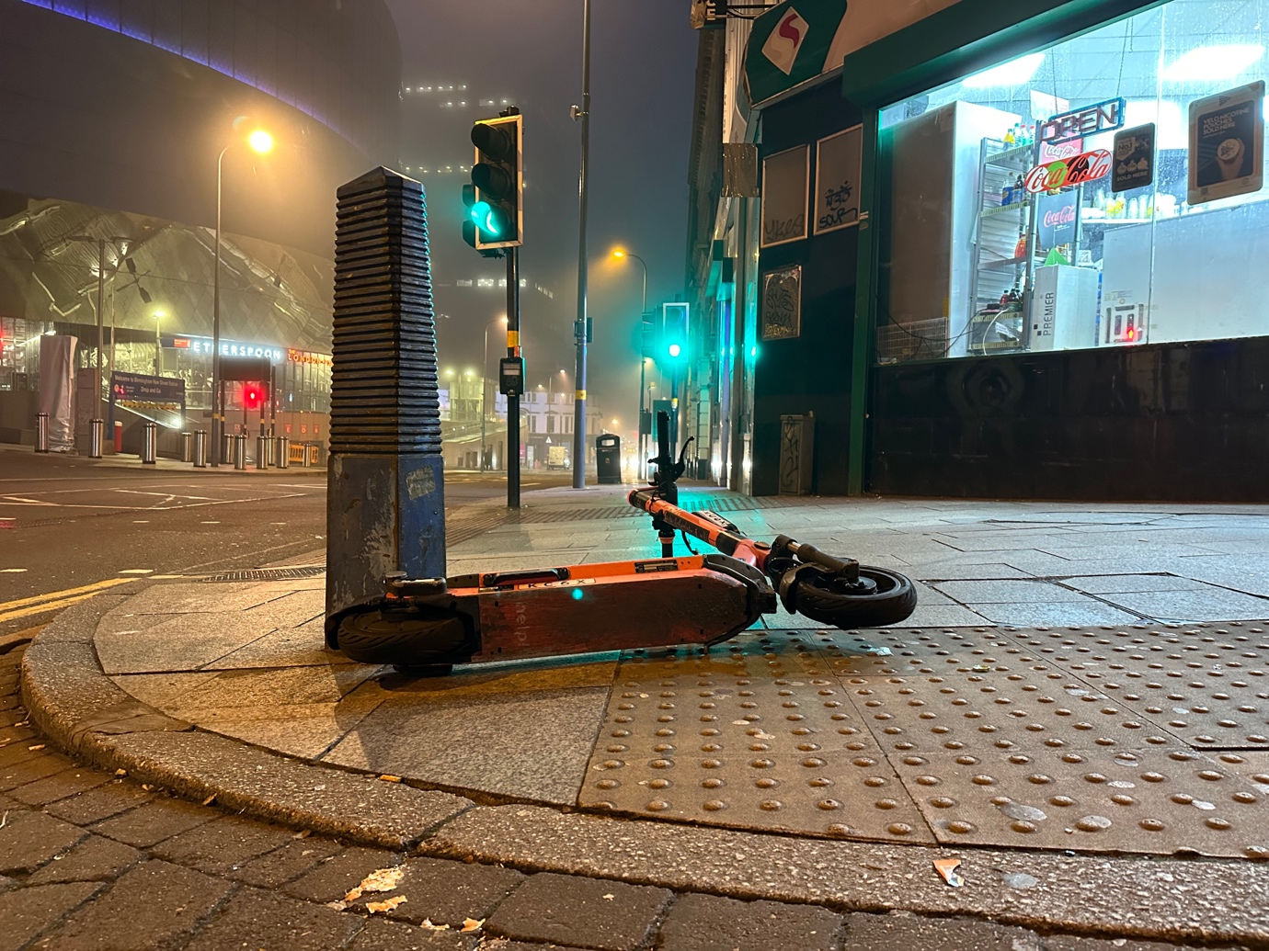
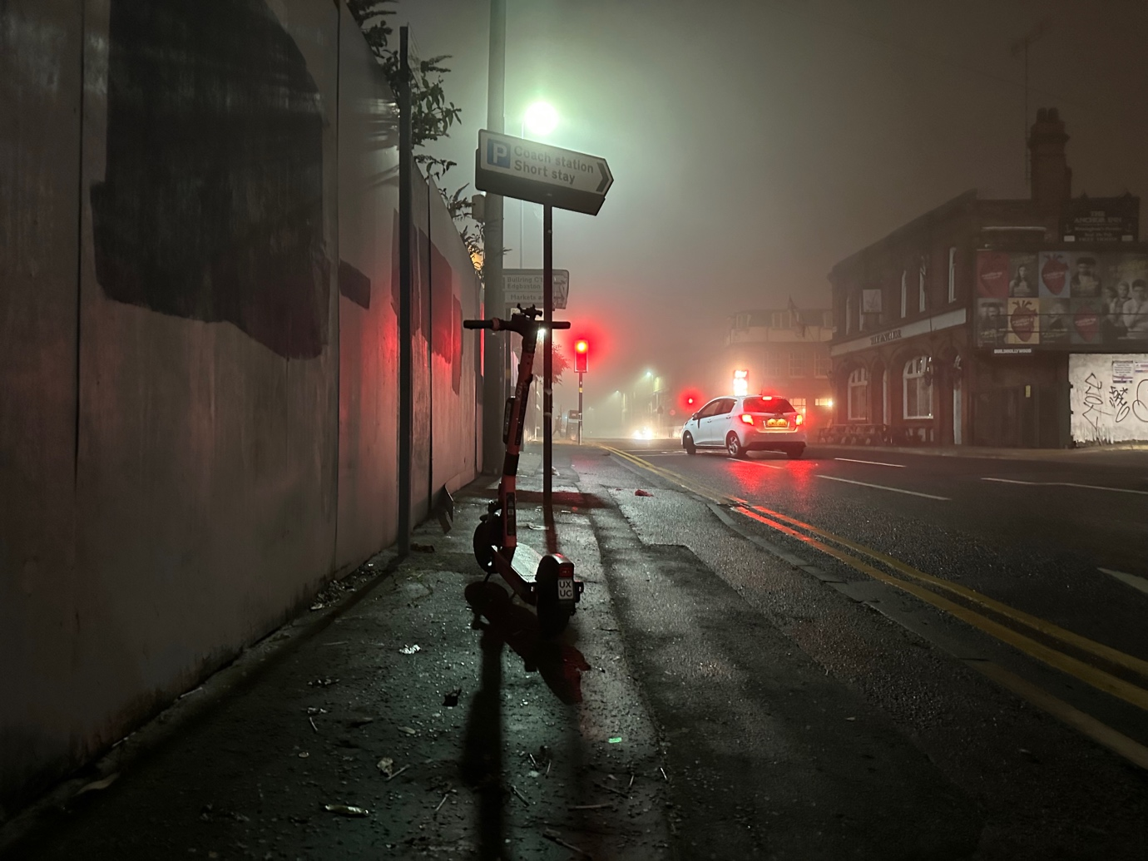

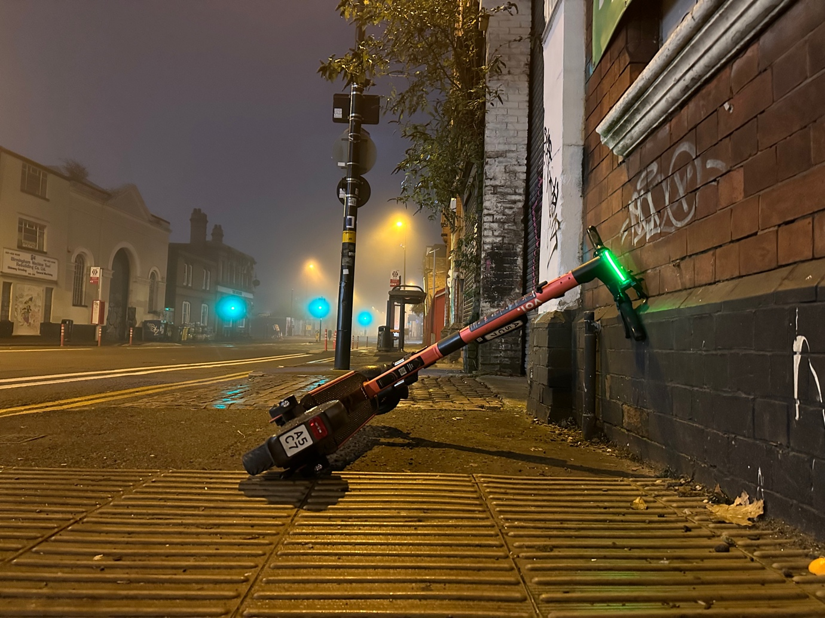
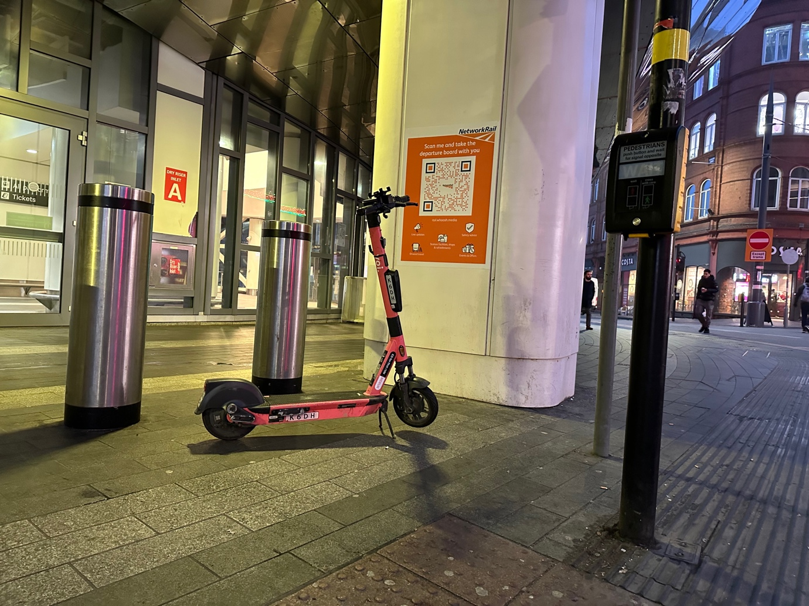

Appendix H Bristol E-scooter Trial Voi E-Scooters February 2022

The Bristol trial had not resolved key safety and accessibility concerns for riders and pedestrians. E-scooters were found stored in significant quantities and dumped on the pavements and riders were still witnessed riding double, riding through pedestrian crossings while on red and on the pavements, many of which were shared use pavements.

Parking / dumping of e-scooters
E-scooters were observed in unsafe locations, found in an unsafe manner causing obstructions and trip hazards on the pavement, public places and next to bus stops. Photos below illustrate what we found.
- Left on pavements, in the middle of the pavement, on the kerb line, on the building line, on dropped kerbs, leading up to pedestrian crossing points and left close to and on tactile paving for use by blind and visually impaired pedestrians.
- E-scooters were found knocked over.
- E-scooters were found with no kick stand deployed.
- Long lines of e-scooters were found on building lines and in long lines next to seating areas in the city making it difficult for people to sit if needing a rest.

Riding of e-scooters
E-scooters were observed been ridden of the pavements at speed, two people riding e-scooters, riders were not wearing helmets. Riders were riding in front of people on pedestrian crossings and on pavements. The rider behaviour around pedestrian was not safe at all and was very frighting as a pedestrian. There are many shared use pavements between cyclists and pedestrians, which e-scooters could use, even on pavements where buses uses for to pick up passengers. Sharing space with cyclists is not safe and needs to be halted, and to have to share space this space with e-scooters has and is very dangerous and should never been allowed in the first place. It was a very hostile place to be a pedestrian in.

Photos
29 photos are given below showing e-scooters left in unsafe location on the pavement, next to pedestrian crossings, next to bus stops and knocked over. Creating obstructions and trip hazards for pedestrians.

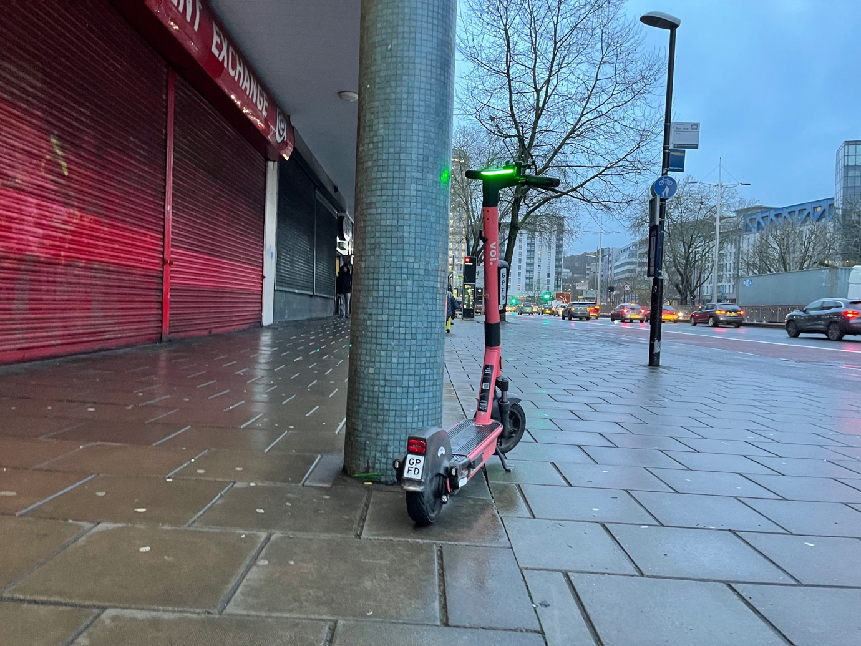

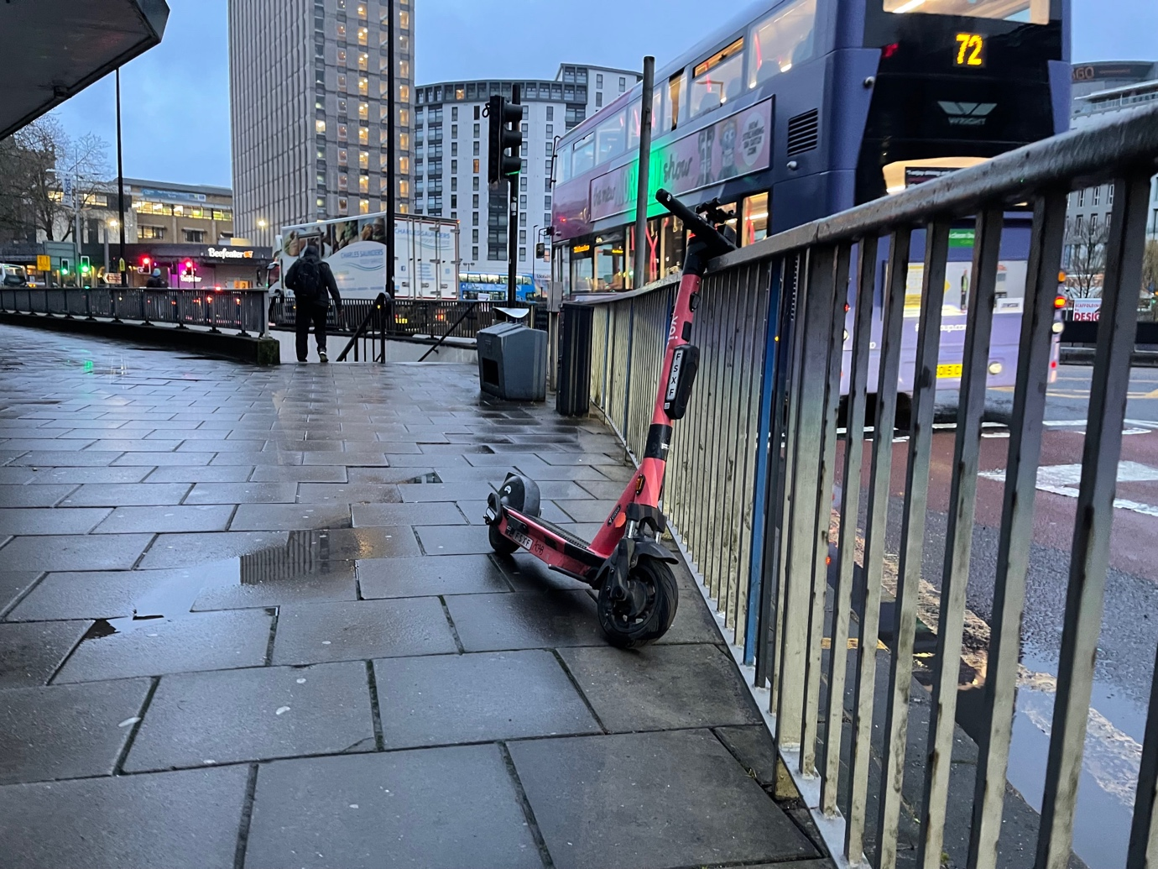
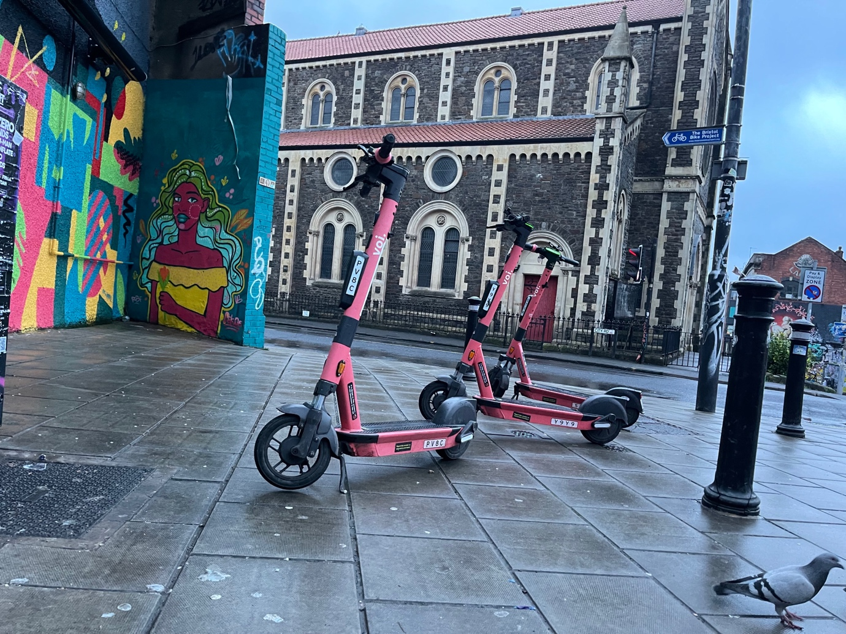

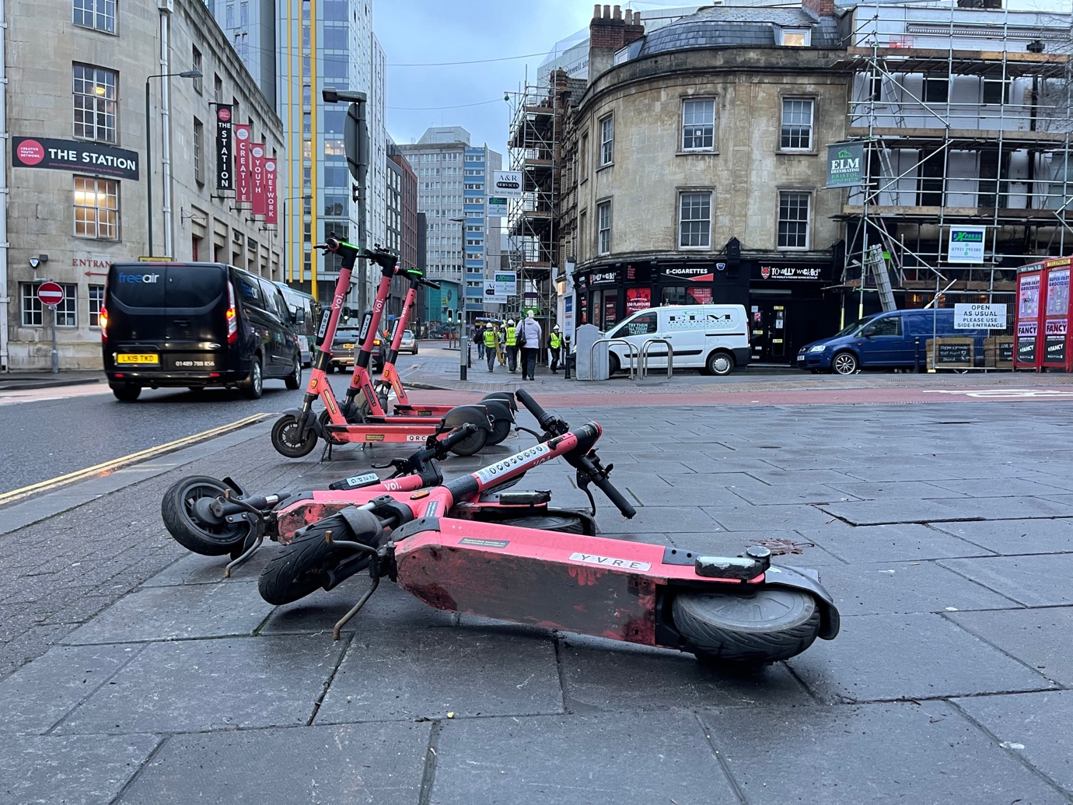

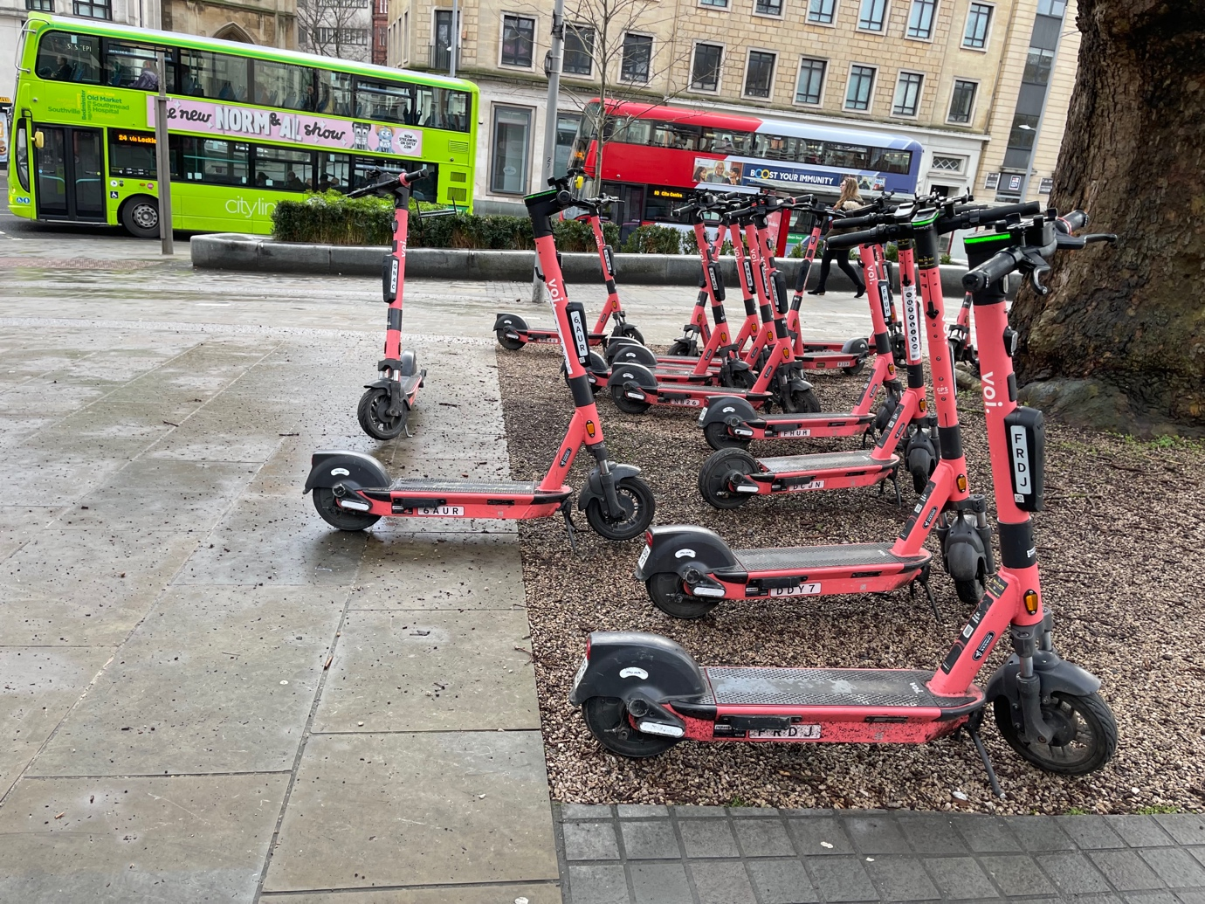
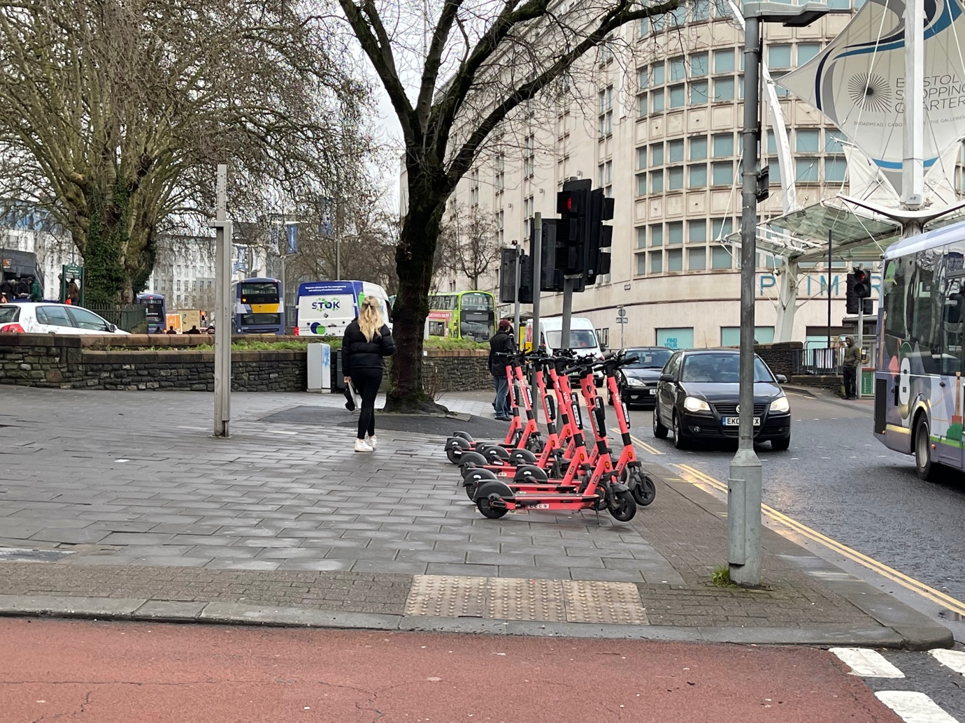

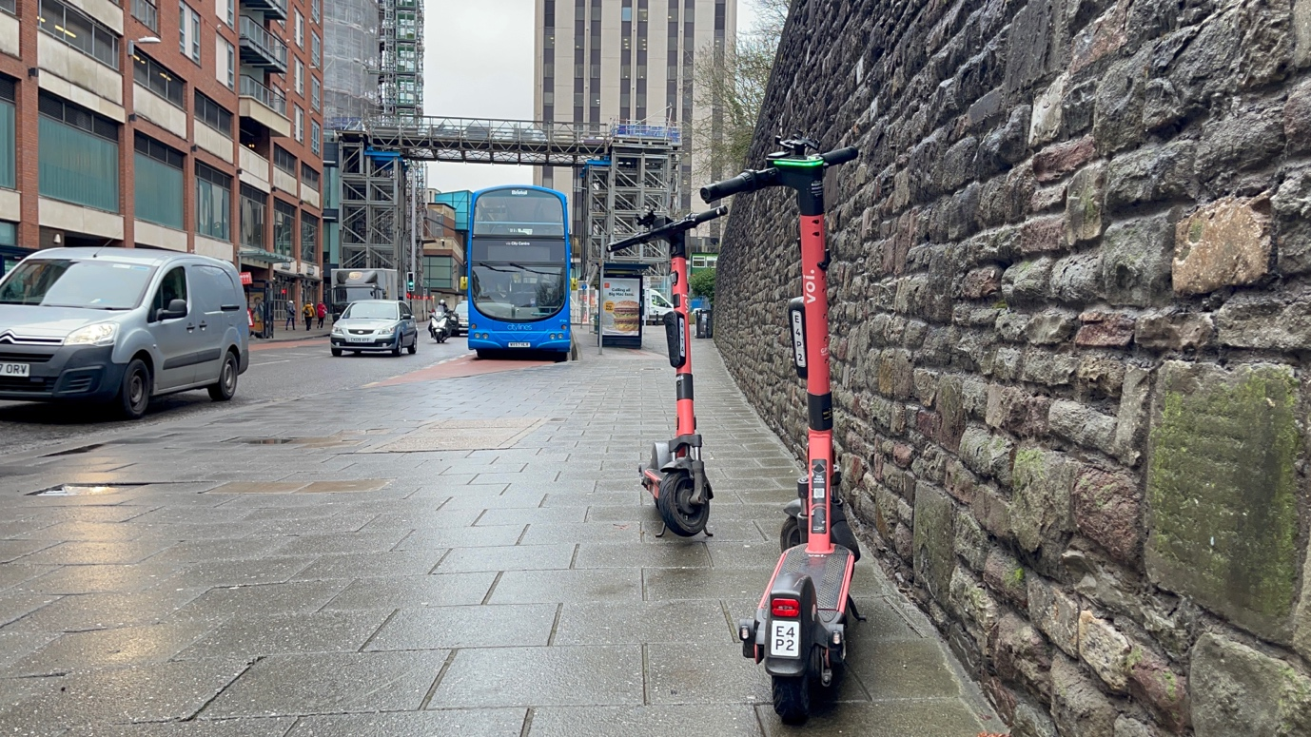
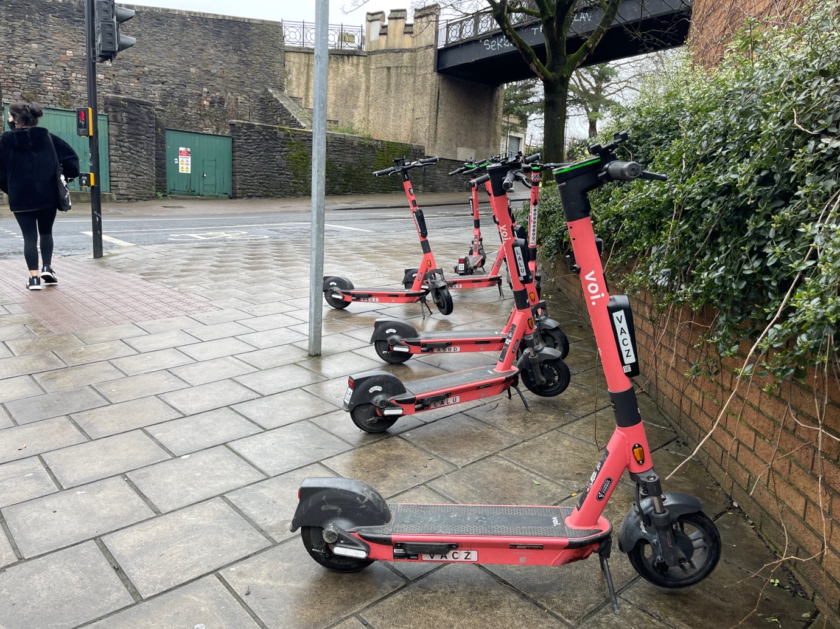

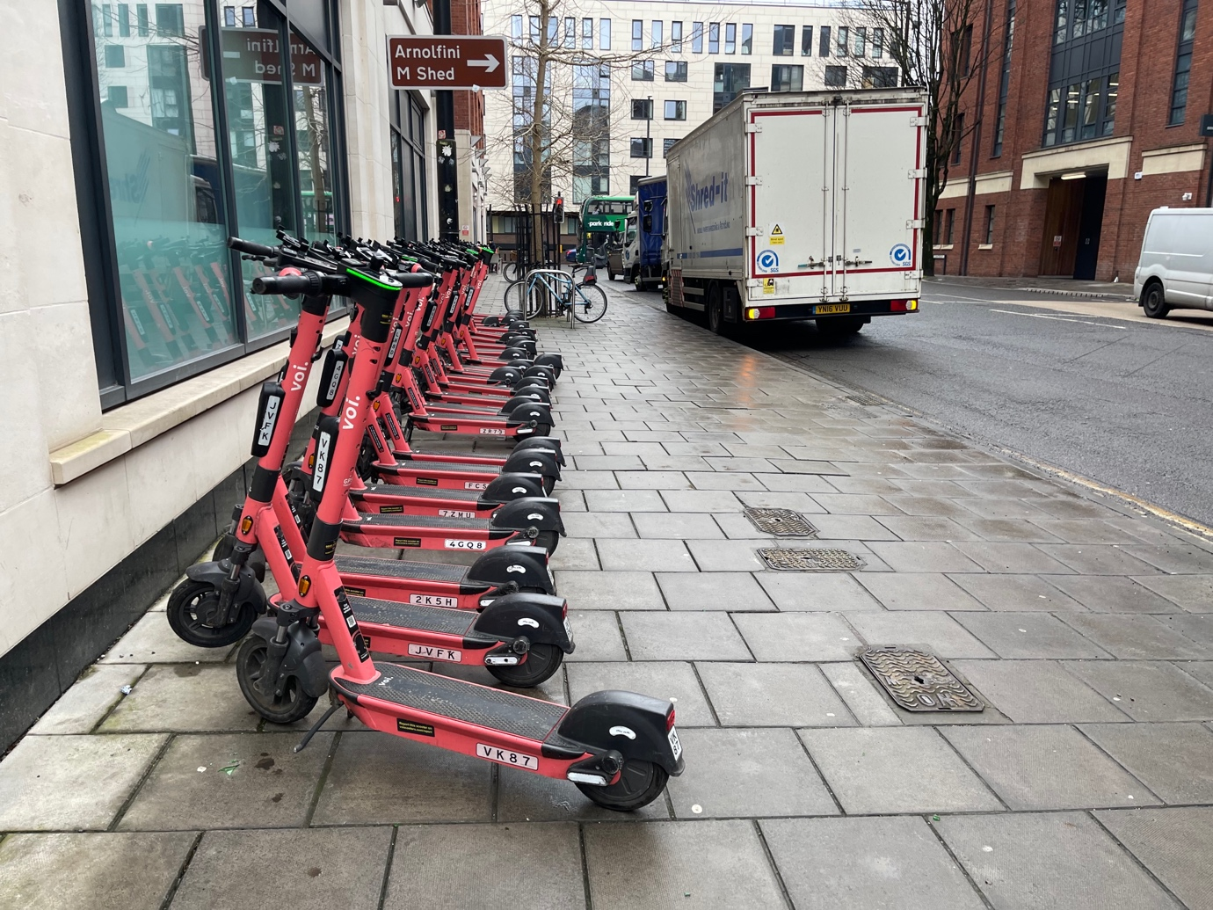
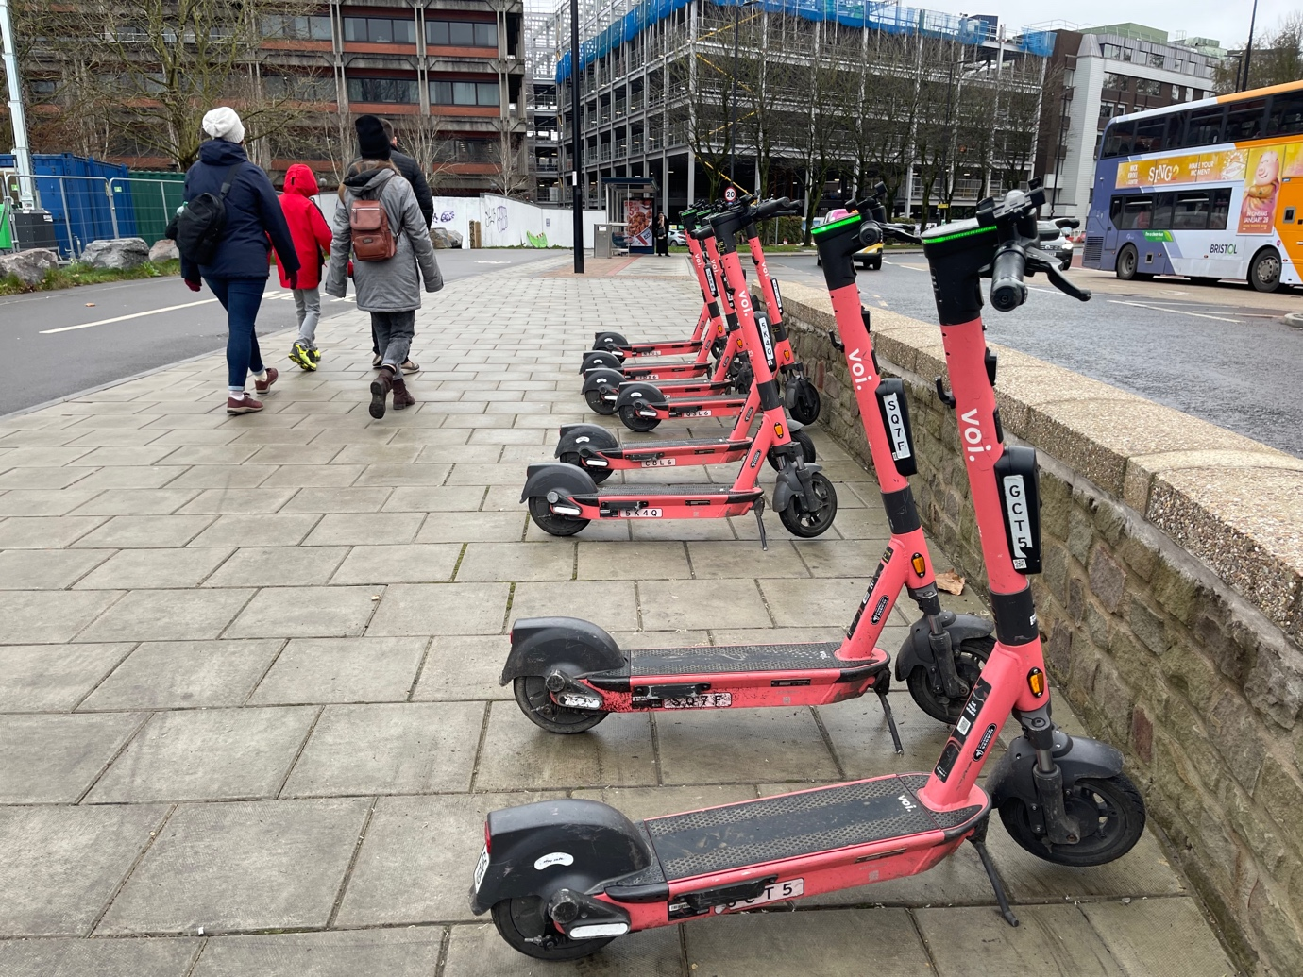

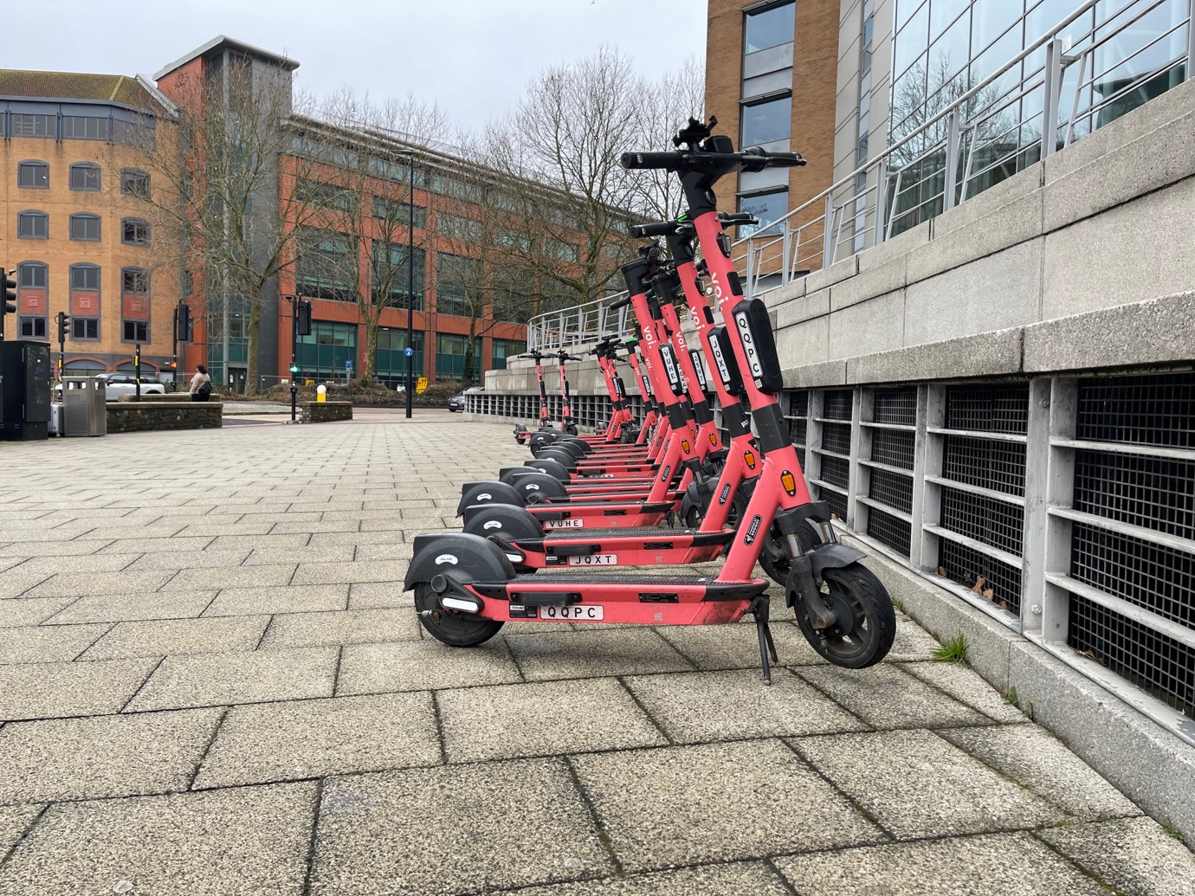
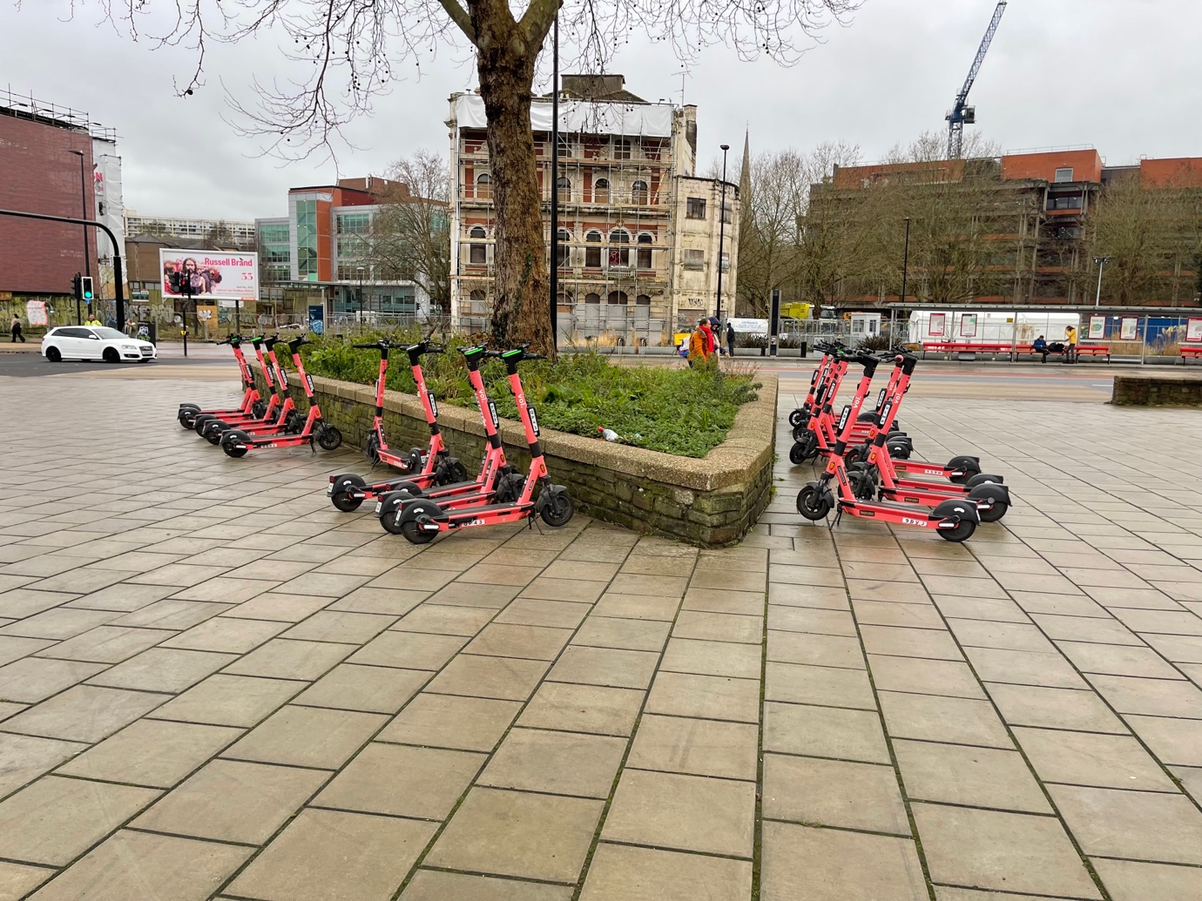

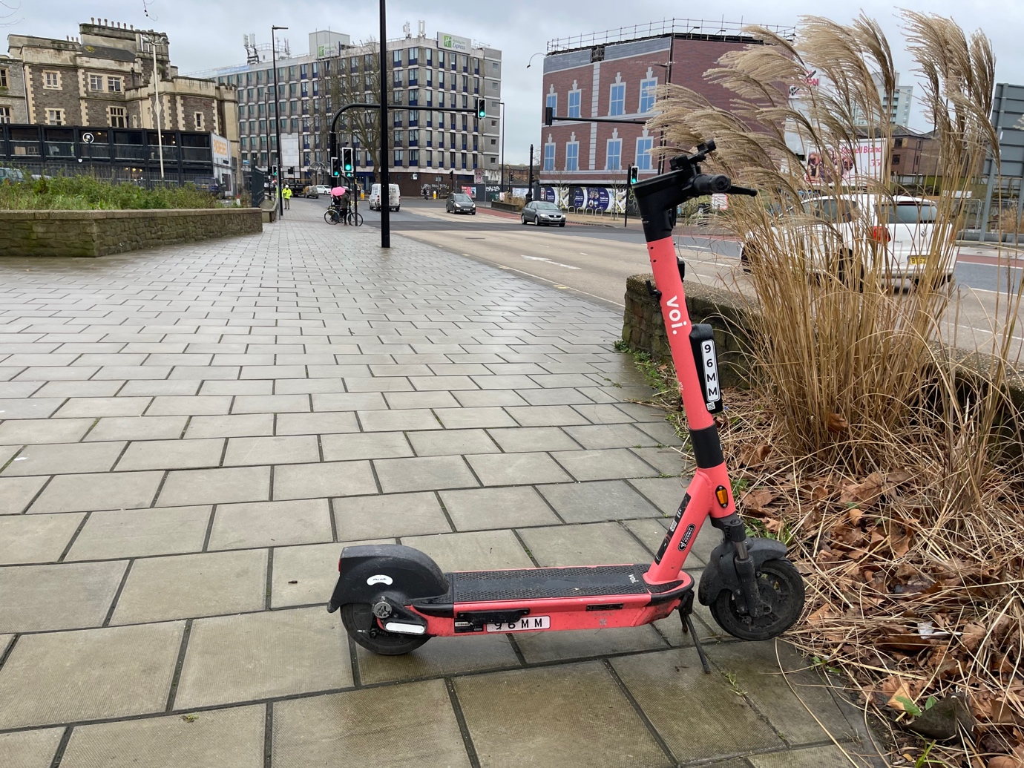
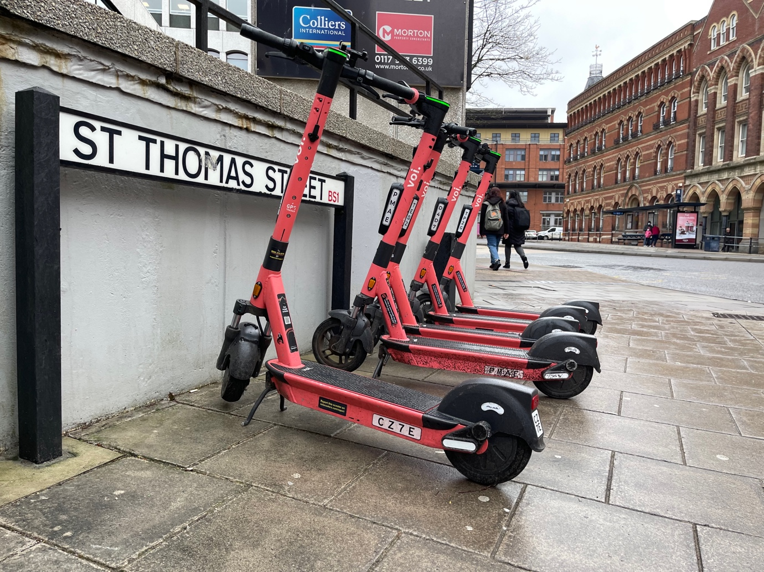

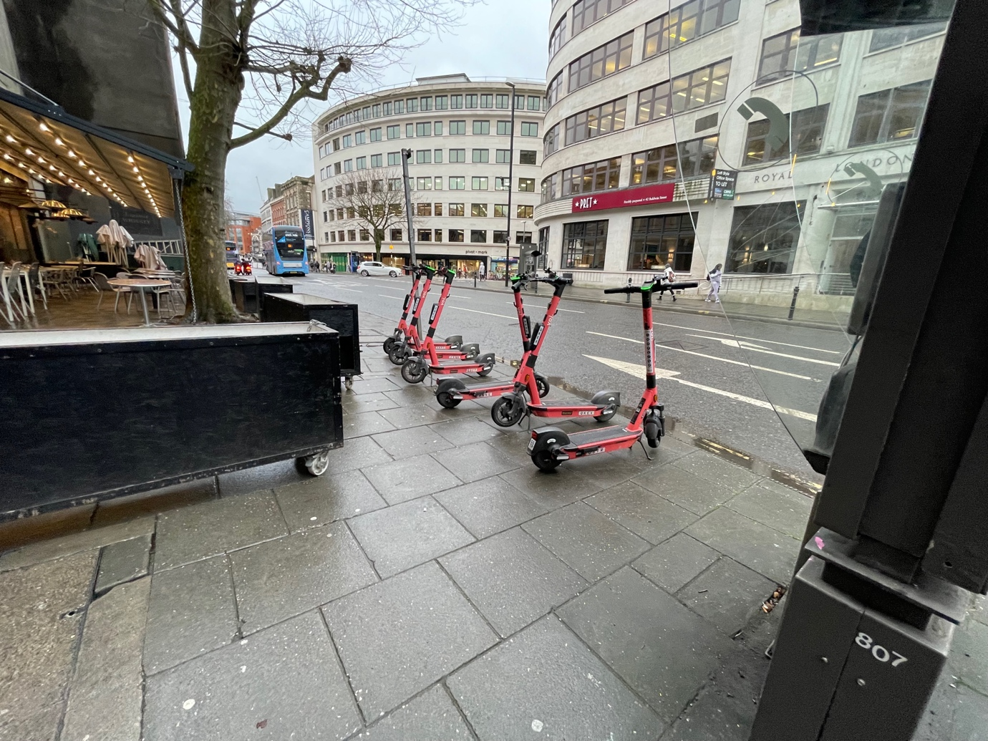
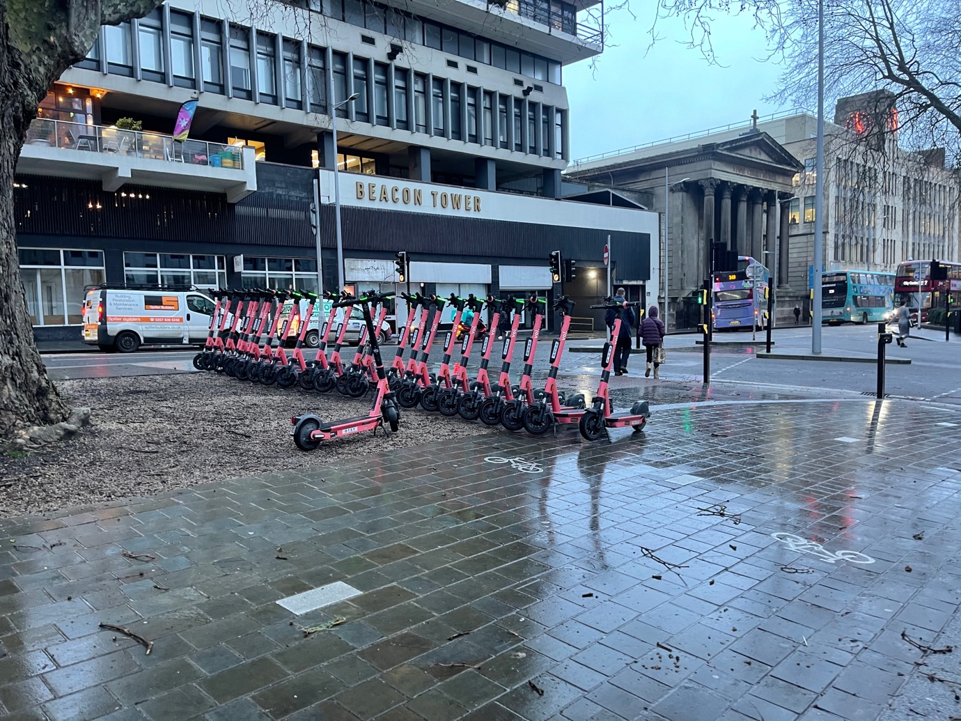

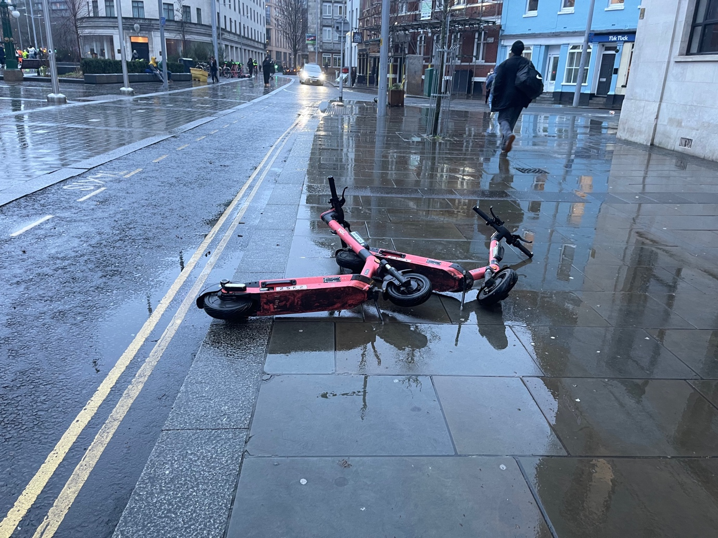
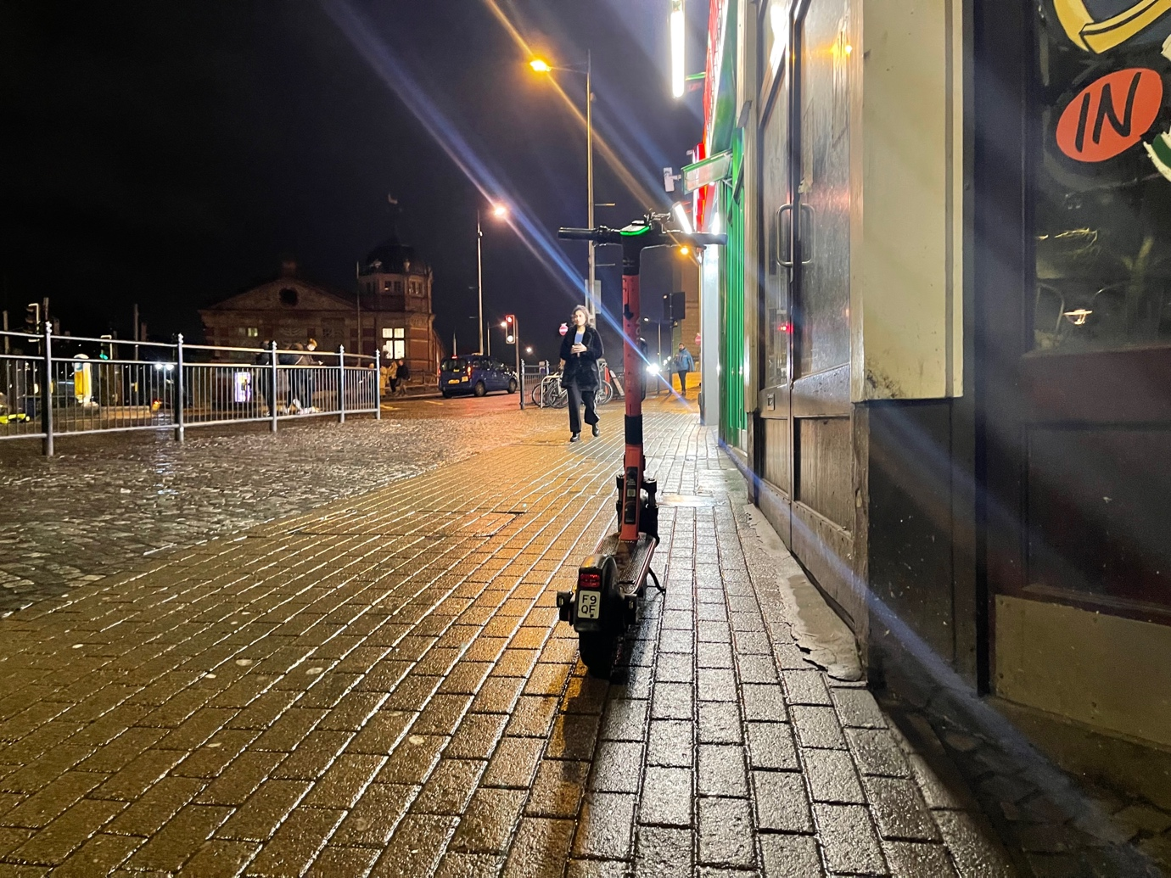

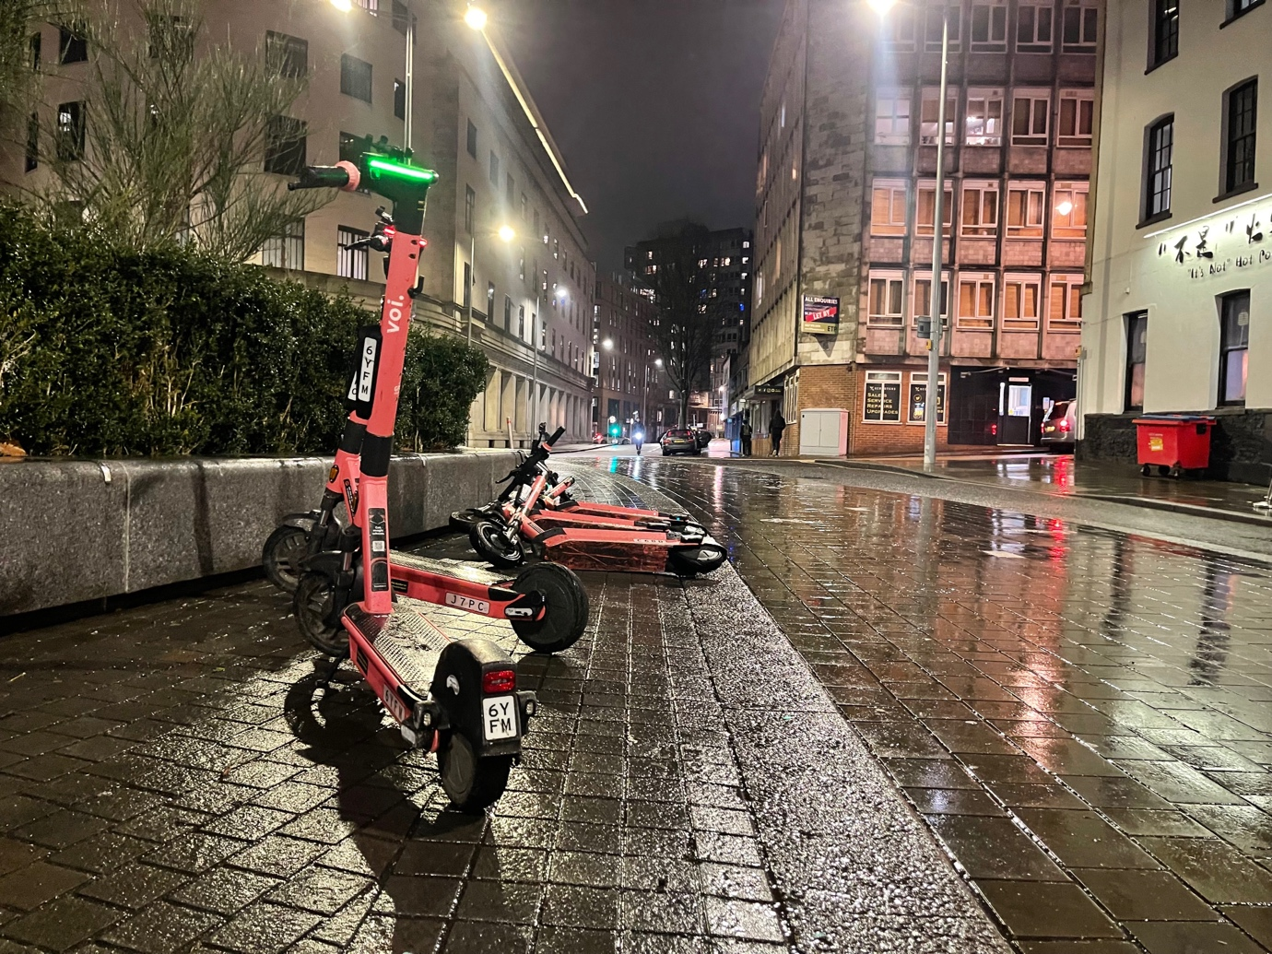
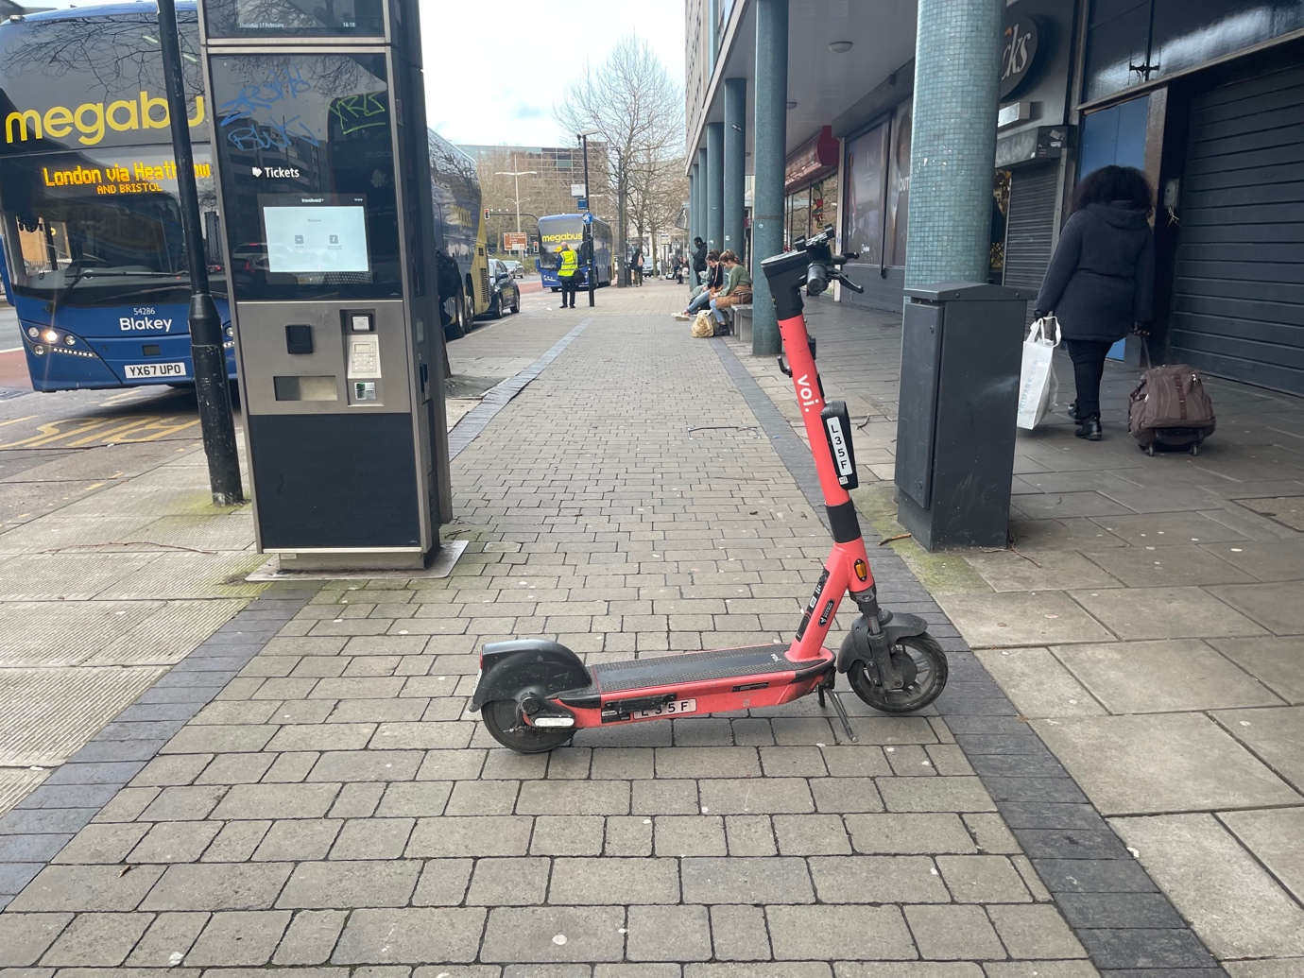

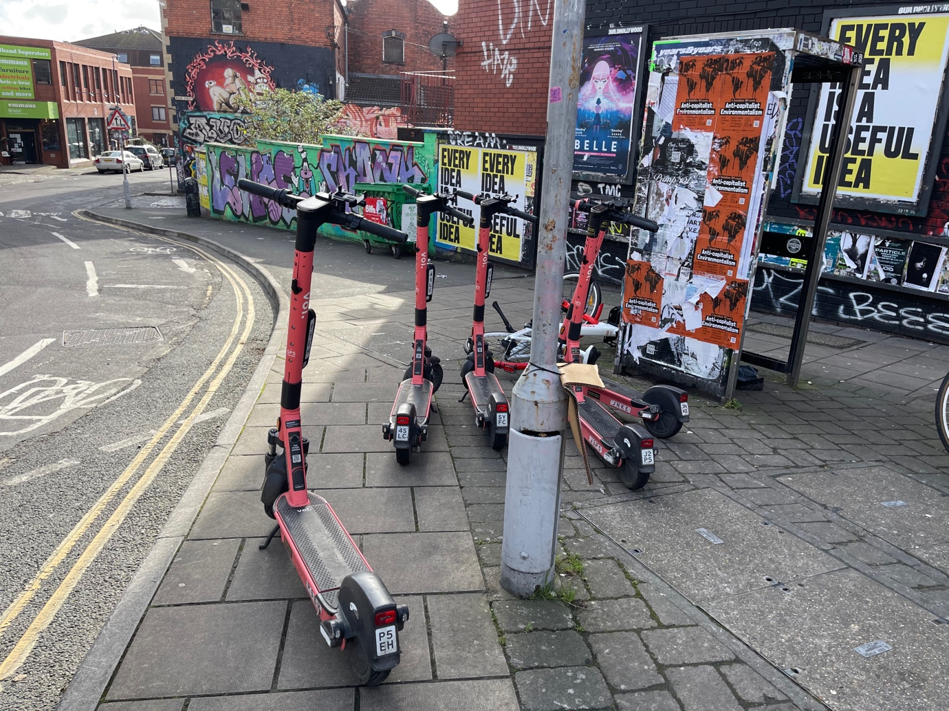
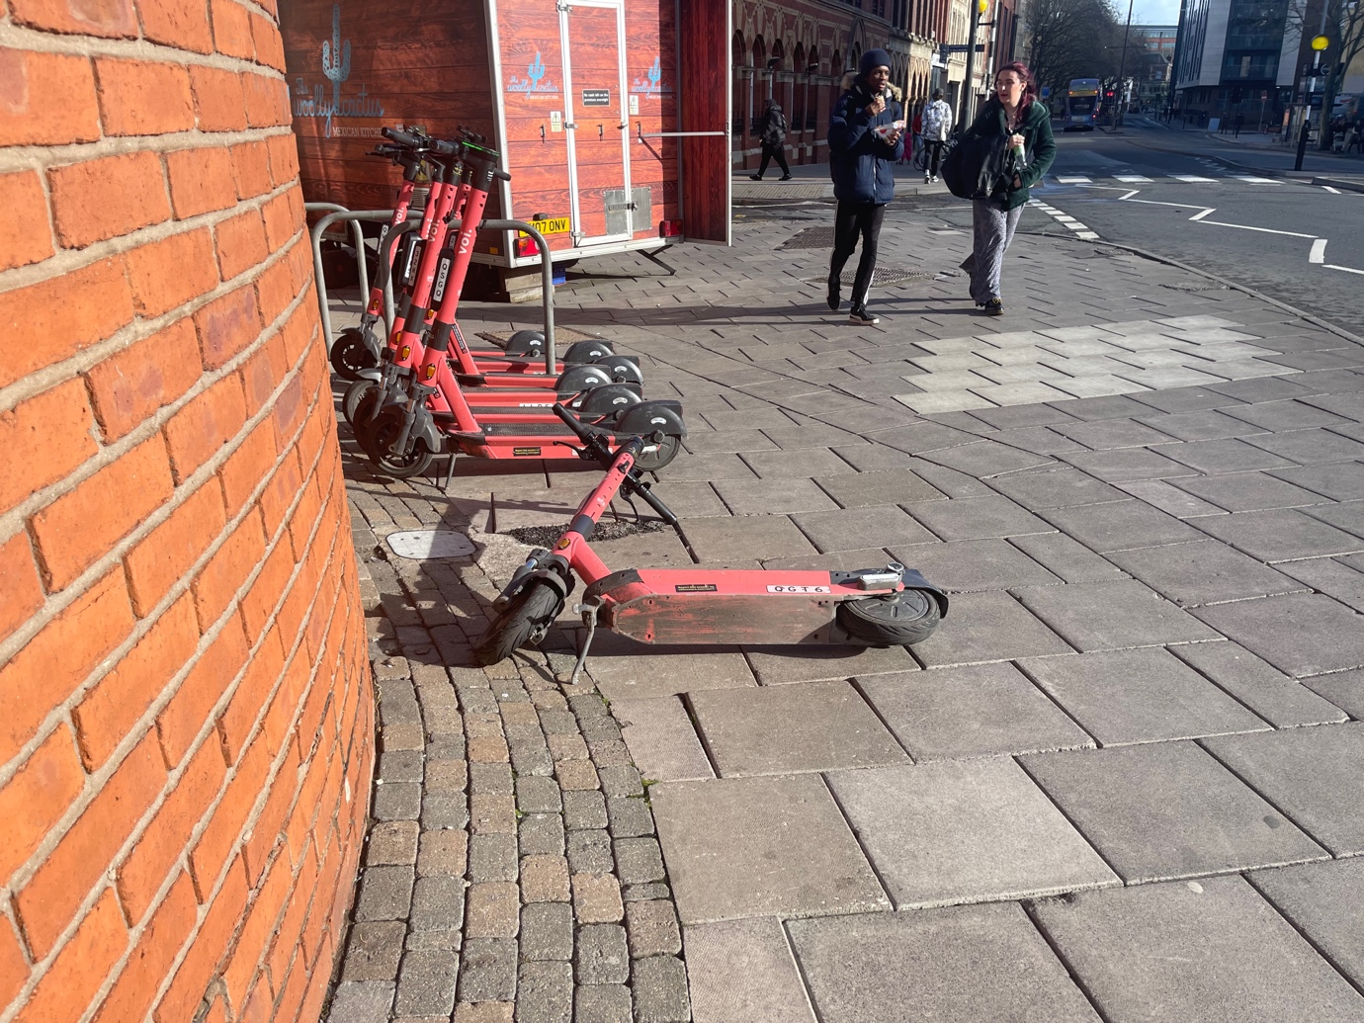

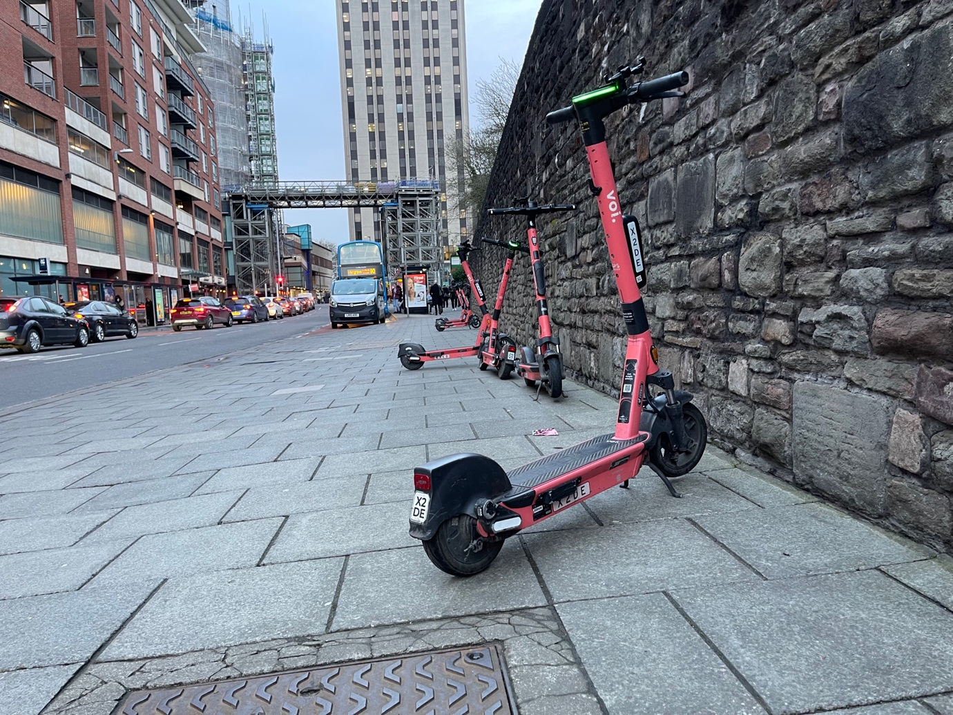
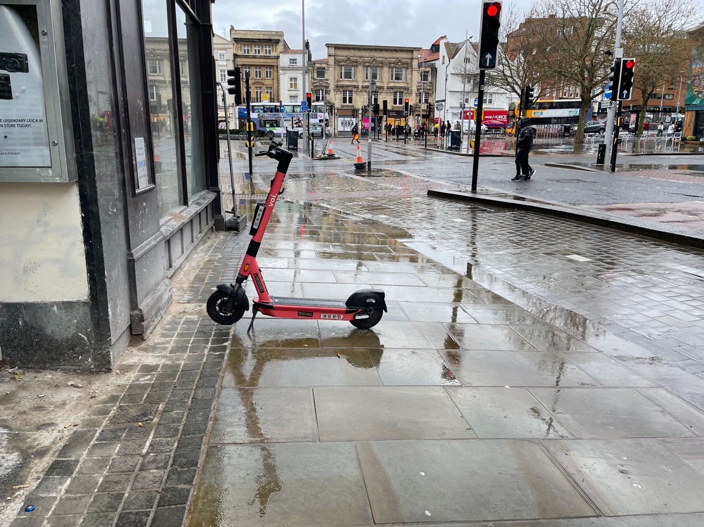

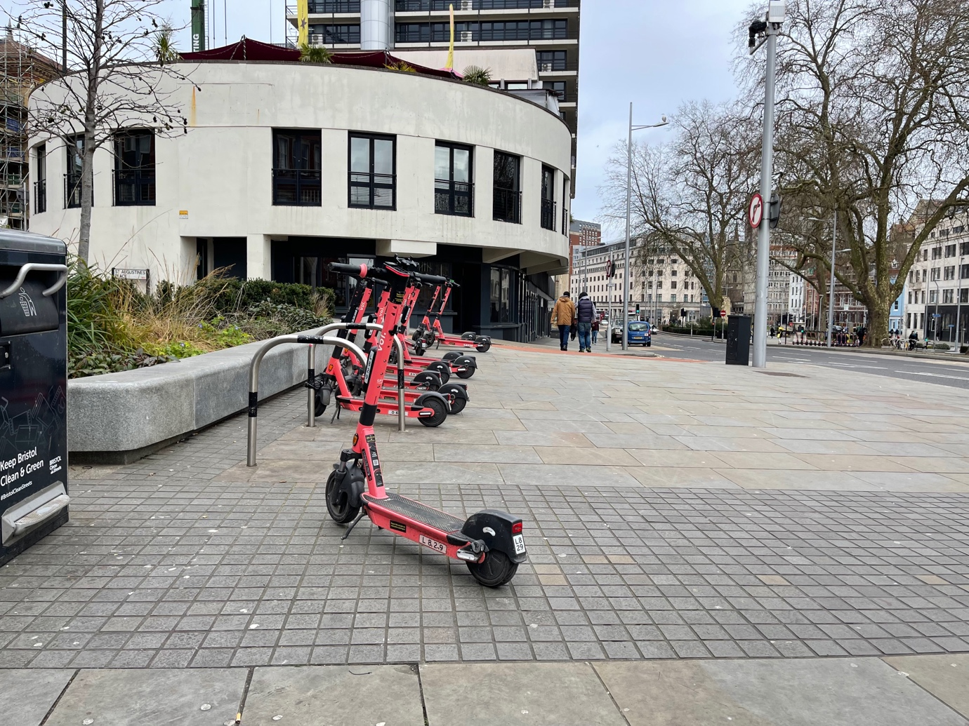
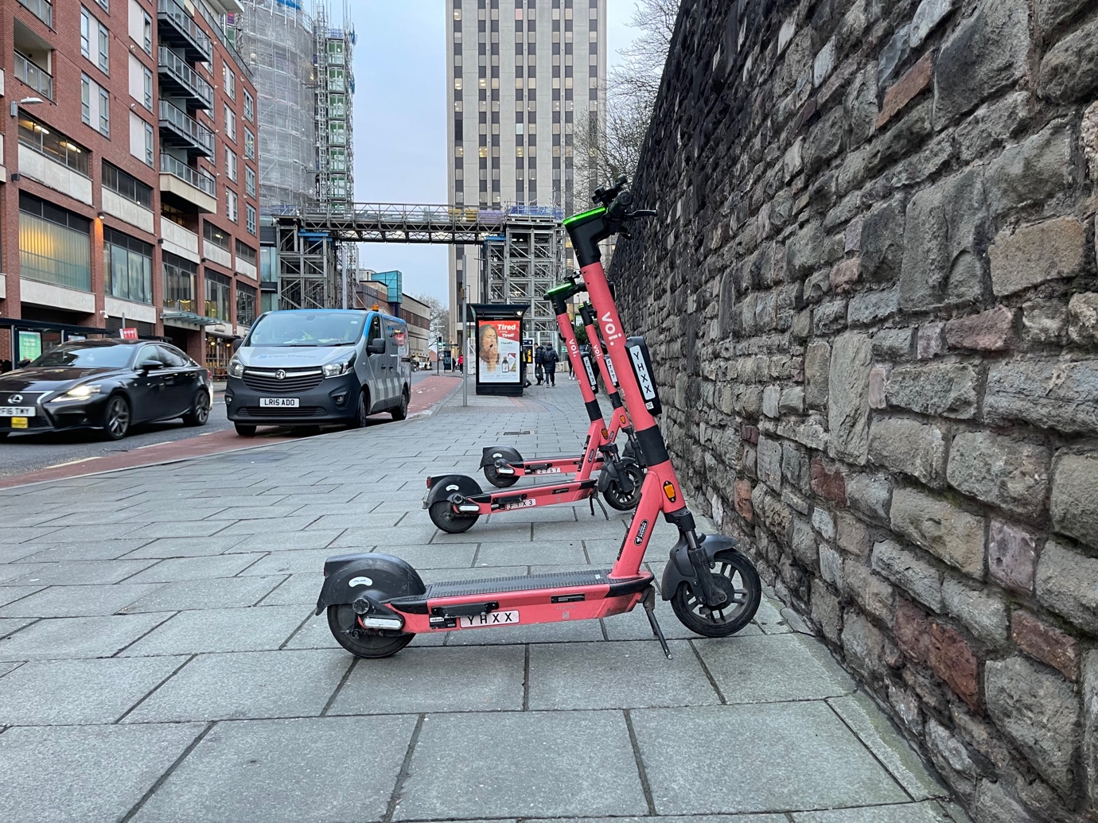

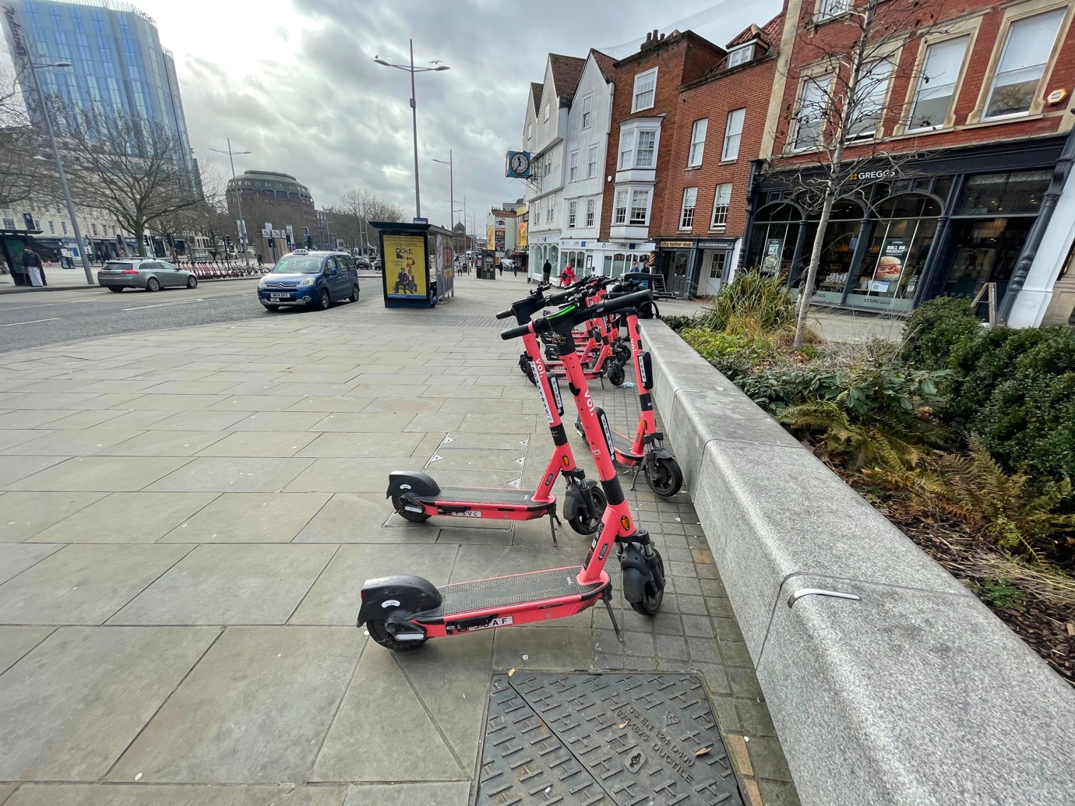

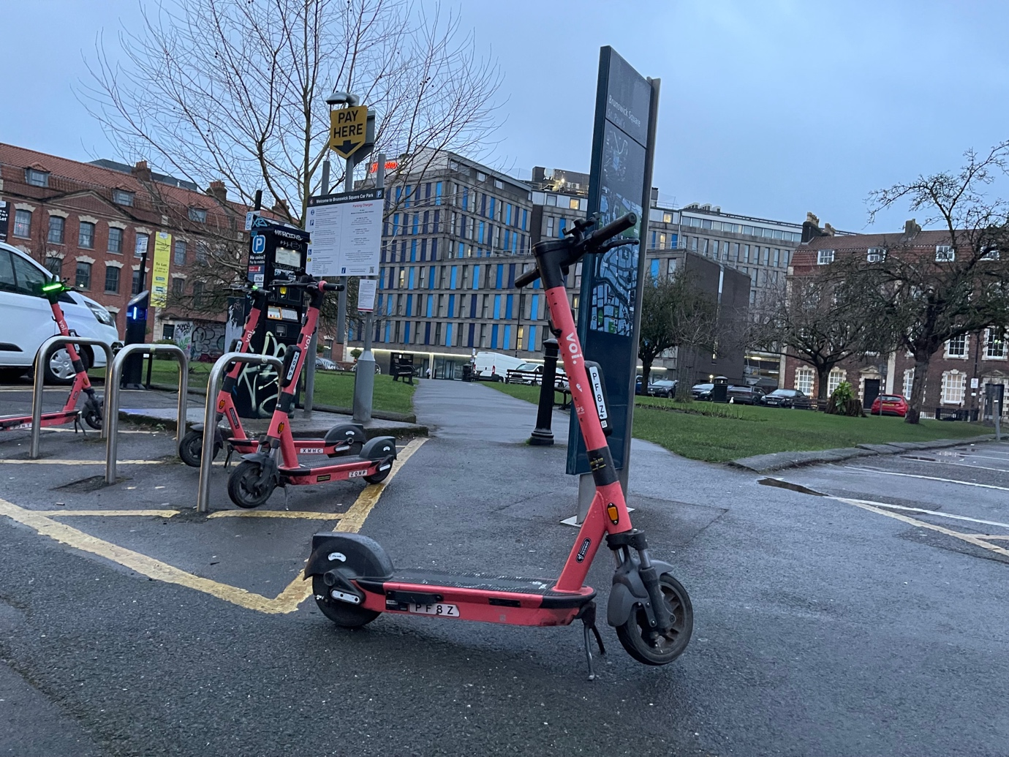

Appendix I Liverpool E-scooter Trial Voi E-Scooters 25 August 2021

A number of the e-scooters witnessed where found to be unsafe with worn out tread on the tyres and cracks in the tyres. E-scooters found left on parked up on pavements, taking pedestrian space, and even if they were put neatly they were still a trip hazard. Other scooters were found lying on the pavement, causing trip hazards and obstructions for pedestrians. It was clear the e-scooters had not been maintained properly and the trial was not safe.

E-scooters were witnessed being ridden dangerously on pavements, with double riding and adults riding them with children.

This was not a safe trial, vulnerable children were being put at risk from parents riding the e-scooters with them and pedestrians had to ensure the dangerous riding of the users of the e-scooters.

Photos
28 photos are given below showing e-scooters left in unsafe location on the pavement, next to pedestrian crossings, next to bus stops and knocked over. Creating obstructions and trip hazards for pedestrians. The photos also show e-scooters with no tread on the tyres and splits on the sidewall of the tyre.

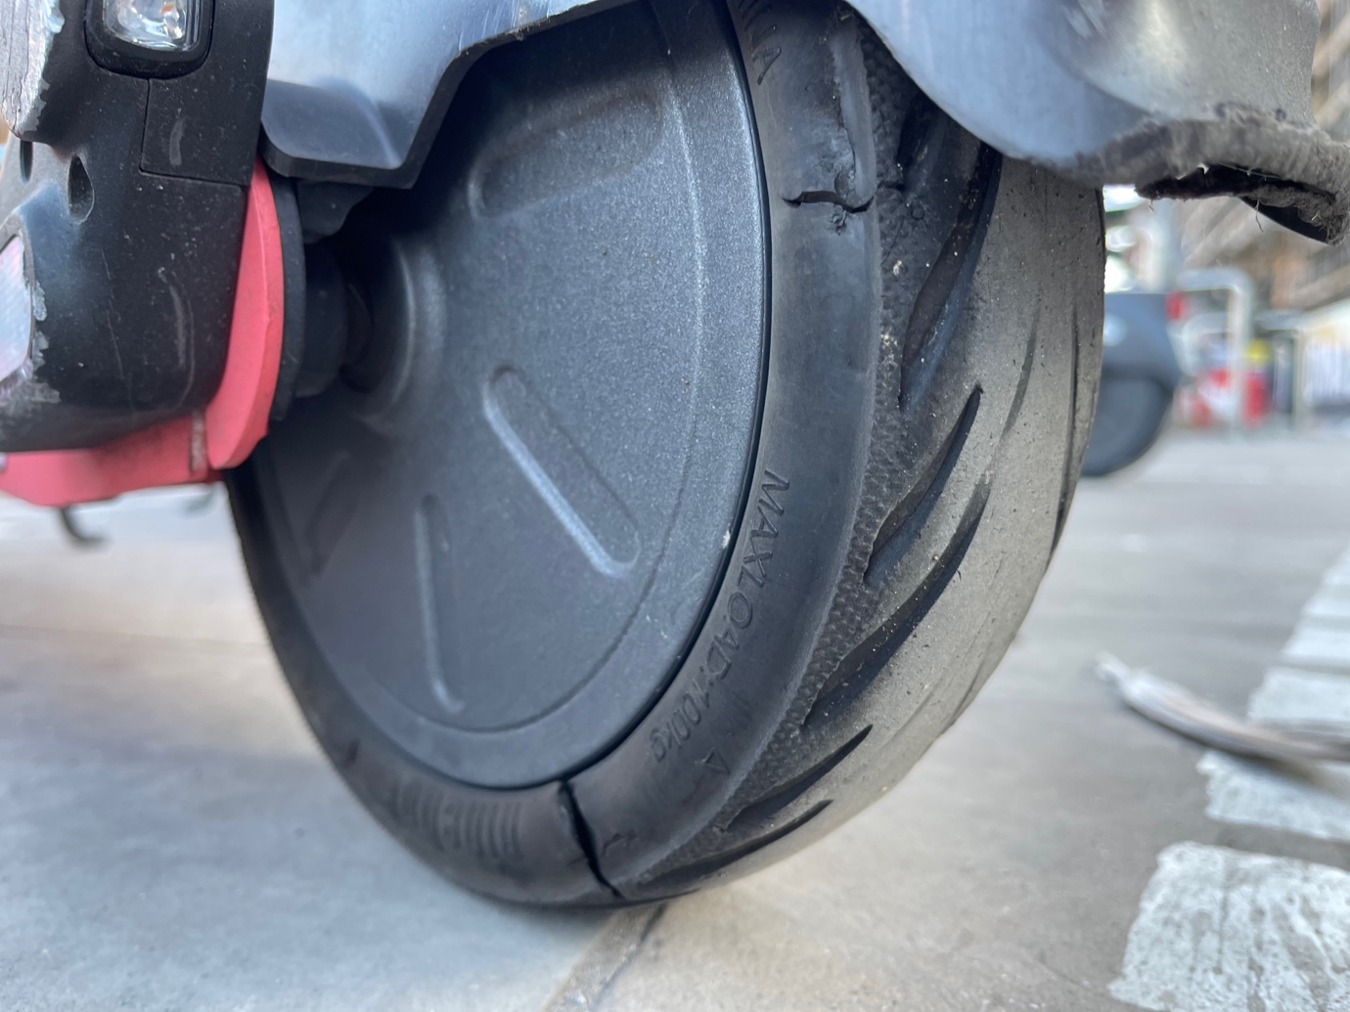
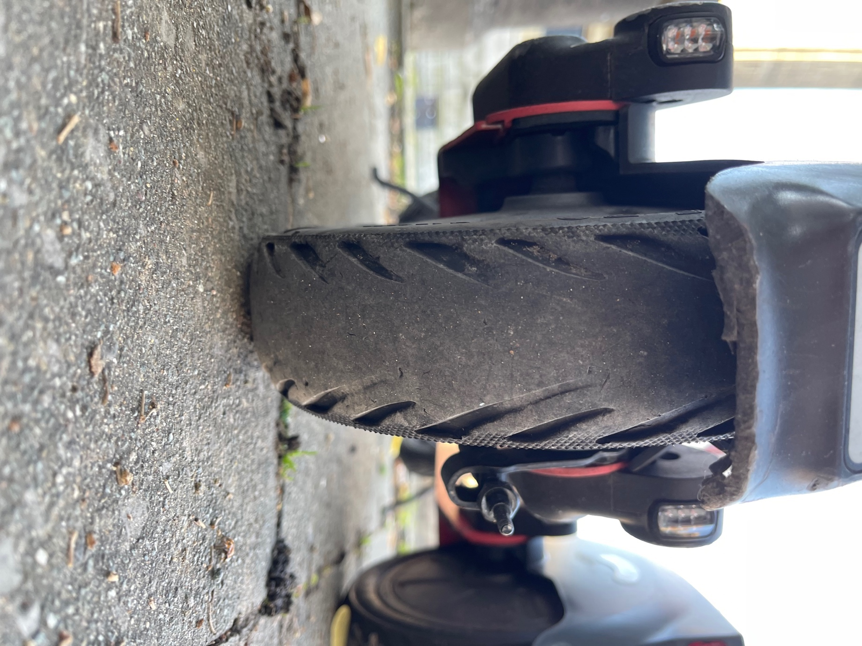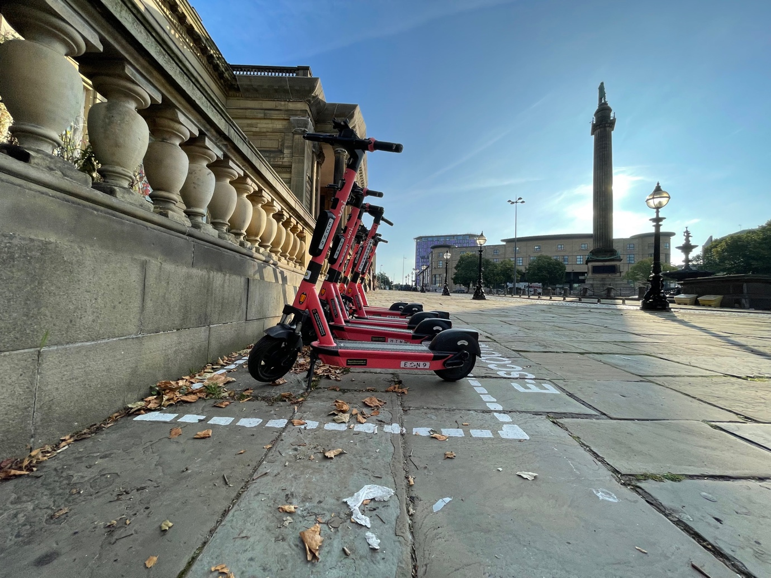

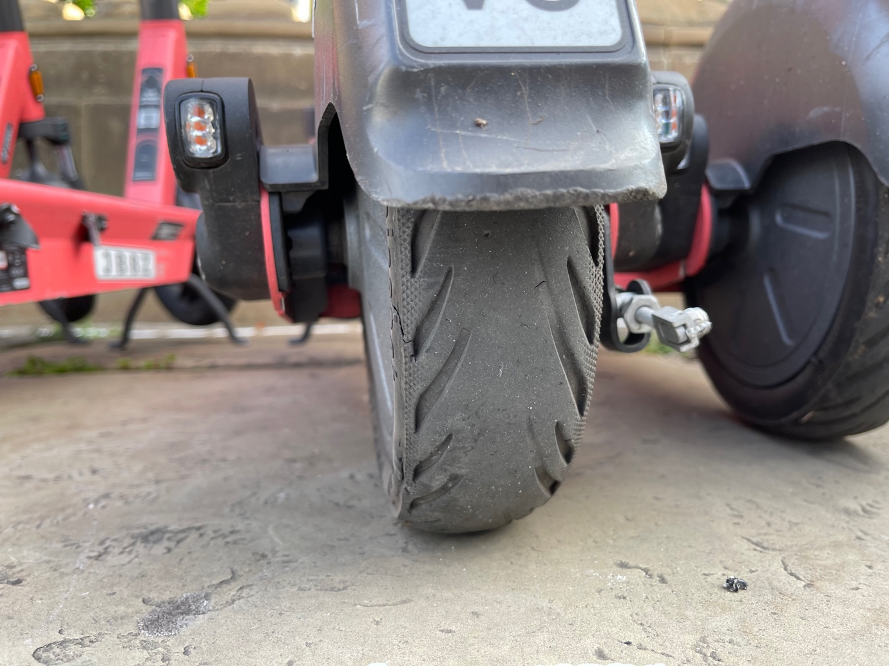
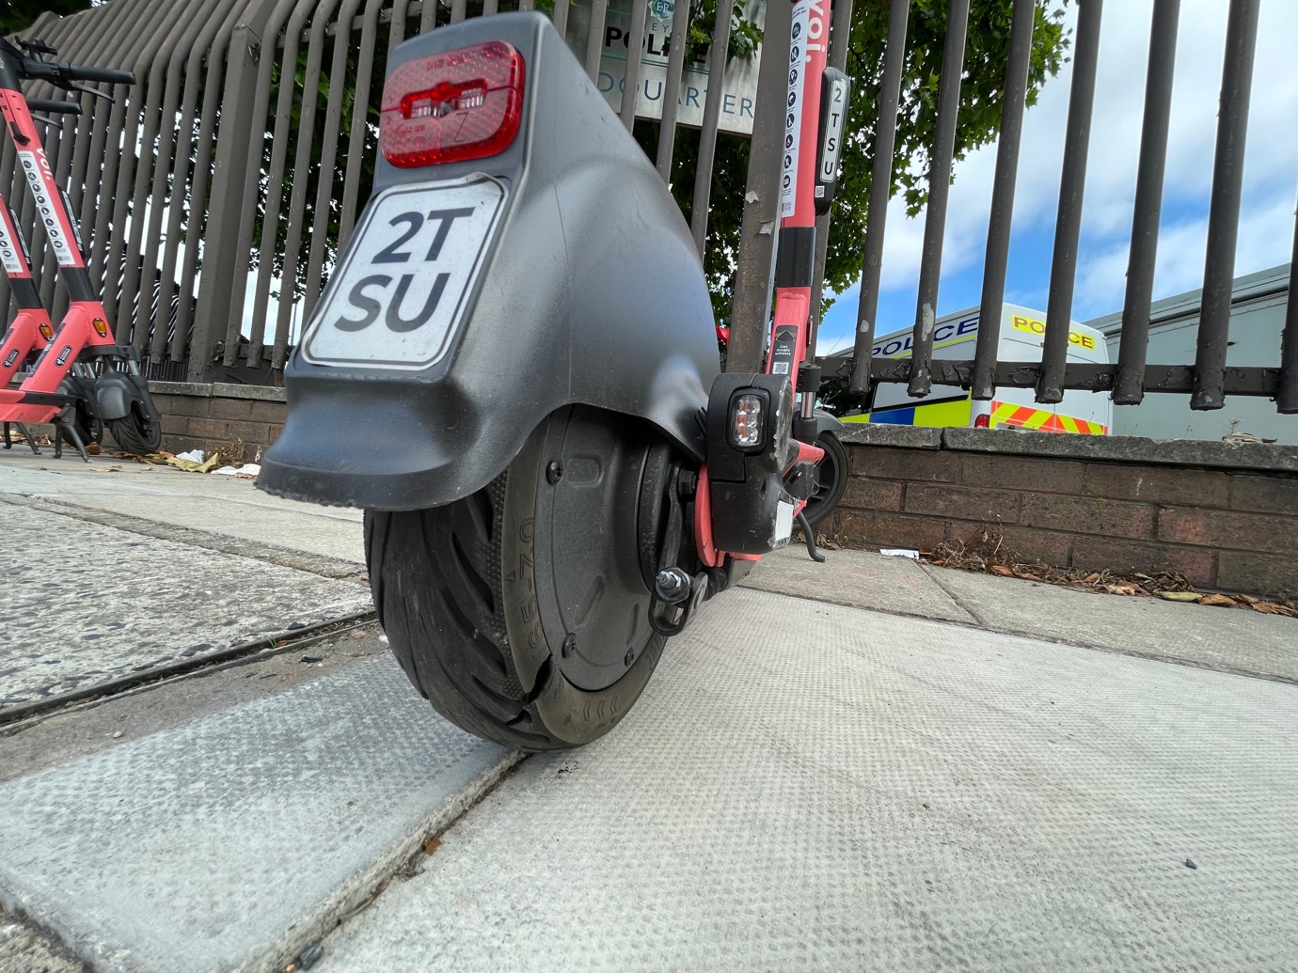

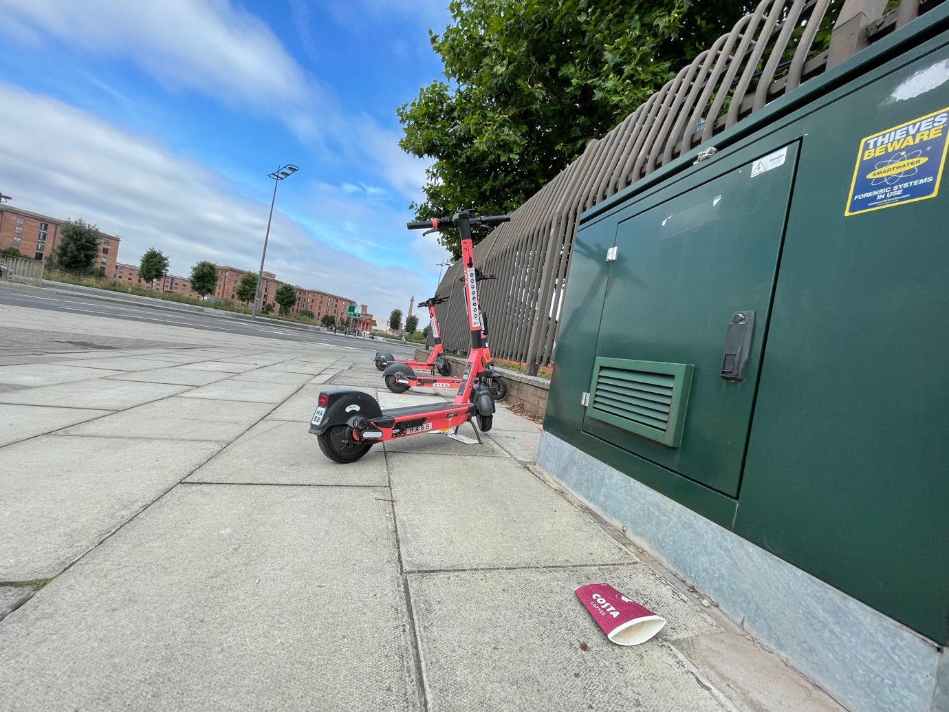
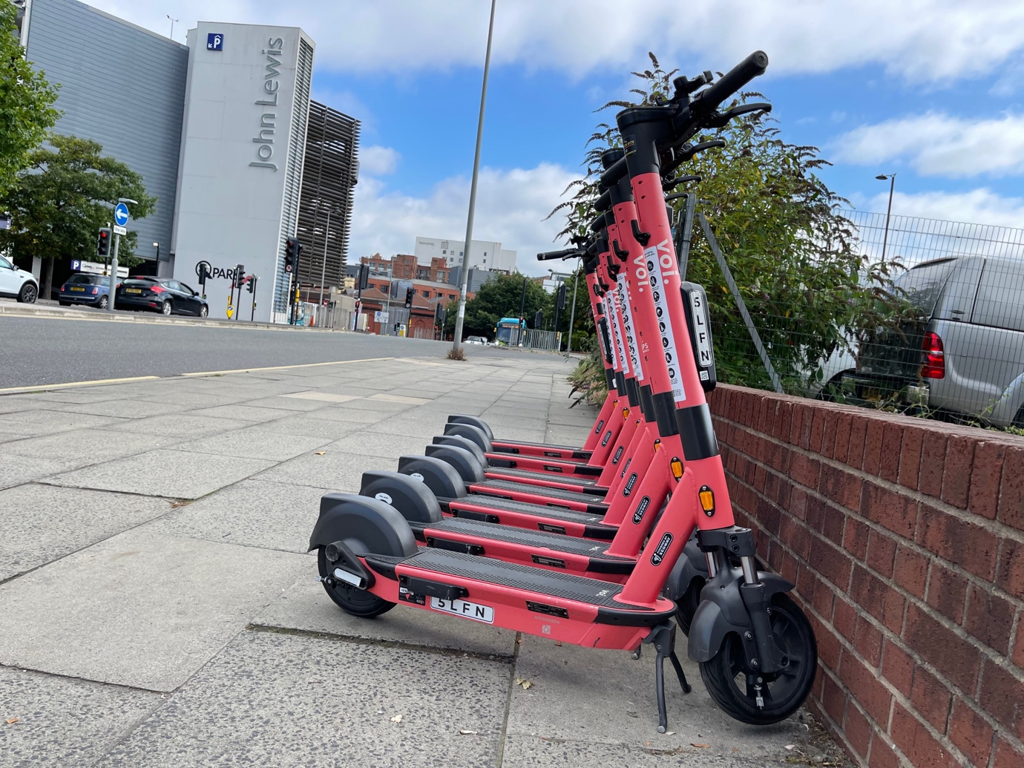

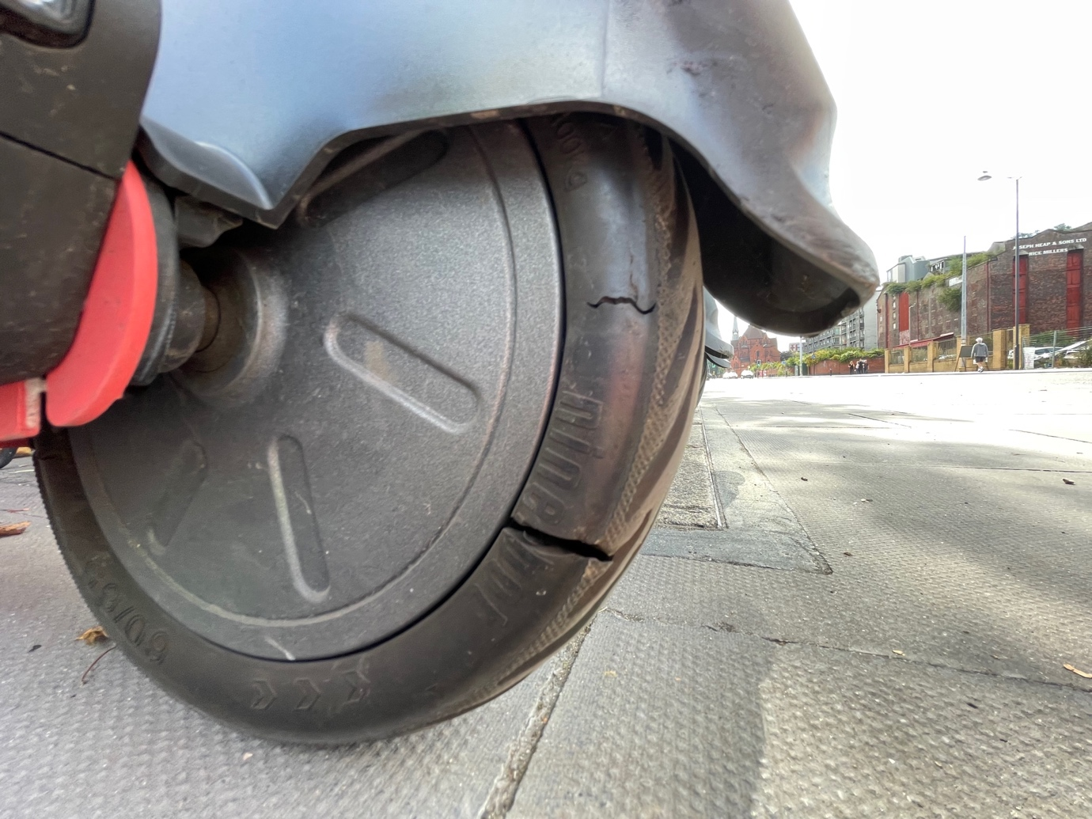
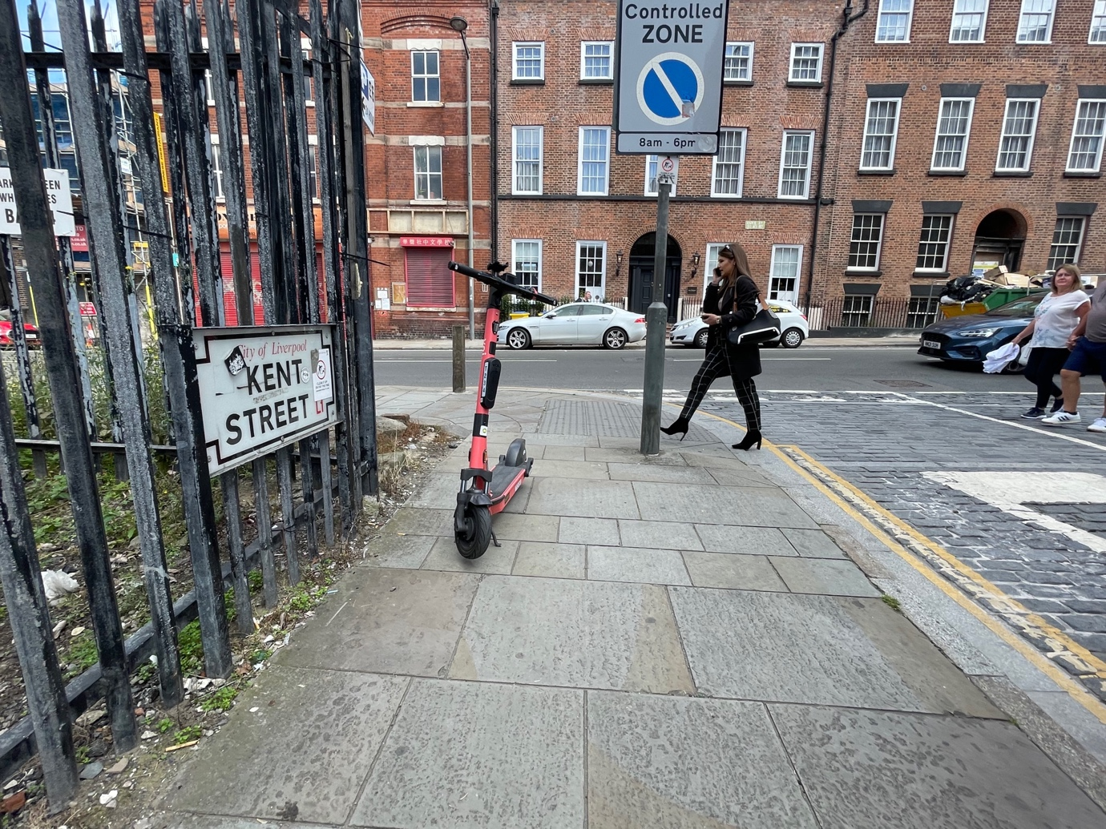

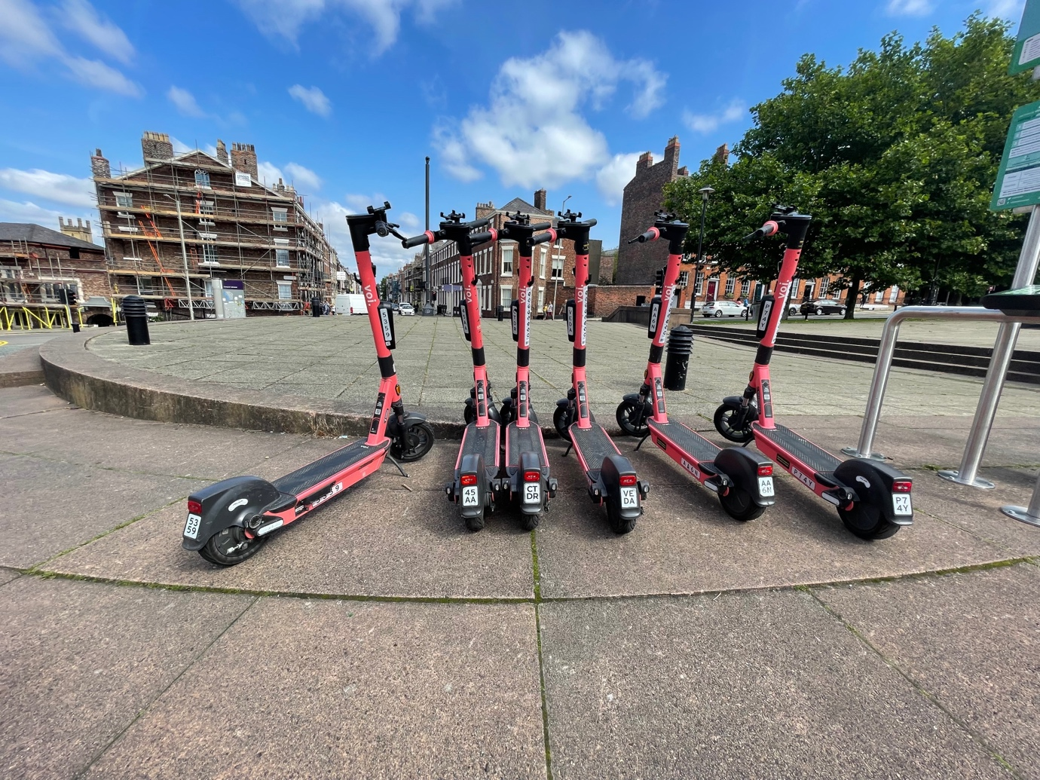
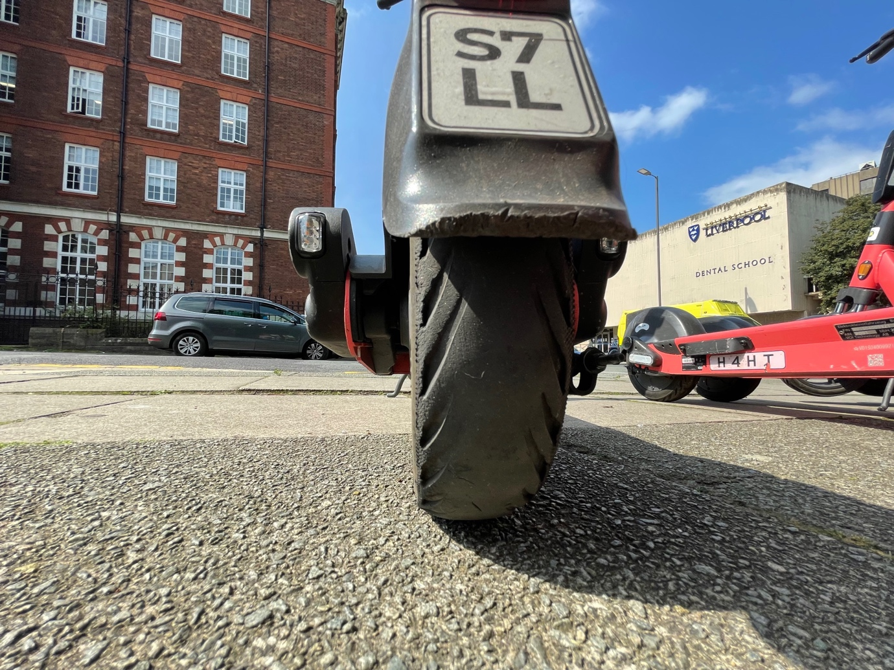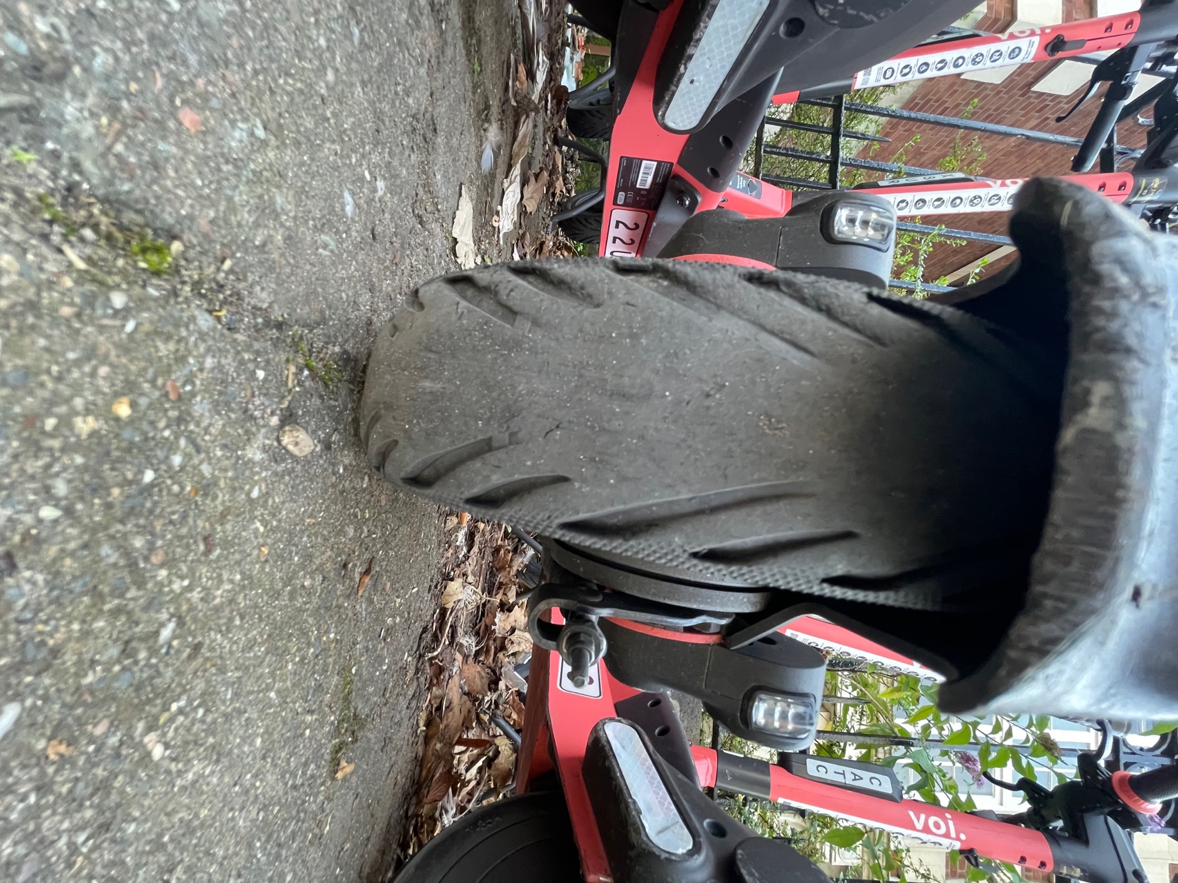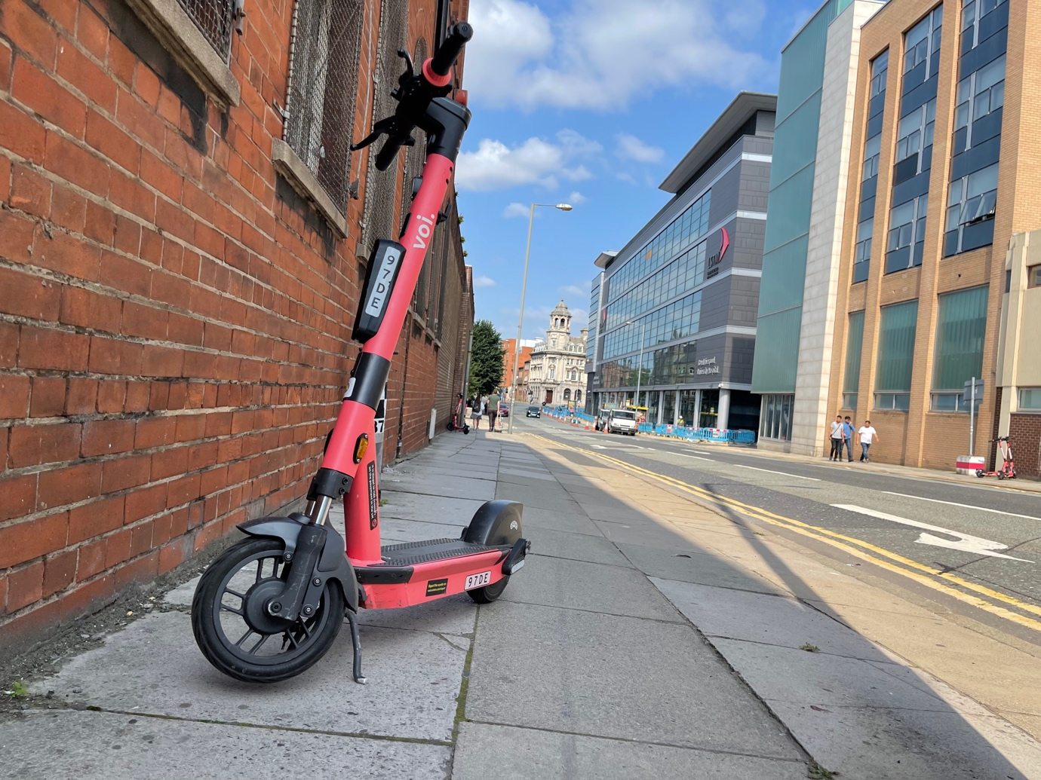

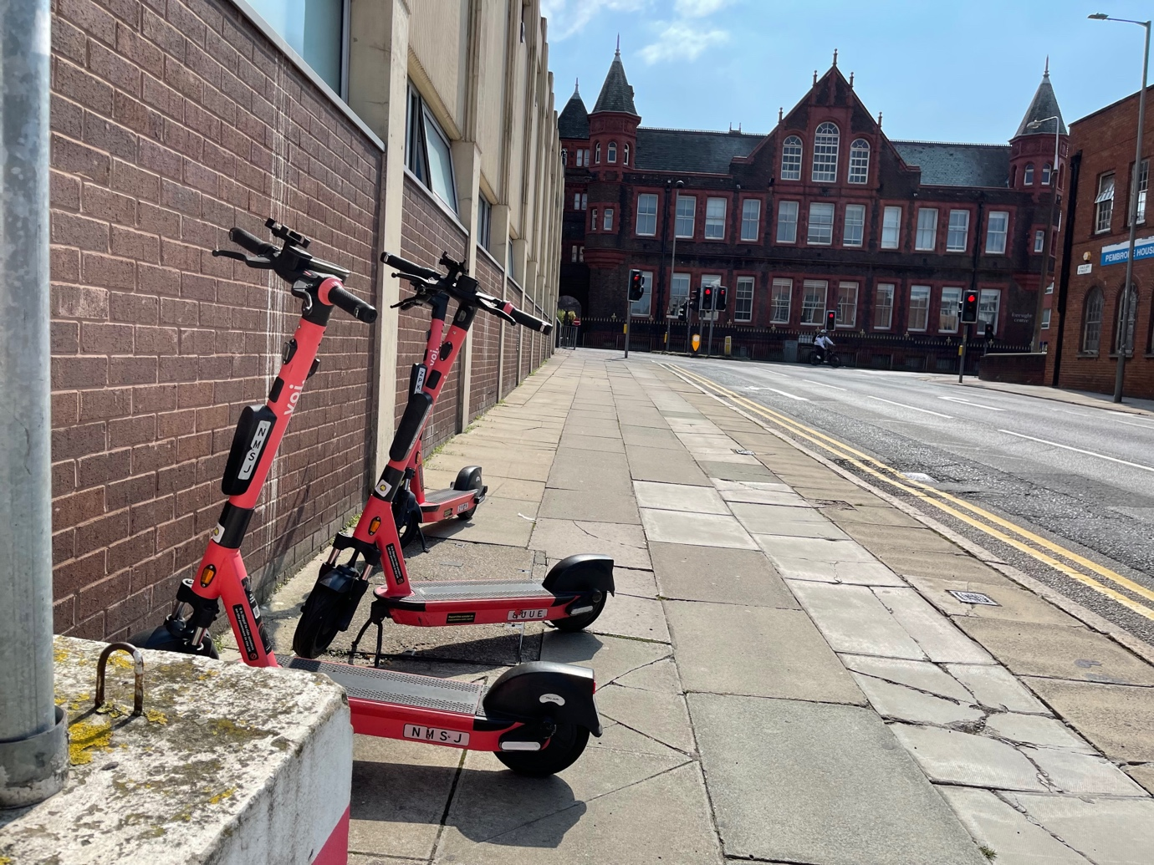
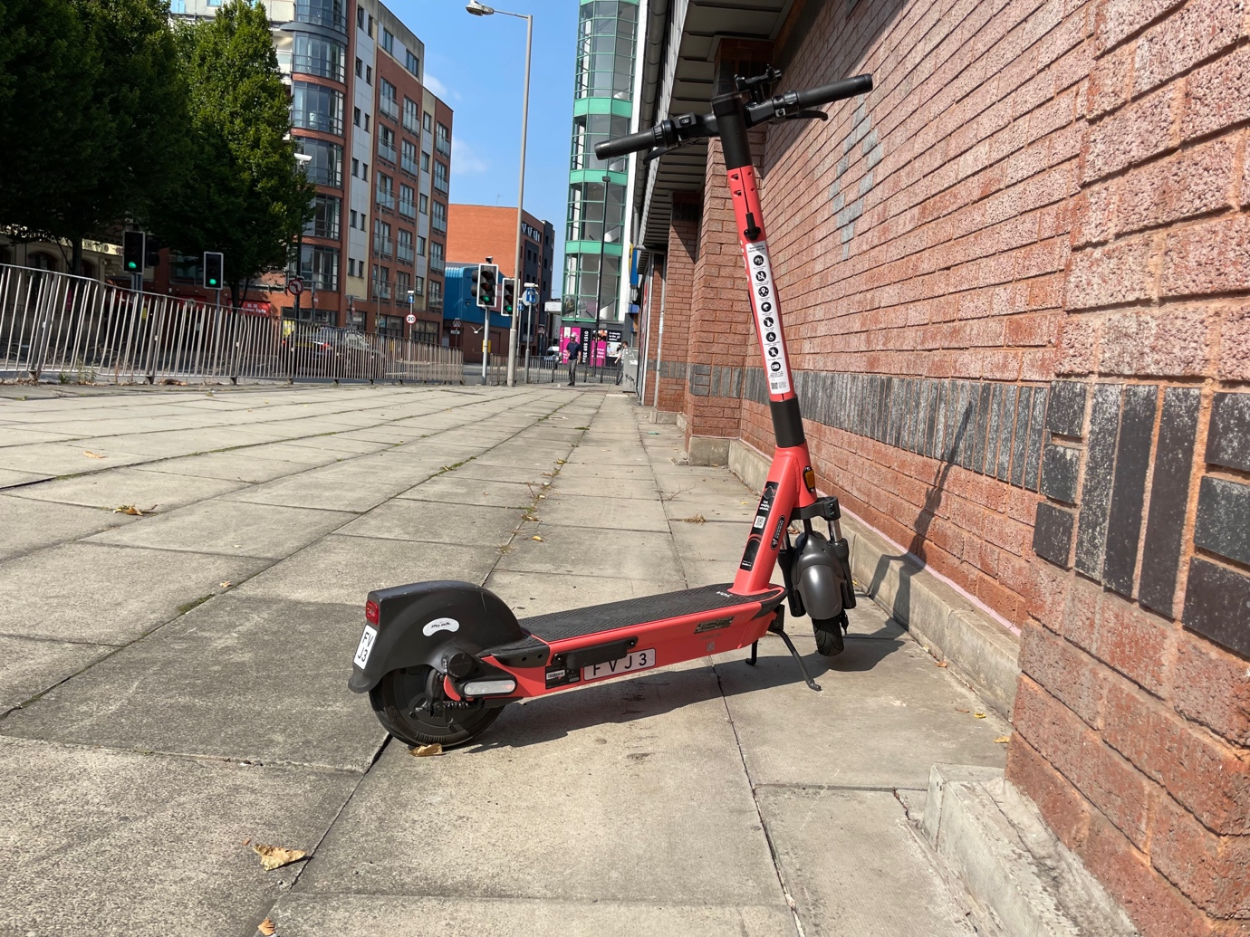

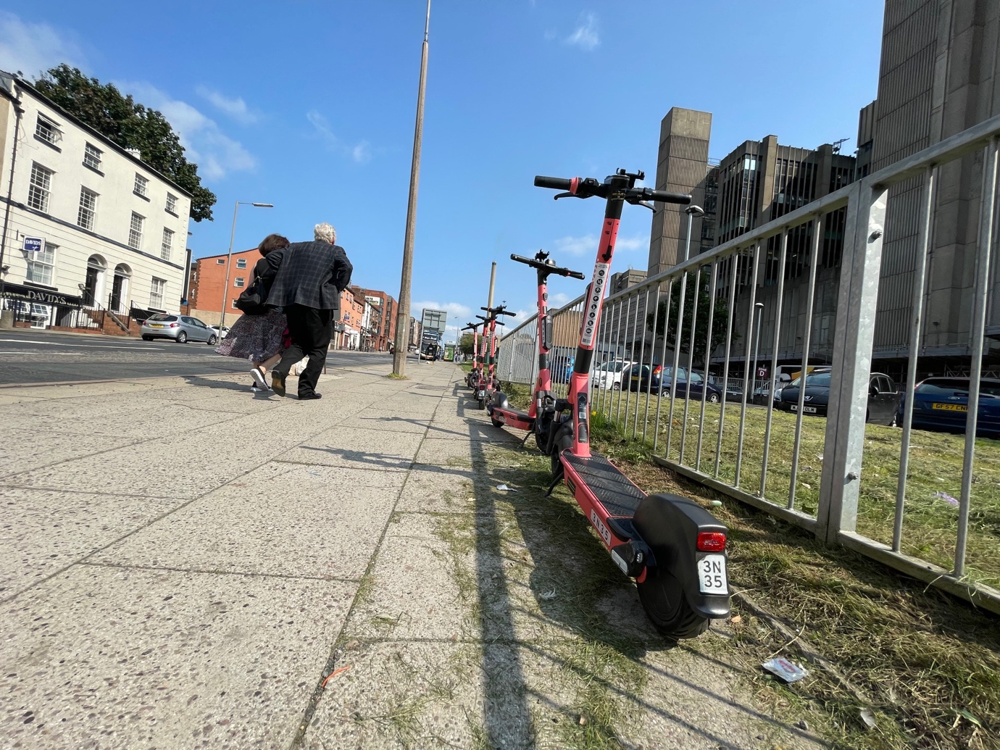
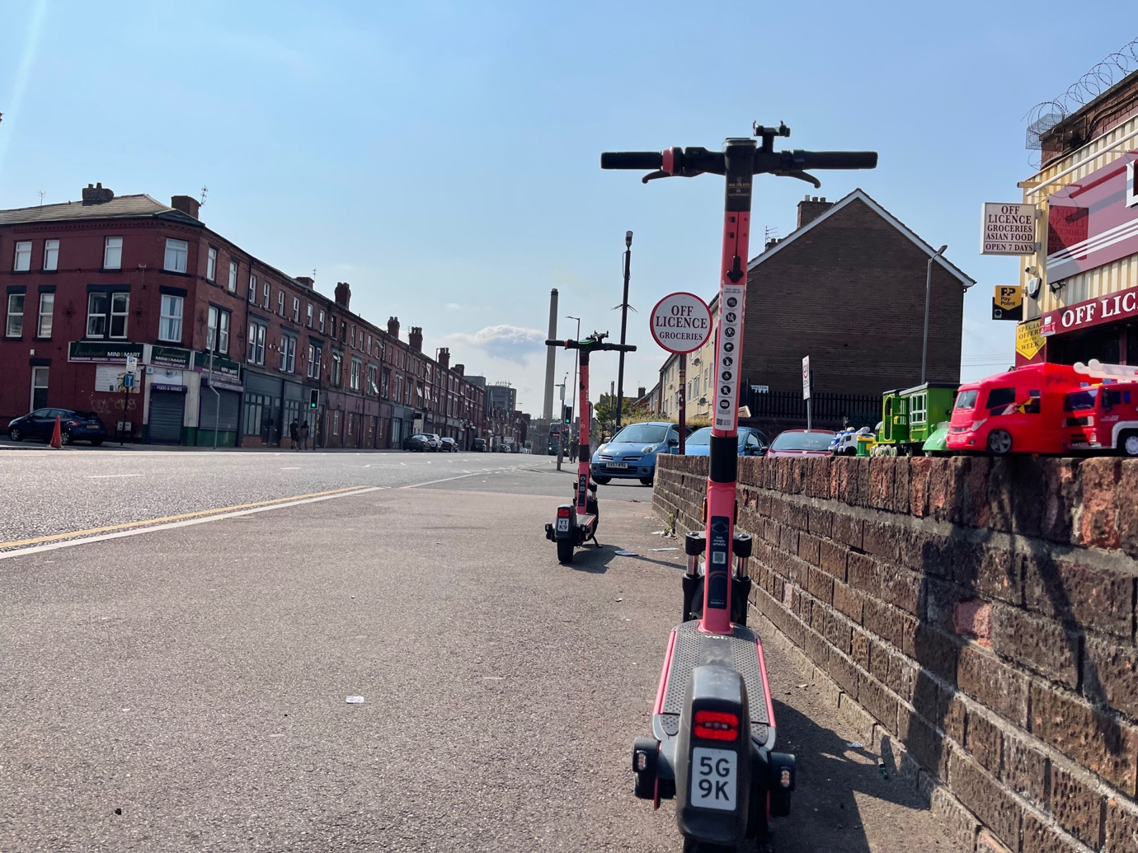

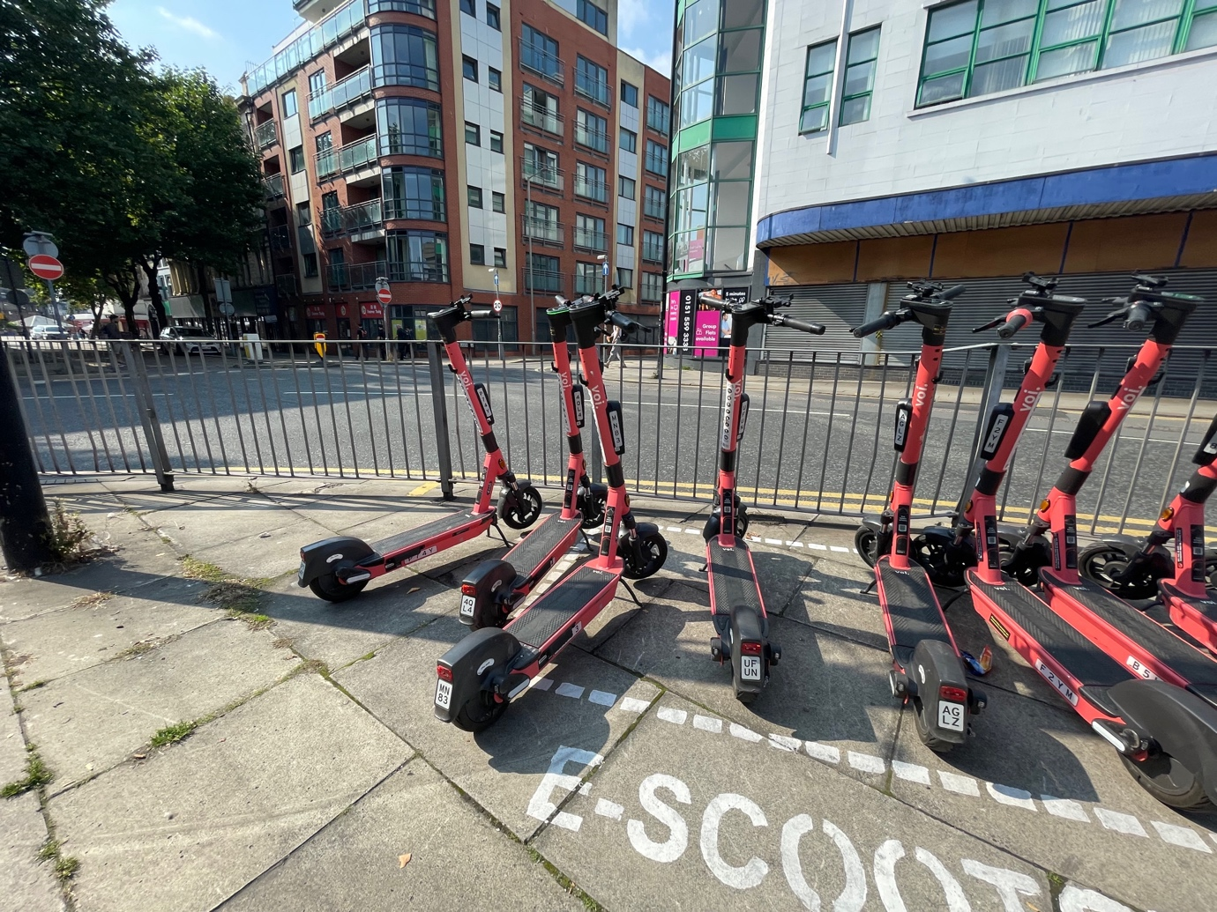
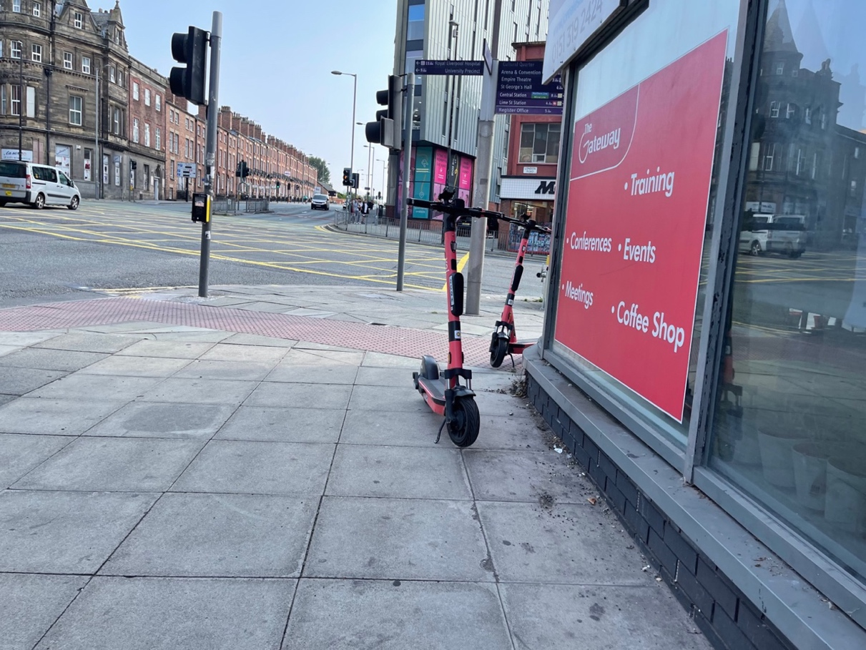

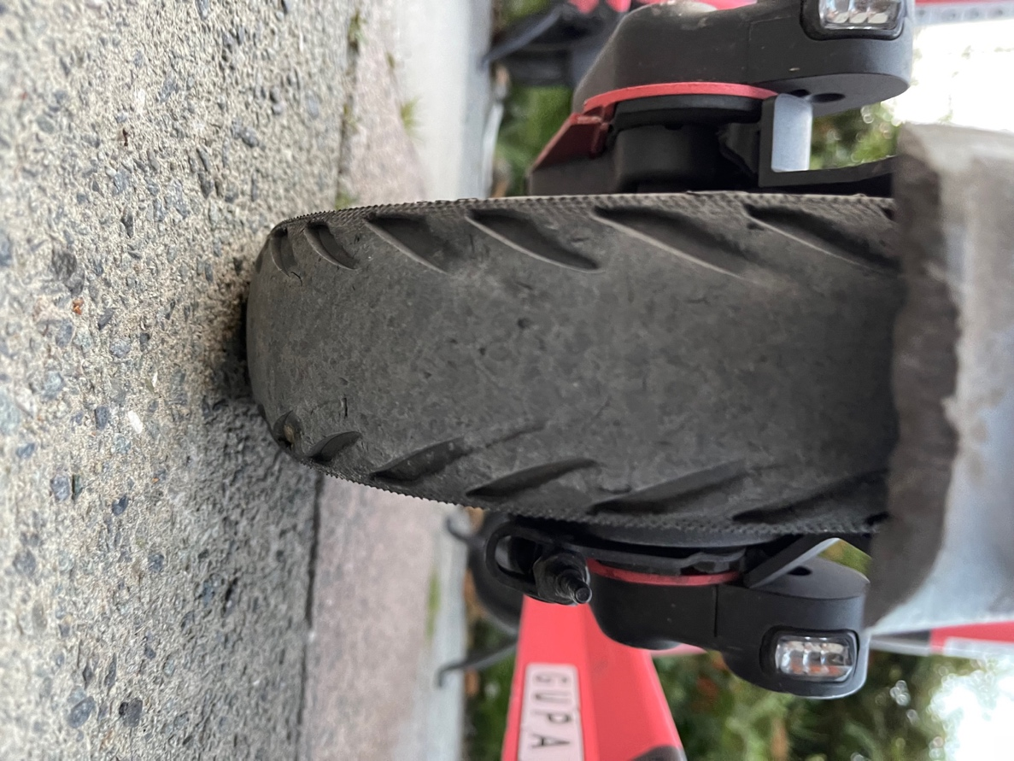
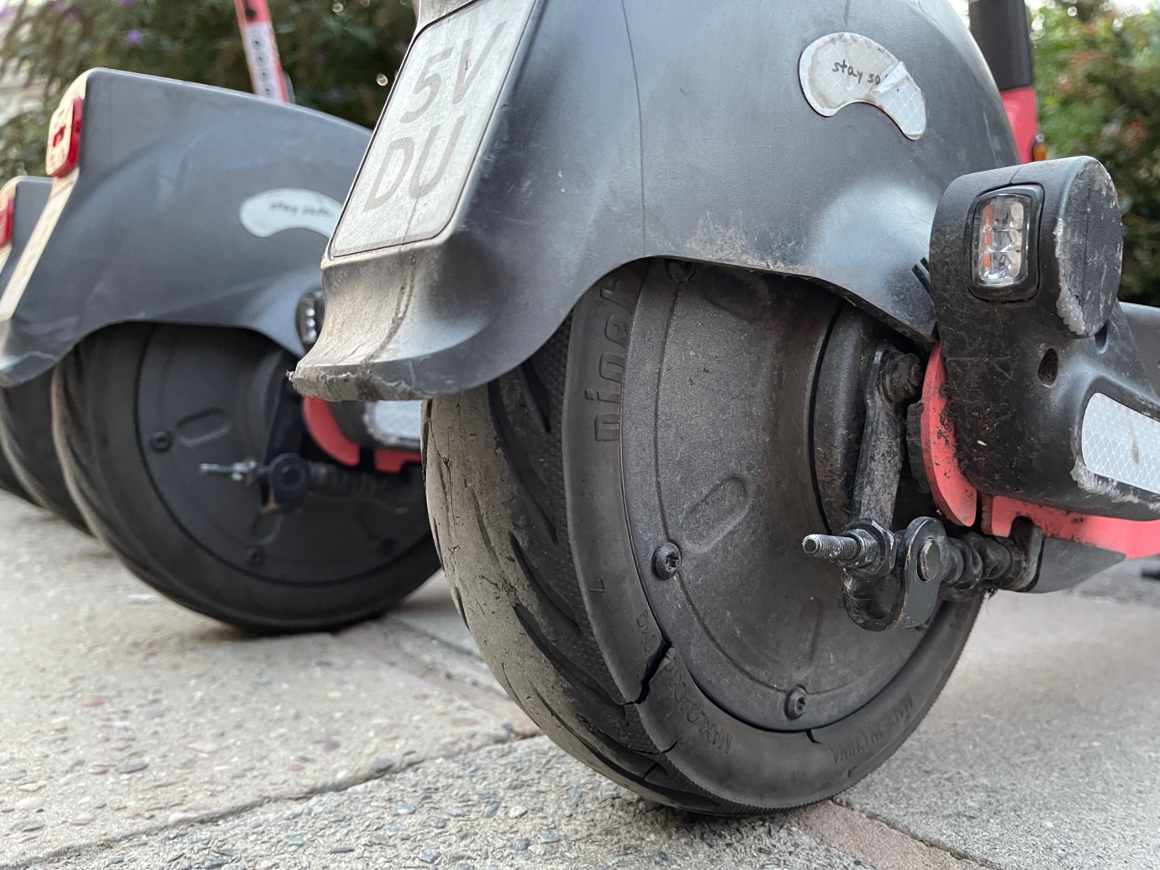

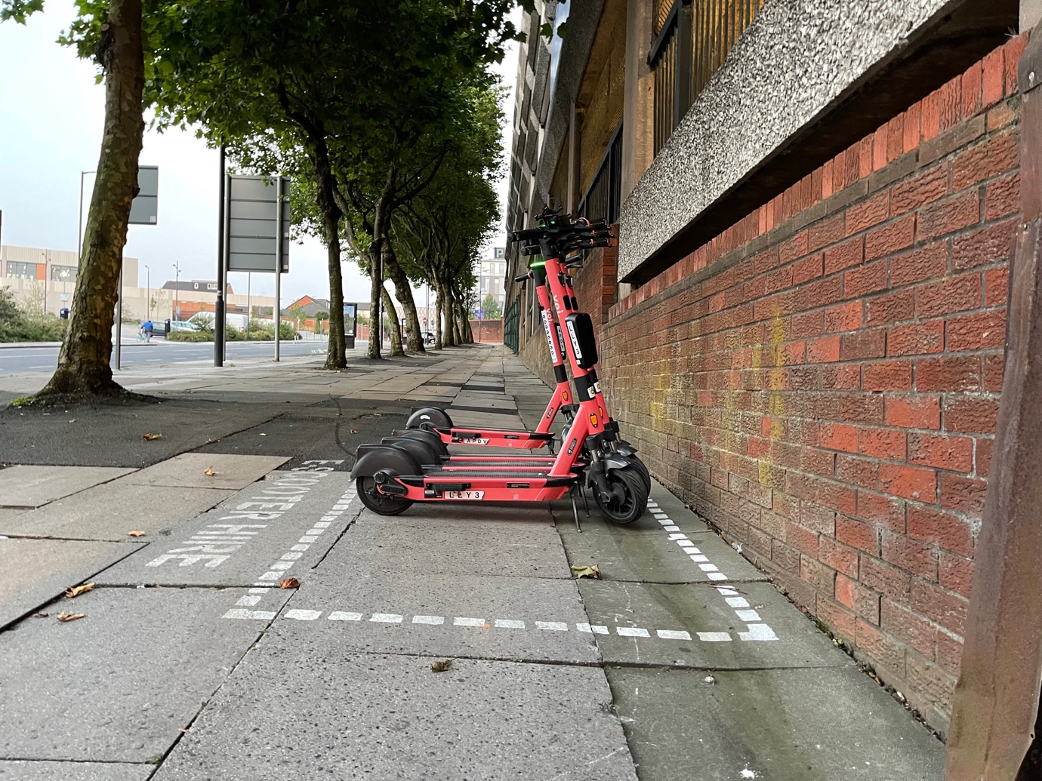
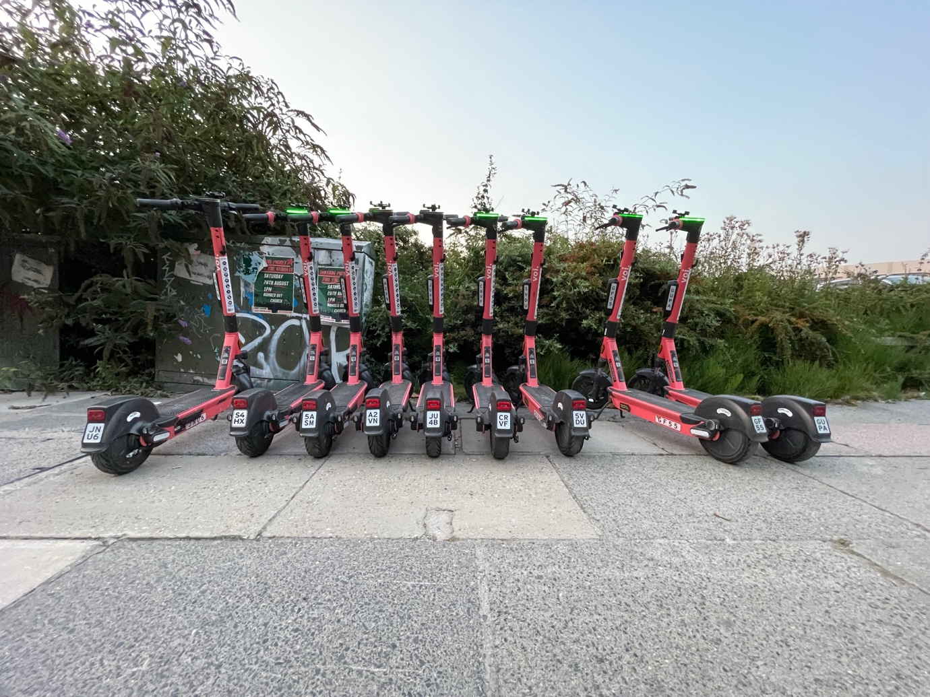

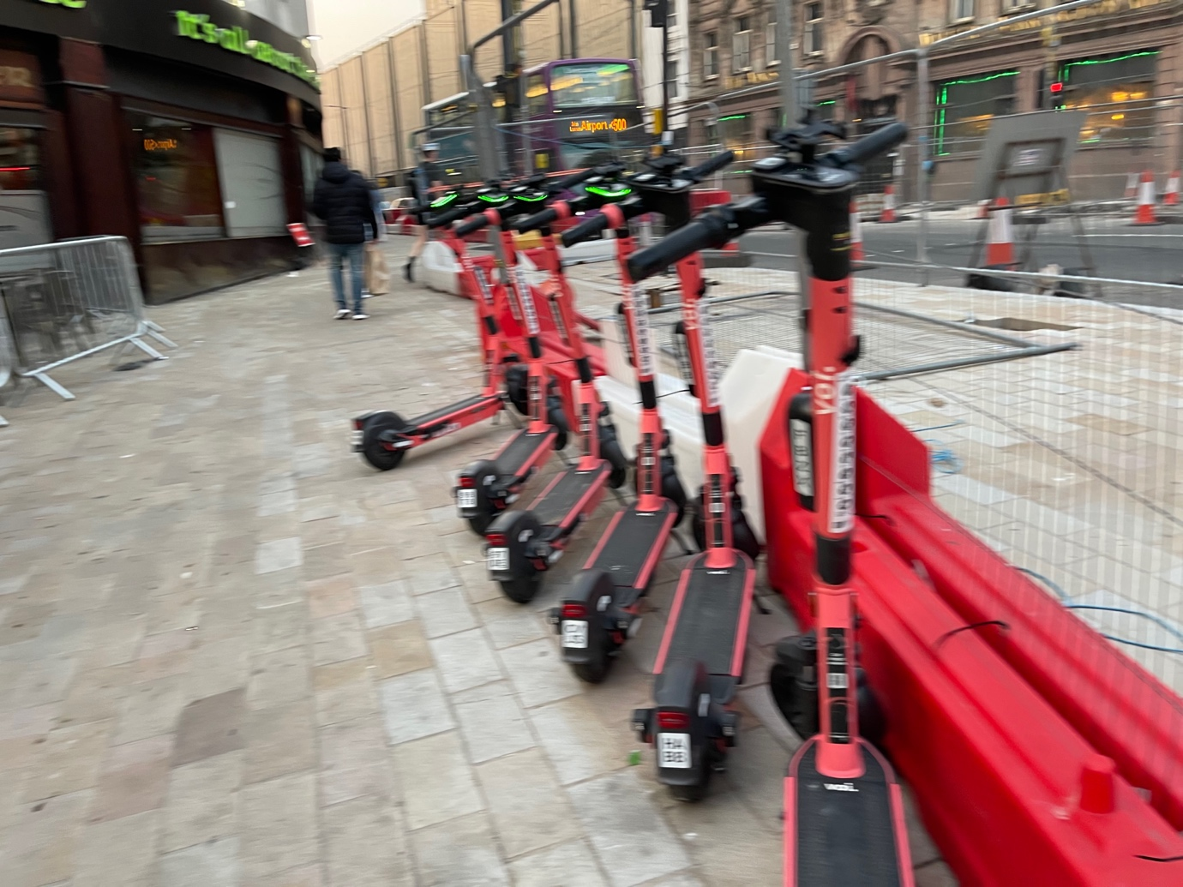
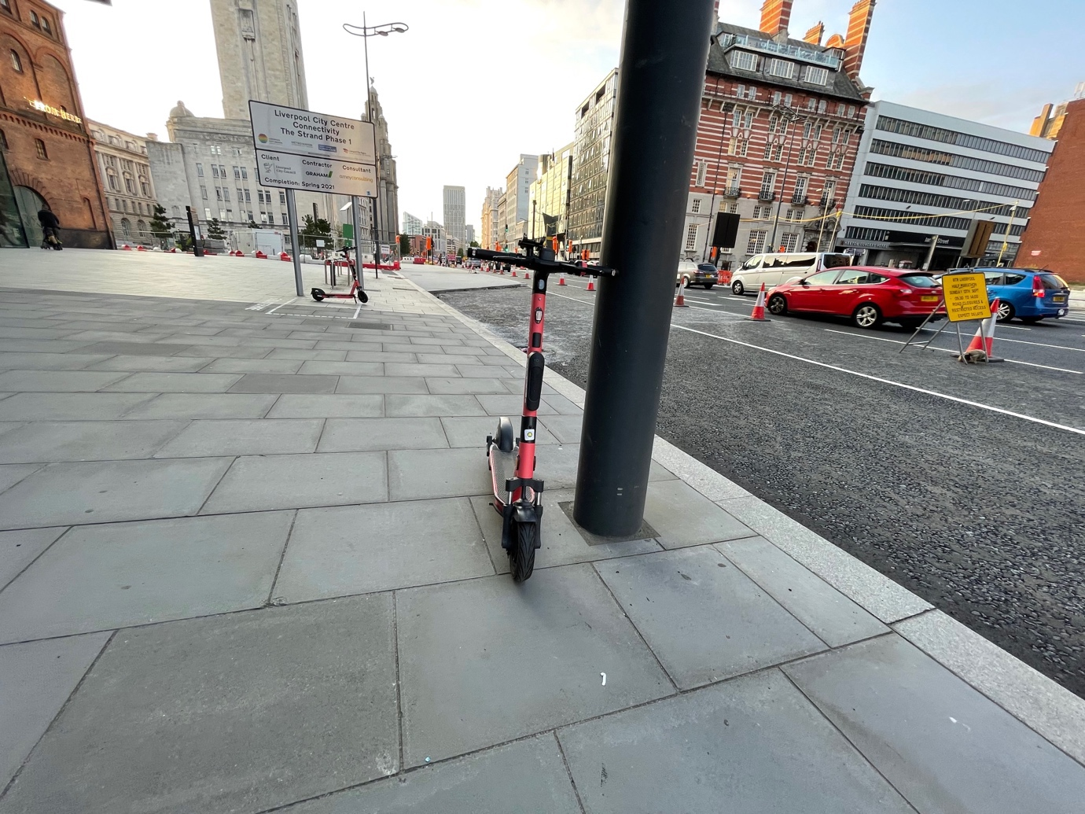

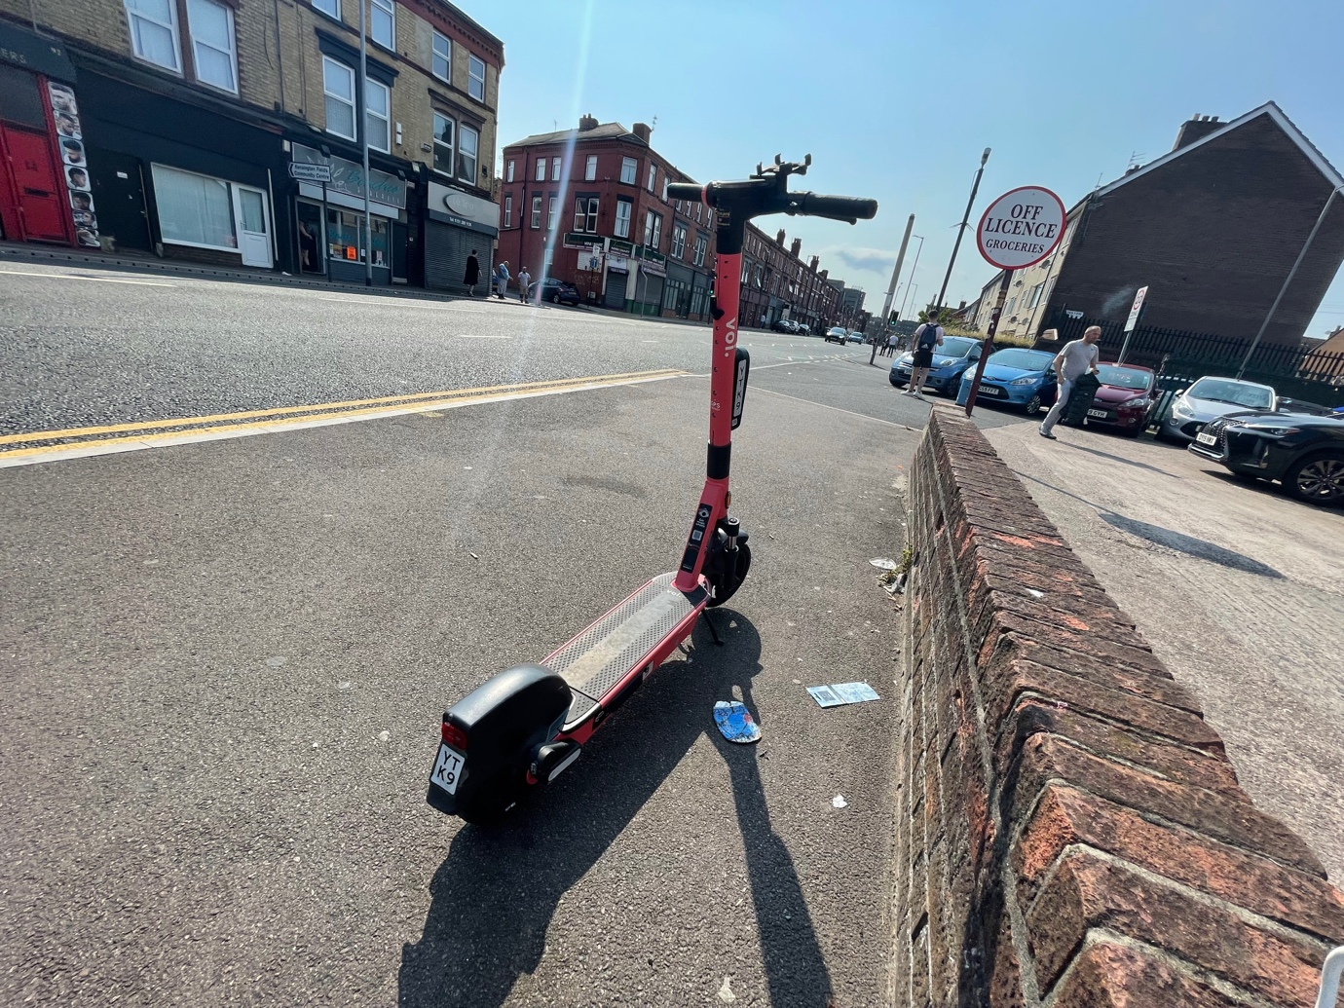
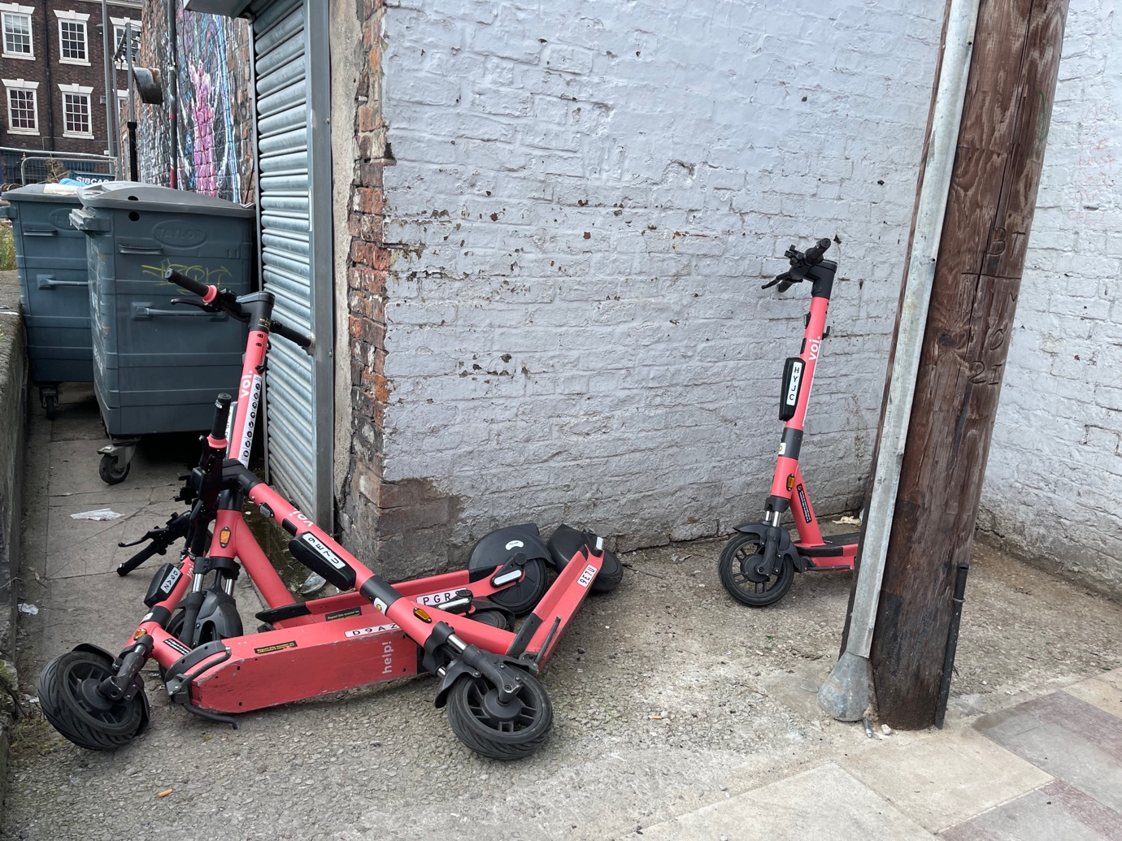

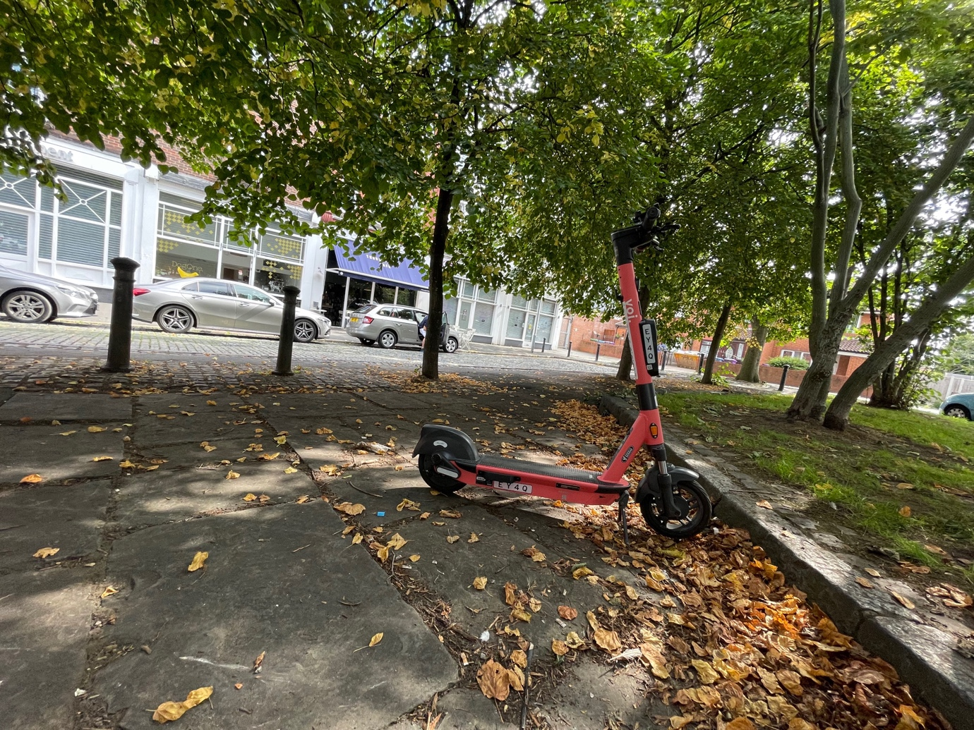

Appendix J Rochdale E-scooter Trial Lime E-Scooters 8 August 2021

This trial has been shut down. A number of the e-scooters witnessed where found to be unsafe with brakes not working, a cable cut on one of them, the battery missing on another, with the e-scooters found left on or lying on the pavement, causing trip hazards and obstructions for pedestrians. It was clear the e-scooters had not been maintained properly and the trial was not safe. These are shown in the photos below.

Site Visit | Appendix Site Visits | Twitter Films Trip & Obstructions | Twitter Films E-scooter Safety Concerns
*Rochdale | Appendix J | October 2021 | October 2021

Photos
9 photos are given below showing e-scooters left in unsafe locations, on pavements and on paths causing an obstruction and a trip hazard. E-scooters found in unsafe situation with broken brakes, cut cable and even a battery was missing on one of them.
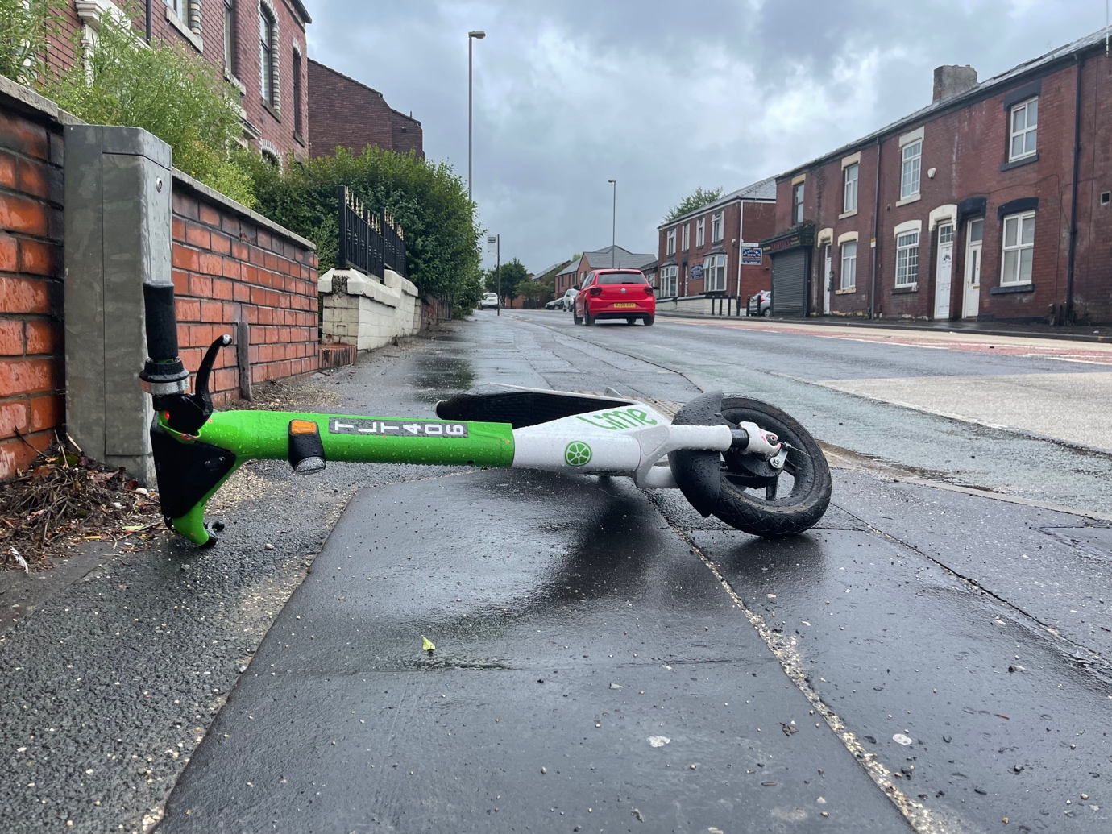
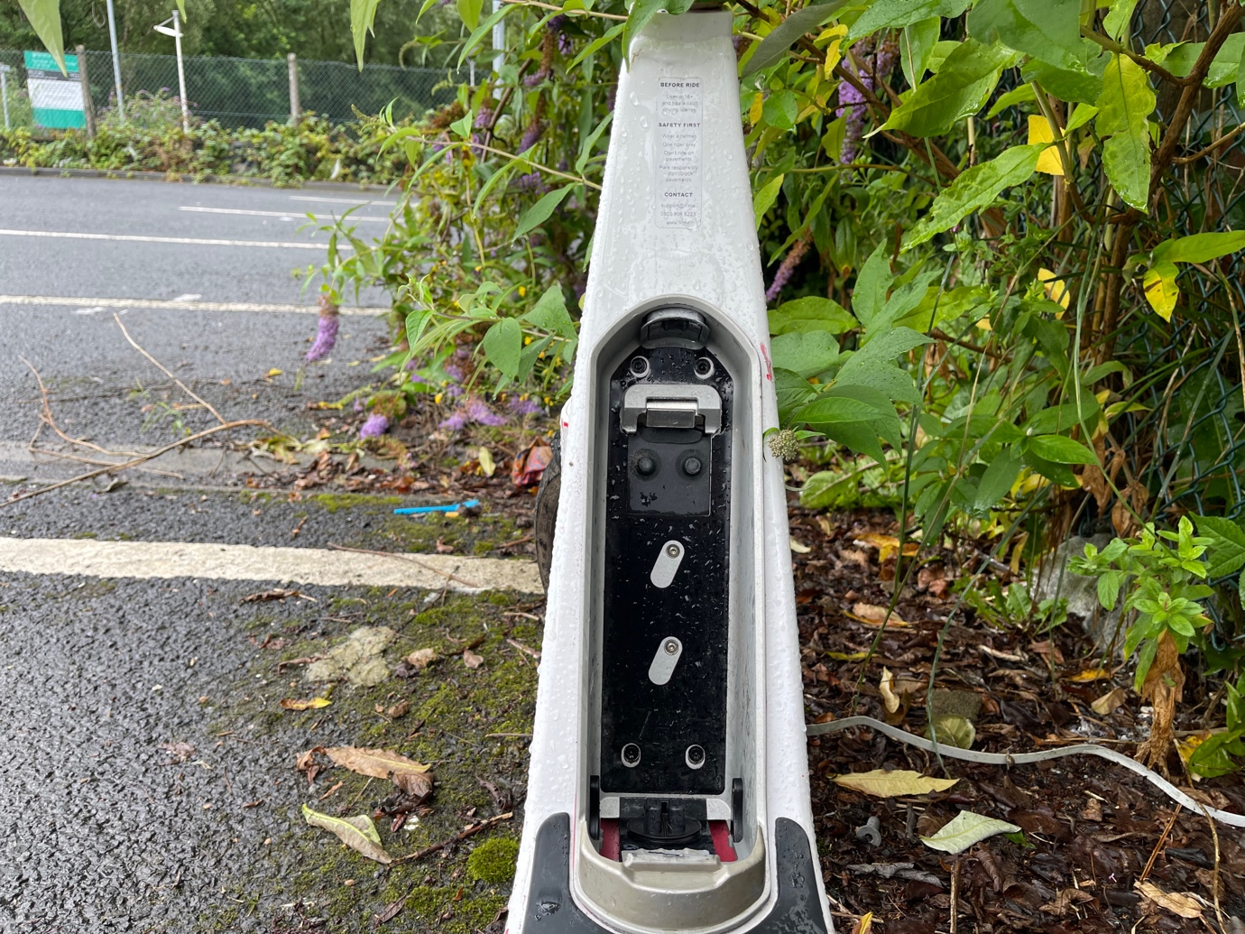

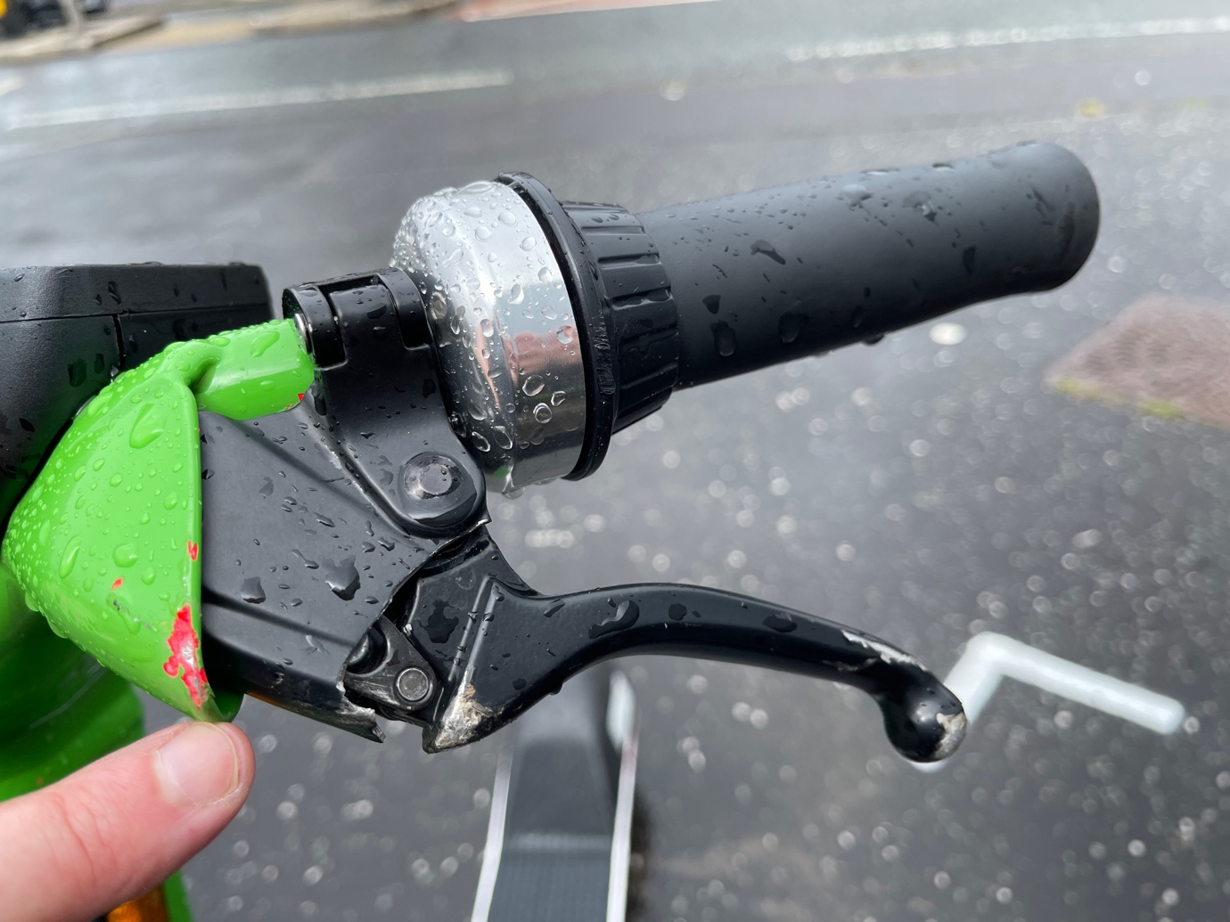
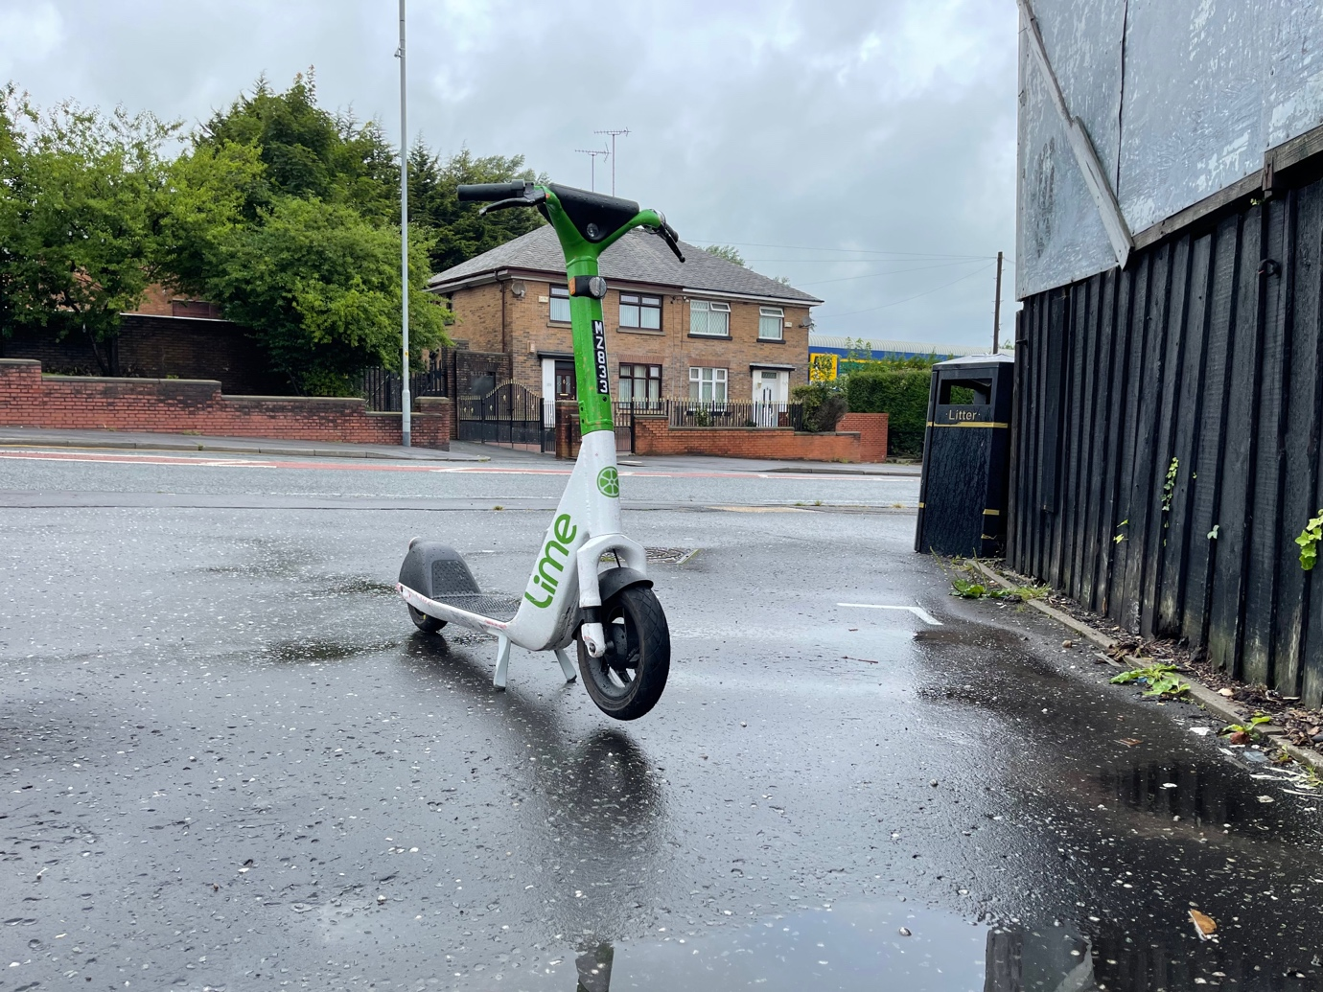

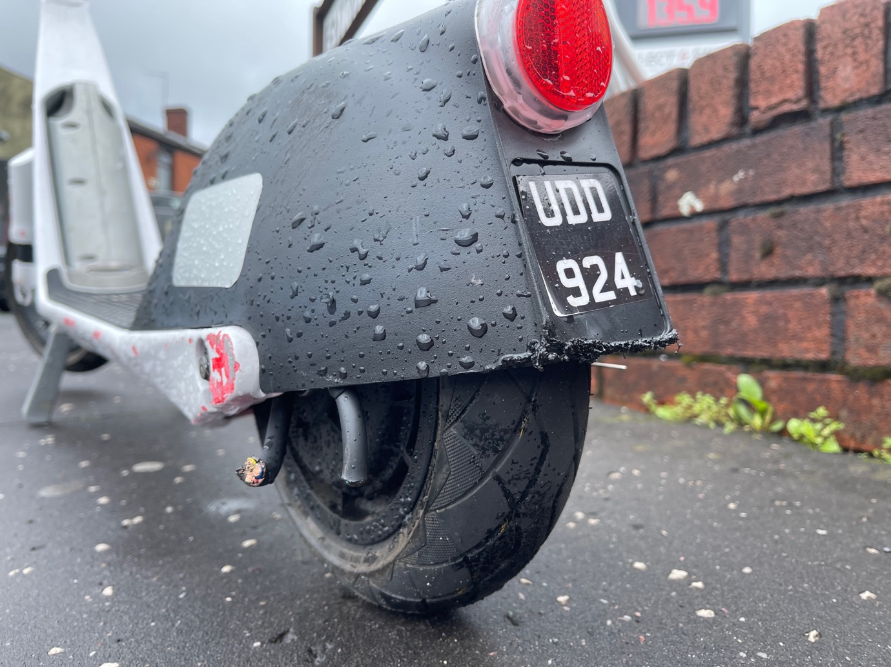
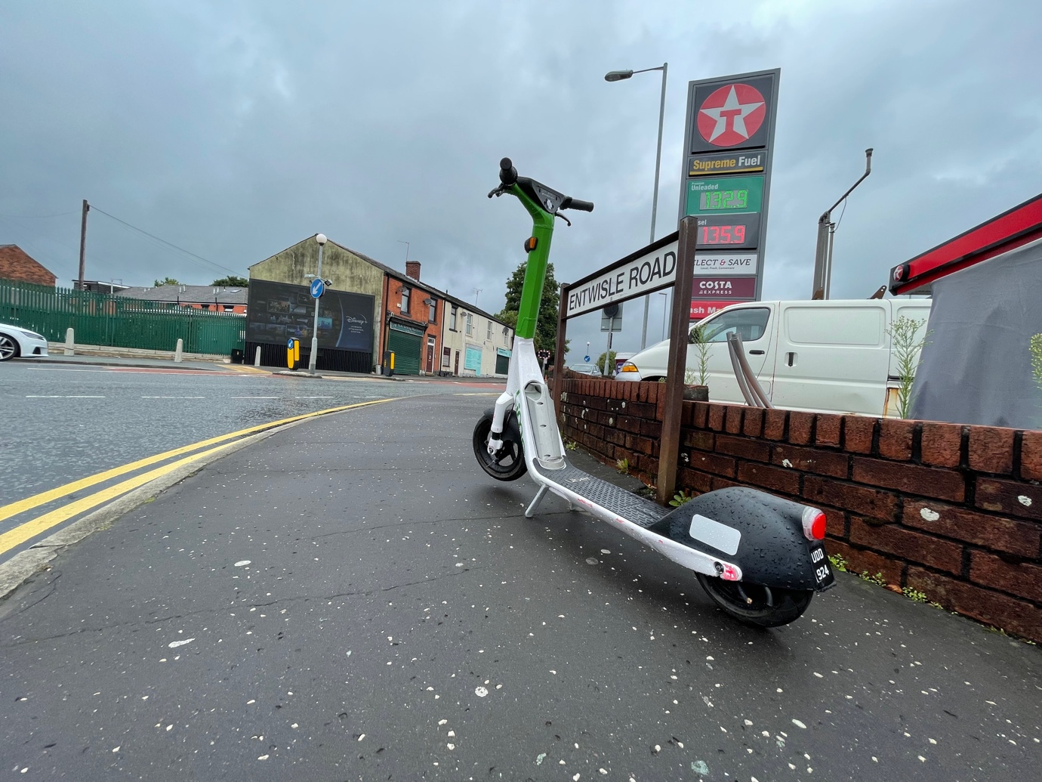

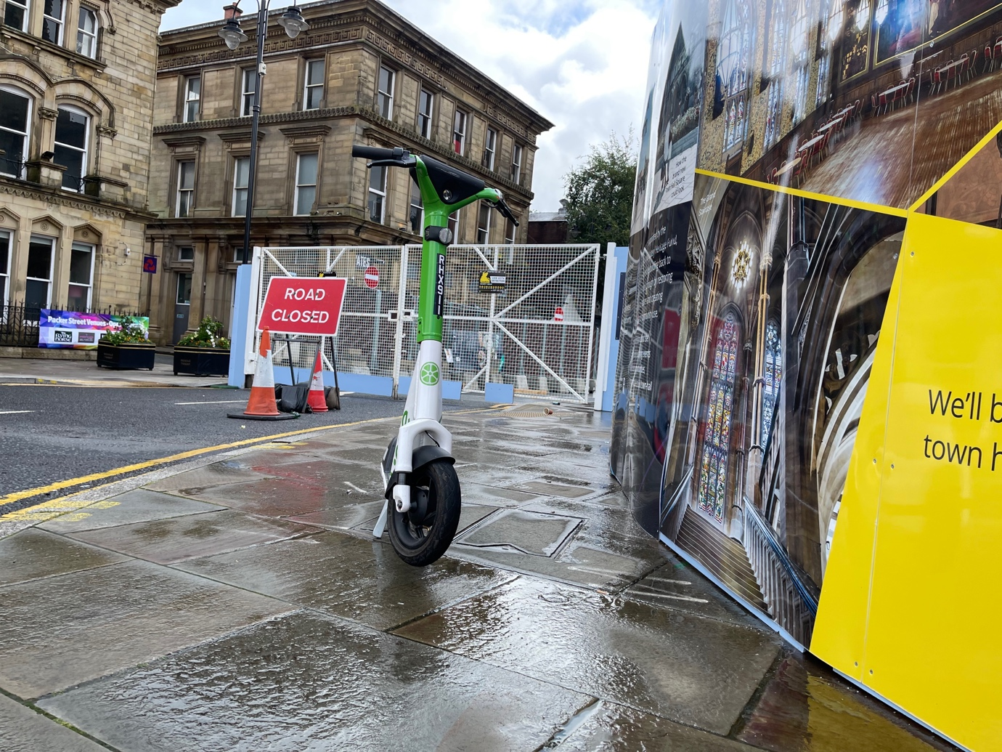
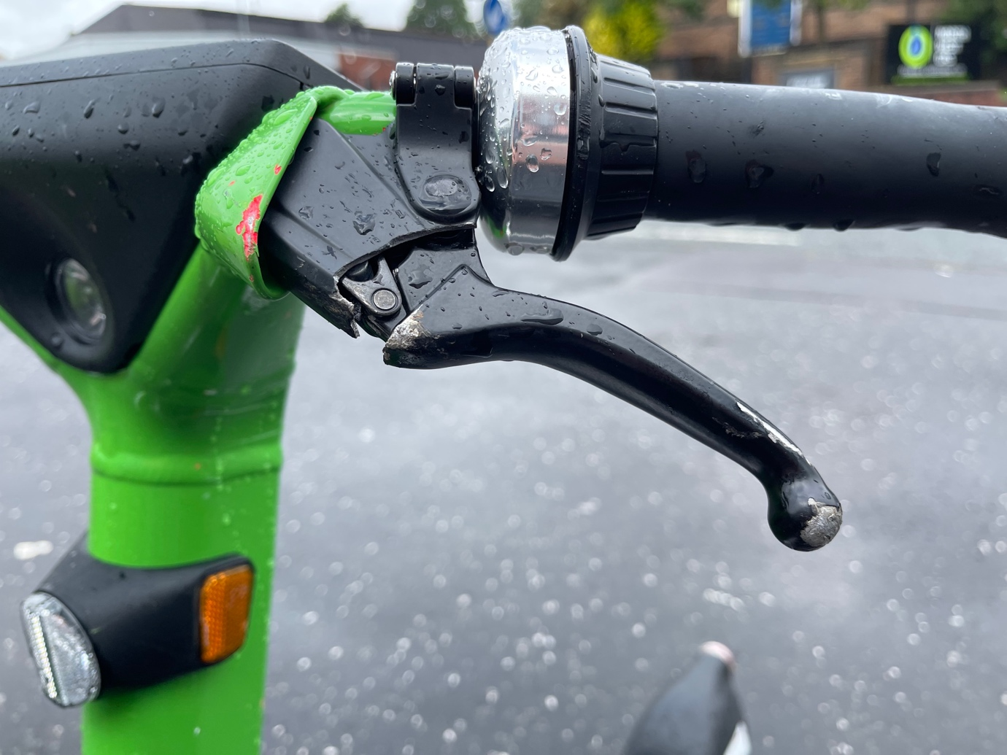

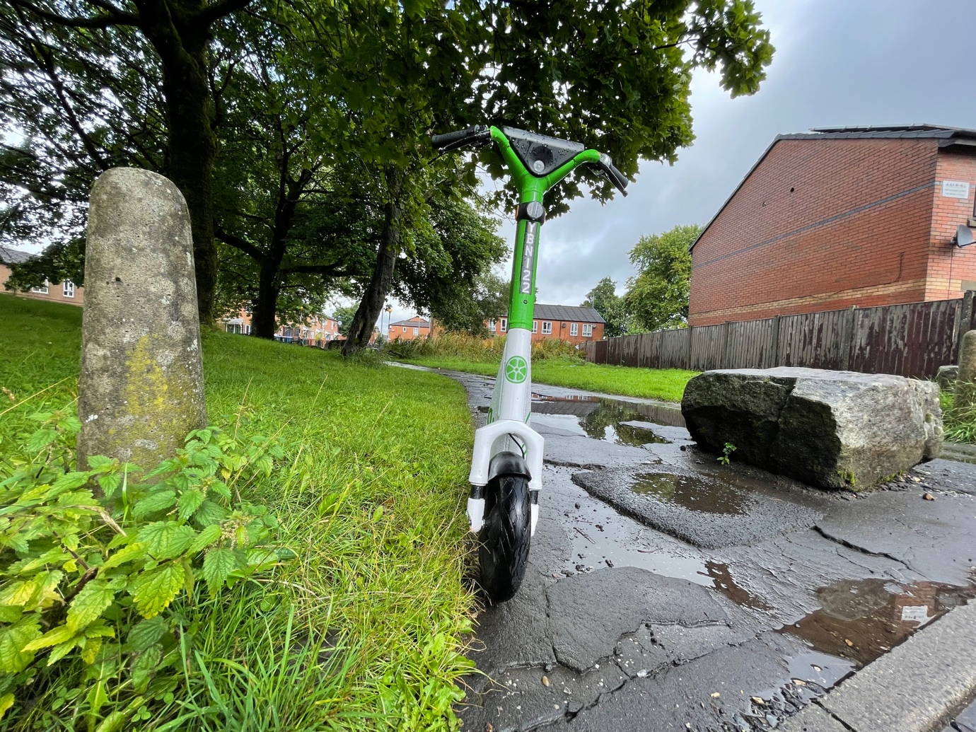

Appendix K Kettering Site Visit Voi E-scooters 3 March 2023 and 26 August 2021

3 March 2023 Visit

This was a short visit, with 10 photos showing e-scooters left on pedestrian walk ways, knocked over on pedestrian areas, left on pavements and showing tyres which had worn away exposing the next layer of the tyres.

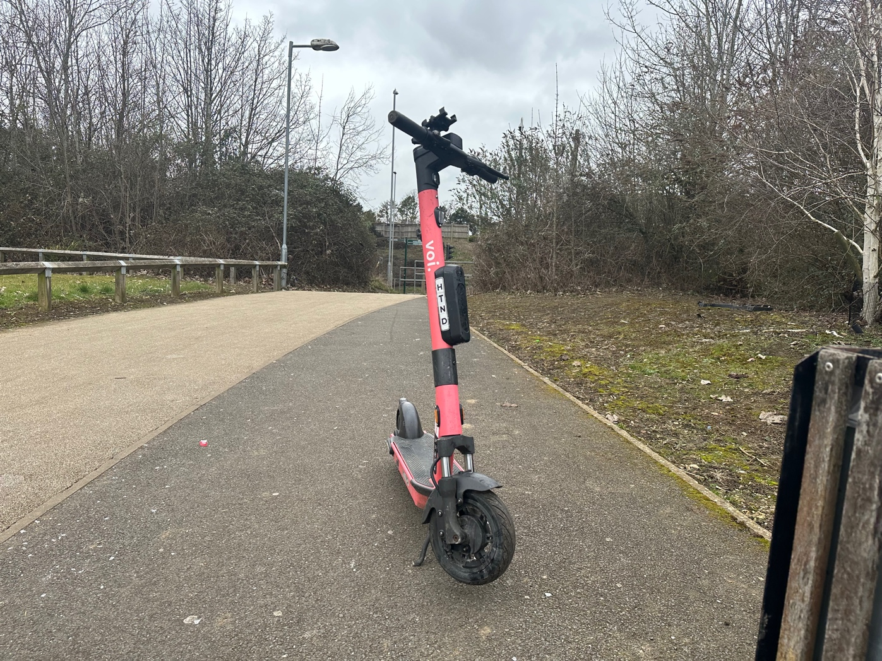
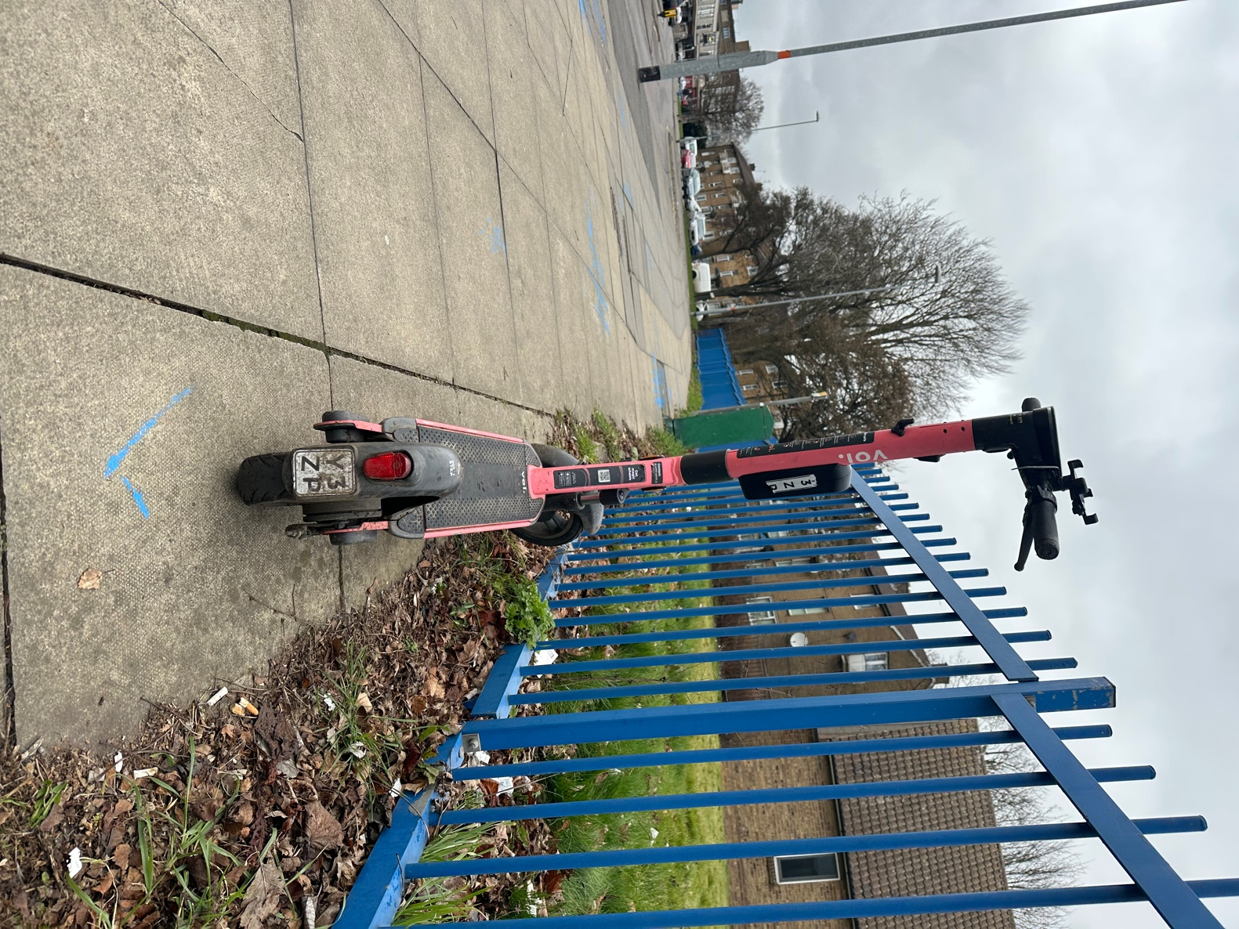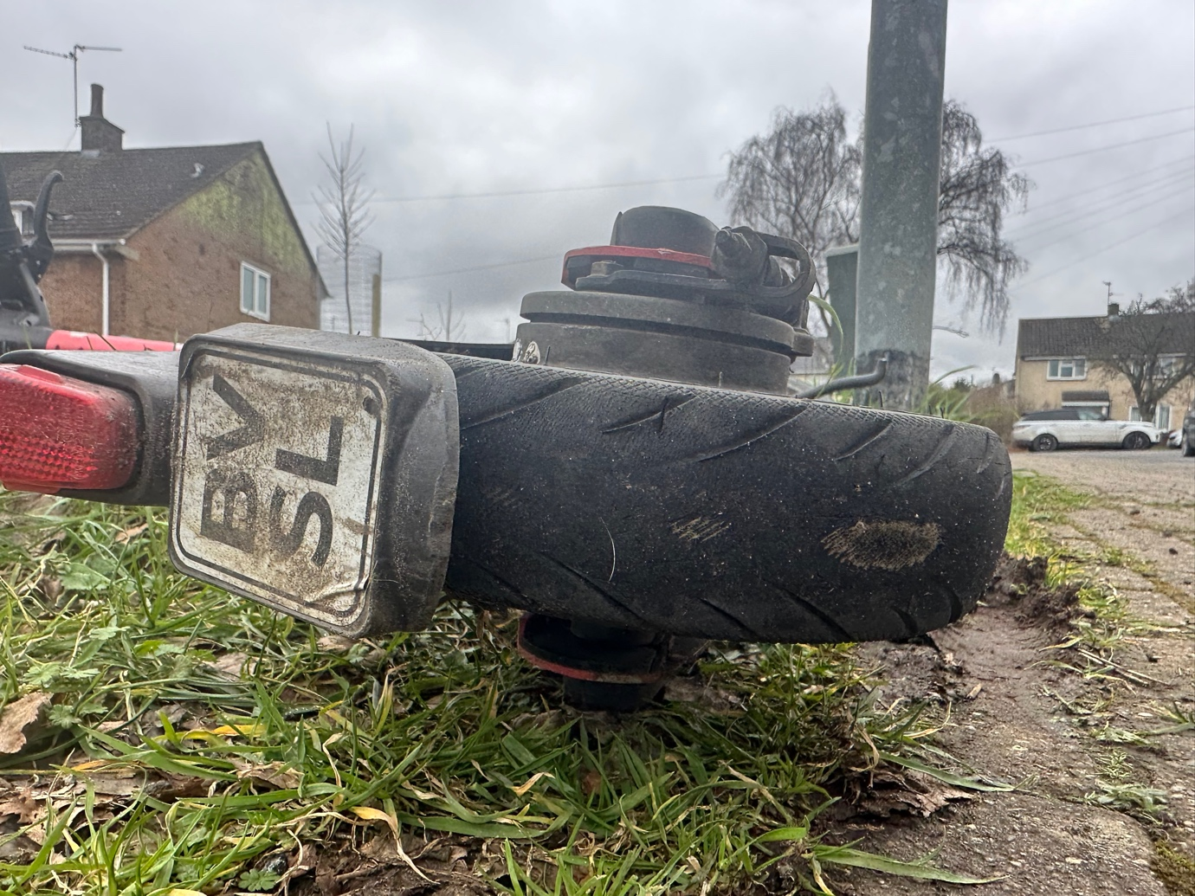

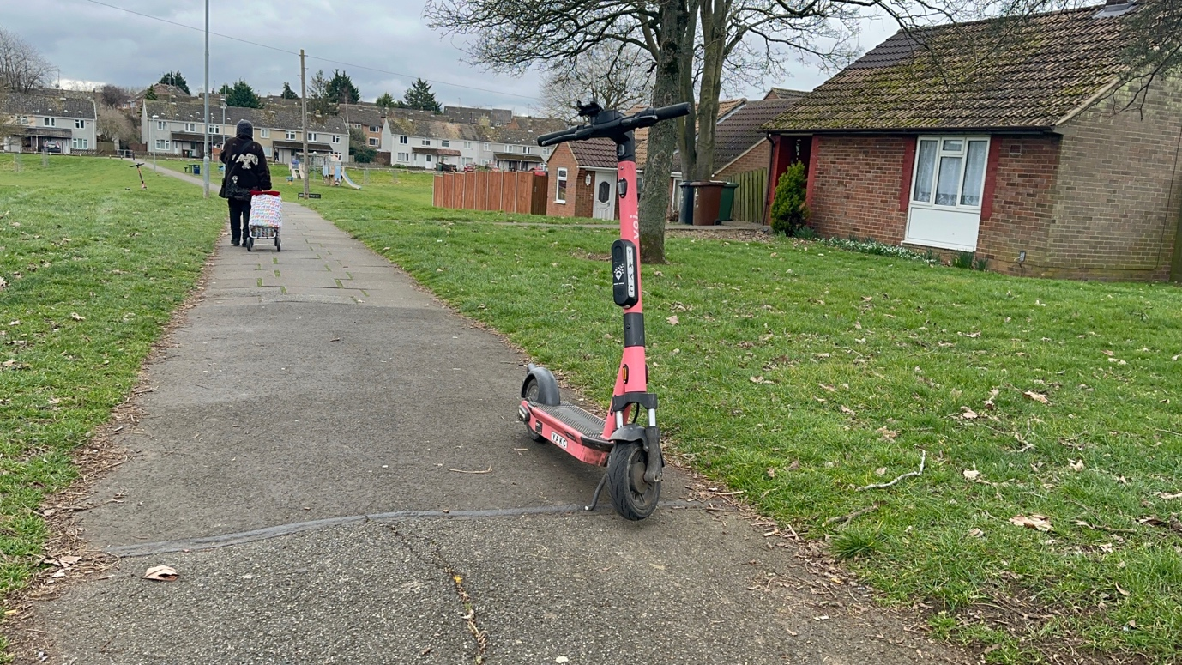
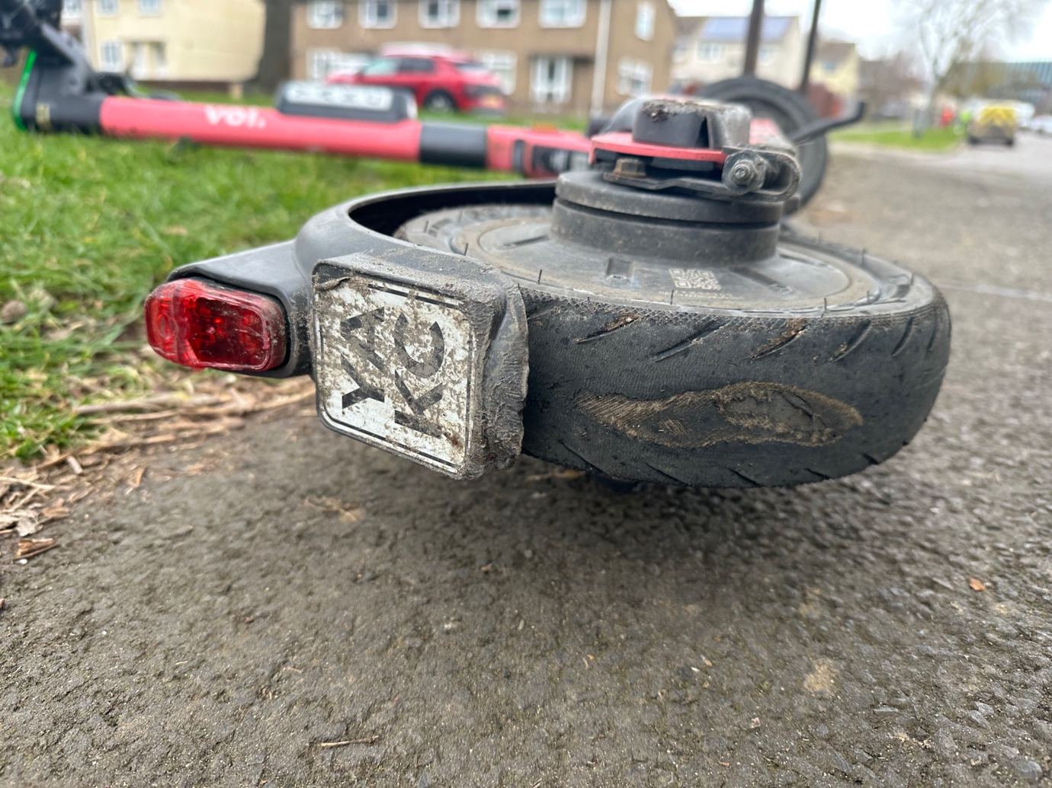

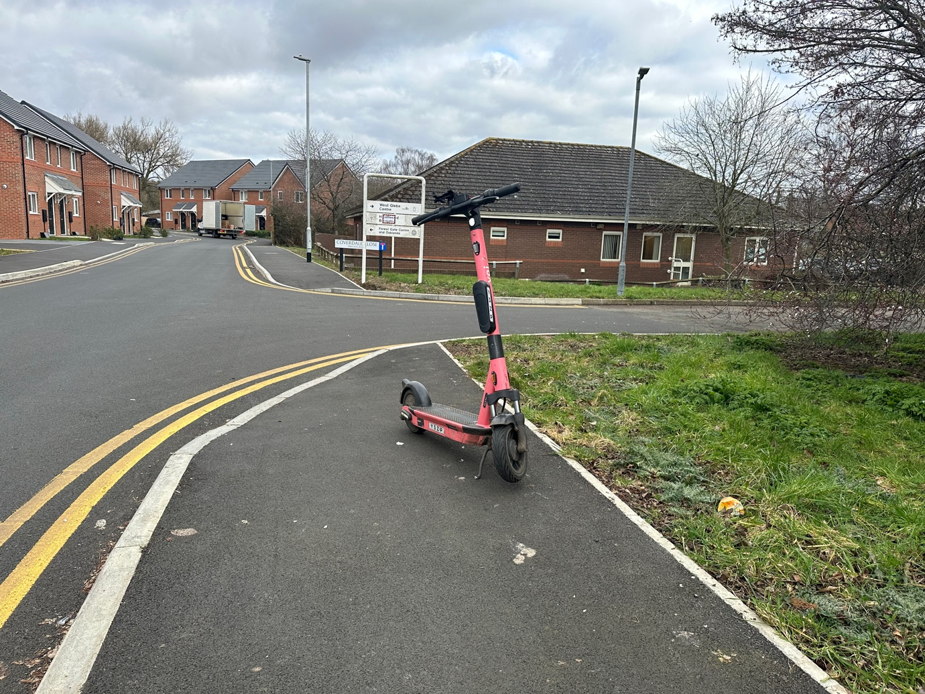
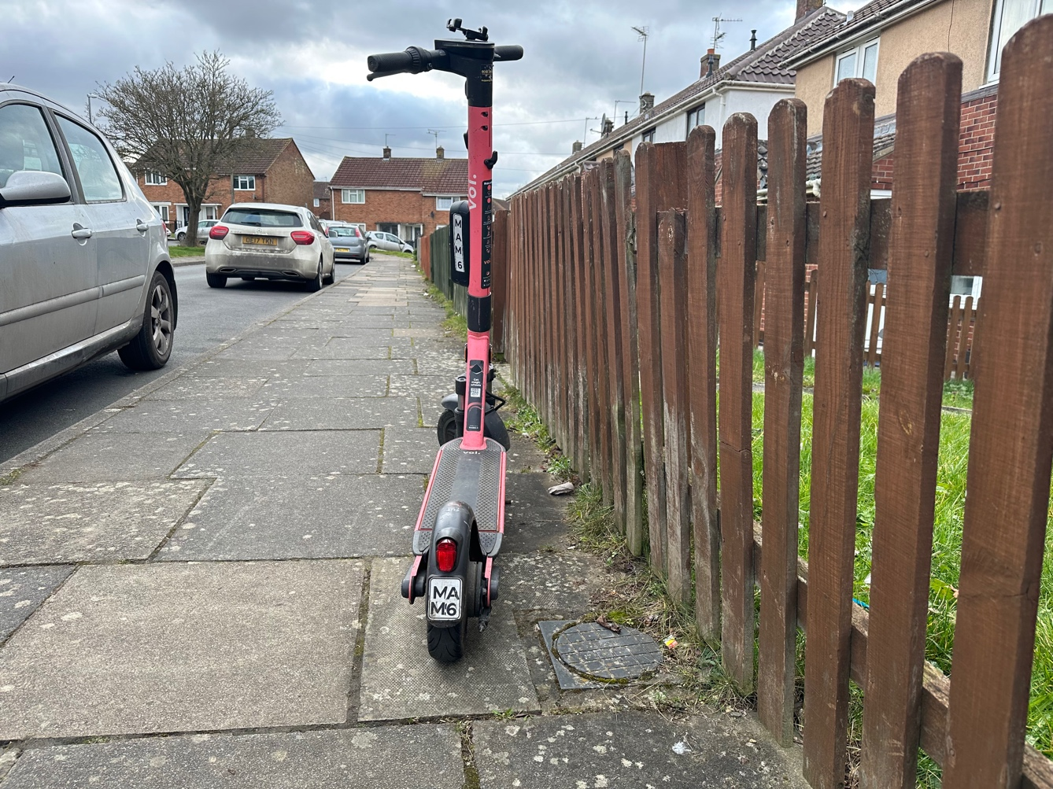
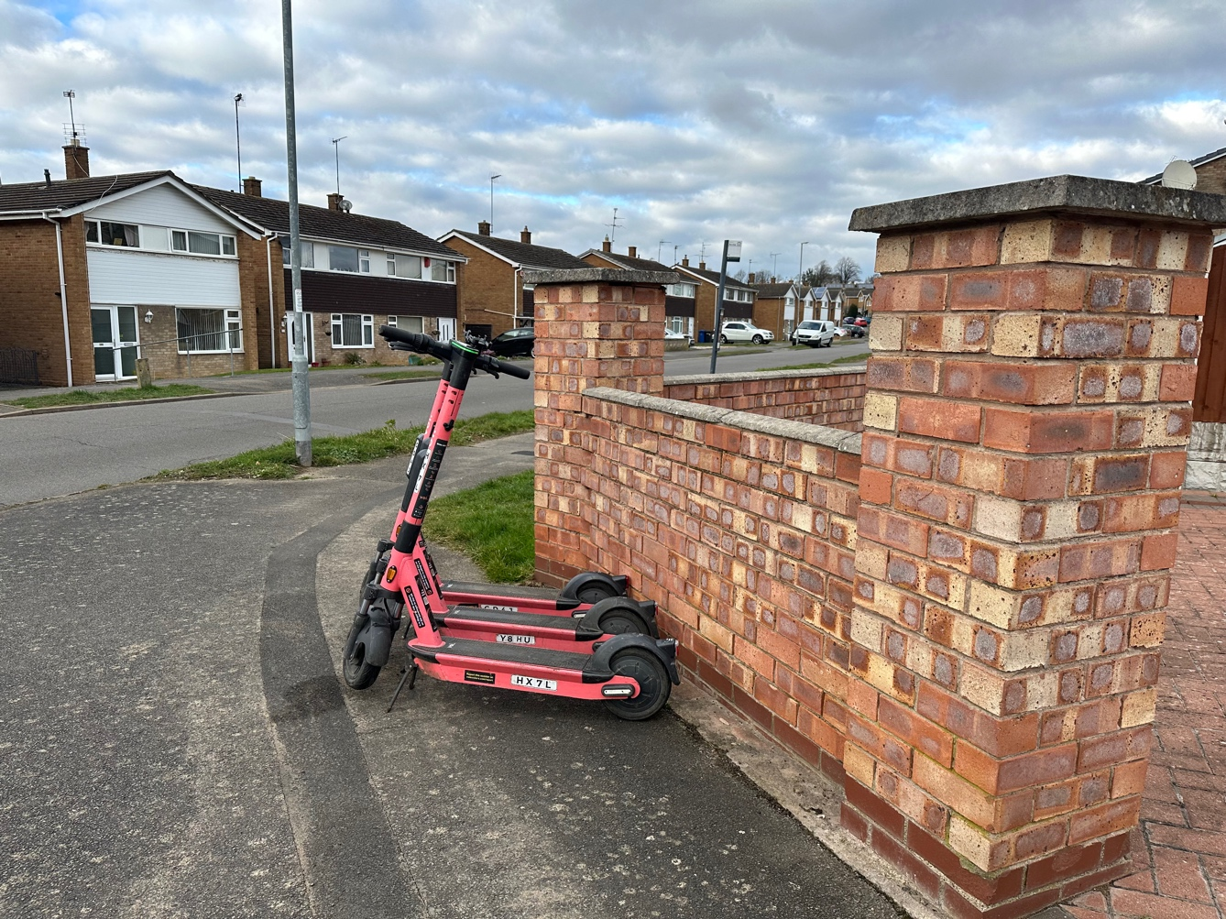
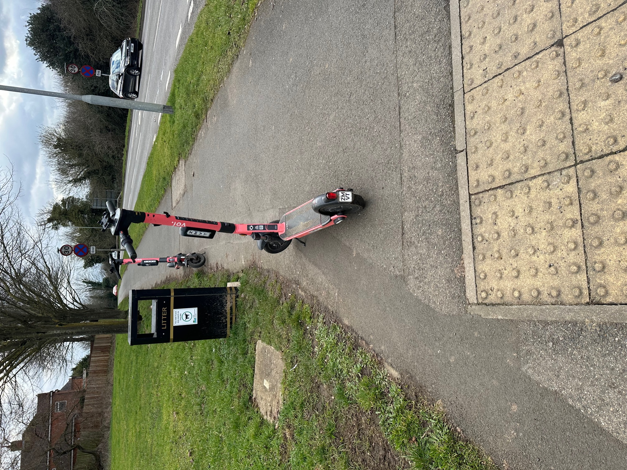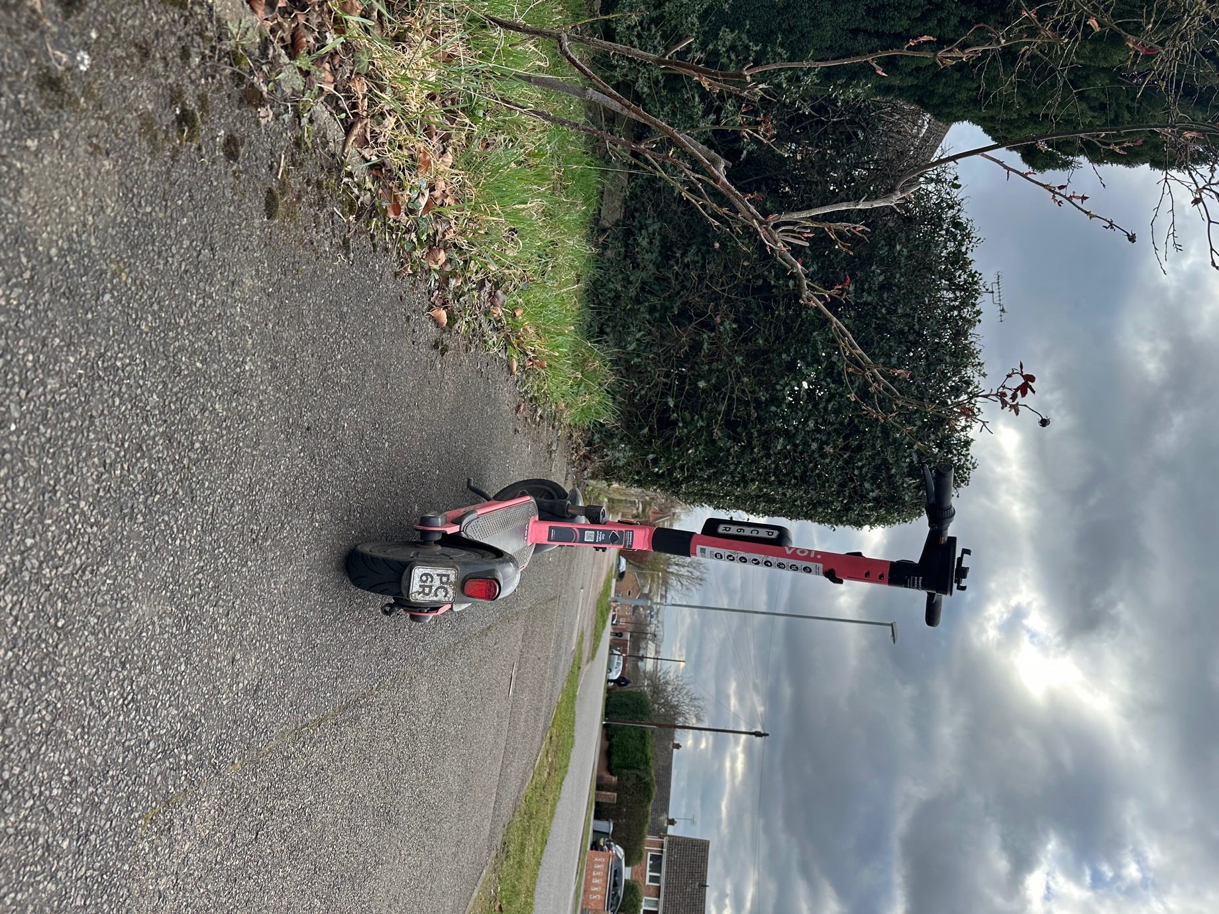

26 August 2021 Visit

18 photos showing E-scooters found in unsafe locations, left on pavements, public spaces and next to pedestrian crossings causing obstructions and trip hazards. A number of e-scooters were found in an unsafe manner with the mud guard removed and a wire was found over the back of the e-scooter back tyre.

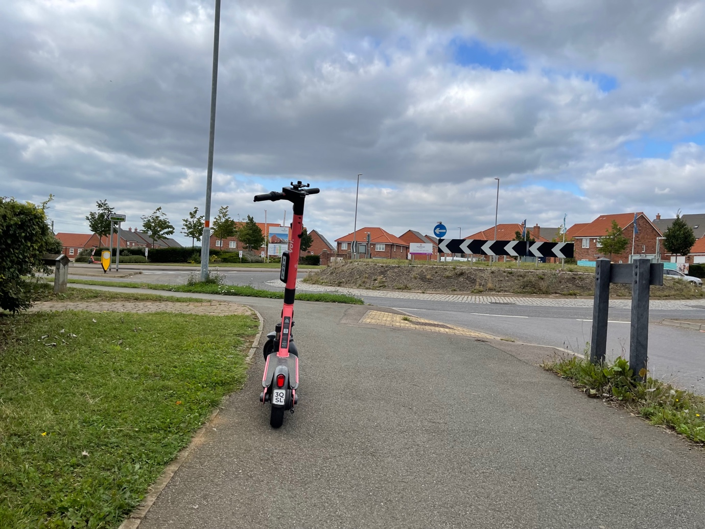

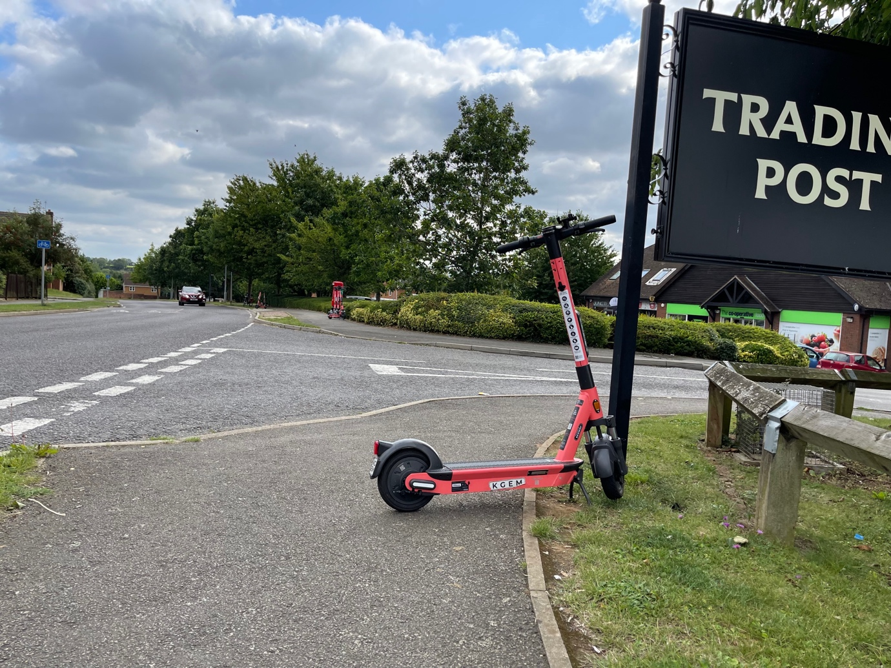

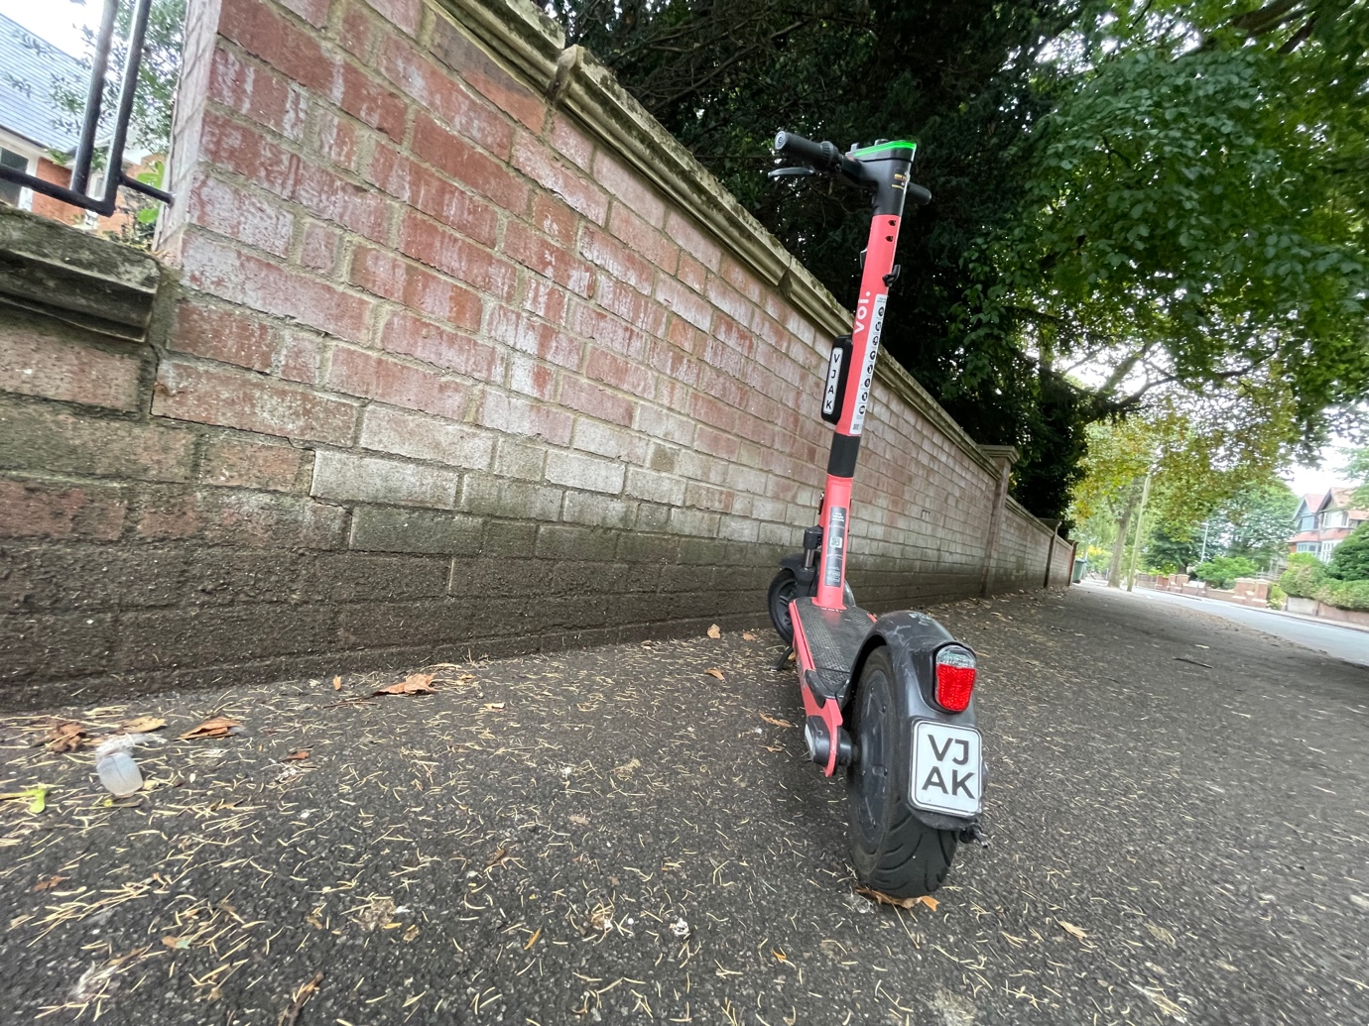

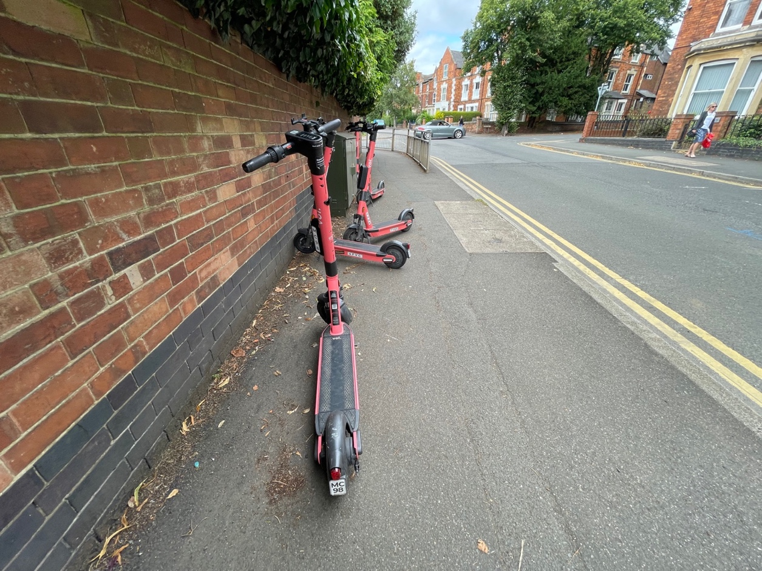

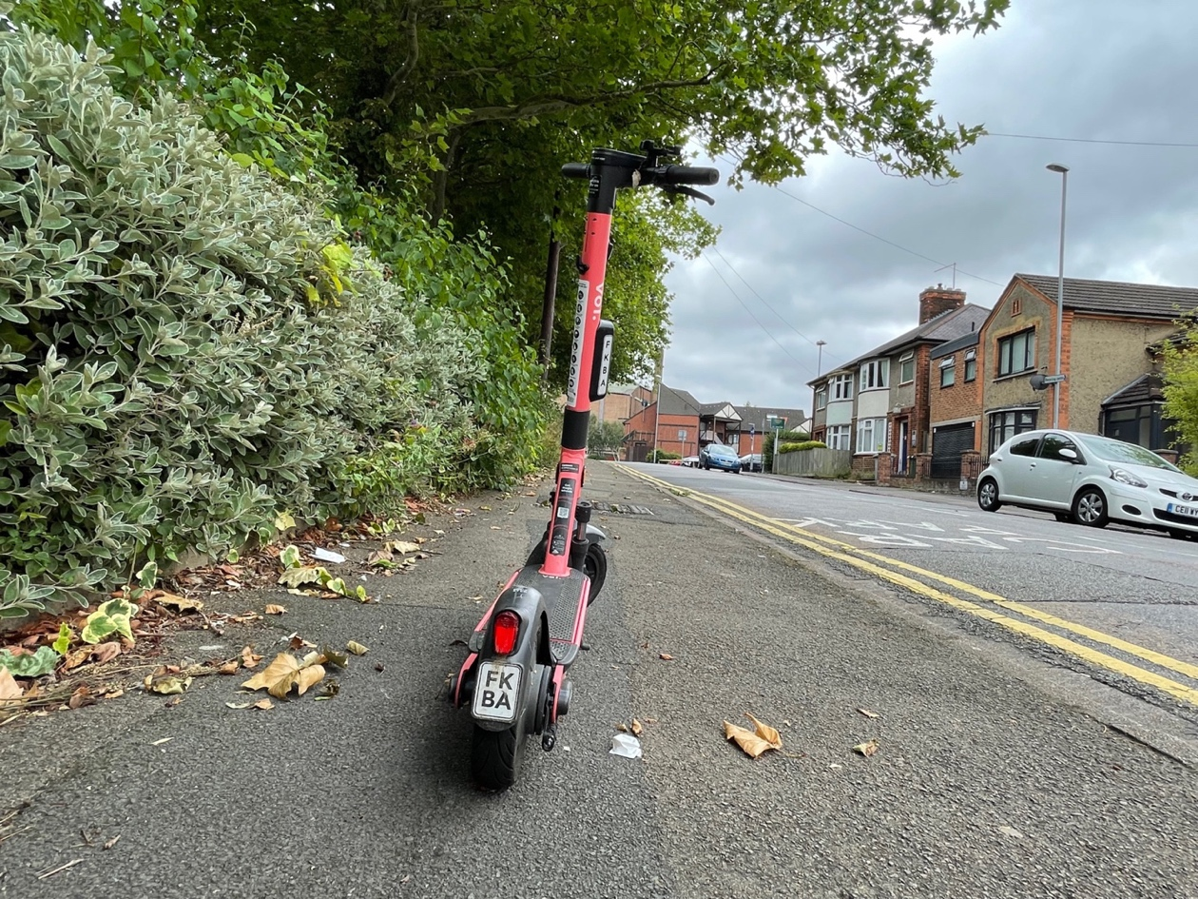

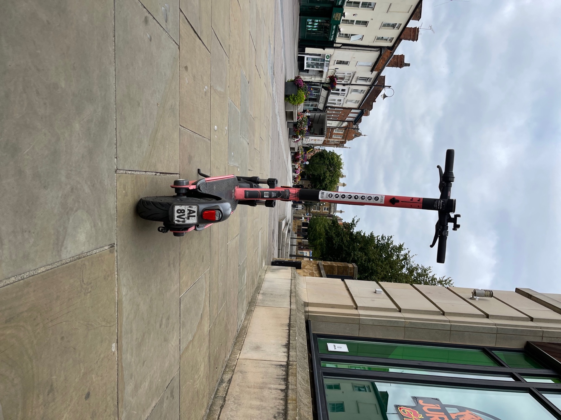

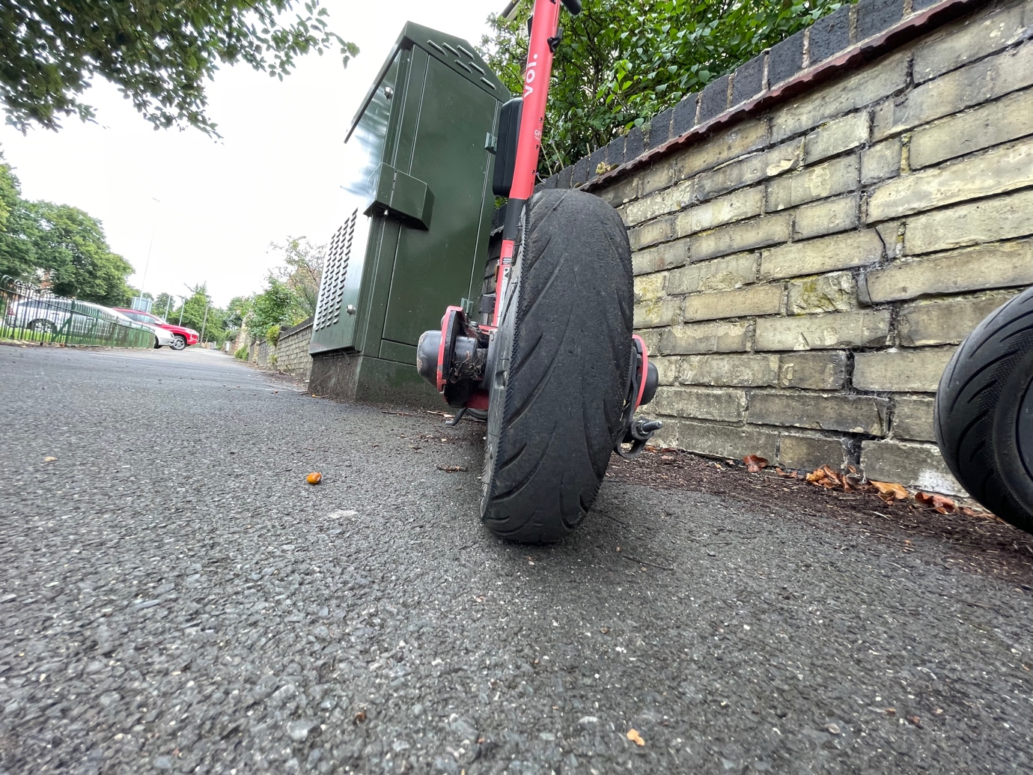

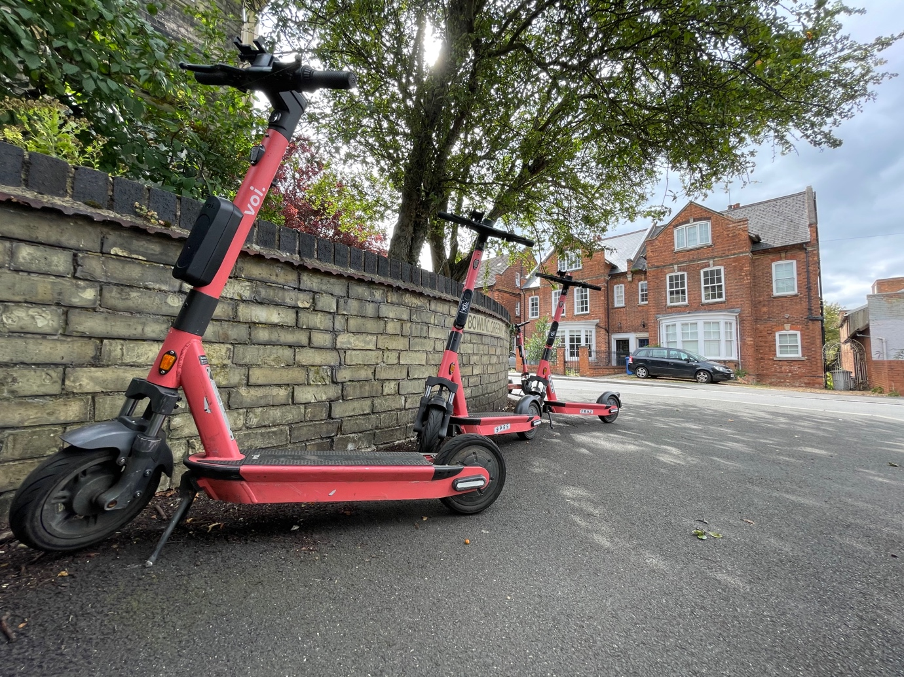

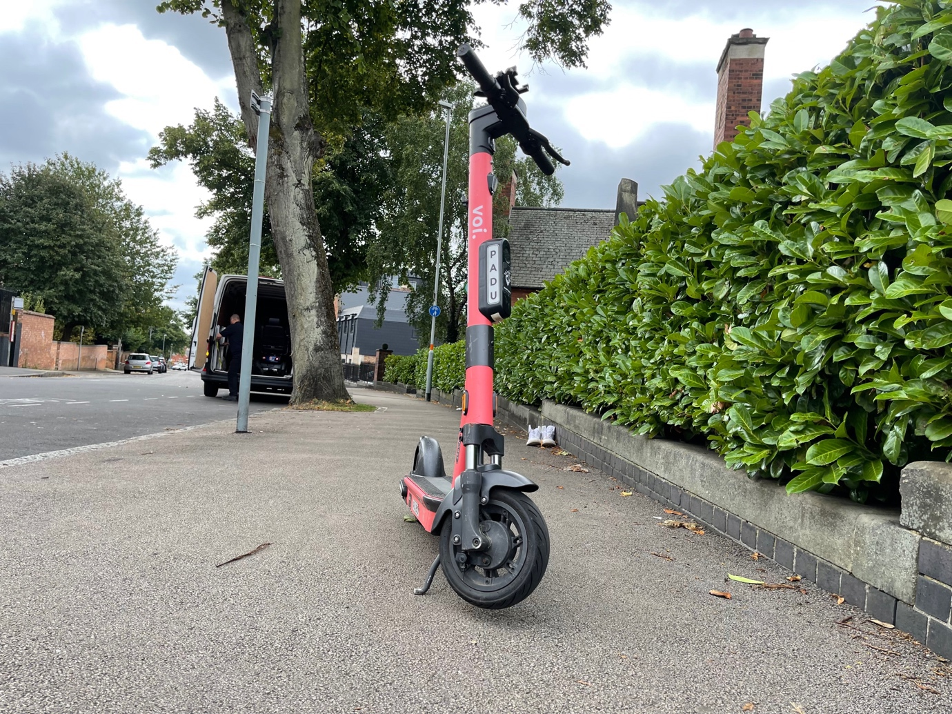
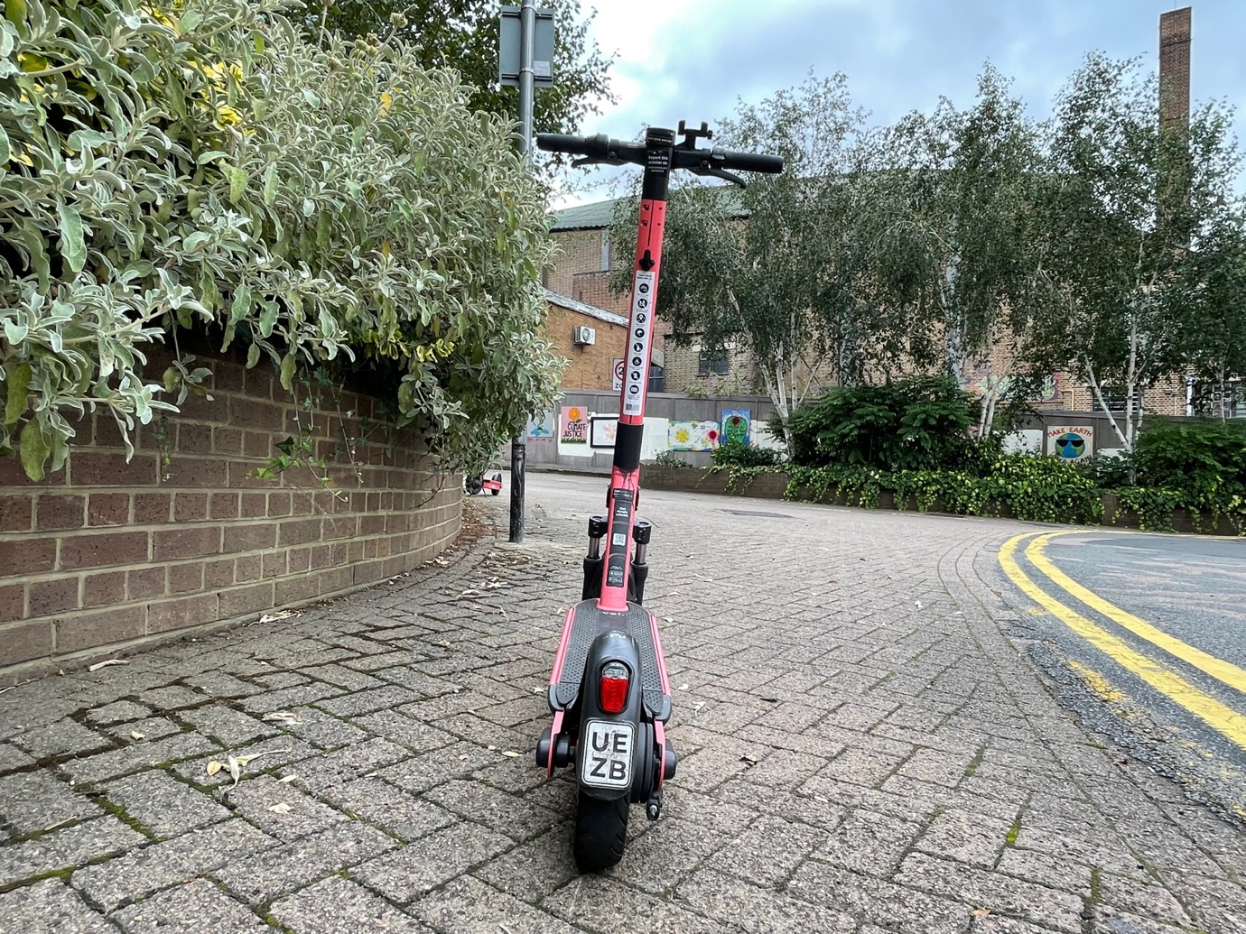
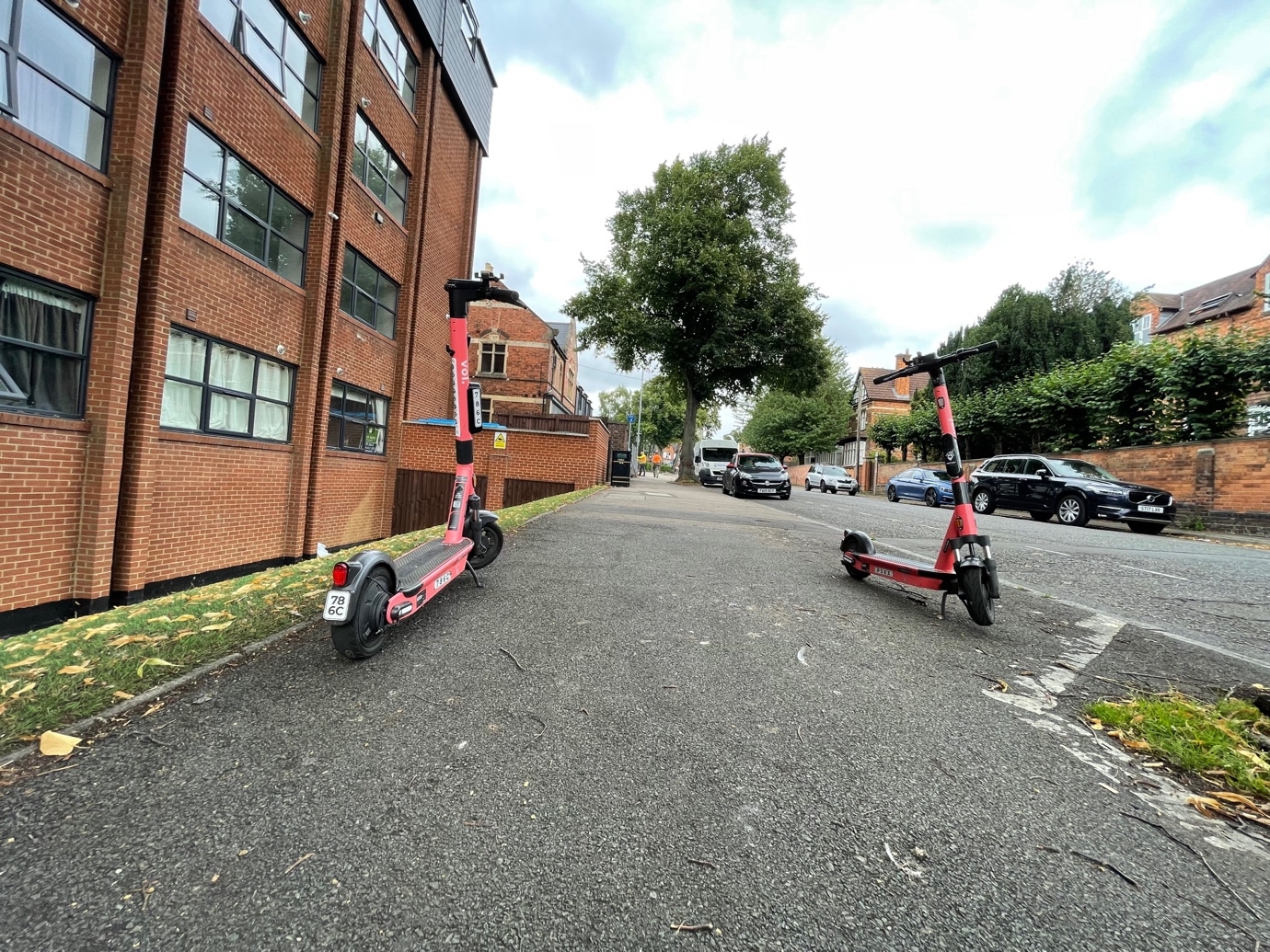

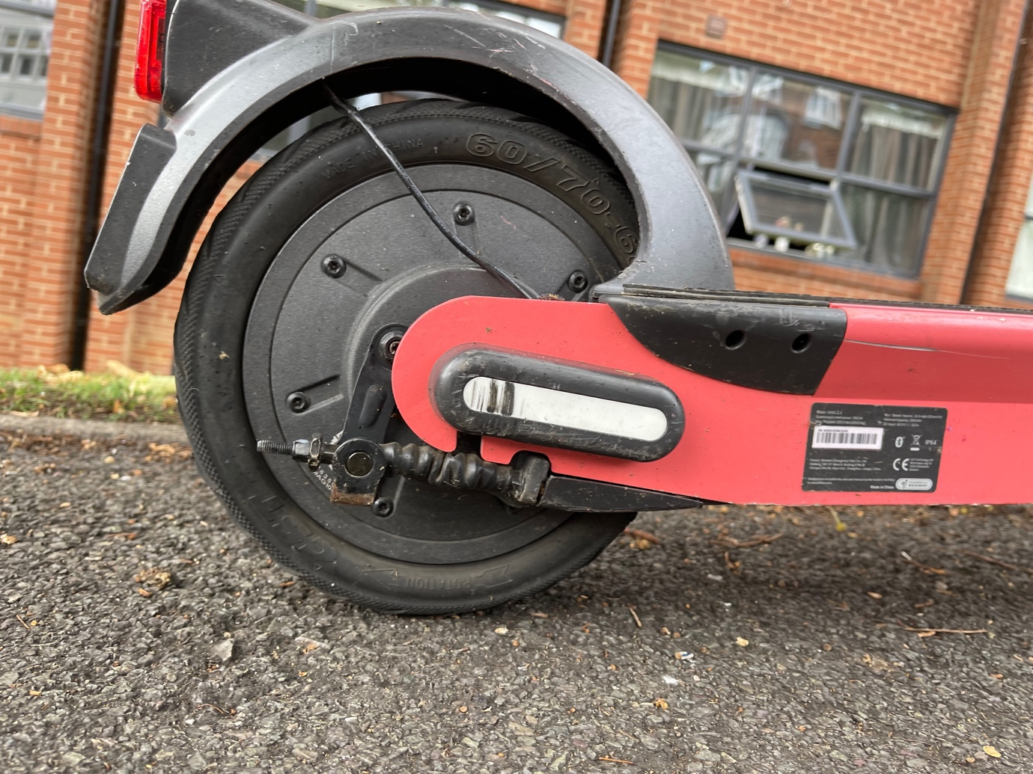

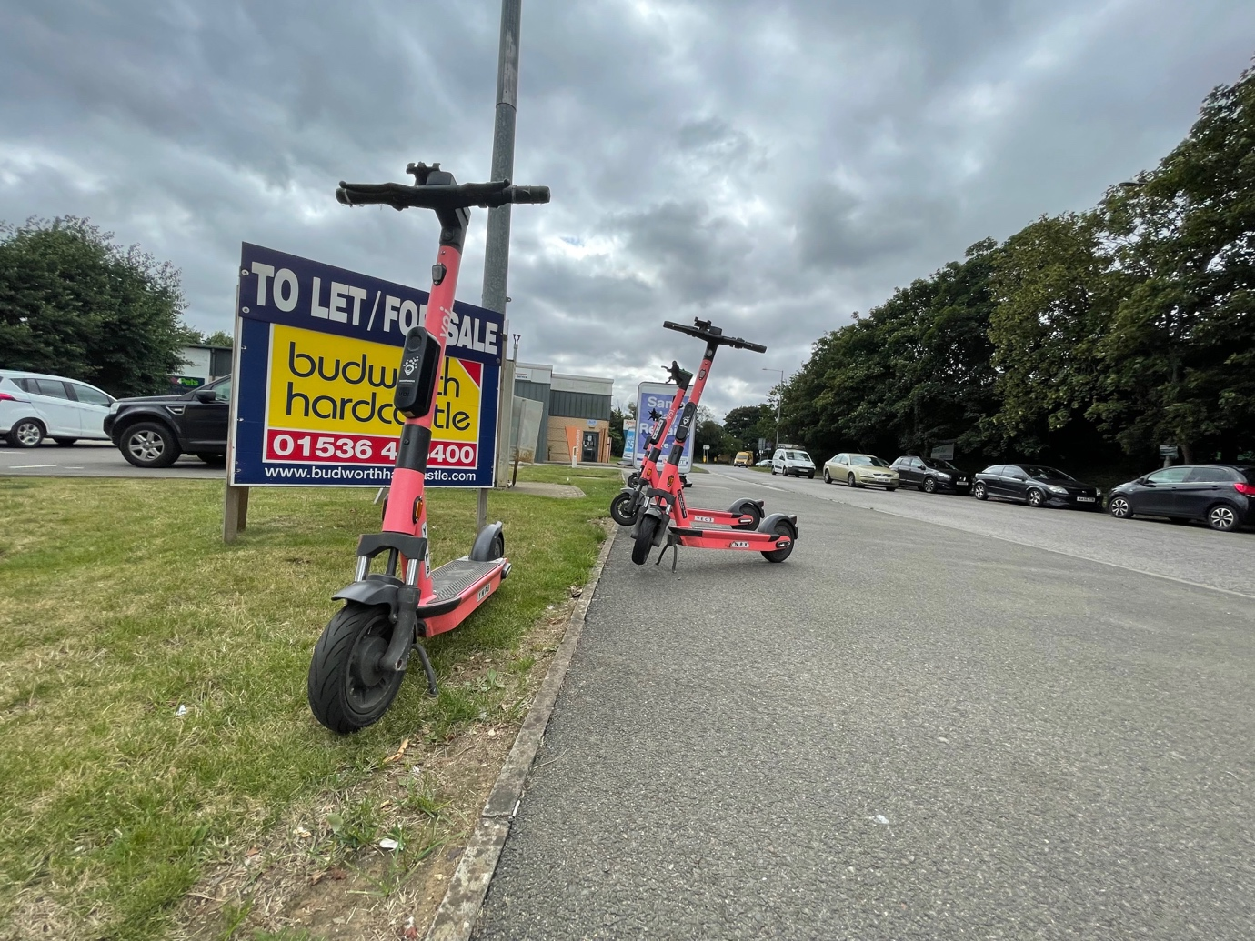
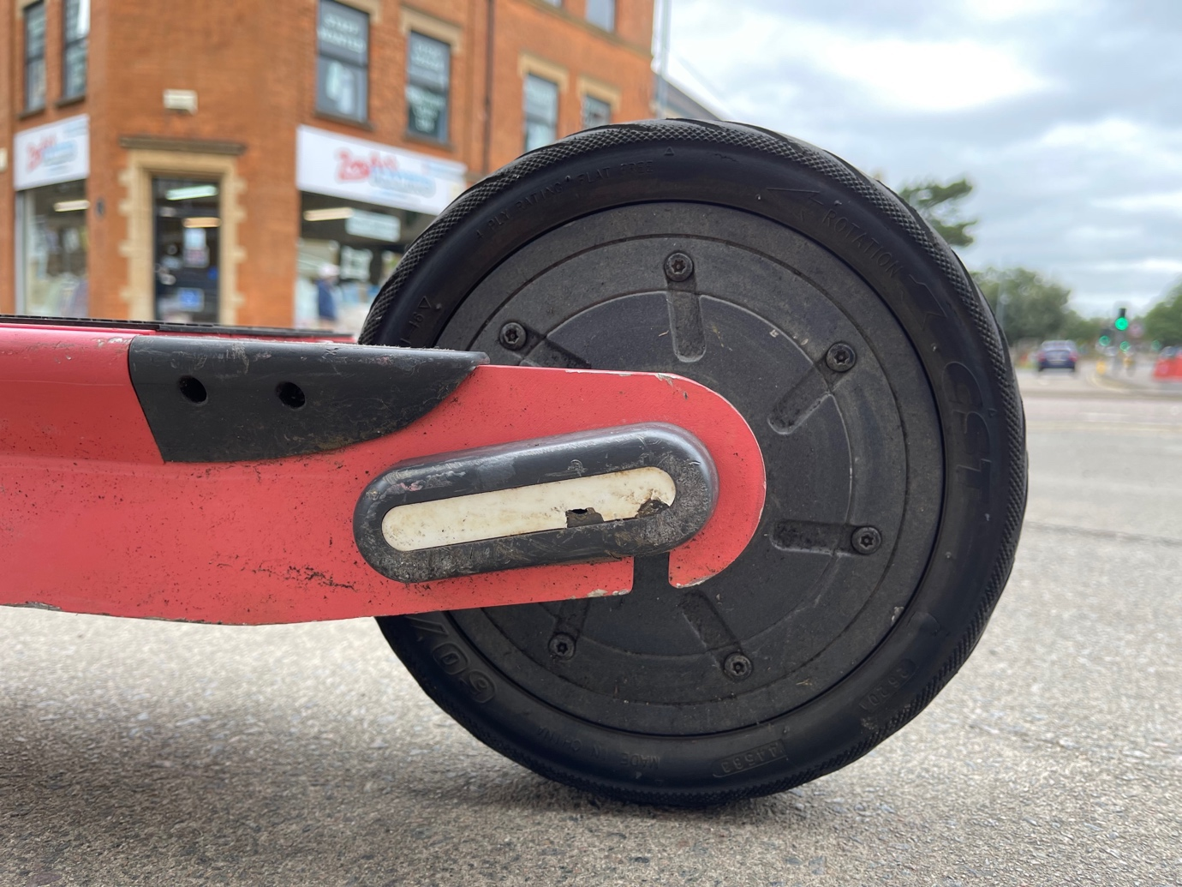

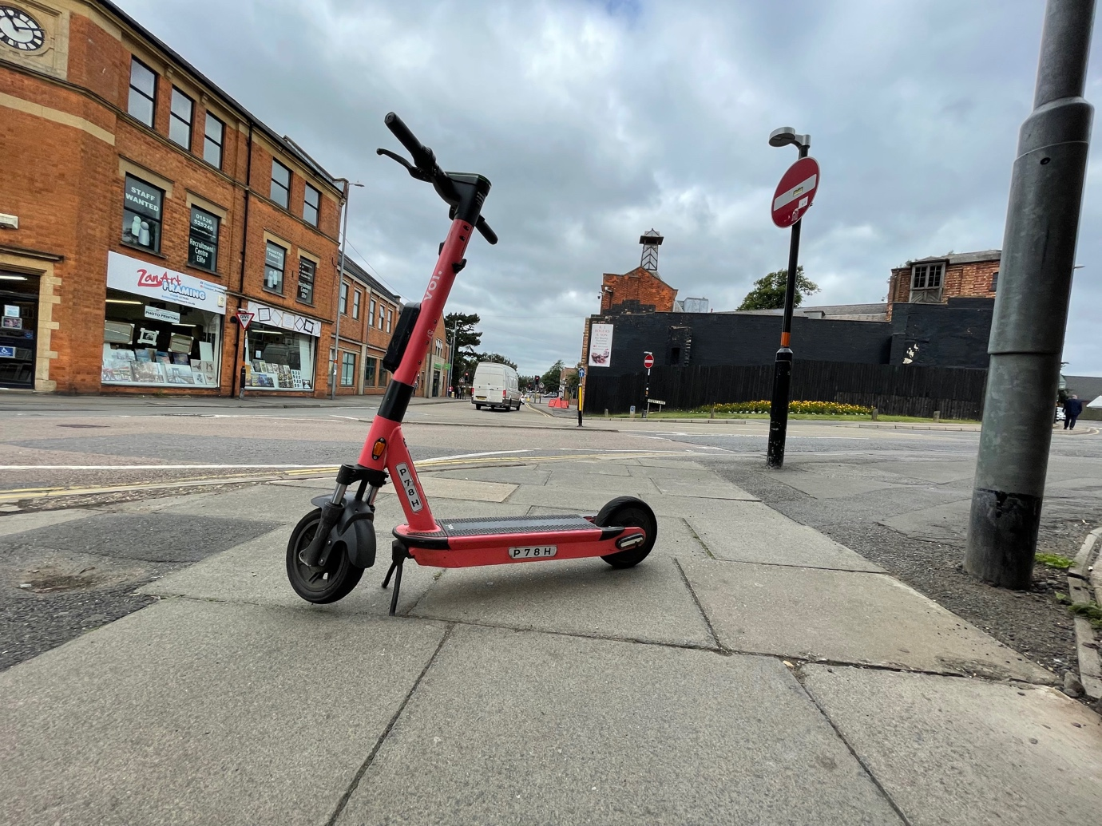
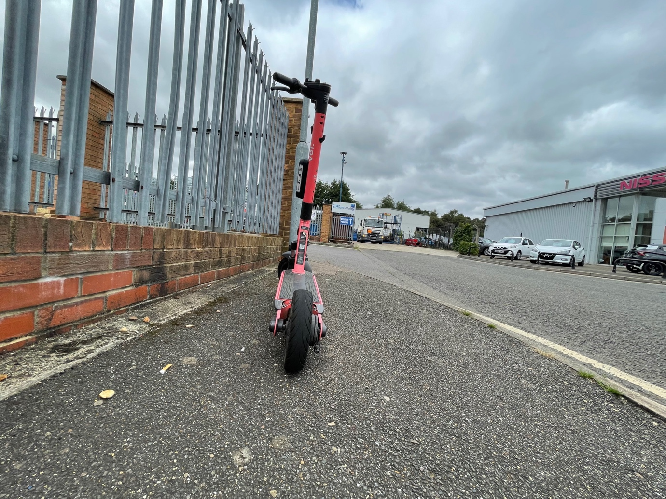

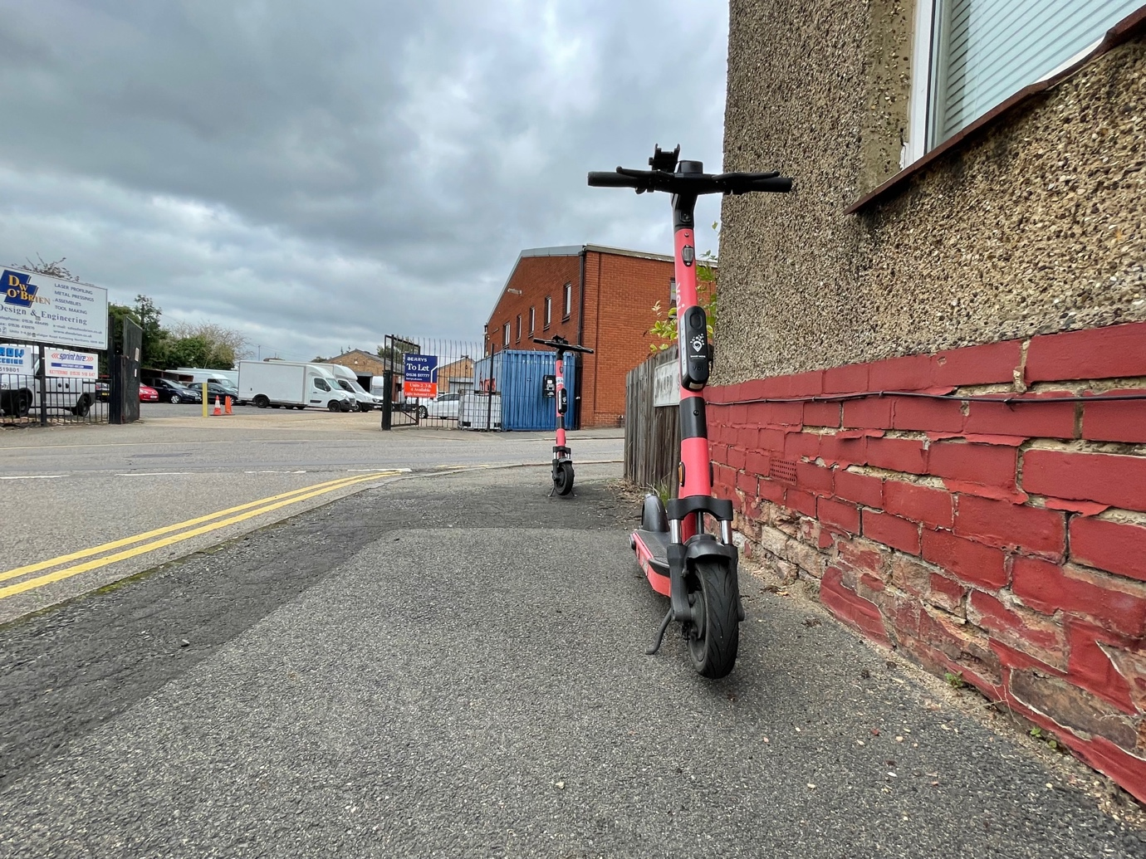
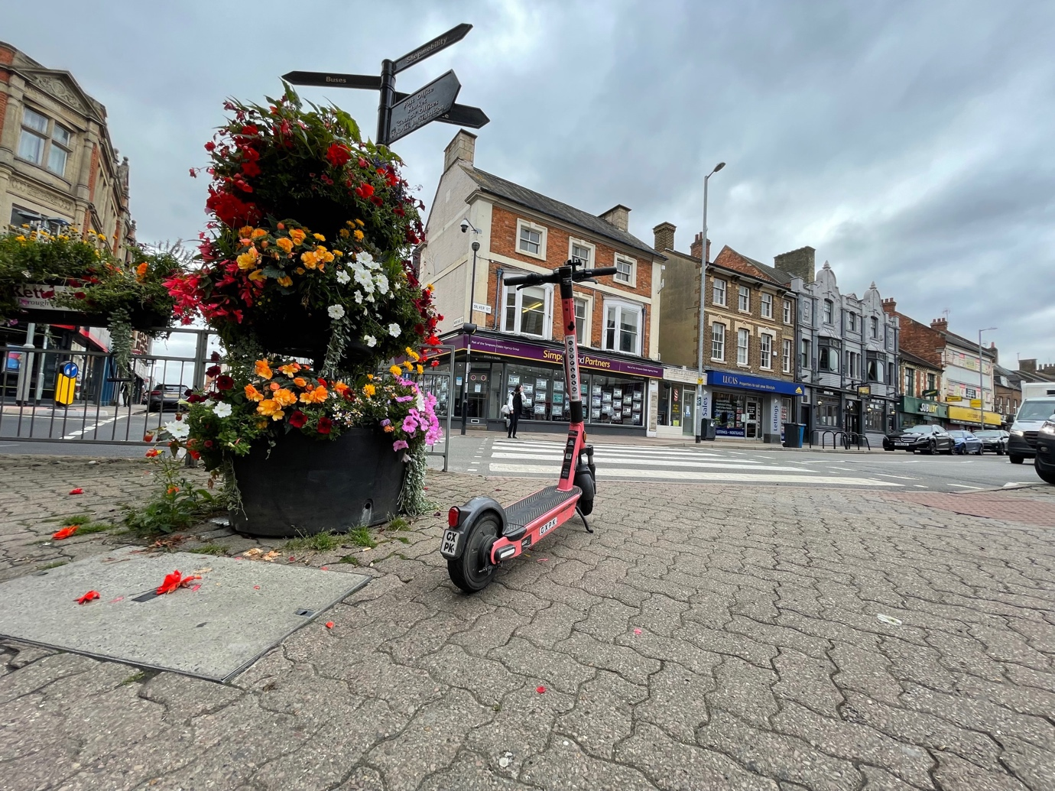

Appendix L Milton Keynes Site Visit E-scooters 25 August 2021

E-scooters were found in unsafe locations, left on pavements, public spaces and next to pedestrian crossings causing obstructions and trip hazards.

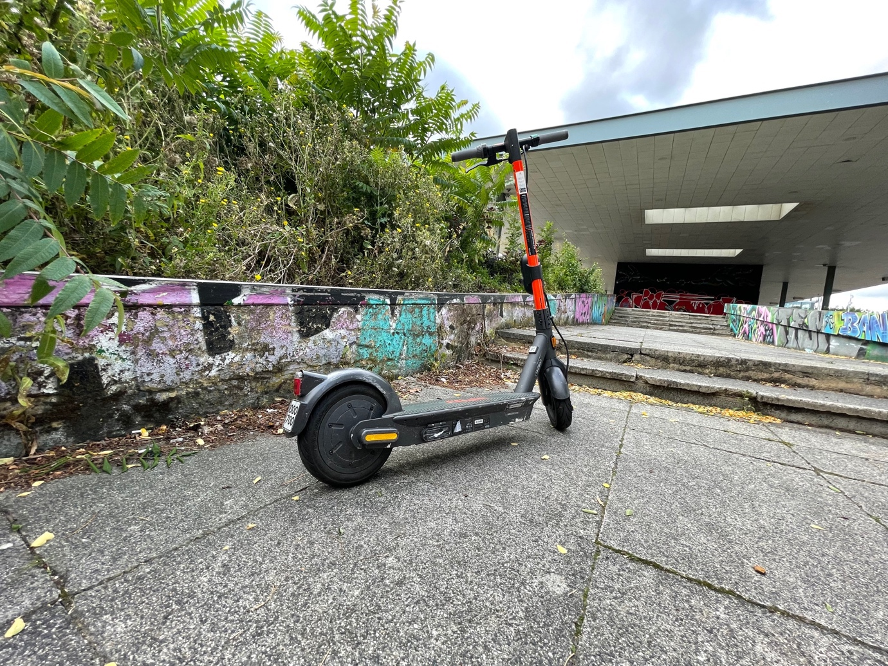

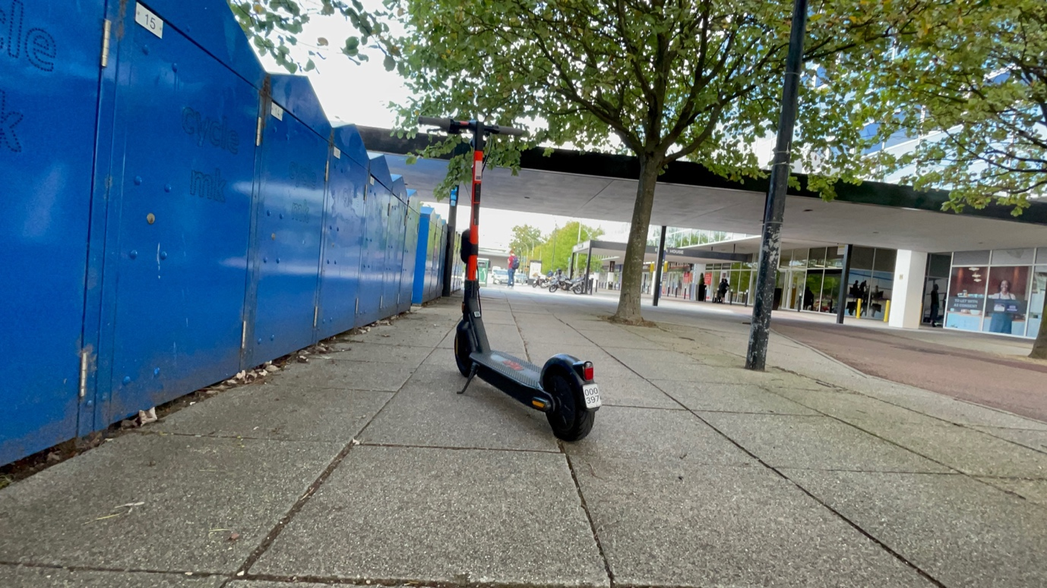
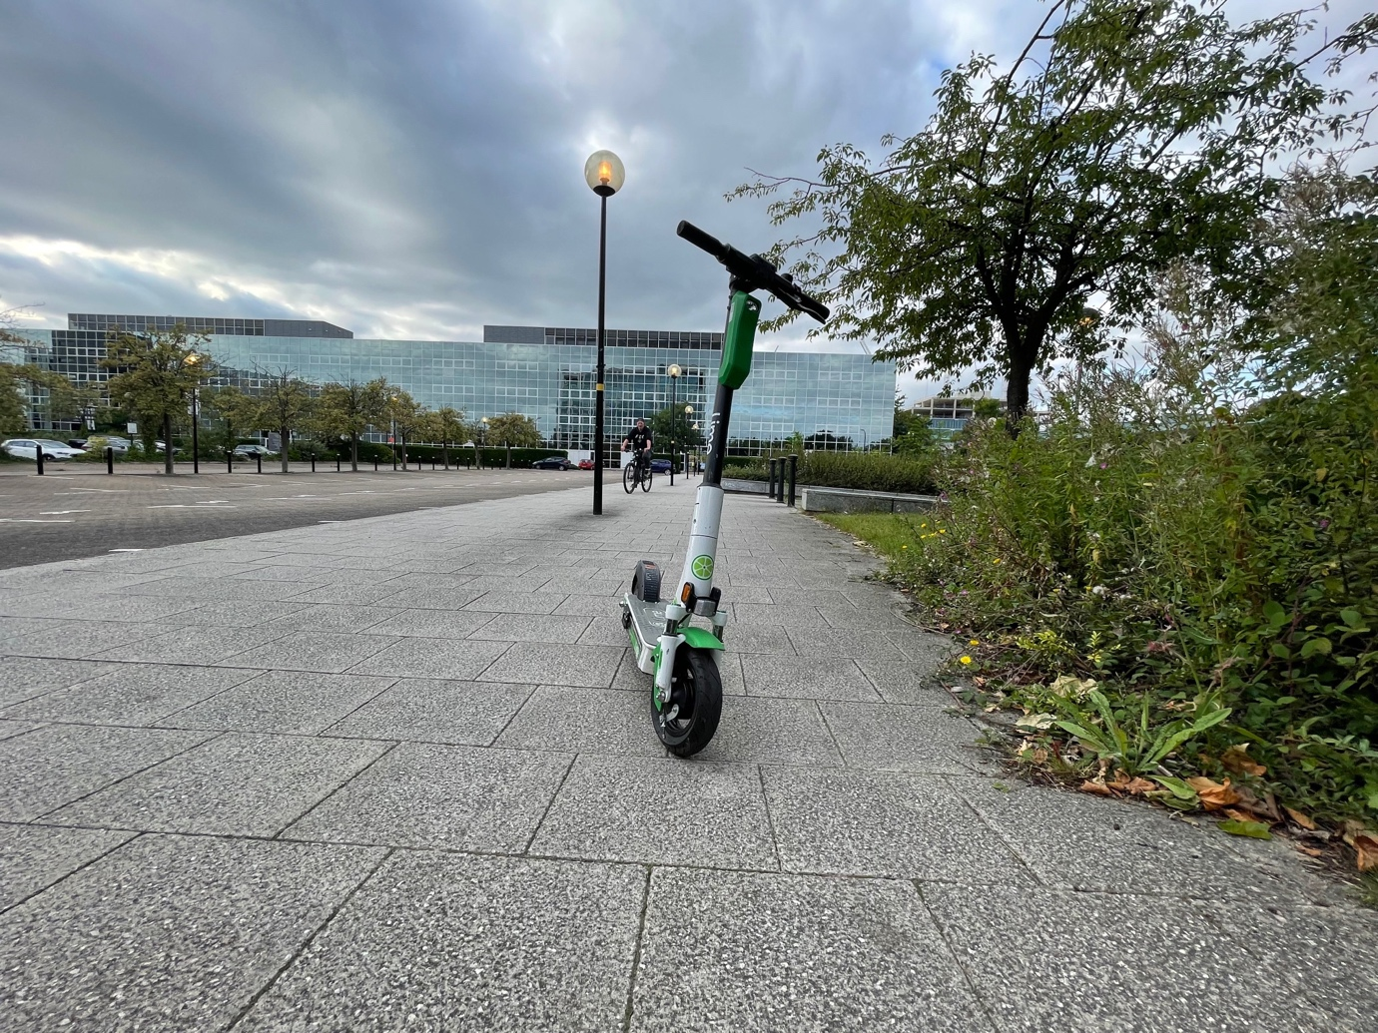

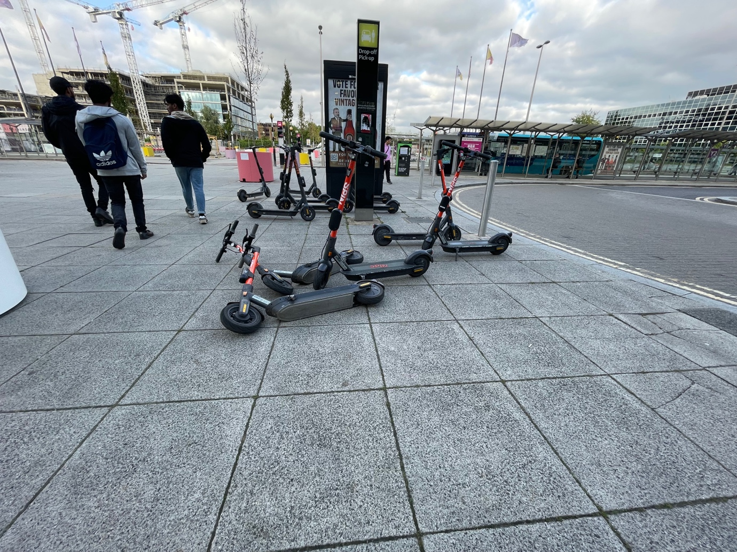

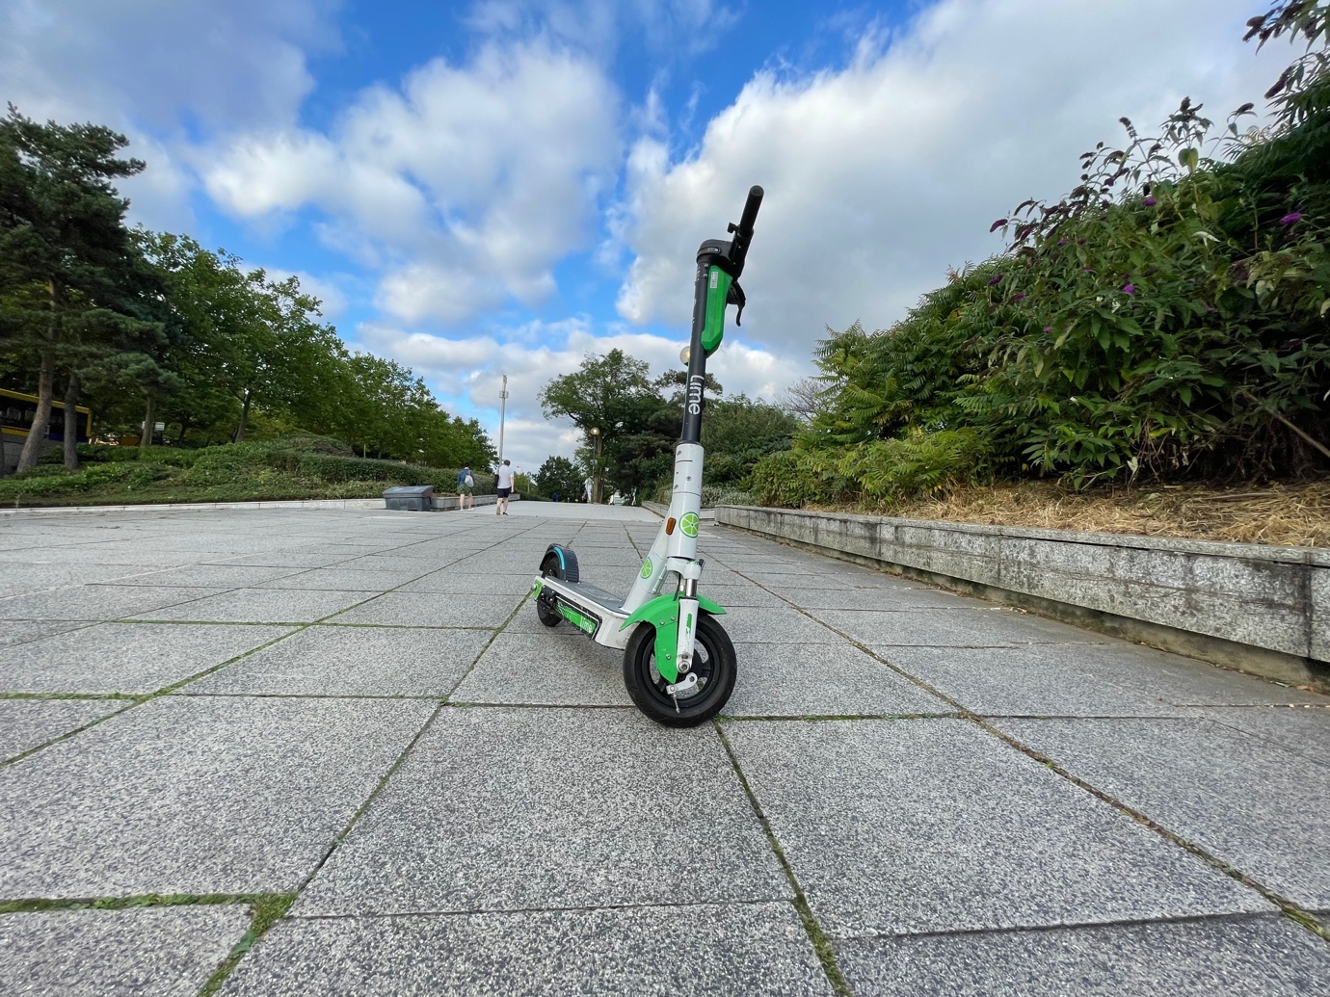

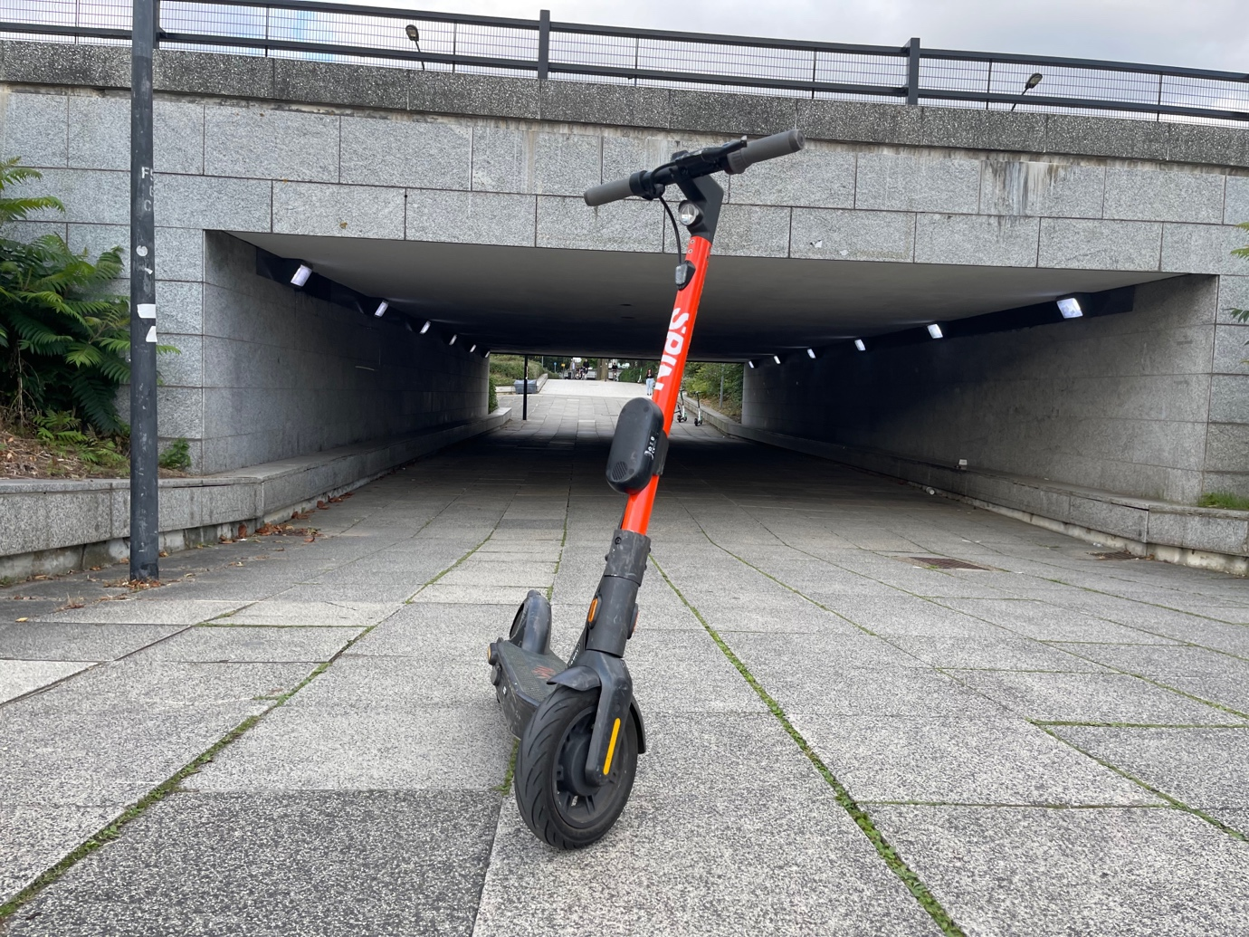
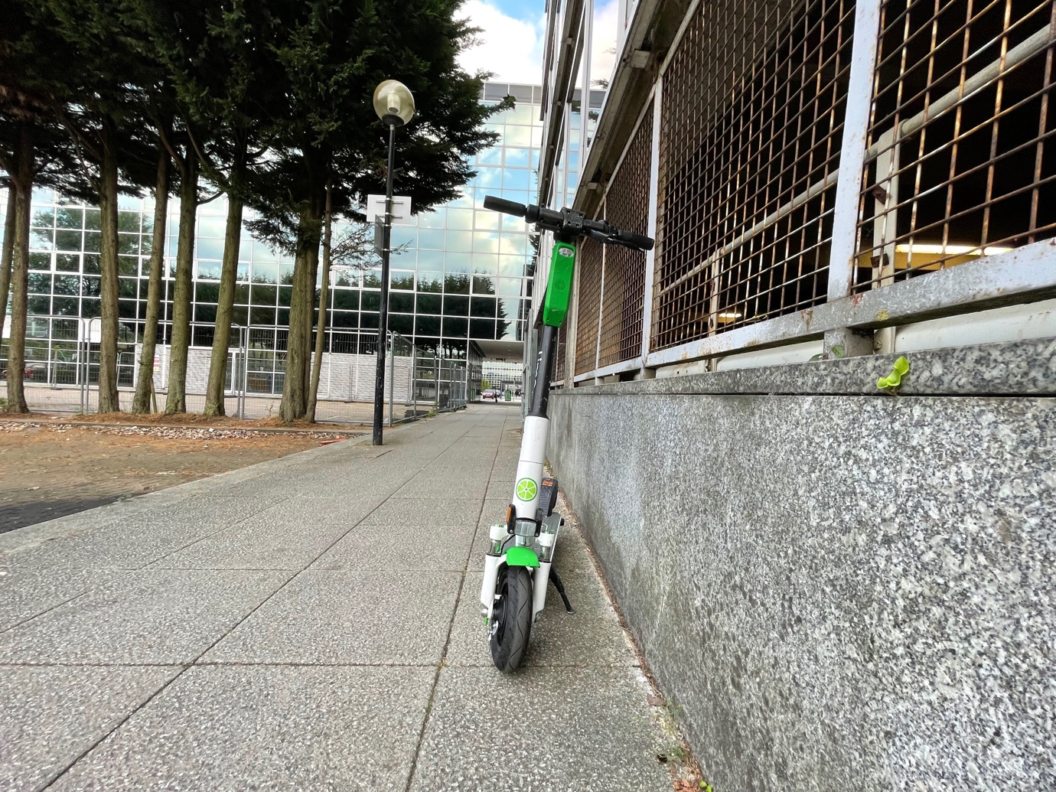

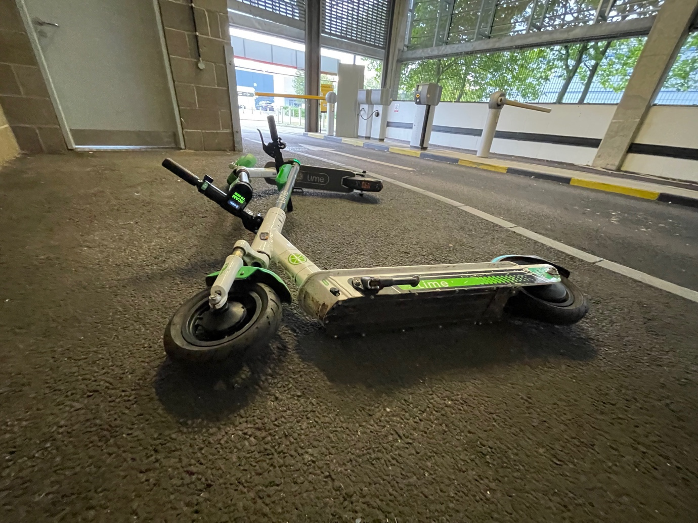
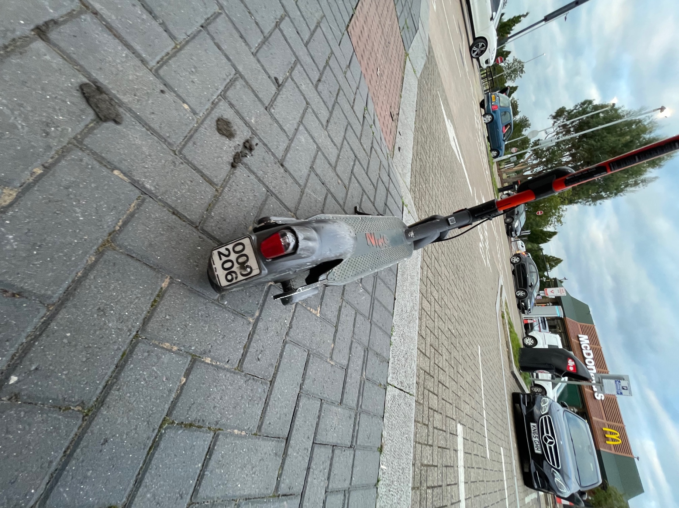

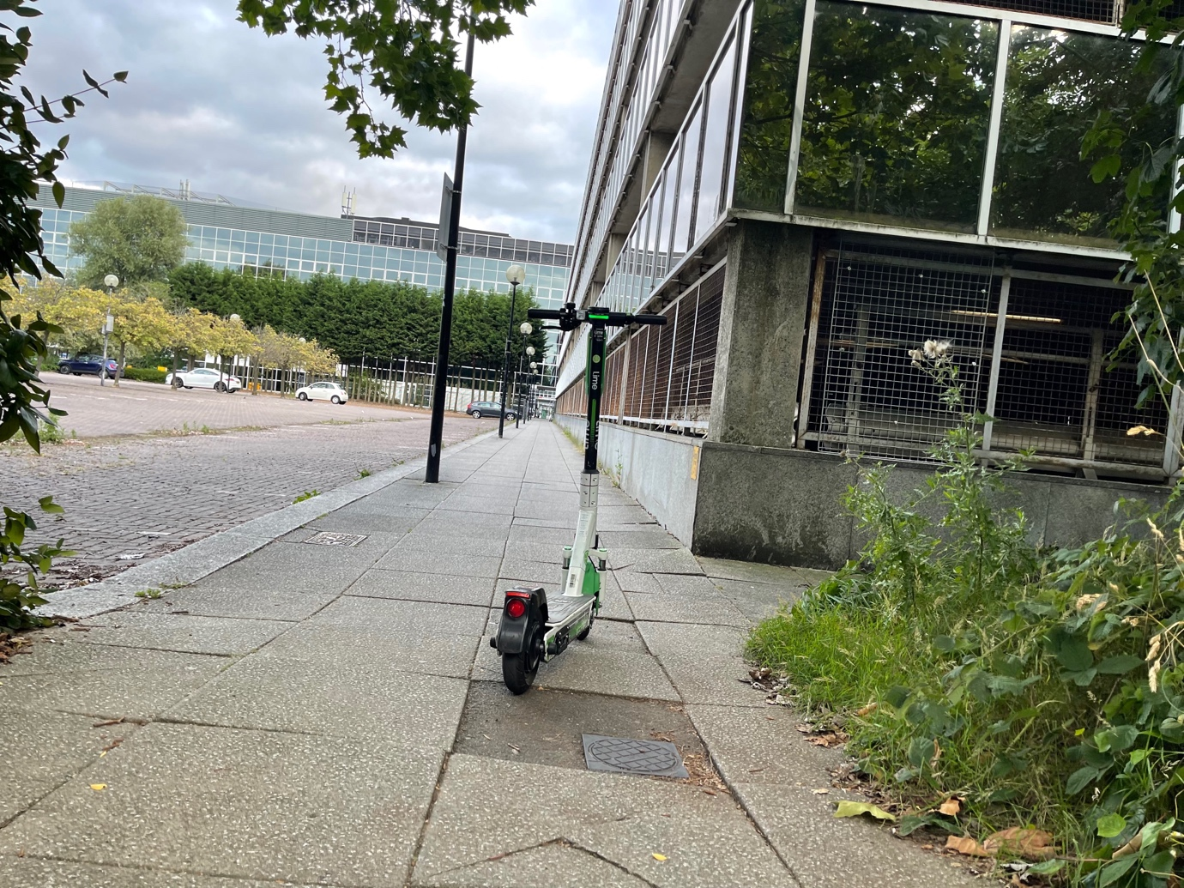

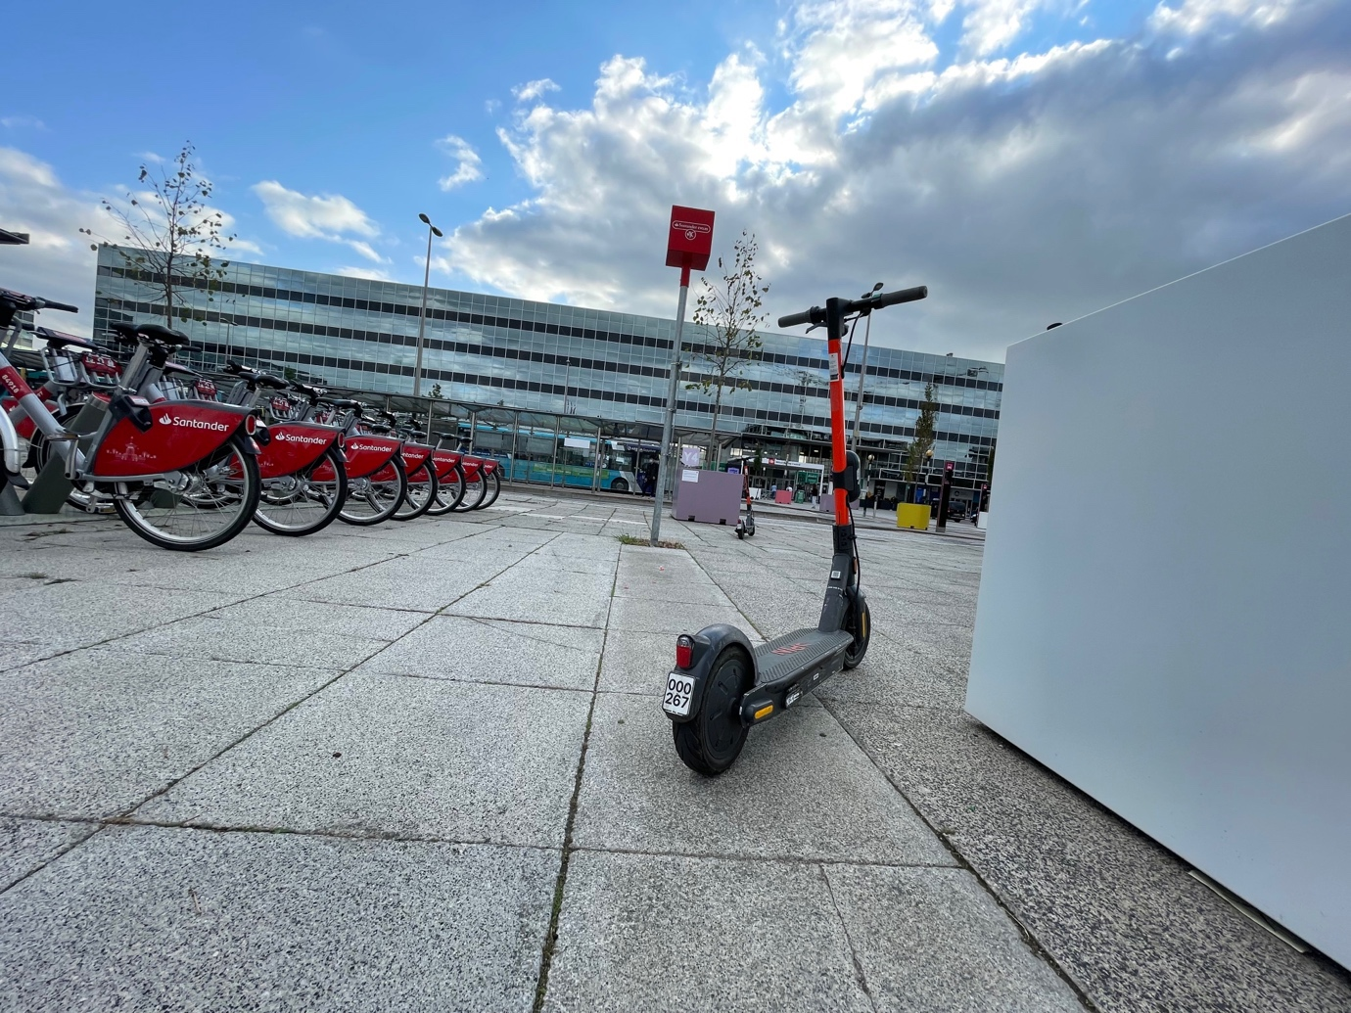

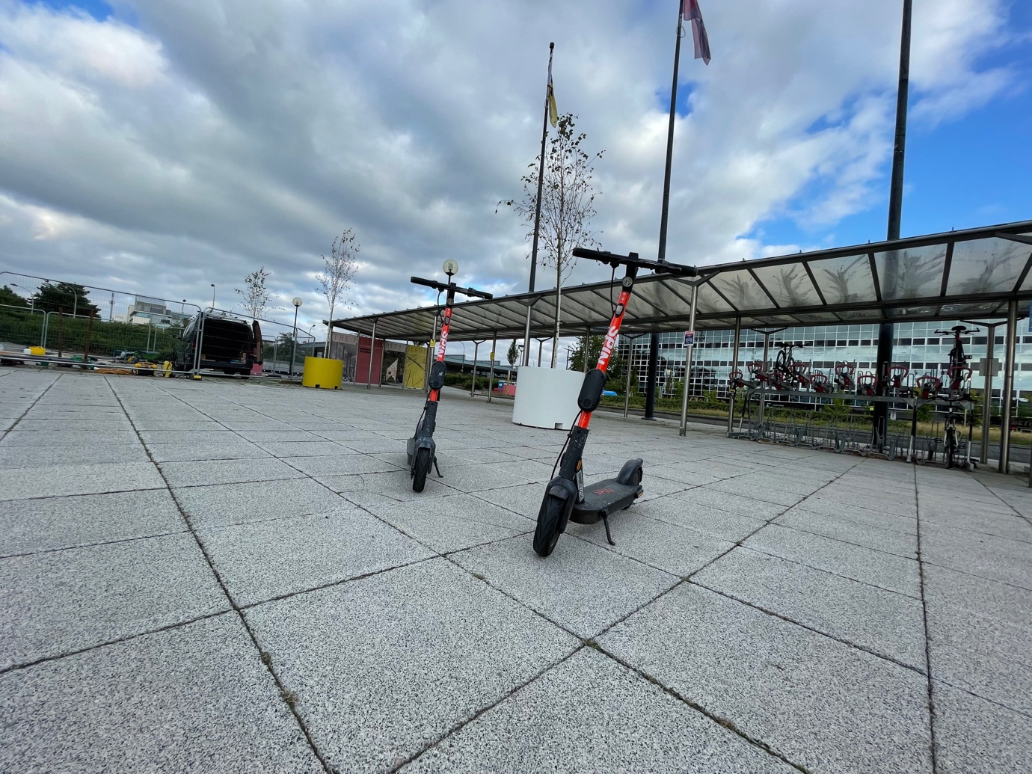

Appendix M Coventry E-scooter Trial 13 September 2020

E-scooters were found in unsafe locations, left on pavements, public spaces and next to pedestrian crossings causing obstructions and trip hazards as well as being ridden in dangerous manner. The photos given below show how the e-scooters were being left / dumped on pavements, at bus stops and in public places.

Site Visit | Appendix Site Visits | Twitter Films Trip & Obstructions | Twitter films Dangerous Riding
Coventry | Appendix M | September 2020 | September 2020  September 2020  September 2020

Photos
14 photos are given below showing e-scooters left in an unsafe location, on pavements, on paths and next to bus stops, causing an obstruction and a trip hazard. E

