Evidence on the Rental E-scooter Trials in England and Private Use of E-scooters

Submitted to Transport Select Committee Inquiry on E-scooters by the National Federation of the Blind of the UK

Appendices Part 2
If further information is required about any of the appendices please contact the NFBUK office admin@nfbuk.org or 01924 291313.

Nottingham | Appendix E a, E b & E c
London | Appendix F a & F b

Appendix E a, E b and E c Nottingham E-scooter Trial Link E-Scooters Site Visit 4 December 2022

This trial has not resolved key safety and accessibility concerns for riders and pedestrians and needs to be halted. The trial has had significant time to resolve safe parking and ensuring riders do not use pavements. This has not happened. The trial needs to be halted. Table 1 below has short films to the concerns raised in the trials. Photos are given below.

Parking / dumping of e-scooters
E-scooters were observed in unsafe locations, found in an unsafe manner causing obstructions and trip hazards on the pavement, public places and next to bus stops.
- Left on pavements, in the middle of the pavement, on the kerb line, on the building line, on dropped kerbs, leading up to pedestrian crossing points and left close to tactile paving for use by blind and visually impaired pedestrians.
- E-scooters were found knocked over.
- E-scooters were found left next to bus stops creating trip hazards and obstructions for anyone needing to use public transport.
- One parking rack was observed however the rack posed a trip hazard for blind and visually impaired pedestrians and an e-scooter was found close to the parking rack but left on the pavement, with e-scooters knocked over on the pavement next to the rack. Illustrating how ineffective the parking racks are for safe storage of the e-scooters when not in use. Also the rack was on the pavement meaning riders would ride to and from this area on the pavement, which is not safe or accessible for pedestrians.

Safety of E-scooters Several the number plates were missing.

Riding of e-scooters
E-scooters were observed been ridden on the pavements at speed, on pedestrian crossings, two people riding e-scooters and riders were not wearing helmets.

Appendix E Table 1: Evidence on rider behaviour, trip hazards and obstructions from dumped e-scooters on pavements and public spaces and concerns raised on the safety of the maintenance of the rented e-scooters in Nottingham Trial.
Site Visit | Appendix Site Visits | Twitter Films Trip & Obstructions | Twitter films Dangerous Riding | Twitter Films E-scooter Safety Concerns
Nottingham | Appendix E | December 2022  May 2022  March 2022  February 2022  February 2022  October 2021  October 2021  September 2021  September 2021  September 2021  September 2021  September 2021  September 2021  September 2021  September 2021  September 2021  September 2021  September 2021 | January 2023  May 2022  March 2022  September 2021 | October 2021  October 2021  October 2021  September 2021  September 2021  September 2021  September 2021  September 2021  September 2021  September 2021  September 2021  September 2021  September 2021  September 2021  September 2021  December 2020 – to words of select committee report
Photos
32 photos are given below showing e-scooters left in unsafe location on the pavement, next to pedestrian crossings, next to bus stops and knocked over. Creating obstructions and trip hazards for pedestrians.
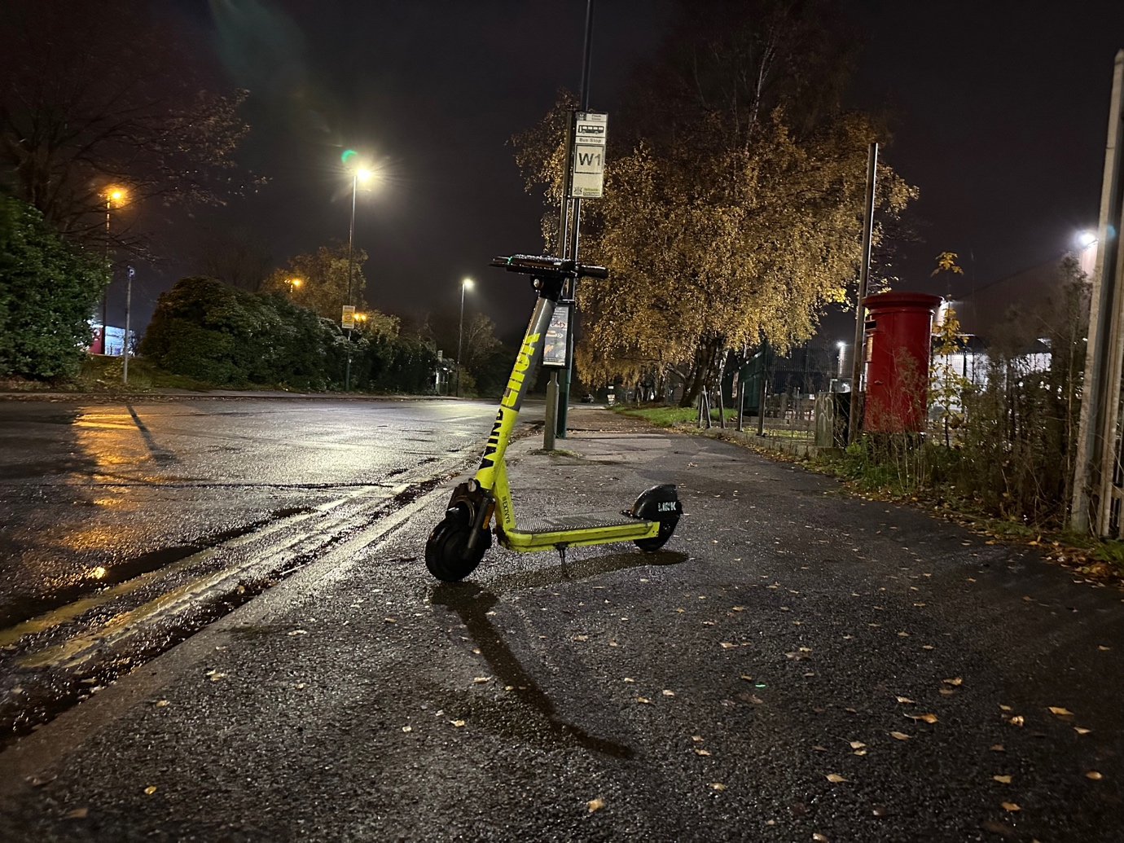

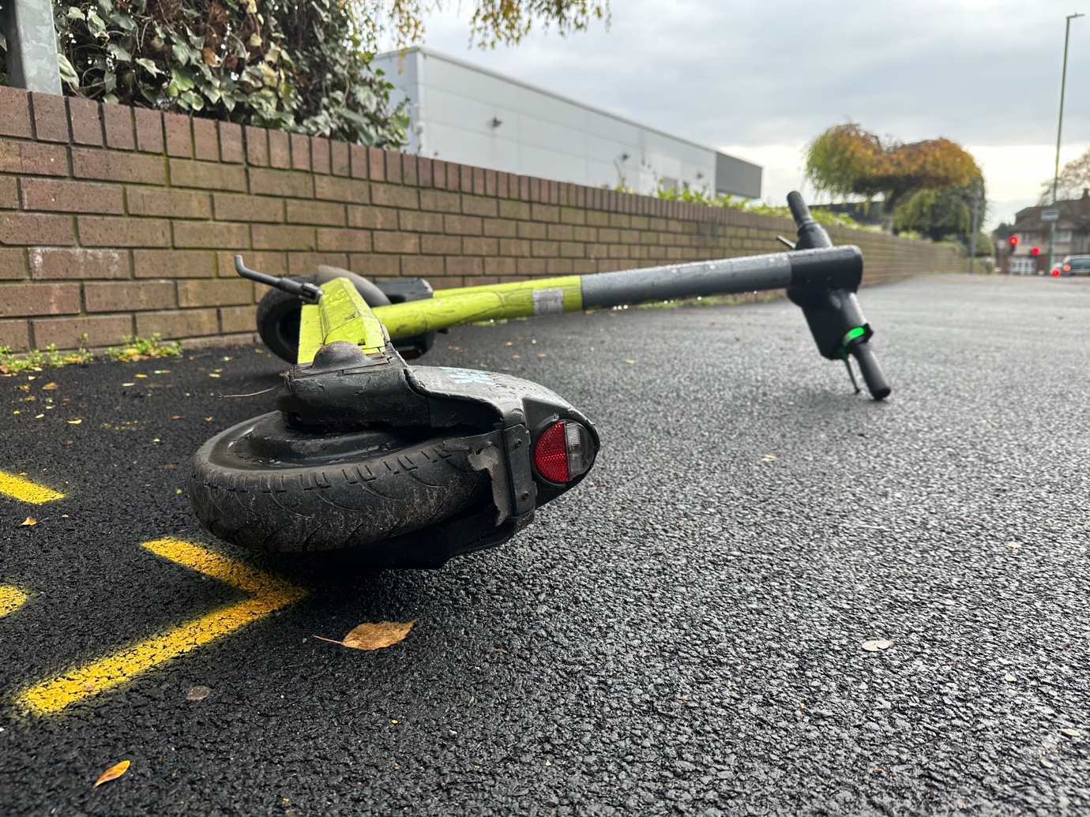

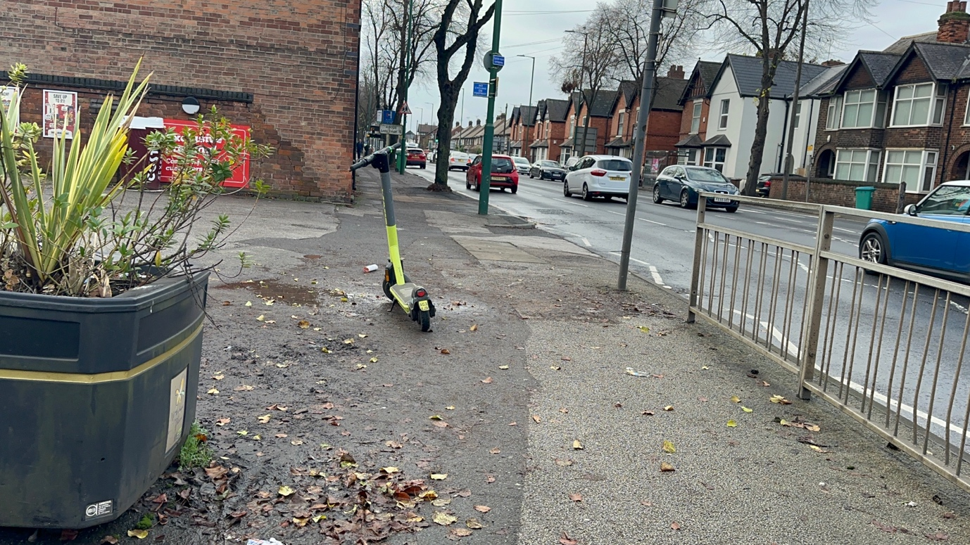
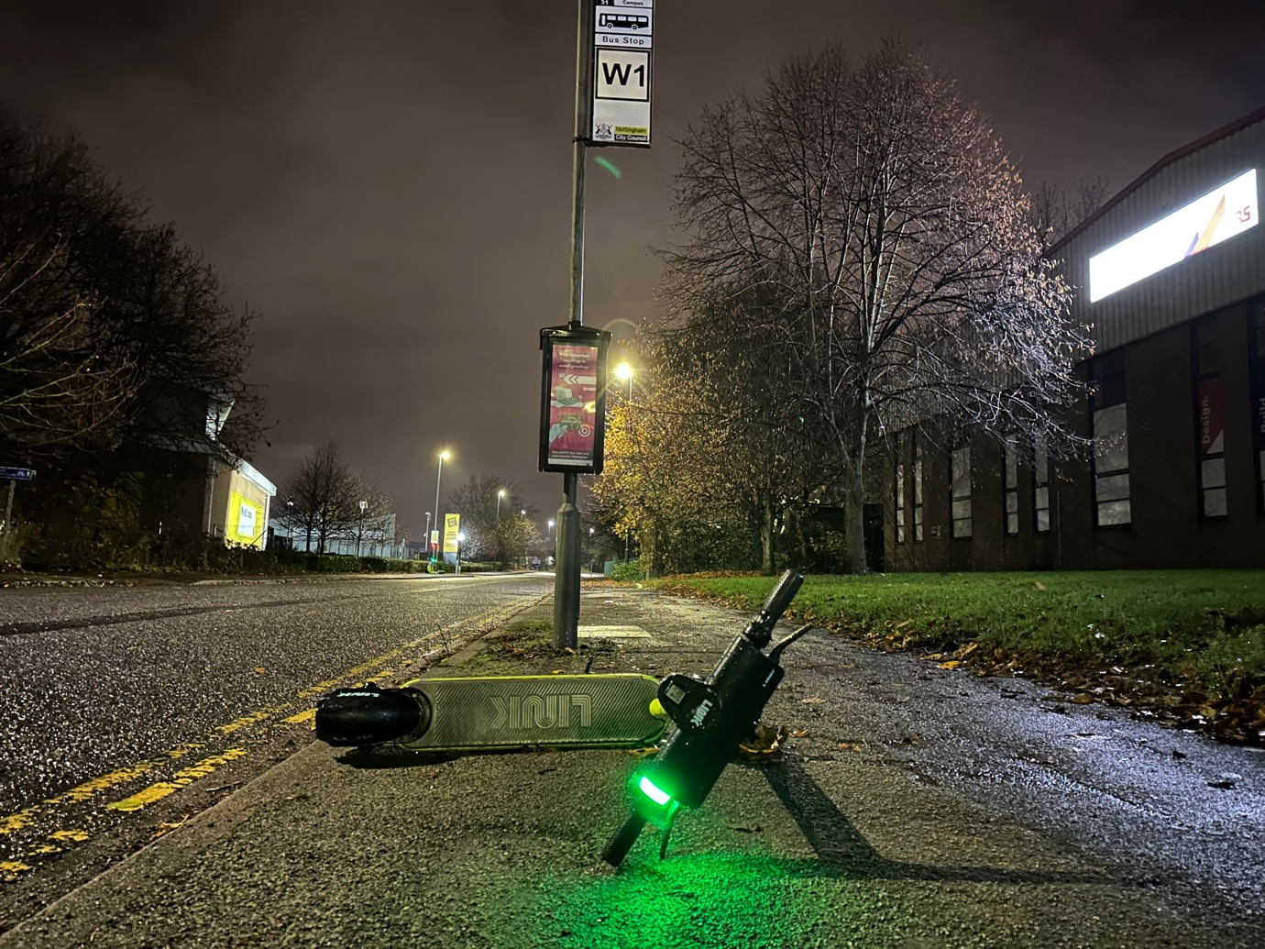

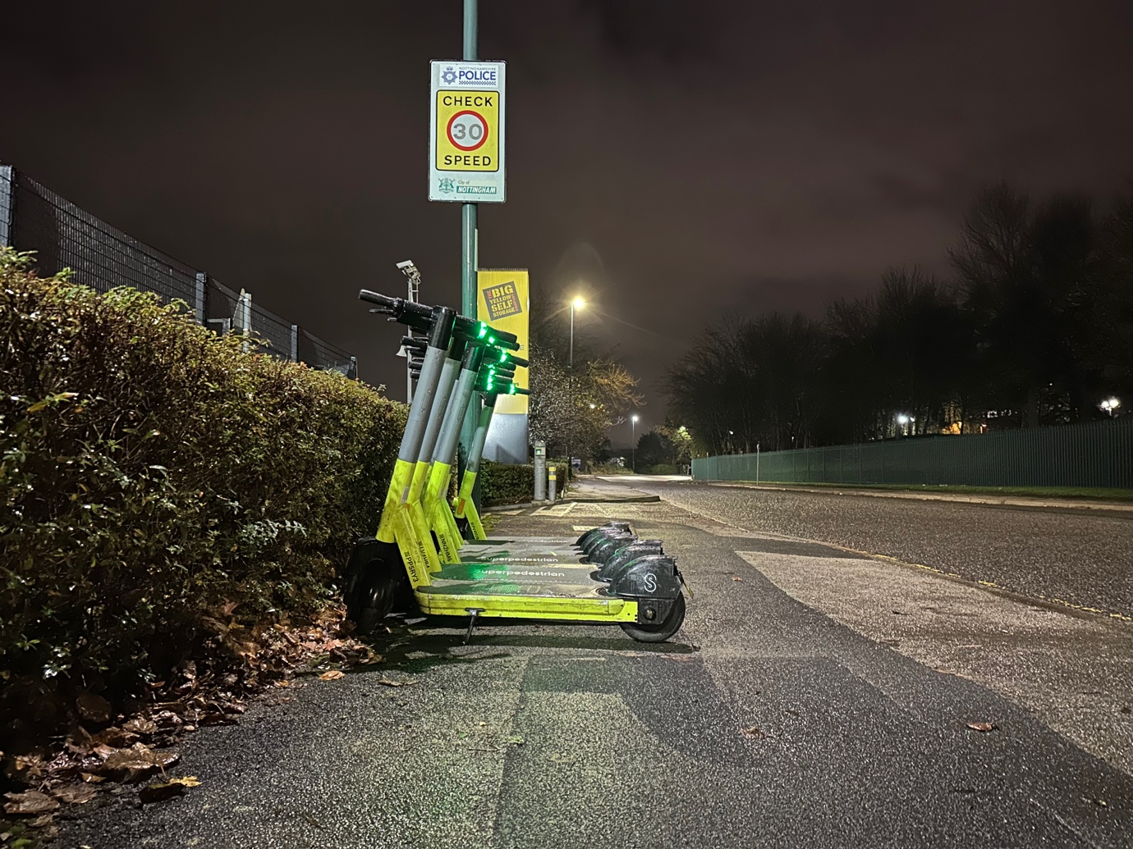
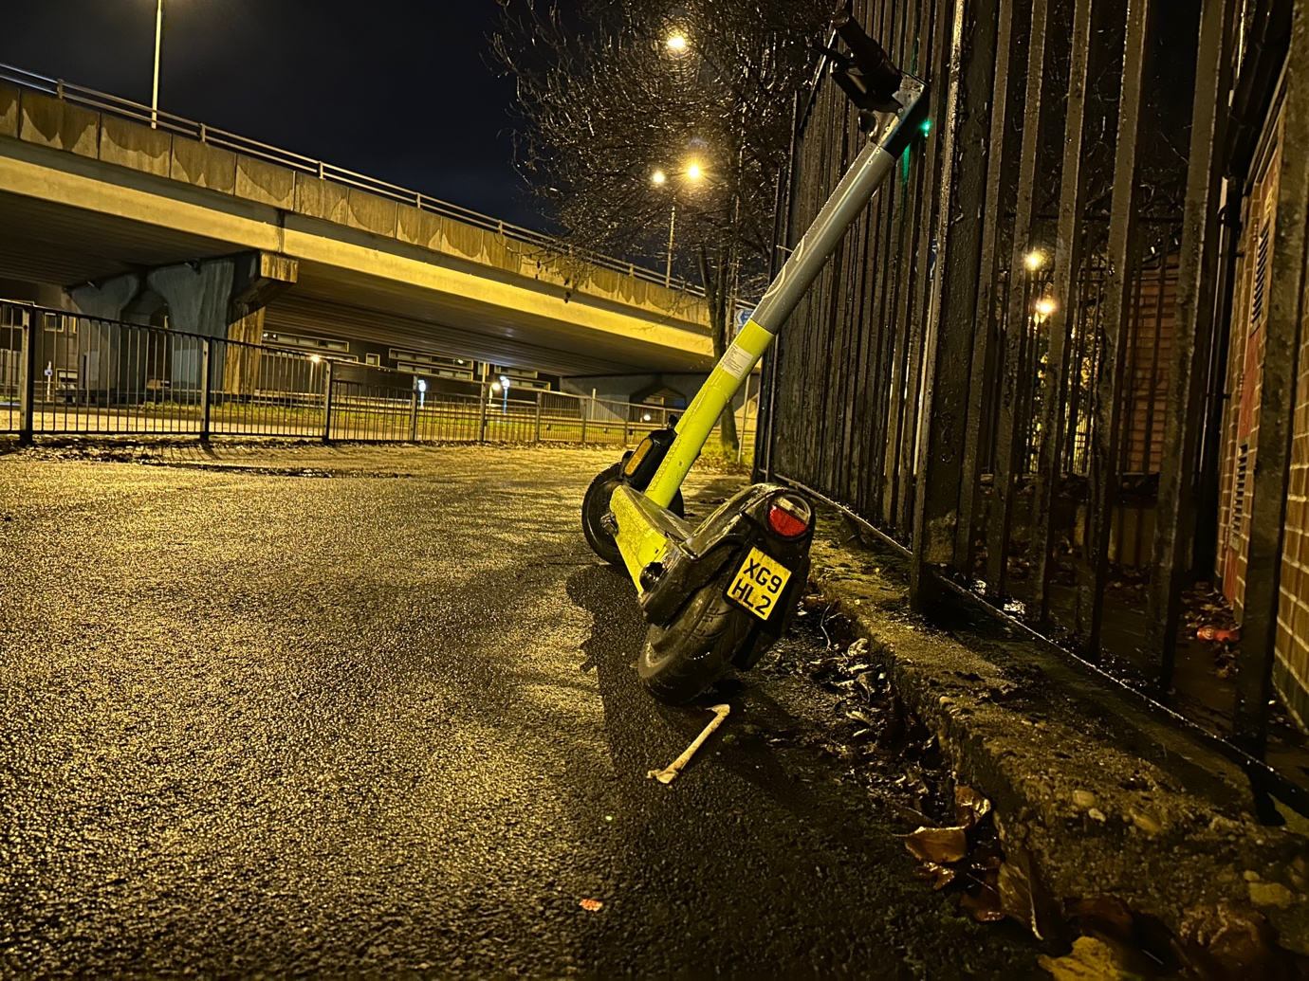

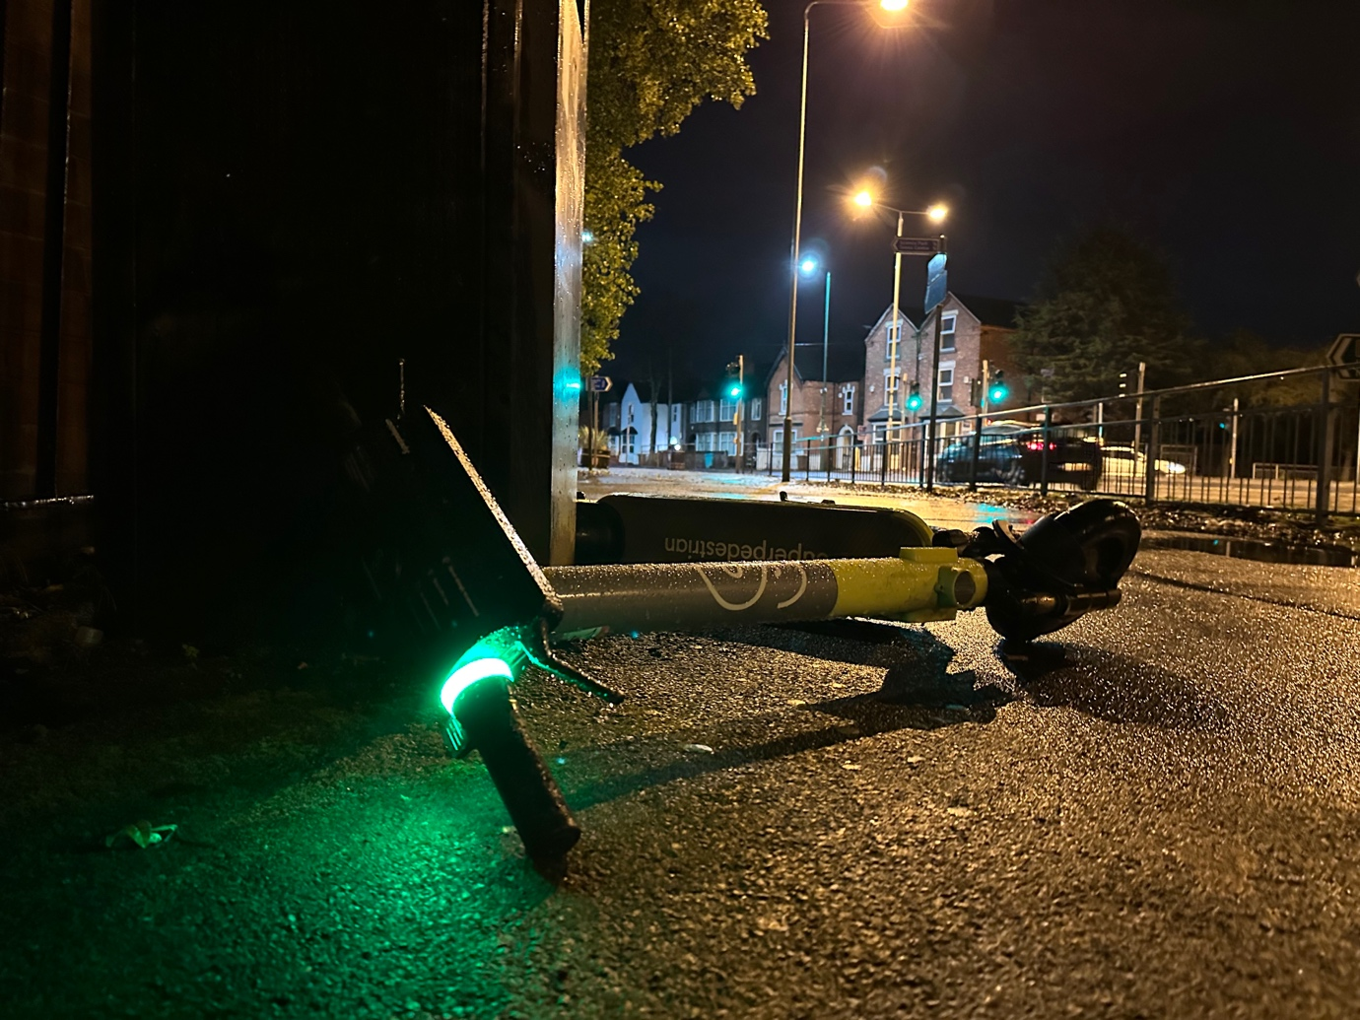
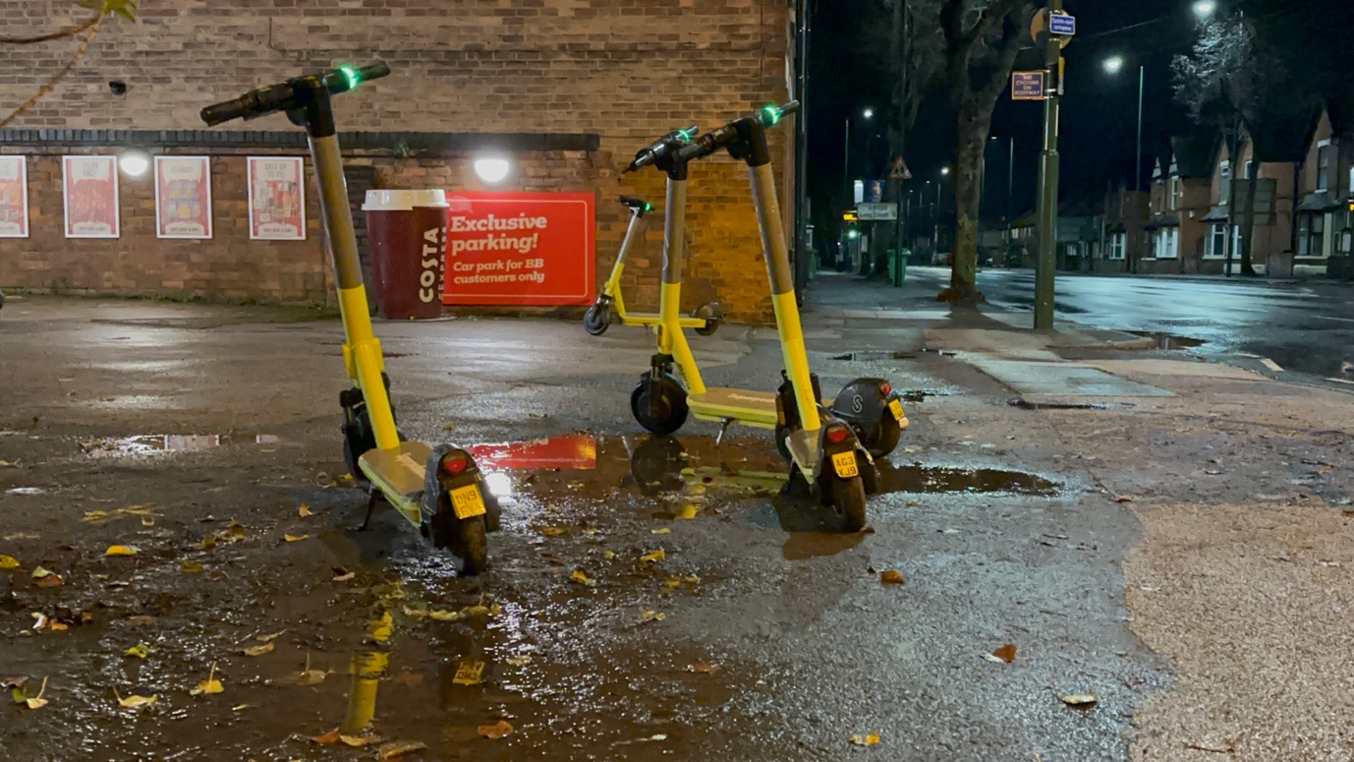

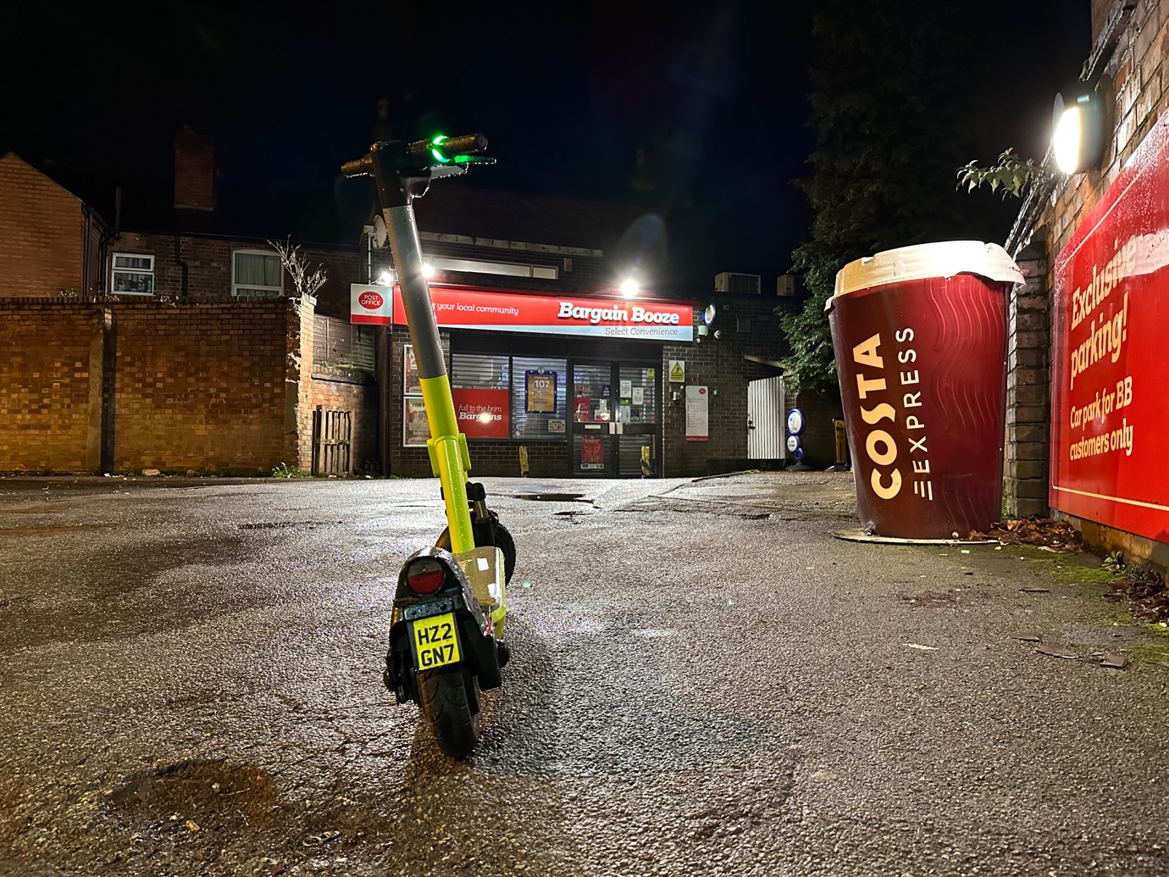
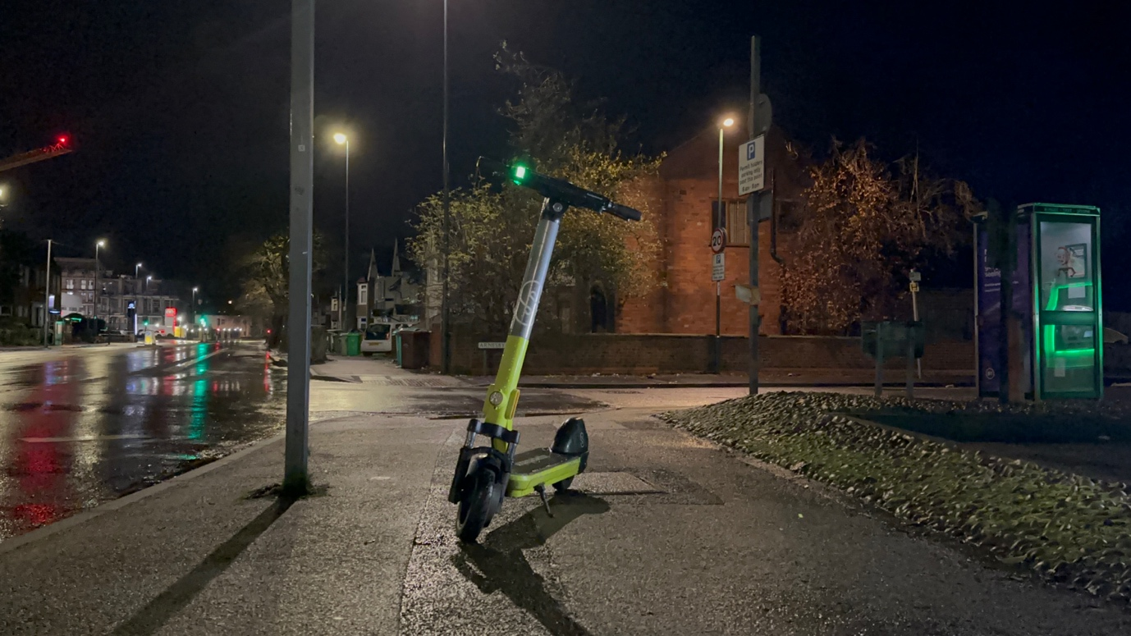

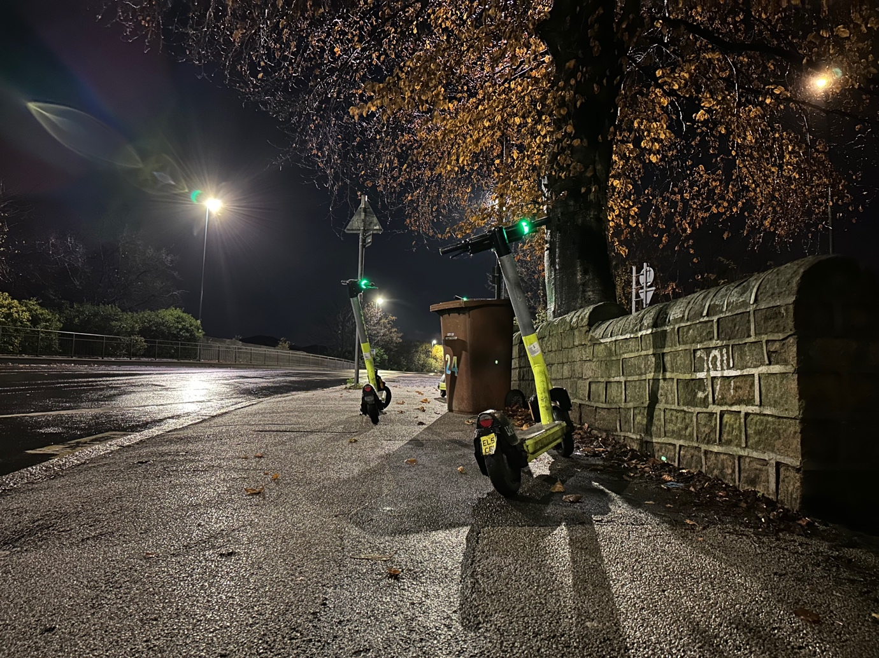
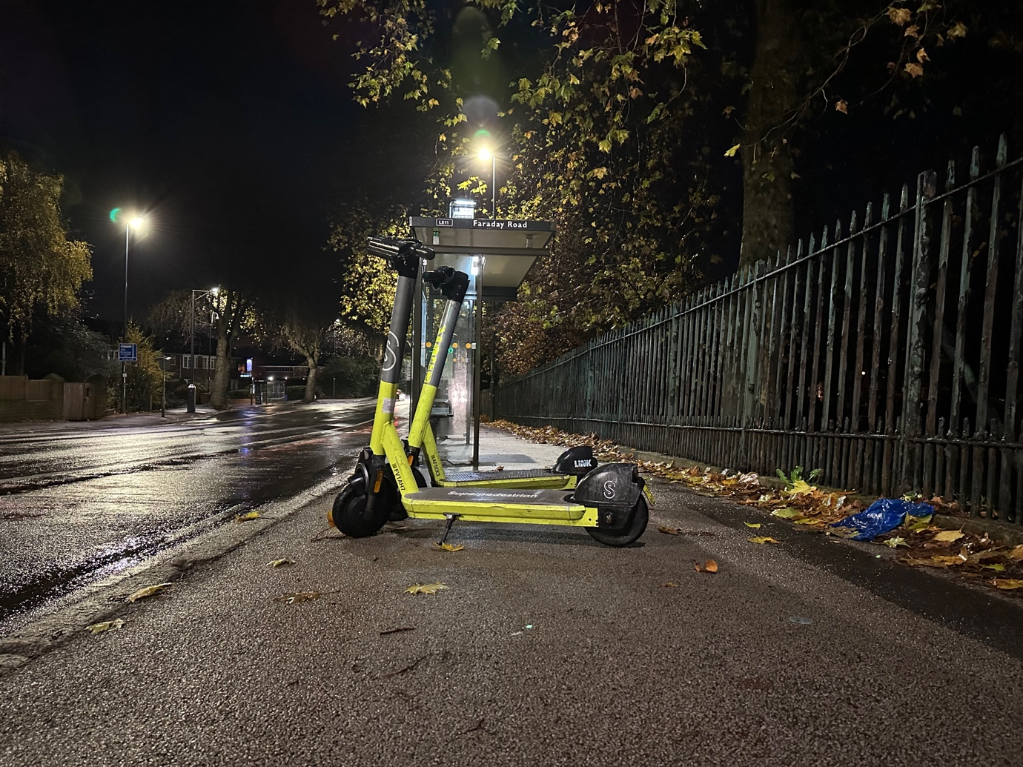

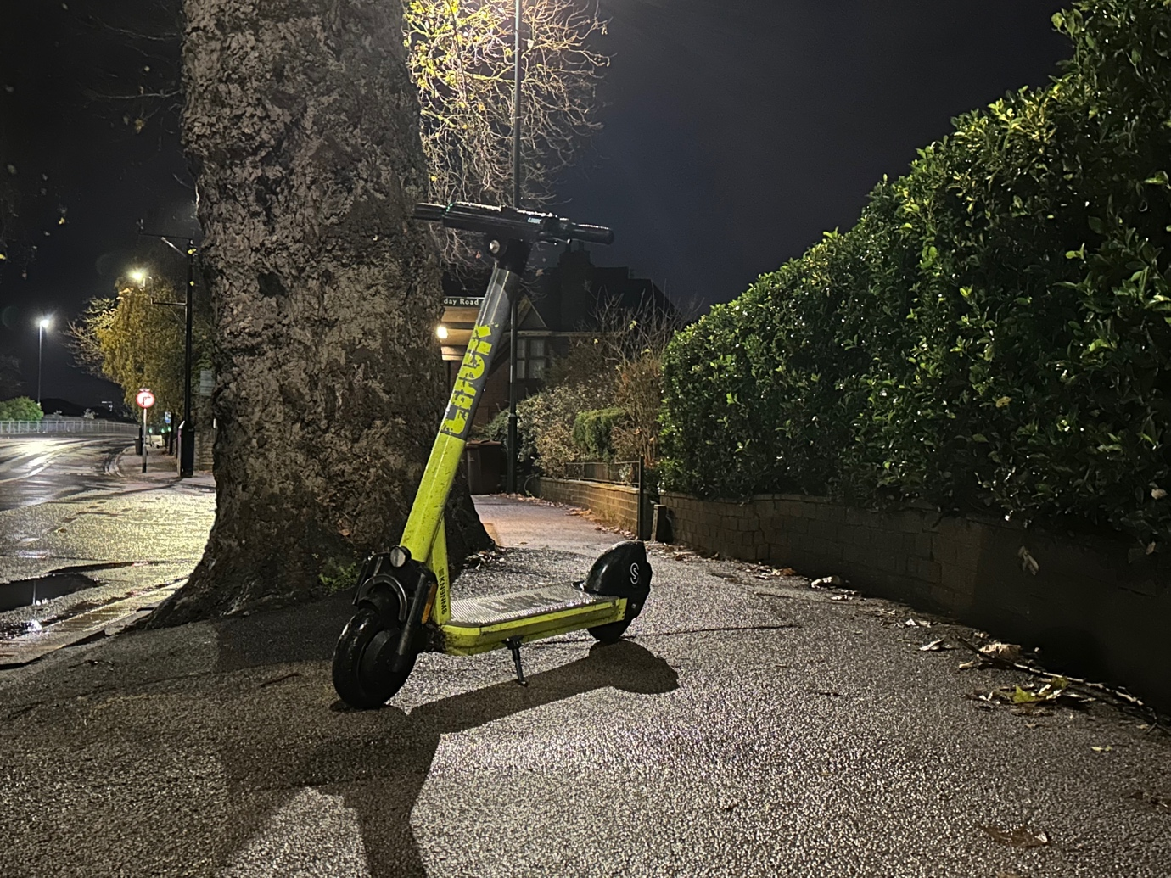
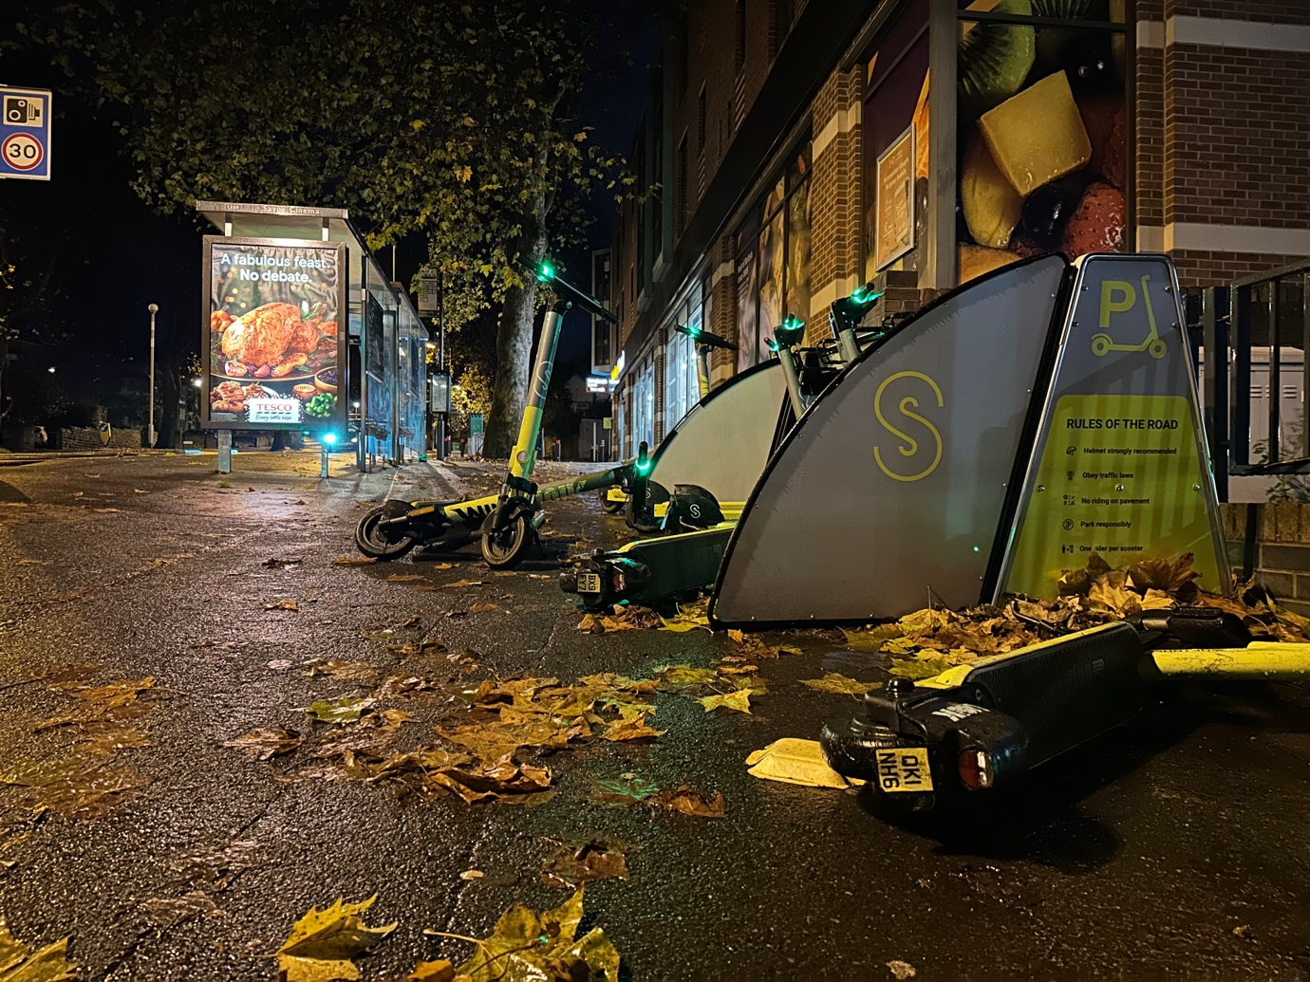

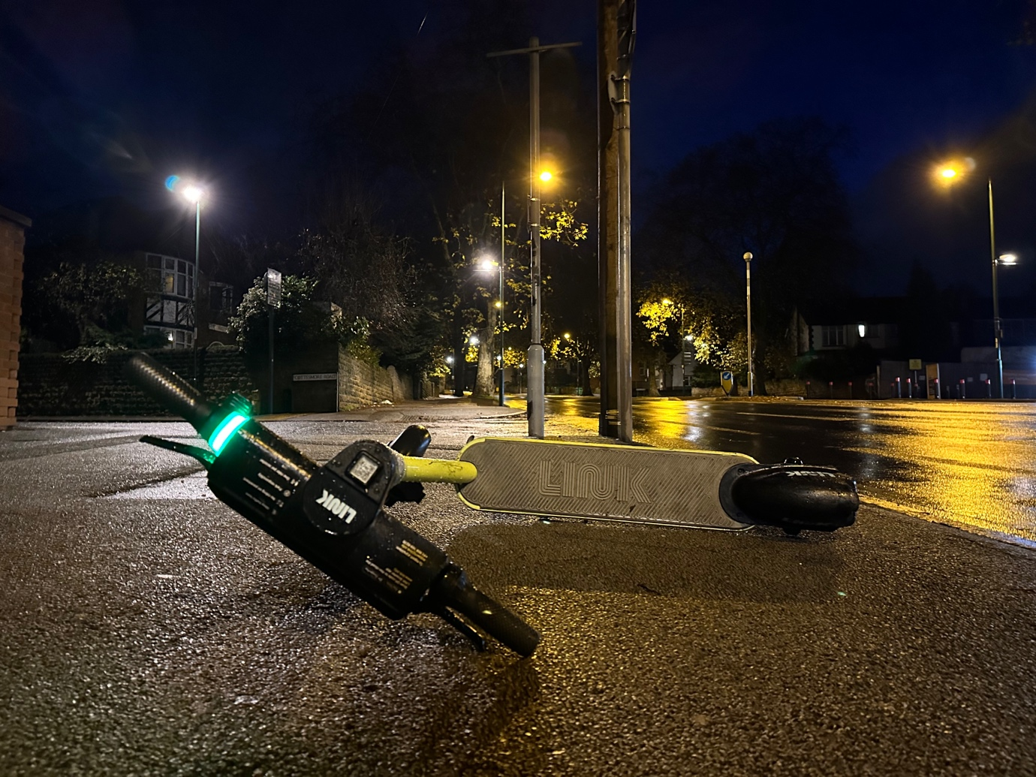

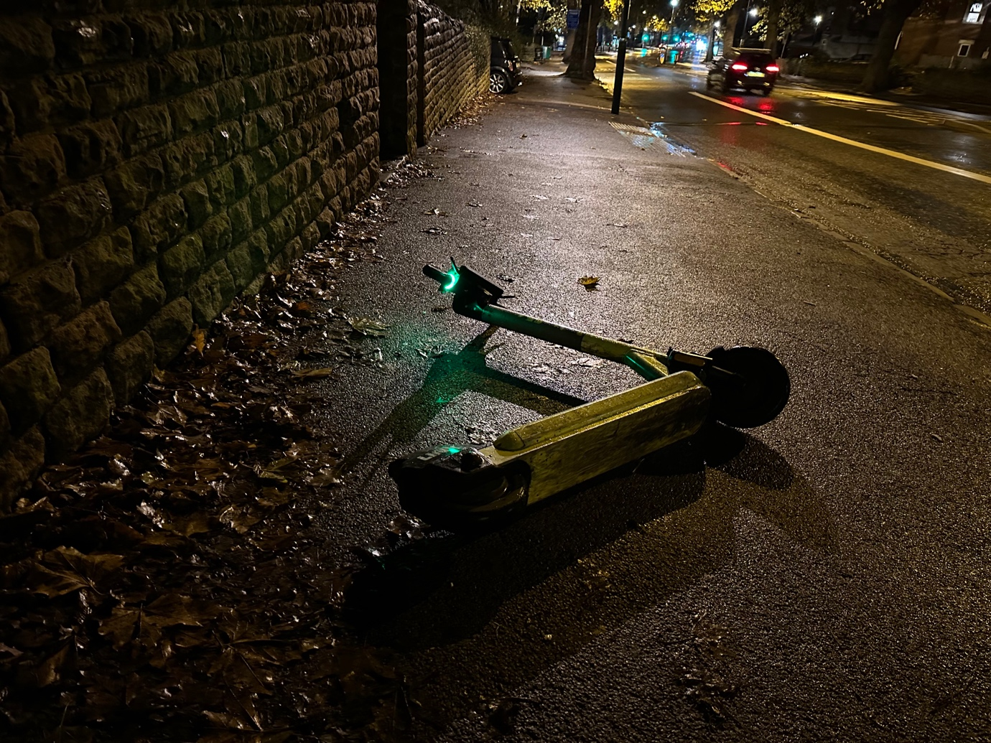
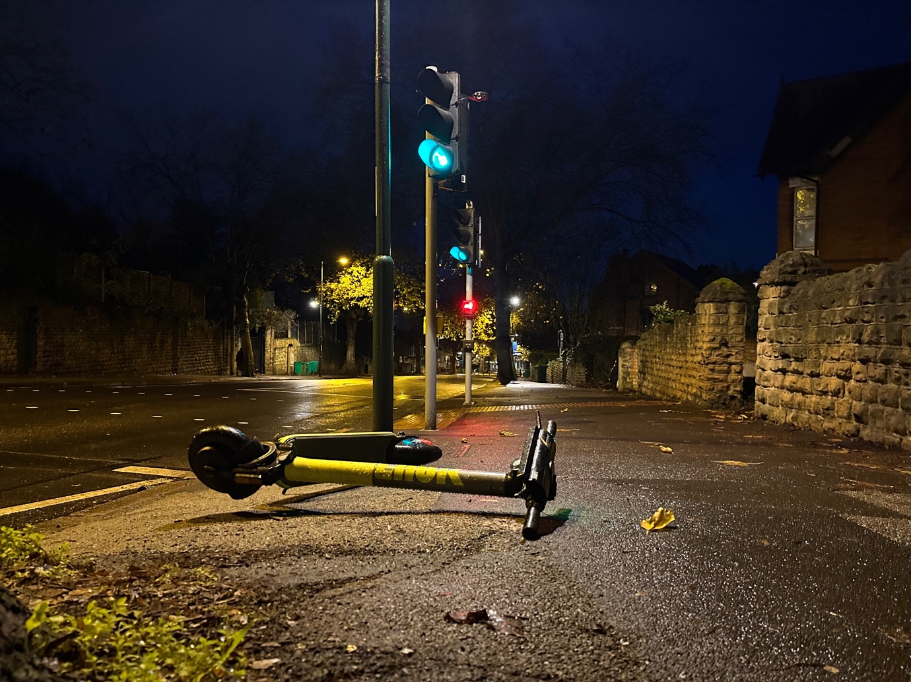
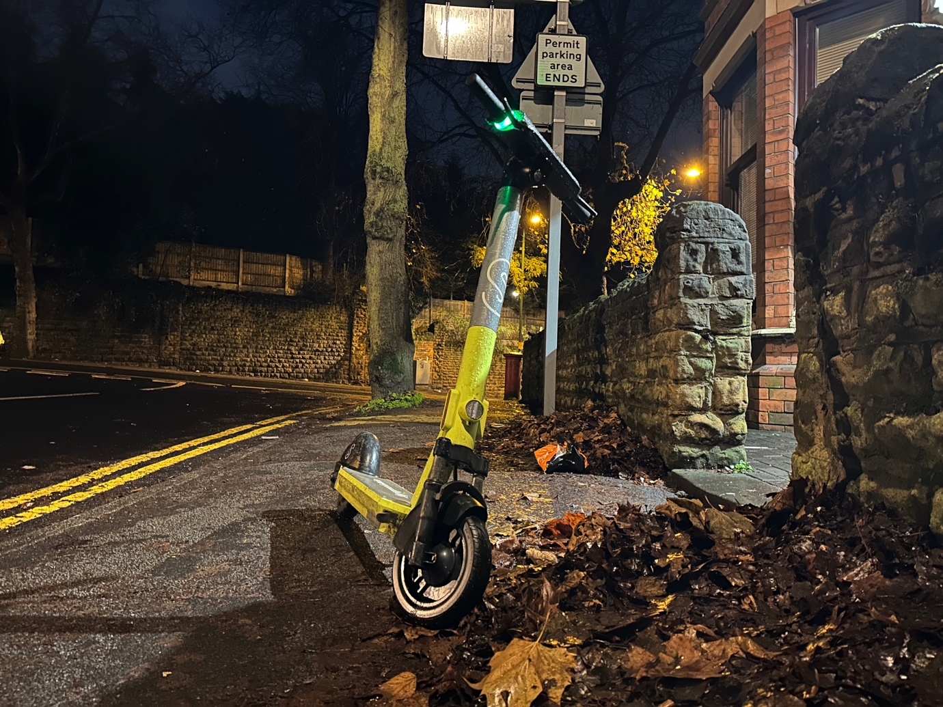

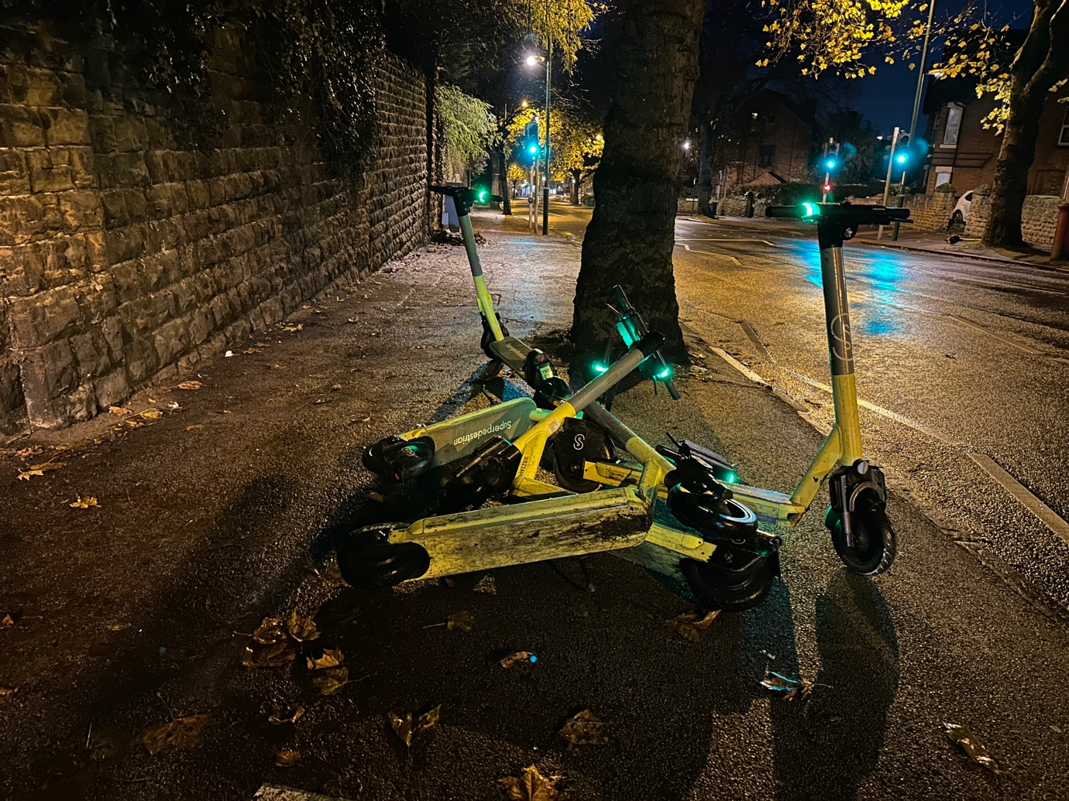
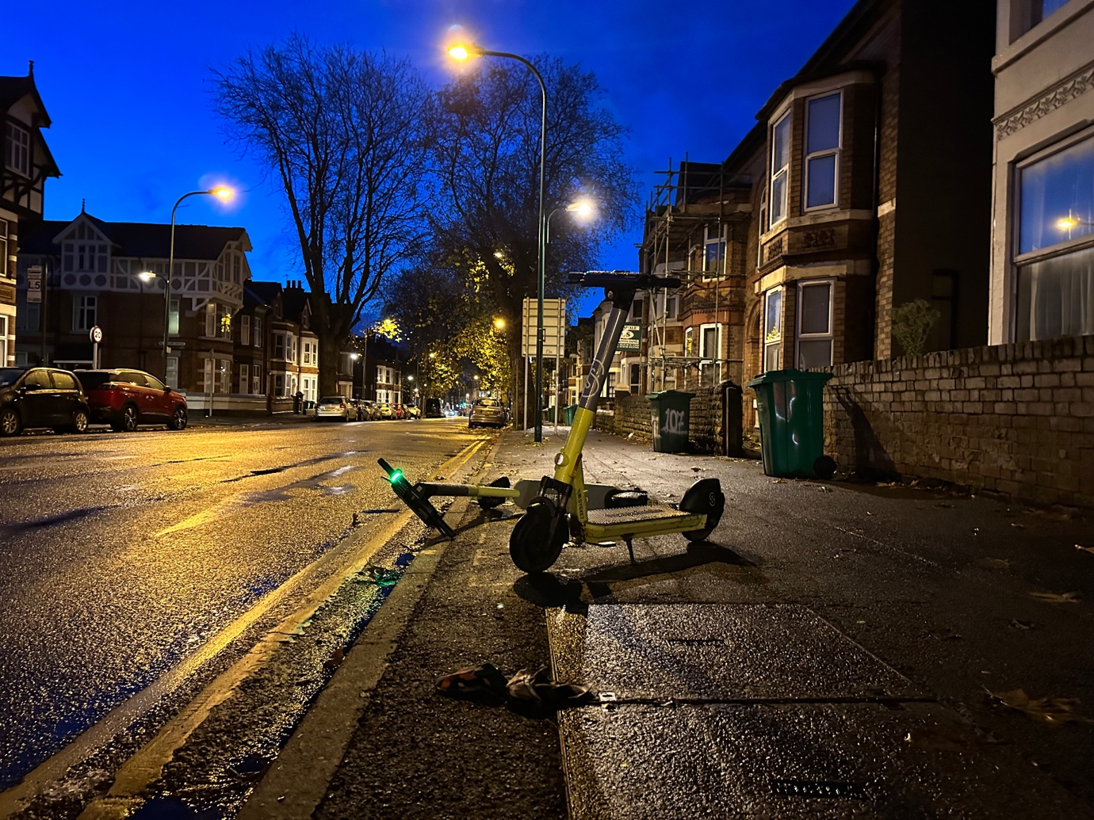
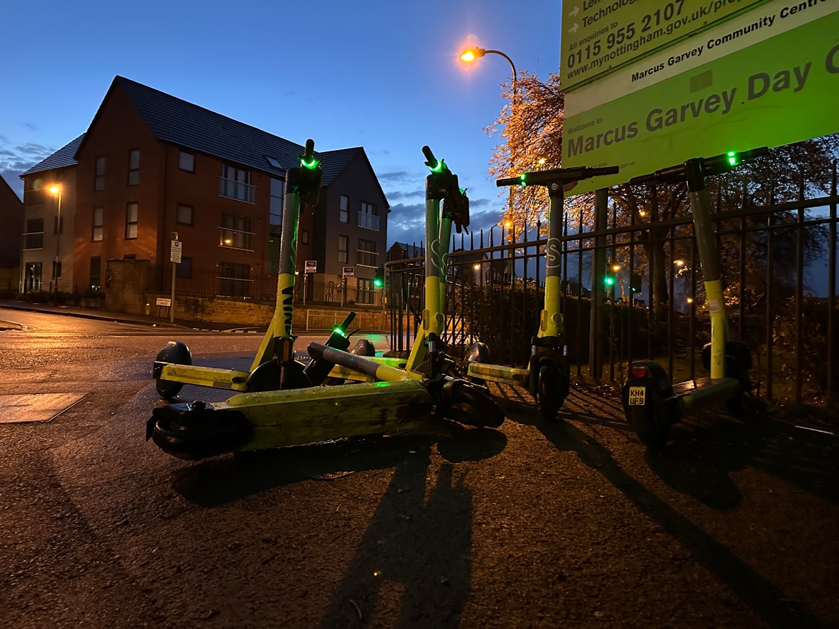
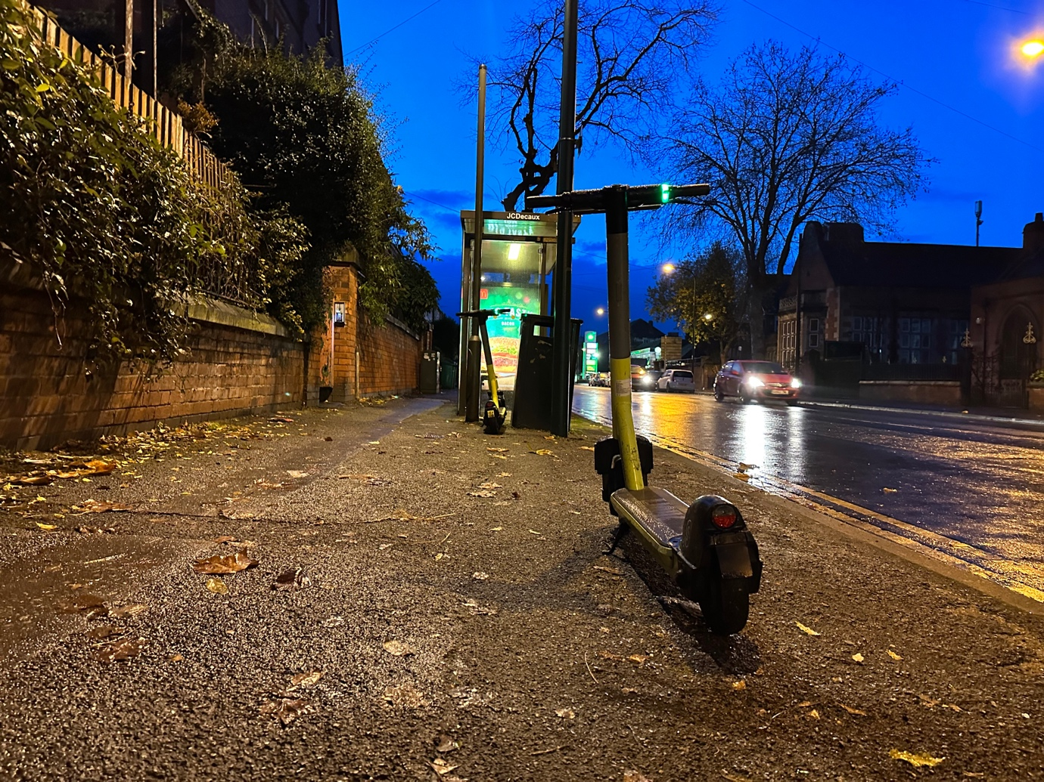

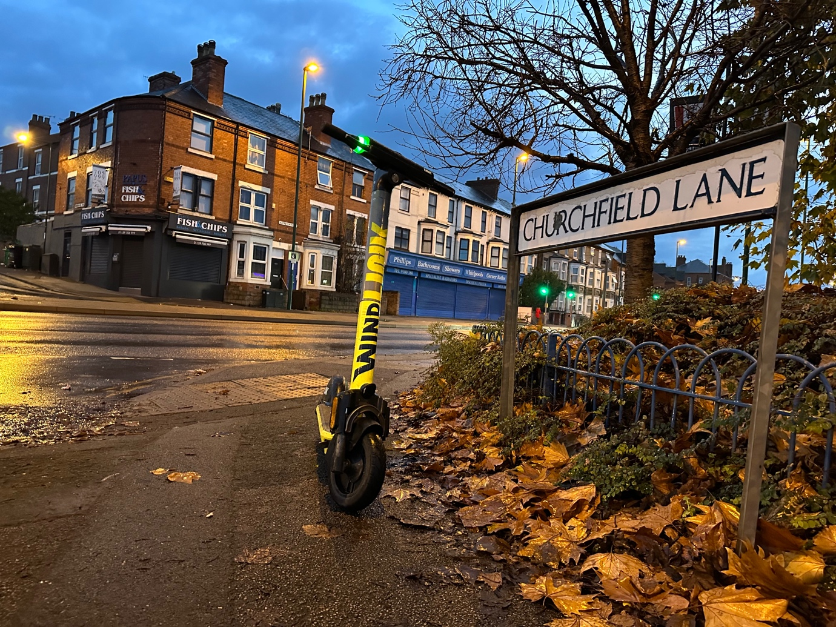
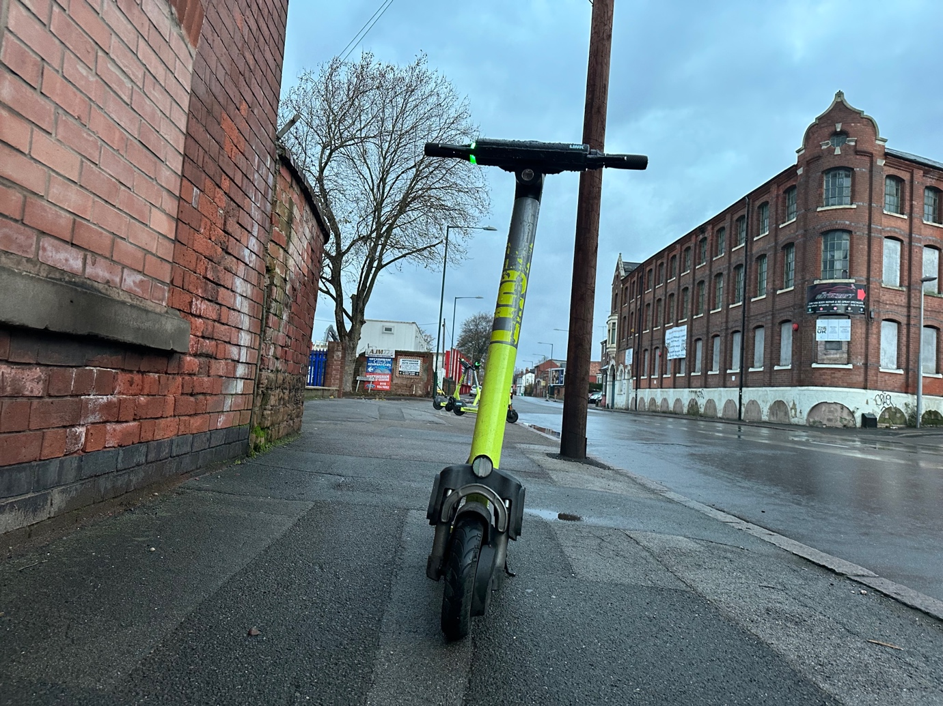

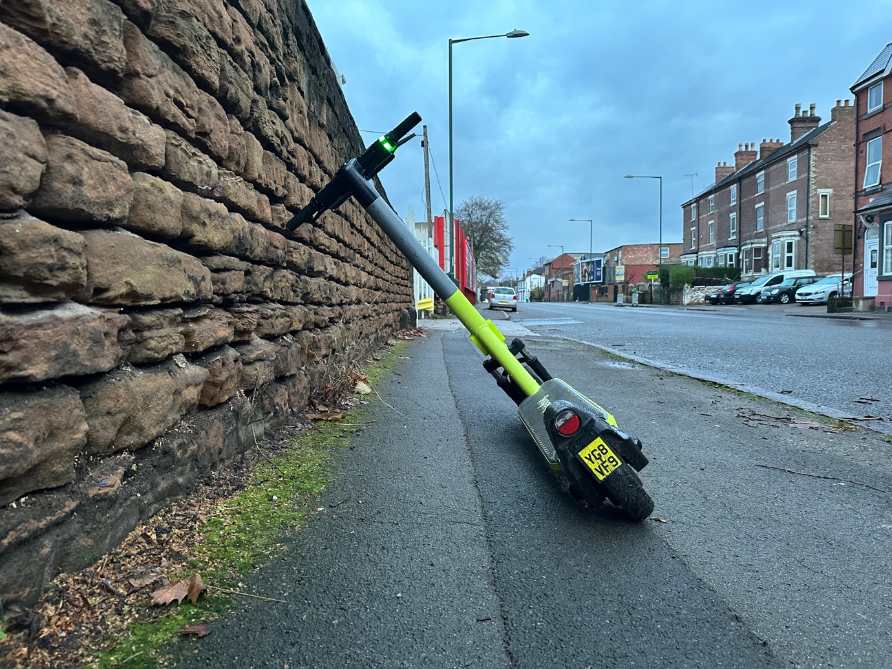
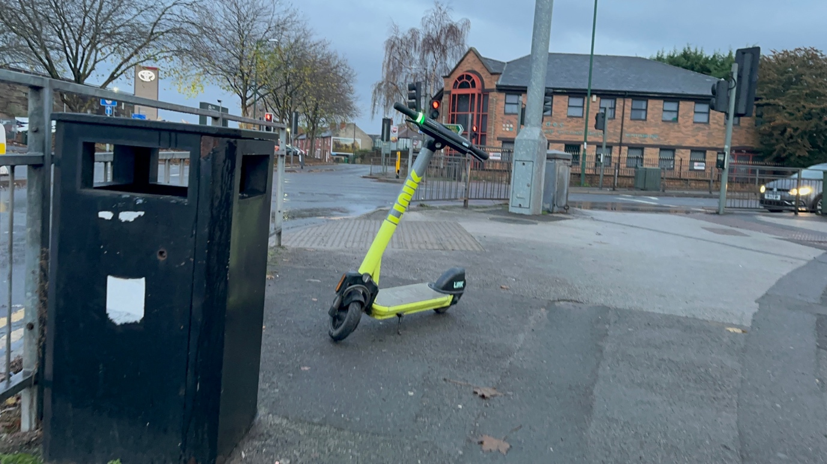

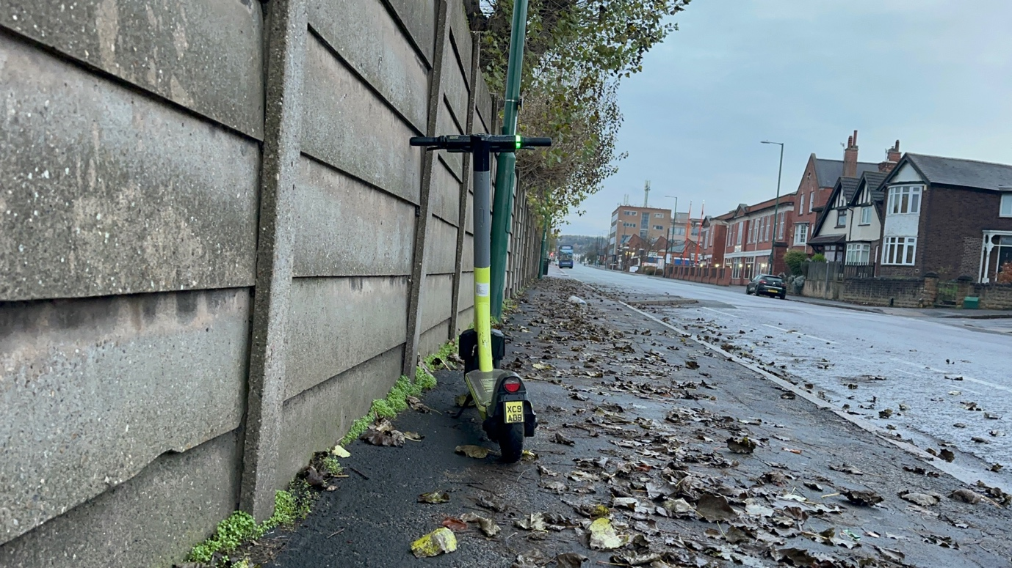
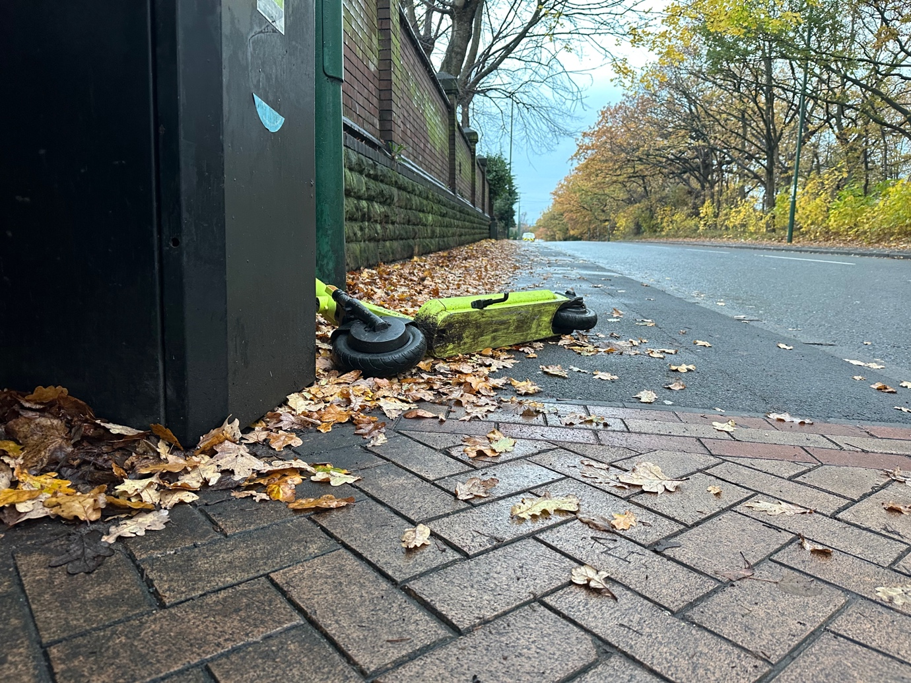

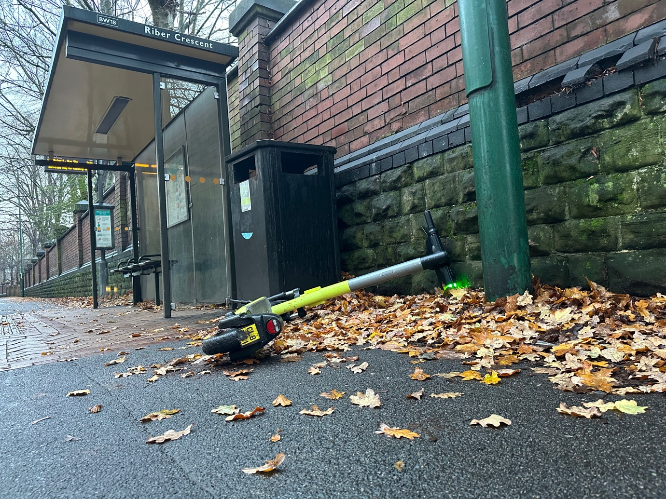
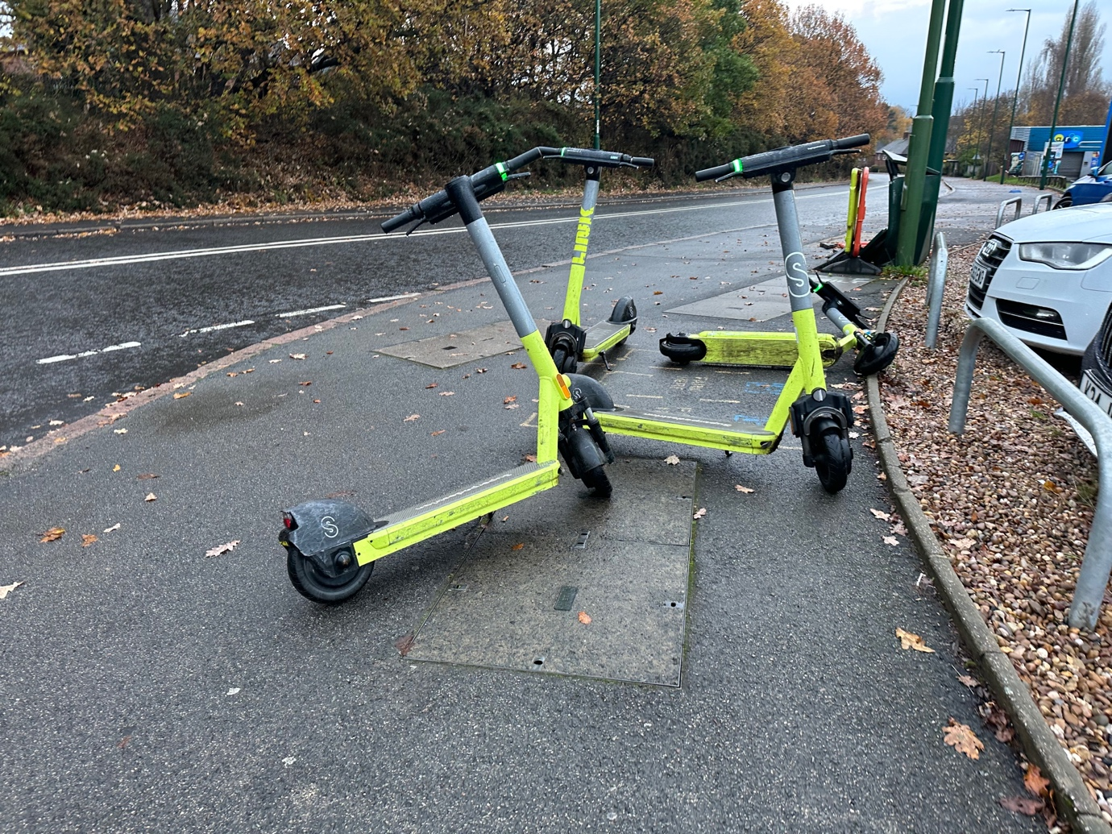

Appendix E b Nottingham E-scooter Trial Link E-Scooters Site Visit 4 December 2022 and 22 May 2022

Photos
29 photos are given below showing e-scooters left in unsafe location on the pavement, next to pedestrian crossings, next to bus stops and knocked over. Creating obstructions and trip hazards for pedestrians.
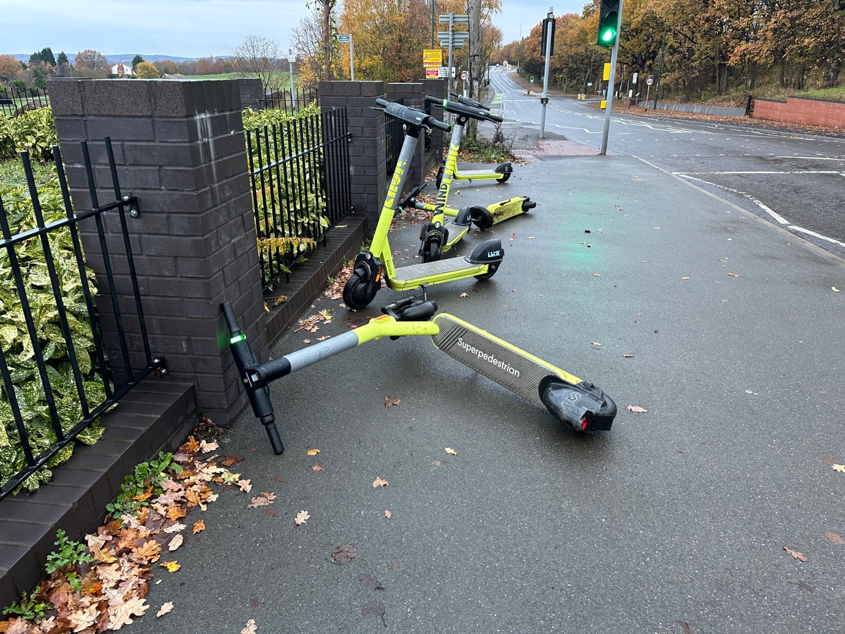

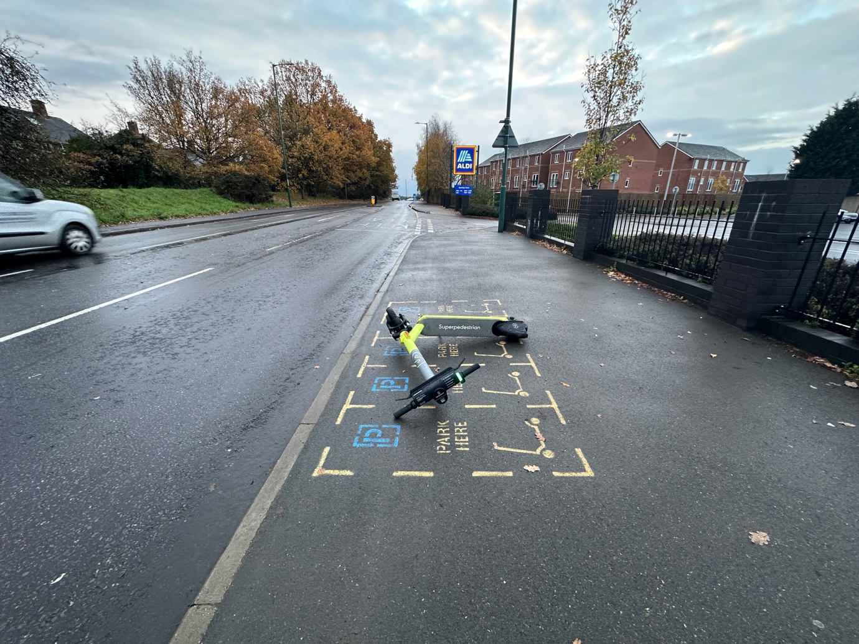

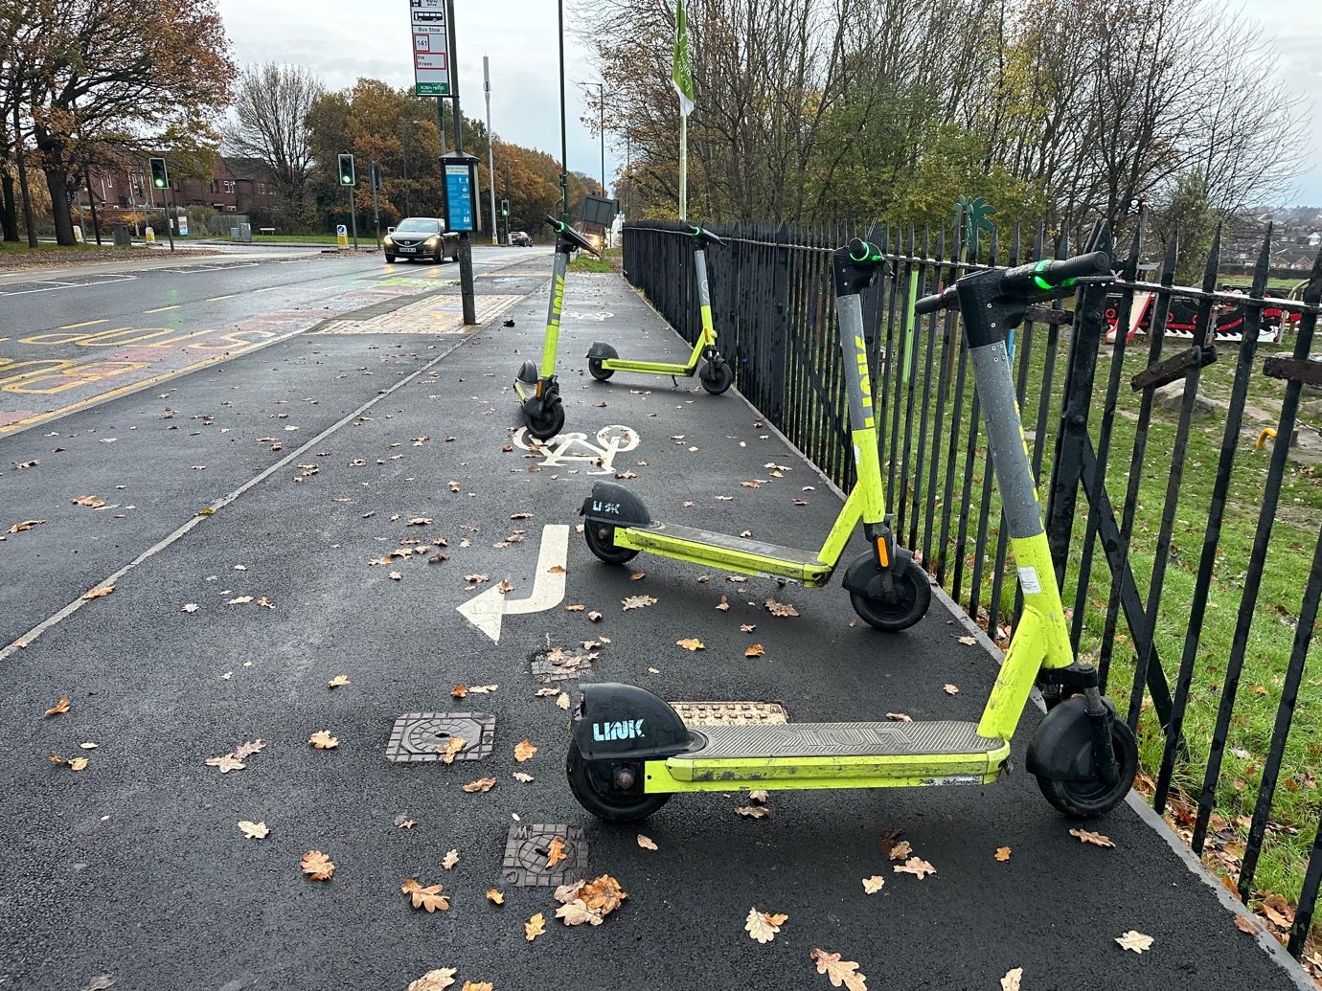
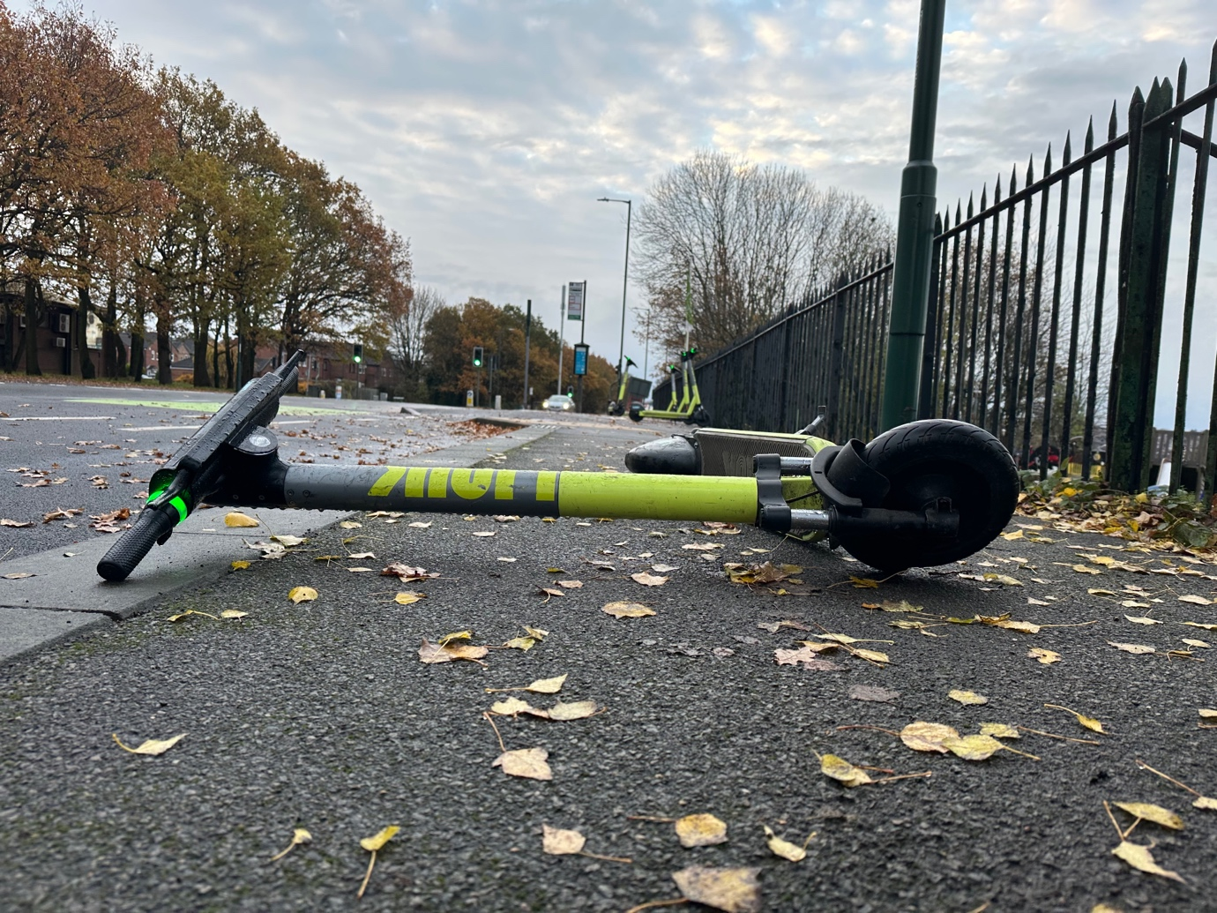

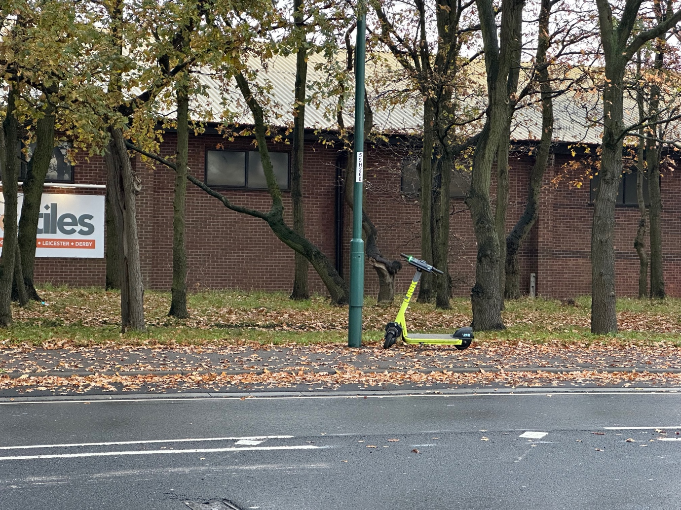

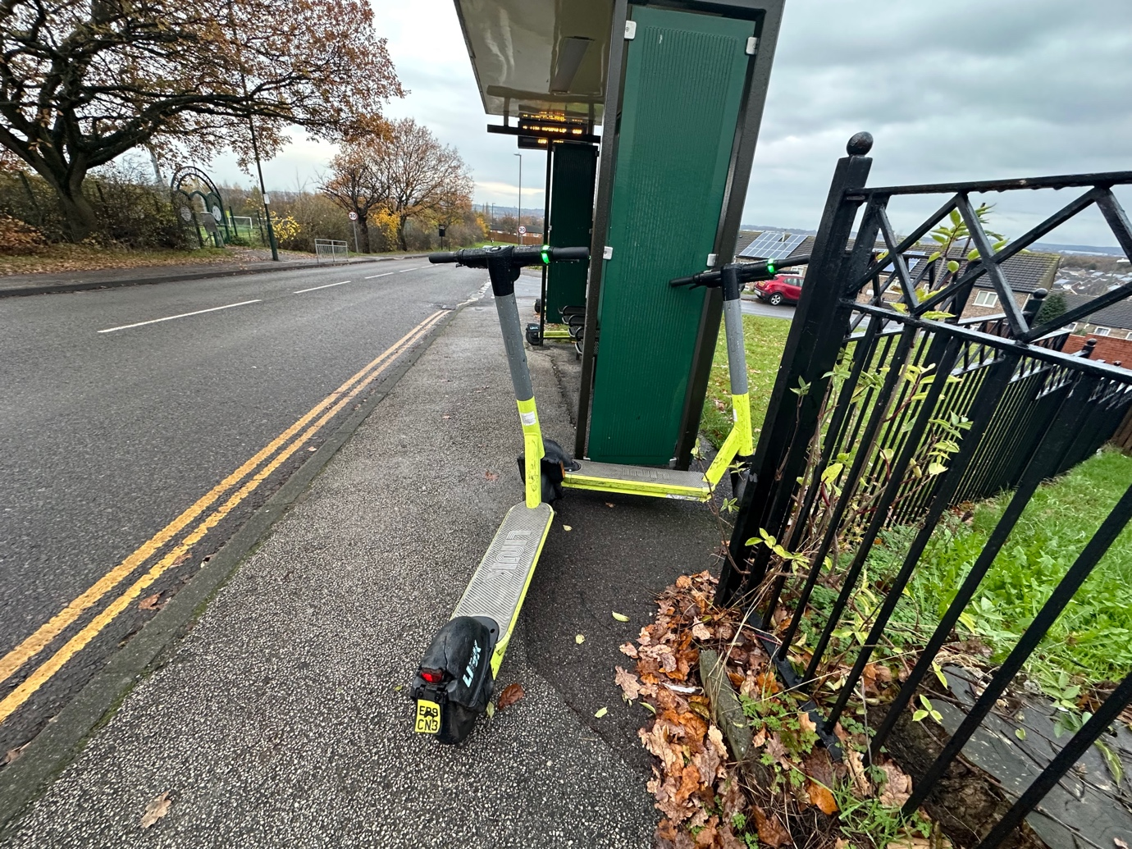
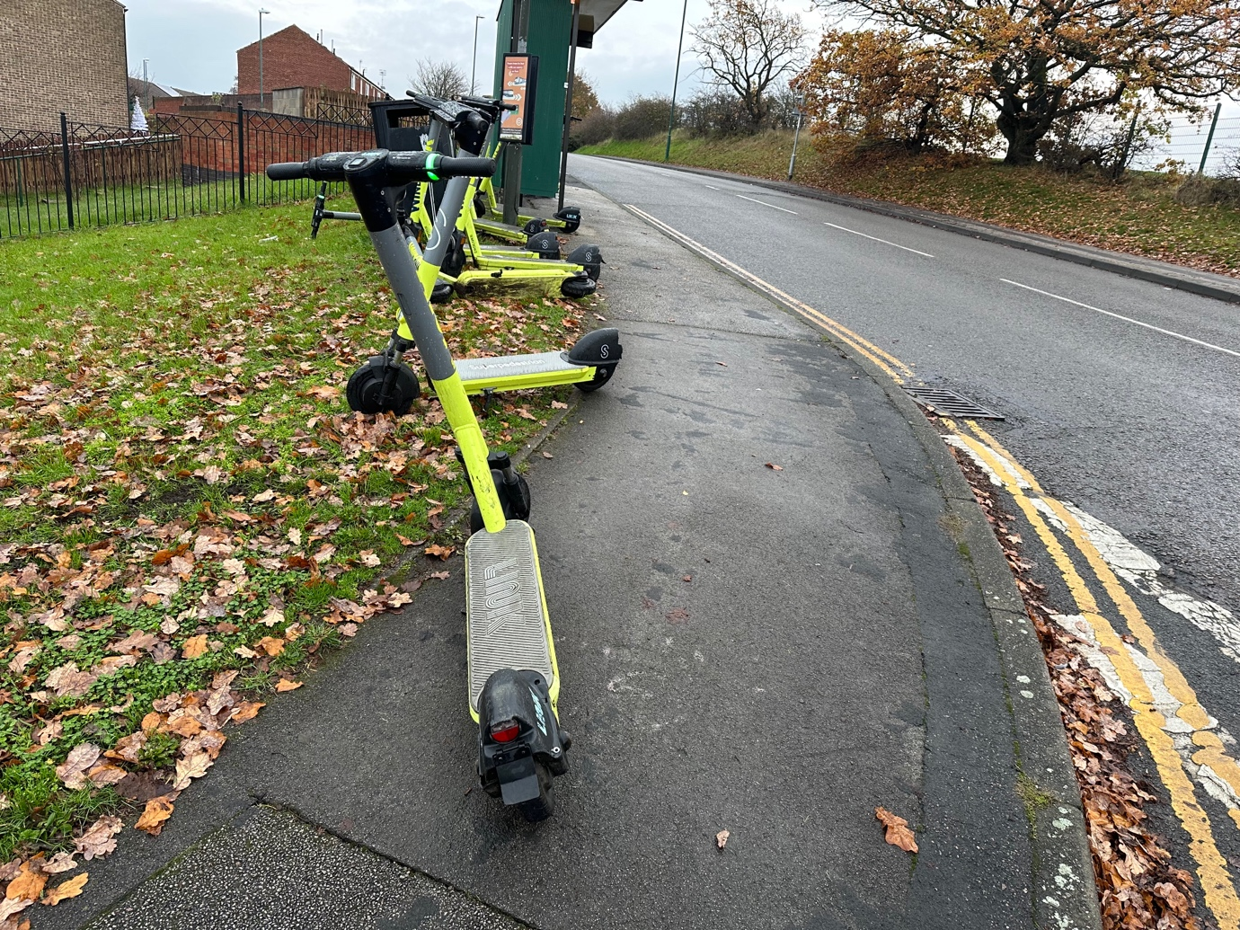

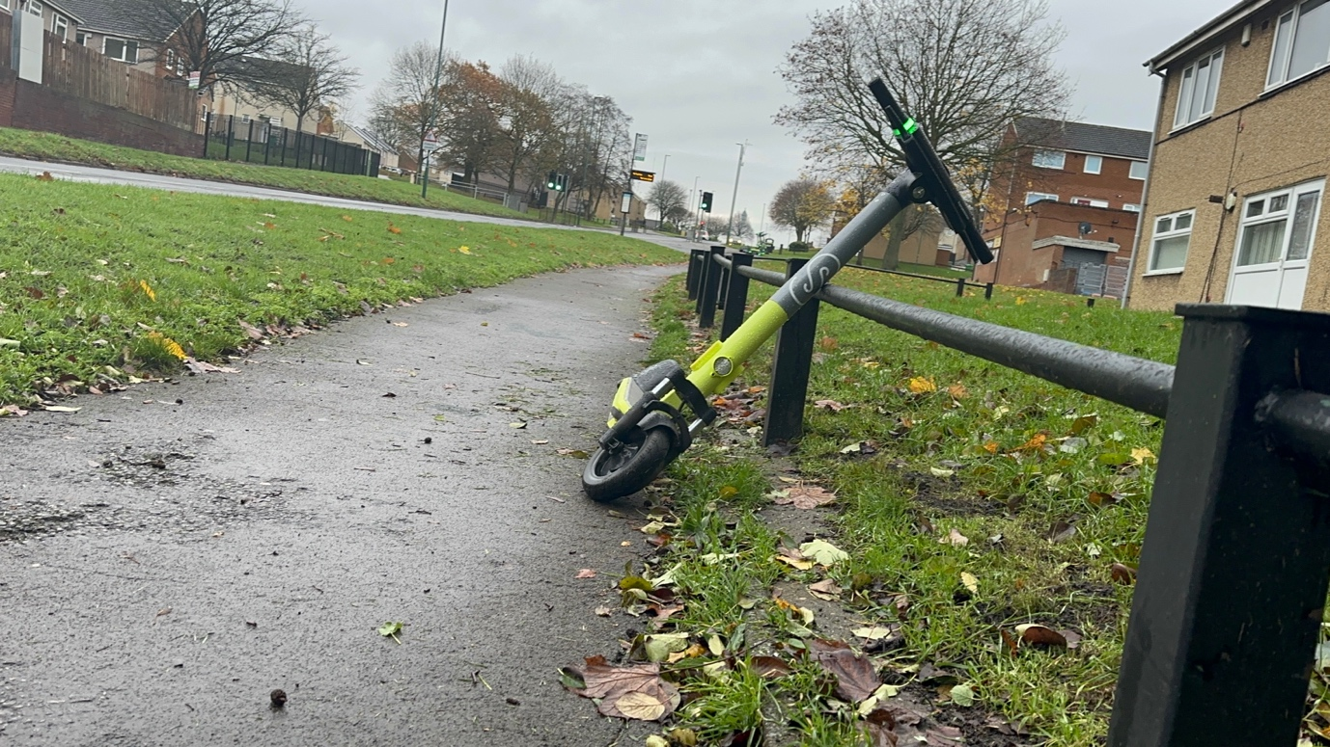
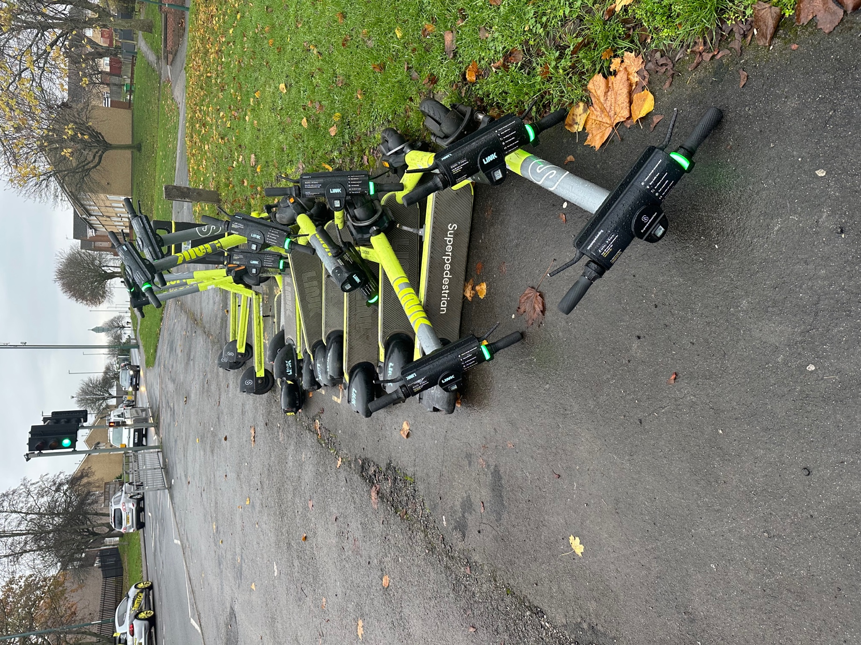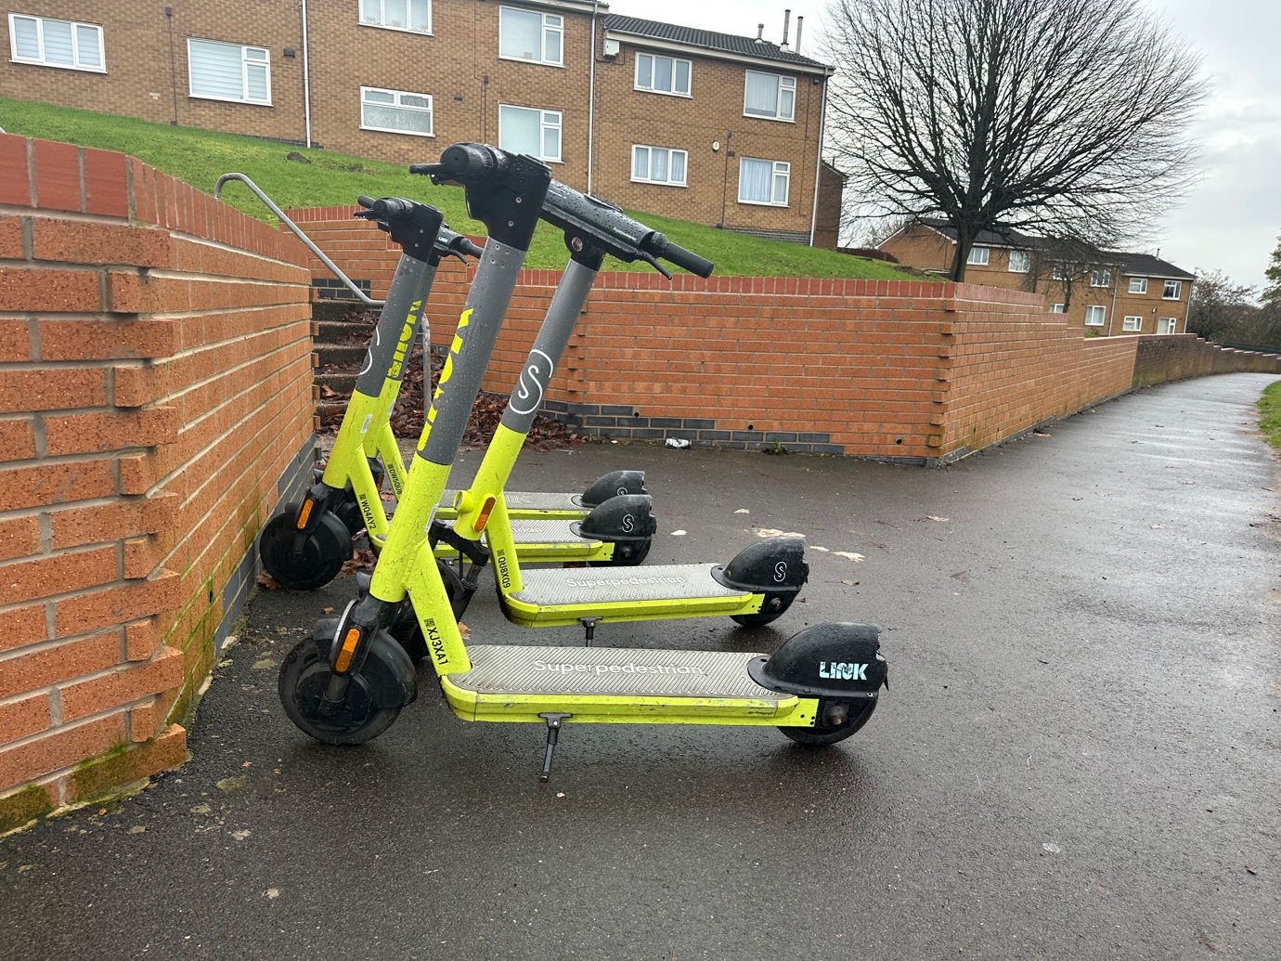

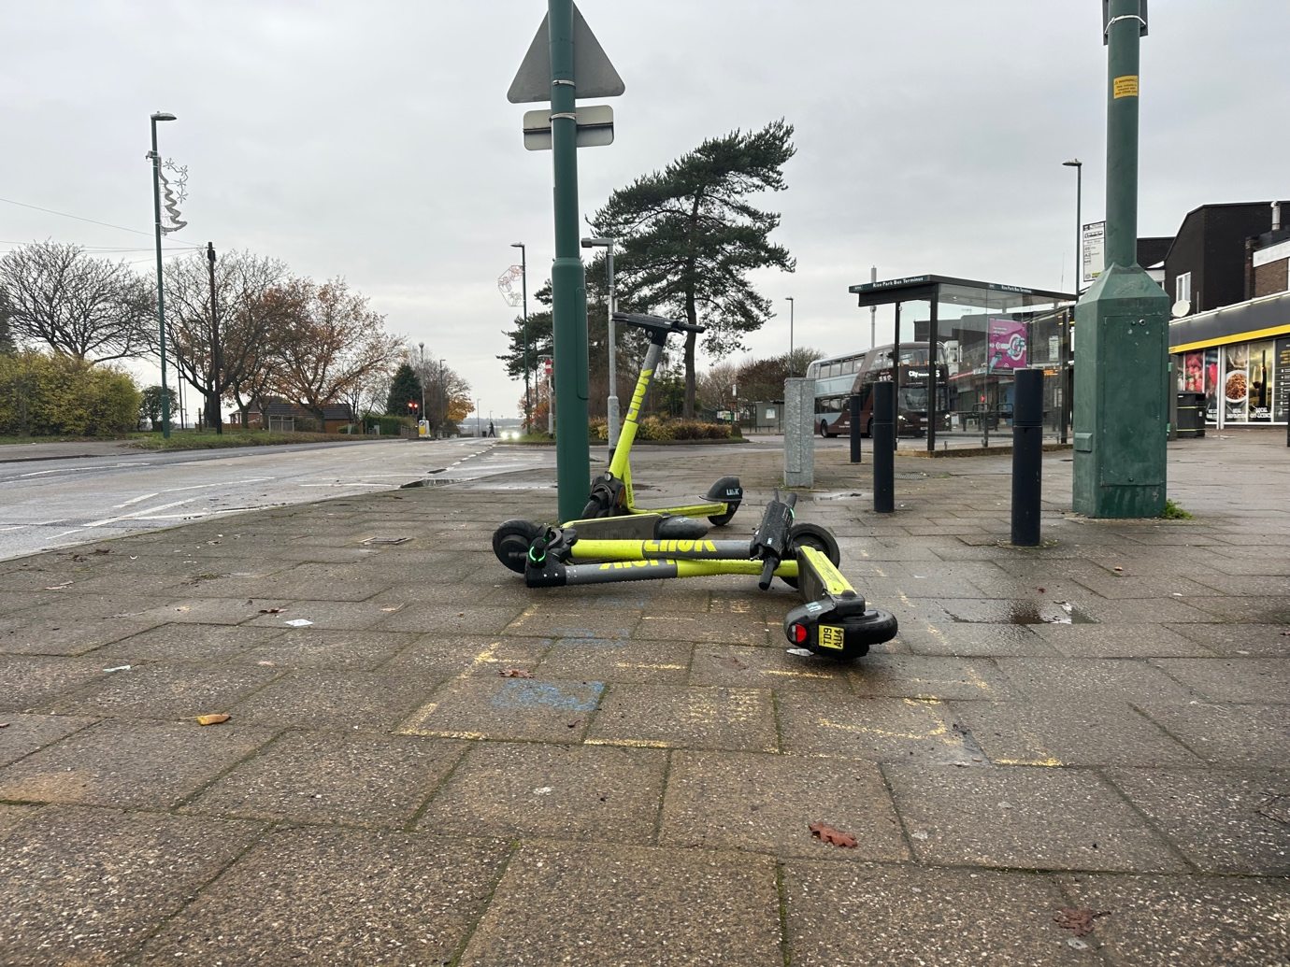
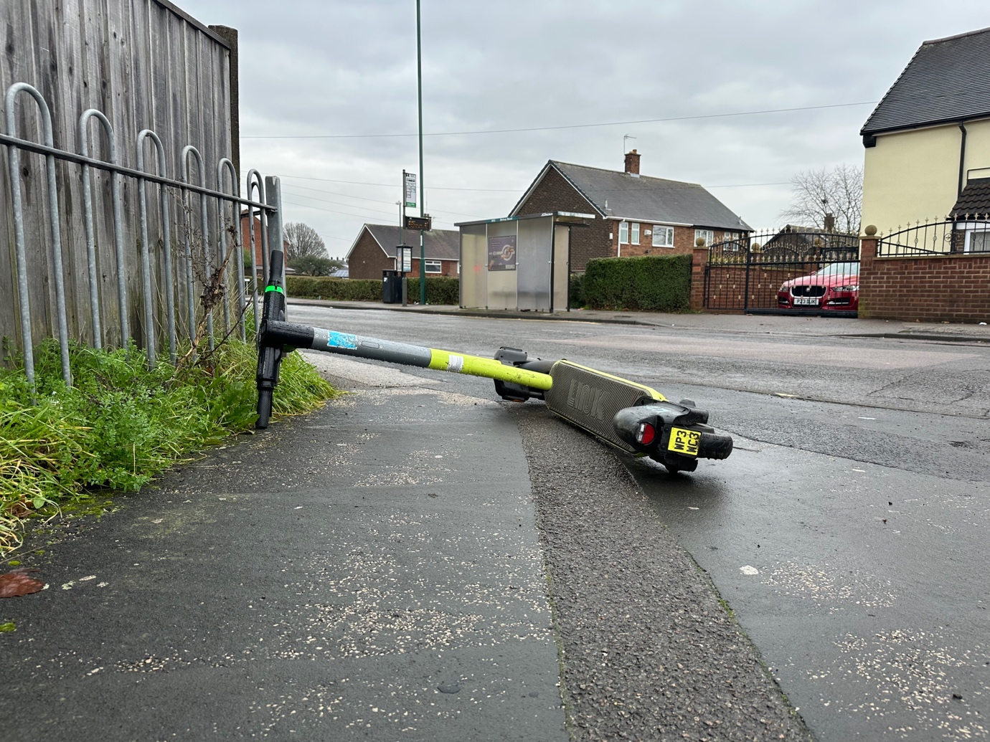

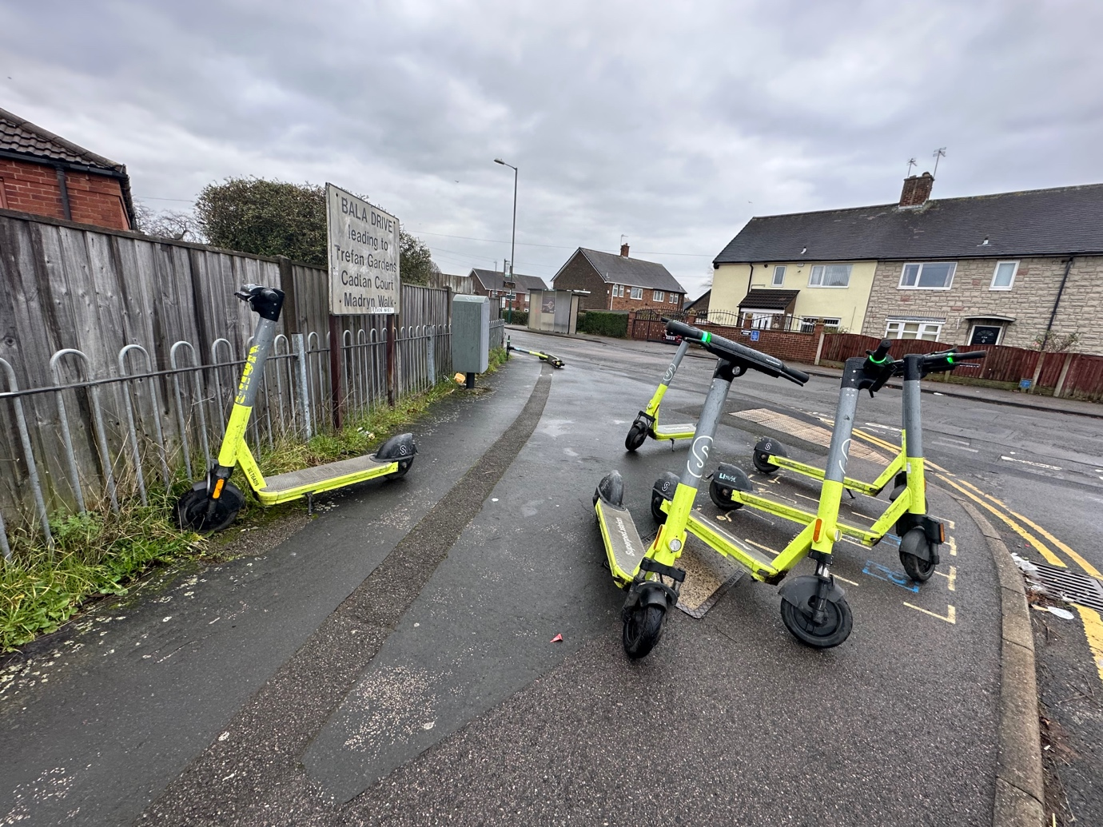
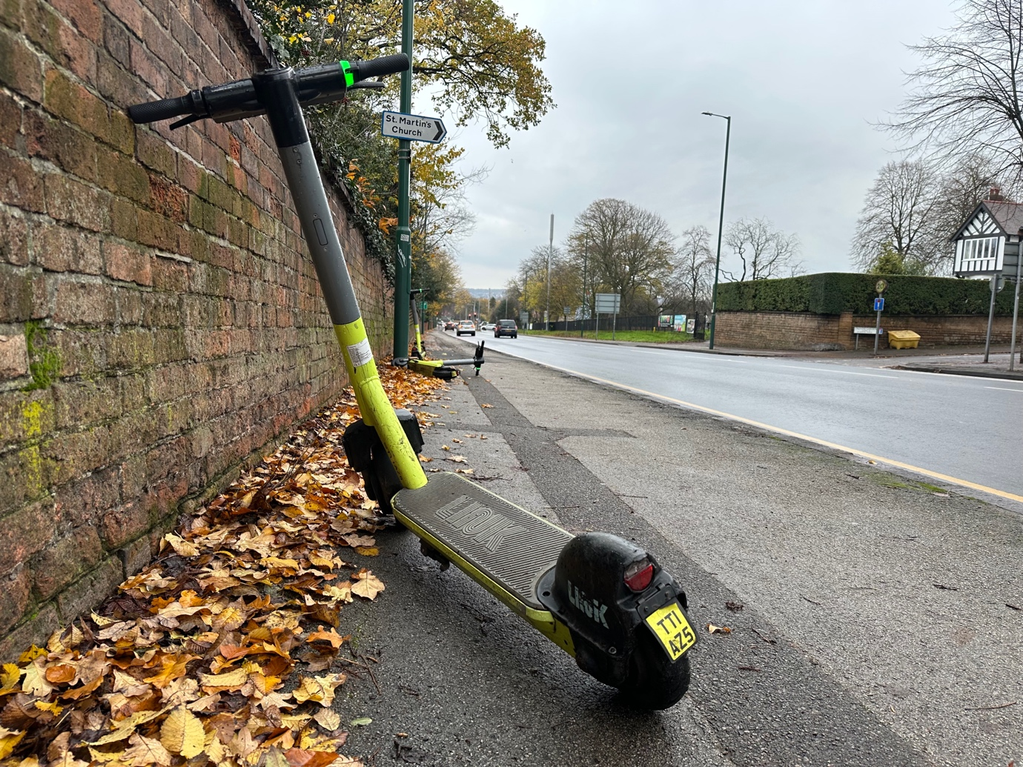

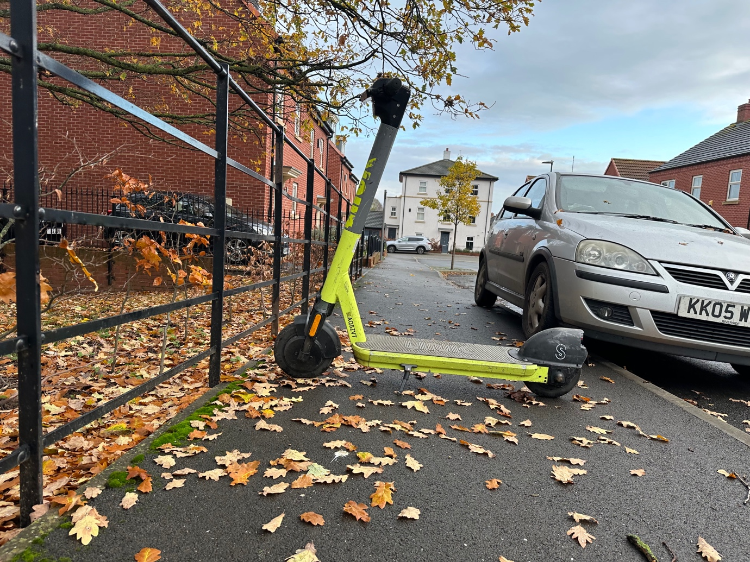

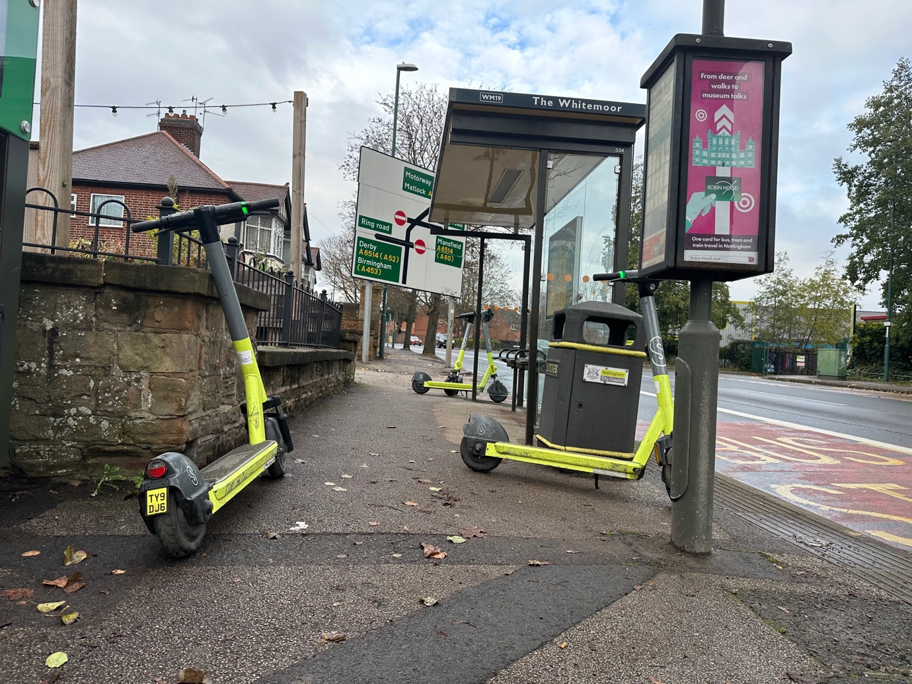

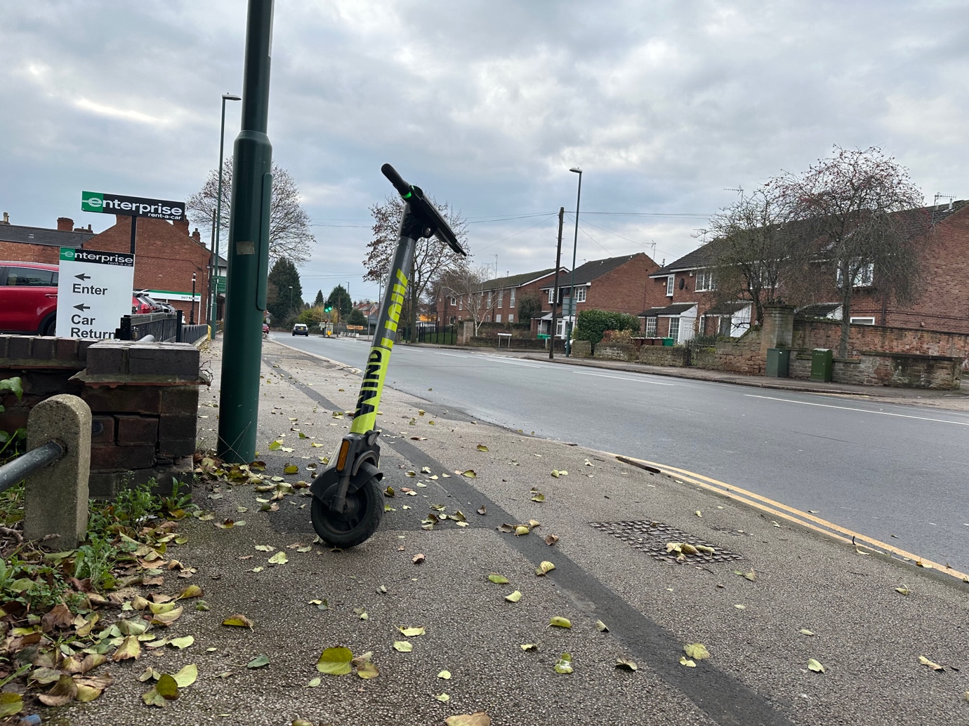
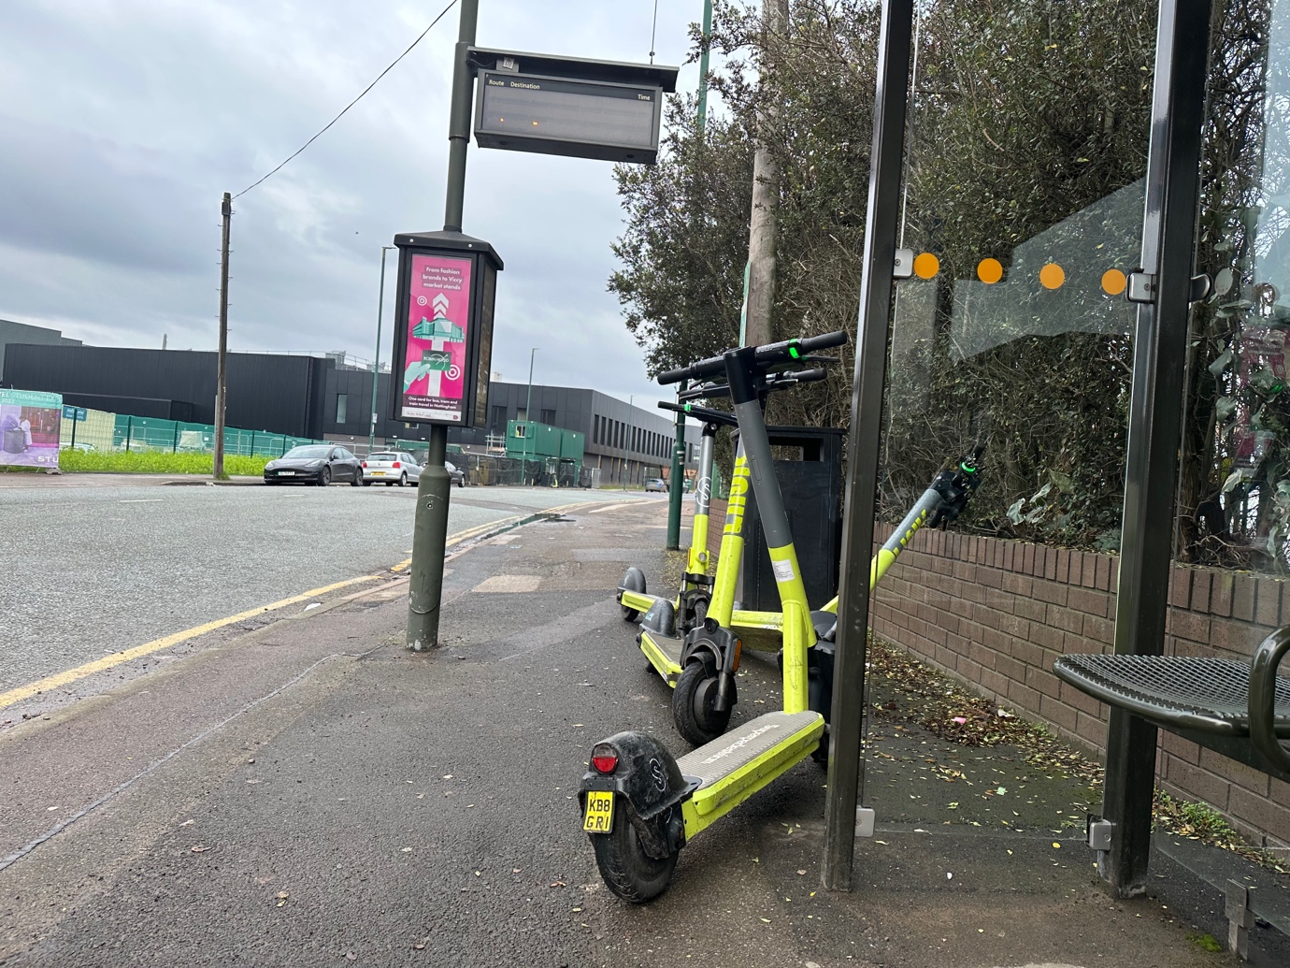

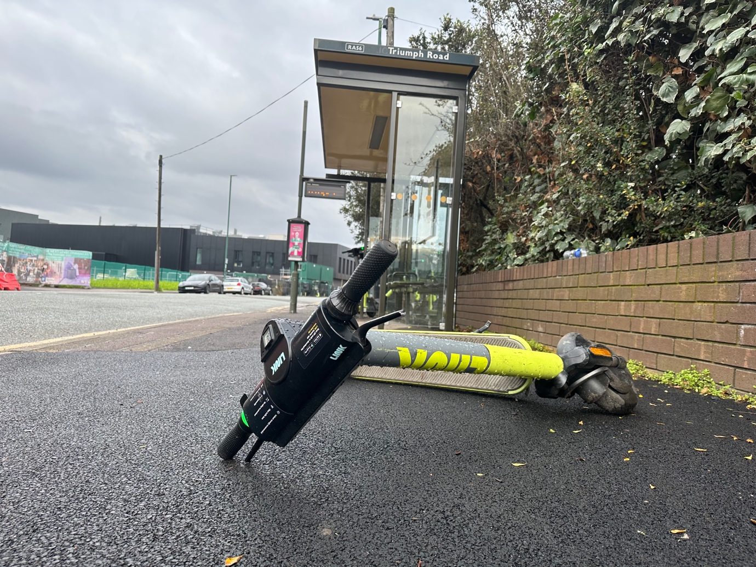

Nottingham E-scooter Trial Link E-Scooters Site Visit 22 May 2022

All same problems identified as previous site visit. Sarah Leadbetter with her Guide Dog Nellie attended this site visit. Nellie could not safely navigate around the e-scooters left on the pavements and refused to take Sarah past them.

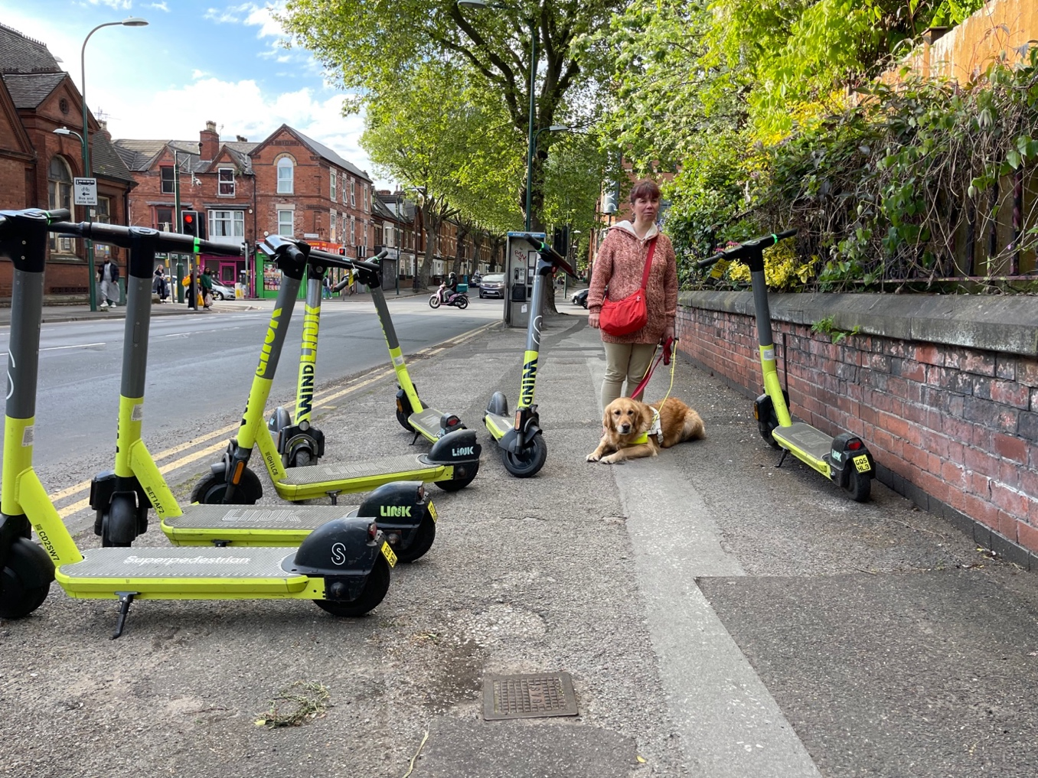
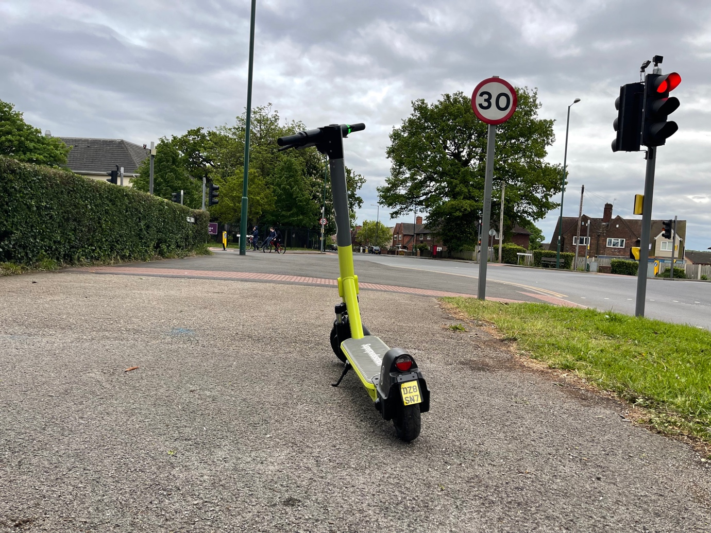

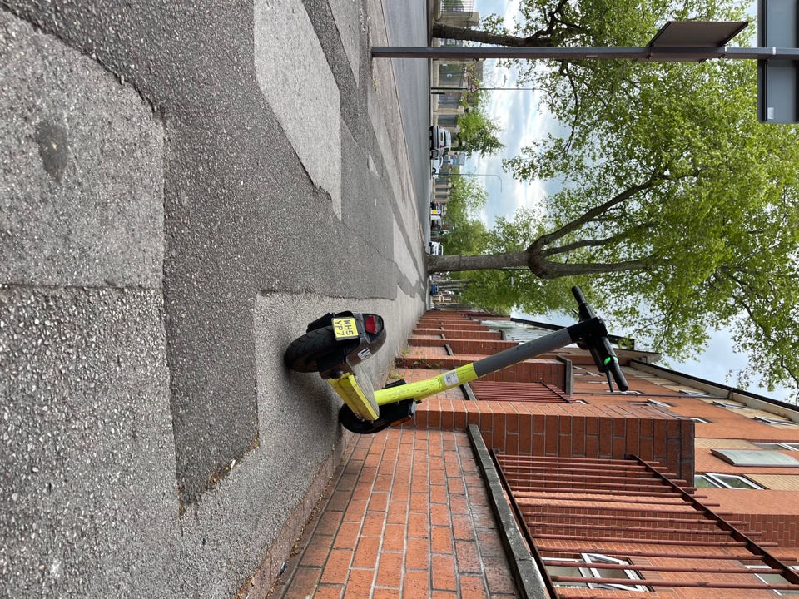
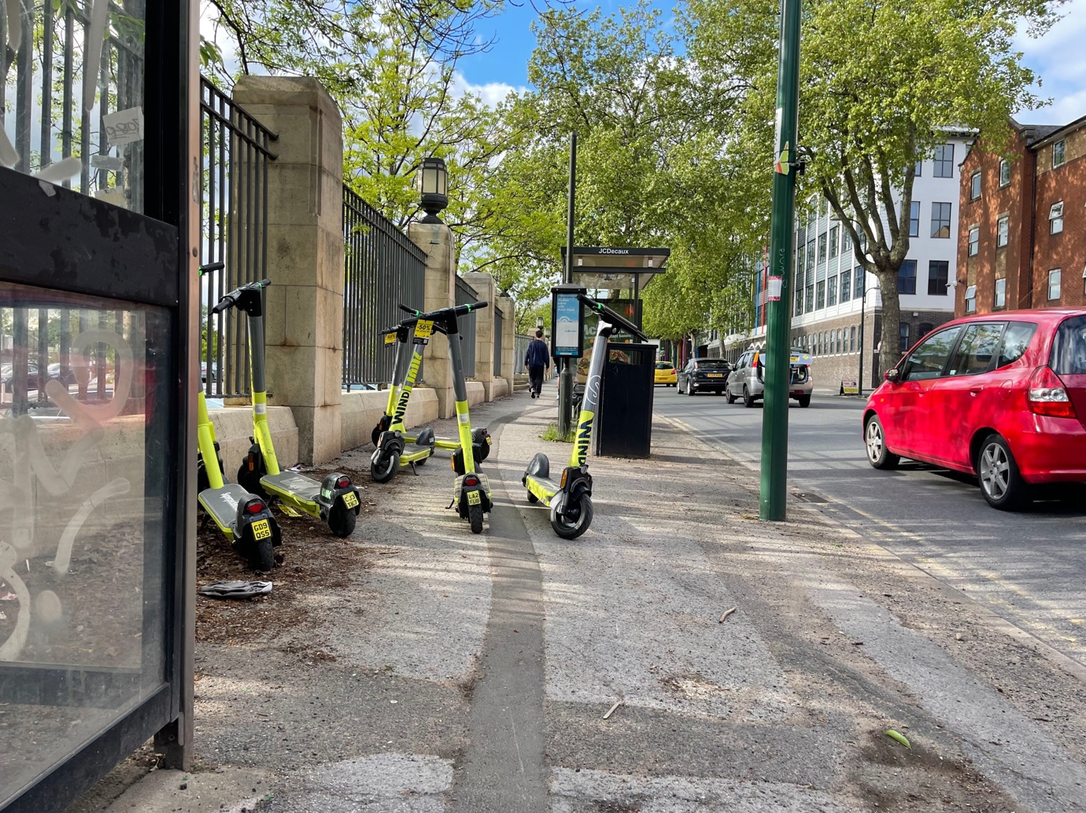

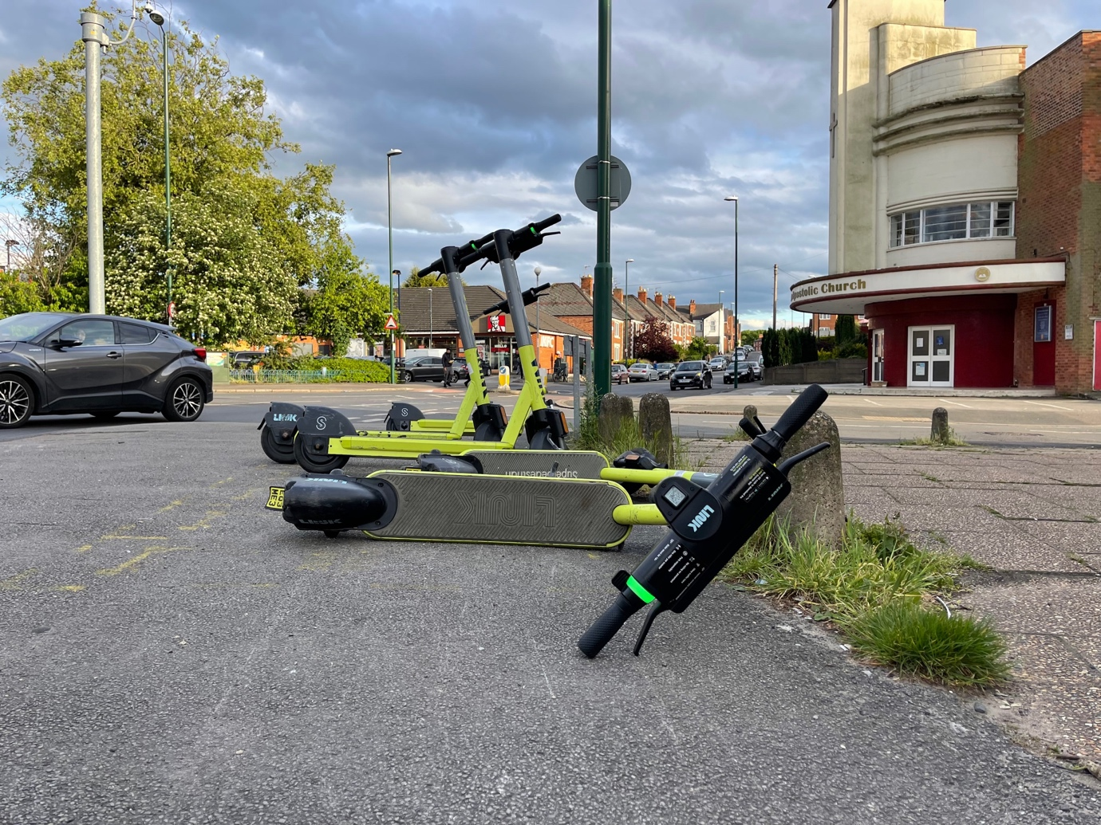

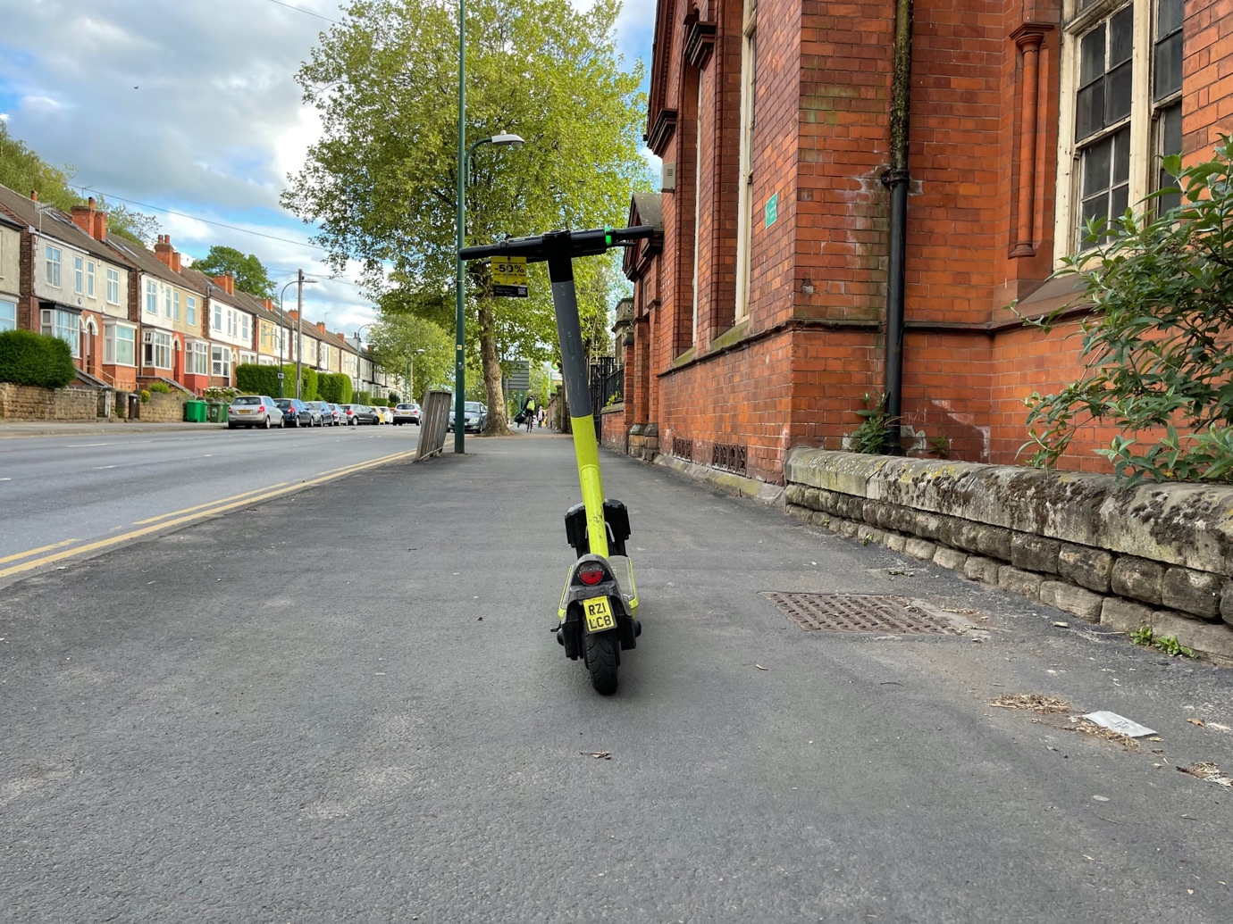

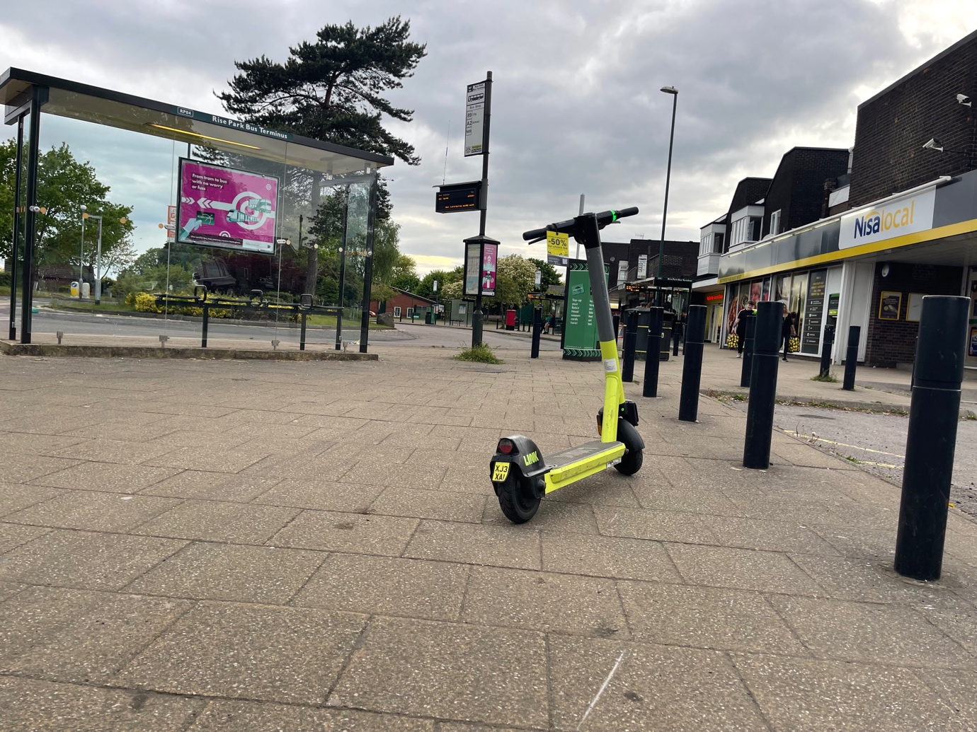

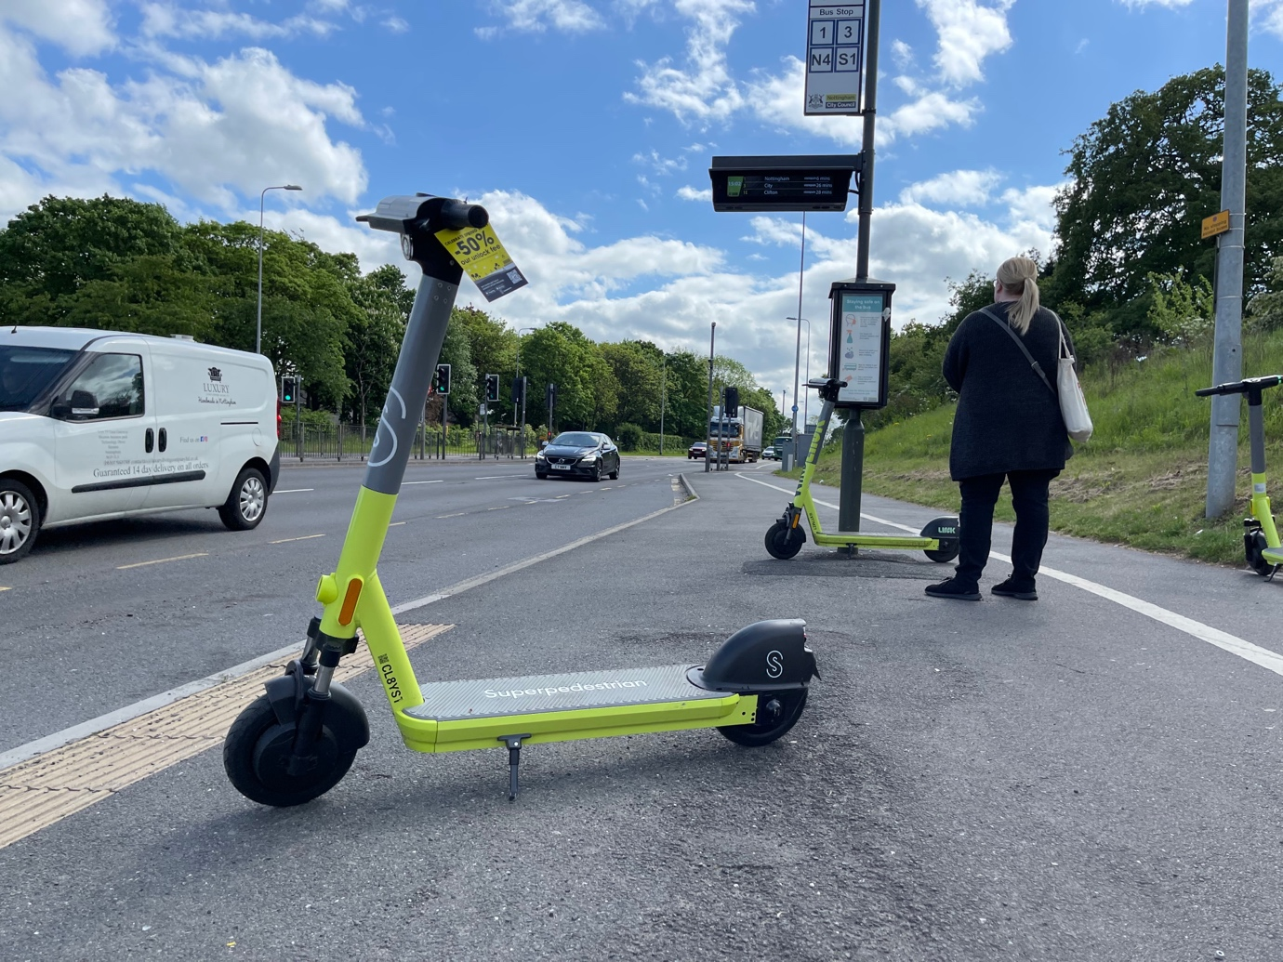

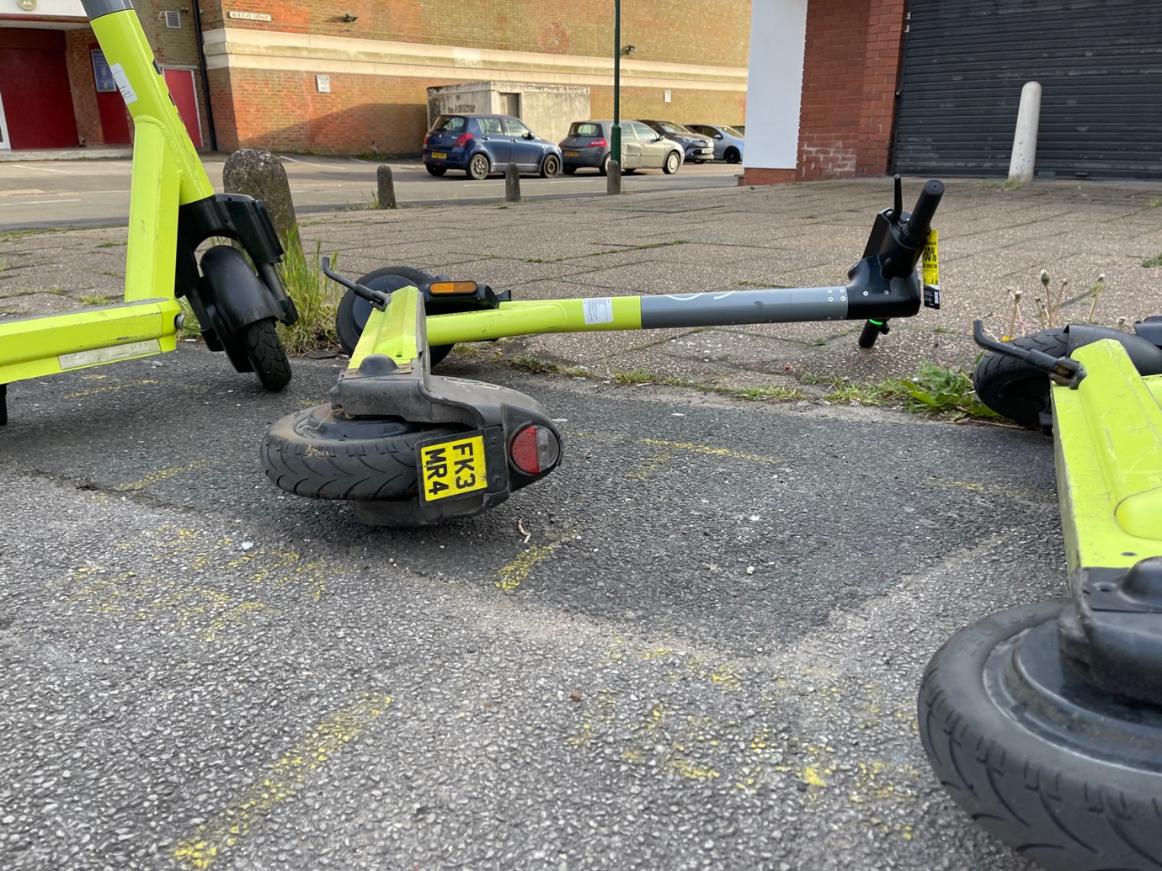

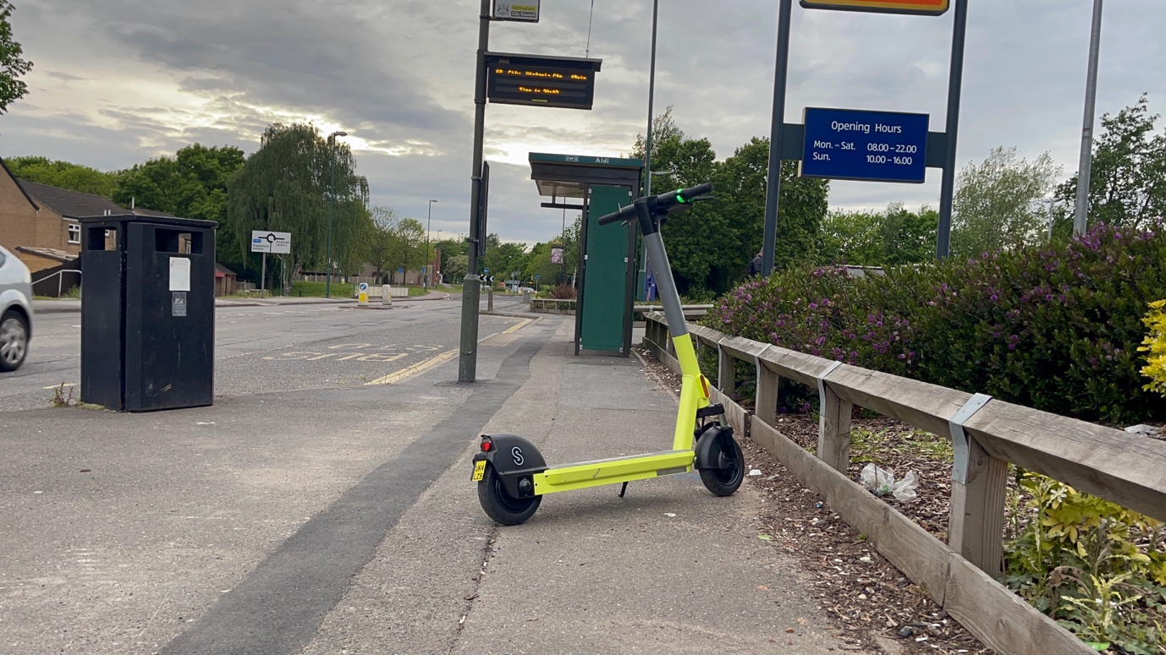

Appendix E c Nottingham E-scooter Trial Previous WIND e-scooters used in Nottingham 30 August 2021
10 examples of e-scooters are given below showing e-scooters left in unsafe locations on the pavement, next to pedestrian crossings, bus stops and knocked over. Creating obstructions and trip hazards for pedestrians. Also showing unsafe back tyres with the tread missing and holes worn through the tread on some of them. The helmets were also found damaged.

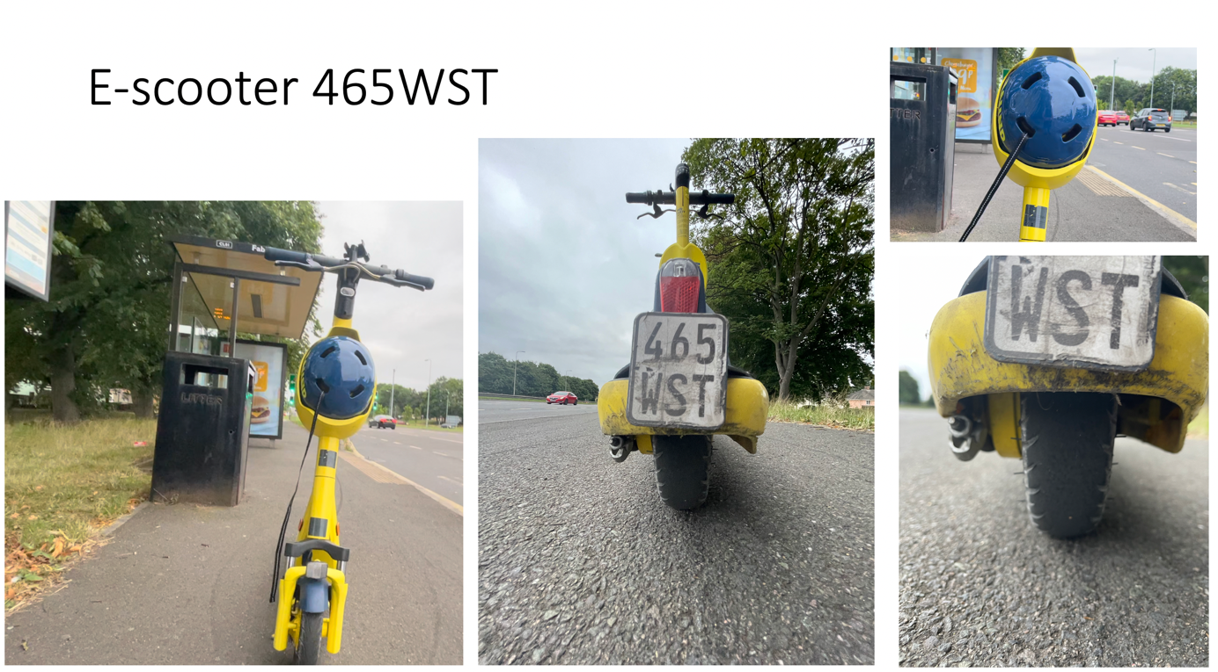

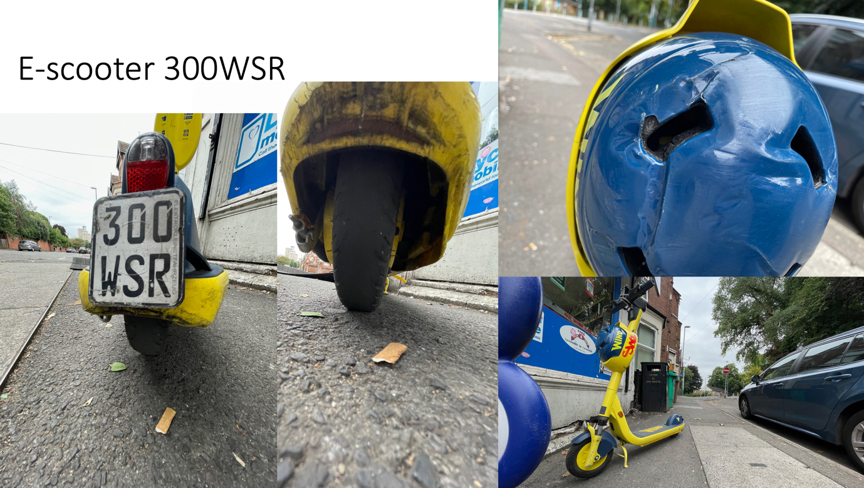

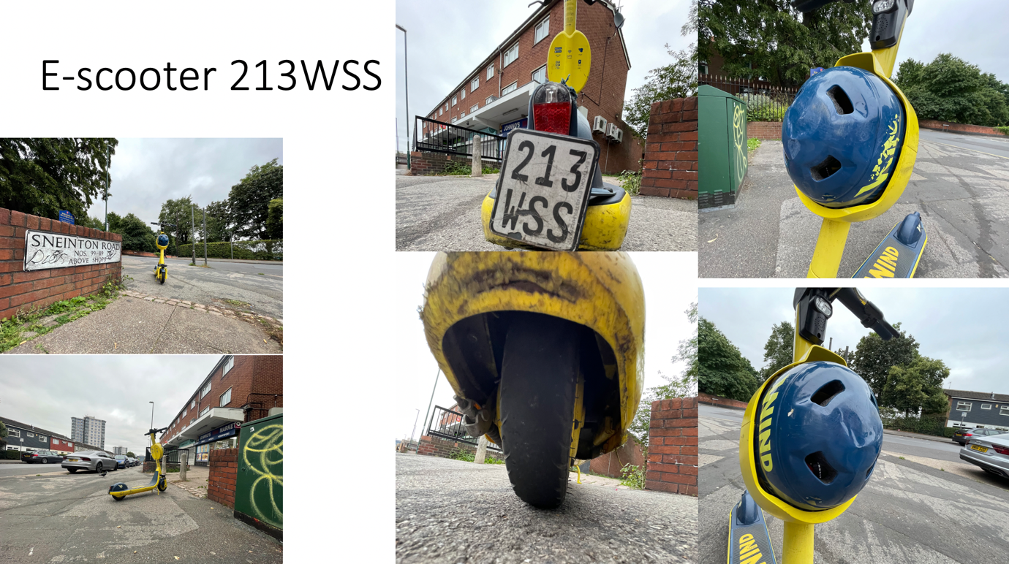

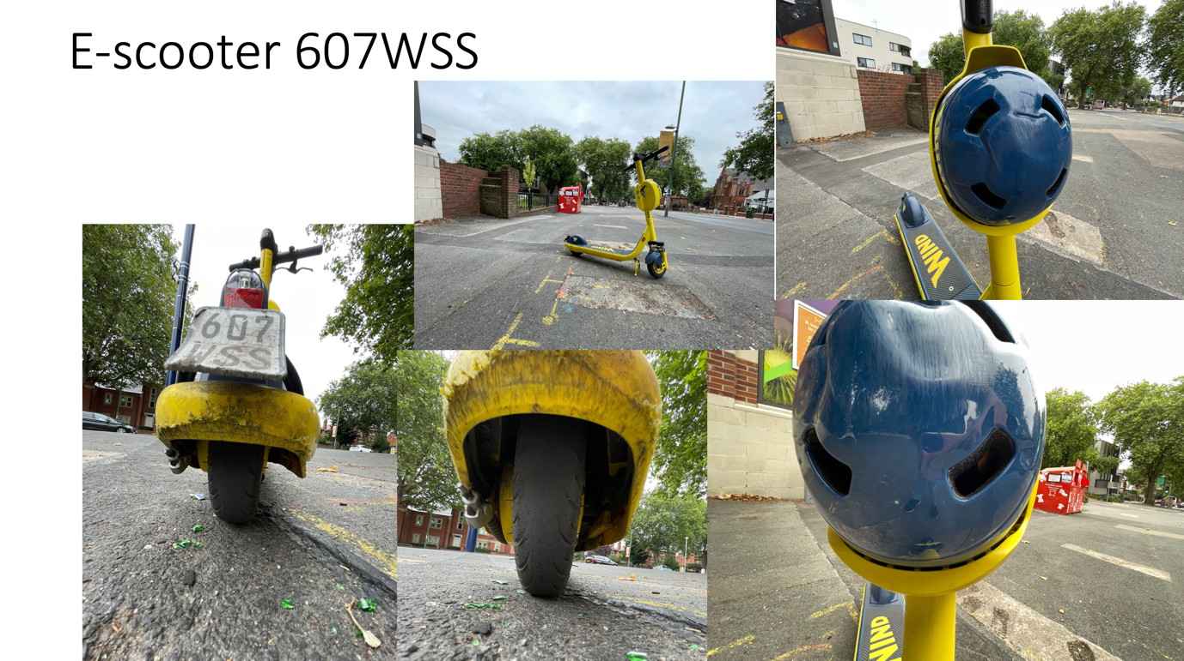

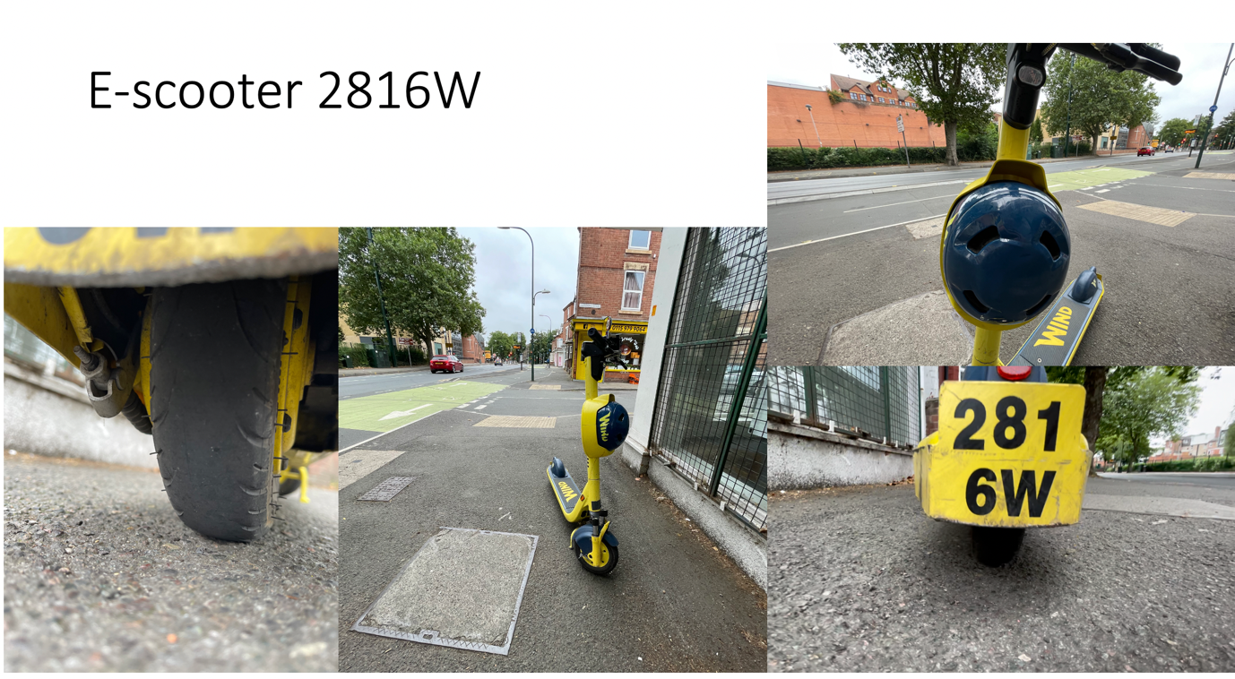

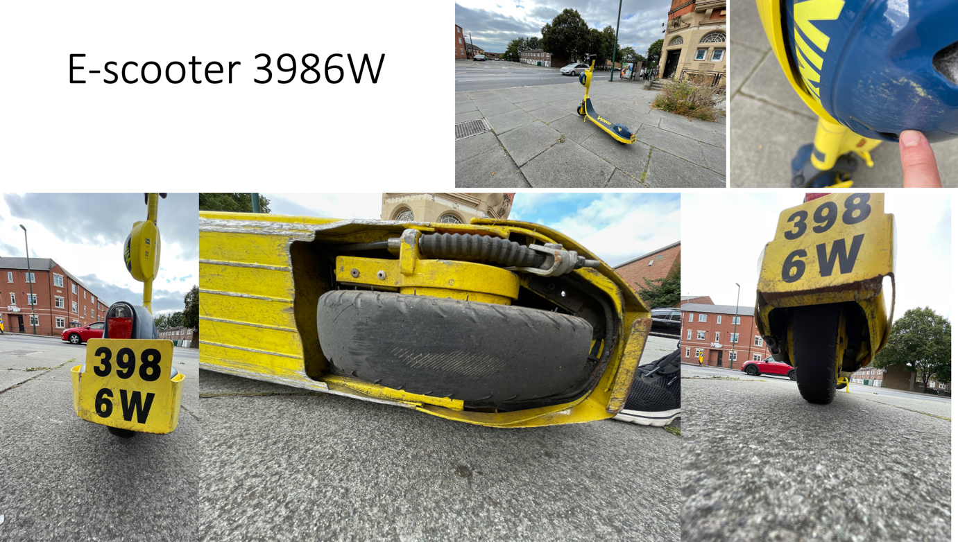

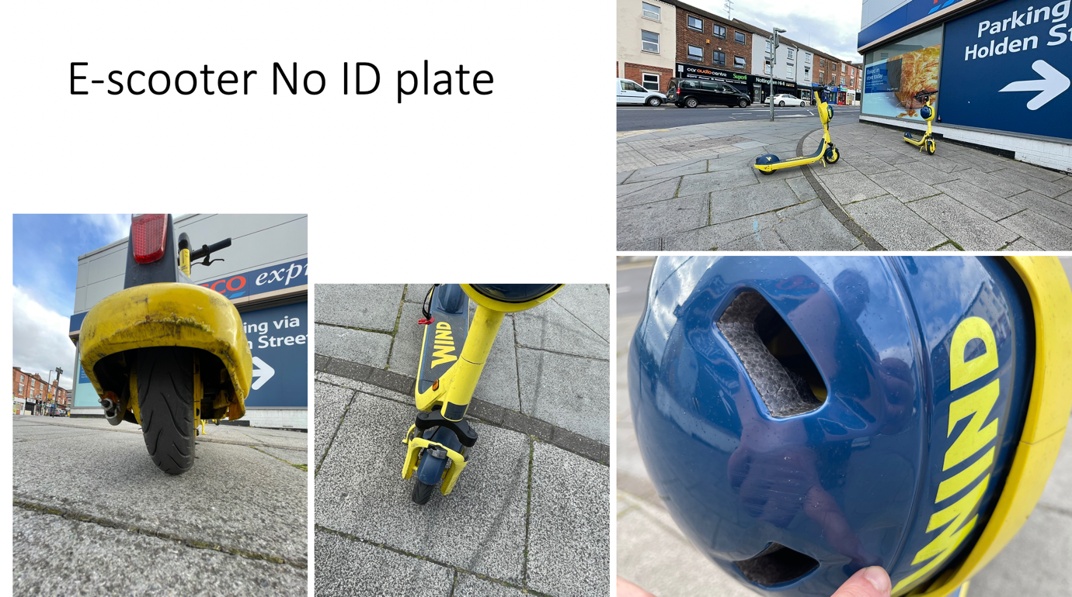

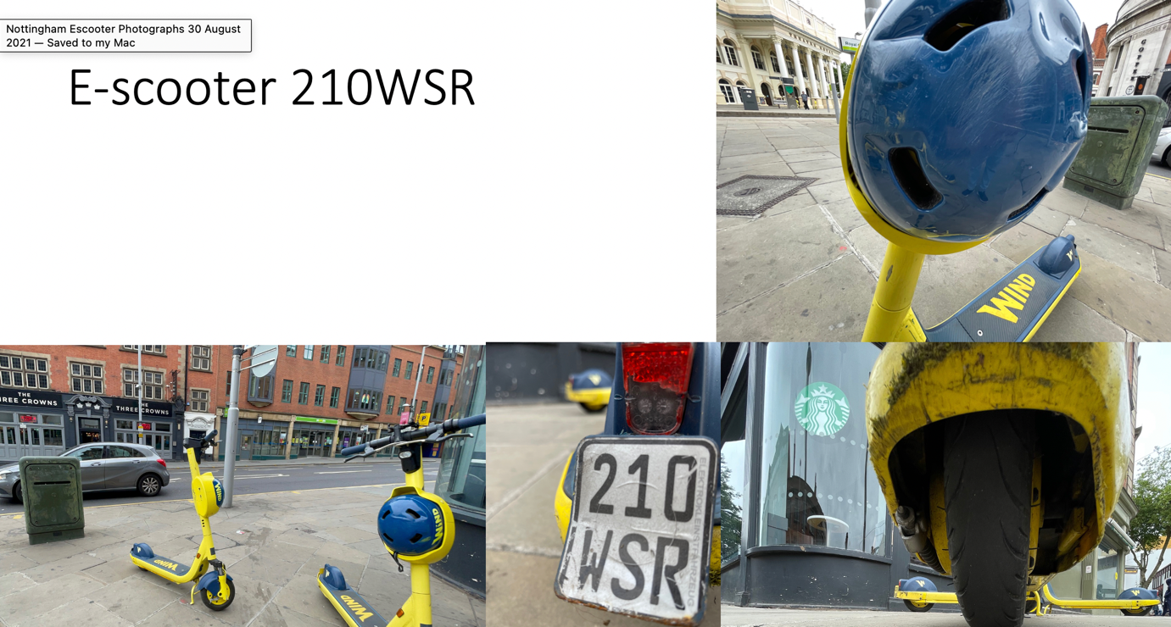

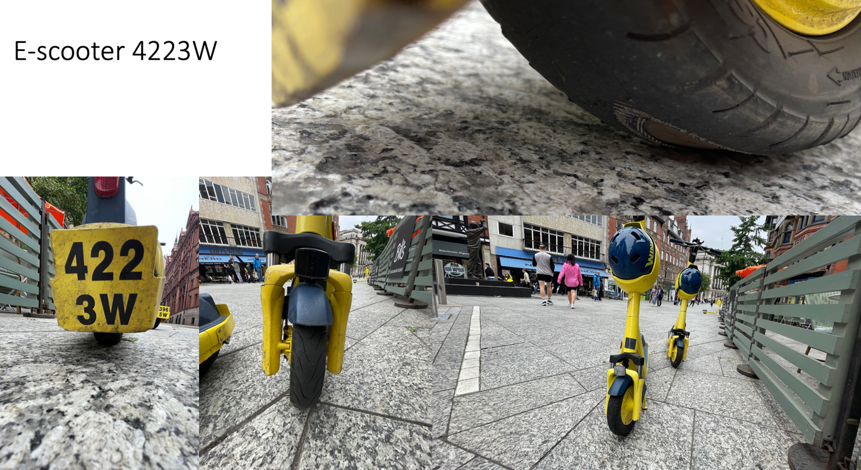
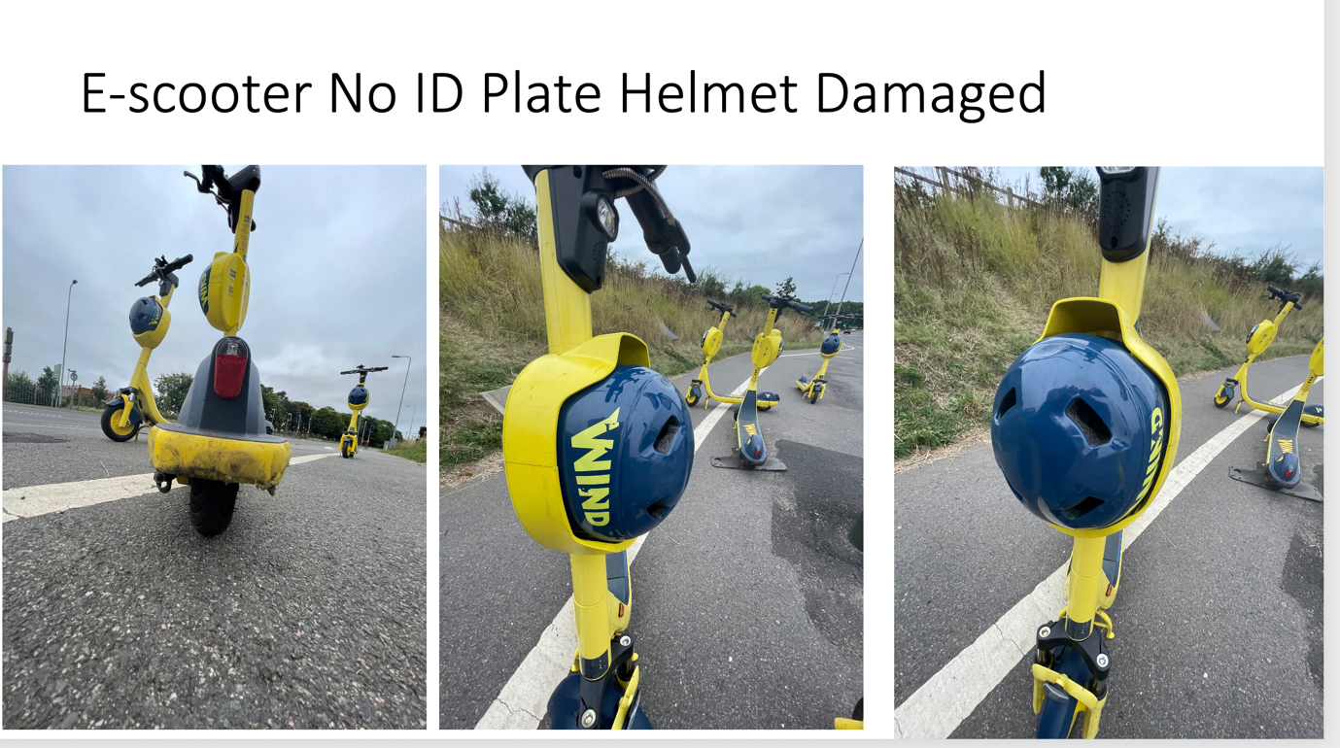

Appendix F a London E-scooter Trial Teir, Lime and Dott E-Scooters

These photos are just from 29 January 2023, 11 December 2022, 19 October 2022 , 17 November 2022, 27 March 2022, June 2021 and 12 August 2021. These are given below and in Appendix F b.

Although promises were made for e-scooters not to be parked on pavements, this has happened in London, with parking bays appearing in some Boroughs with e-scooters being left on pavements. E-scooters have also been left on pavements and left knocked over on pavements.

Parking / dumping of e-scooters
E-scooters were observed in unsafe locations, found in an unsafe manner causing obstructions and trip hazards on the pavement, public places and next to bus stops.
- Left on pavements, in the middle of the pavement, on the kerb line, on the building line, on dropped kerbs, leading up to pedestrian crossing points and left close to tactile paving for use by blind and visually impaired pedestrians.
- Many found without kick stands deployed & knocked over lying on the ground.
Safety of E-scooters
E-scooters were found with under inflated tyres, cracks in some of the tyres and on one occasion the tyre was half on half off the e-scooter.

Riding of e-scooters
E-scooters were observed been ridden of the pavements, jumping red lights and two people riding e-scooters in an unsafe manner.
This trial has not resolved key safety and accessibility concerns for riders and pedestrians and needs to be halted.

Site Visit | Appendix Site Visits | Twitter Films Trip & Obstructions | Twitter films Dangerous Riding | Twitter Films E-scooter Safety Concerns
London | Appendix F | December 2022  December 2022  June 2022  May 2022  May 2022  April 2022  April 2022  March 2022  October 2021  August 2021  August 2021  August 2021  August 2021  July 2021  July 2021  Topple test July 2021  June 2021 – Will Norman on BBC stating e-scooters not parked on pavements but e-scooters were allowed to be parked on pavements | December 2022  March 2022  March 2022  October 2021  August 2021  July 2021 Handing over e-scooter to another rider  July 2021 | December 2022  December 2022  March 2022  March 2022  March 2022  October 2021  October 2021  October 2021  October 2021  August 2021

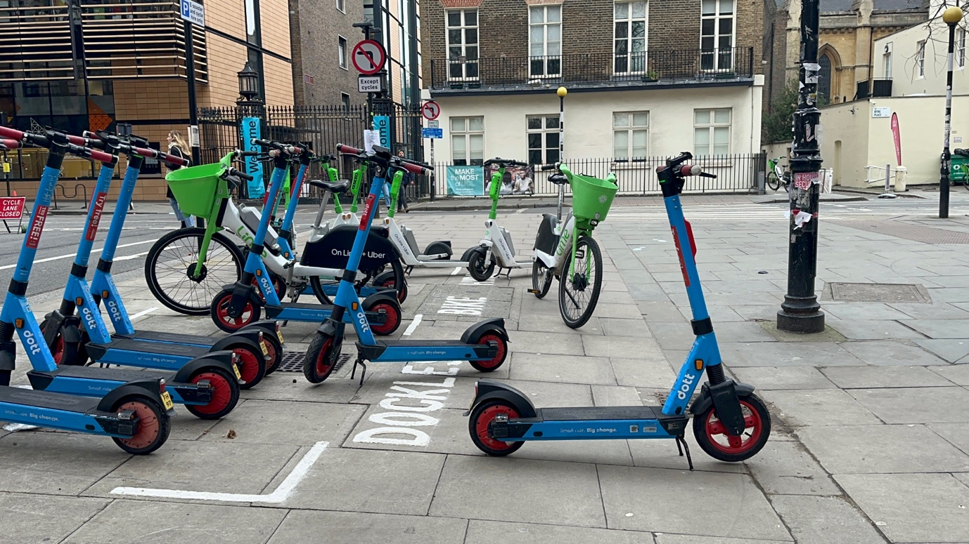
Photo 1 E-scooters and e-bikes some in painted bay on pavement ad some not. Riders will be riding towards and from the bay with the e-scooter or bike. They are an left in an unsafe situation, they are an obstruction and trip hazard.
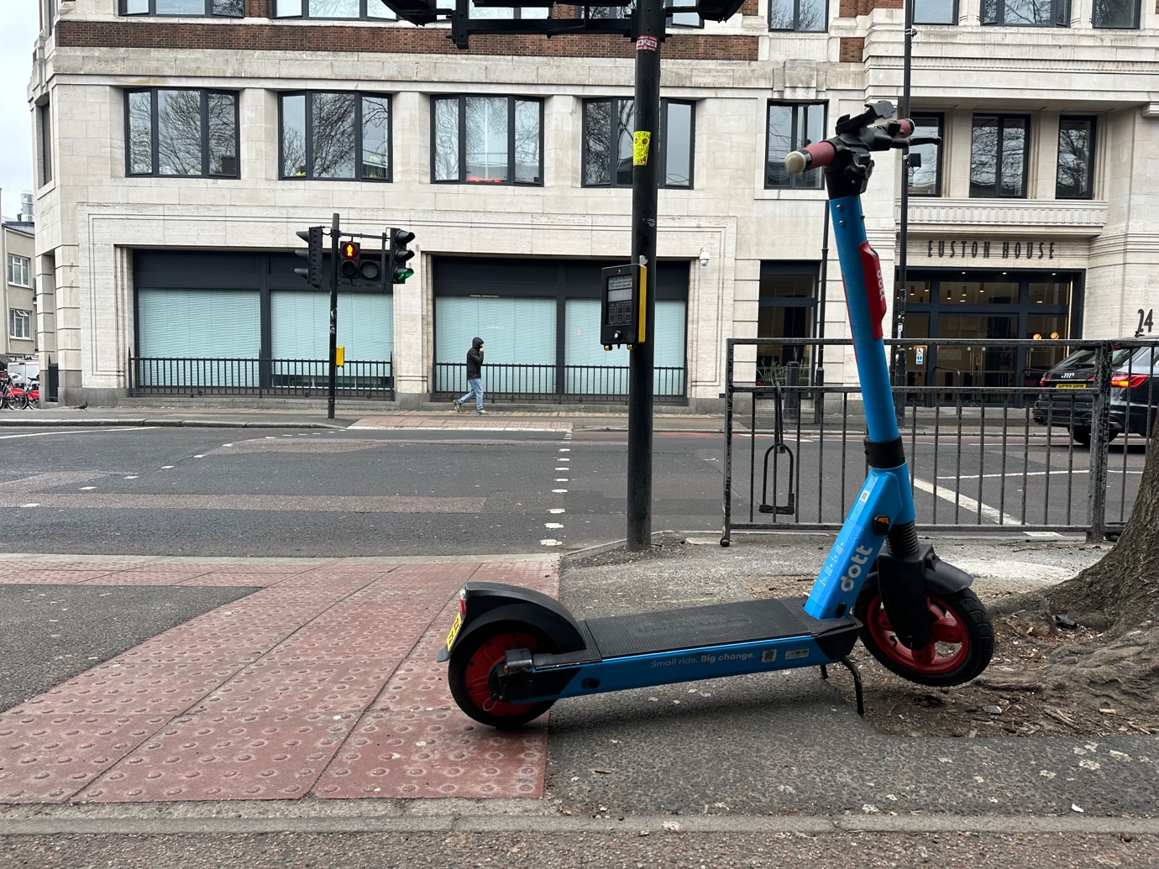
Photo 2 E-scooter left on tactile paving leading to pedestrian green man crossing. This is unsafe and it is a trip hazard.
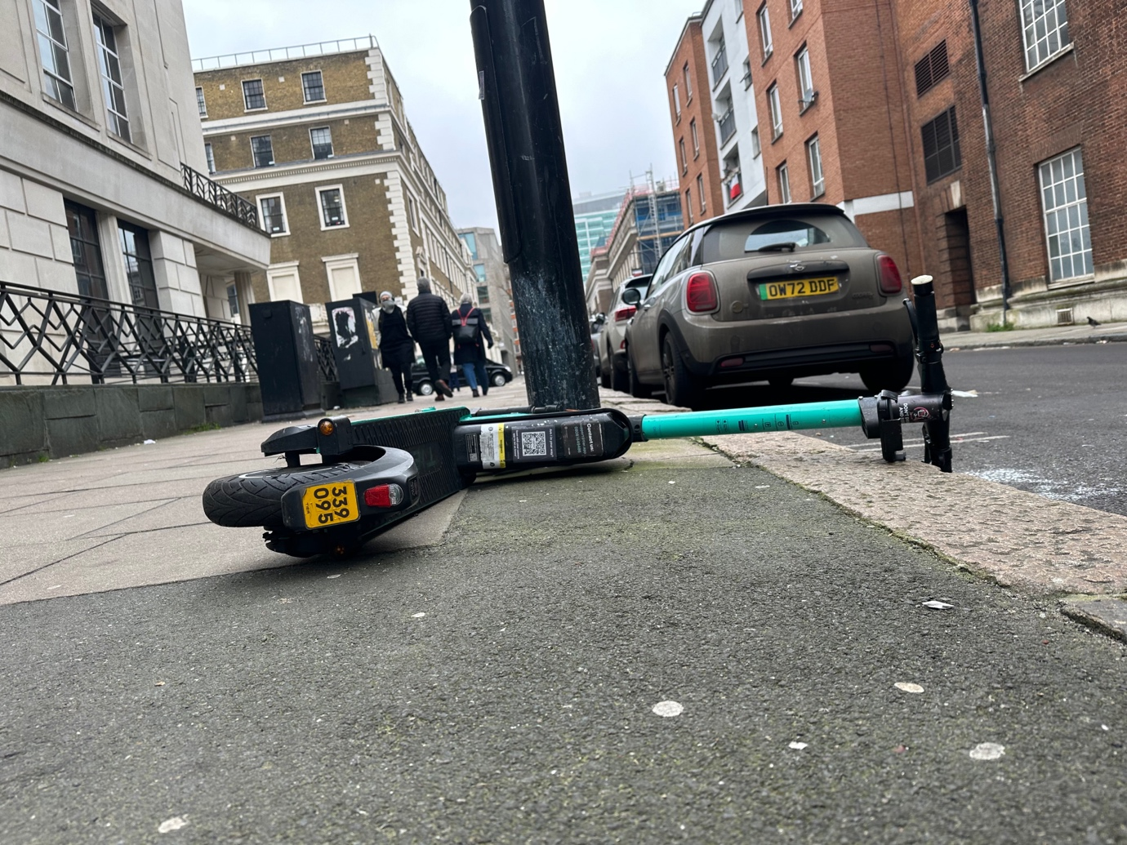
Photo 3 E-scooter knocked over on the pavement on the kerb line. The is unsafe and it is a trip hazard.
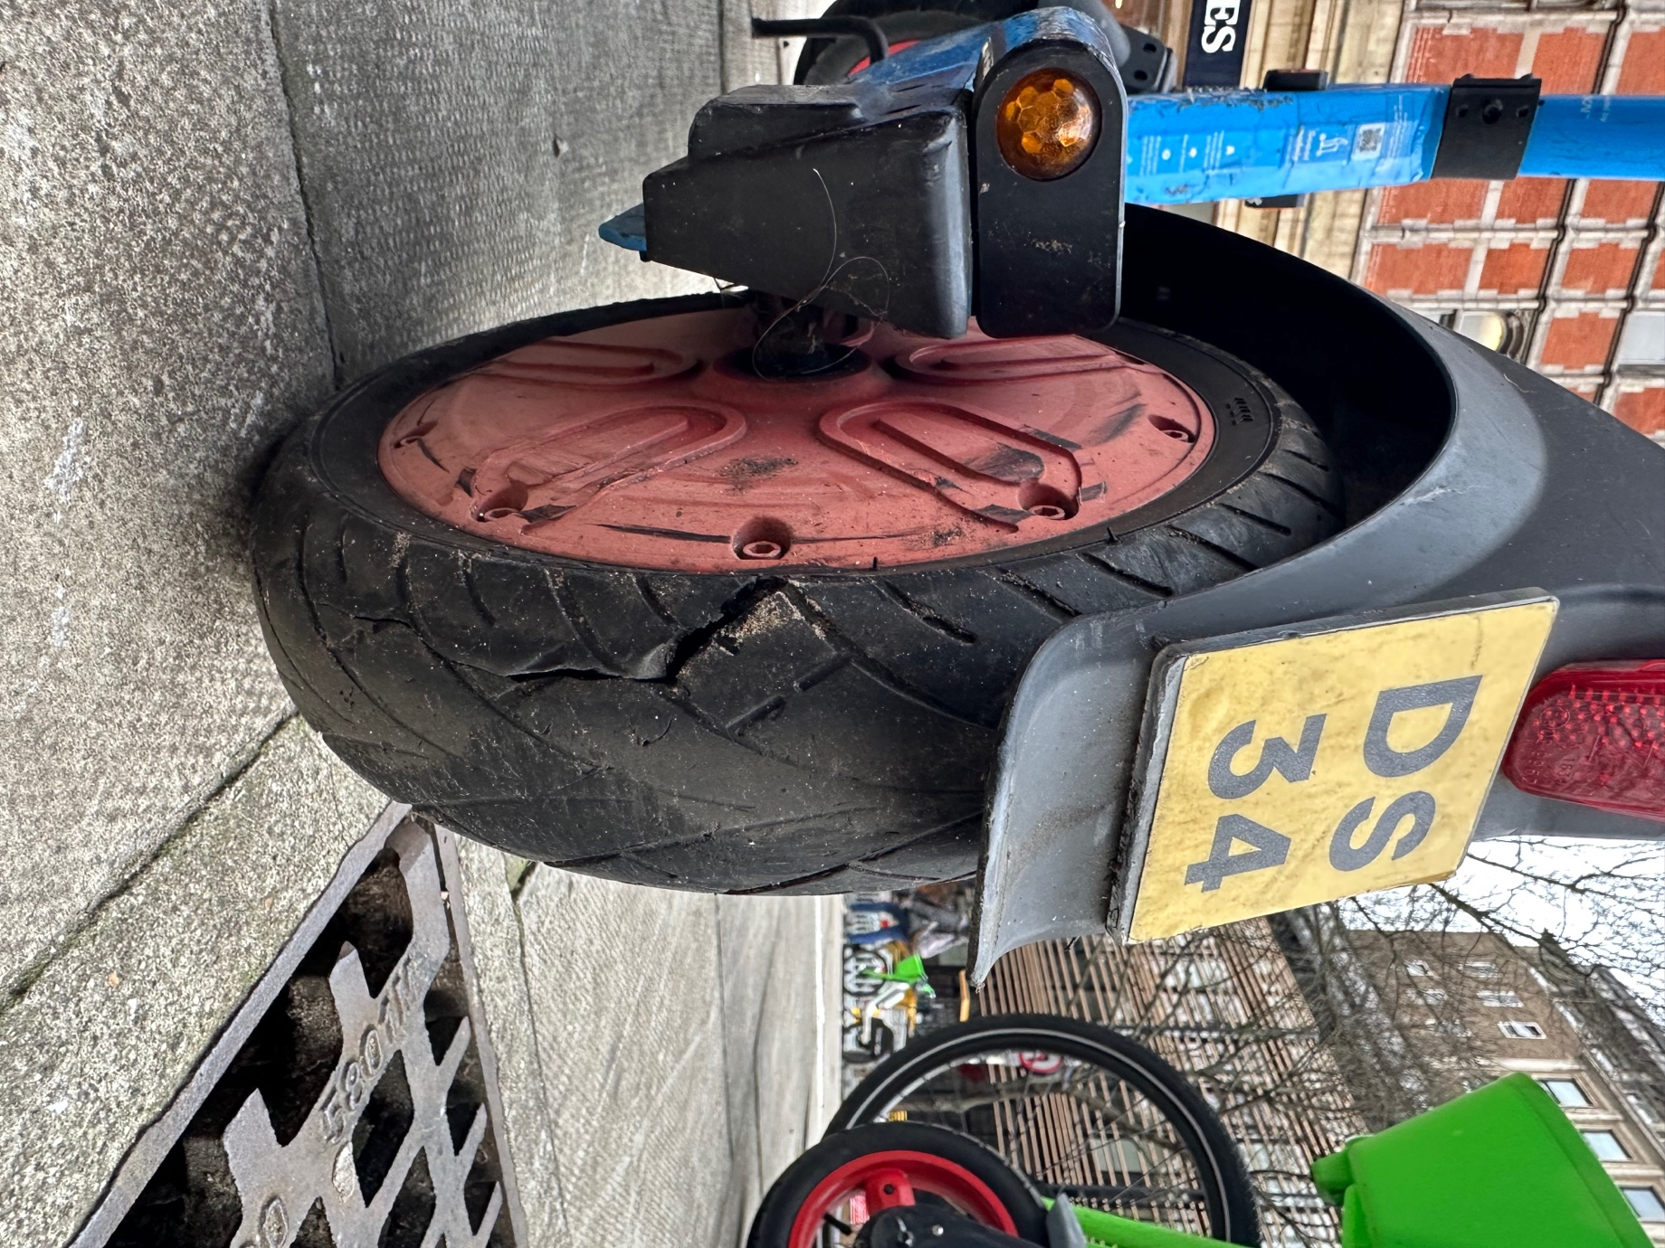
Photo 4 Dott with split back tyre.

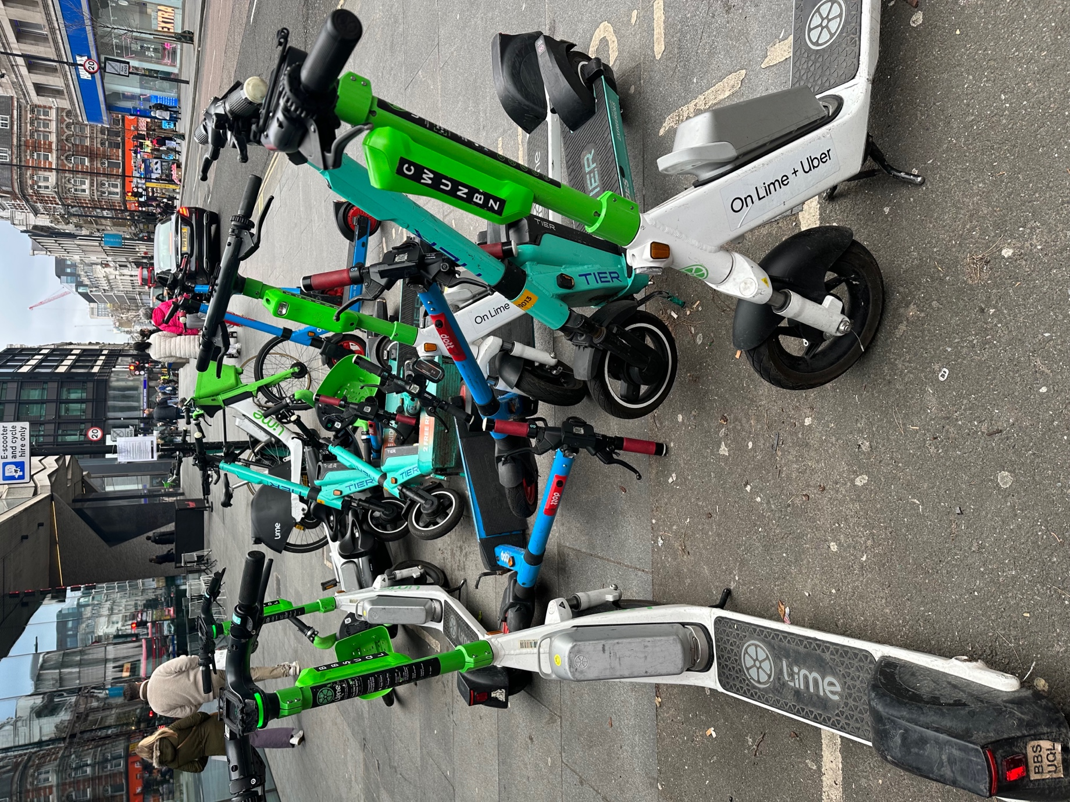
Photo 5 E-scooters and e-bikes left in a unsafe situation on the pavement, knocked over and in a heap in and around a painted parking bay. These are a trip hazard and people will be using the pavement to ride to and from the parking spot.

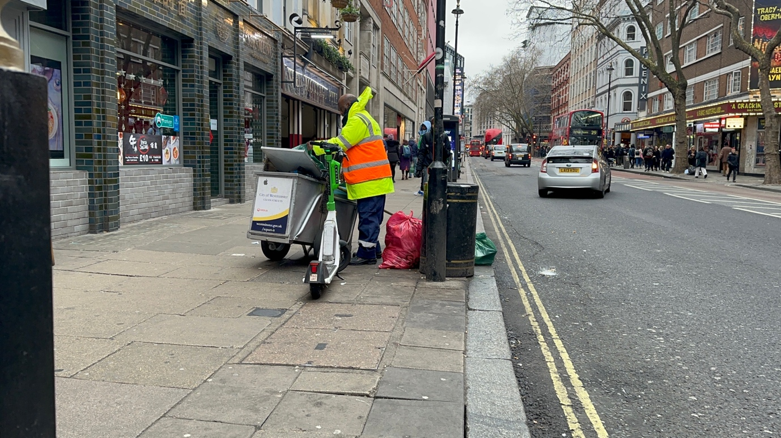
Photo 6 E-scooter left on pavement next to bin, it has been left in an unsafe location and is a trip hazard.

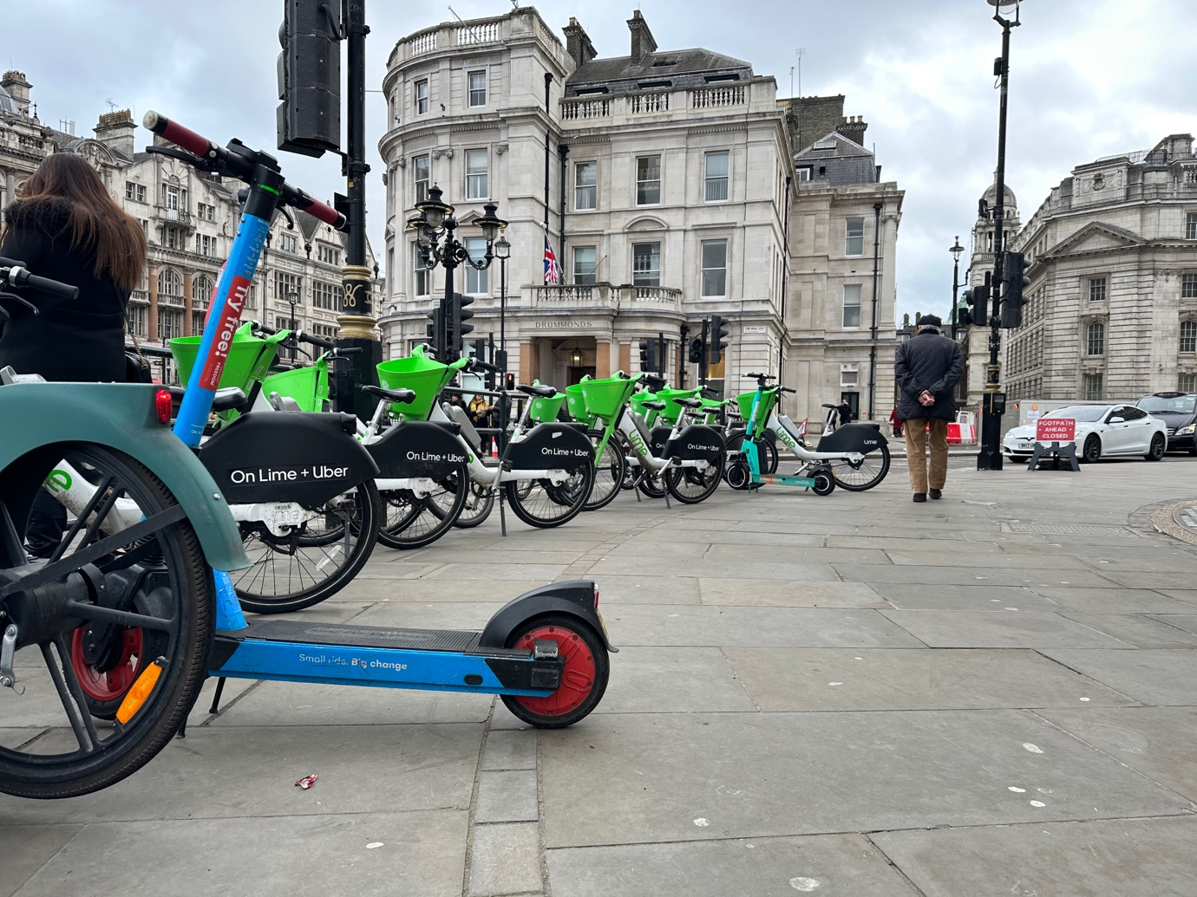
Photo 7 E-scooters and e-bikes left on the pavement on the railing. In between two pedestrian crossings. This is unsafe and is a trip hazard.
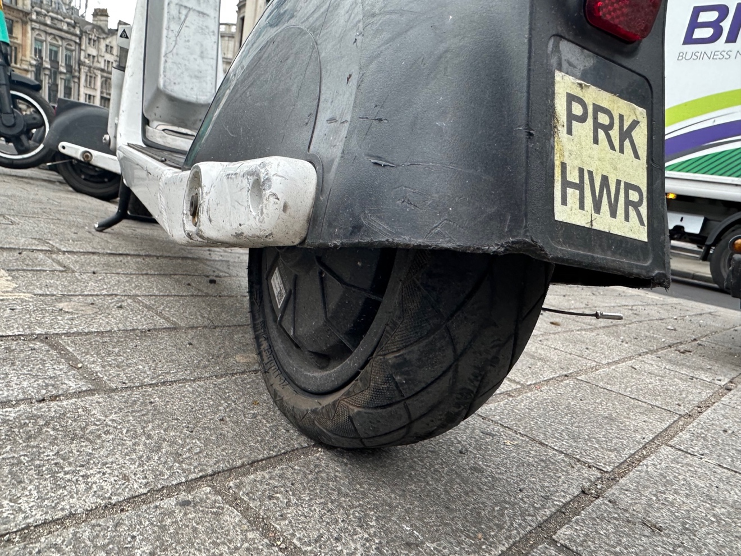
Photo 8 Flat Lime e-scooter back tyre.

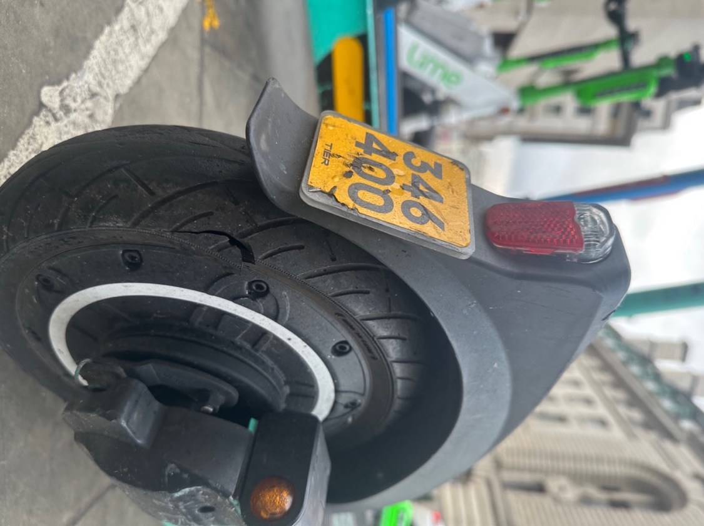
Photo 9 Tier with split back tyre.

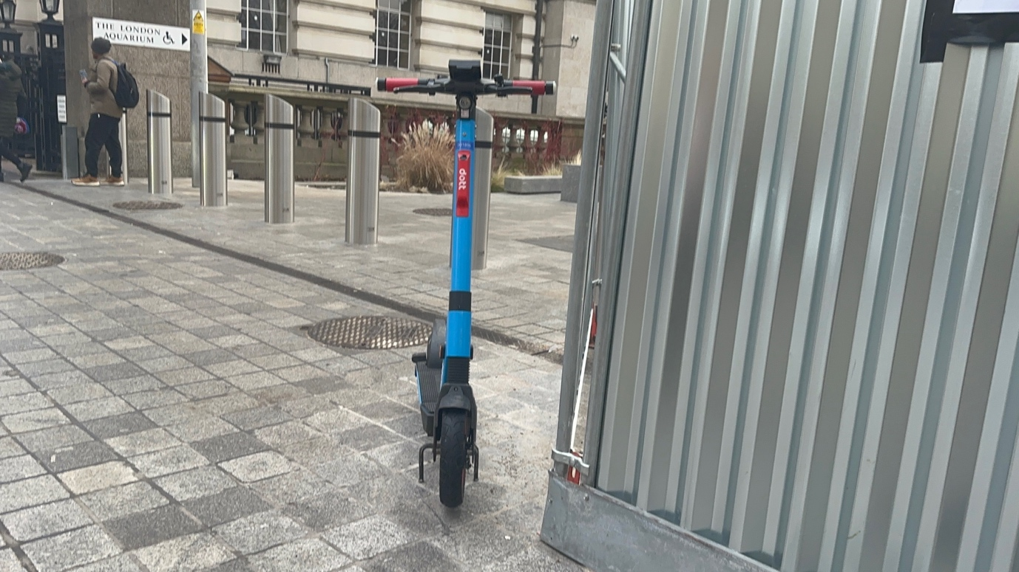
Photo 10 E-scooter left on pavement on corner causing obstruction and trip hazard. It has been left in an unsafe situation.

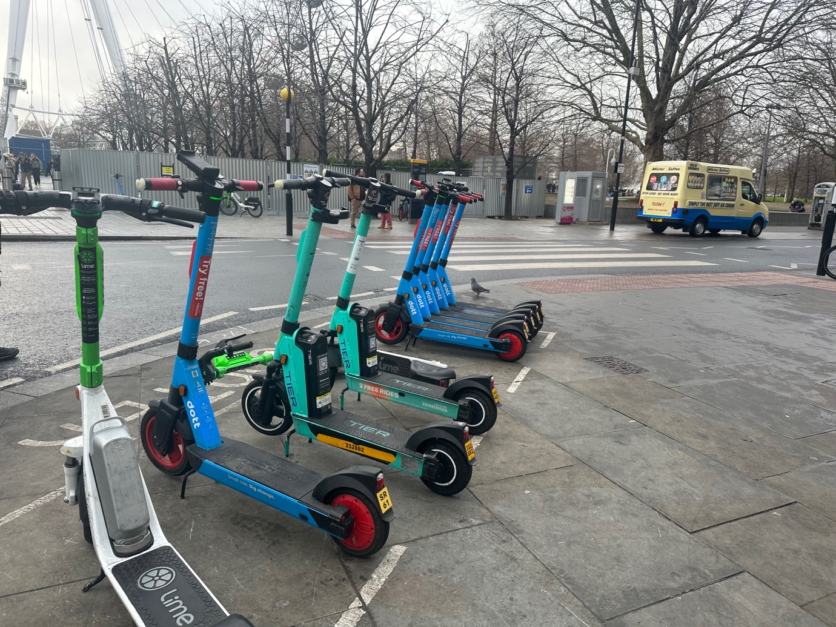
Photo 11 E-scooters left on unsafe situation on pavement next to pedestrian crossing. They are in a painted marking bay but they still are a trip hazard. One has been knocked over.

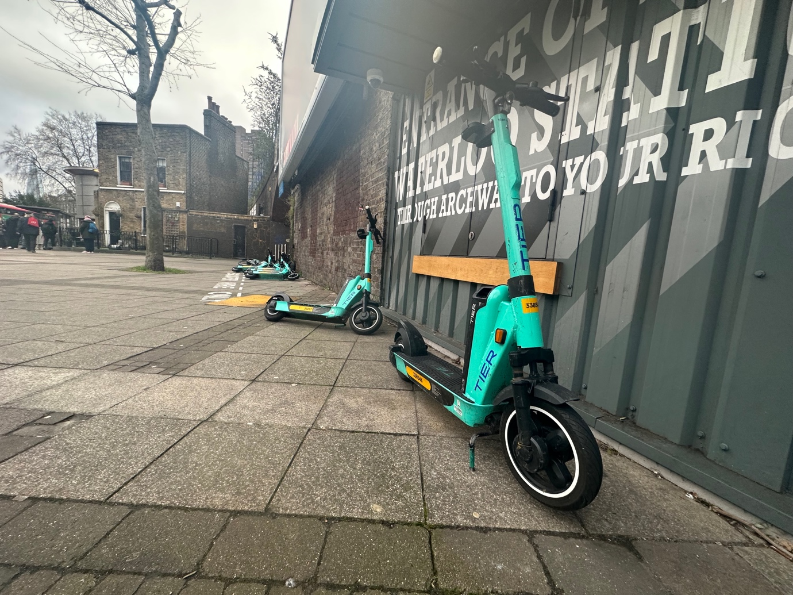
Photo 12 E-scooters left on building line in an unsafe locations, these are a trip hazard.

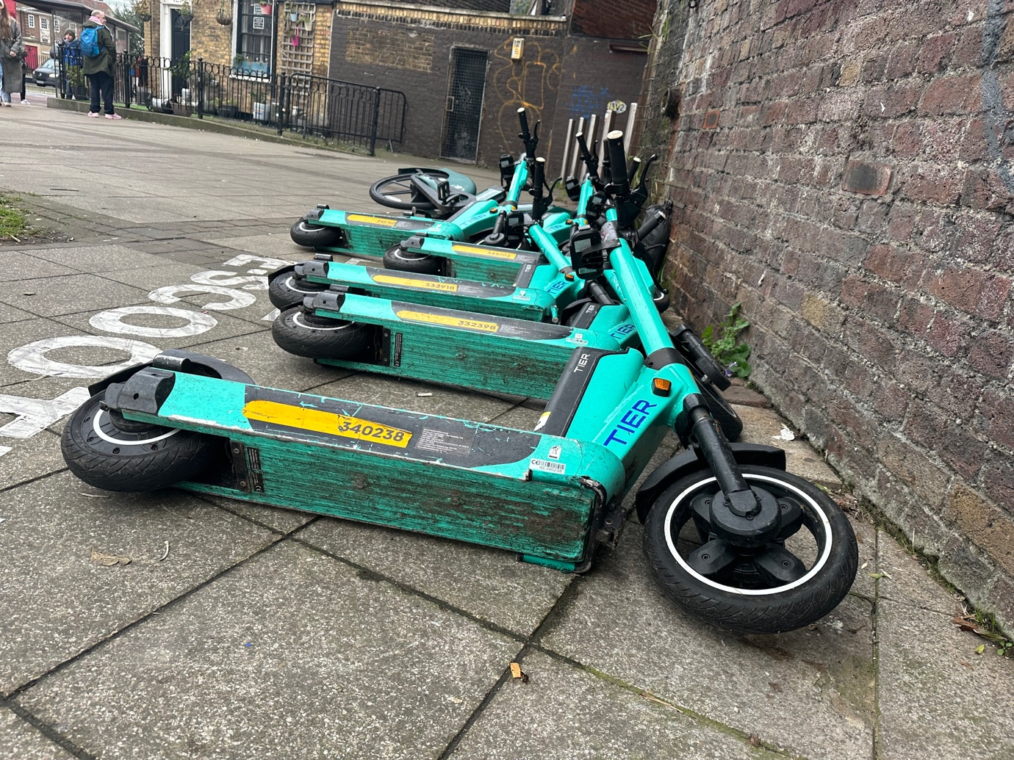 Photo 13 E-scooters (can be seen in photo 12) eft on building line in an unsafe locations, these are a trip hazard.

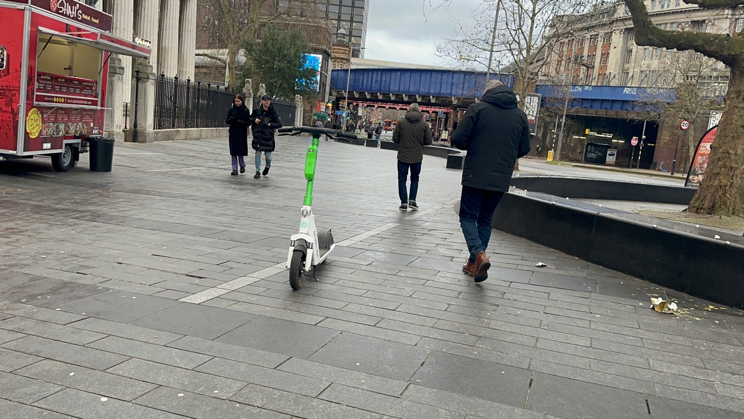
Photo 14 E-scooter left in the middle of pedestrian walkway in a unsafe location. This is a trip hazard.

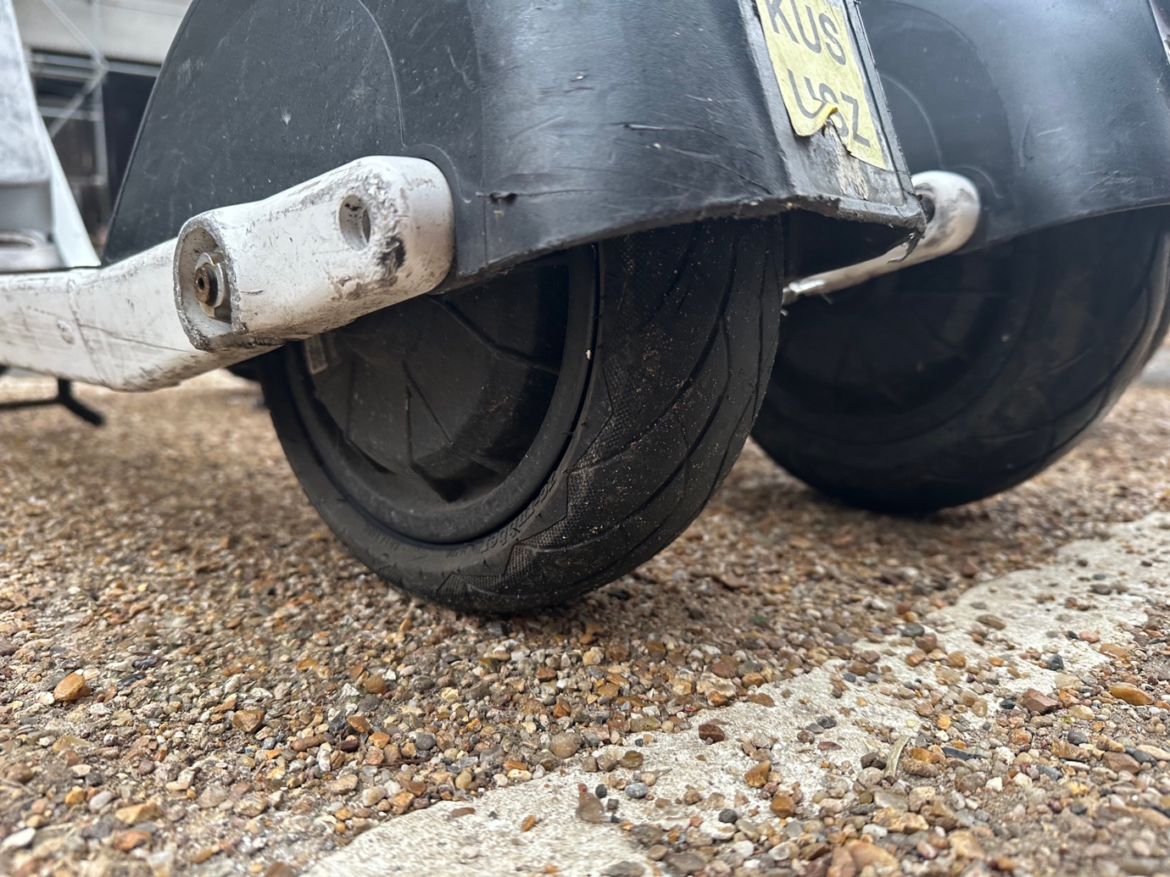
Photo 15 Lime e-scooter back tyre flat next to one that is not flat.
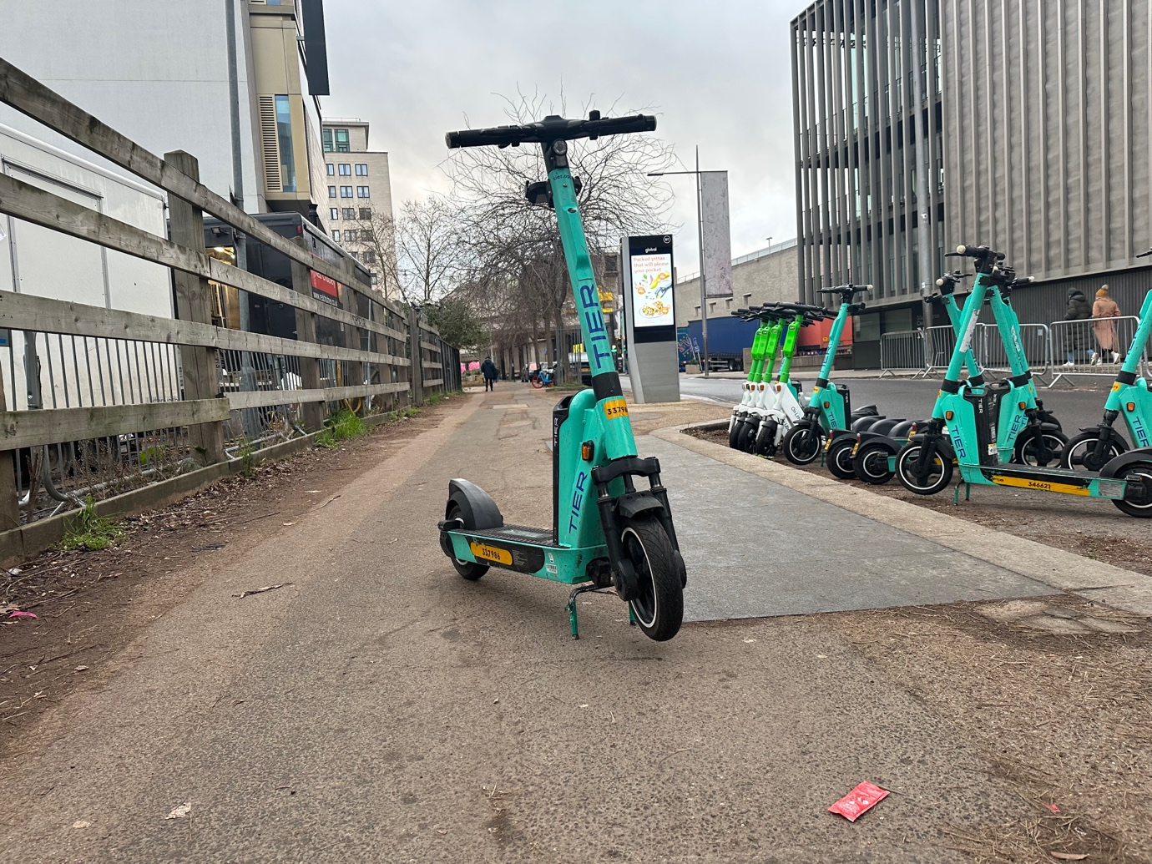
Photo 16 E-scooter left in the middle of the pavement in an unsafe location, which is not safe. Parking bay on the road is literally next to where the e-scooter has been left.

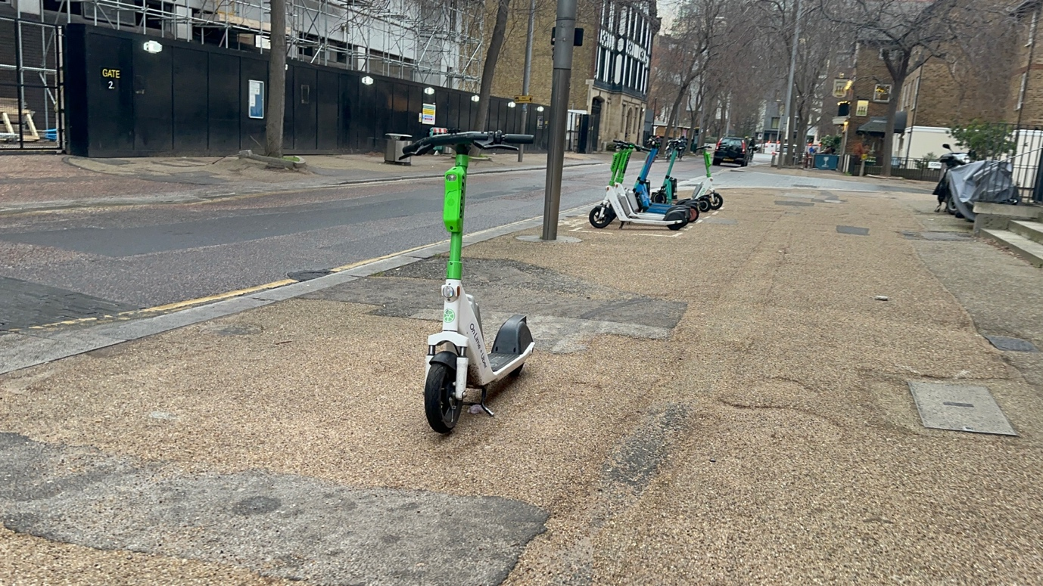
E-scooter 17 E-scooter left on the pavement with painted parking bay just behind it in an unsafe situation. This is a trip hazard. The painted parking bay seen in the background is also not safe being located on the pavement.
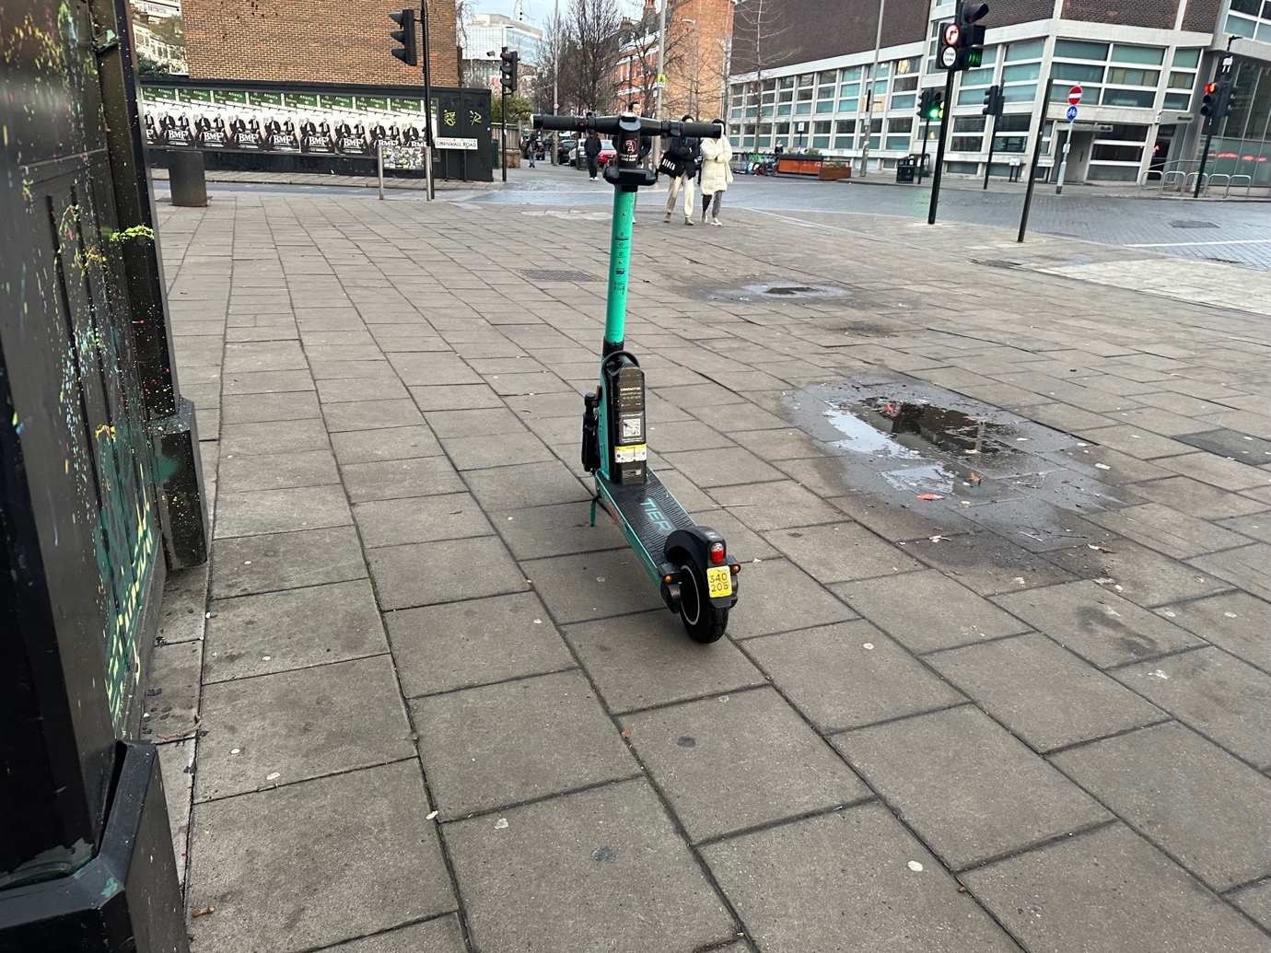
Photo 18 E-scooter left on pavement close to building line in a unsafe location. This is a trip hazard.

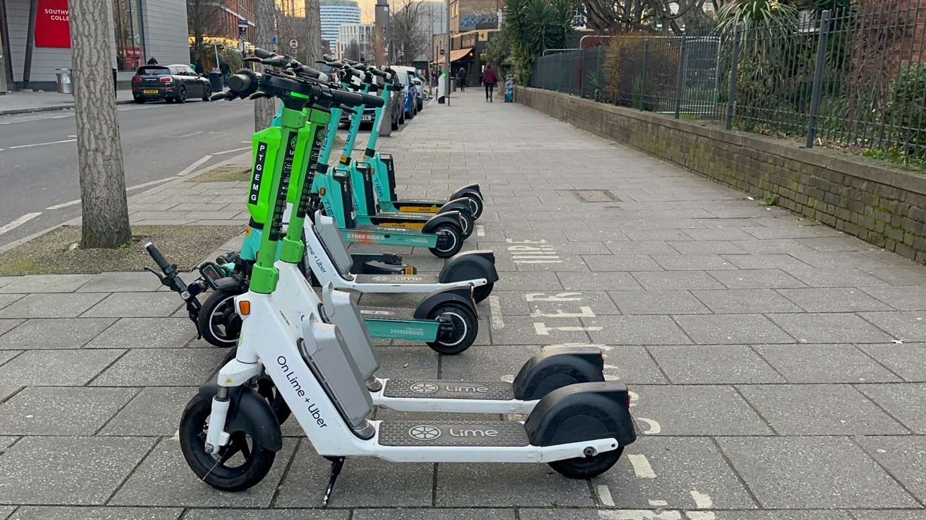
Photo 19 E-scooters left on unsafe situation on pavement next to pedestrian crossing. They are in a painted marking bay but they still are a trip hazard. One has been knocked over. There is a zebra crossing just next to this parking bay which is out of shot.

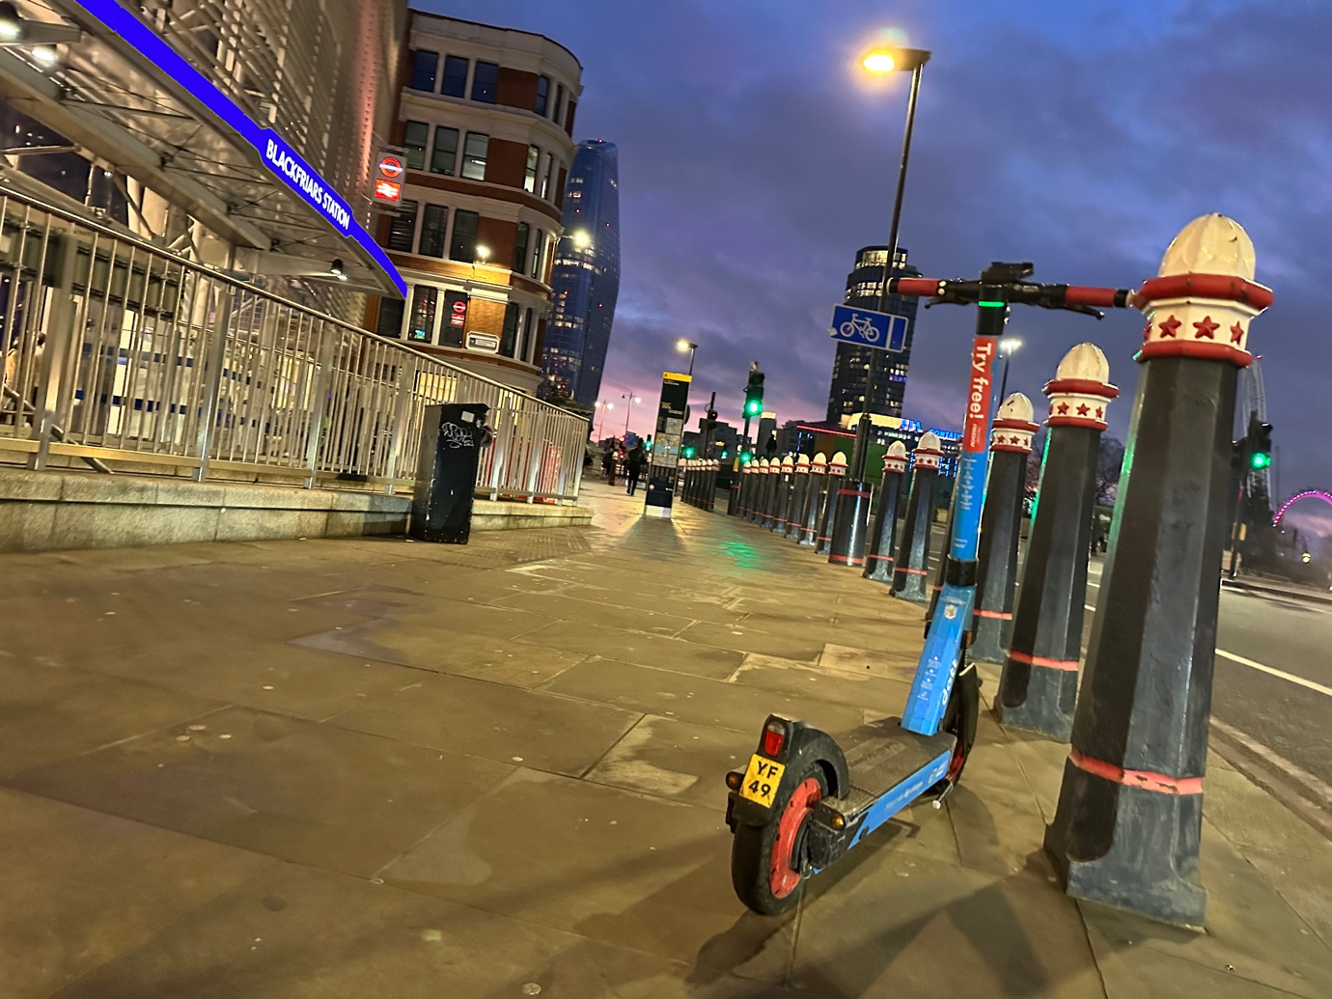
Photo 20 E-scooter left outside busy train station on pavement in an unsafe location. This is a trip hazard.

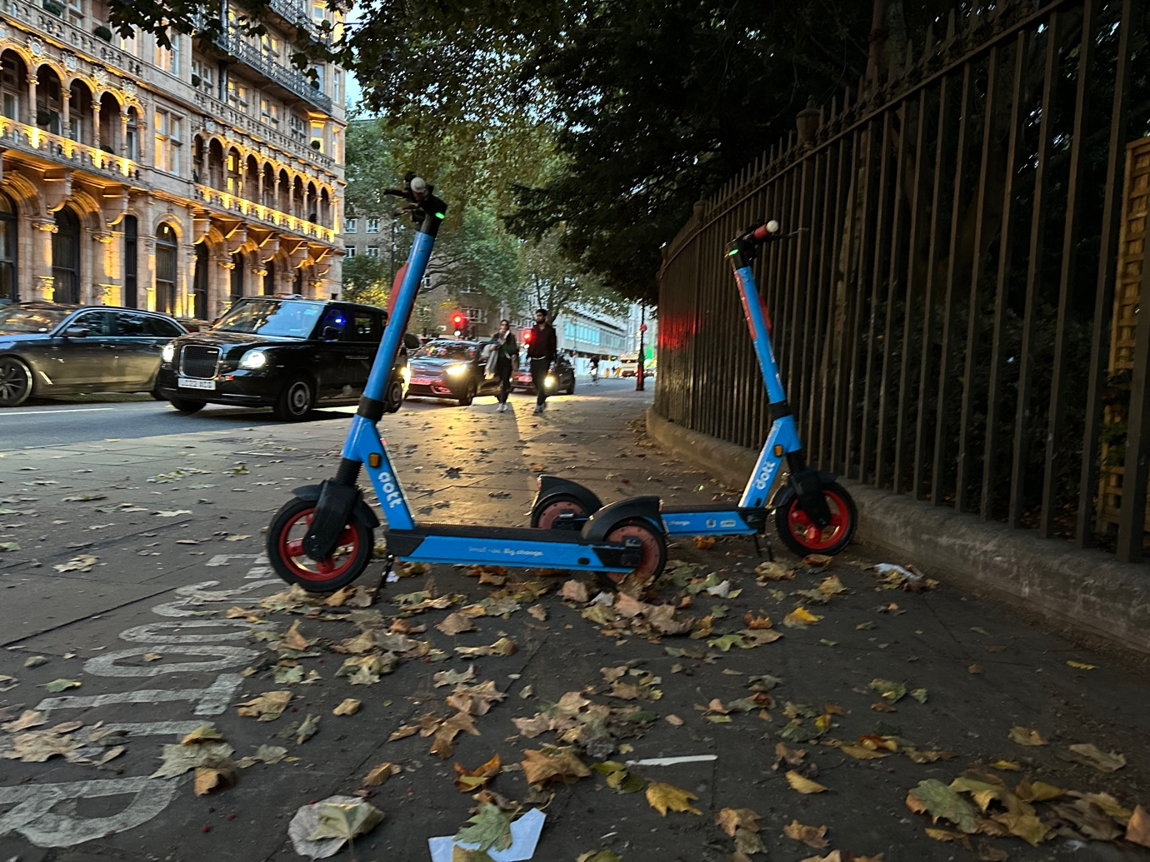
Photo 21 E-scooters left in an unsafe situation on the building line, these are tarip hazard.
E-
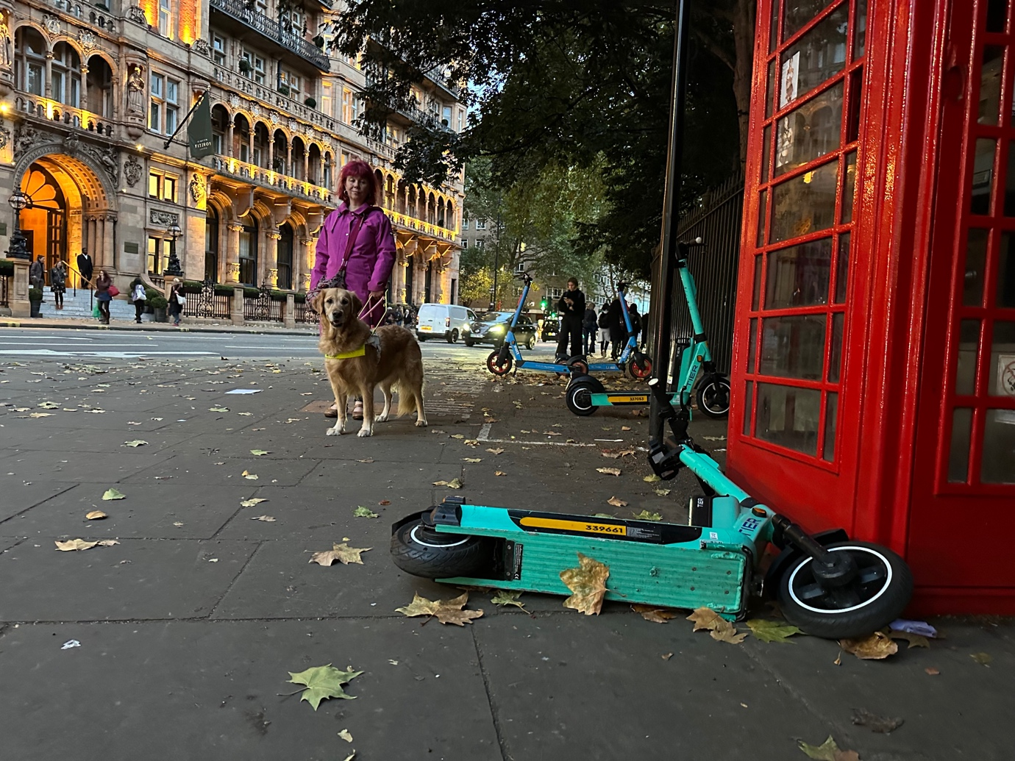
Photo 22 E-scooters left in an unsafe situation on the building line, these are atrip hazard. One is knocked over and the same scooters in photo 21 are seen in the background.

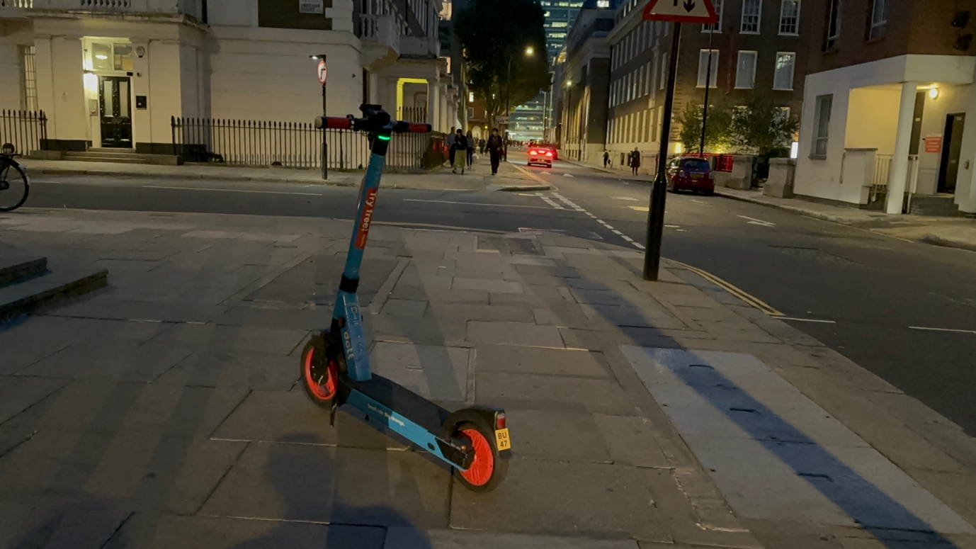
Photo 23 E-scooter left in the middle of pavement which is unsafe location and is a trip hazard.

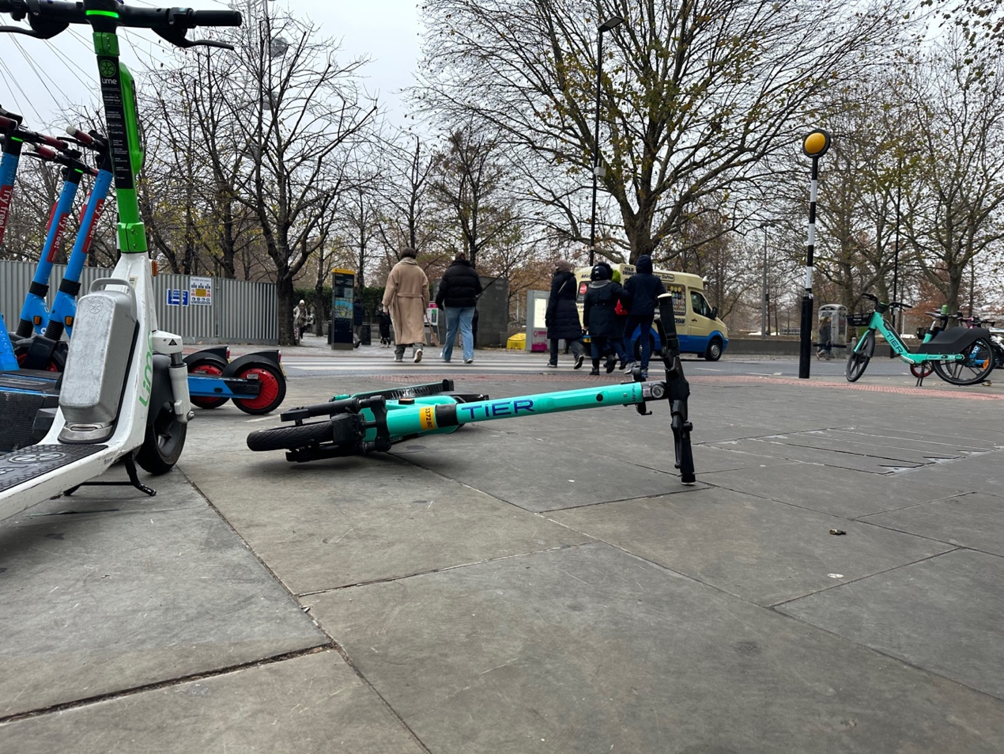
Photo 24: E-scooters left on the pavement and creating a trip hazard and obstructions. One has fallen over and this is all close to a pedestrian zebra crossing. There is an e-bike seen next to the tactile paving at the crossing. This is not a safe situation.

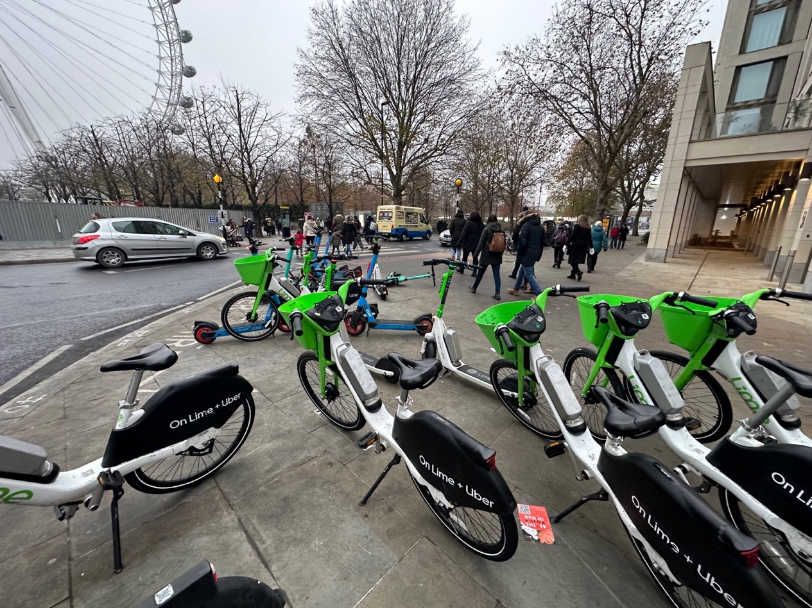
Photo 25 Same photo as 24 but shows more bikes and e-scooters left on the pavement in an unsafe situation.
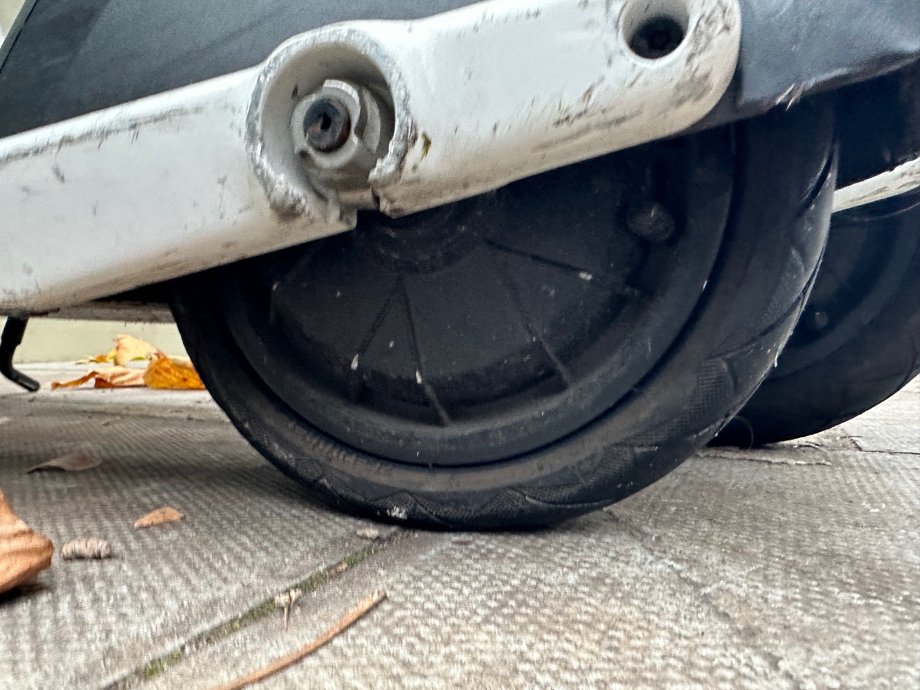
Photo 26 Flat Lime back tyre.

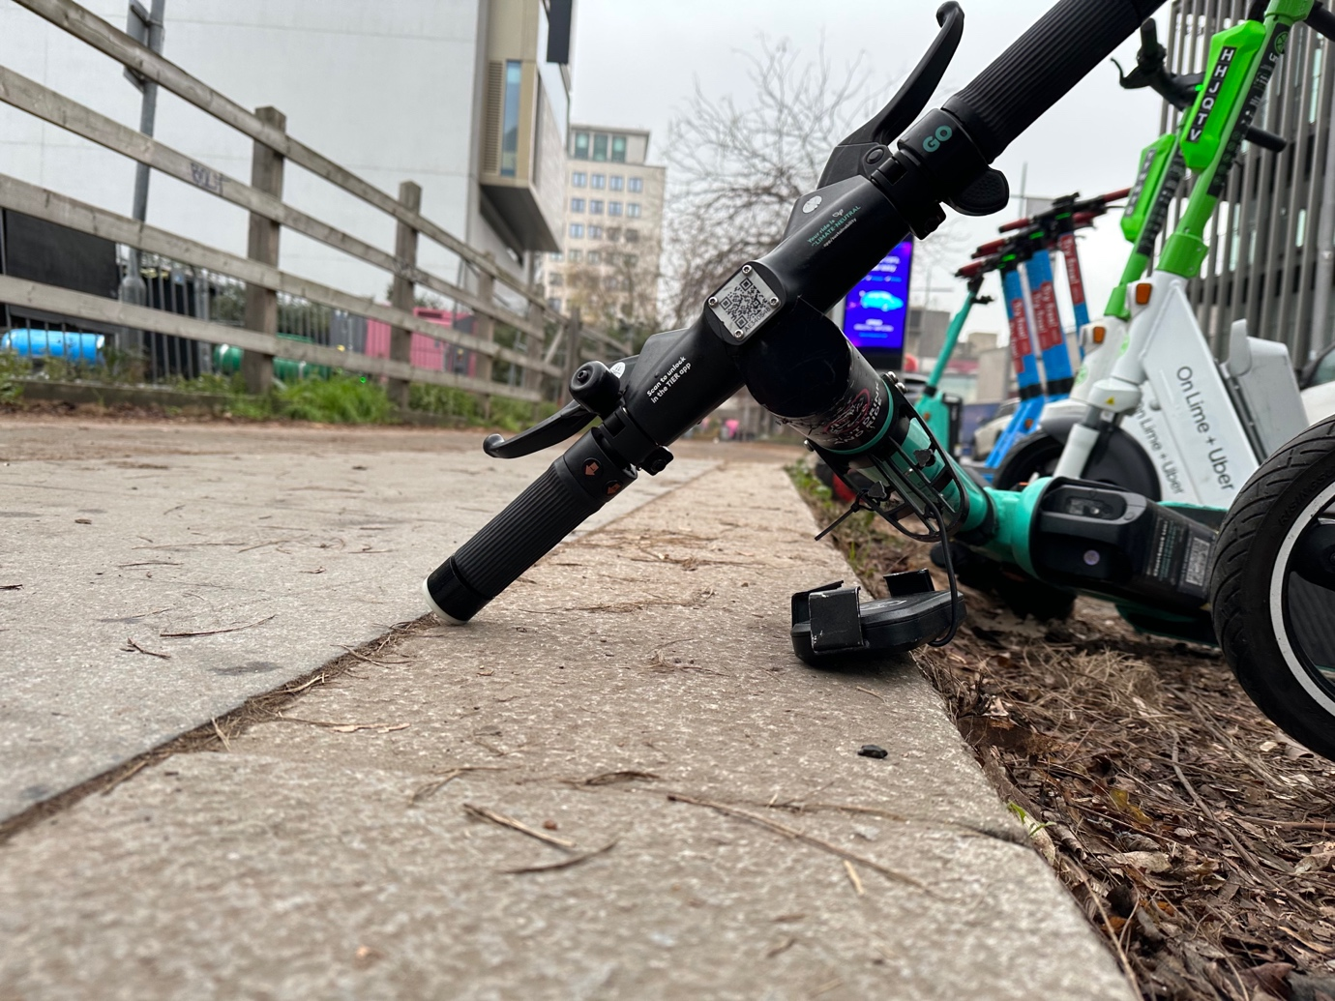
Photo 27 E-scooter knocked over from parking bay onto the pavement creating a trip hazard on the pavement.
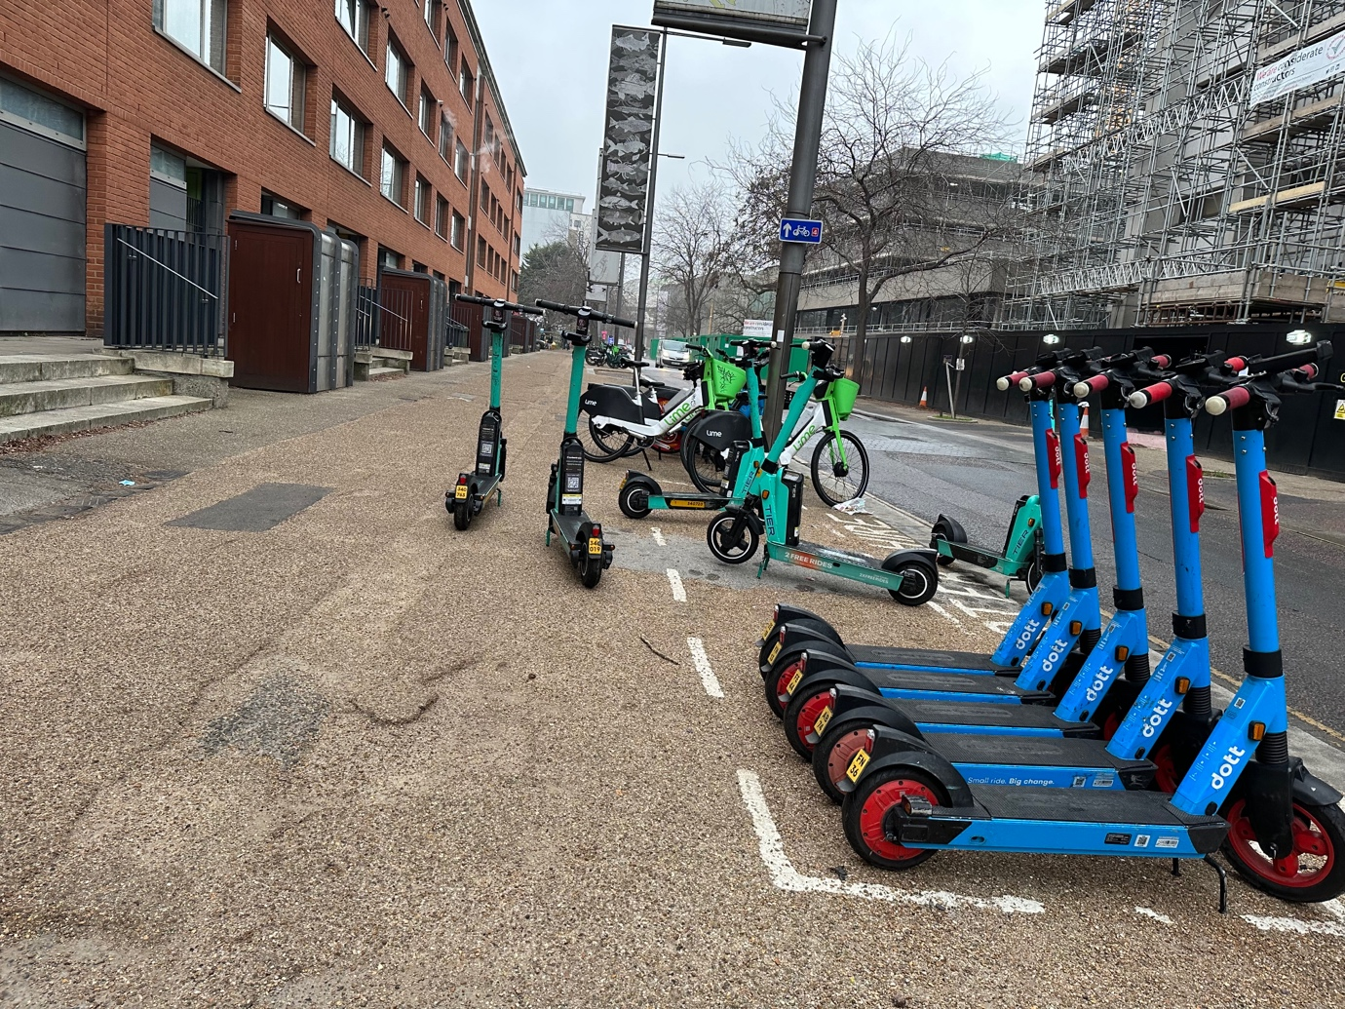
Photo 28 E-scooters in painted bay on pavement and two left next to them on the pavement. This is not safe situation, and the e-scooters are a trip hazard.

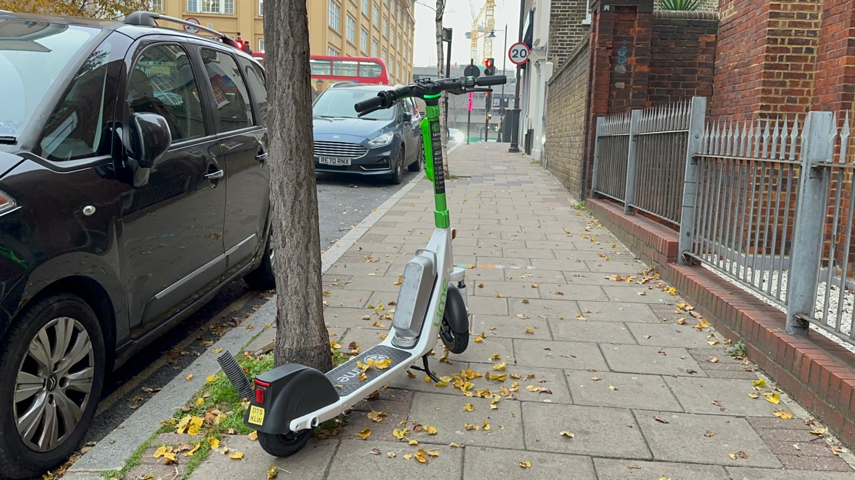
Photo 29 E-scooter left on pavement creating an unsafe situation and a trip hazard.
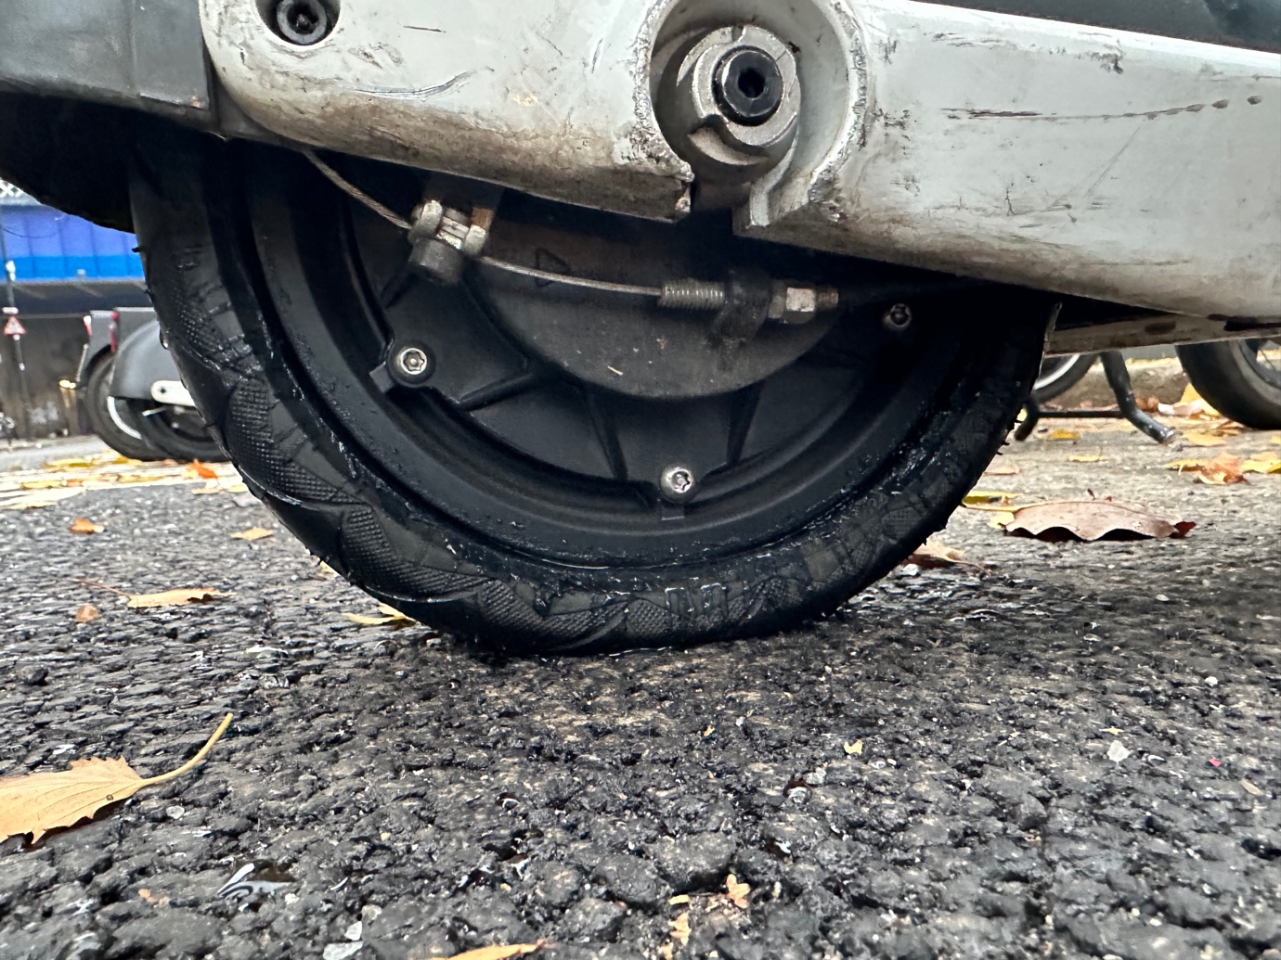
Photo 30 Flat Lime back tyre

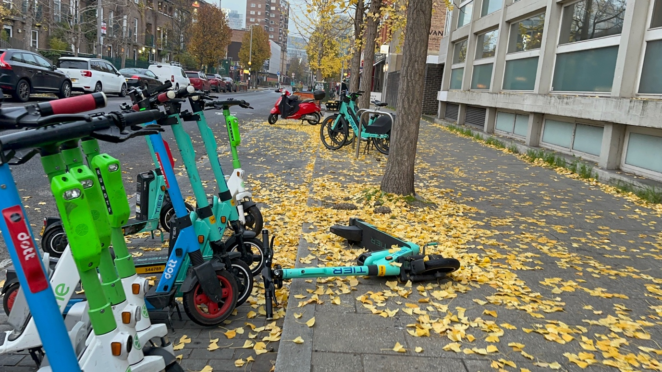
Photo 31 E-scooter bay is on the road parking bay and e-scooter left knocked over on pavement in an unsafe manner.

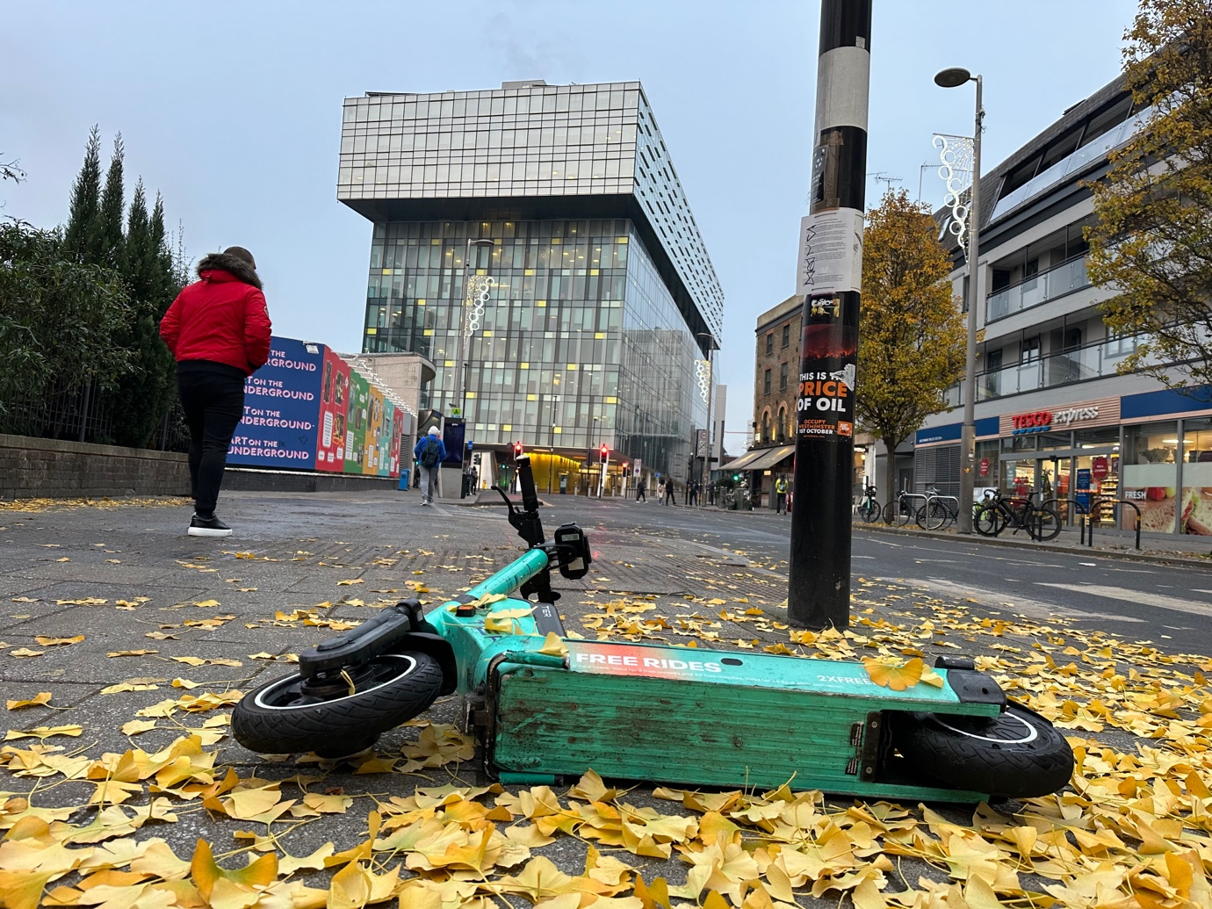
Photo 32 E-scooter knocked over on pavement next to zebra crossing and the tactile paving used for blind and visually impaired people to find the crossing.
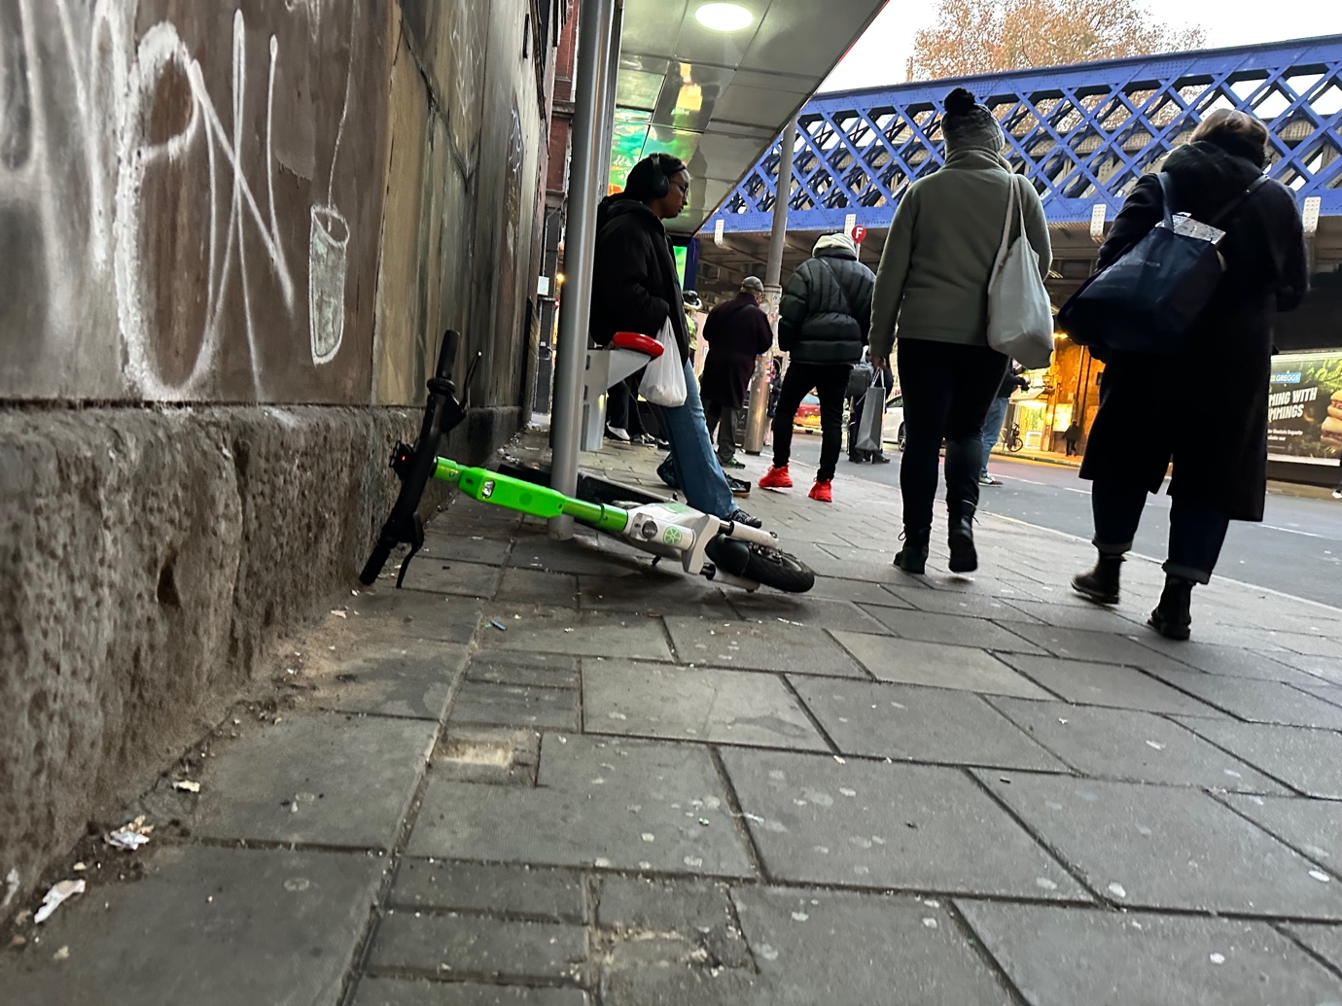
Photo 33 E-scooter left on pavement knocked over next to bus stop in an unsafe manner. This is a trip hazard.
Appendix F b London E-scooter Trial Teir, Lime and Dott E-Scooters

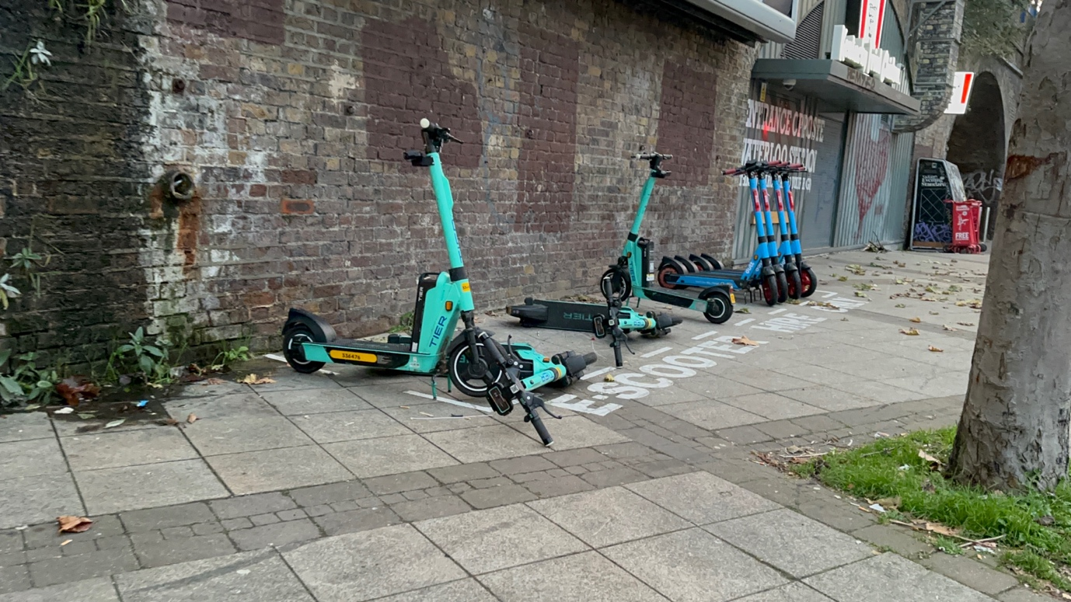
Photo 34 E-scooters left on building line with one fallen over. This is an unsafe location of the e-scooters to be left. They are a trip hazard.
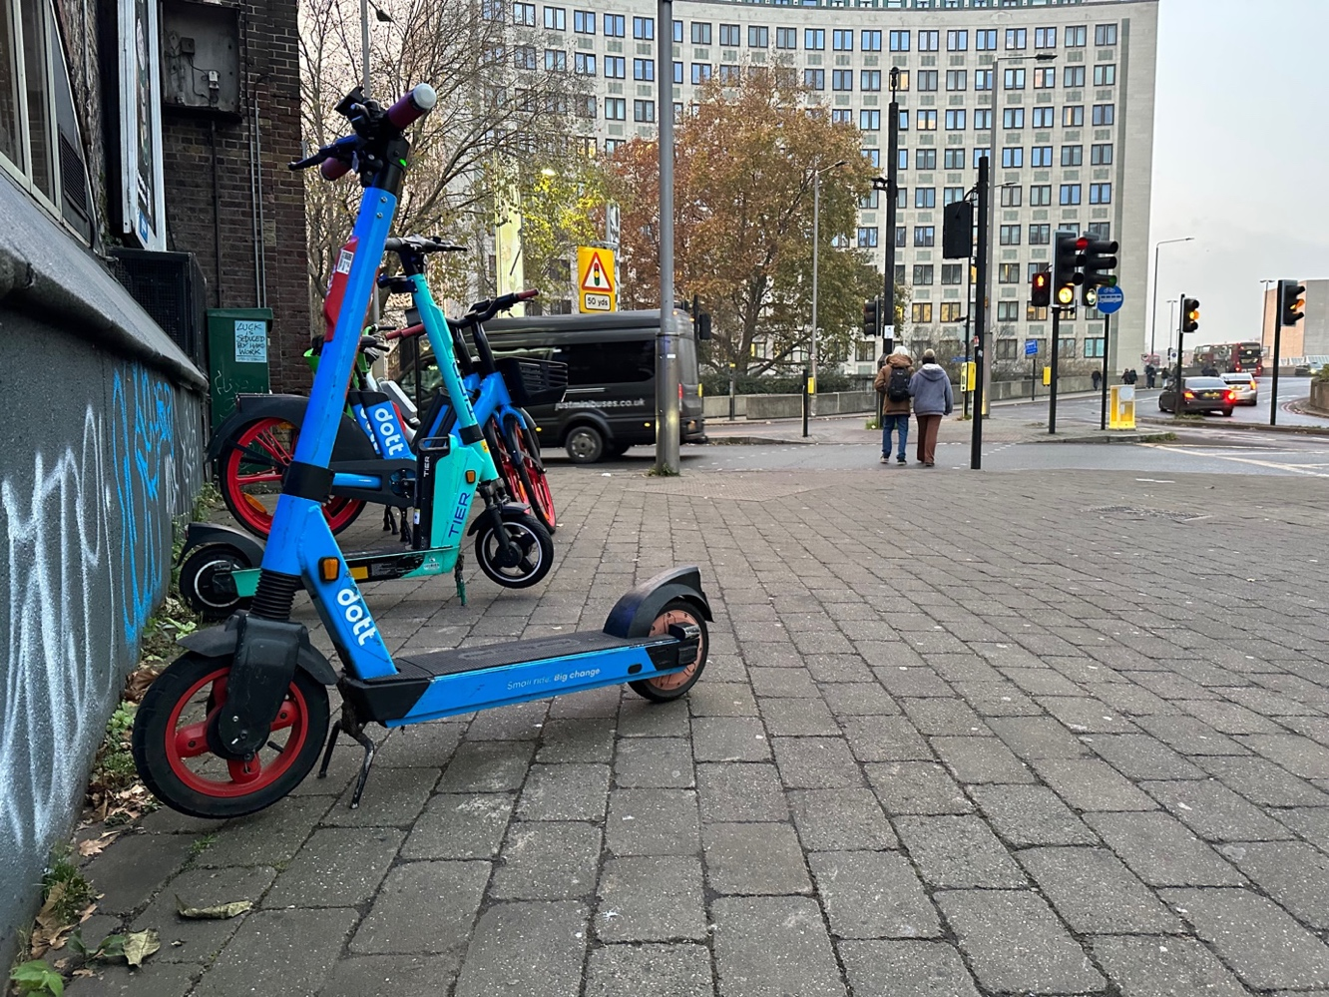
Photo 35 E-scooters left on building line with e-bikes . This is an unsafe location of the e-scooters they are a trip hazard. This is just up from photo 34.
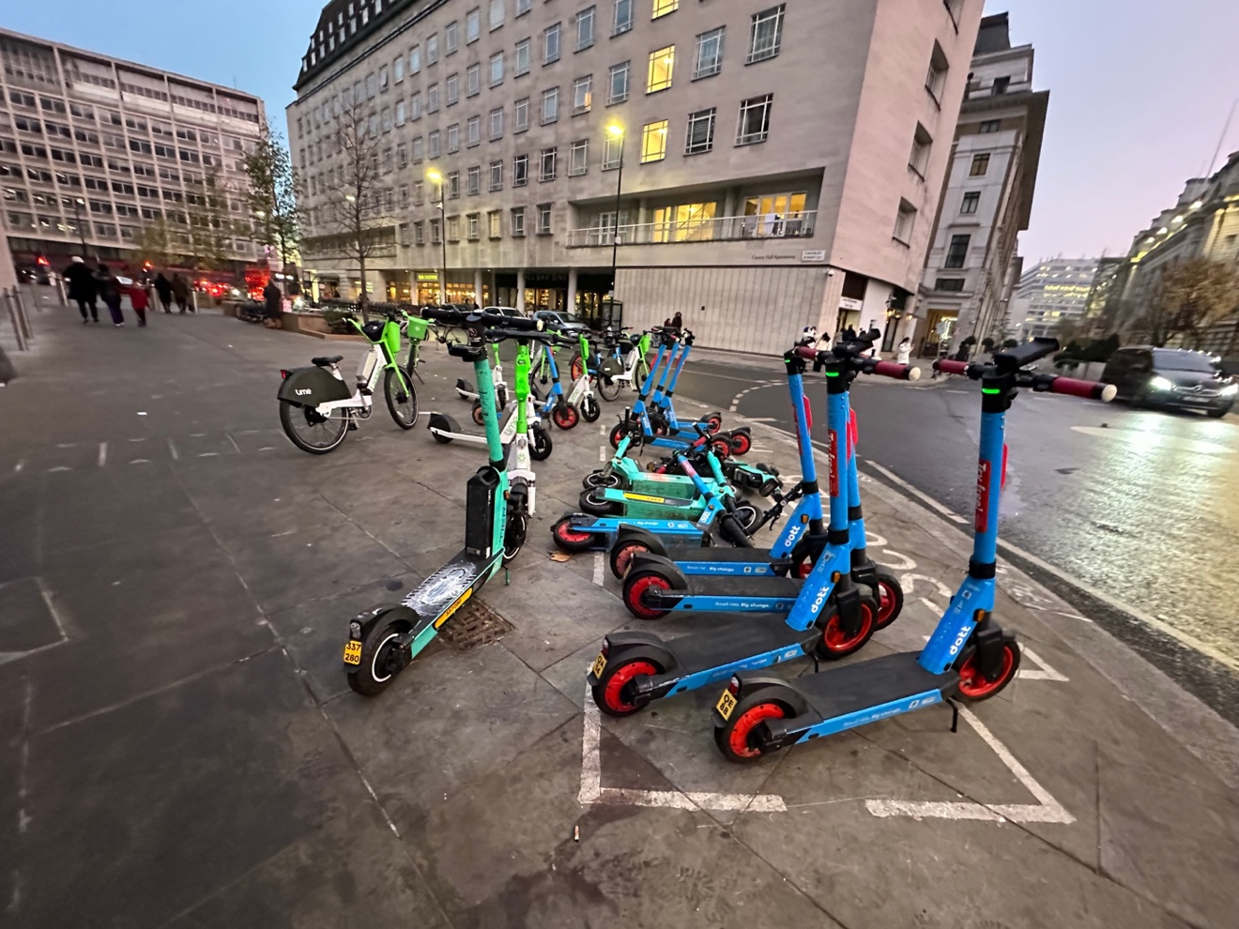
Photo 36: E-scooters left on the pavement and creating a trip hazard and an obstruction. E-scooters have fallen over. There are e-bikes also left on the pavement. This is not a safe situation. This is close to a zebra crossing as shown in photo 37.

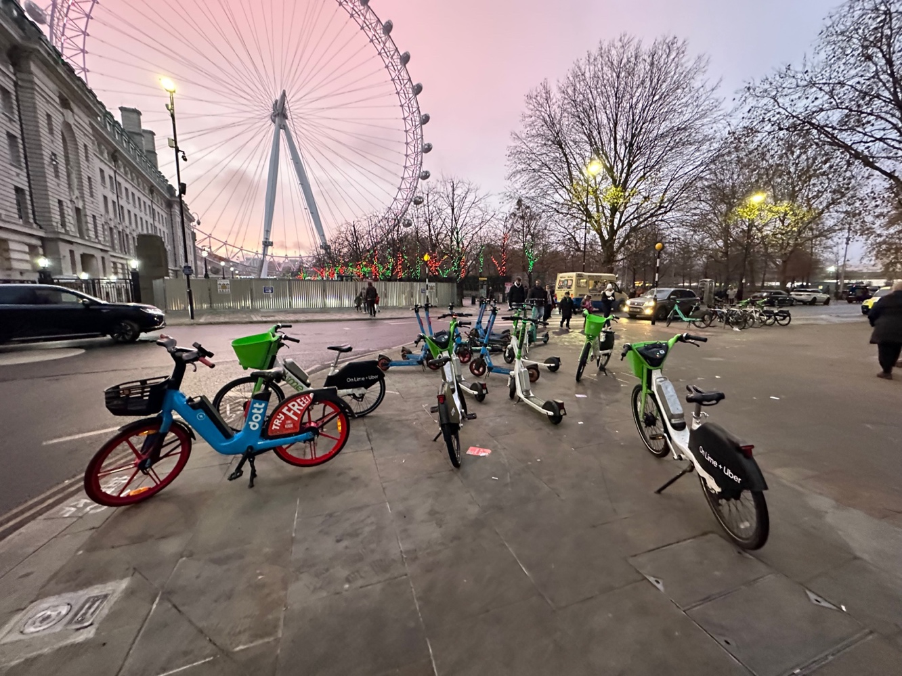
Photo 37 Same as photo 36 illustrating the location of the pedestrian crossing.
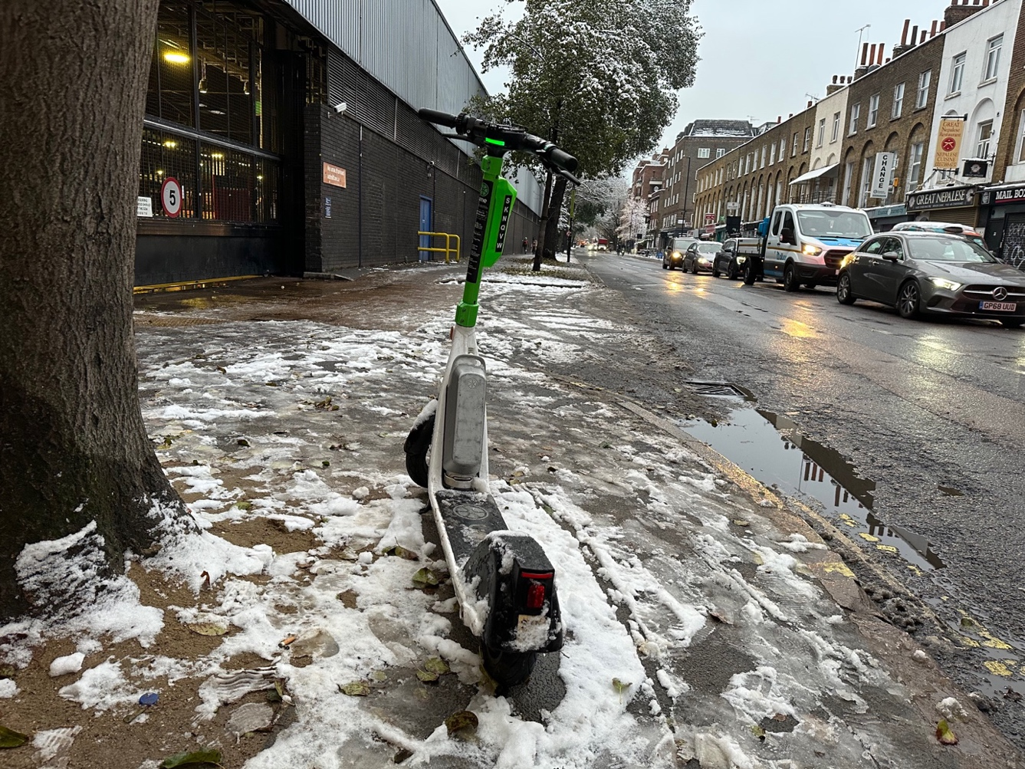
Photo 38 E-scooter left on the pavement which has a bus stop behind it. As seen from the footprint’s pedestrians use this part of the pavement. This is unsafe location to leave this e-scooter.
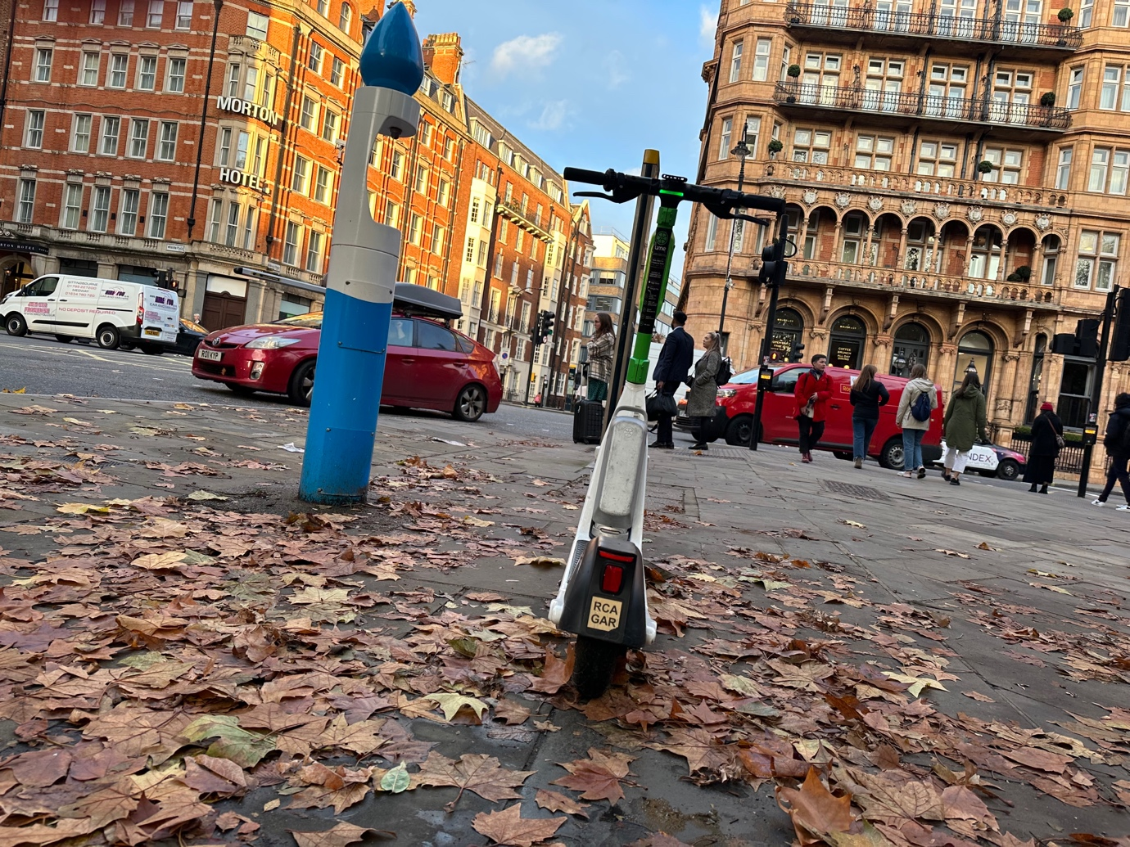
Photo 39 E-scooter left in an unsafe situation in the middle of the pavement creating ta rip hazard.

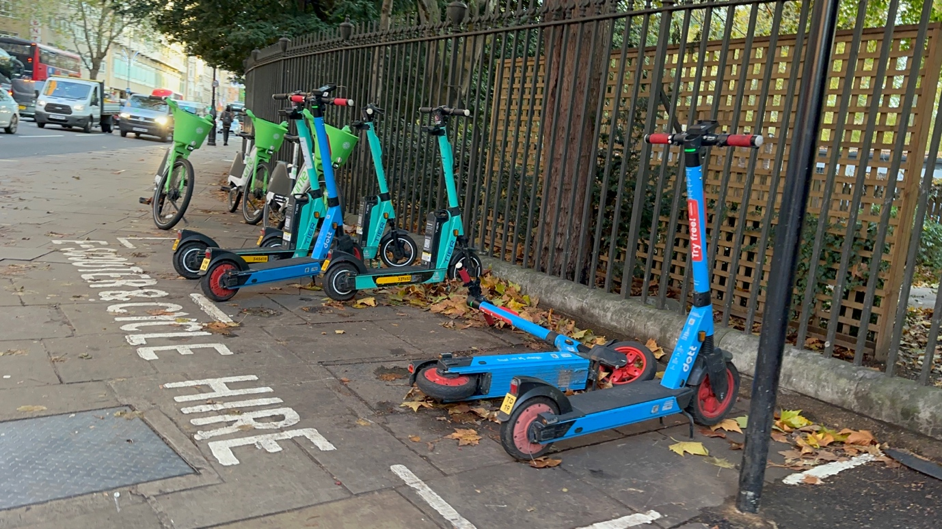
Photo 40 E-scooters left on the building line of the pavement with e-scooters knocked over and with e-bikes left there too. This is unsafe situation and the e-scooters are trip hazards.
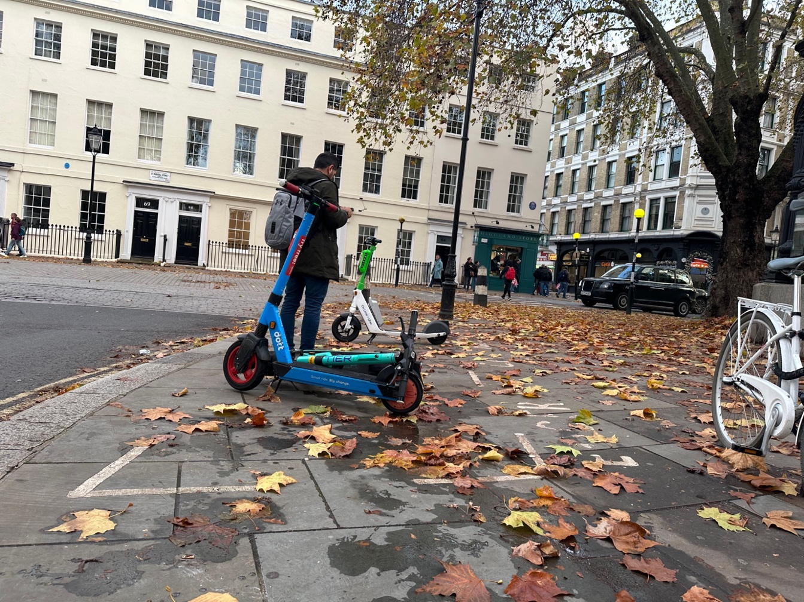
Photo 41 E-scooters left on the pavement in a painted parking bay next to the kerb line in an unsafe location and manner. One of the e-scooters is knocked over. This is a trip hazard.

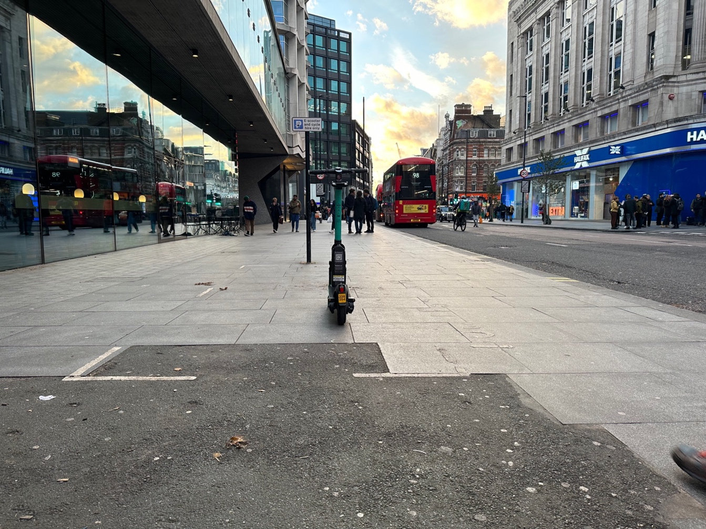
Photo 42 One e-scooter left in the middle of the pavement in a painted parking bay. This is not safe location, and it is a trip hazard.
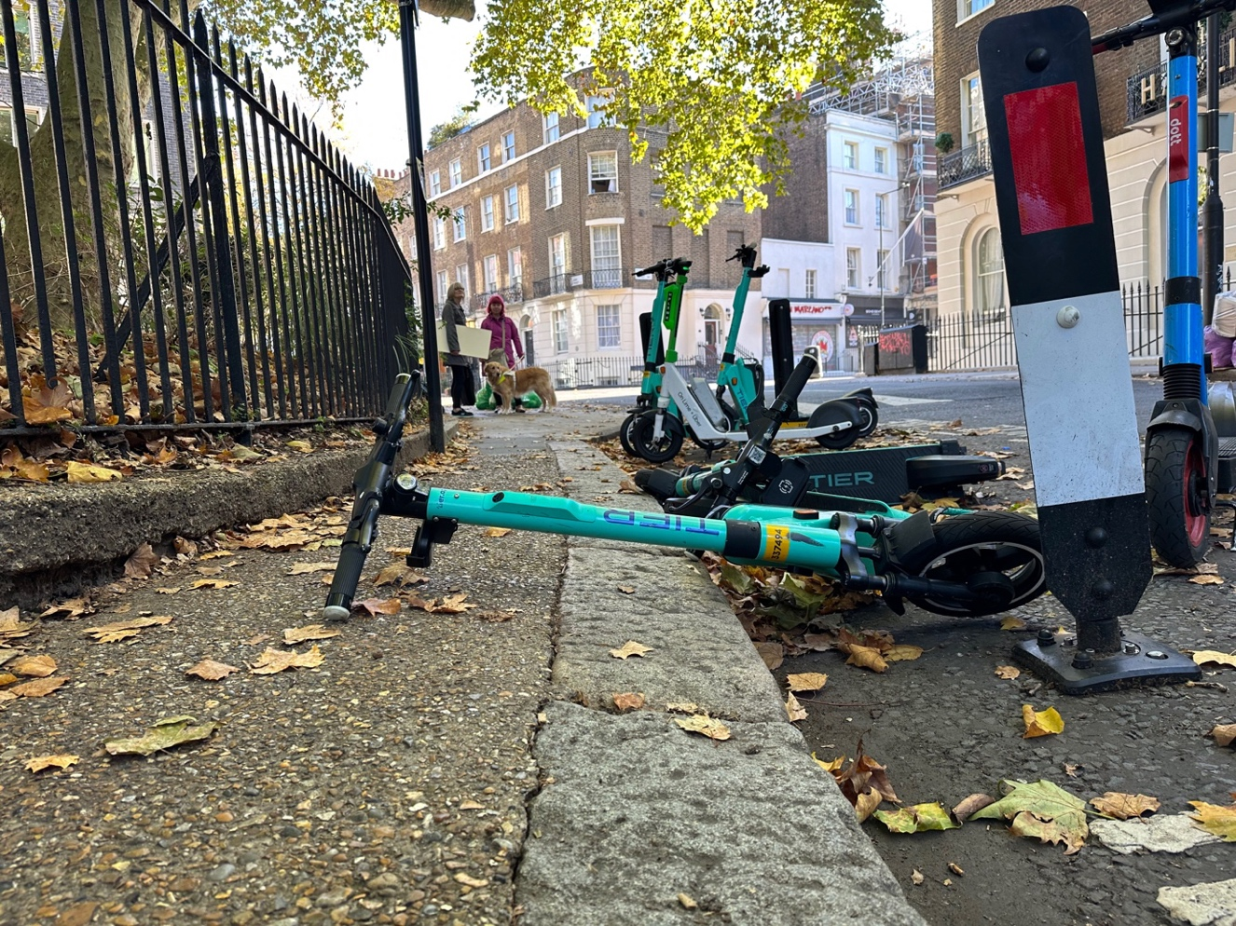
Photo 43 E-scooter parked on road but fallen over onto pavement and is blocking access to the pavement. This is unsafe and it is a trip hazard.

London 27 March 2022 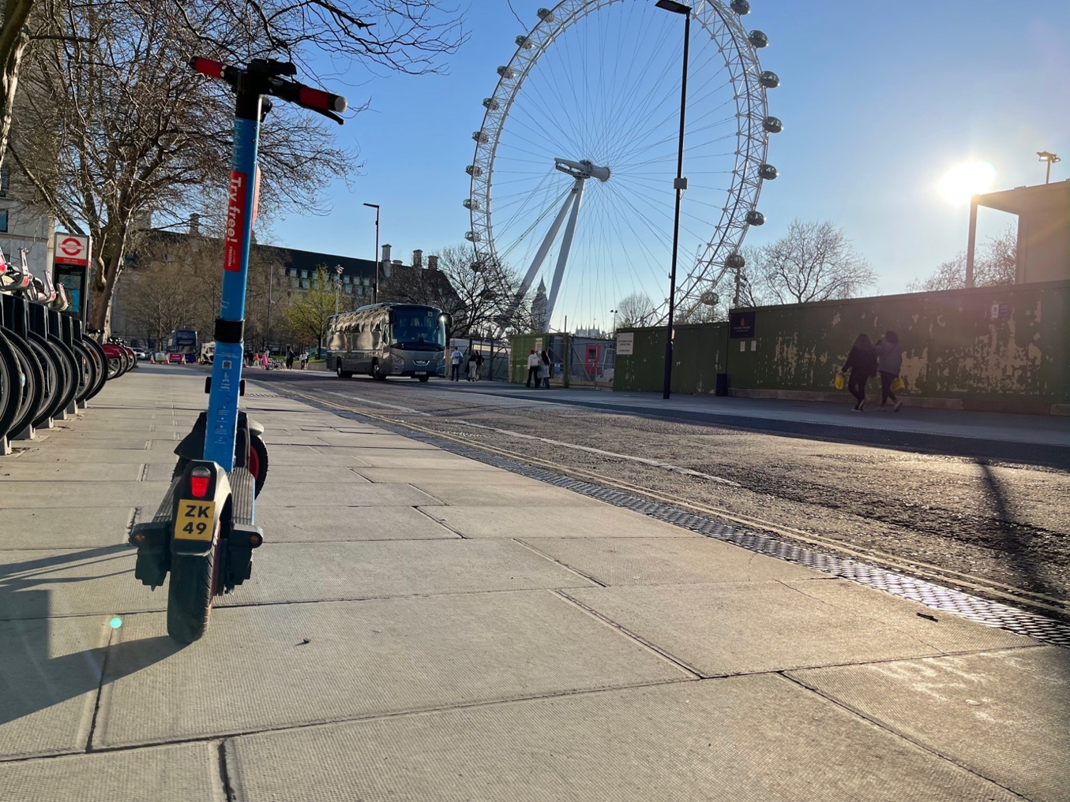
Photo 44 E-scooter left on pavement in an unsafe manner. It is a trip hazard.
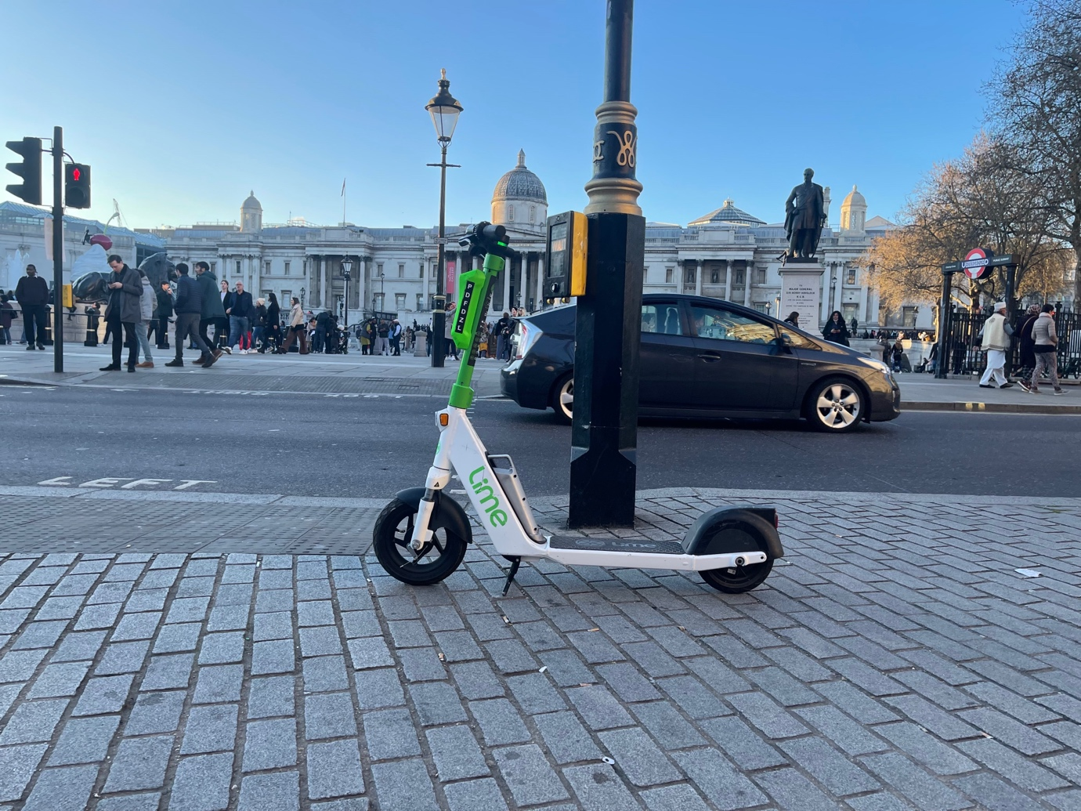
Photo 45 E-scooter left next to pedestrian crossing tactile and push button control box. This is unsafe situation blocking safe access to the pedestrian crossing and is a trip hazard.

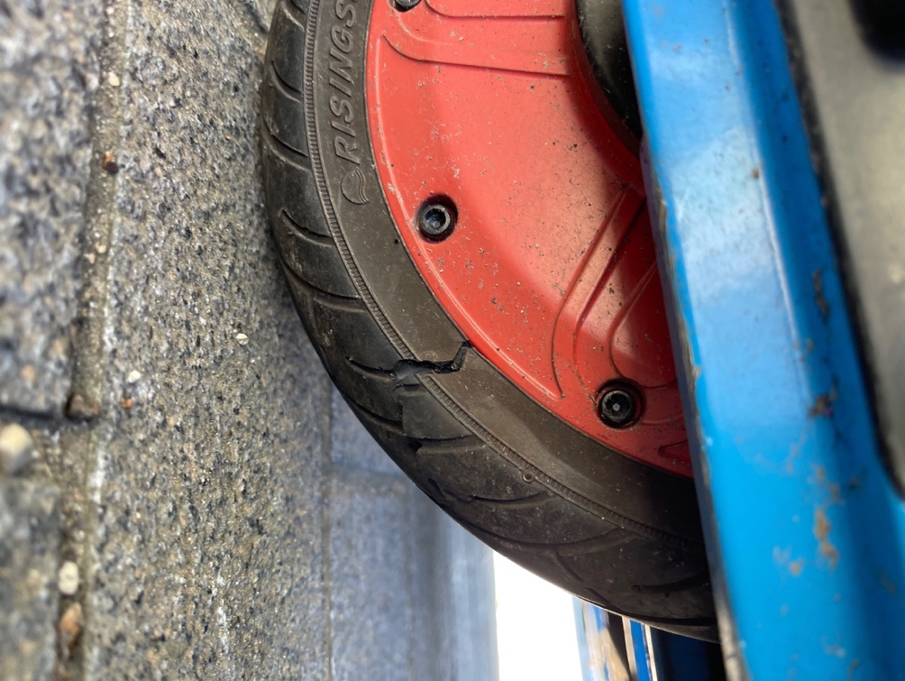
Photo 46 Split back tyre of Dott e-scooter.
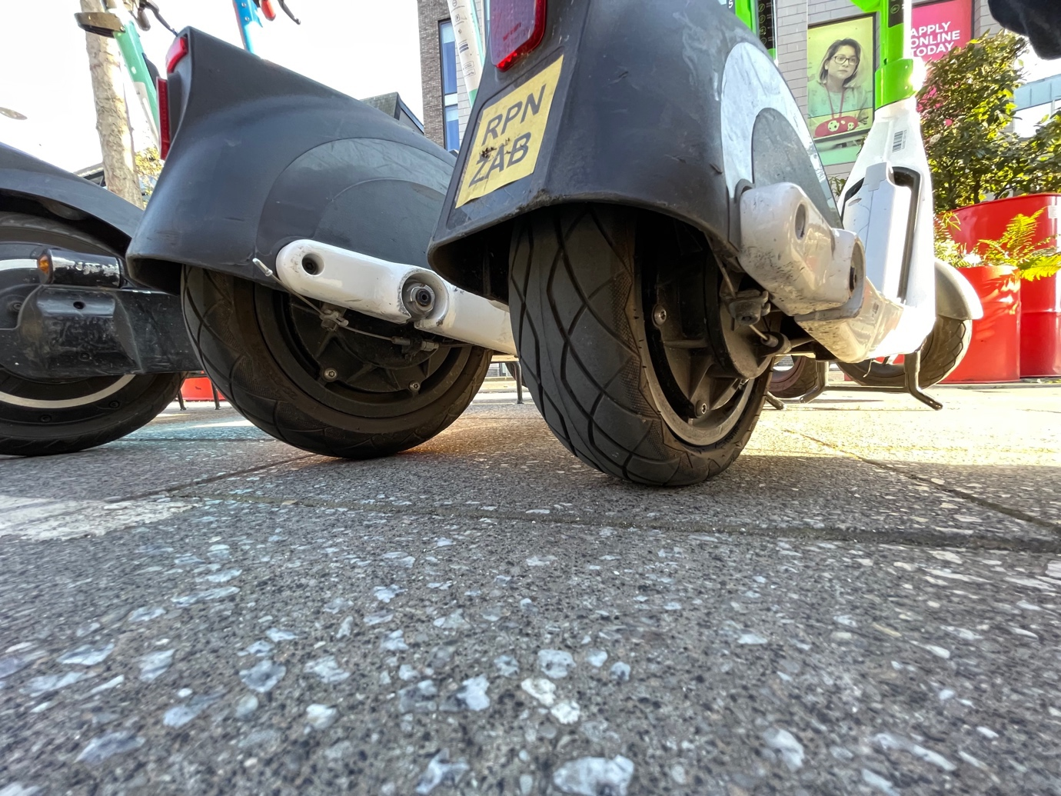
Photo 47 Flat back tyre of Lime e-scooter.

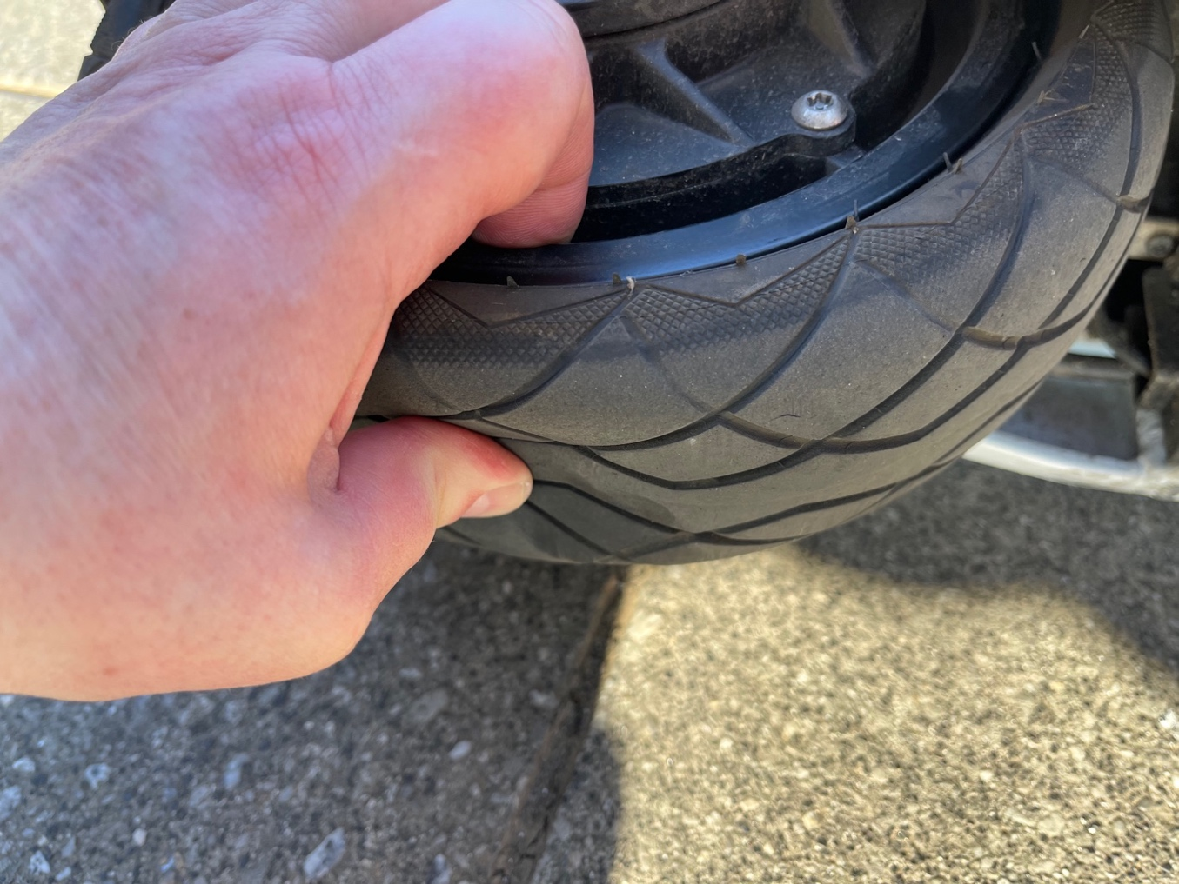
Photo 48 The e-scooter tyre from photo 47 showing how underinflated it was.
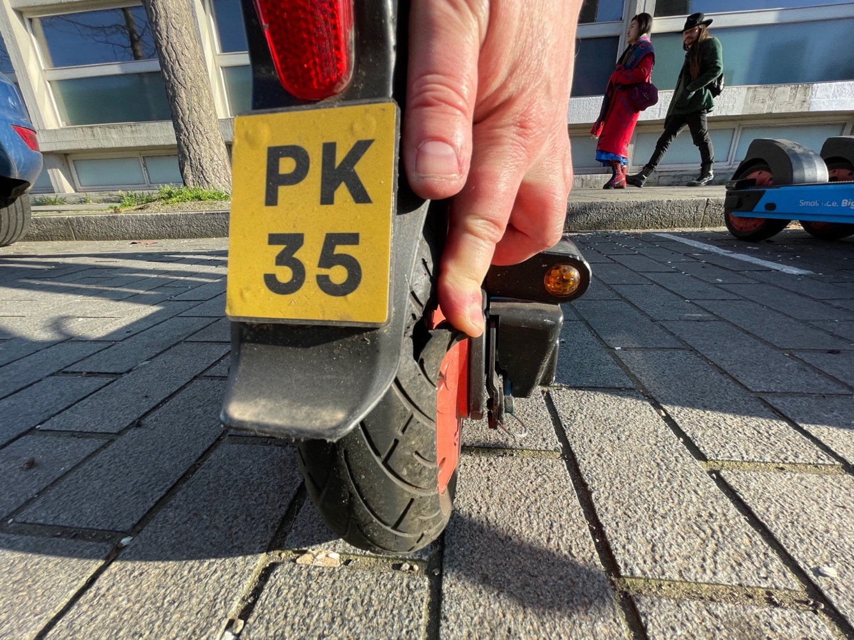
Photo 49 Split side wall on rented e-scooter.

