Evidence on the Rental E-scooter Trials in England and Private Use of E-scooters

Submitted to Transport Select Committee Inquiry on E-scooters by the National Federation of the Blind of the UK

Appendices Part 1
If further information is required about any of the appendices please contact the NFBUK office admin@nfbuk.org or 01924 291313.

Northampton | Appendix A
Corby | Appendix B
Redditch | Appendix C
Newcastle | Appendix D a & D b

Appendix A
Northampton E-scooter Trial Voi E-Scooters Site Visit 5 March 2023

This trial has not resolved key safety and accessibility concerns for riders and pedestrians and needs to be halted. The trial has had significant time to resolve safe parking, ensuring riders do not use pavements and for the e-scooters to be safe for riders. This has not happened. The trial needs to be halted.

The table below contains links to short films to show the dangers of e-scooters that have been ridden badly, dumped dangerously or had safety concerns raised.

Parking / dumping of e-scooters
E-scooters were observed in unsafe locations, found in an unsafe manner causing obstructions and trip hazards on the pavement, public places and next to bus stops.
- Left on pavements, in the middle of the pavement, on the kerb line, on the building line, on dropped kerbs, leading up to pedestrian crossing points and left close to tactile paving for use by blind and visually impaired pedestrians.
- E-scooters were found knocked over.
- A few parking racks were observed however the racks were located on the pavement, where riders would have had to ride to the and from the racks to pick up and leave the e-scooters. At each rack e-scooters were also found not put in racks, found in close proximity to the racks left on the pavement and e-scooter left knocked over close to the rack. Resulting in e-scooters being a trip hazard for blind and visually impaired pedestrians. This illustrated how ineffective the parking racks are for safe storage of the e-scooters when not in use. This is not safe or accessible for pedestrians.
- Photos are given below of the where the e-scooters were found in this visit and can be watched in this short twitter film.

Safety of E-scooters
The reflectors on the e-scooters close to the back of the e-scooter was missing on several e-scooters and a couple of e-scooters were witnessed with wires from the e-scooter exposed as parts of it had fallen off.

Riding of e-scooters
E-scooters were observed been ridden of the pavements at speed, two people riding e-scooters, riders were not wearing helmets. Riders were riding in front of people on pedestrian crossings and on pavements. The rider behaviour around pedestrian was not safe at all and was very freighting as a pedestrian. This short twitter film shows the rider behaviour witnessed.

Appendix A Table 1 Site Visits to Northampton with links to twitter films on obstructions caused by VOI e-scooters, dangerous riding of e-scooters and safety concerns with e-scooters.

Site Visit | Appendix Site Visits | Twitter Films Trip & Obstructions | Twitter films Dangerous Riding | Twitter Films E-scooter Safety Concerns
Northampton | Appendix A | March 2023  May 2021  May 2021  April 2021  April 2021  October 2020  October 2020  October 2020  October 2020  October 2020  October 2020  October 2020  September 2020  September 2020  September 2020  September 2020  September 2020  September 2020  September 2020  September 2020  September 2020  September 2020  September 2020  September 2020 | March 2023  May 2021  May 2021 Handing over e-scooter to a mate to ride.  October 2020  October 2020  October 2020  September 2020  September 2020  September 2020  September 2020  September 2020  September 2020  September 2020  September 2020  September 2020  September 2020  September 2020  September 2020 | October 2020

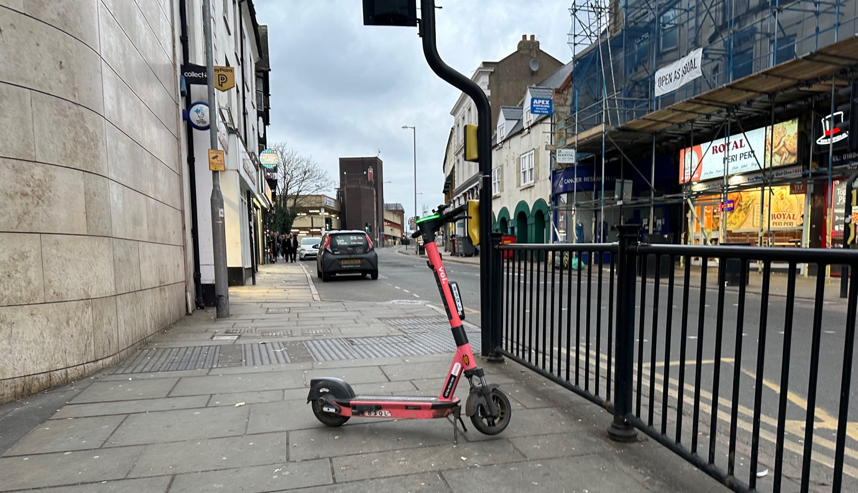
Photo 1 E-scooter causing an obstruction and trip hazard on the pavement, leading to a controlled green man pedestrian crossing and the tactile paving blind and visually impaired people use to find the crossing.
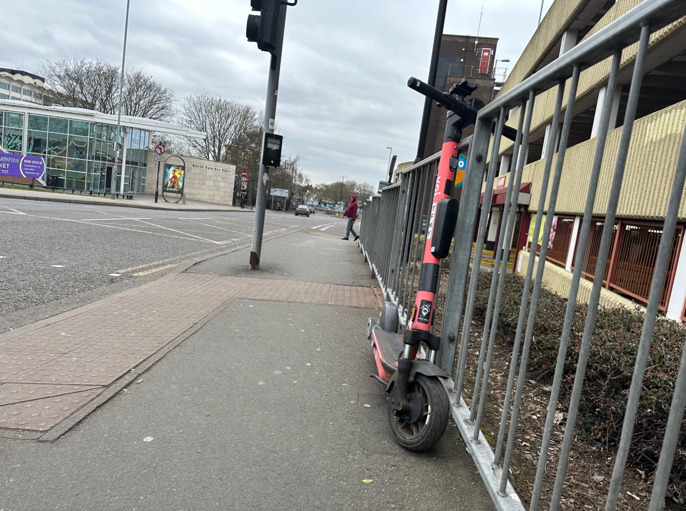
Photo 2 E-scooter left in an unsafe situation on pavement, leading to a controlled green pedestrian crossing and the tactile paving blind and visually impaired people use to find the crossing. The e-scooter does not have its kick stand down making it unstable.

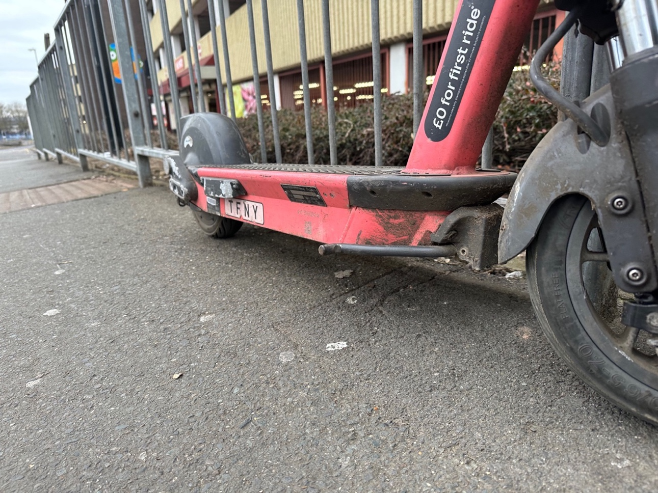
Photo 3 Same e-scooter as in photo 2. Kick stand not deployed making the e-scooter even
more unstable.
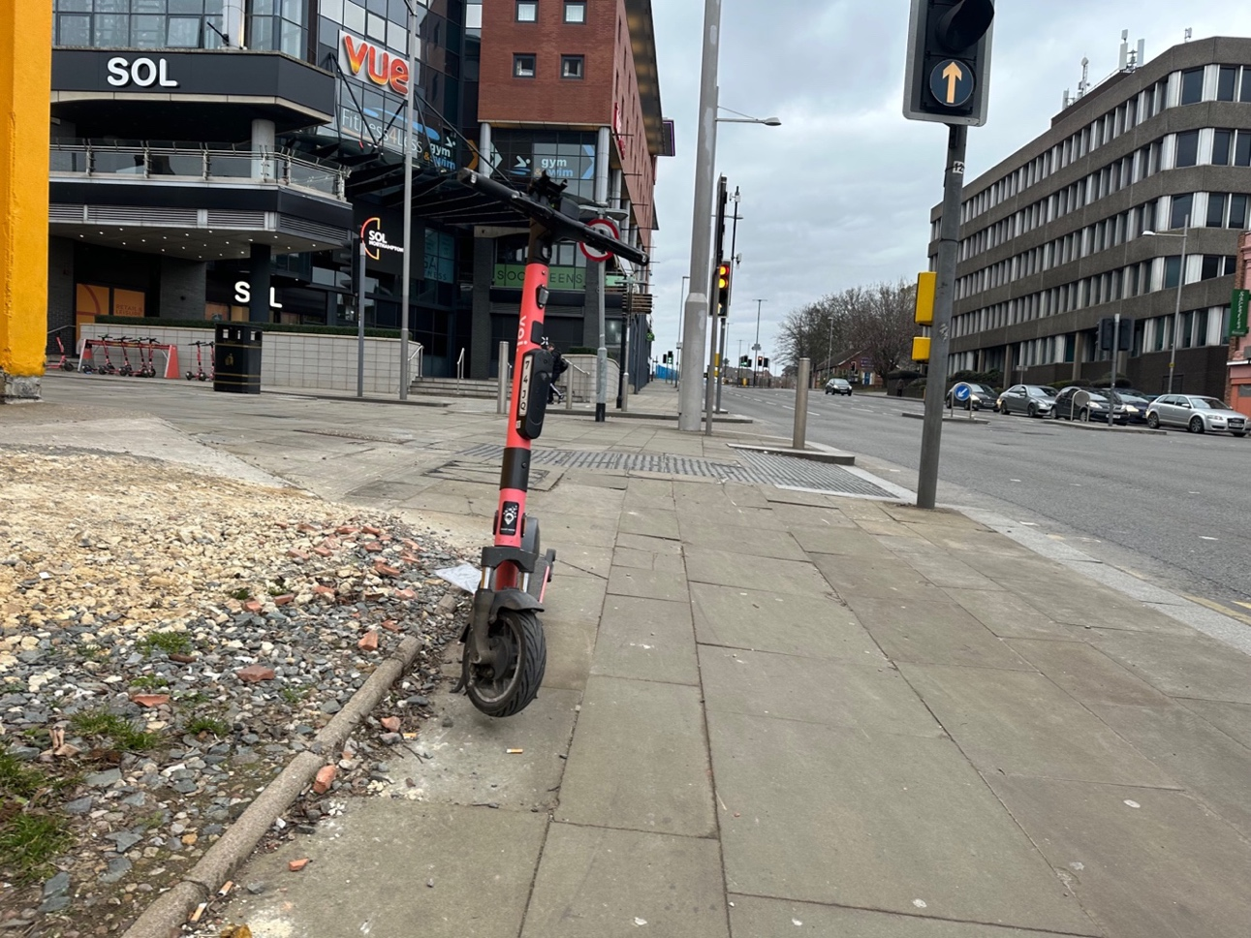
Photo 4 E-scooter is an obstruction and trip hazard on pavement, leading to a controlled green pedestrian crossing and the tactile paving blind and visually impaired people use to find the crossing. A parking rack can be seen in the back of the picture illustrating even if racks are provided this does not mean they will be used.
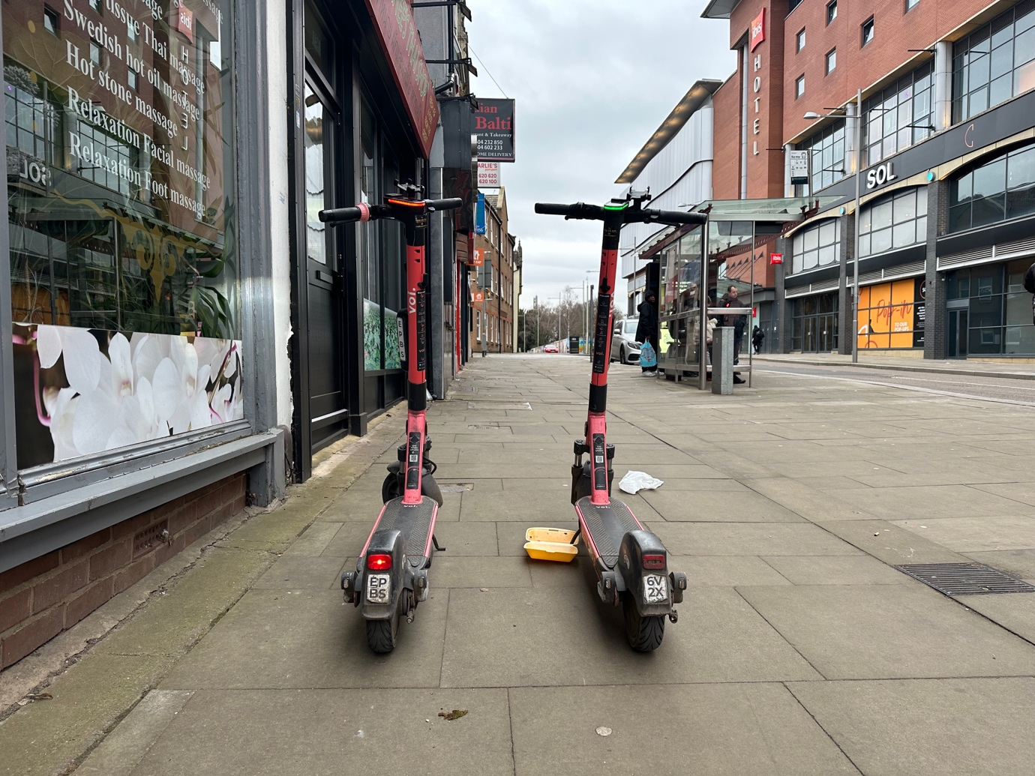
Photo 5 Two e-scooters left in an unsafe location, on the pavement and next to the building line causing an obstruction and trip hazard on pavement. Also leading to a bus stop.
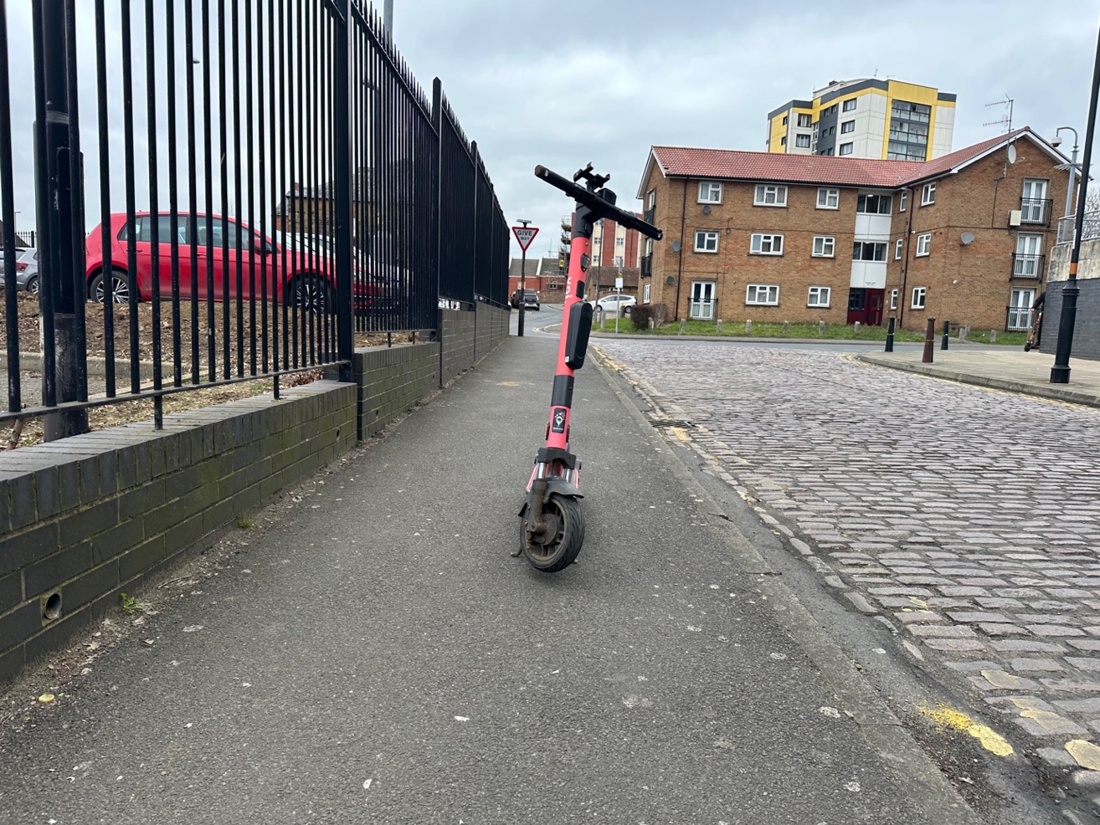
Photo 6 E-scooter left in an unsafe location causing an obstruction and trip hazard on the pavement.

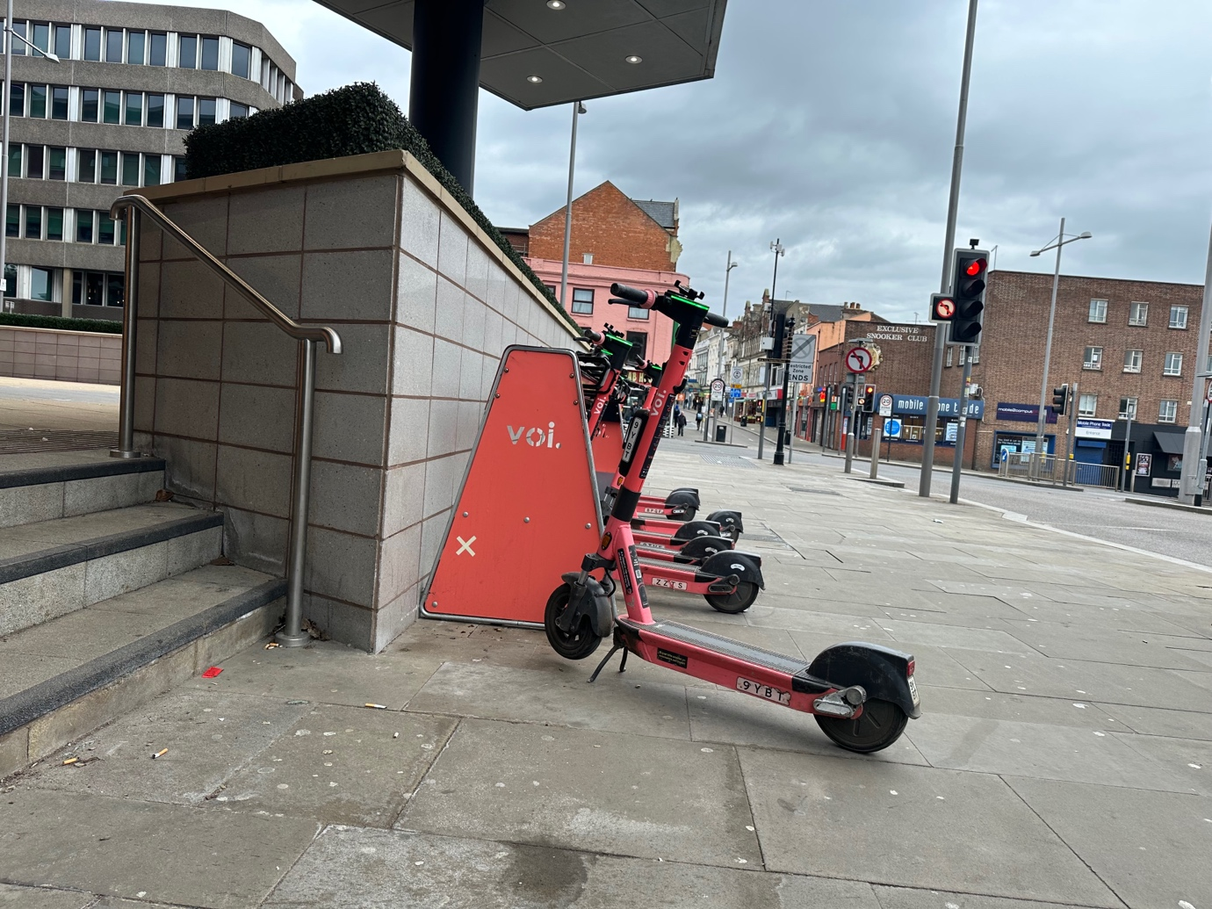
Photo 7: The parking rack is pavement clutter and is in an unsafe location. The e-scooters are still causing a trip hazard as they are sticking out from the parking rack and e-scooters are still being left on the pavement area around the parking rack. Riders will be using the pavement to ride on and off to park the e-scooters, which is not safe at all for pedestrians.
Photo 8 Reflector strip missing on e-scooter.
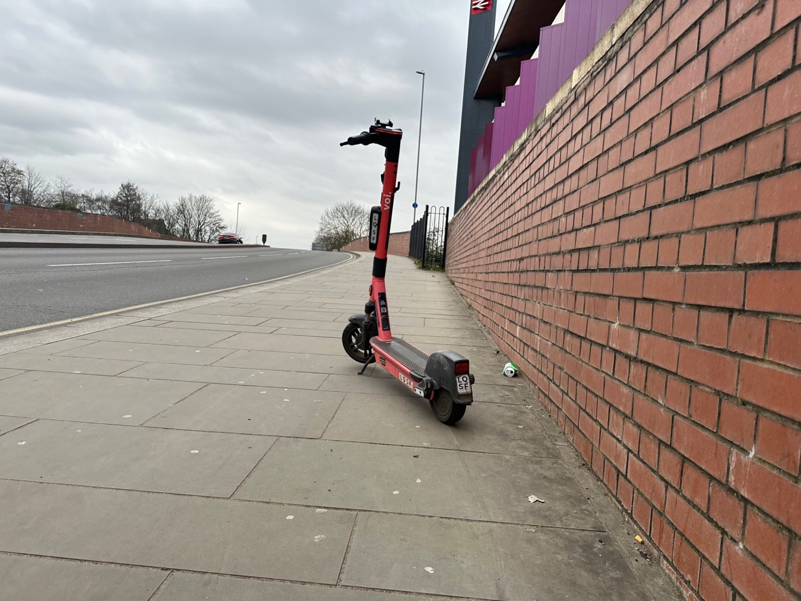
Photo 9 E-scooter left in an unsafe location on the pavement next to building line causing an trip hazard.
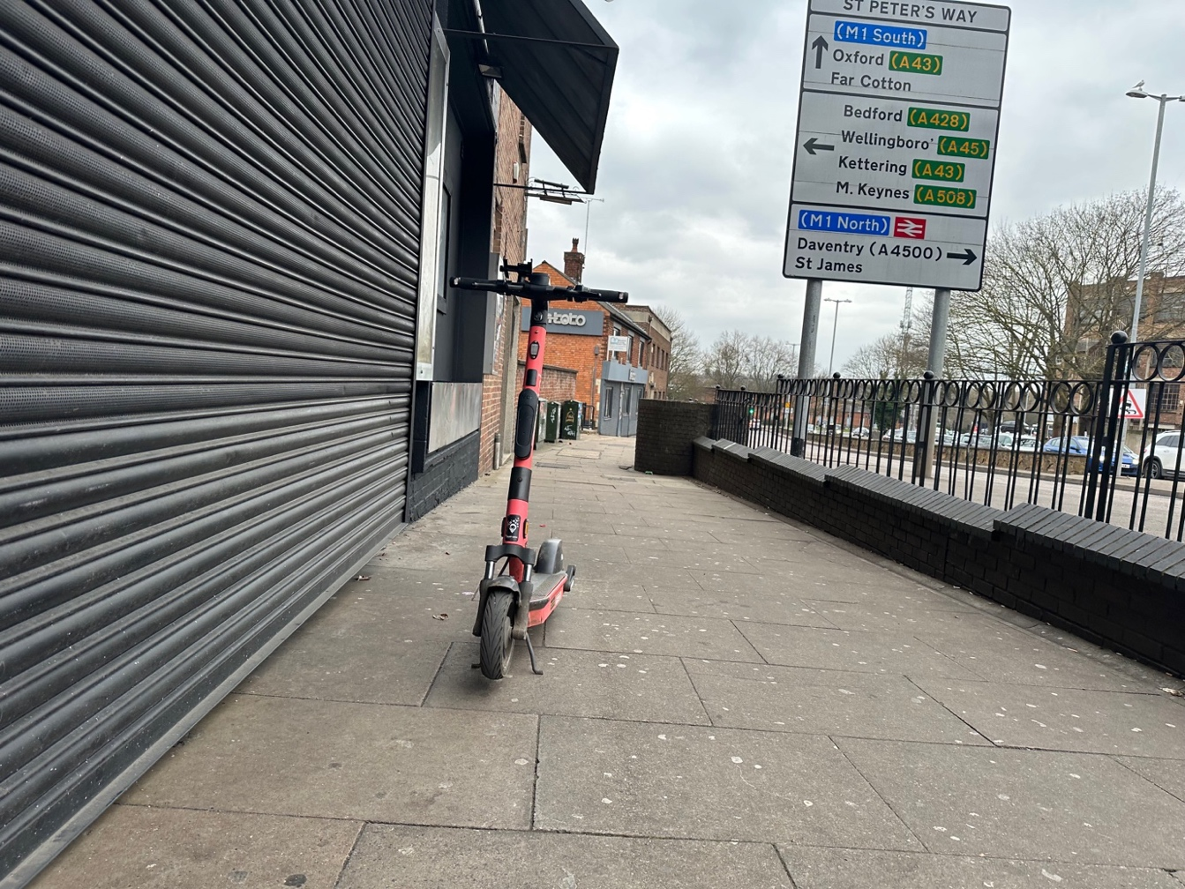
Photo 10 E-scooter left in an unsafe location causing trip hazard on pavement on the building line.

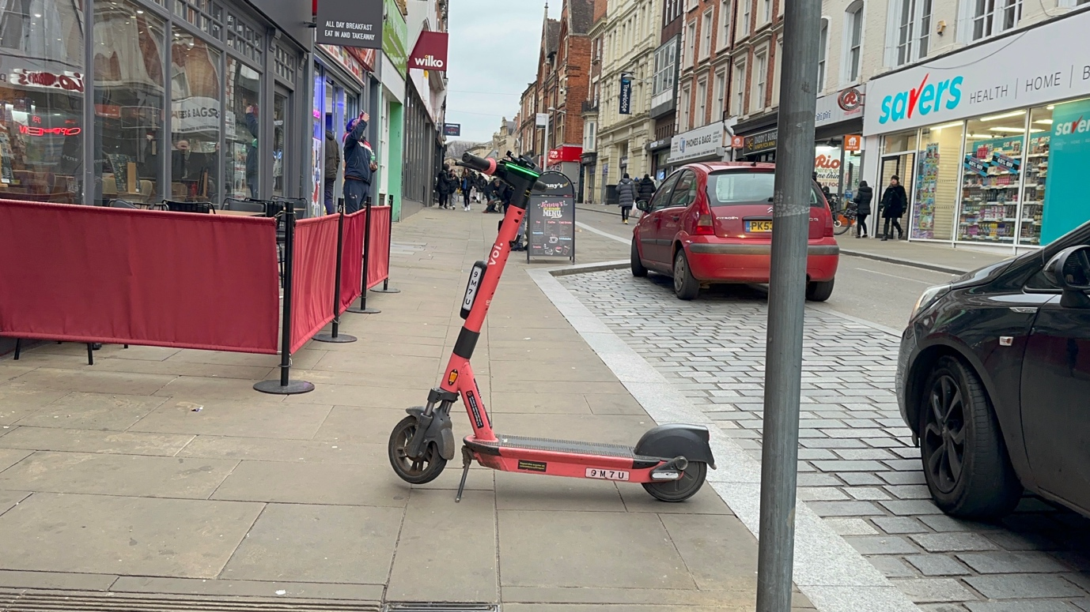
Photo 11 E-scooter cleft in unsafe location causing an obstruction and trip hazard on pavement.

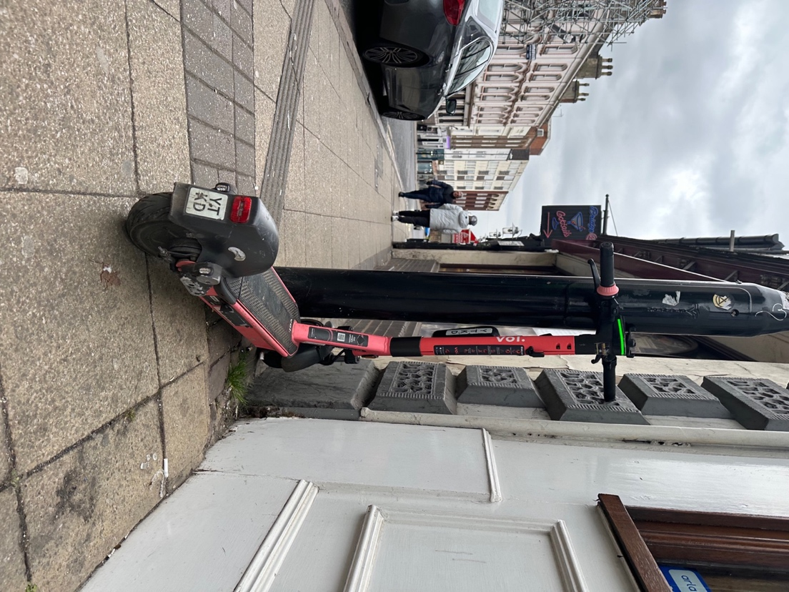
Photo 12 E-scooter left in unsafe location causing a trip hazard on pavement on the building line.

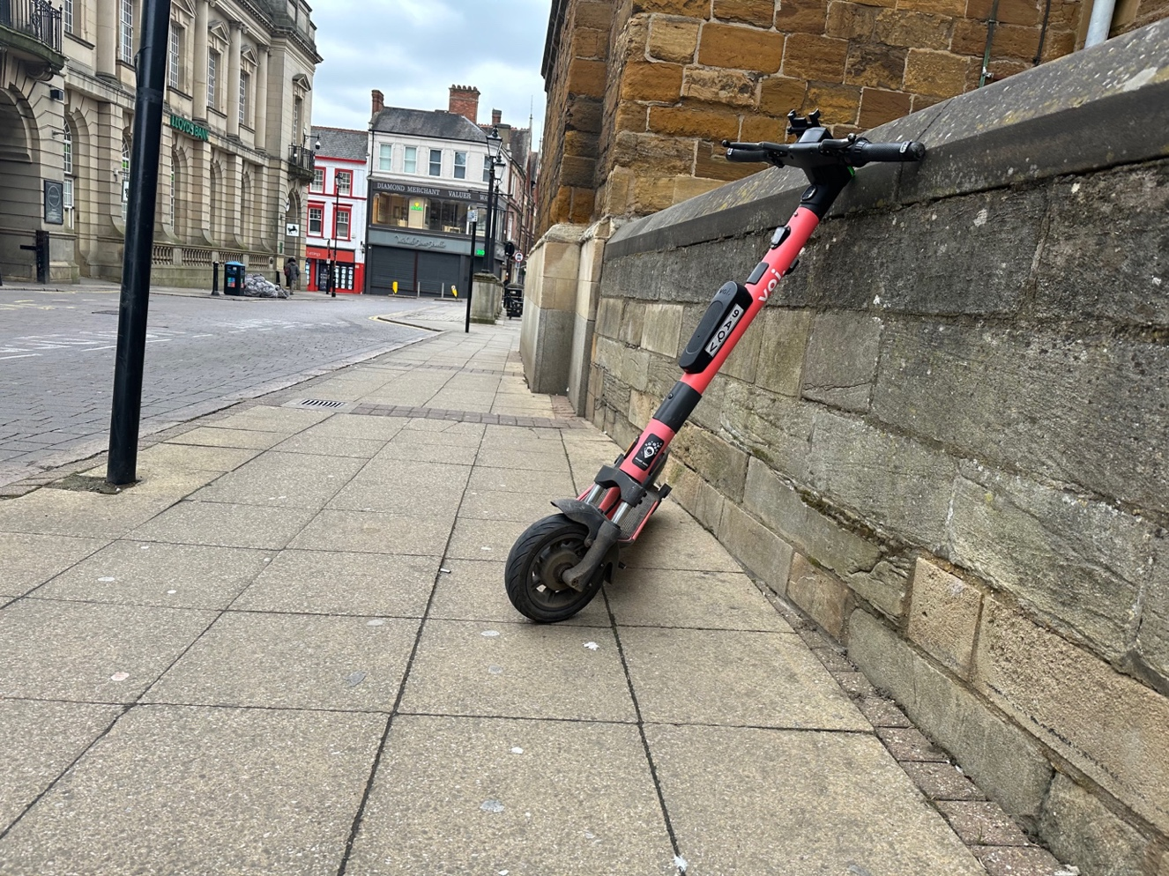
Photo 13 E-scooter left in unsafe location causing a trip hazard on pavement on the building line. It is not on its kick stand, making it even more unsafe and unstable.

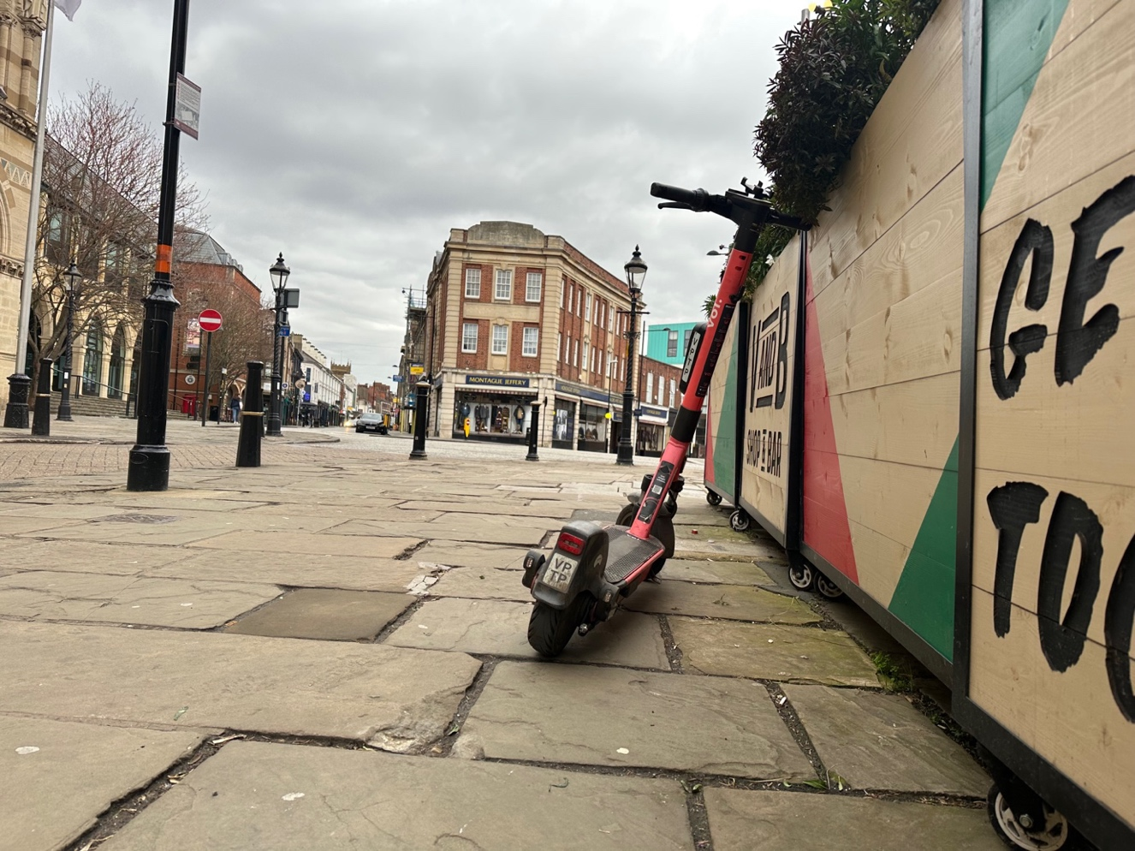
Photo 14 E-scooter left in unsafe location causing a trip hazard on pavement on the building line. It is not on its kick stand, making it even more unsafe and unstable.

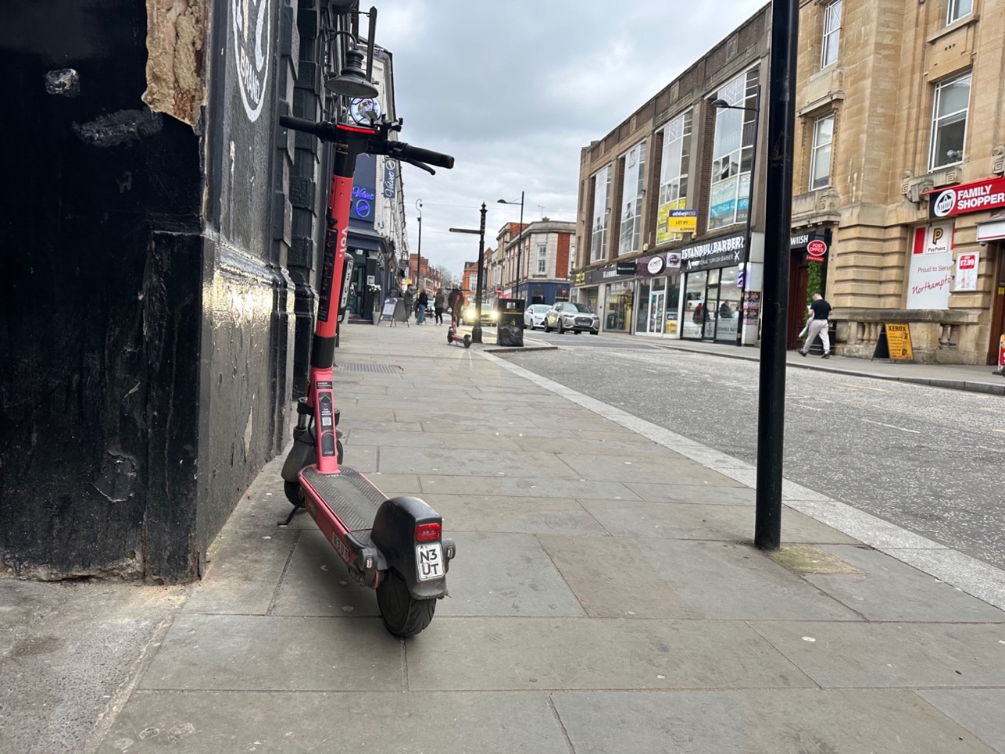
Photo 15 E-scooter left in unsafe location causing a trip hazard on pavement on the building line.
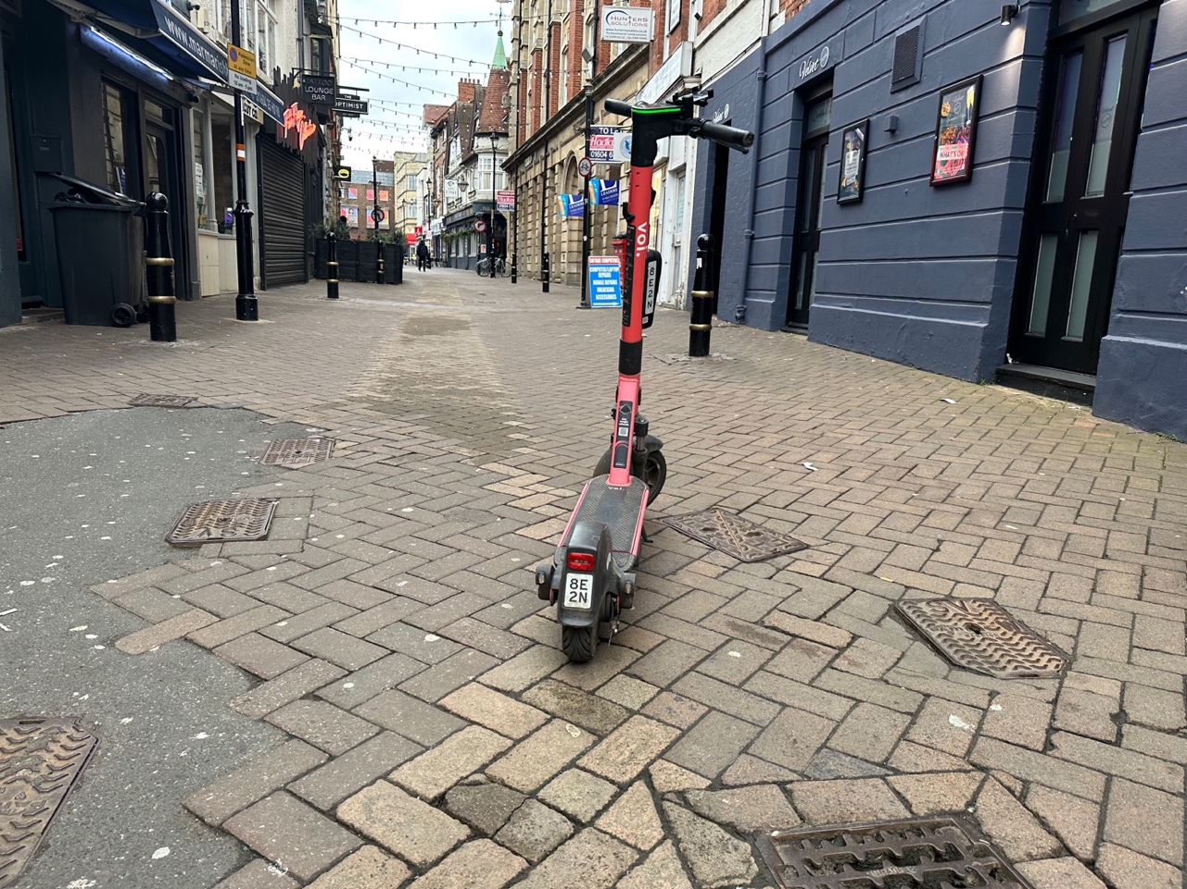
Photo 16 E-scooter left in an unsafe location causing ta rip hazard on pavement in pedestrian zone.
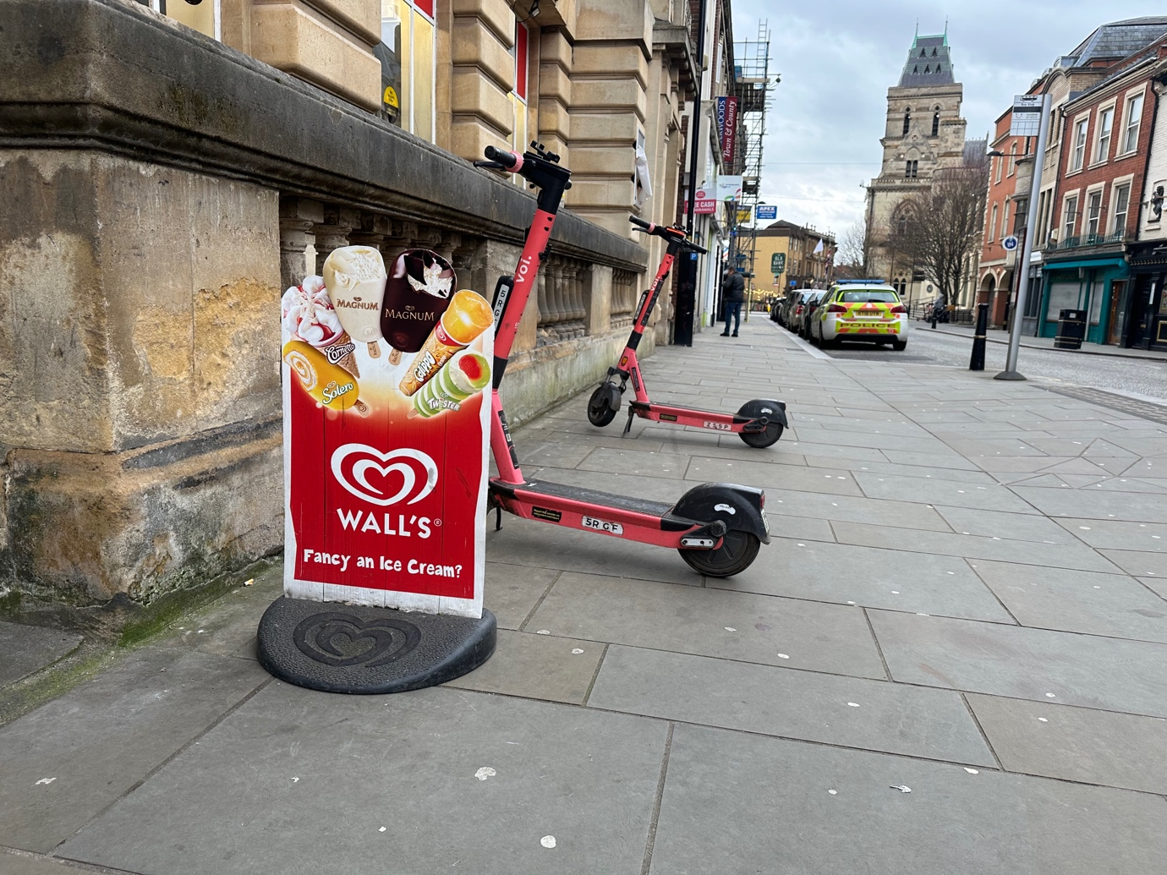
Photo 17 Two e-scooters left in an unsafe location causing a trip hazard on the pavement on the building line.

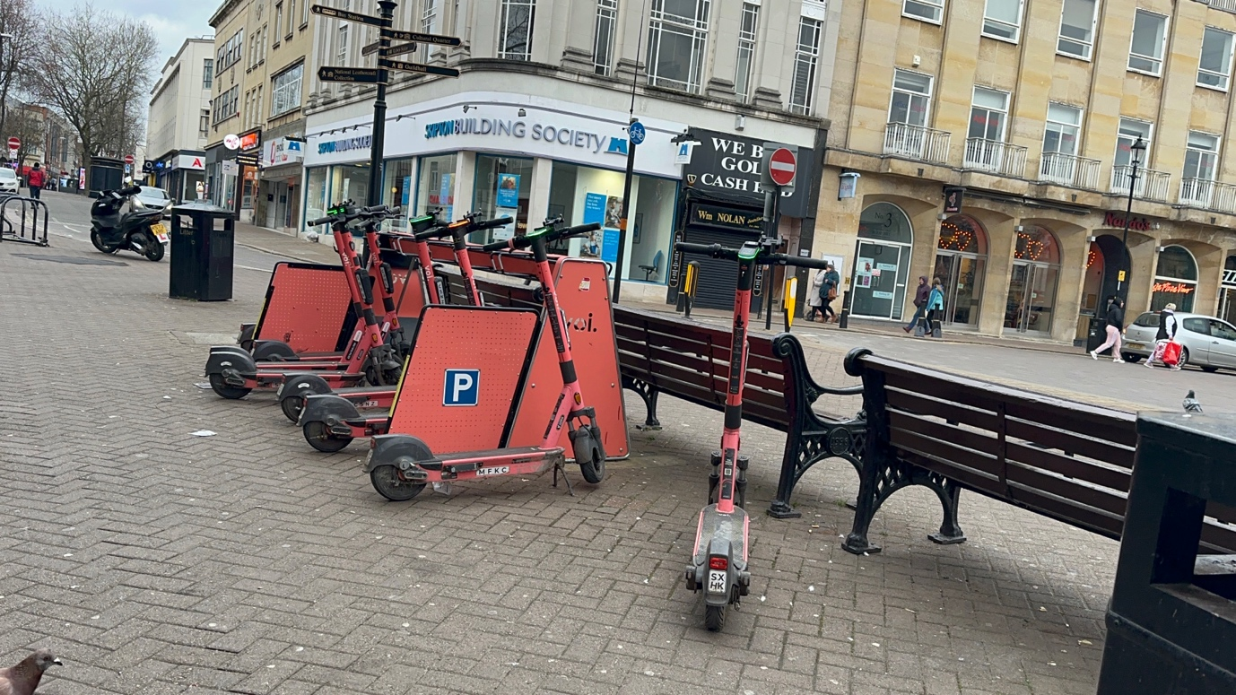
Photos 18: Parking rack with e-scooters still left around it not in the parking rack itself. The rack is street clutter, creates trips hazards with the e-scooters left next to it and encourages people to ride on the pavement to and from it when dropping off and picking up the e-scooters.
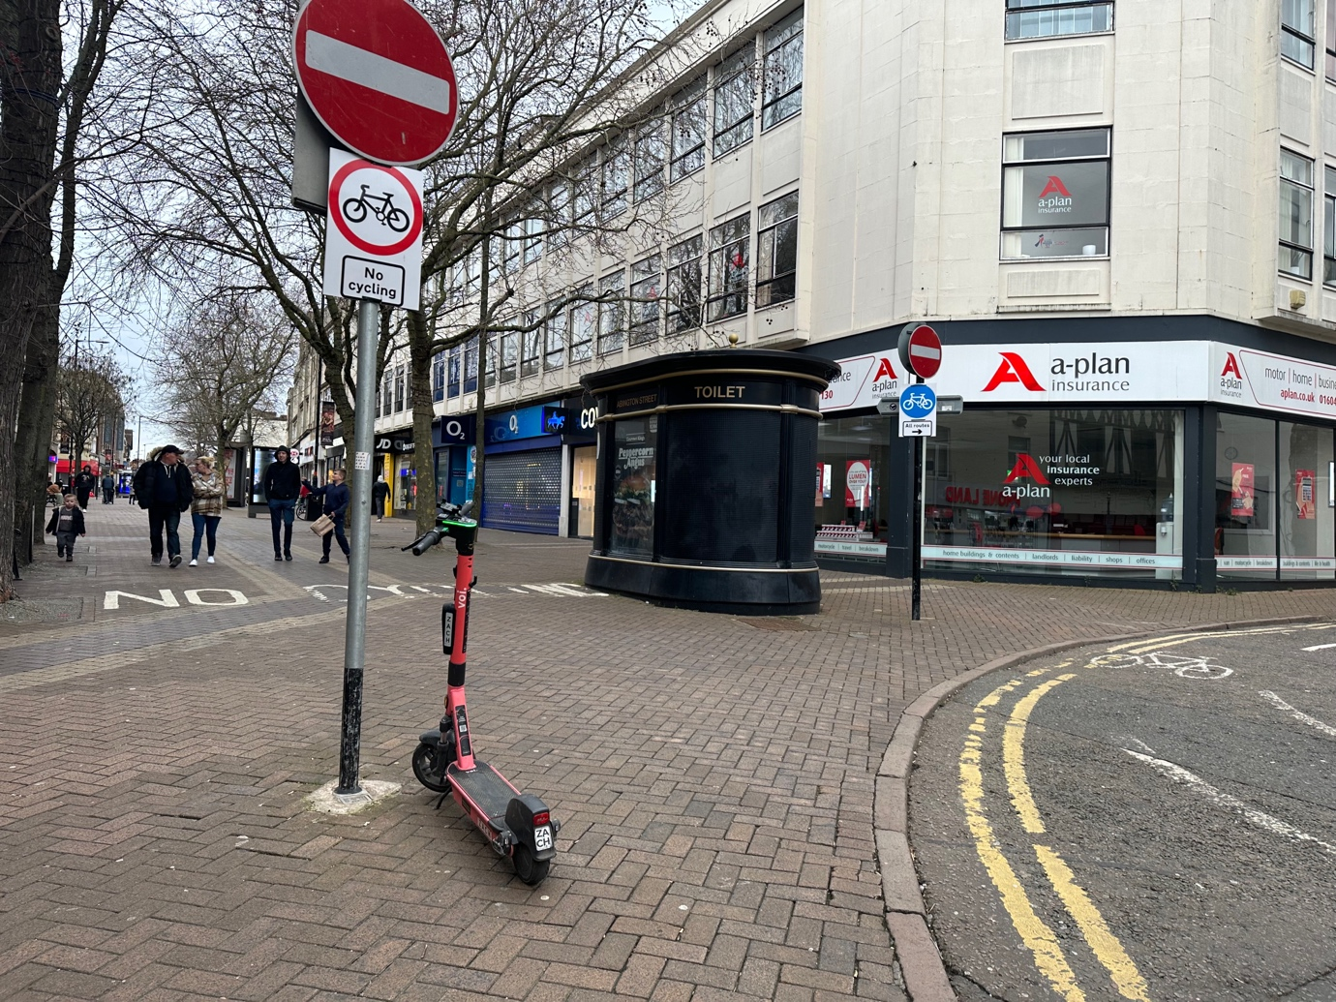
Photo 19: E-scooter left just before the start of pedestrian no cycling area on pavement are creating a trip hazard.
Photo 20: Broken e-scooter.

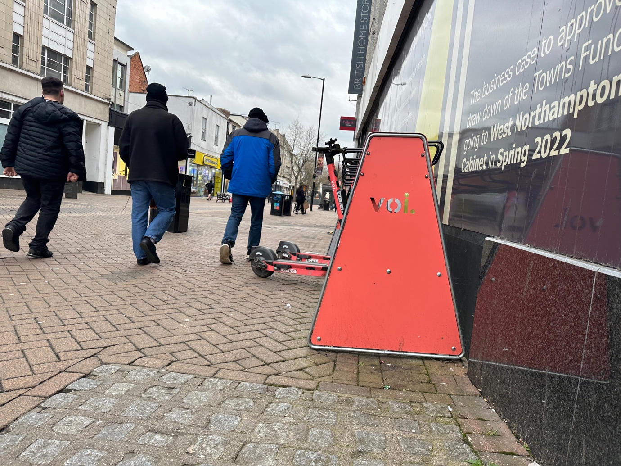
Photo 21: The parking rack is pavement clutter and is located in a pedestrian only no cycling area. The e-scooters are still causing a trip hazard as they are sticking out from the parking rack. Just around the corners in the Photo 23 e-scooters were found left on the pavement.

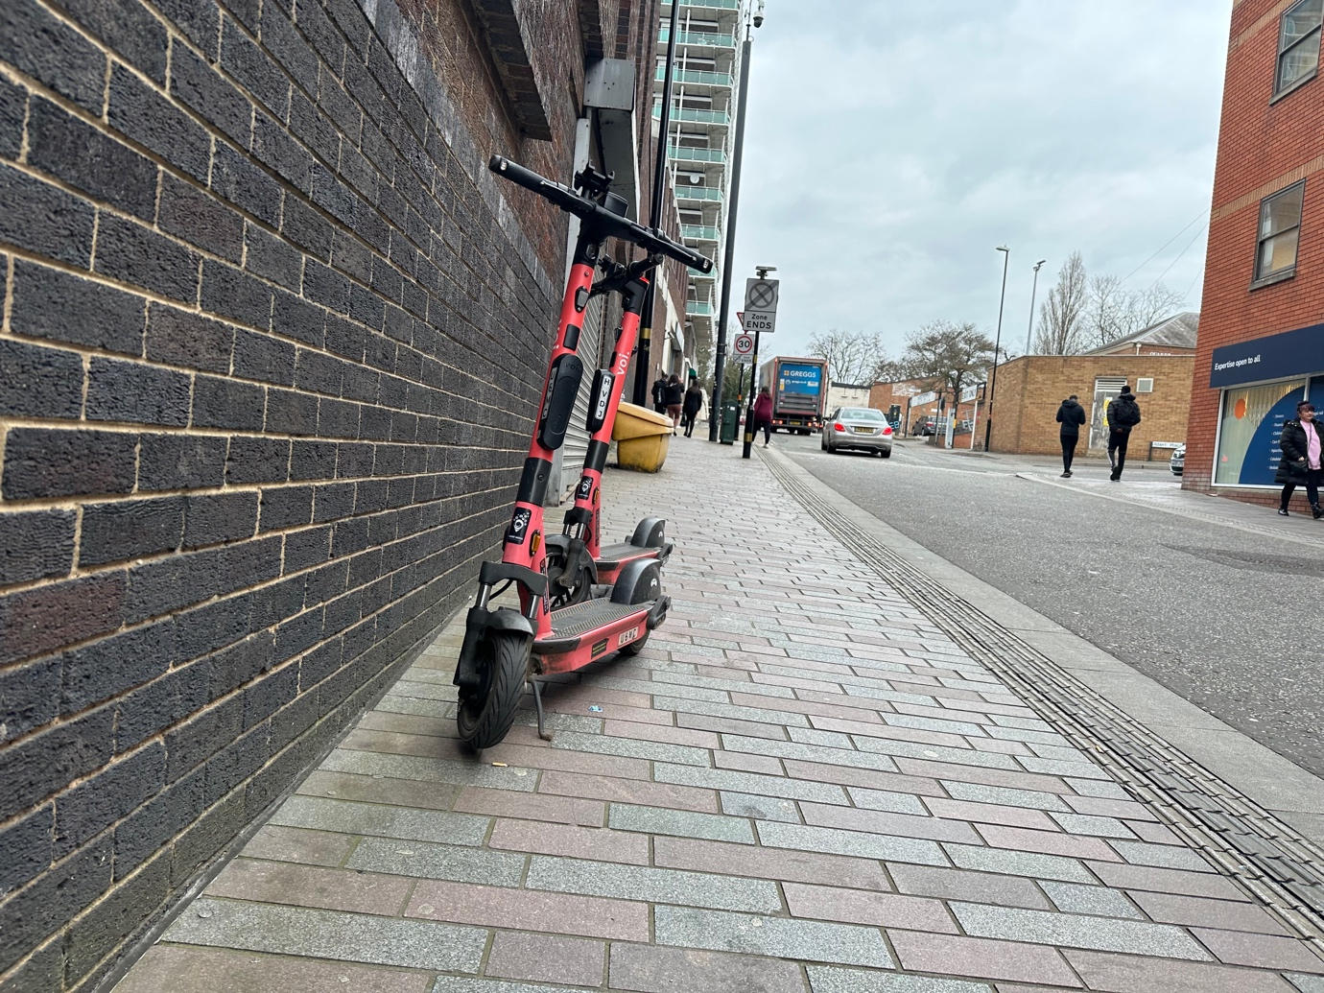
Photo 22 Two e-scooters left in an unsafe location and are a trip hazard on the pavement on the building line.

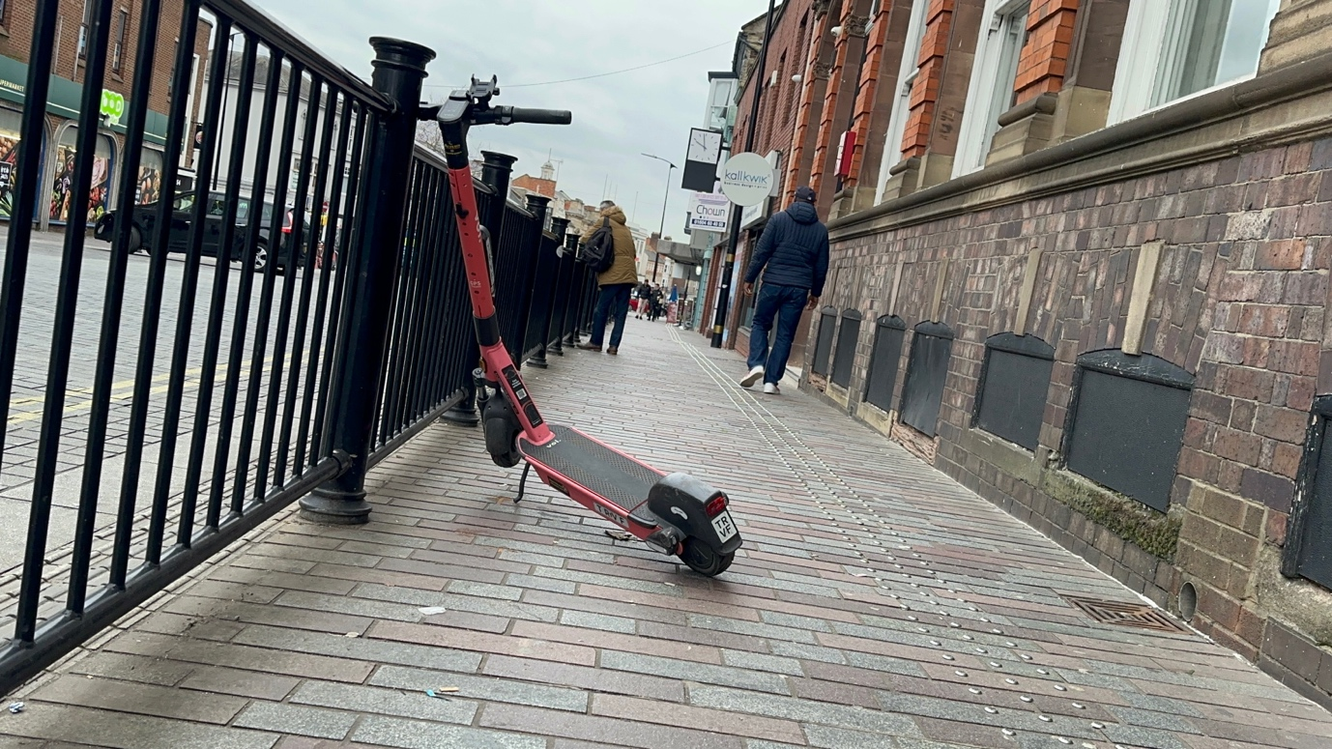
Photo 23 E-scooter left in an unsafe situation causing a trip hazard on the pavement.

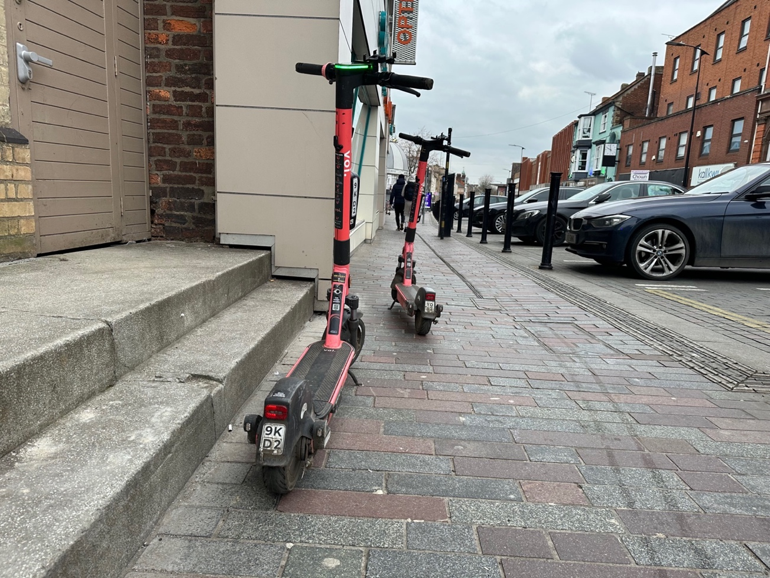
Photo 24 Two e-scooters left in an unsafe location on the building line of the pavement causing a trip hazard.
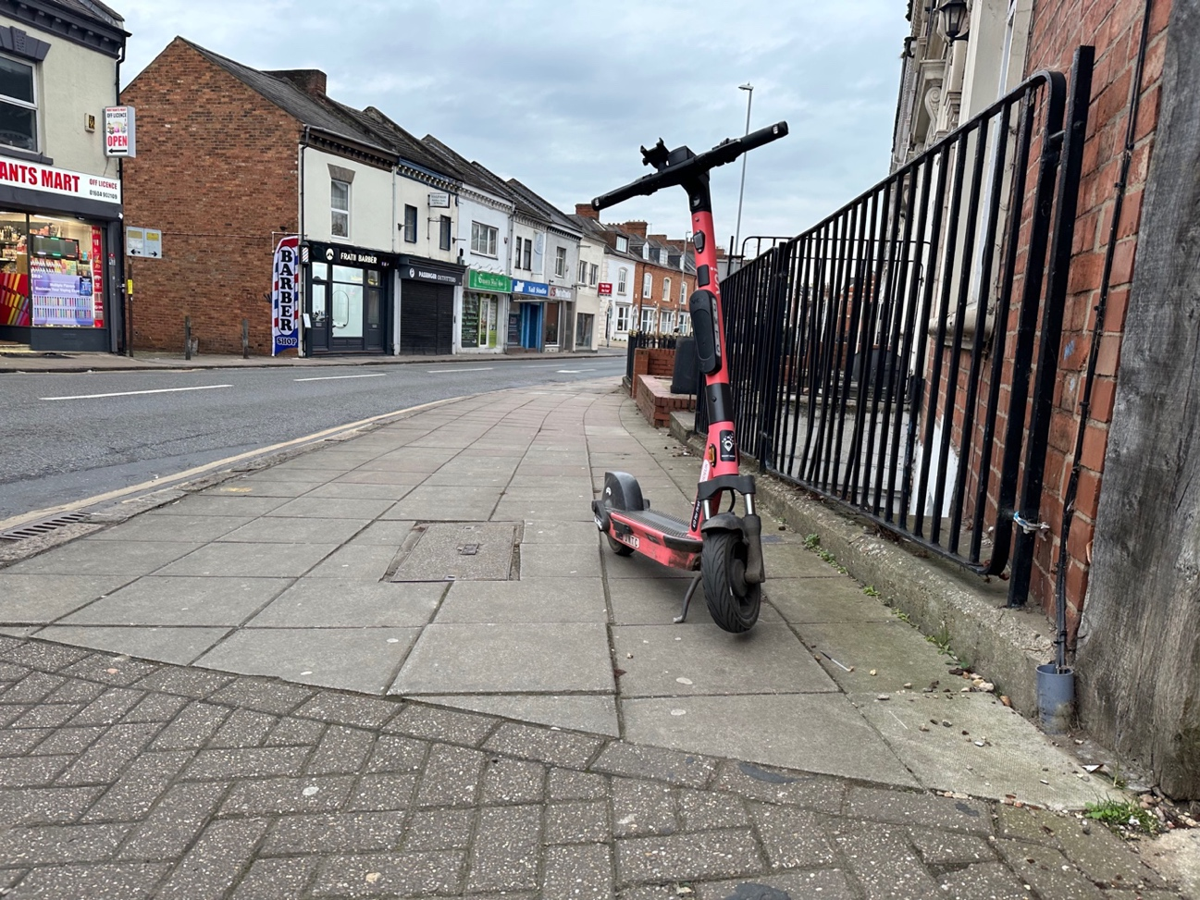
Photo 25 An e-scooter left in an unsafe location creating a trip hazard on pavement on the building line.

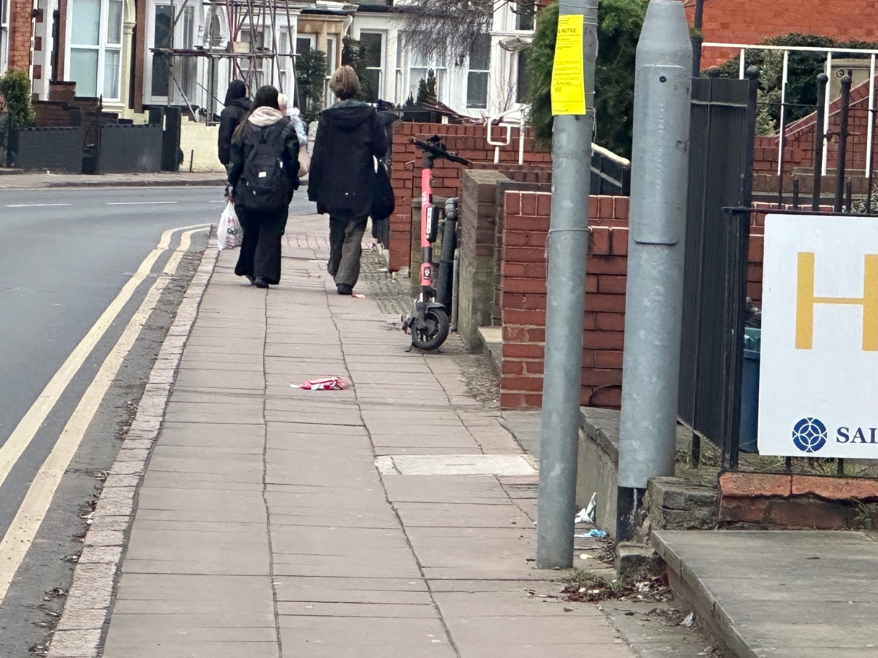
Photo 26 An e-scooter left in an unsafe location creating a trip hazard on pavement on the building line.
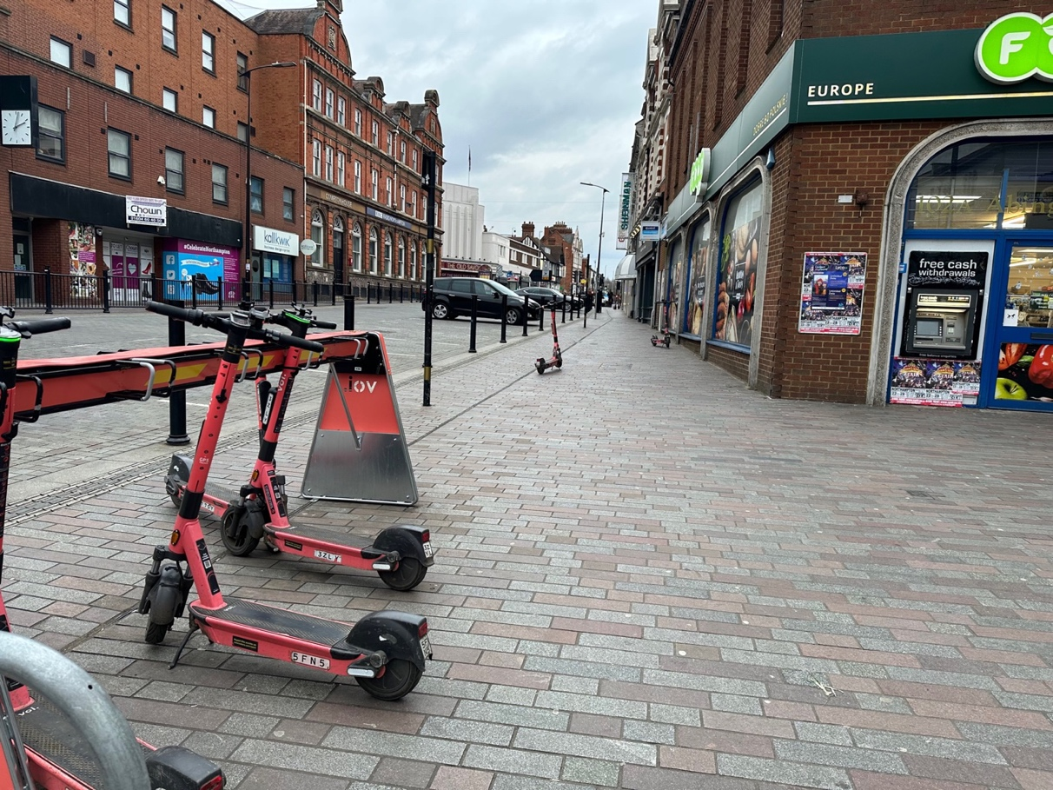
Photo 27 The parking rack is pavement clutter on the public space. The e-scooters are still causing a trip hazard as they are sticking out from the parking rack and e-scooters are still left on pavement area close to the parking rack. Riders will be using the pavement to ride on and off to park the e-scooters, which is not safe at all for pedestrians.

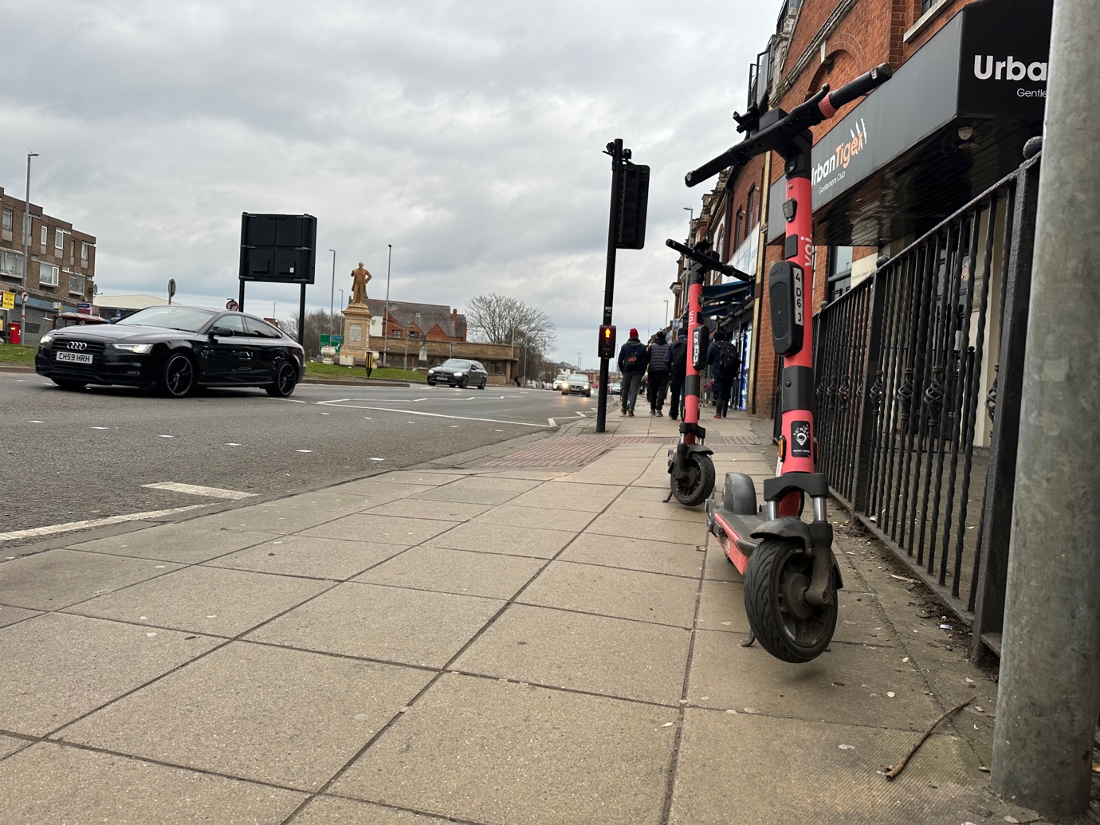
Photo 28 Two E-scooters causing trip hazard on pavements, leading to a controlled green pedestrian crossing and the tactile paving blind and visually impaired people use to find the crossing.

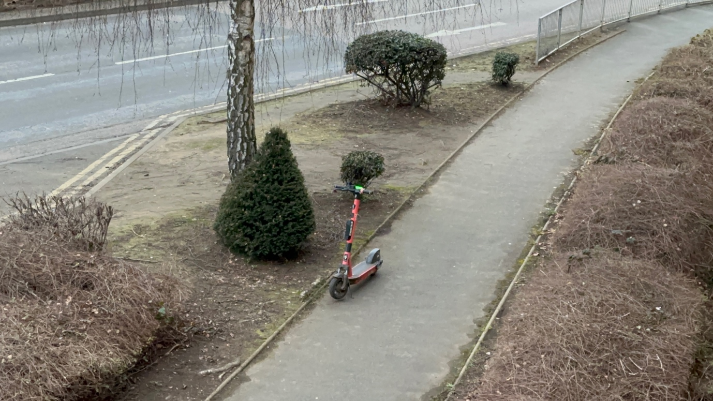
Photo 29: E-scooter causing trip hazard on the pavement.

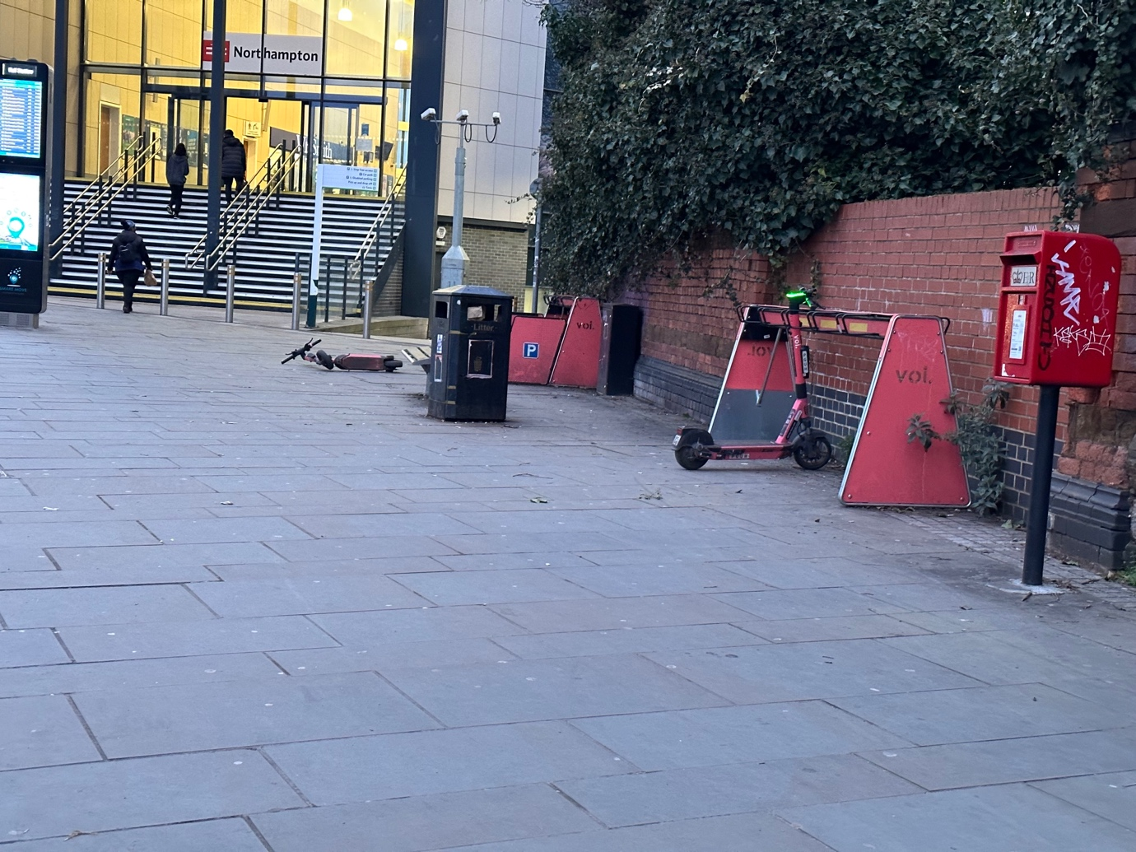
Photo 30: Two parking racks present outside train station in Northampton. One with extendable sides and one with not. E-scooters are still causing a trip hazard and one e-scooter is left knocked over on the pavement away from the parking rack. Creating a trip hazard. Riders will be riding on the pavement to pick up the e-scooters and ride away on them, which is not safe for pedestrians. Even after all this time e-scooters are left in an unsafe manner.

Appendix B Corby E-scooter Trial Voi E-Scooters Site Visit 3 March 2023

This trial has not resolved key safety and accessibility concerns for riders and pedestrians and needs to be halted. The trial has had significant time to resolve safe parking, ensuring riders do not use pavements and for the e-scooters to be safe for riders. This has not happened. The trial needs to be halted.

Parking / dumping of e-scooters
E-scooters were observed in unsafe locations, found in an unsafe manner causing obstructions and trip hazards on the pavement, public places and next to bus stops.
- Left on pavements, in the middle of the pavement, on the kerb line, on the building line, on dropped kerbs, leading up to pedestrian crossing points and left close to tactile paving for use by blind and visually impaired pedestrians.
- E-scooters were found knocked over.
- One parking rack was observed however the rack posed a trip hazard for blind and visually impaired pedestrians and an e-scooter was found close to the parking rack but left on the pavement illustrating how ineffective the parking racks are for safe storage of the e-scooters when not in use. Also the rack was on the pavement meaning riders would ride to and from this area on the pavement, which is not safe for pedestrians.

Safety of E-scooters
E-scooters tyres were observed with no tread and tread which had visible holes in them. The reflectors on the e-scooters close to the back of the e-scooter was missing and some of the e-scooter lights were broken.

Riding of e-scooters
E-scooters were observed been ridden of the pavements.

Site Visit | Appendix Site Visits | Twitter Films Trip & Obstructions | Twitter films Dangerous Riding | Twitter Films E-scooter Safety Concerns
Corby | Appendix B | March 2023 |  | March 2023  September 2021

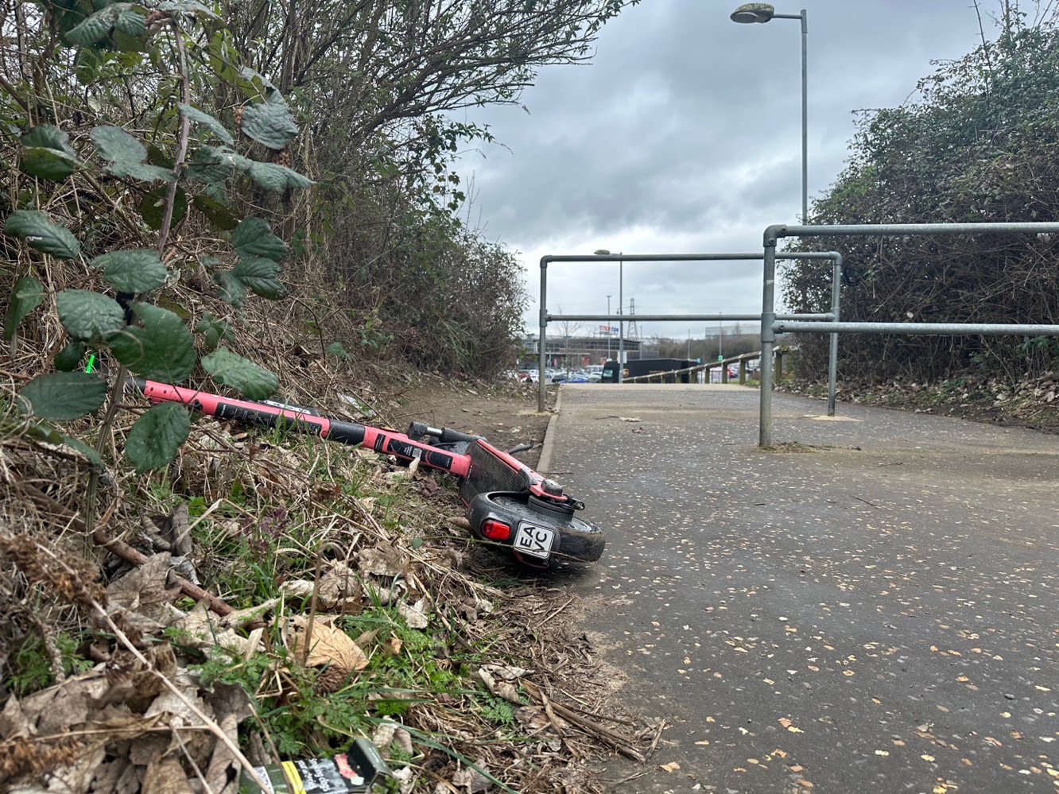
Photo 1 E-scooter knocked in an unsafe location on the edge of a path creating a trip hazard.
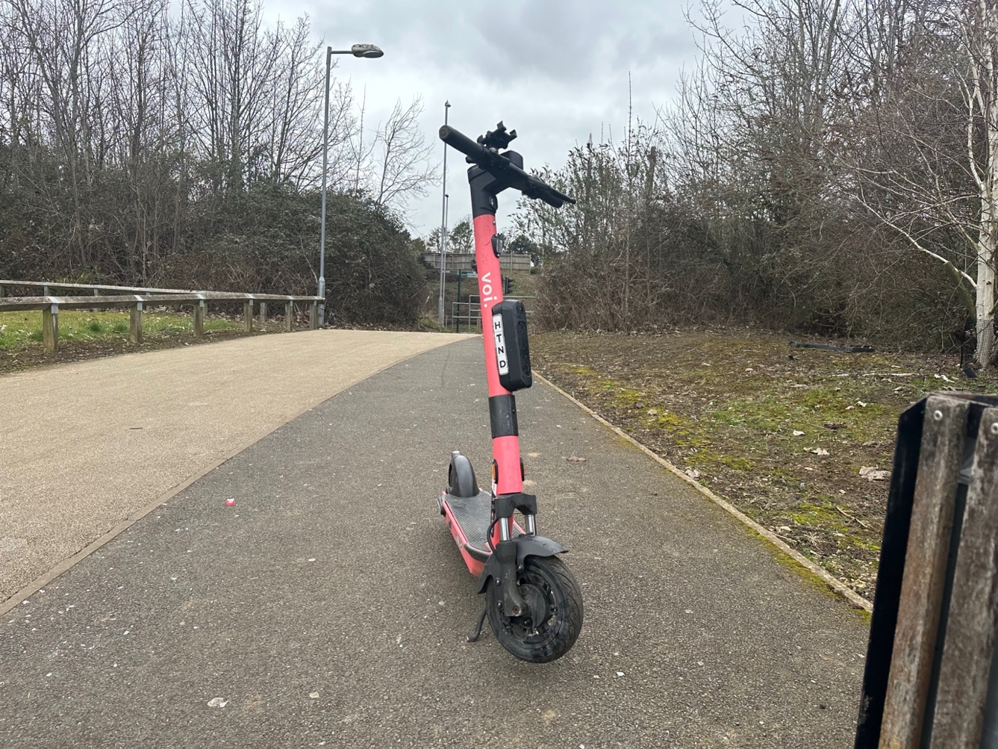
Photo 2 E-scooter left in an unsafe location on path causing a trip hazard.
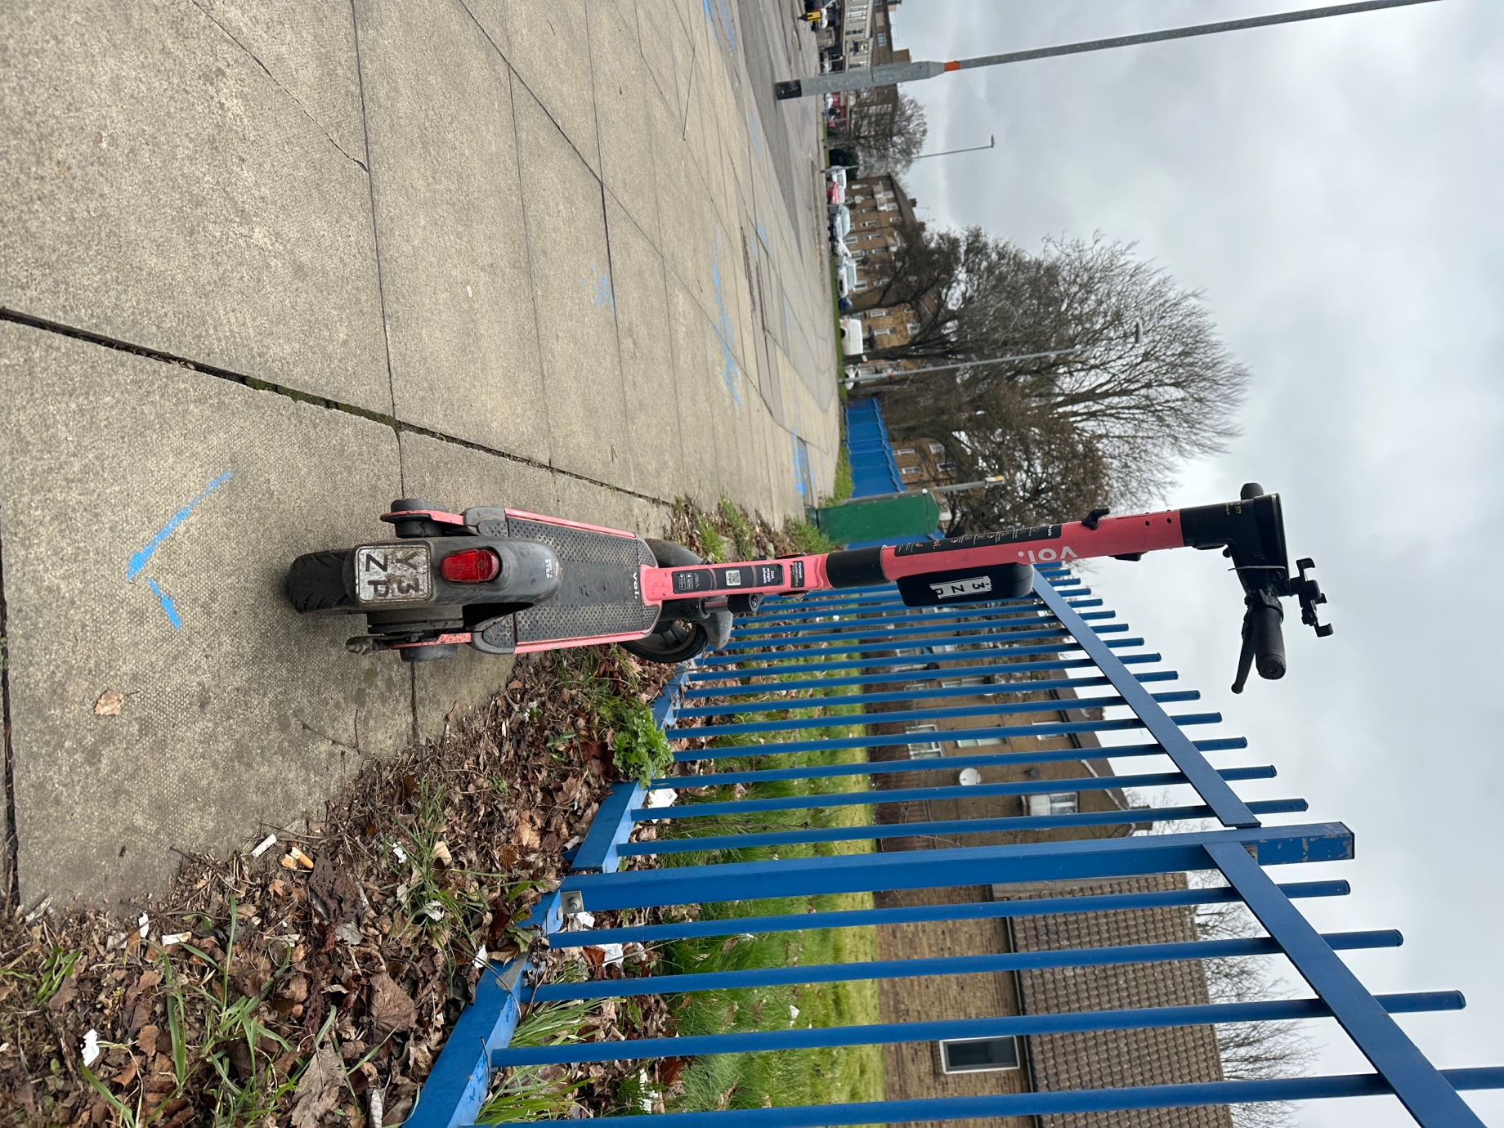
Photo 3 E-scooter left in an unsafe location on the pavement causing a trip hazard on the building line.

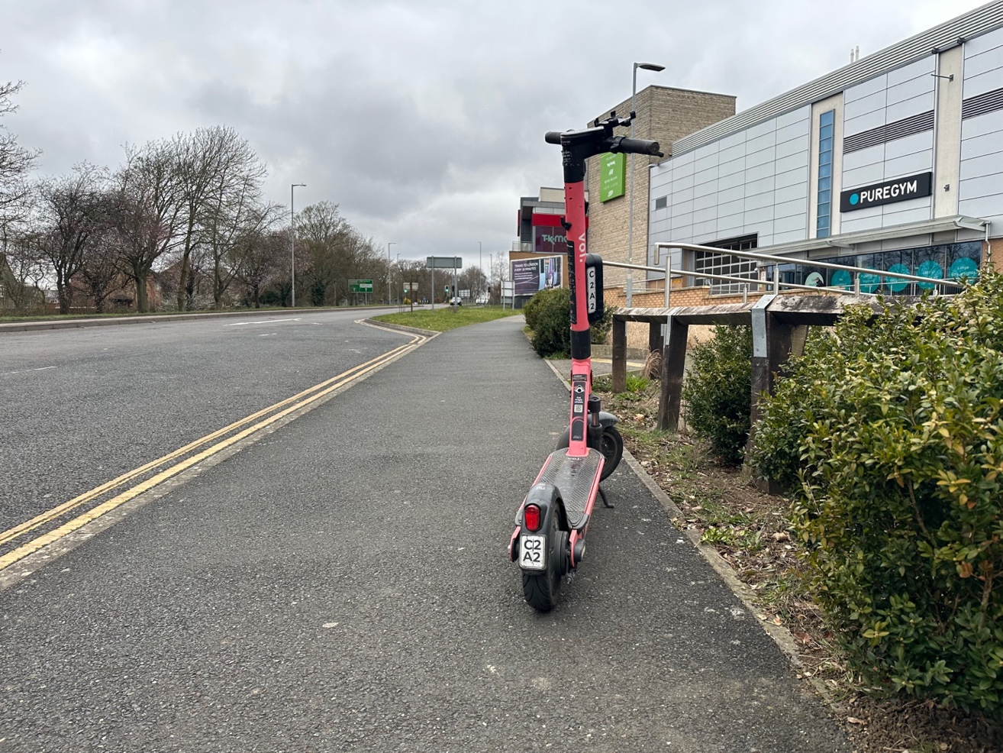
Photo 4 E-scooter left in an unsafe location, left on pavement causing a trip hazard.
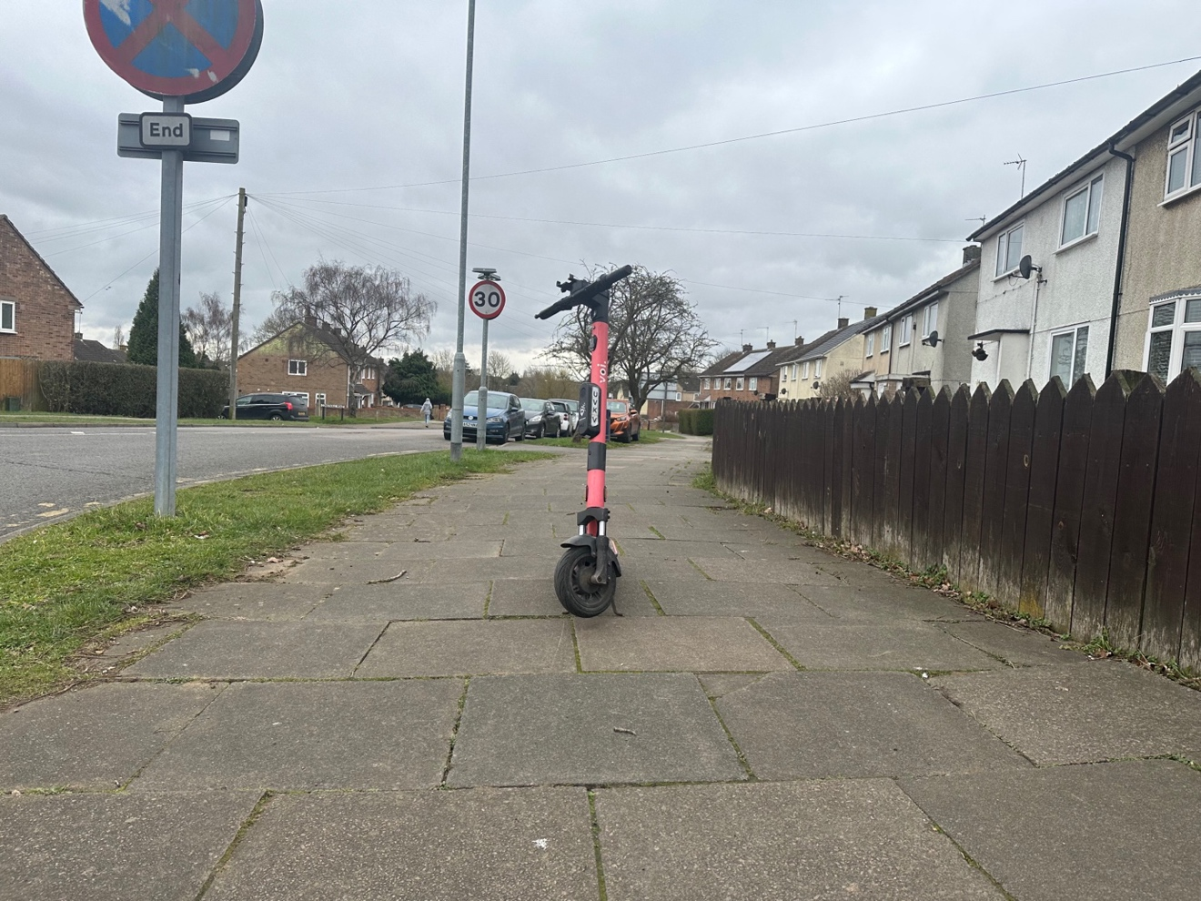
Photo 5 E-scooter left in an unsafe location, left in the middle of the pavement causing an obstruction and a trip hazard.

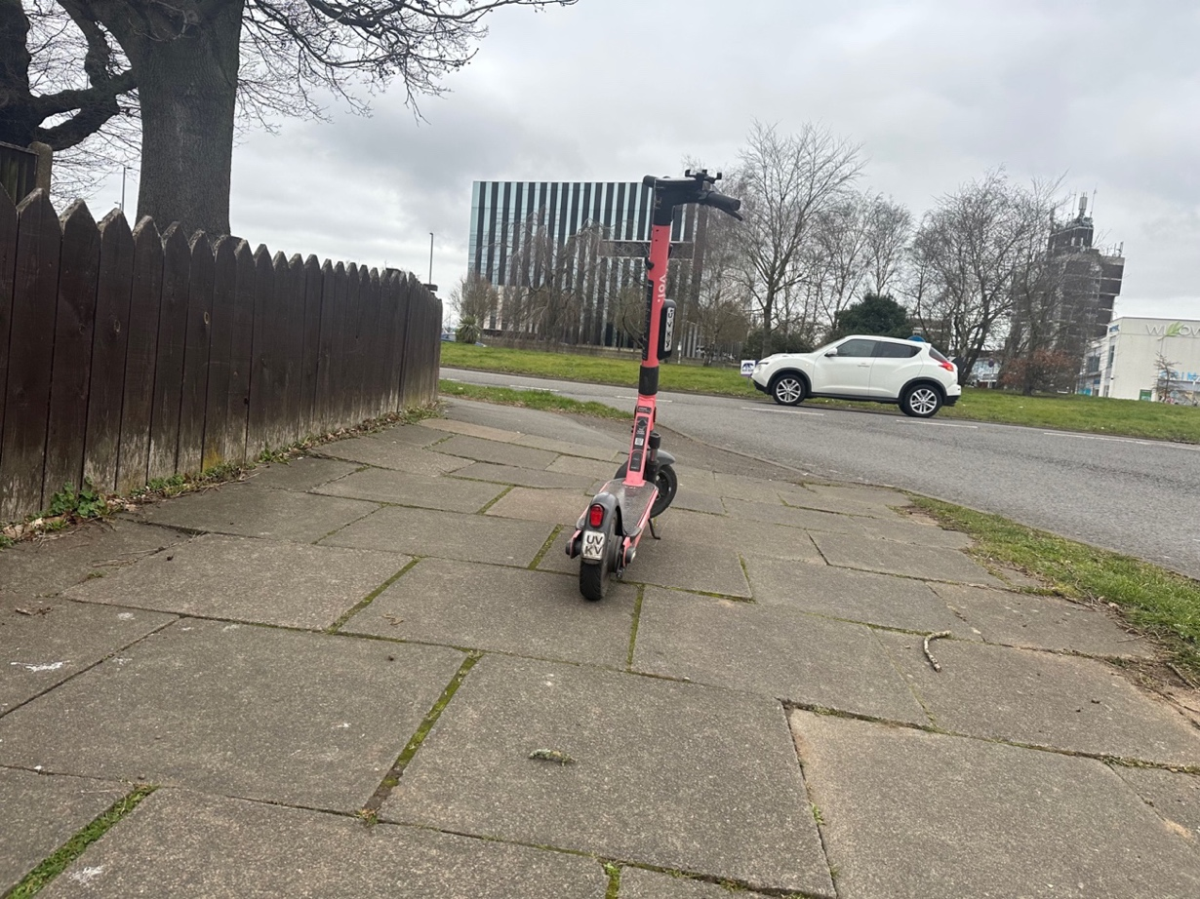
Photo 6 E-scooter left in an unsafe location in the middle of the pavement causing an obstruction and a trip hazard.

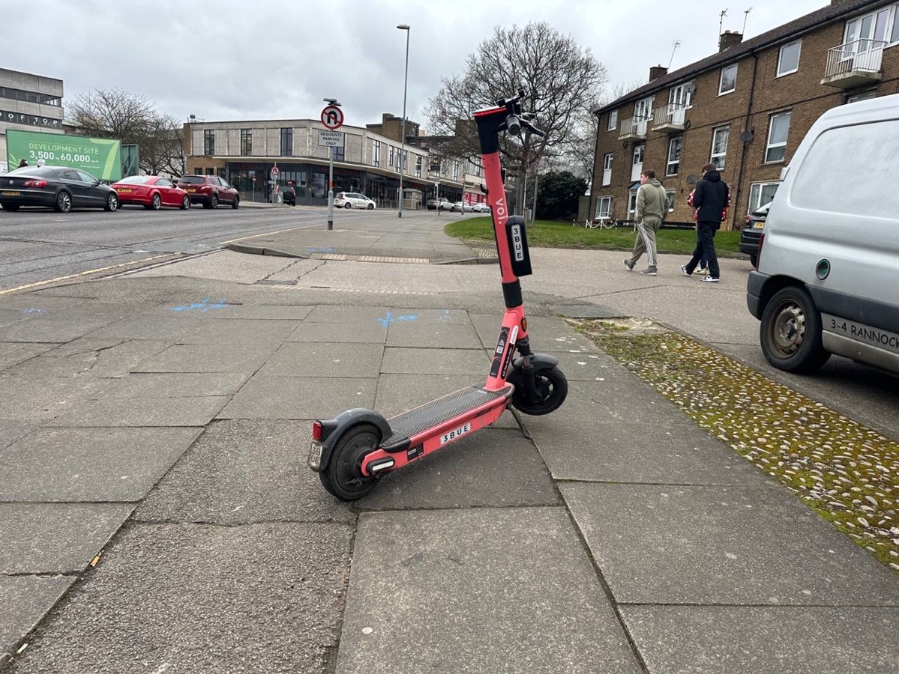
Photo 7 E-scooter left in an unsafe location, left in the middle of the pavement causing an obstruction and a trip hazard.

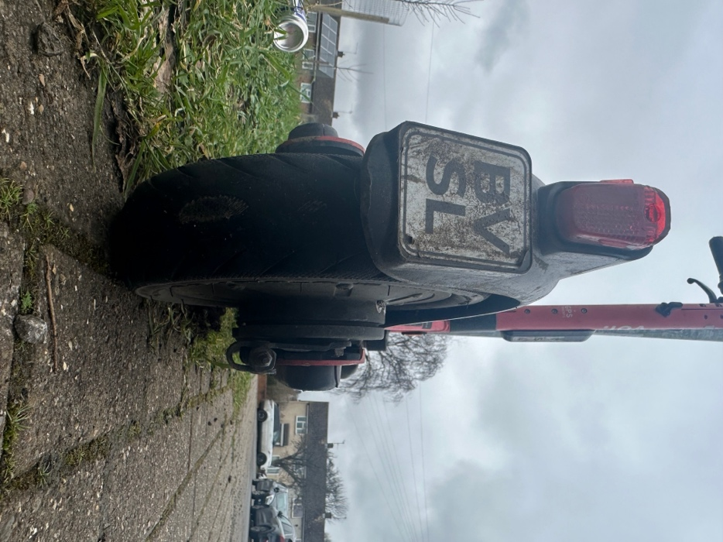
Photo 8 E-scooter left on pavement edge next to grass. This is still not safe as these e-scooters are not stable and can be easily knocked into and knocked over.
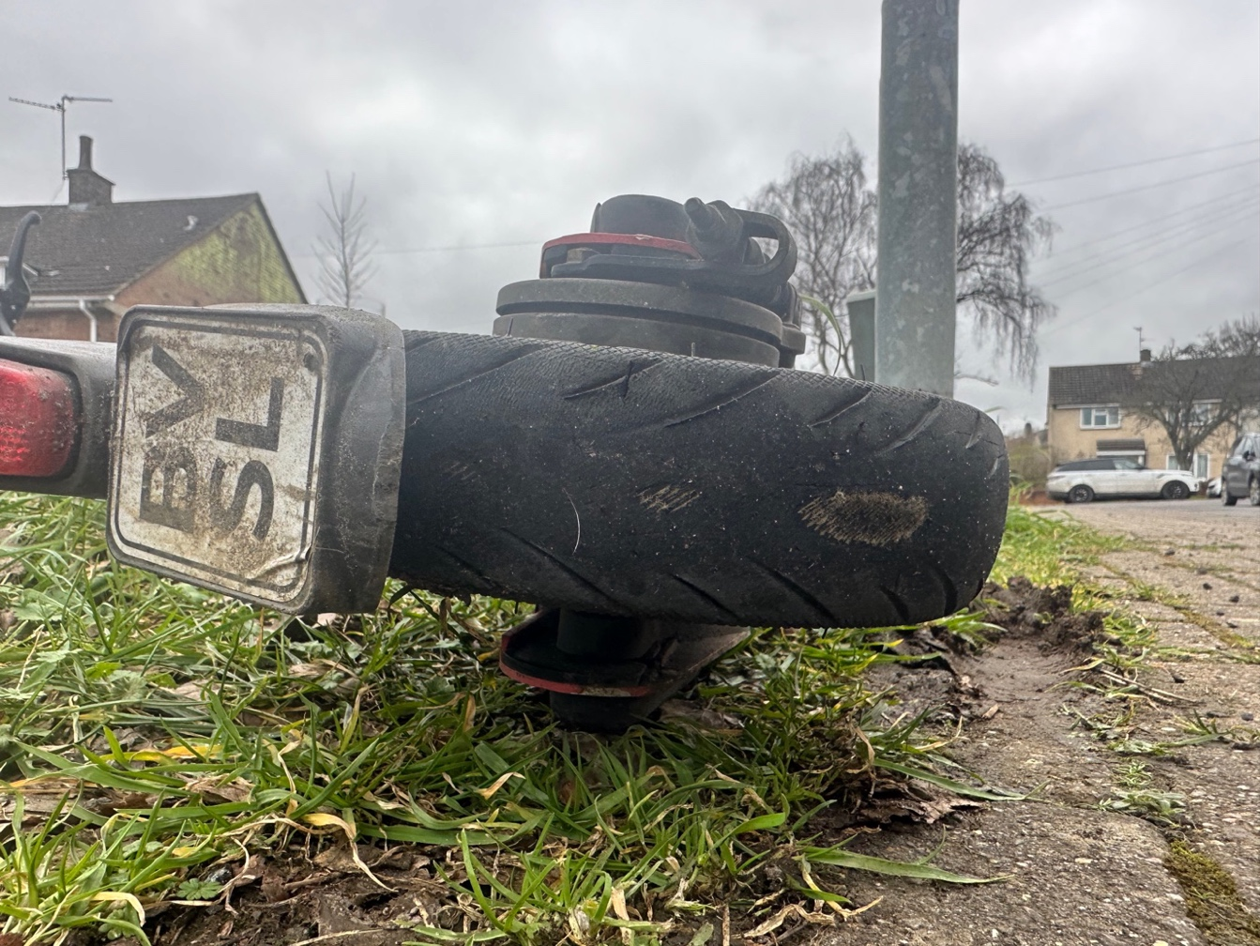
Photo 9: This is the same e-scooter as in photo 8 above and the unsafe state of the back tyre can be seen The tyre has been worn through the tread of the e-scooter.
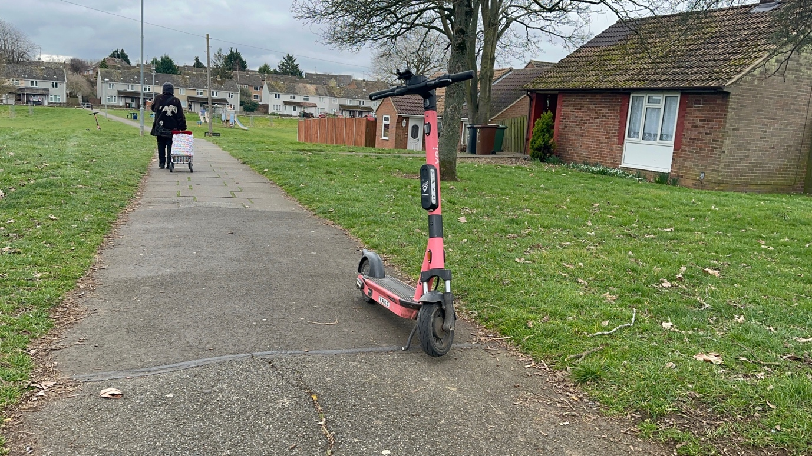
Photo 10 E-scooter left on path edge next to grass. This is still not safe location. The e-scooters are not stable and can be easily knocked into. It still a trip hazard.

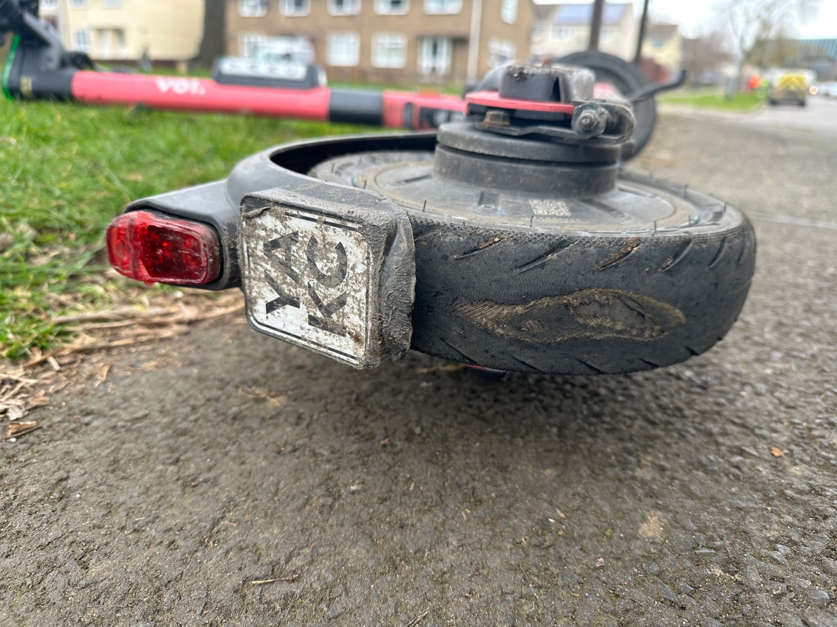
Photo 11: This is the same e-scooter as in photo 8 above and unsafe tyre can be seen. The tyre has worn through the tread of the e-scooter.

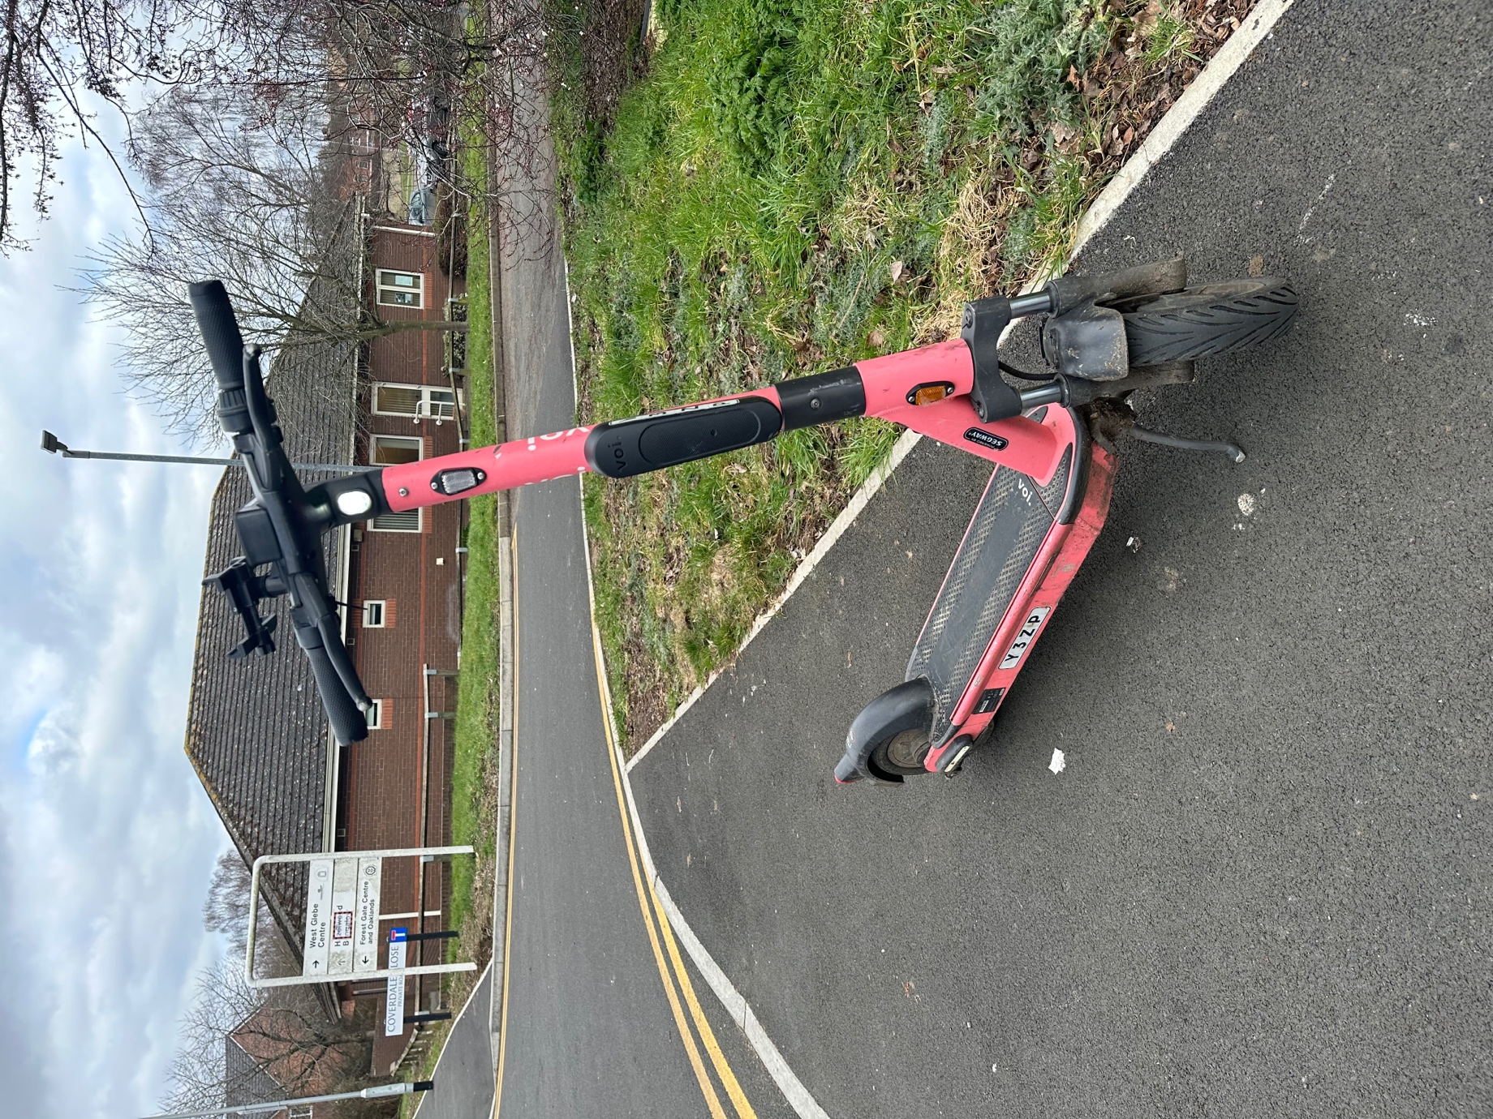
Photo 12 E-scooter left in an unsafe location causing on obstruction on the pavement and to the dropped kerb, as well as a trip hazard.

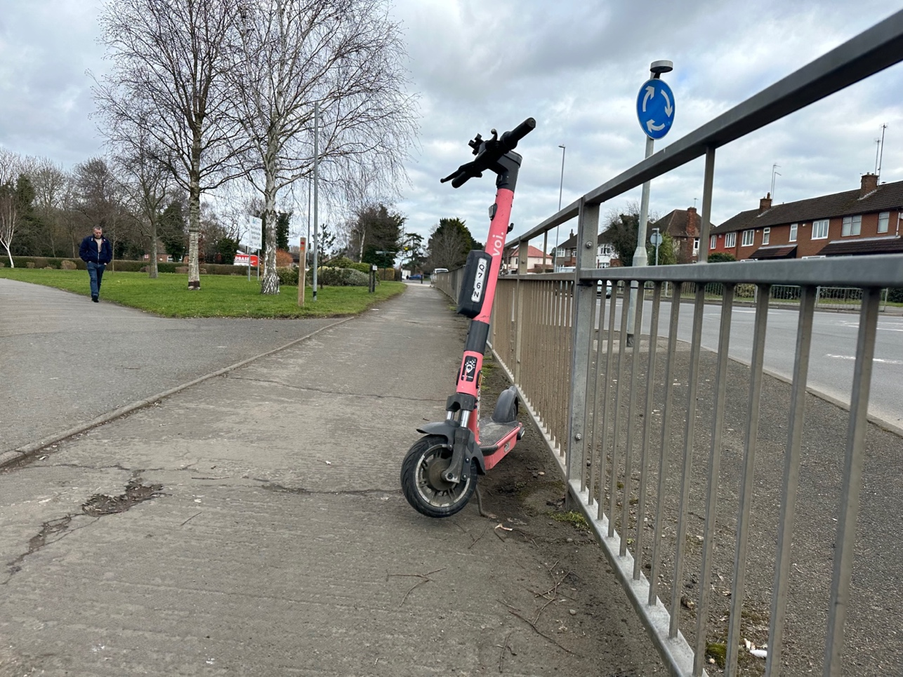
Photo 14 E-scooter left in an unsafe location on the railings on the pavement the path a trip hazard.
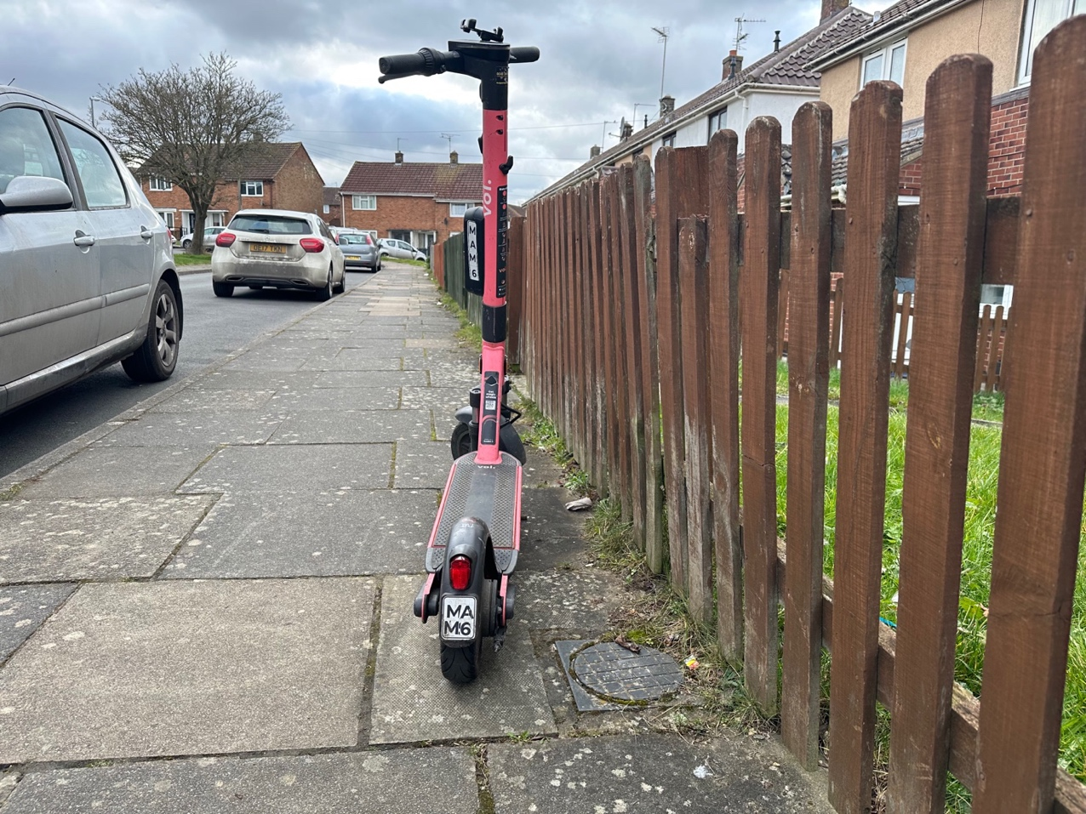
Photo 15 E-scooter left in an unsafe location on the railings on the pavement the path causing a trip hazard.
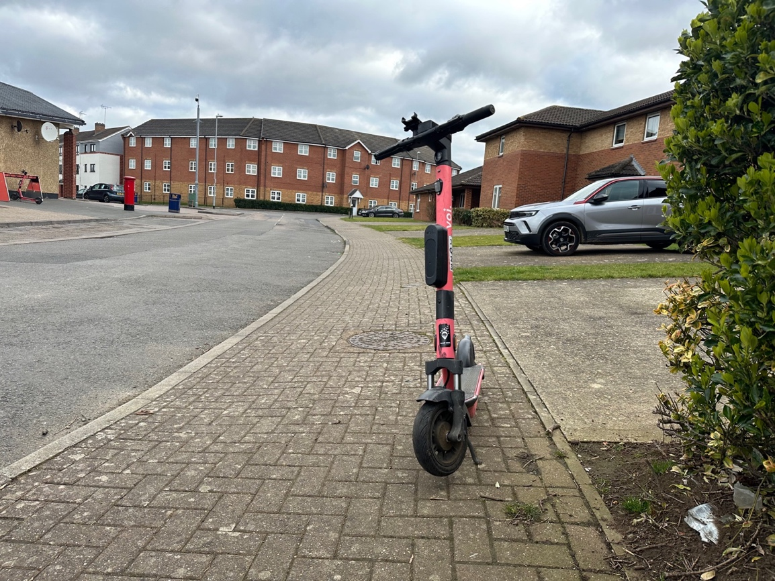
Photo 16 E-scooter left on pavement causing unsafe situation, causing a trip hazard. The parking rack for the e-scooters can be seen in the background of the photo and in photo 17 below. Illustrating even when racks are present riders are not using them.

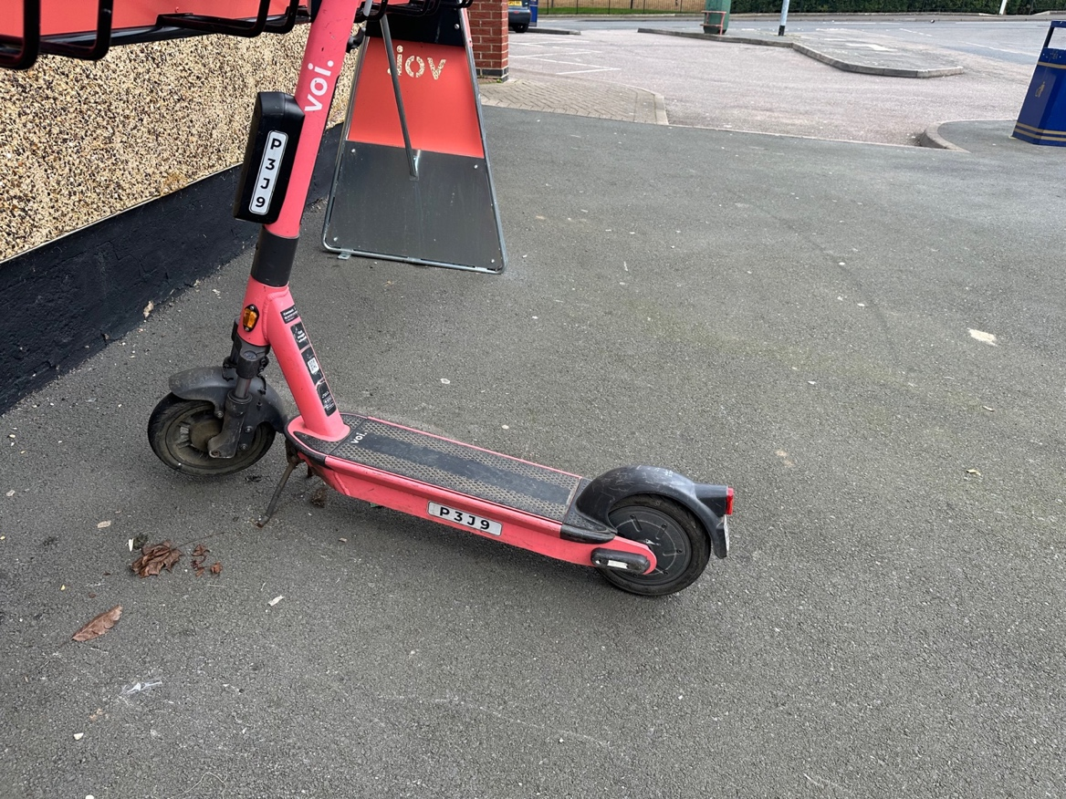
Photo 17: The parking rack is pavement clutter and is in an unsafe location. The e-scooters are still causing a trip hazard as they are sticking out from the parking rack and e-scooters are still being left on pavement area around the parking rack. Riders will be using the pavement to ride on and off to park the e-scooters, which is not safe at all for pedestrians.

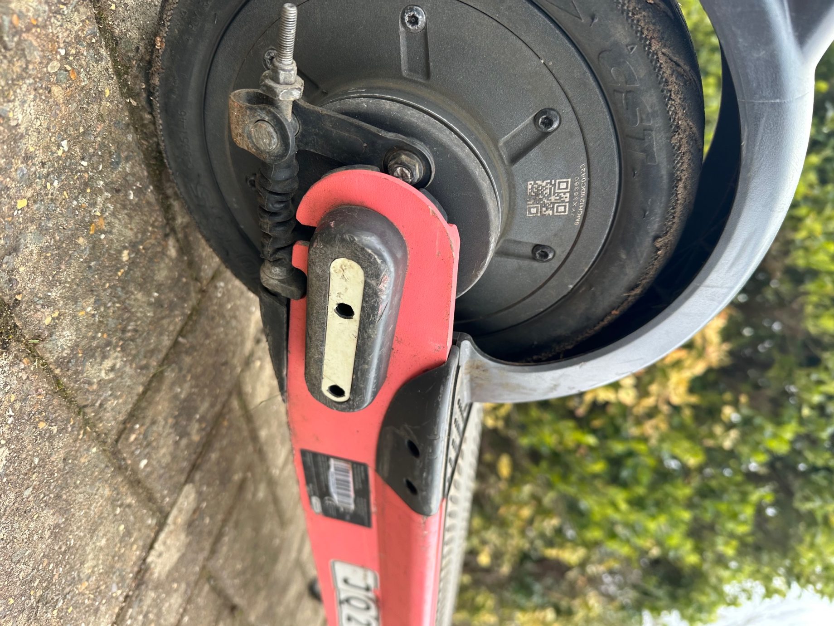
Photo 18 The e-scooter reflector is missing.

Appendix C Redditch E-scooter Trial Bird E-Scooters Site Visit 2 March 2023

Parking / dumping of e-scooters
E-scooters were observed in unsafe locations, found in an unsafe manner causing obstructions and trip hazards on the pavement, public places and next to bus stops.
- Left on pavements, in the middle of the pavement, on the kerb line, on the building line, on dropped kerbs, leading up to pedestrian crossing points and left close to tactile paving for use by blind and visually impaired pedestrians.
- Found left in the bus station on walk ways and next to bus stops
- Many were found without the kick stands not deployed
- Many were found knocked over.

Safety of E-scooters
Two e-scooters were found with under inflated tyres. Not all tyres were checked.

Riding of e-scooters
E-scooters were observed been ridden of the pavements.

This trial has not resolved key safety and accessibility concerns for riders and pedestrians and needs to be halted.
Site Visit | Appendix Site Visits | Twitter Films Trip & Obstructions | Twitter films Dangerous Riding | Twitter Films E-scooter Safety Concerns
Redditch | Appendix C | March 2023  July 2021  June 2021 | July 2021 – Handing over e-scooter to another person to ride | March 2023  March 2022  March 2022  July 2021  July 2021  July 2021  July 2021  June 2021

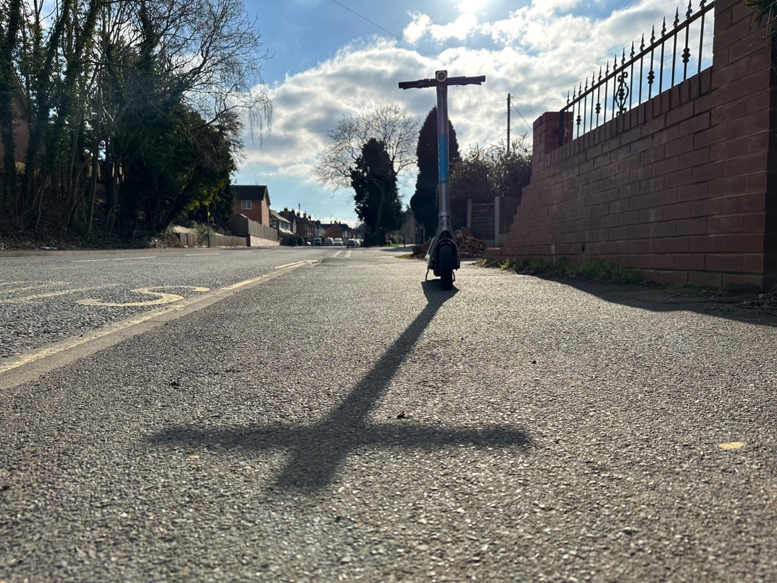
Photo 1 E-scooter left in unsafe situation in the middle of the pavement, creating an obstruction and trip hazard.
. 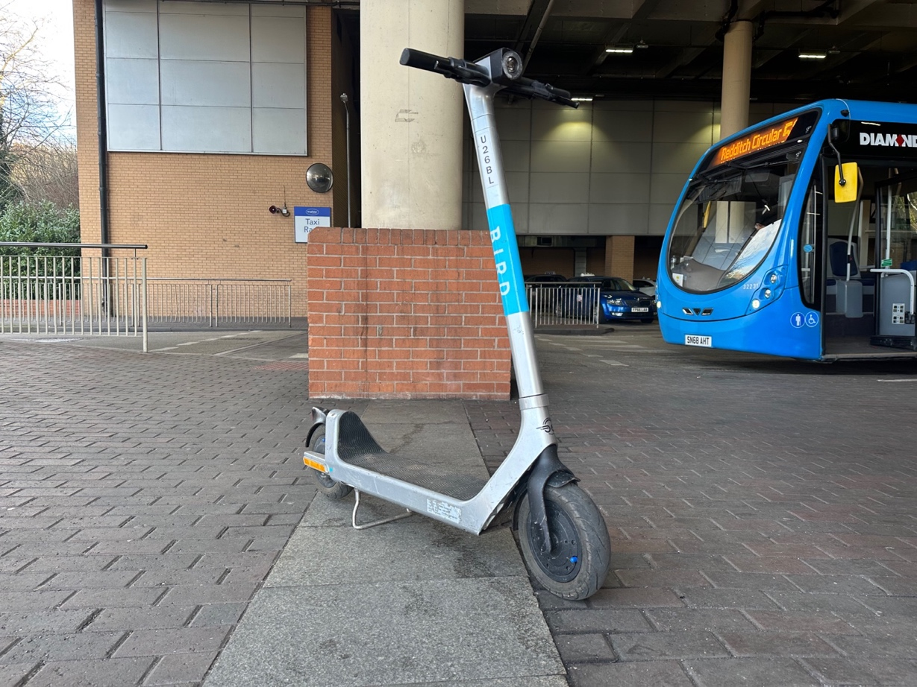
Photo 2 E-scooter left in unsafe situation in the middle of a walkway in the bus station creating and obstruction and trip hazard.

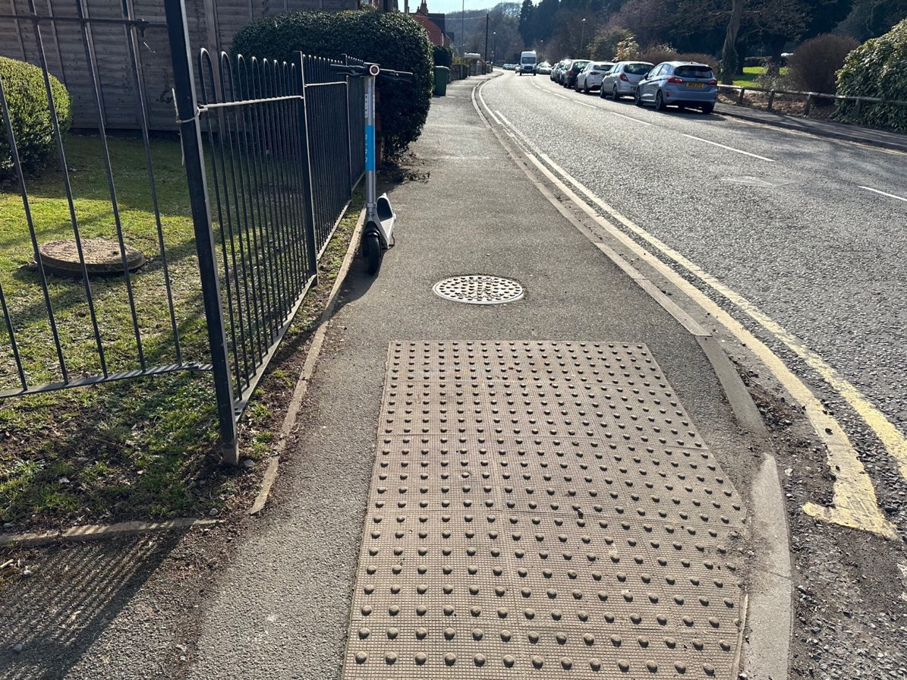
Photo 3: e-scooter left in an unsafe situation on building line on the pavement close to tactile paving used by blind and visually impaired people.

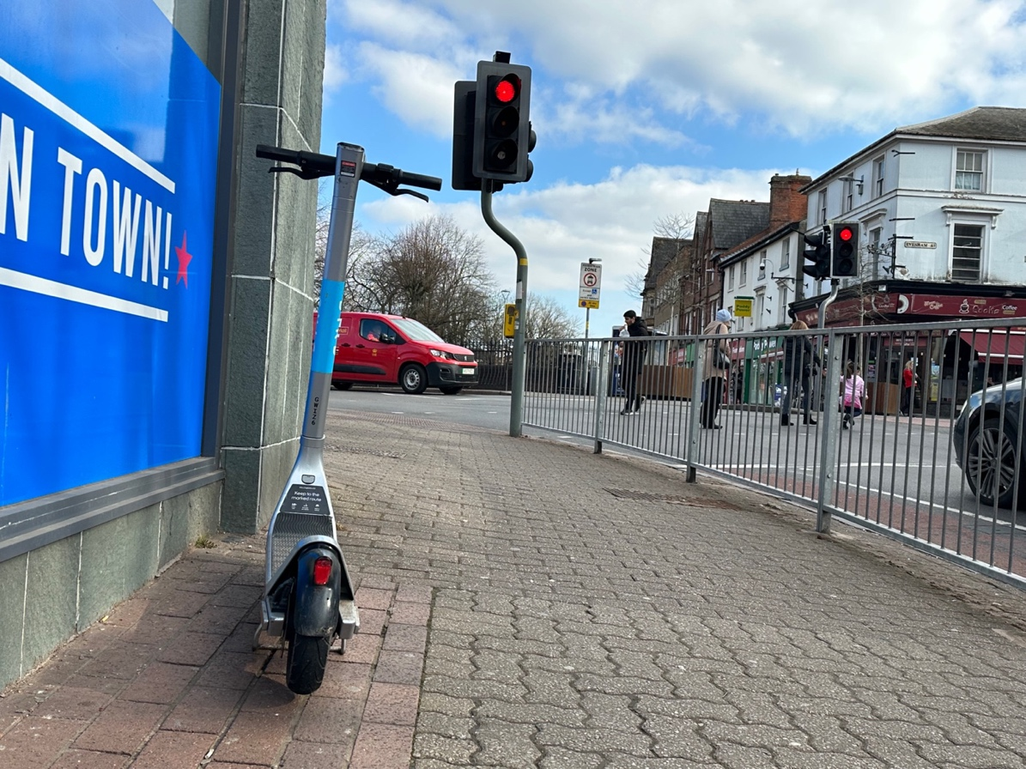
Photo 4: E-scooter left in an unsafe situation on building line on pavement cleading towards controlled green man pedestrian crossing.
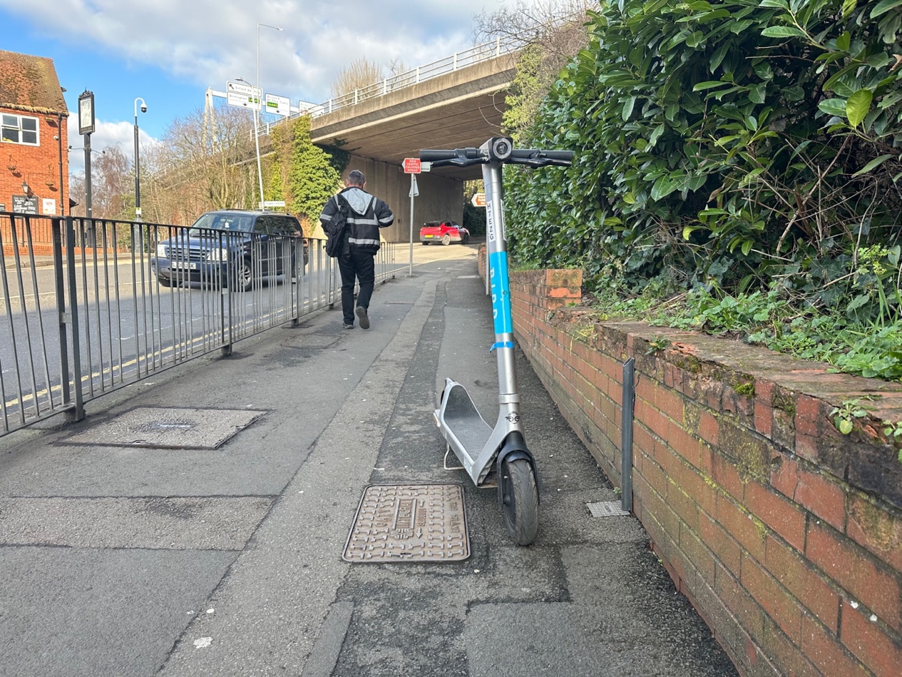
Photo 5 E-scooter left in unsafe situation on the pavements building line, creating a trip hazard.
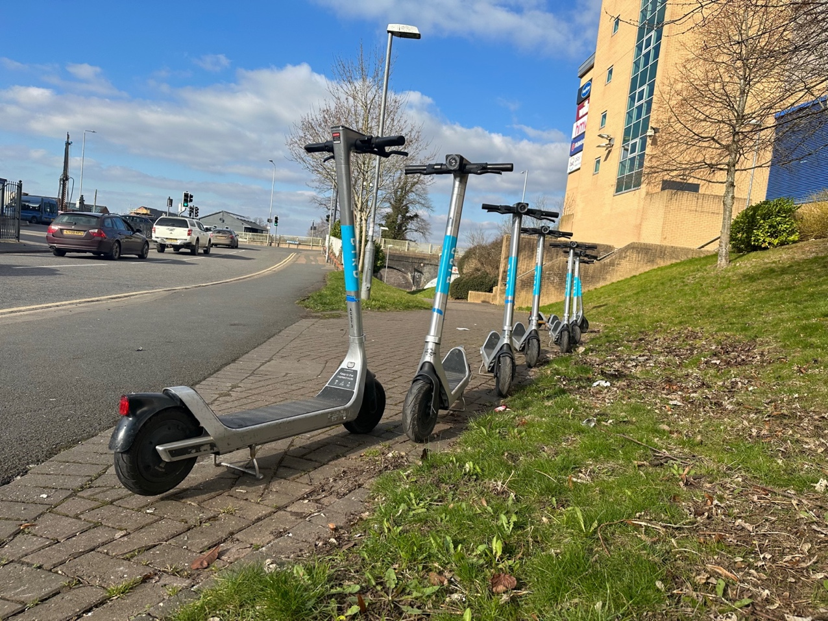
Photo 6 Seven e-scooters left in unsafe situation on the edge of a path leading to and from the train station, a trip hazard.

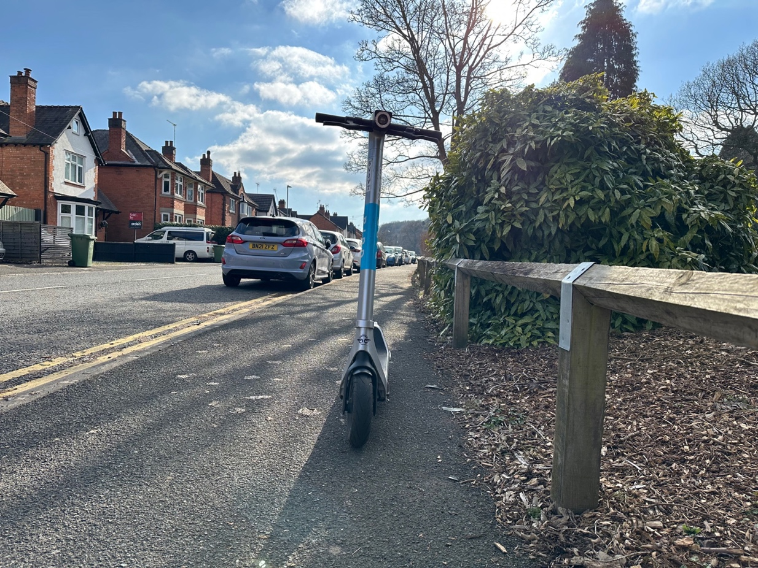
Photo 7 E-scooter left in unsafe situation on the building line of the pavement, creating a trip hazard.

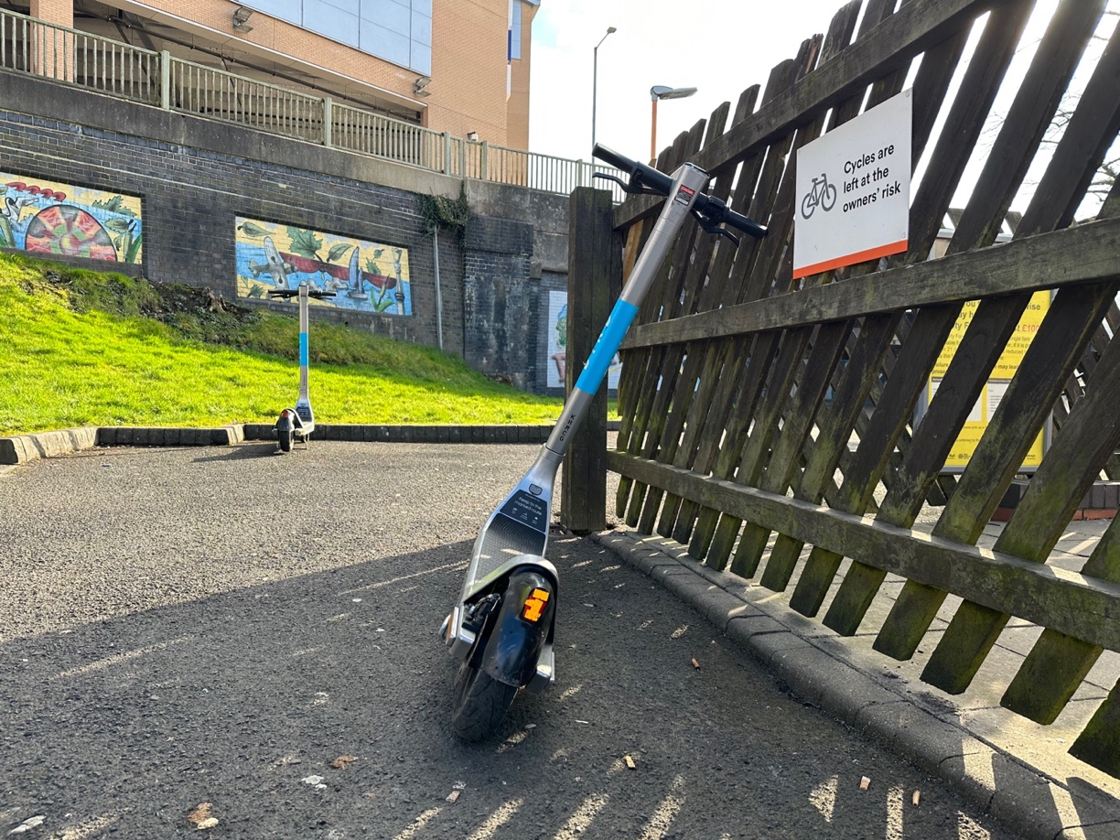
Photo 8 E-scooter left in unsafe situation on the building line of walkway at the train station, not on its kick stand making it even more unsafe, creating a trip hazard.

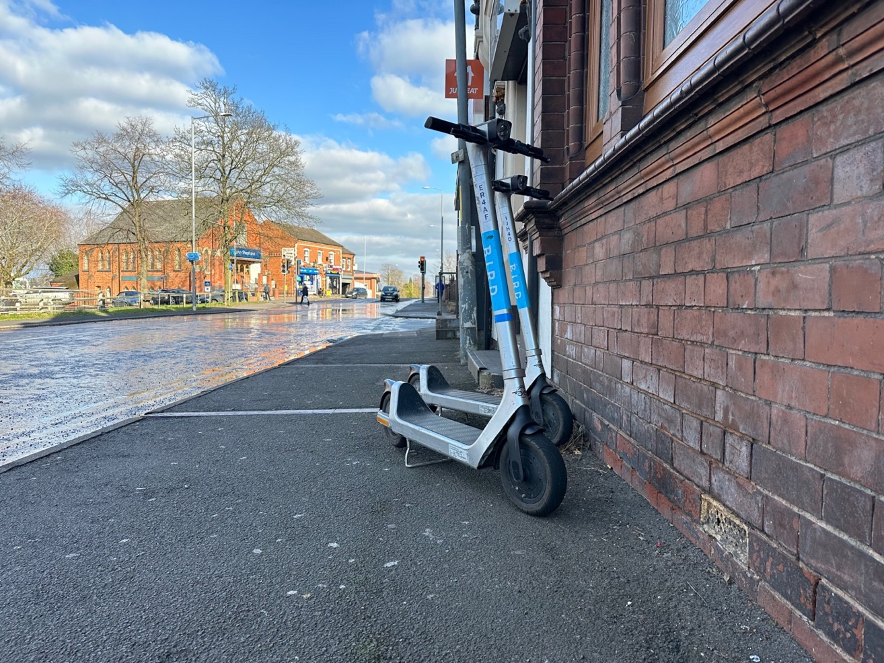
Photo 9 Two e-scooters left on the pavement in an unsafe situation creating a trip hazard.
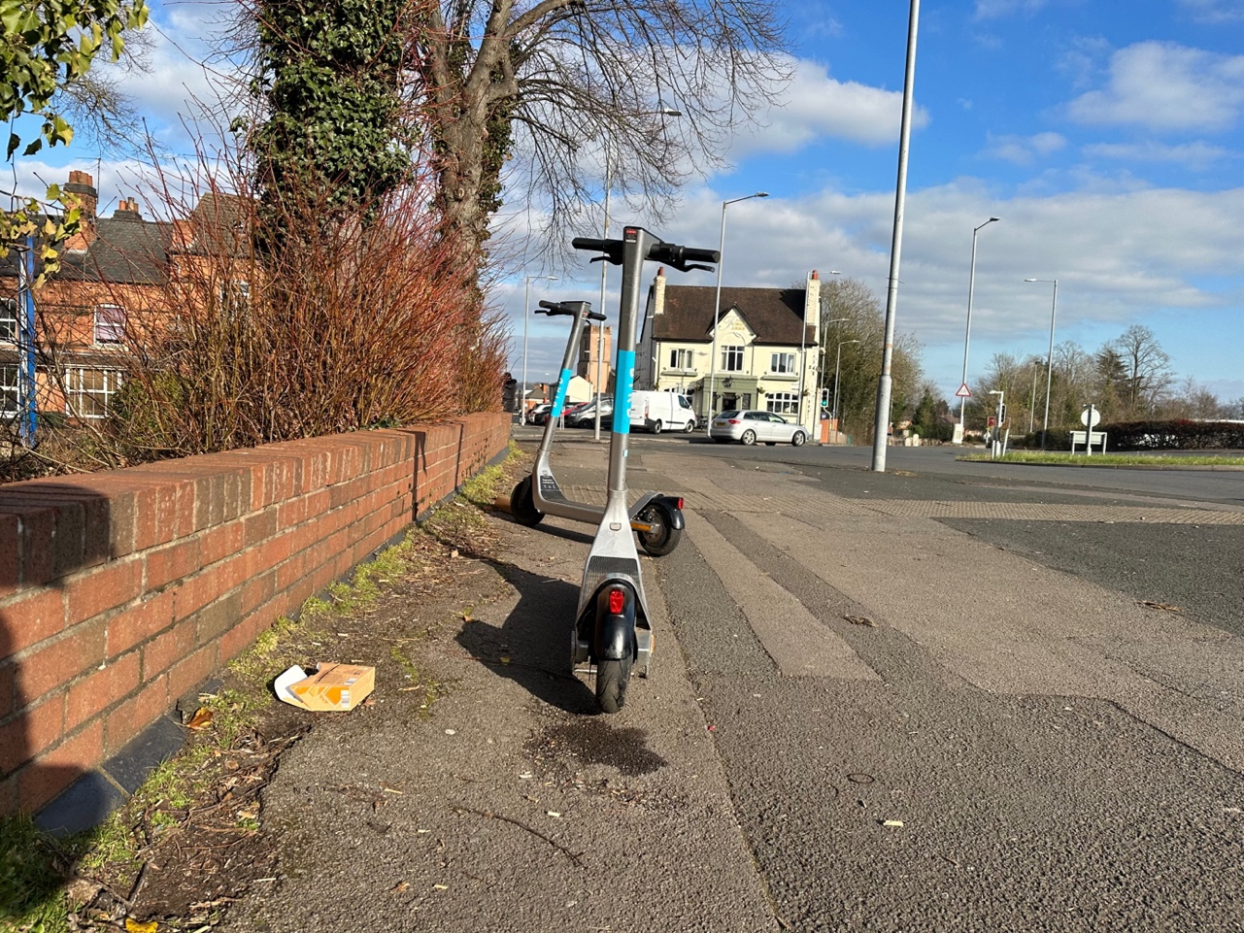
Photo 10 Two e-scooters left on the pavement in an unsafe situation a trip hazard.

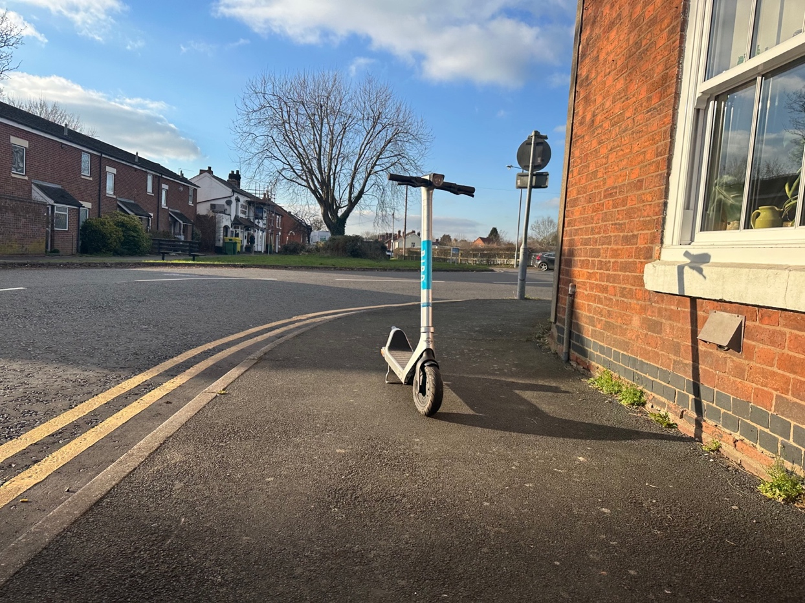
Photo 11 E-scooter left in unsafe situation in the middle of the pavement, creating an obstruction and trip hazard.
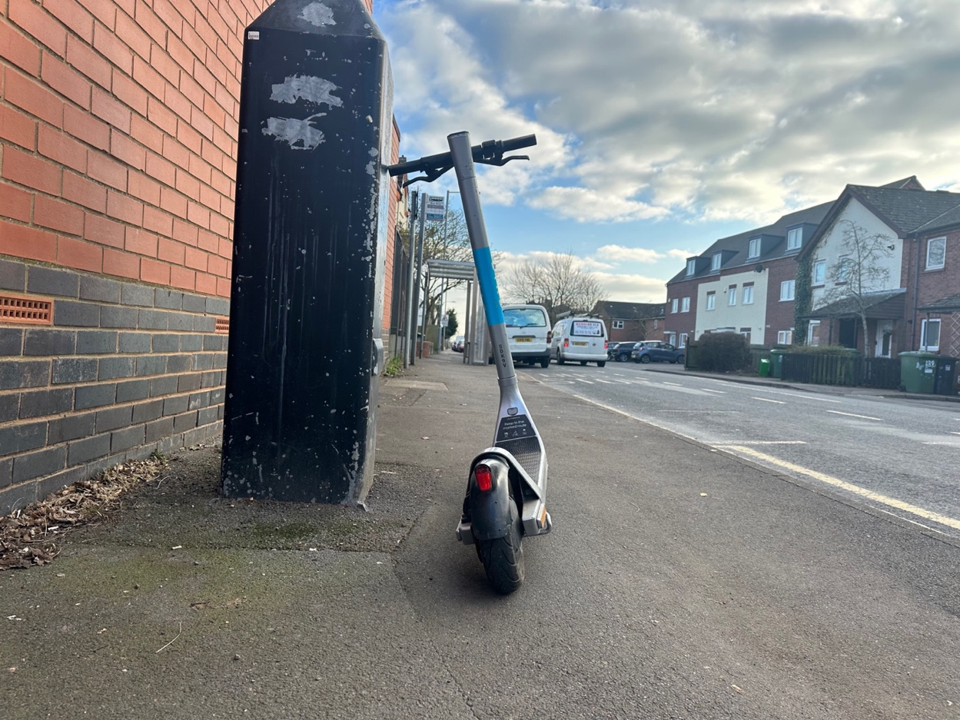
Photo 12 E-scooter left in unsafe situation on the building line of the pavement without its kick stand deployed making it even more unstable, creating a trip hazard.
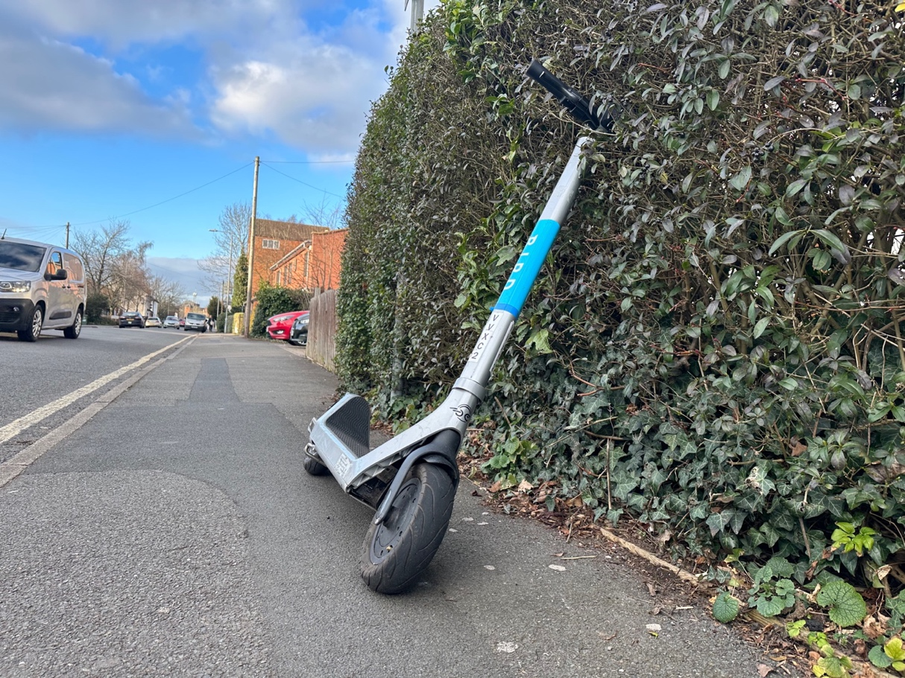
Photo 13 E-scooter left in unsafe situation on the building line (hedge) of the pavement without its kick stand deployed making it even more unstable, creating a trip hazard.

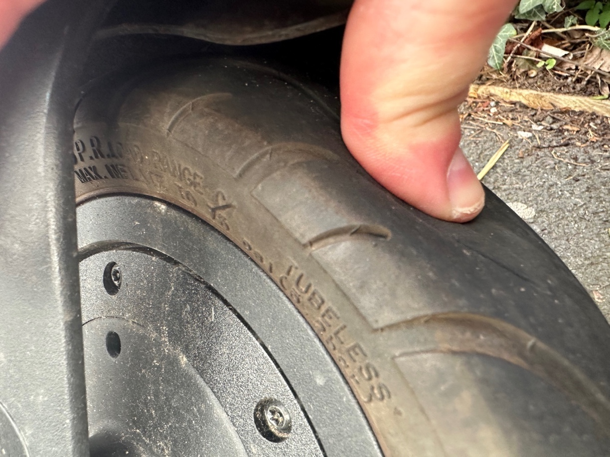
Photo 14 Thumb being pressed on e-scooter to show it is underinflated as seen in this twitter film.

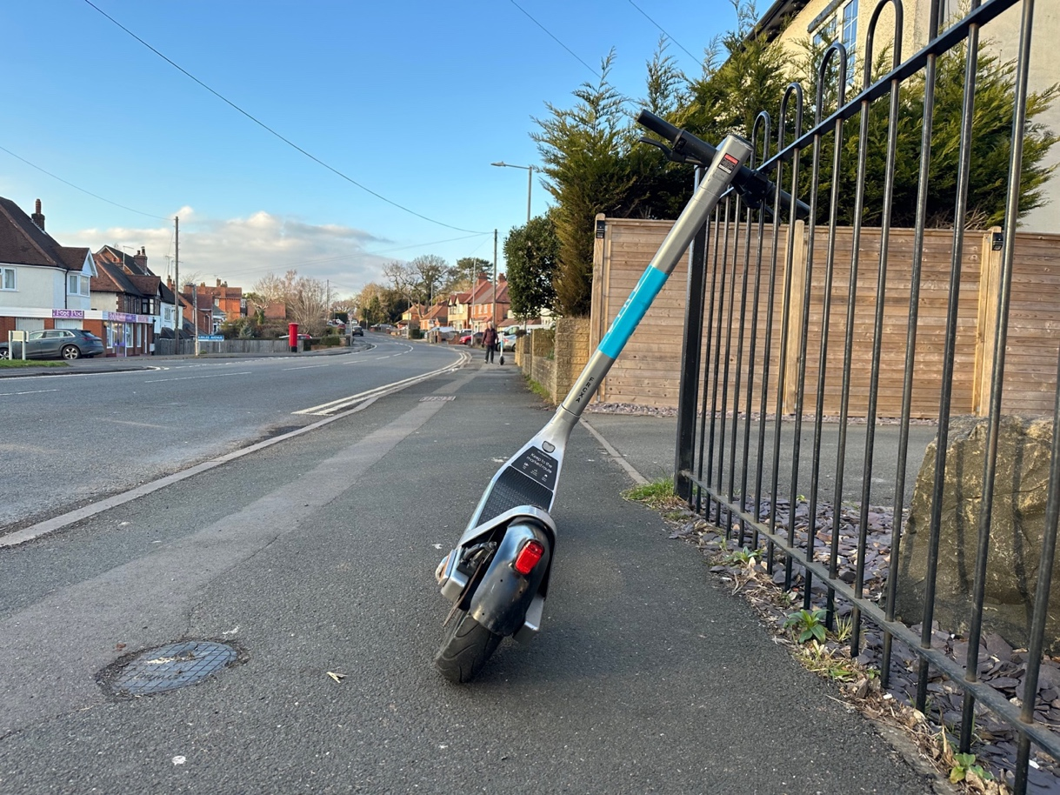
Photo 15 E-scooter left in unsafe situation on the building line of the pavement without its kick stand deployed, creating a trip hazard.

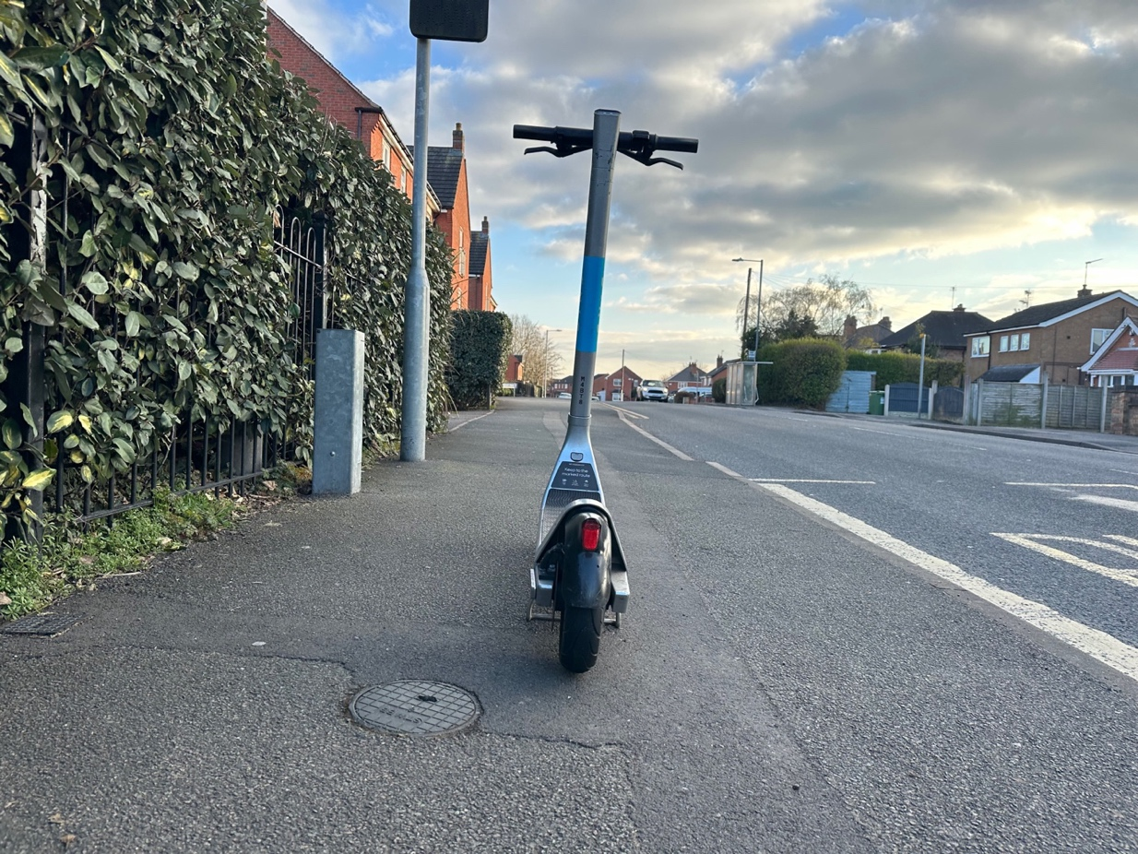
Photo 16 E-scooter left in unsafe situation in the middle of the pavement, creating an obstruction and trip hazard.

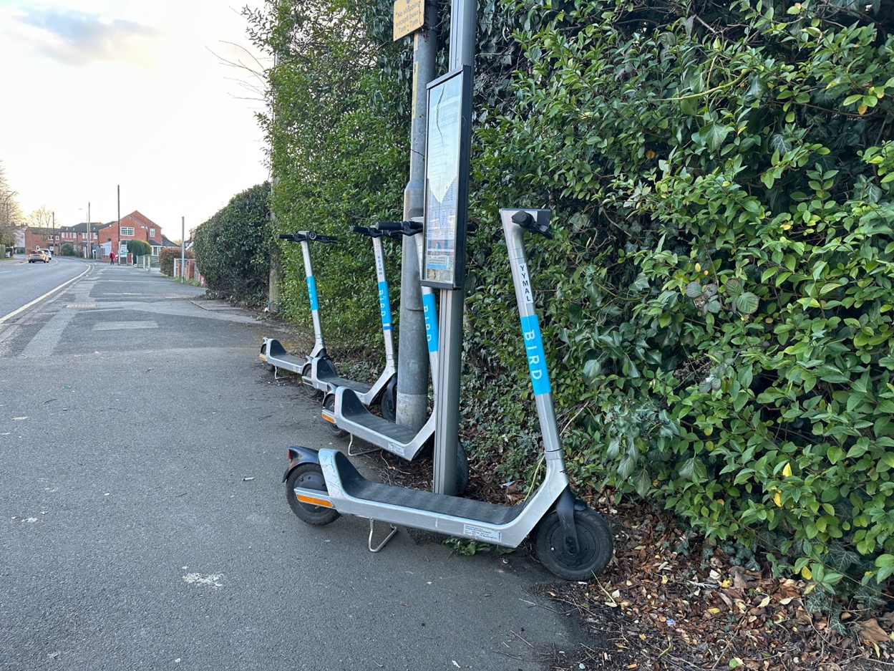
Photo 17 Four E-scooters left on building line next to the display pole for bus information. Creating an unsafe situation on the pavement and close to the bus stop.
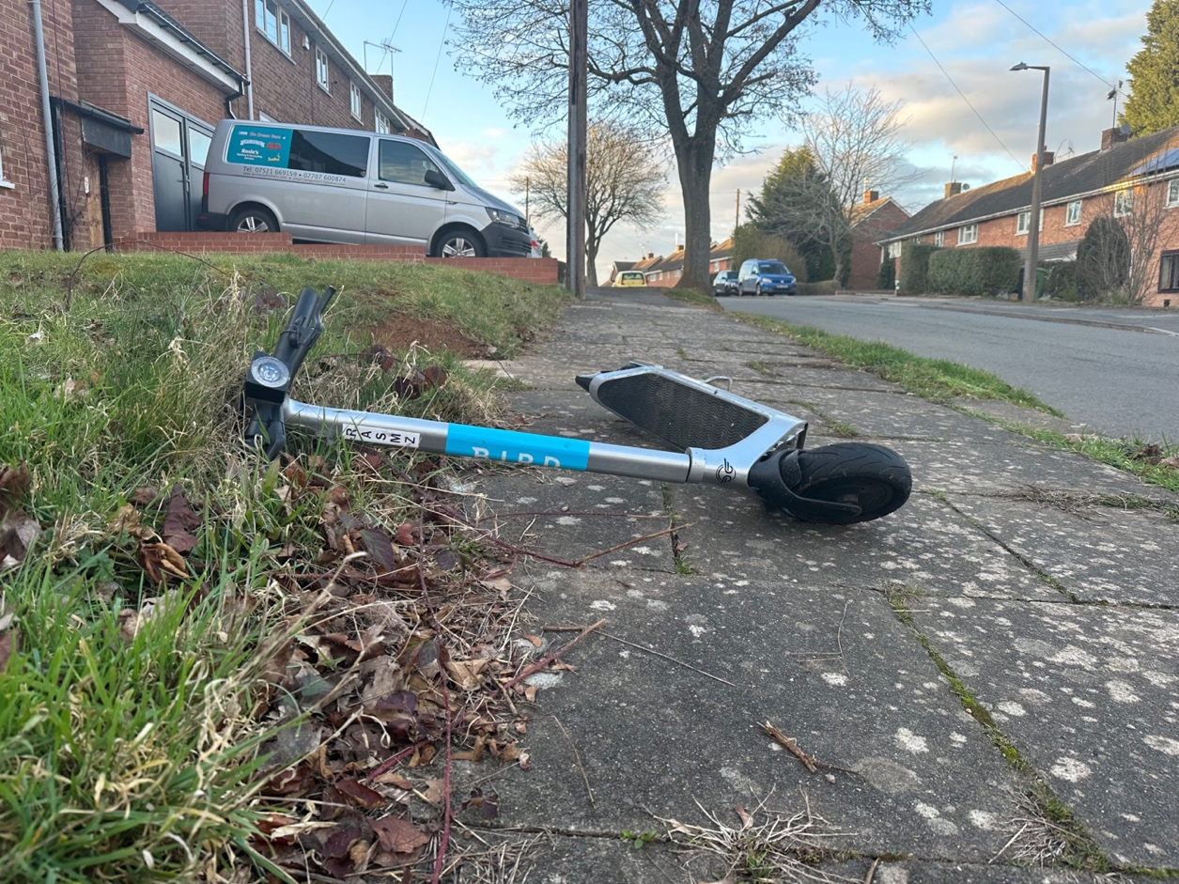
Photo 18 E-scooter left dumped fallen over on the pavement causing a trip hazard and an obstruction.

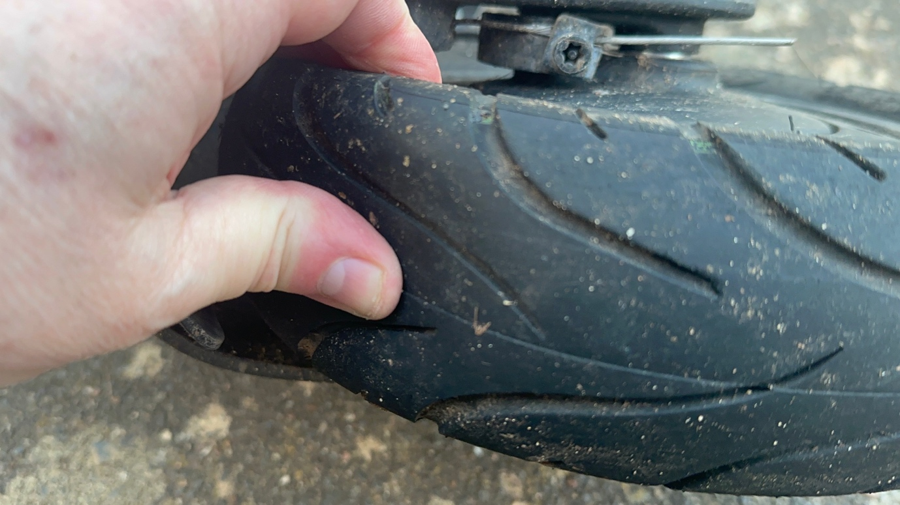
Photo 19 This is the e-scooter from photo 18 illustrating the underinflated tyre.

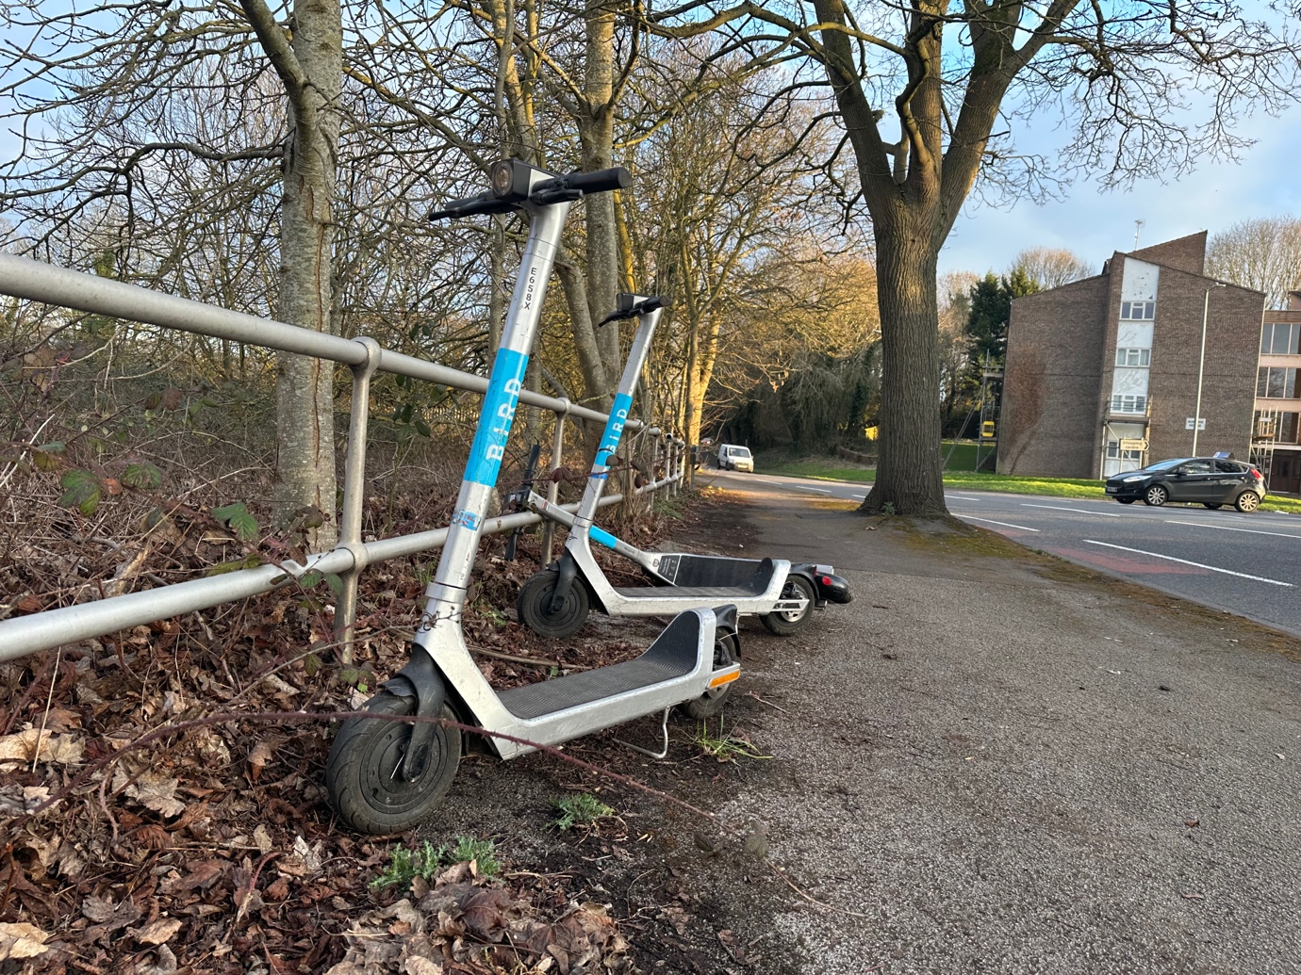
Photo 20 Three e-scooters left on the building line on the pavement, one which has been knocked over. These are in an unsafe situation a trip hazard.

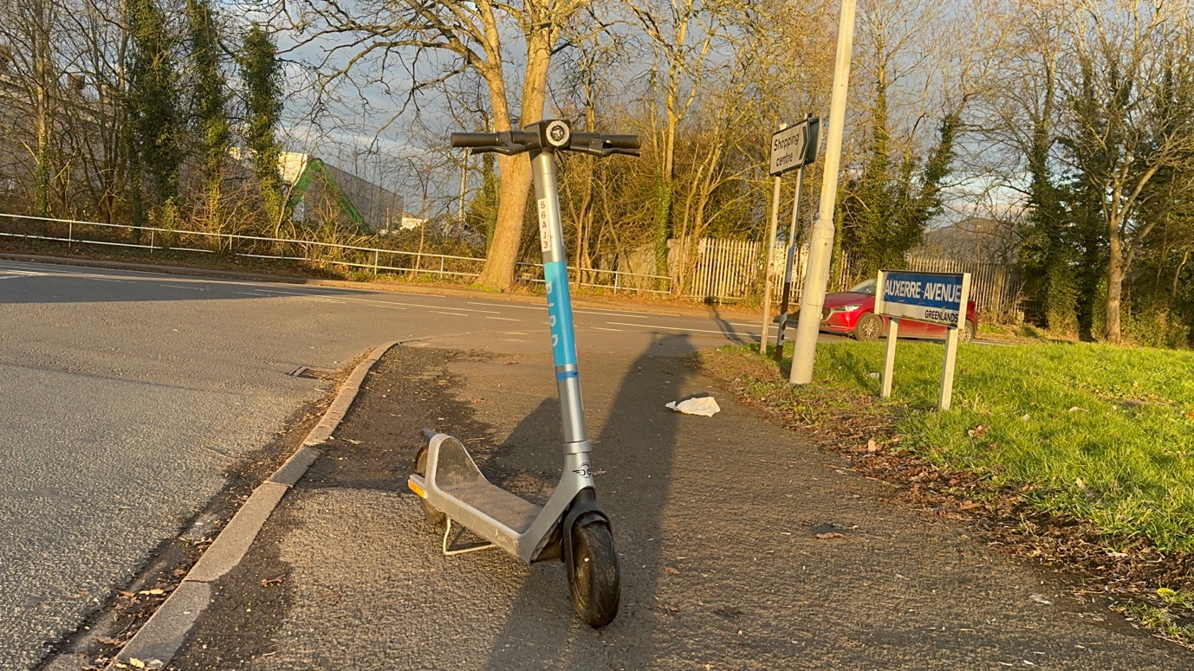
Photo 20 E-scooter left in unsafe situation on the pavement, creating an obstruction and trip hazard.

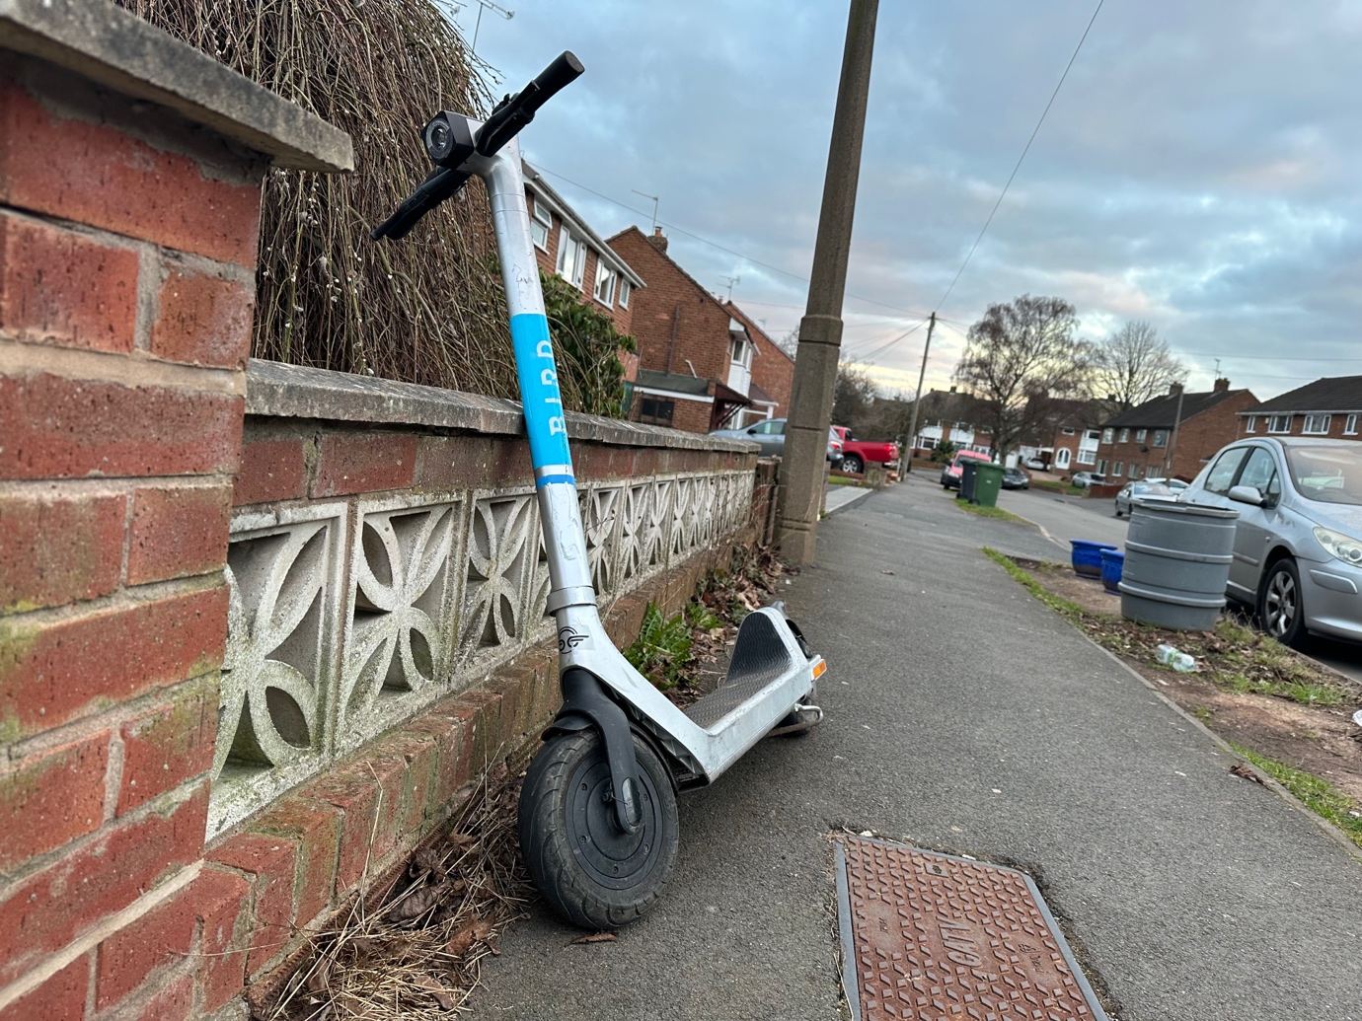
Photo 21 E-scooter left in unsafe situation on the building line of the pavement without its kick stand deployed, creating a trip hazard.

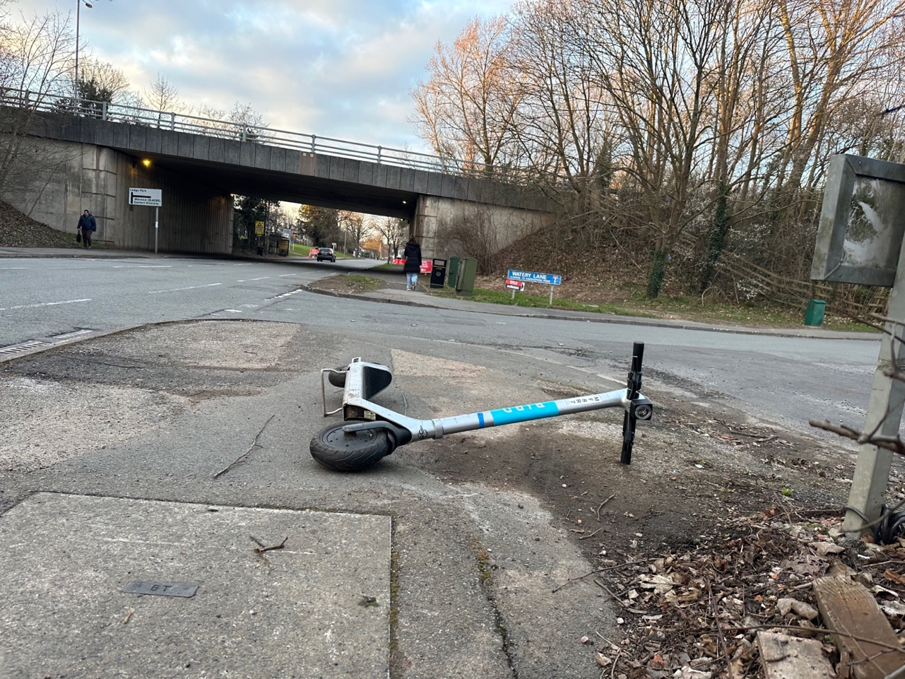
Photo 22 E-scooter left in unsafe situation knocked over and dumped on the pavement creating a trip hazard.
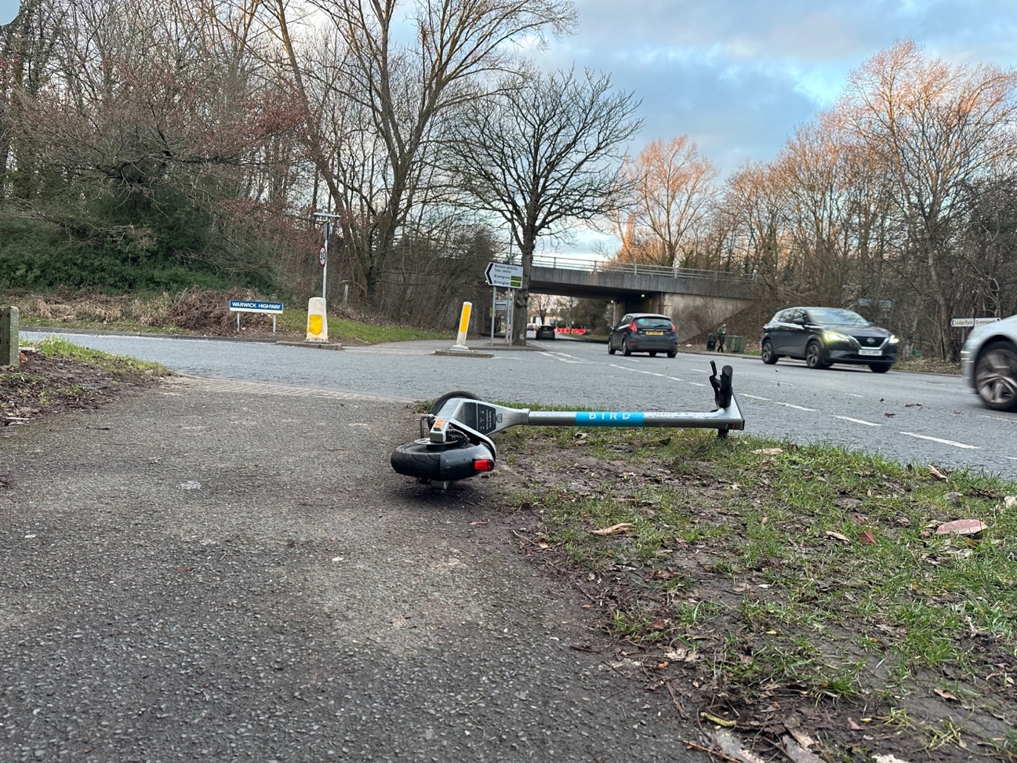
Photo 23 E-scooter left in unsafe situation knocked over and dumped on the pavement creating a trip hazard.

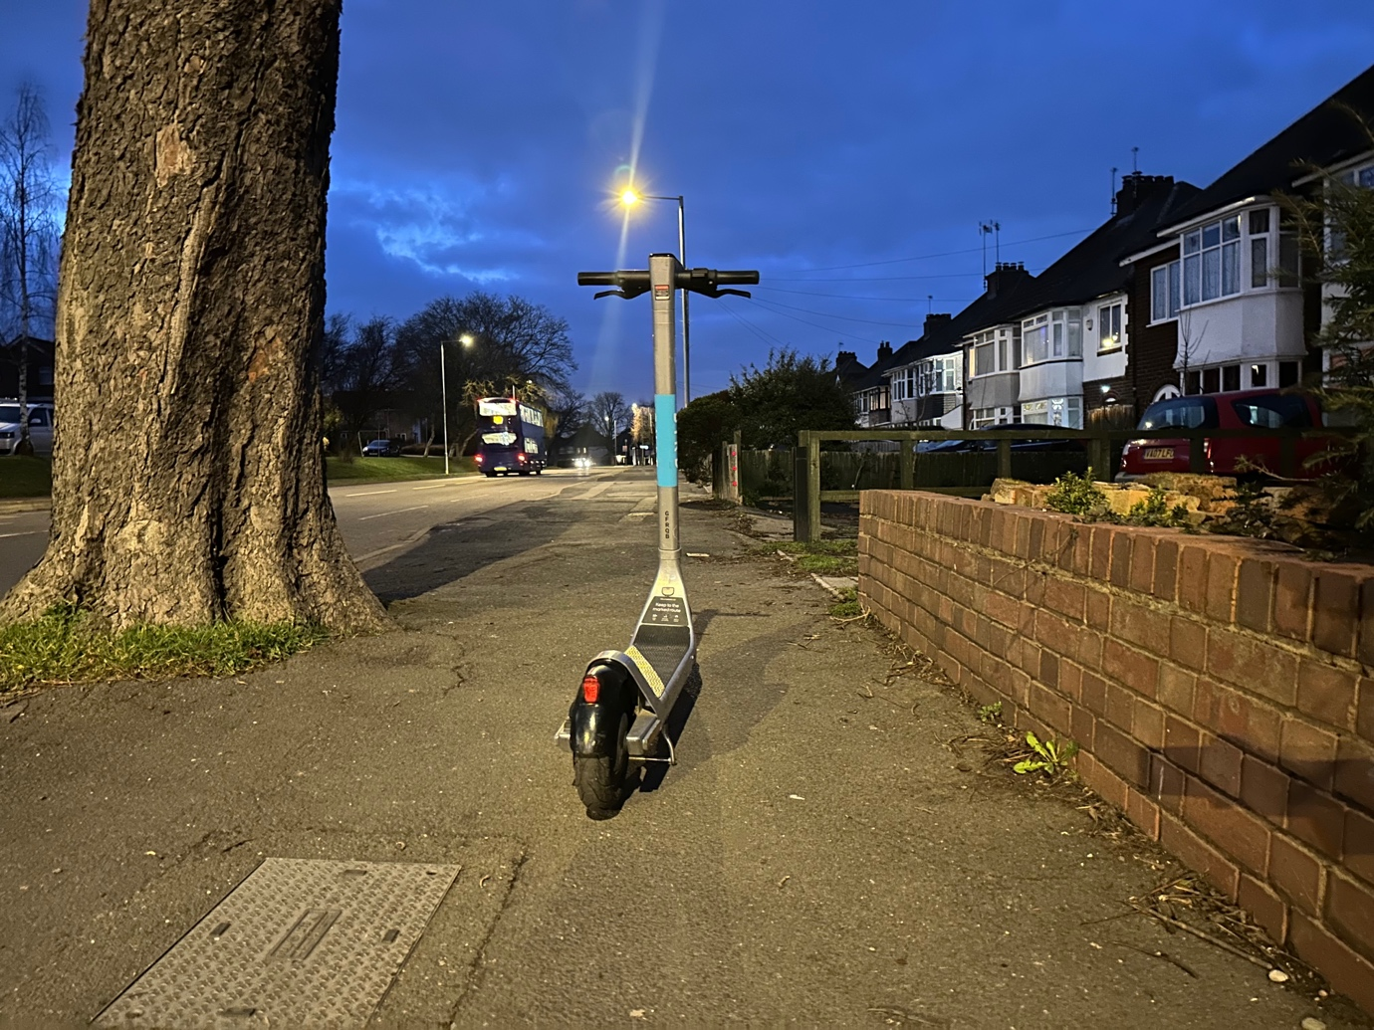
Photo 24 E-scooter left in unsafe situation in the middle of the pavement, creating an obstruction and trip hazard. This photo was taken in the early evening.

Appendix D a Newcastle E-scooter Trial Neuron E-Scooters Site Visit 8 to 10 February 2023

This trial has not resolved key safety and accessibility concerns for riders and pedestrians and needs to be halted. The trial has had significant time to resolve safe parking, ensuring riders do not use pavements and for the e-scooters to be safe for riders. This has not happened. The trial needs to be halted. The photos below and in Appendix D b show the concerns raised.

Parking / dumping of e-scooters
E-scooters were observed in unsafe locations, found in an unsafe manner causing obstructions and trip hazards on the pavement, public places and next to bus stops.
- Left on pavements, in the middle of the pavement, on the kerb line, on the building line, on dropped kerbs, leading up to pedestrian crossing points and left close to and on tactile paving for use by blind and visually impaired pedestrians.
- E-scooters were found knocked over.
- E-scooters were found with no kick stand deployed.

Helmet Safety
The helmets in use were observed as not fit for purpose for the use with e-scooters and many helmets which many were smashed, broken and dented lying on the floor next to the e-scooters or lying underneath the fallen e-scooters.
- The safety label inside the helmet reads as follows 'This helmet is for pedal cycles, skateboarders and roller skates’ there is no mention of it being for e-scooter riders’ and clearly states ‘not for motorised vehicle use’ as seen in photo 1 below.
- How did no local authority officer, elected councillor, the Department for t
Transport civil servants or the consultants undertaking the National Monitoring Report not pick this up and resolve this serious safety issue?
- Many helmets were broken, smashed, dented, found lying next to or underneath fallen e-scooters.
- 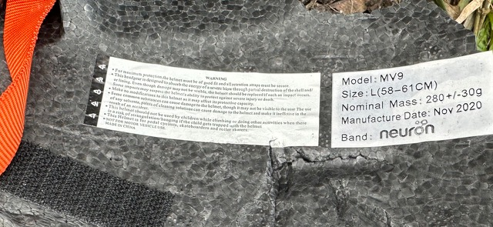
Photo 1 E-scooter warning label on Neuron helmet.

Safety of E-scooters
E-scooters tyres were observed with no tread on the tyres.

Site Visit | Appendix Site Visits | Twitter Films Trip & Obstructions | Twitter films Dangerous Riding | Twitter Films E-scooter Safety Concerns
Newcastle | Appendix D | February 2023 |  | February 2023

Riding of e-scooters
E-scooters were observed been ridden of the pavements and through red traffic lights.

Photos
38 photos are given below showing unsafe situation of e-scooter backs tyres, damaged helmets, the helmet safety warning label, e-scooters left in unsafe location on the pavement, next to pedestrian crossings and knocked over. Creating obstructions and trip hazards for pedestrians.

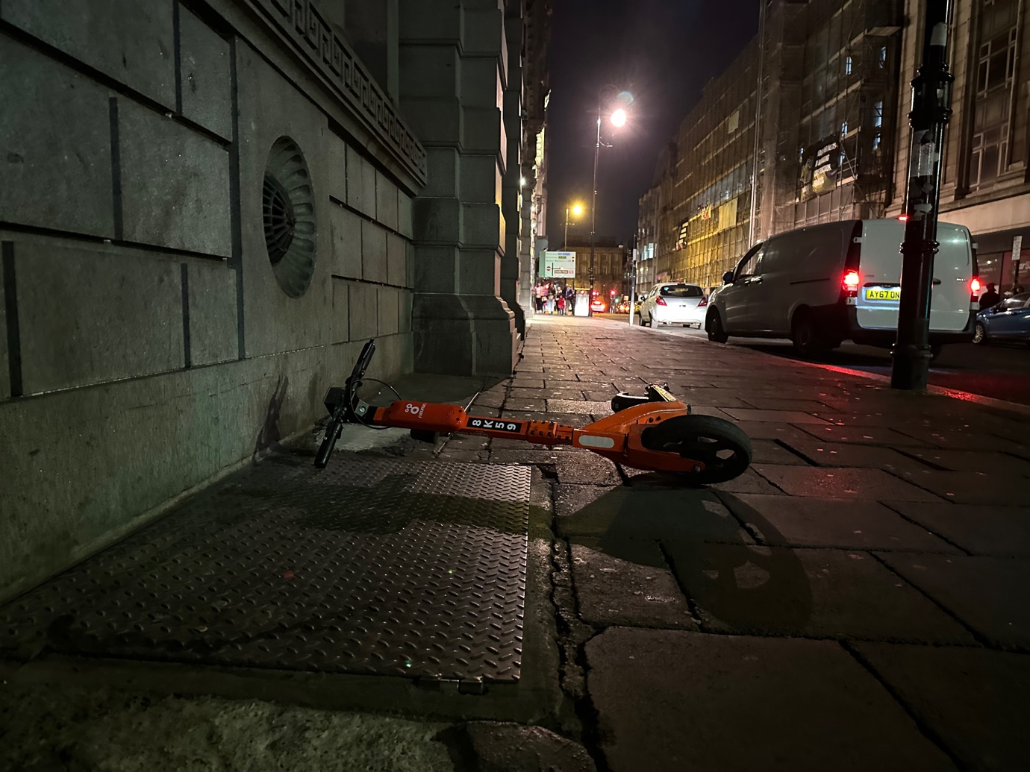

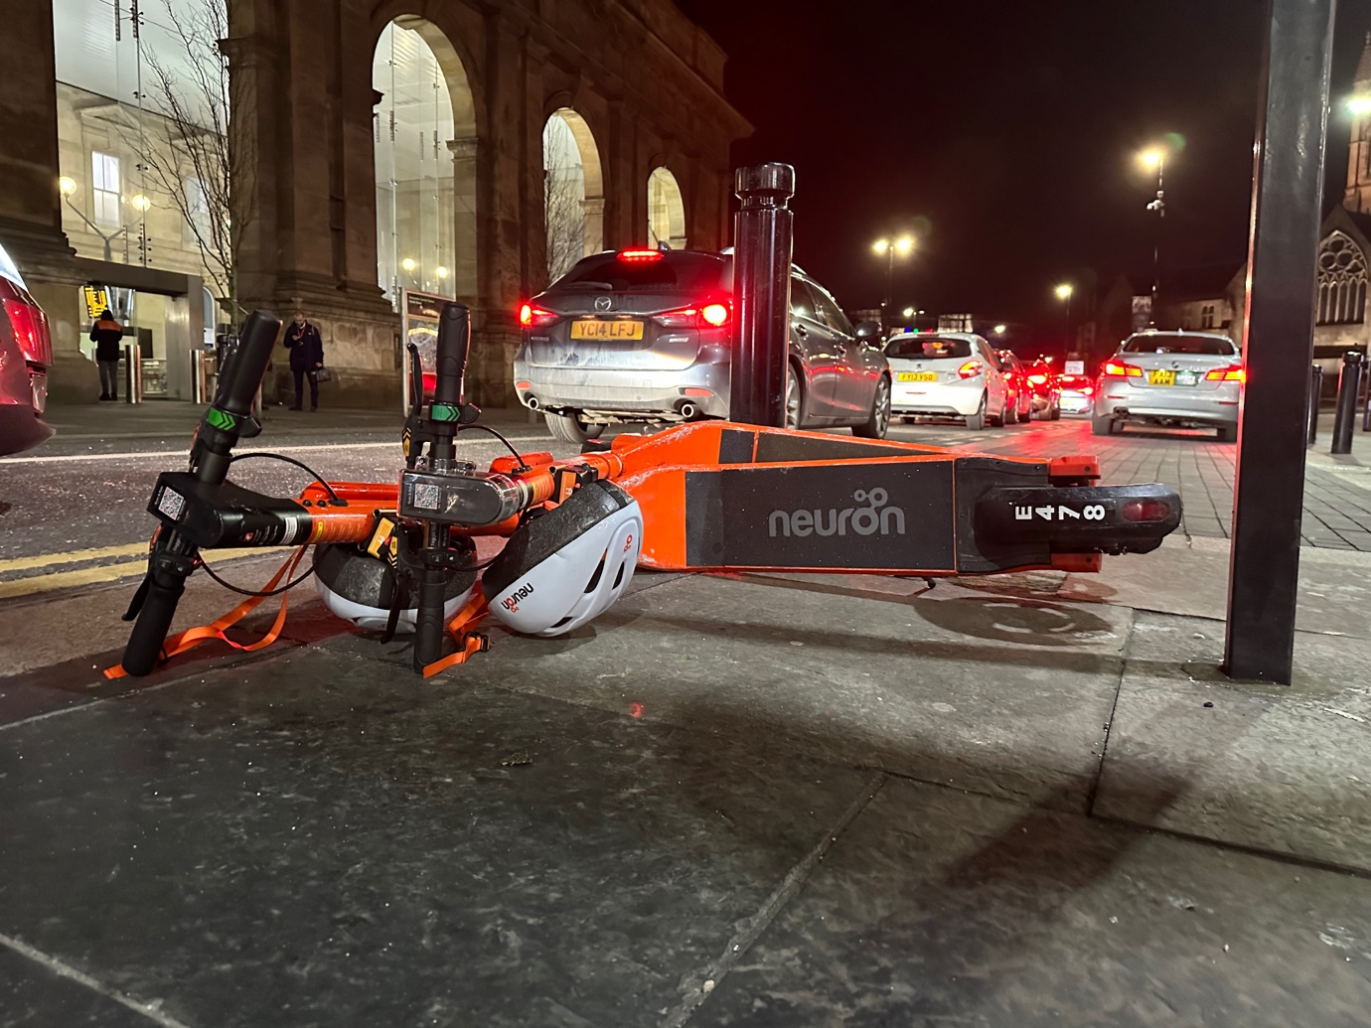

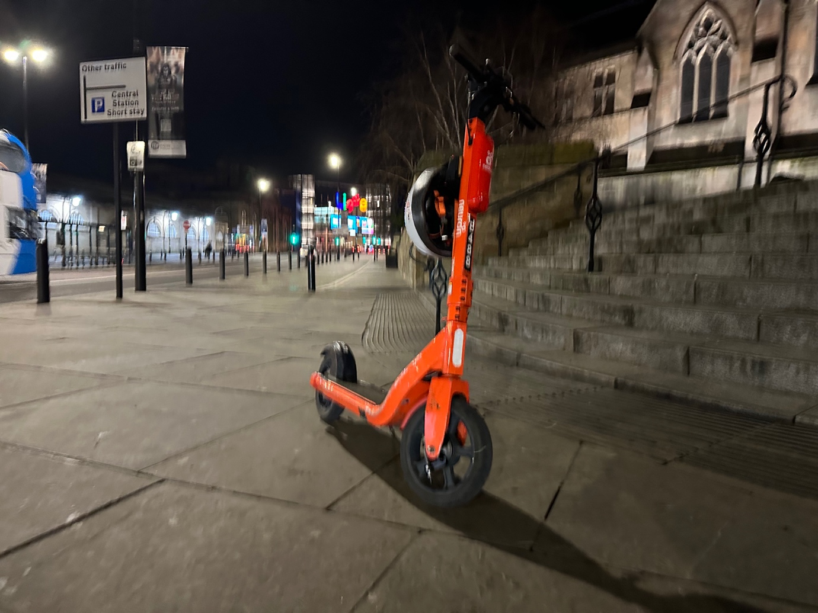

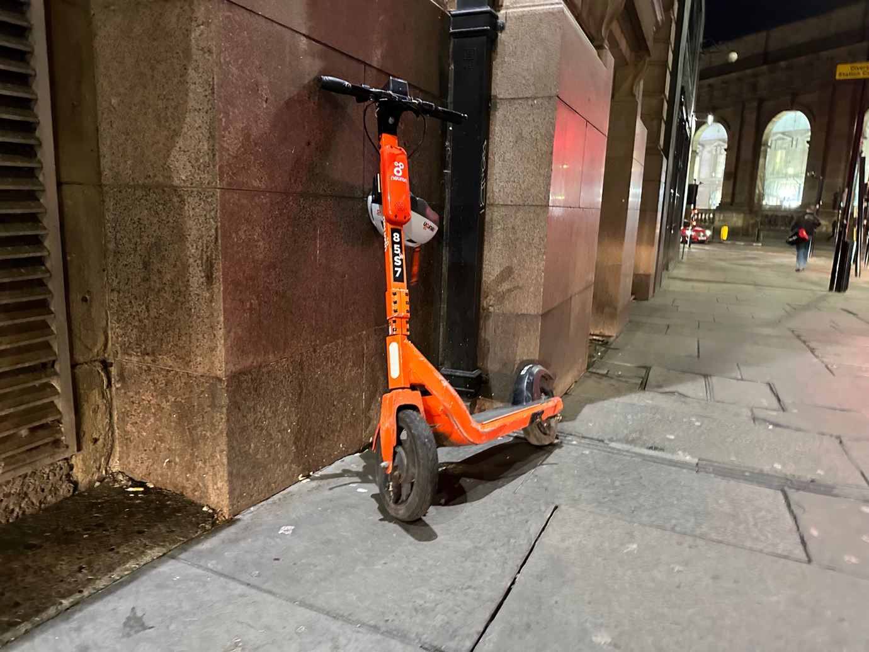

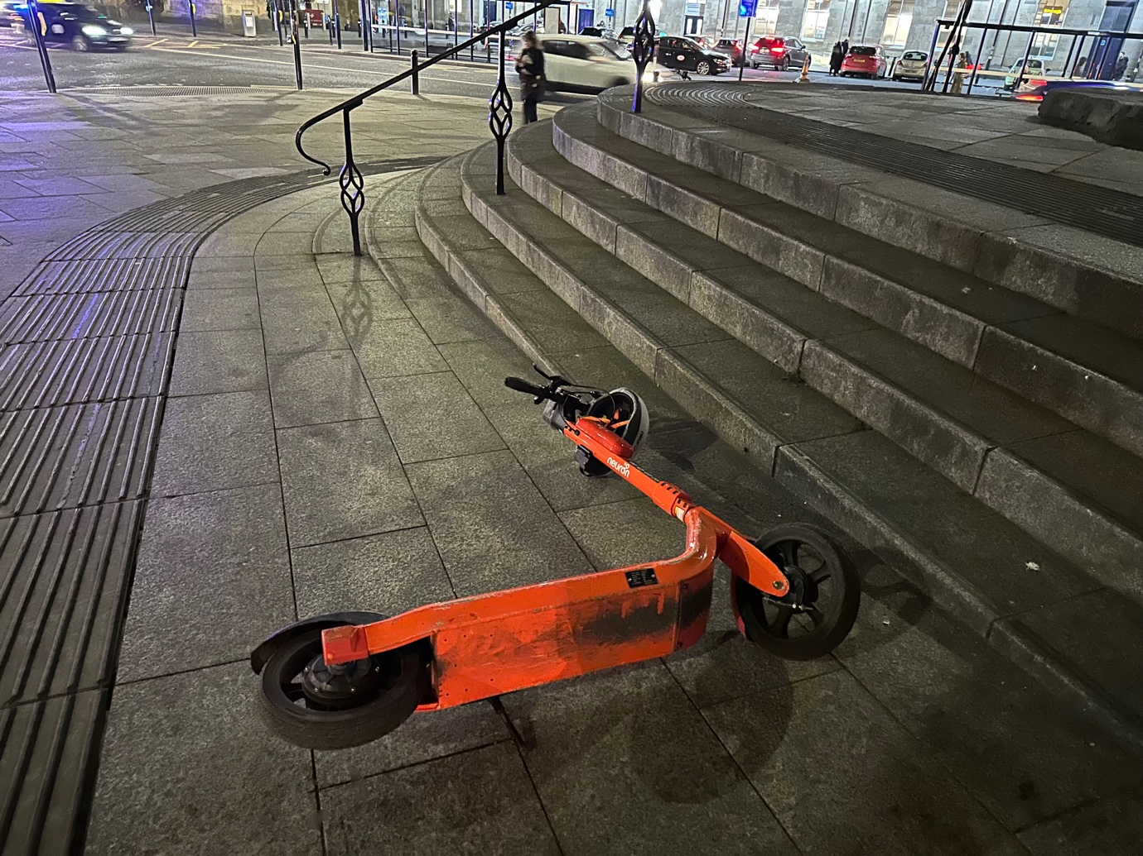

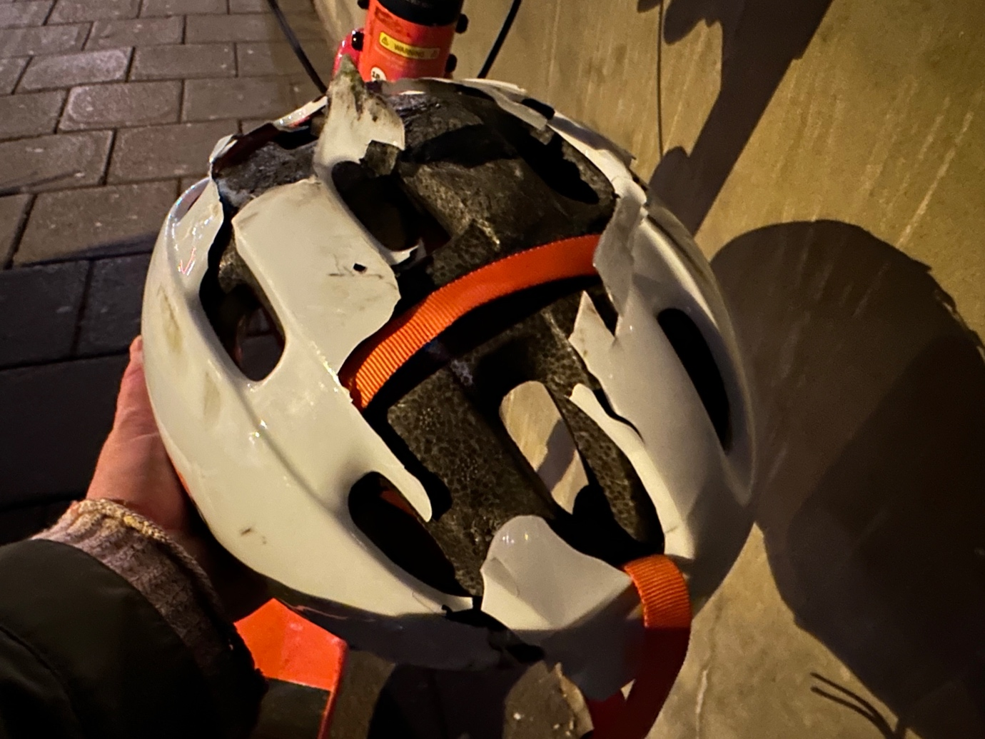

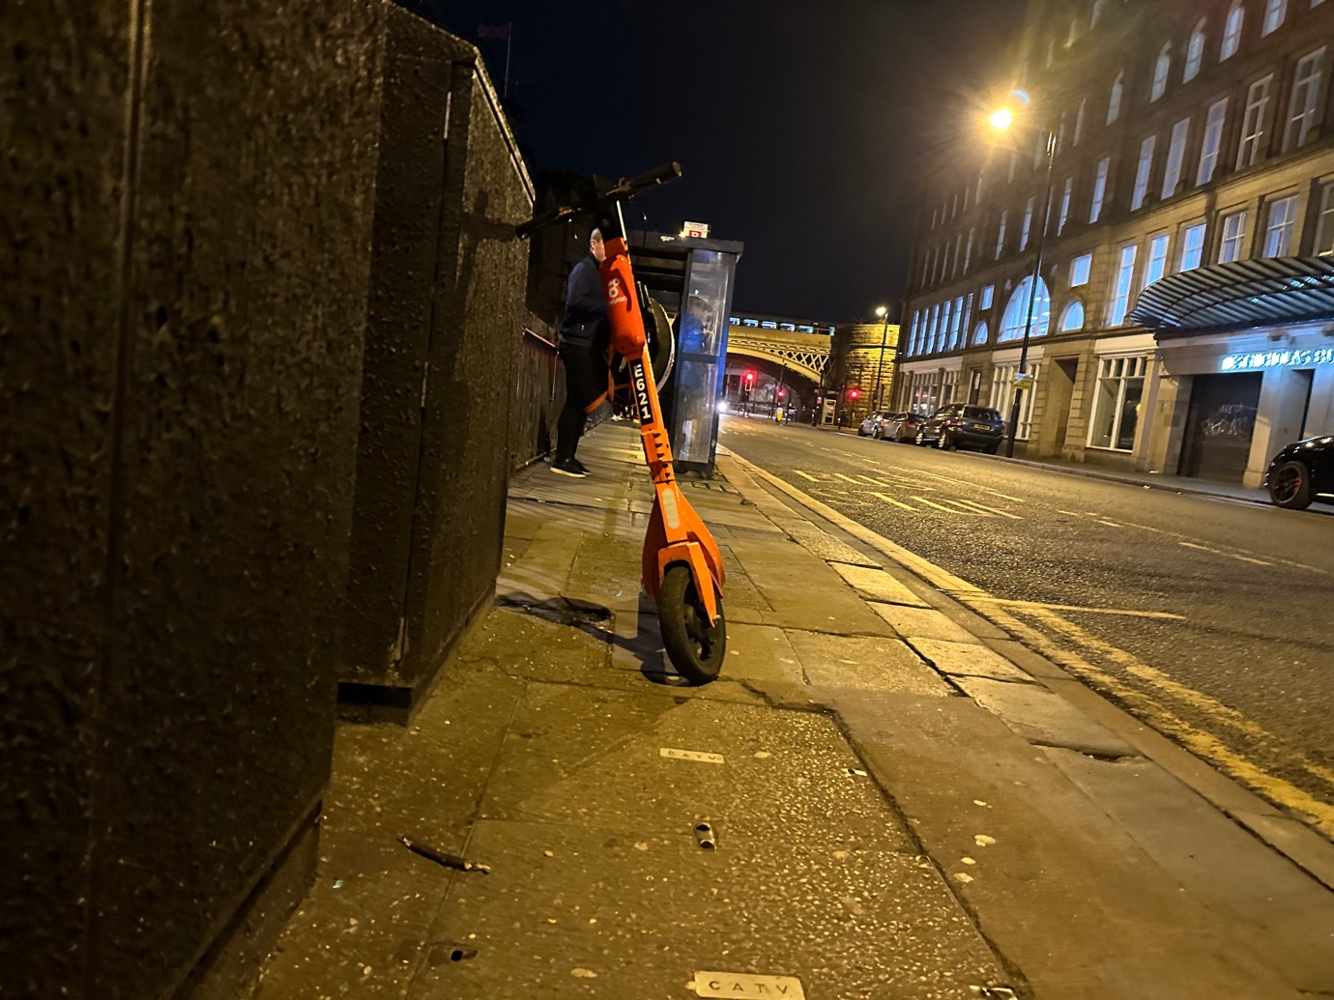

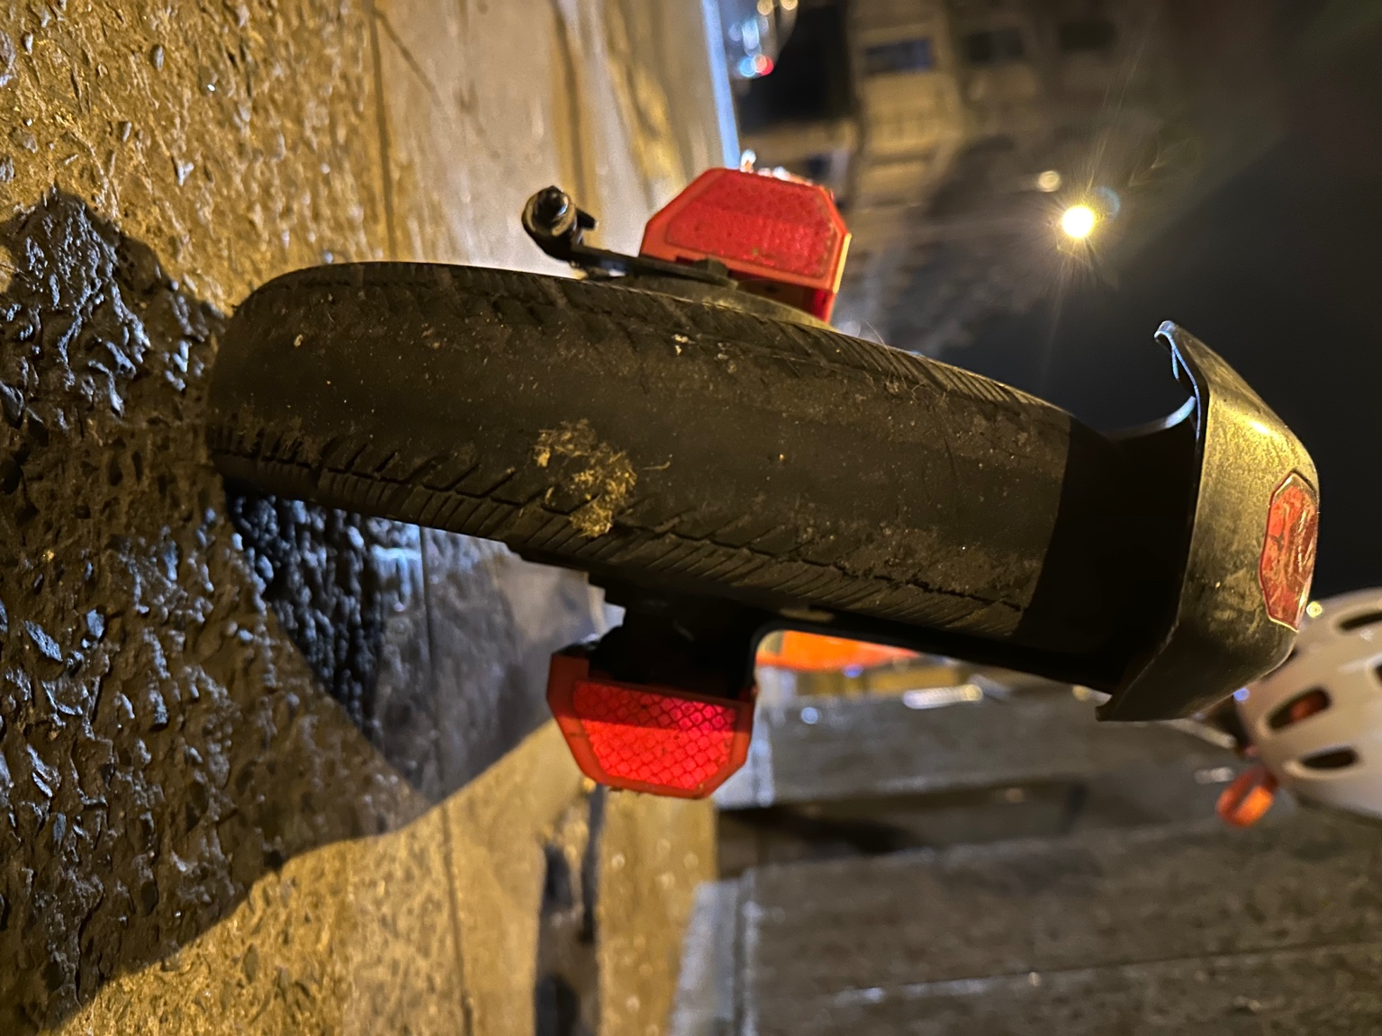

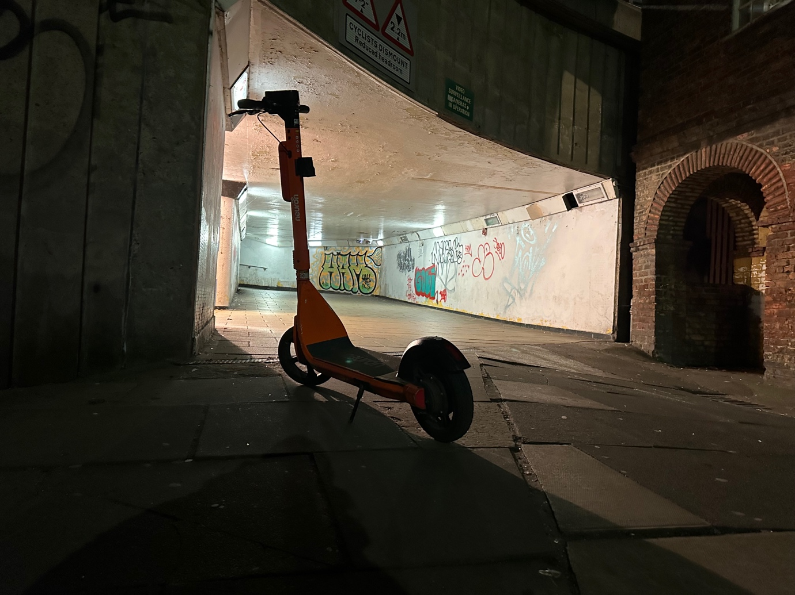

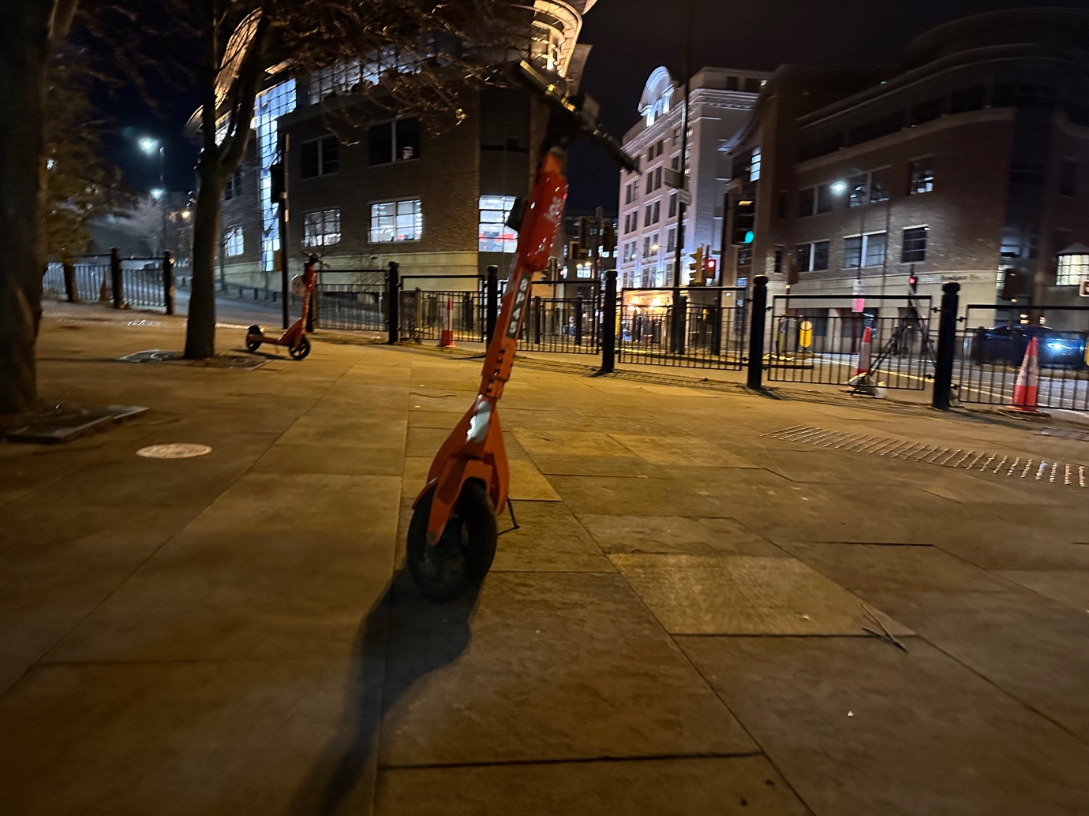

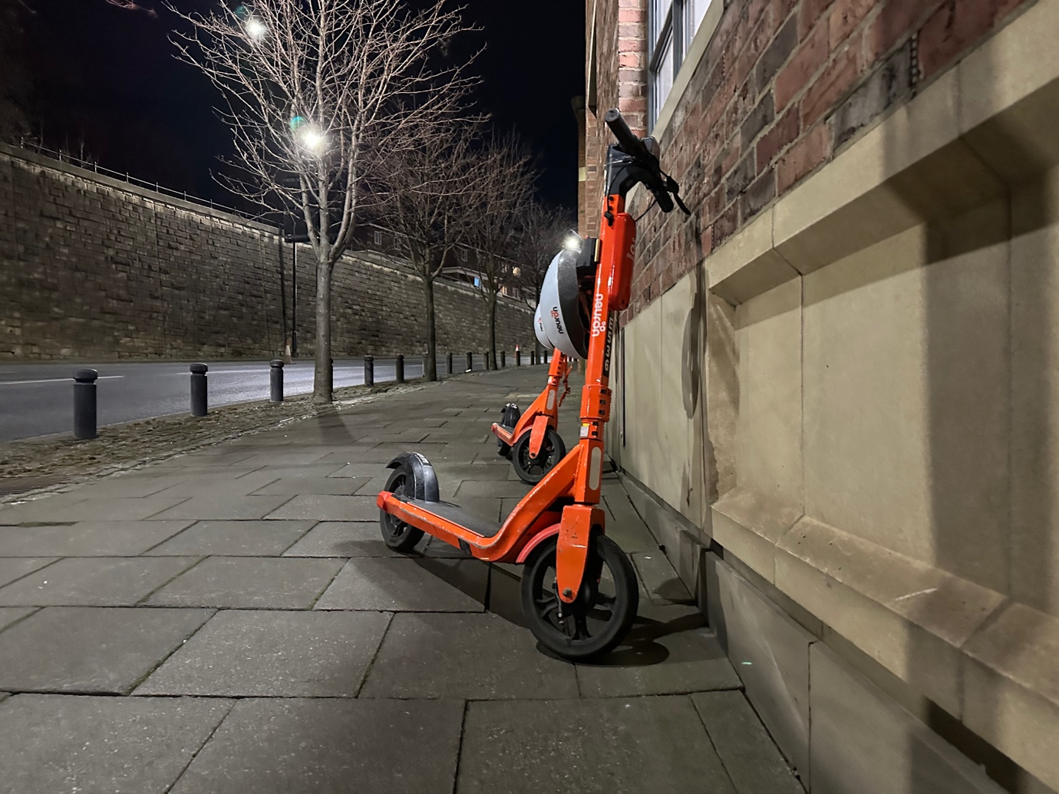

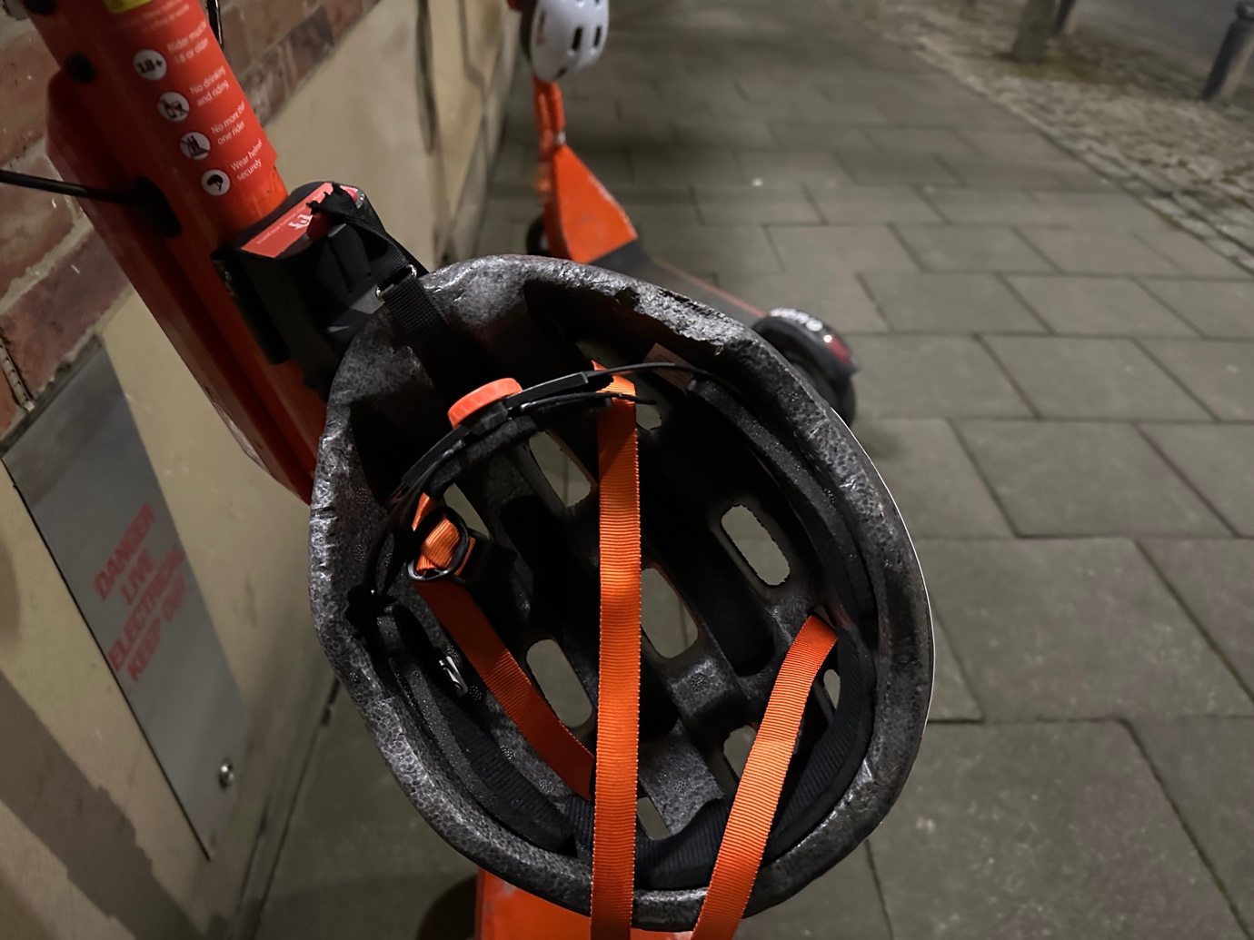

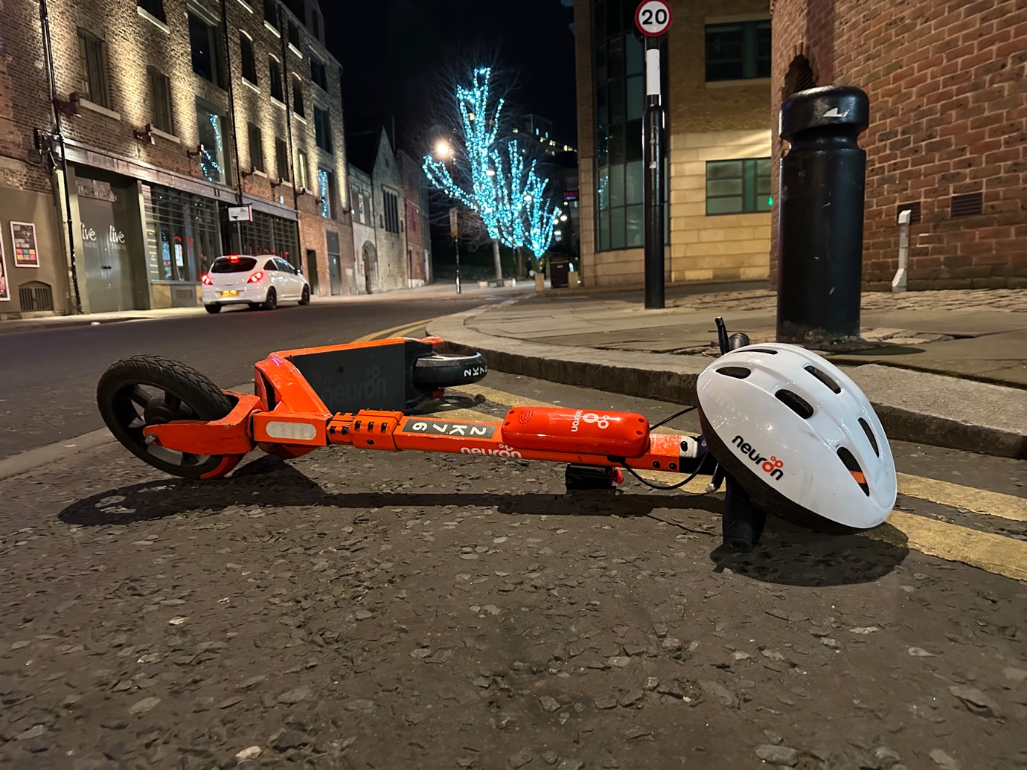

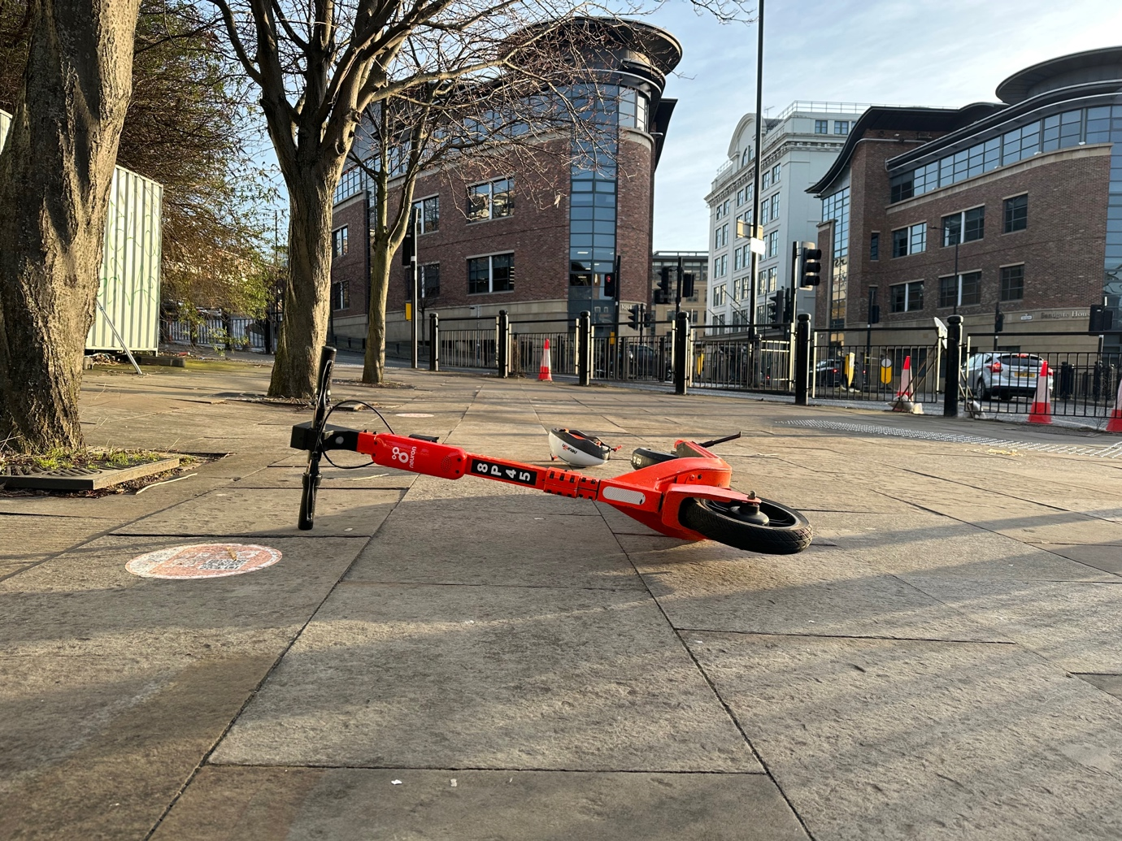

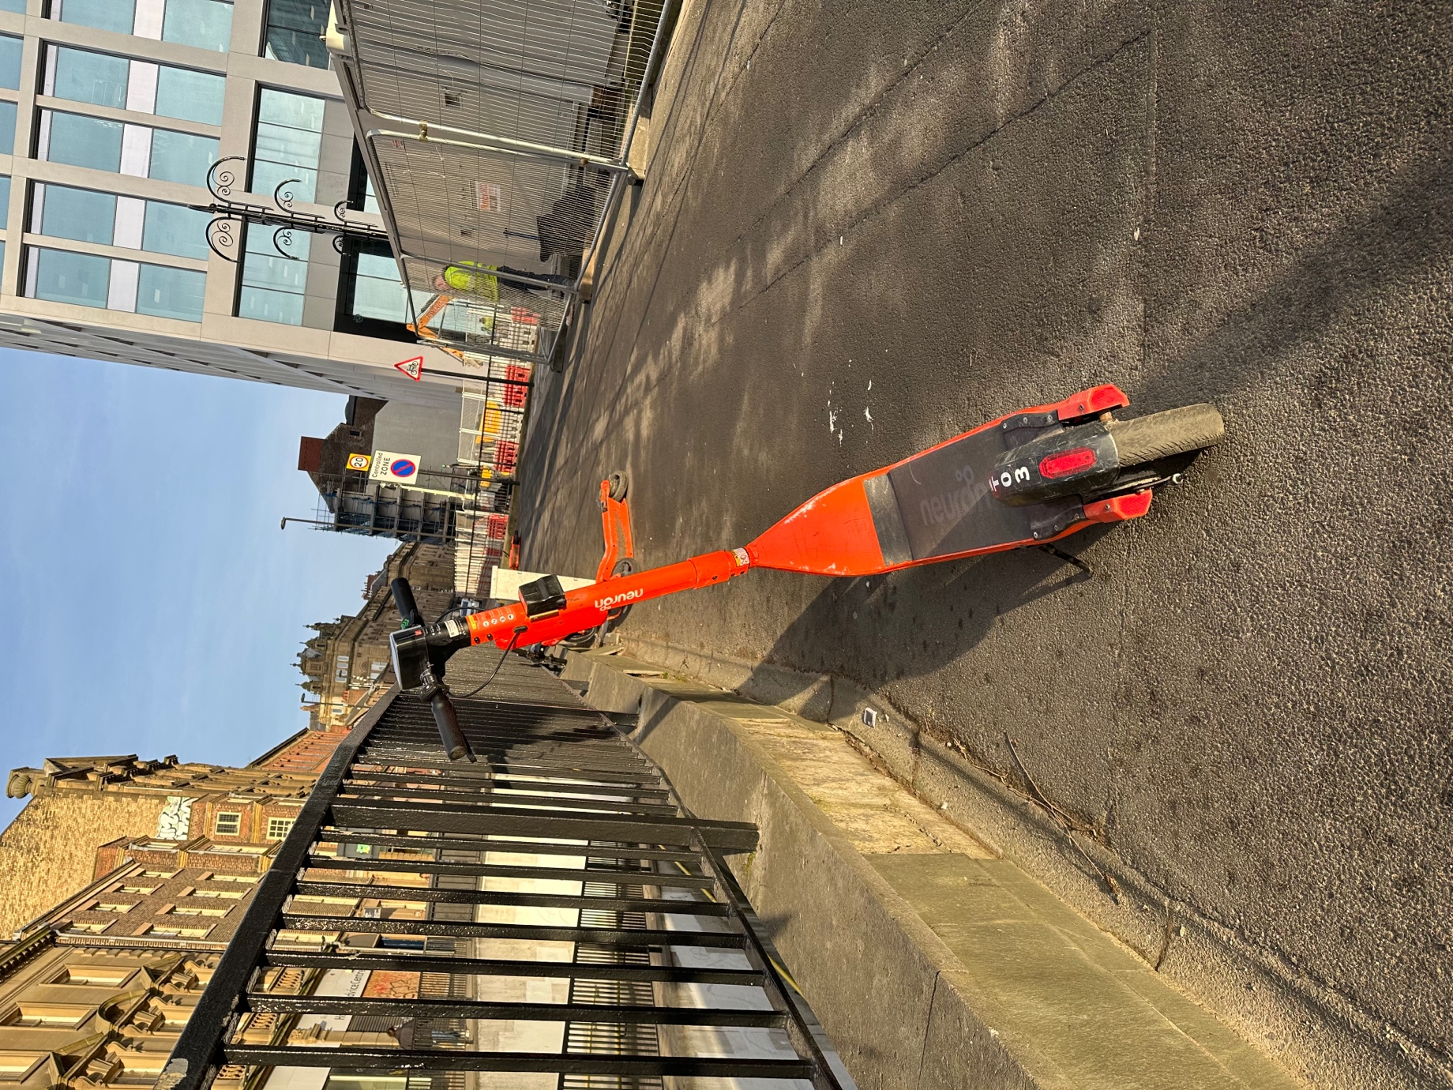

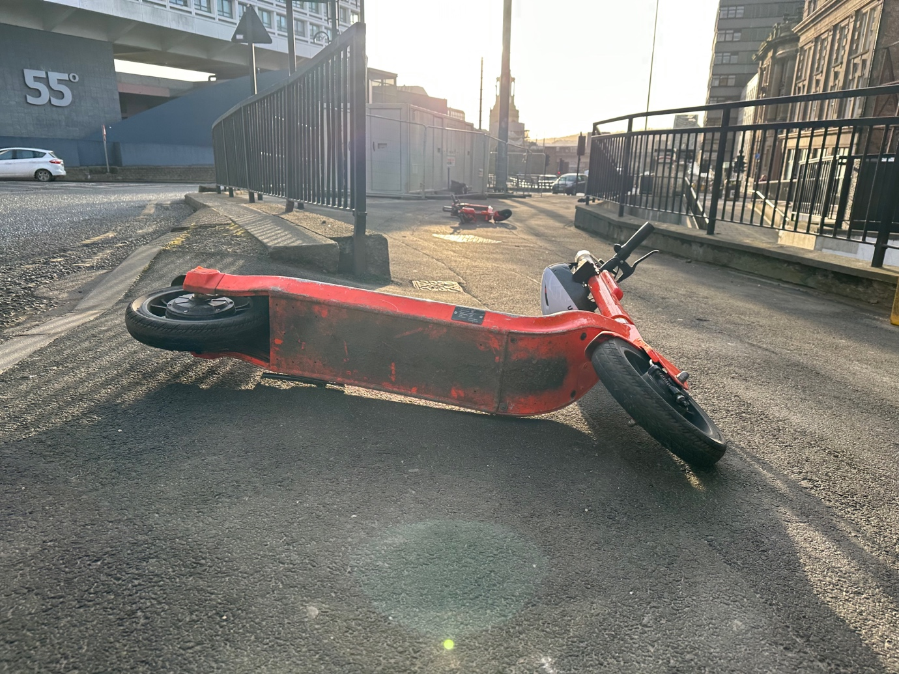

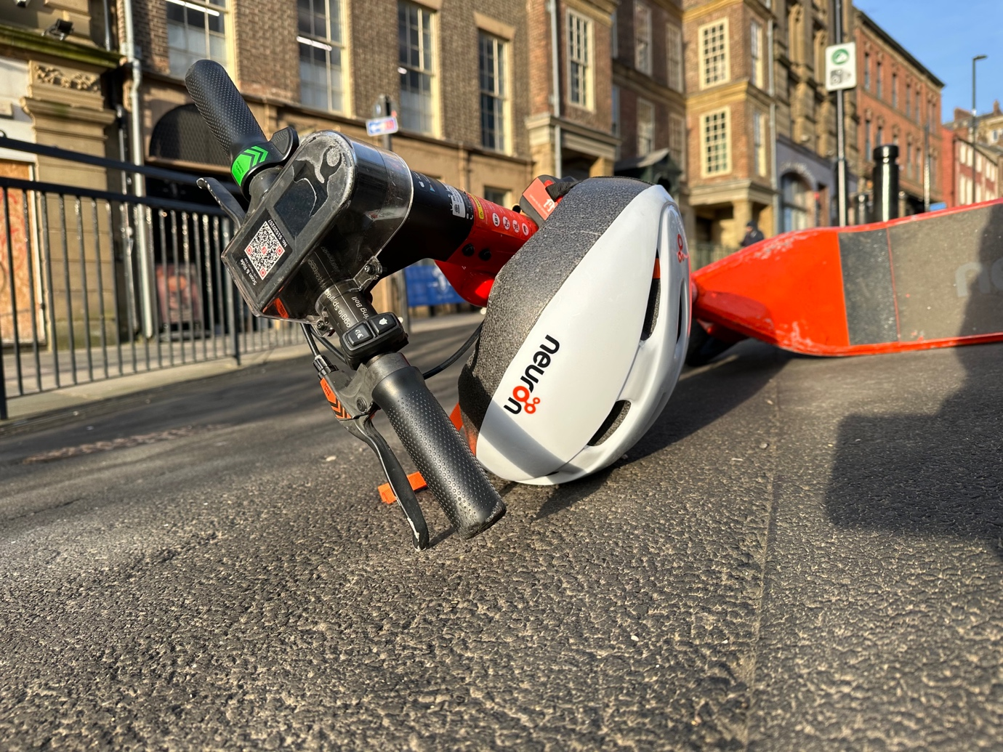

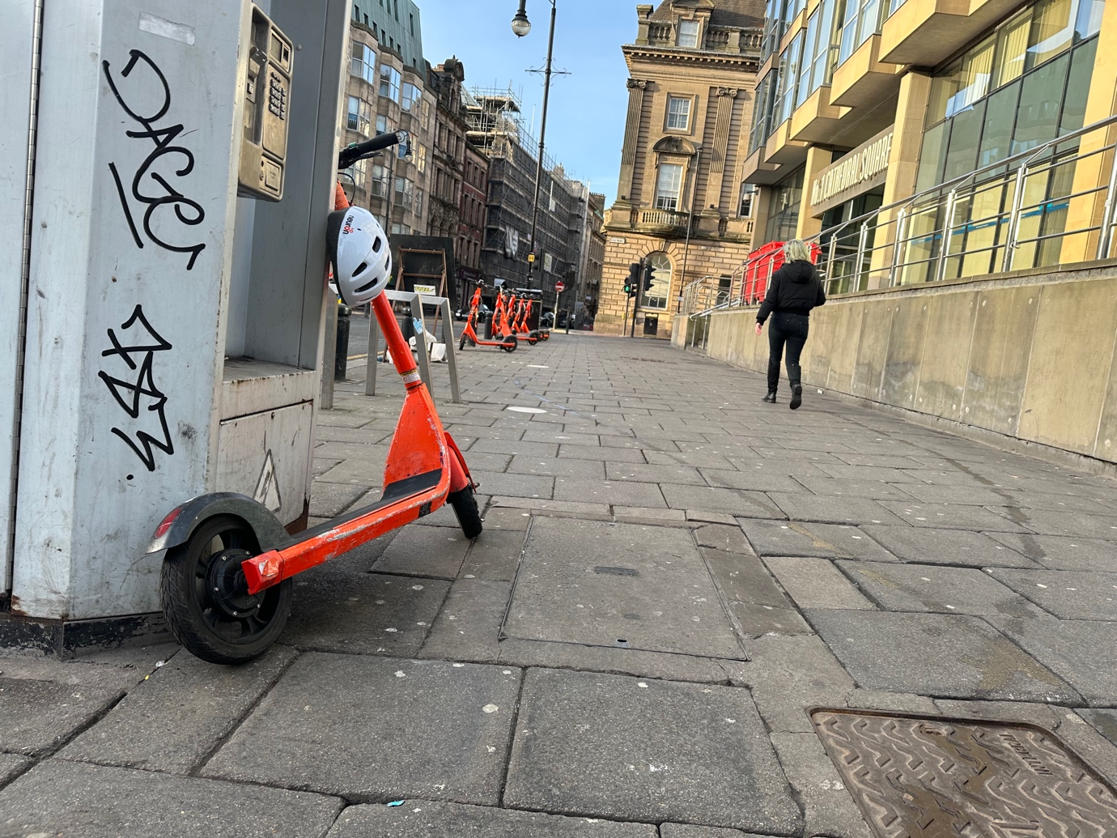

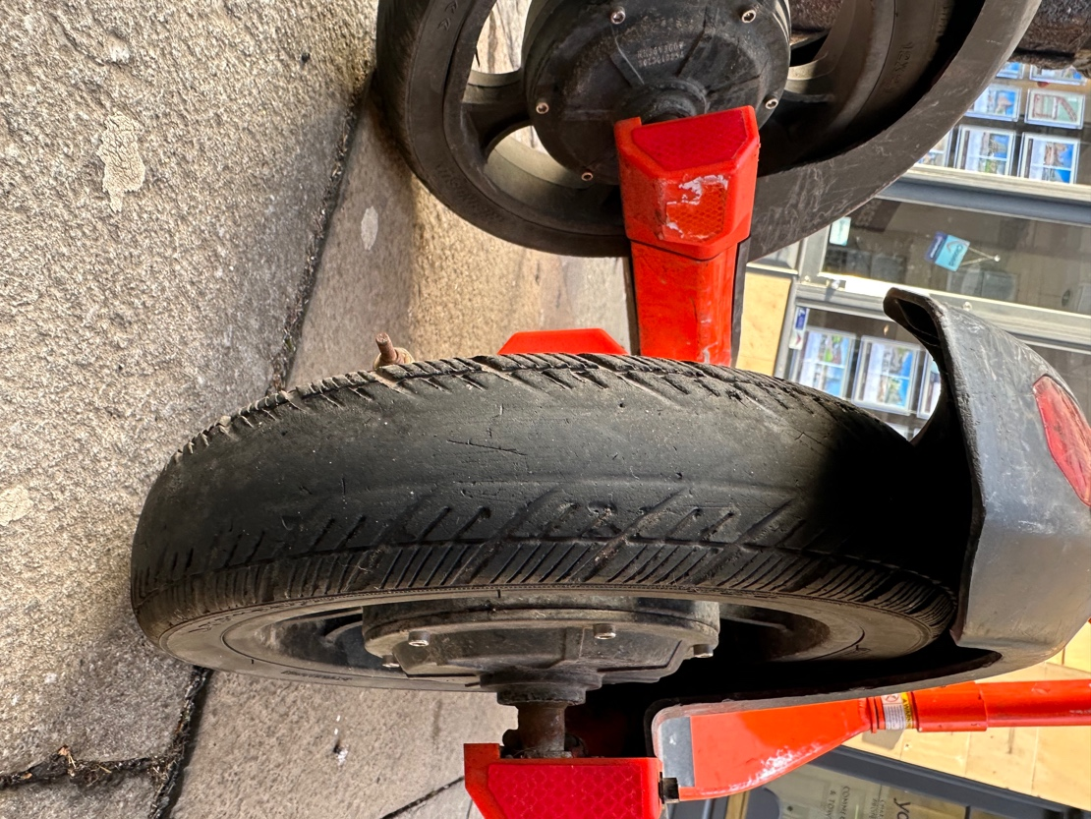

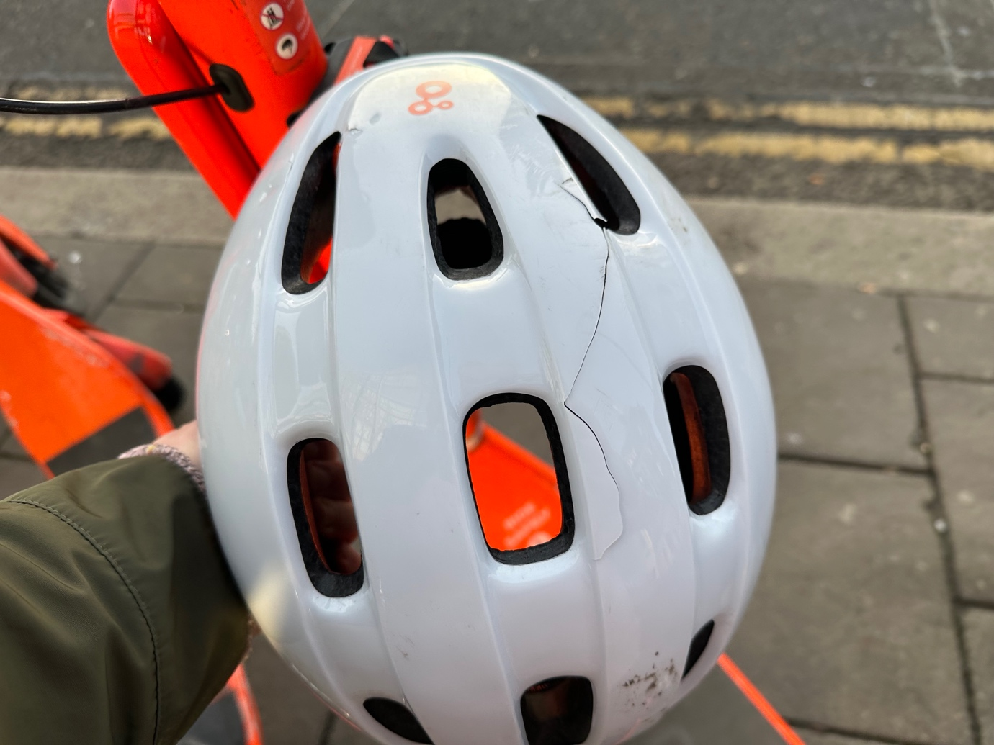

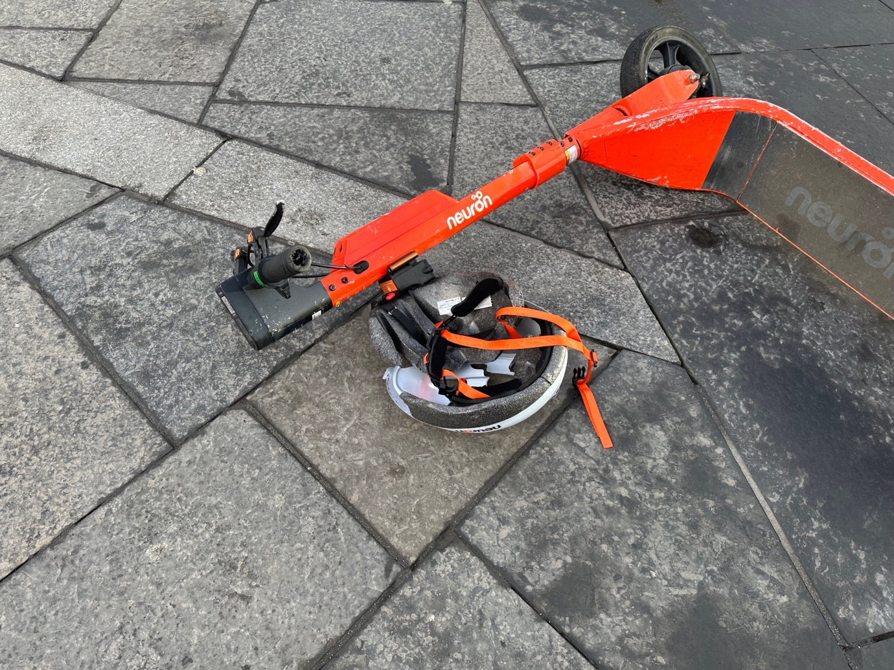
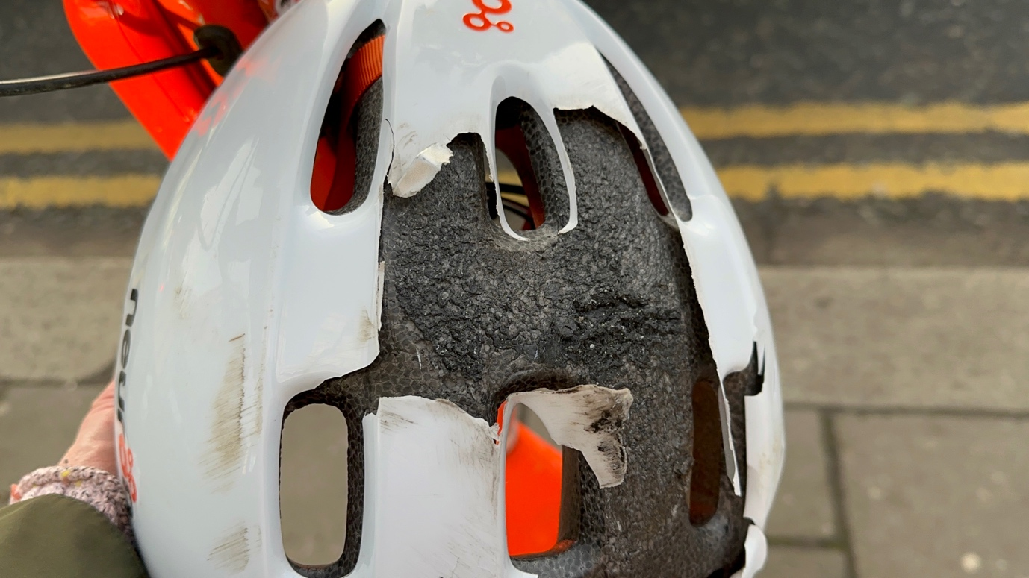

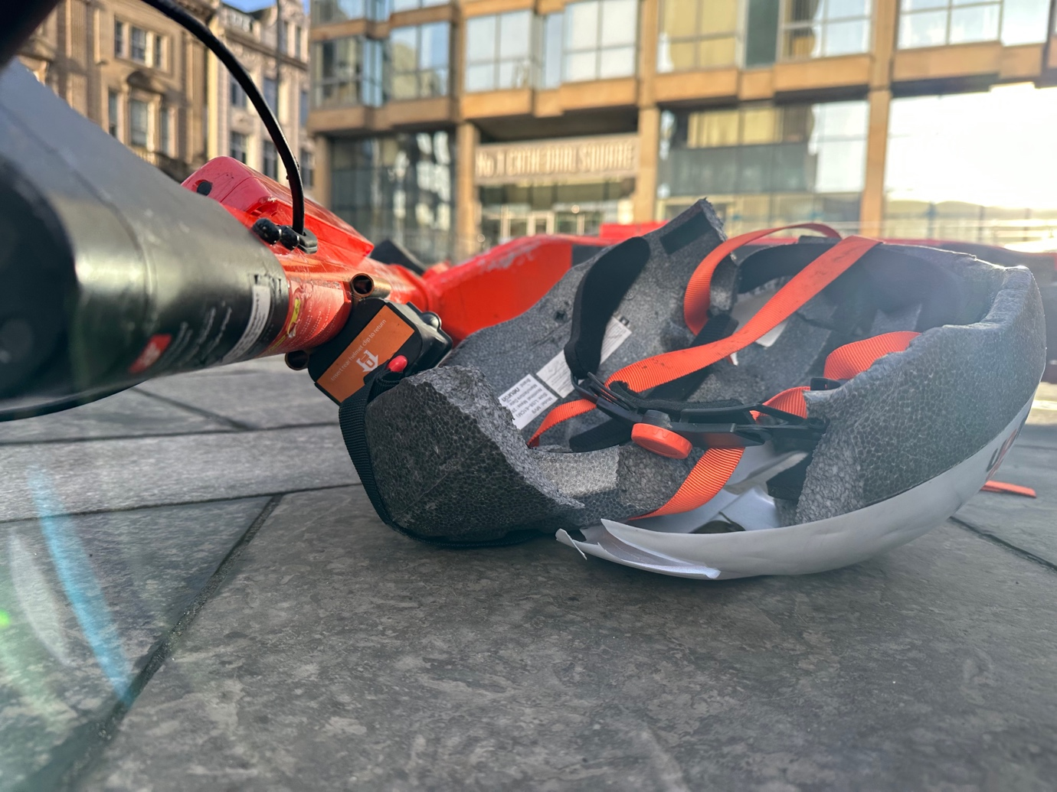

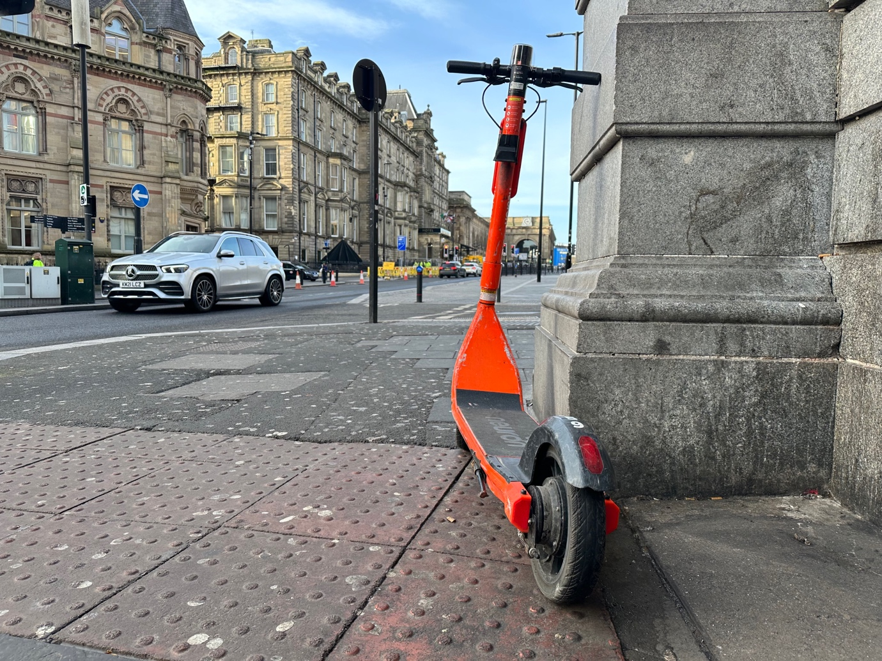

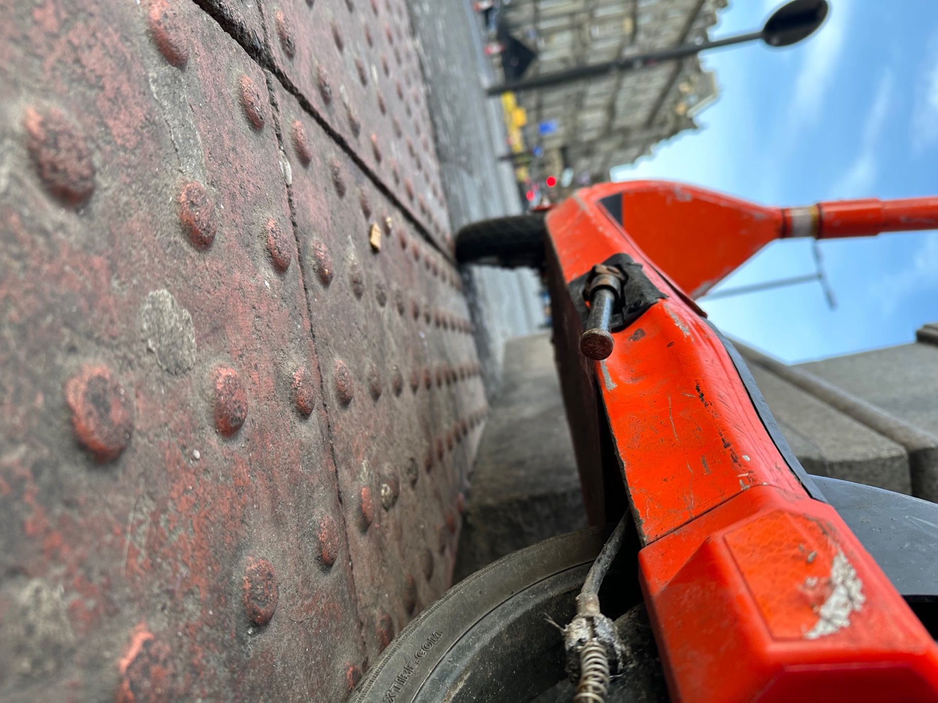

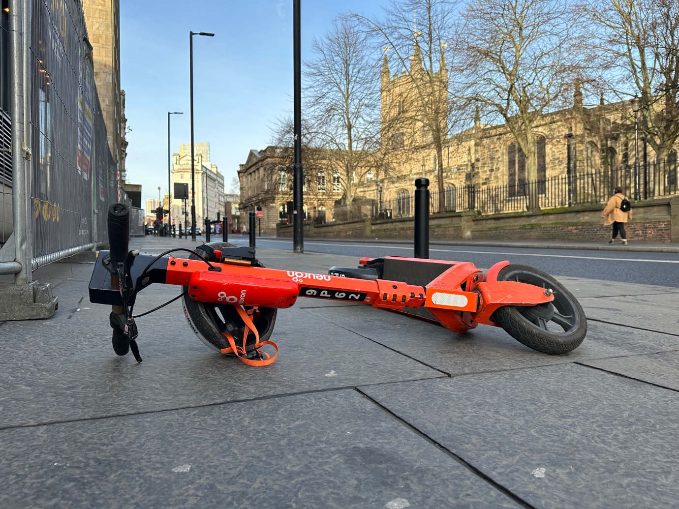

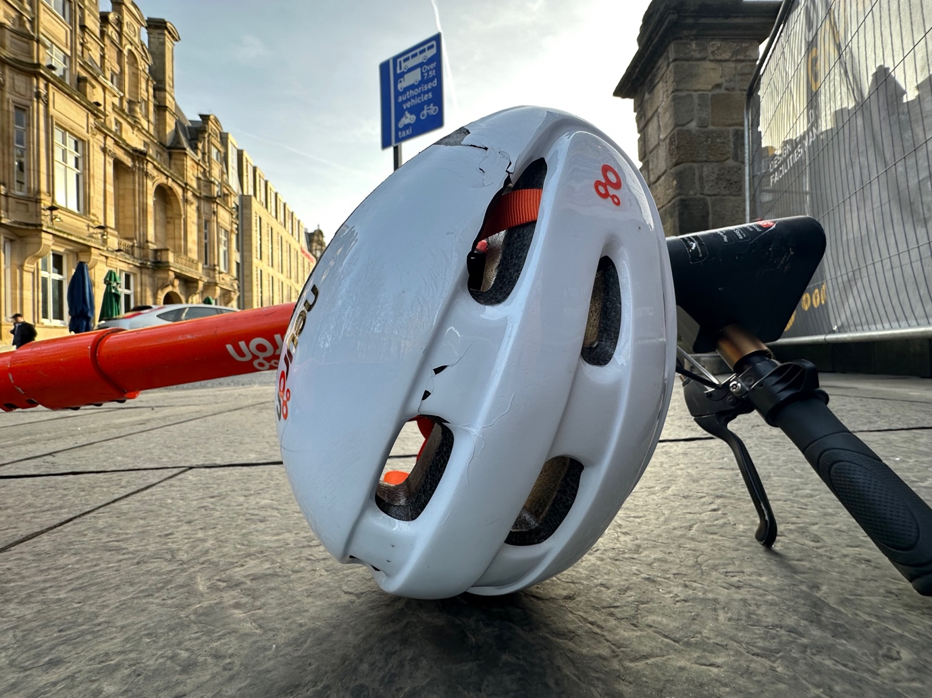

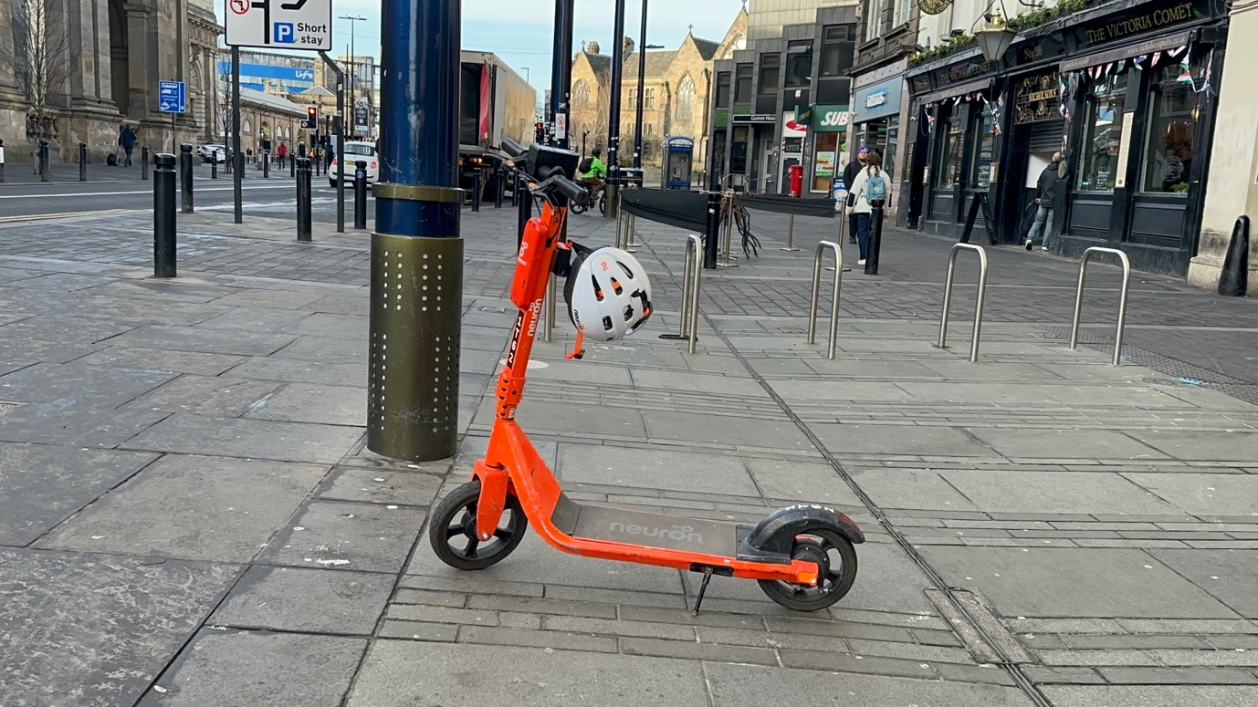

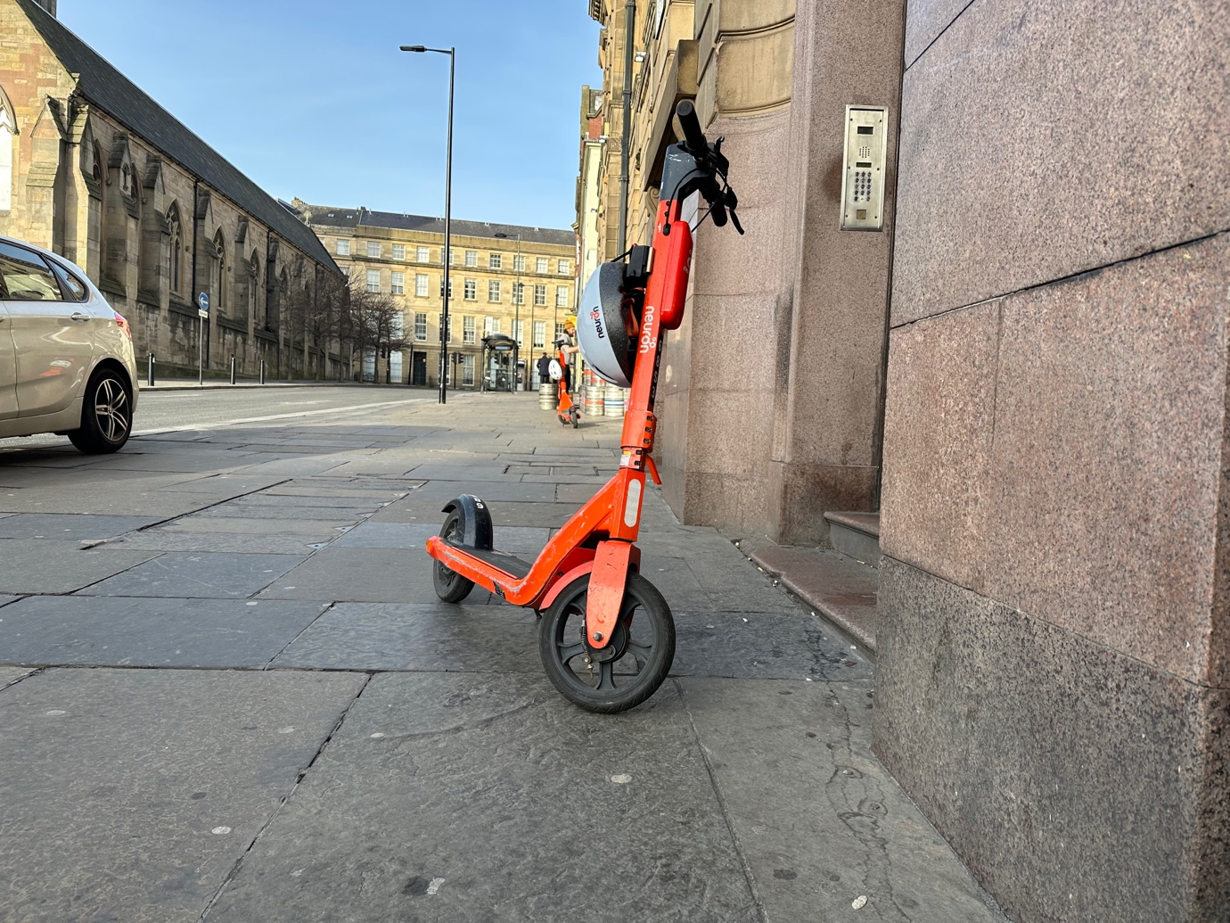

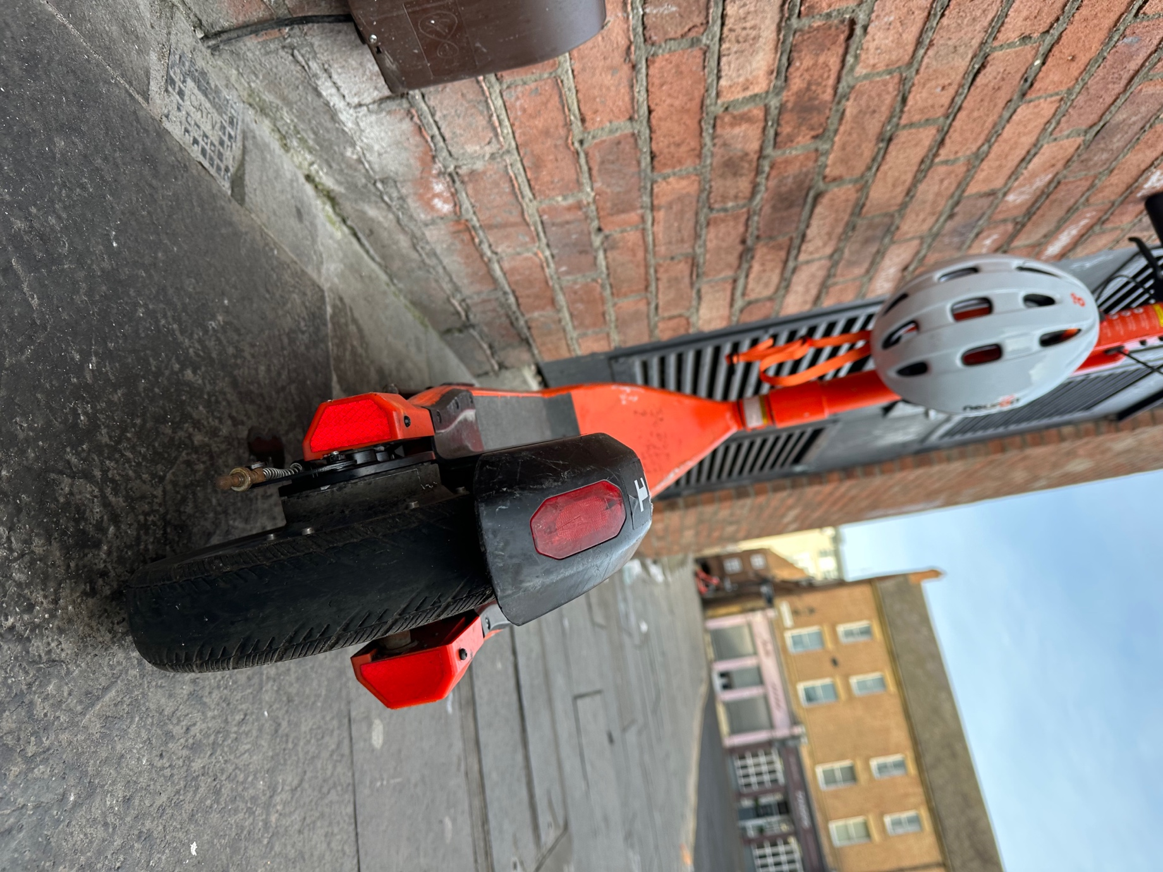

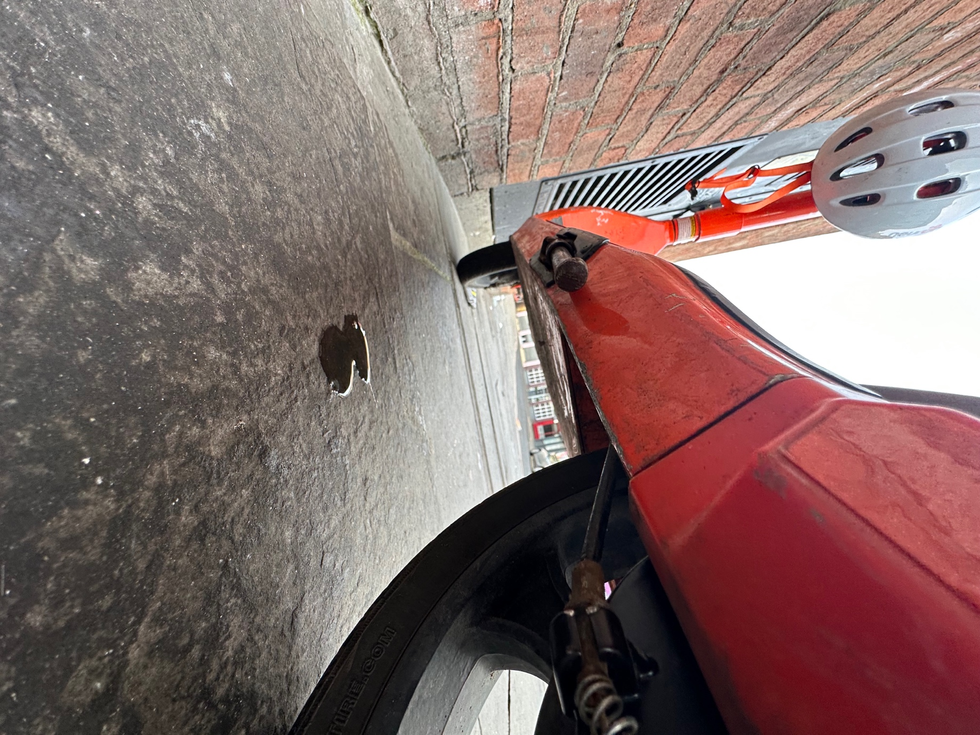

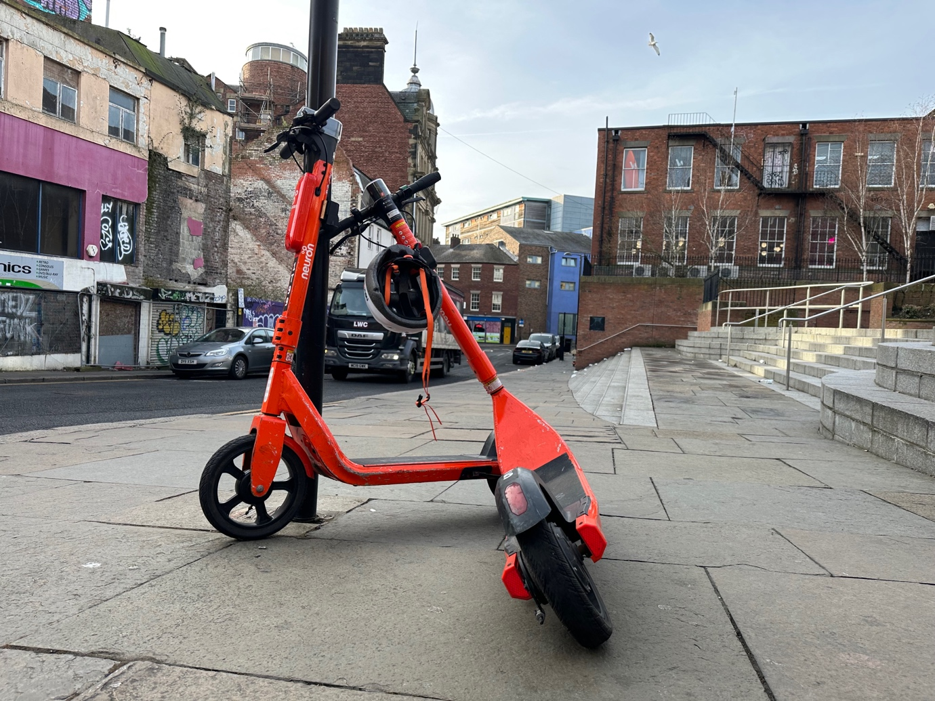

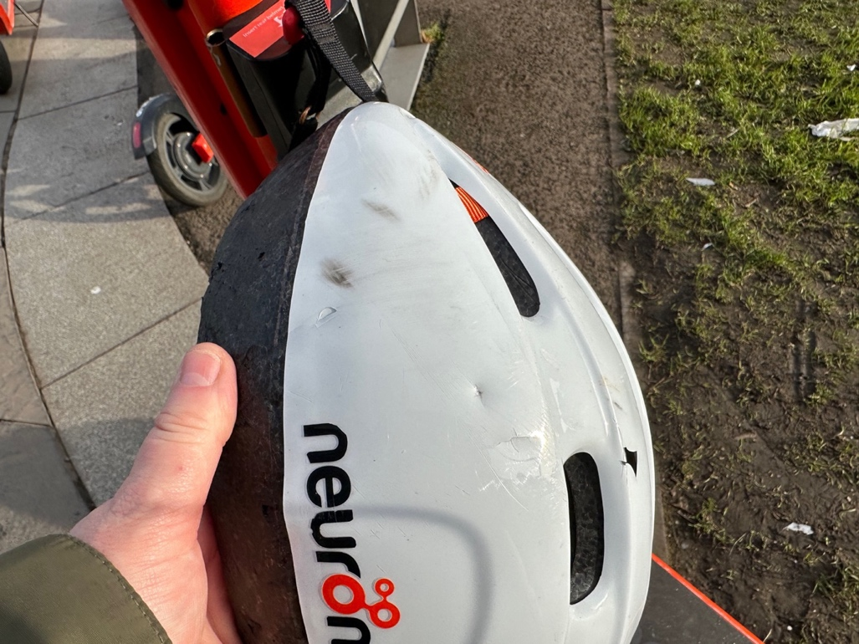

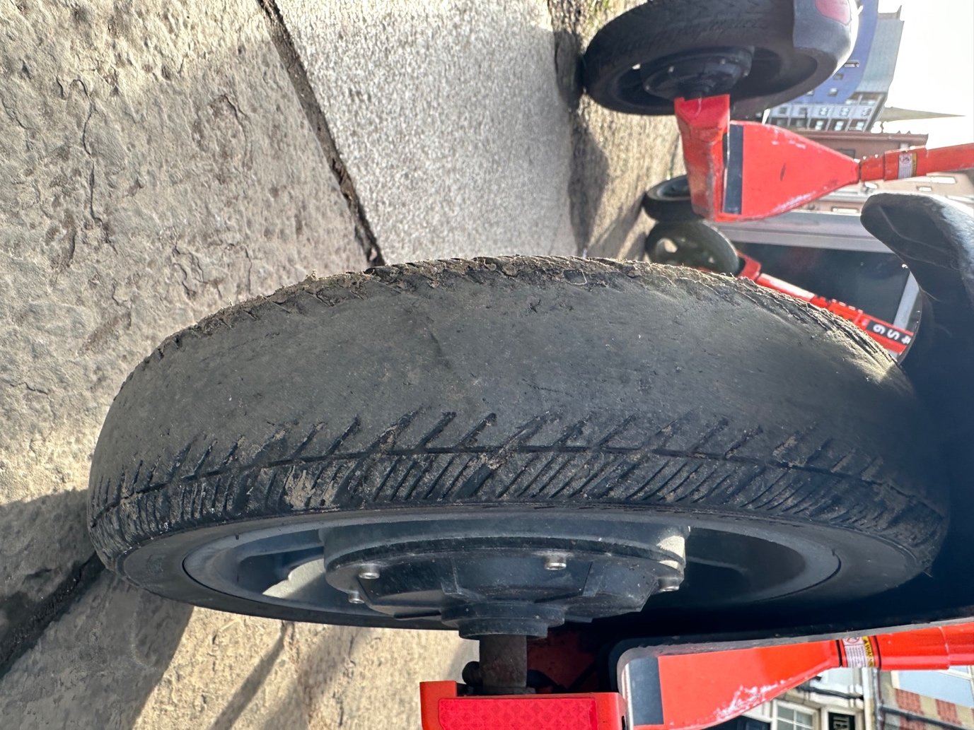

Appendix D b Newcastle E-scooter Trial Neuron E-Scooters Site Visit 8 to 10 February 2023

Photos Continued
33 photos are given below showing unsafe situation of e-scooter backs tyres, damaged helmets, the helmet safety warning label, e-scooters left in unsafe location on the pavement, next to pedestrian crossings and knocked over. Creating obstructions and trip hazards for pedestrians.
