Below is the London NFB UK logo -it is a line drawing of the London eye with the NFB UK name as part of its spokes to support the wheel of capsules.
Dear London members,
Welcome to issue 59 of London Life. We would like to wish everyone a happy and chocolate filled Easter. A huge thanks to everyone who continues to contribute to this publication. If you have any articles or would like to submit a personal story please email: london@nfbuk.org

Please use this email, if you would like to unsubscribe from this circulation.

This edition includes:

Date of next Campaigns Forum -Monday 17th April at 7pm on Zoom.

London Technology Forum to go national.

Contributions needed for Fed News.

News from our members

Aquabats social.

My first time entering a nightclub alone.

The art of Minute taking.

The amazing adventures of an extraordinary VIP: Part 2.

News and activities from other organisations.

Aquabats

Be My Eyes.

Blind Ambition.

Extant’s No Dramas workshops

Eye Matter is delighted to announce: A community event

RNIB is moving.

Technology News.

New Guide Dogs resource page

Emergency alert planned for Sunday 23rd April on all mobile phones and tablets.

Opportunities at Moorfields (ROAM) - Moorfields Research & Innovation.

Apple launches five hidden features in their latest 16.4 update in April.

Amazon one-time passwords: item thefts and parcel switches

Twitter ‘verification’ scam

Transport News.

Avanti West Coast is now available on Be My Eyes Specialized Help for all users in the UK.

How accessible are the taxi apps?

Silvertown Tunnel opening bus network consultation report.

Date of next Campaigns Forum -Monday 17th April at 7pm on Zoom.

This is a session to discuss what areas the London Branch should consider becoming involved with. Over the next few months we intend to invite specialised campaigners to share their experiences with the group.

If you would like to find out more please email: london@nfbuk.org

London Technology Forum to go national.

Following a request from our Trustees, this forum will be in collaboration with Nottingham and all other NFB branches.

At our last Forum, we discussed different screen readers, vacuum cleaners and bread-makers. To receive a copy of our Minutes please email: london@nfbuk.org

Jeff, from TAVIP, will be making a presentation at our next forum on Tuesday 25th April at 7pm on Zoom.

Please email london@nfbuk.org to receive the details.

Contributions needed for Fed News.

We are looking for articles about what sort of equipment you use around the home. How do you operate a commercial tumble dryer or vacuum cleaner? Have you purchased a specialised piece of equipment recently,, such as a talking weighing scales and would be willing to share your experience of it?. Please send your contributions to our new Technology section in Fed News.
Please email: fednews@nfbuk.org
If you would like to receive our next edition of Fed News, in an alternative format, please email: admin@nfbuk.org

News from our members

Aquabats social.
By Priti Damania.

I was very pleased to be able to join the social dinner held at The Gladstone Arms on Thursday 23rd March through the charity Aquabats.

The pub is family run by Gorav and Megha, a lovely couple who have welcomed me before, once through the NFB and again when I visited for a lovely lunch with my amazing friends who I had the pleasure of working with on the Virtually Eastbourne Team; Pardy,, Jess, Jason, Fiona and Alex, although it was sad that Janice and Berin couldn’t make it . It’s so nice how we’ve kept in touch.

The pub is virtually a stones throw away from Borough Station on the northern line, a 3 minute walk around the corner which made it easy to get to, with a lovely warm welcome, good value and great service.
I arrived around 5.45pm and found myself looking around for someone to help me up to our private dining room as pubs are always dimly lit, only to find that within seconds, Gorav greeted me and helped me. I was really impressed as to how fast he was beside me helping me out.
There were around 20-25 of us. It was so lovely catching up with friends whom I hadn’t seen for a while as well as meeting new people. VI Charities are so important as they help us keep connected and socialising as well as lots of other things. We were all served our food. The majority of us had pre-ordered through our wonderful Pardy which meant things ran smoothly and we weren’t waiting long for our food. Nothing seemed like too much for Gorav and his team, coming in regularly to replenish our drinks and take more orders. I had a lovely indo-Japanese dish of chicken karaage which was fried chicken with ginger, garlic and tossed in sweet chilli sauce with chips and salad which was delicious. Everyone I spoke to also enjoyed the Anglo-Asian cuisine. I’ve had minced goat curry pie there before and it’s delicious, not very spicy as well as being a generous portion. We all had individual tabs which was good.

After we ate, as we chatted away, Connie who had brought a cake as a surprise for Pardy as it was his birthday a few days ago, was liaising with the chef to have it brought up and later cut. Pardy looked surprised and happy as we all sang happy birthday and popped party poppers as he tried to blow the candles out, which I’m pleased to say he eventually did. He is after all, our very own superman.

Overall, it was a wonderful evening out with friends with lots of great chat and a delicious meal. Thank you Aquabats, The Gladstone Arms and my wonderful friends, I can’t wait to go again.

My first time entering a nightclub alone.
Buy Fiona Musgrove .

Below is a photo kindly sent from Eye Matter showing some of us in the nightclub enjoying the atmosphere.

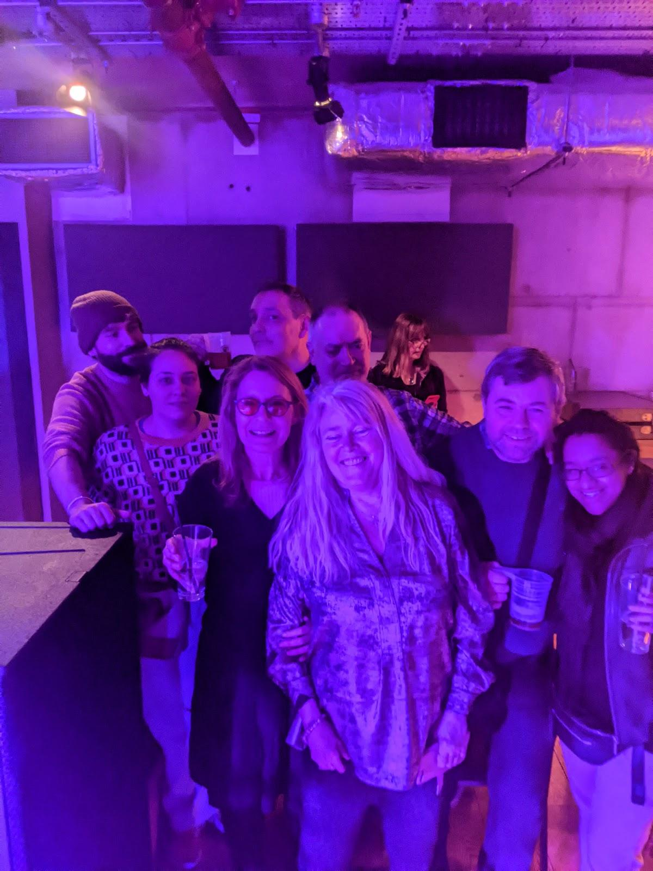

On Tuesday evening Eye Matter arranged for a group to attend a small, intimate gig in the basement of The Lower Third, 26 Denmark St, London WC2H 8NJ, UK. Primarily, we were there to support Janie, from Extant explained Suzie, founder of Eye Matter.

After the support act, of two young ladies, the night blasted into action with the new Indie group TUNGZ . Jamie plays the guitar and was delighted to be supported by Eye Matter.

The group played guitars and keyboards and their sound reflected a multitude of influences including Brian Ferry, Depeche Mode, The Weekend and even a bit of Busted! I was up on my feet, right up front,dancing along to the tunes with everyone else.

Sight loss is a very personal journey and we all cope with it in our own way. Whether you have the confidence to paddle down the Thames, walk the Camino Pilgrim Trail, engage in Blid Bingo, enter a pub alone or, for me, enter a nightclub, these are all adventures Groups like Eye Matter are here to inspire and encourage you to try new concepts and interests.

The staff at the club were excellent. I was guided downstairs bySimon and his colleagues into a pink and blue lit room. They provided me with a chair and guided me towards the bar. I bought a can of wine. Sitting alone in this space didnt daunt me at all. It wasn’t long before the rest of the group arrived after realising I was already inside.I would like to say a huge thanks to Suzie and all her volunteers for a fantastic night. I look forward to joining them again soon.

The art of Minute taking.
BY Arthur Payne.

This article describes how we undertake minutes and gives some hints as to how to do the task.

My role within the NFB committee is to undertake all notes and minutes of branch meetings, officers’ meetings and campaign forums. These events happen every month so possibly about 36 sets of minutes within the year just for NFB.

You may ask how do we get the minutes done so quickly and efficiently. Firstly all meetings are on Zoom and therefore recorded. The recording quality of all meetings is very good. Since we have been using Zoom since the lockdown it has given me the opportunity to undertake minute writing within my own home both for leisure and work purposes. For work meetings I take a note of what is happening whilst the meeting is in progress. So long as people speak clearly and not too fast this is possible because my typing speed is very fast following 33 years experience in typing pools. I also took all the RSA exams and passed them including the RSA advanced audio which gets you to recognise voices and styles.

When the agenda is sent by the host I make a template of all the headings. Then I just put the text within each heading. If a chairperson does not keep to the order of the agenda so long as they say what they are covering then this should be fine as can go to the appropriate heading because sometimes agendas may slightly change due to someone not being able to stay for the whole meeting.

With a Zoom meeting the first thing that happens is that the host comes onto the recording. Other people gradually join and from that I get their voices and can then recognise who is speaking. It is always advisable for people when they speak at a meeting for the first time to give their name before speaking just in case a minute taker does not recognise the voice. This is particularly the case if someone joins a meeting late and then speaks to the meeting. If figures are involved such as happens with the Treasurer’s report we always advise that these are sent to the minute taker in advance so they can already include the report within that heading. If any questions then follow these can be put in after the report as well as who asked the question.

I have been taking minutes now for various social clubs and work situations since 1982 and very much enjoy the role. I hope this article gives you an idea of how minutes are produced so quickly.

The amazing adventures of an extraordinary VIP: Part 2.
By Fiona Musgrove.

Below is a photo of Richard standing in front of his kayak, on the side of the Thames. It is a lovely sunny day. Richard is wearing his wet suit in preparation to begin his adventure.

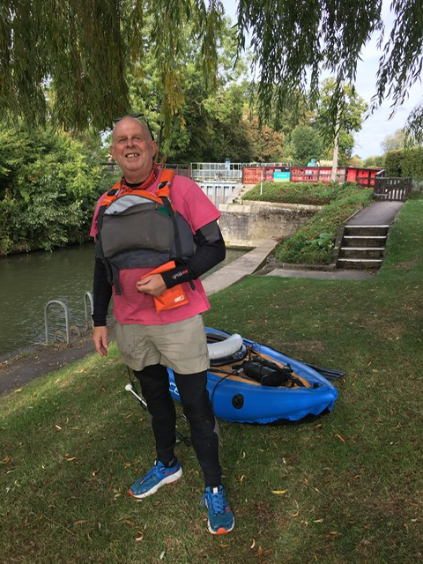

After his mammoth trek from John O’Grouts to Lands End, what was next in store, for our adventurous VIP? One day, he decided to strap a kayak to his back and set out for the source of the Thames.

The source of the Thames,,which spans 215 miles, starts as a ripple in a meadow in the Cotswold called Thames Head, Gloucestershire. Richard, aged 51, decided to launch his adventure, in September 2022, a few miles from Thames Head, outside a small, village pub in Lechlade. Lead singer of Kasabian, Tom Meighan, bought him a pint to get him on his way.

With his roller-ball cane safely strapped to the front of his kayak and a tent , attatched to the back, his launch was interrupted by a couple of men, holding dogs.. It was early morning, he explained, but they insisted on buying me a pint before I began!

The Thames runs through nine counties including Gloucestershire, Wiltshire, Oxfordshire, and Greater London. At times, its height can drop by 55 metres. As a result, Richard had to negotiate his way through 77 locks on his journey.

The lower reaches of the Thames is called the Tideway, derived from its long tidal reach up to Teddington lock. Variations along this tidal stretch can see height changes of 23 metres, at times. Richard was aware that this London section would be the most challenging part of his adventure and he was warned against doing it solo. Consequently, he then described how he got into serious trouble under Westminster Bridge.

Emerging, from underneath, Westminster Bridge he got caught in a high-tide current complicated by dense river traffic. His adventure came to an abrupt halt when he became wedged under the London Eye pier.Then in front of hundreds of on-lookers, Richard was rescued from the Thames from the river staff a and RNLI.

He admitted, at first they were rather astounded that I had been paddling all the way alone on one of the worlds busiest rivers. They were even more astonished when they noticed his white cane strapped to the front of his kayak.

Following advise from the RNLI and other kayak experts Richard finished his adventure in Greenwich where he lives. He had paddled 170 miles along rual and industrial landscapes in 4 weeks. He raised money for RNIB,gained the lead role in the Neutragena video advert, for hand cream and met a lot of interesting people along the way.

Click here to watch more: https://youtu.be/P6a6p7K4ZBQ

In Part1, of this article, we heard how he had trekked from John O’Grouts to Lands End, done the London Loop and is now currently walking along the 700 year old Camino Pilgrims trail somewhere in Spain.

Today, day 7, I received this photo of him enjoying a coffee break at the top of a Spanish mountain. Although his first three days were marred withheavy rain and muddy conditions the temperature has now risen.

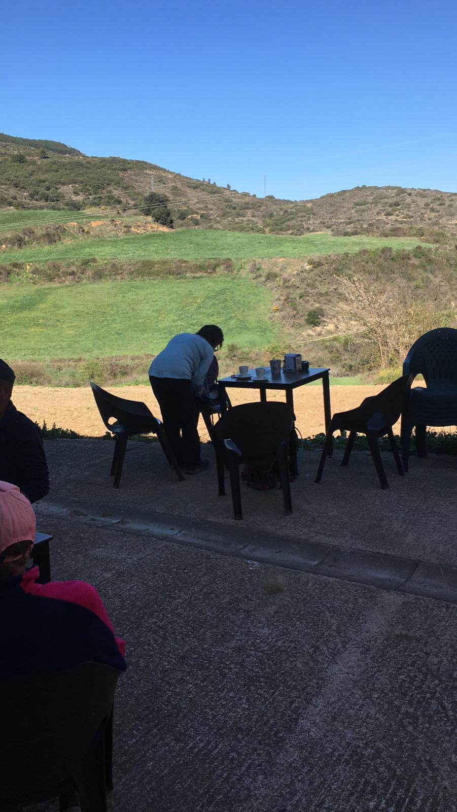

When he returns, he has another adventure planned in which London members could become involved. In September, he plans to walk the 1200 mile Via Francigena, pilgrims trail, from Canterbury to Rome. This will take him from England, France, Switzerlandland and ultimately into Italy. He has estimated it should take three months to complete. The walk from Canterbury to Dover, measuring 18 miles, is where members of our London Branch may wish to join him. This route will be through the beautiful countryside of Kent for two days.

To find more about the Via Francigena,,pilgrims trail please click here: https://www.cicerone.co.uk/walking-the-via-francigena-from-canterbury-to-rome

If you would like to know more about Richard’s adventures, please contact through his social media:

Insta @RichardsBigBlindCamino
Facebook: https://www.facebook.com/RichardsBigBlindJOGL
Twitter: https://twitter.com/rickytsimpson?s=11&t=eZBLbpdia5SZoF89TxllxA

If you would like to donate to his JustGiving page: https://www.justgiving.com/fundraising/richardsbigblindjogl

News and activities from other organisations.

Aquabats

The next event will take place on Thursday 13 April 2023. This will be tenpin bowling at Lewisham. Please meet at Lewisham Railway Station at the exit from Platform 2 at 6,30pm leaving at 6.40pm. Please let either myself or Darren copied know if you would like to bowl by Thursday 6 April.

27 April Zoom social
4 May boat trip London Regatta Centre
11 May walk at Cockfosters
25 May Zoom social final one until September
10 June proposing a joint Aquobats/London Sports walk at Bexleyheath.
These dates are subject to change due to rail strikes announced nearer the time. To register your interest please email: arthur.payne@trade.gov.uk

Be My Eyes.

Have you tried this free app yet? It’s brilliant for reading a birthday card to a mysterious tin lurking in your kitchen cupboard.

Read here for more information: https://www.bemyeyes.com/blog

Blind Ambition.

To register and find out about our full list of 16 webinars that are part of
Series 3, please click the link
https://www.blindambition.co.uk/post/looking-for-work-webinars-rnib-and-blind-ambition. LinkedIn Specialist Series:
We are approaching our first series of LinkedIn courses, running weekly on May 3rd, 10th, 17th and 24th. This series is hosted by us and Mark White who is a LinkedIn specialist. We will cover an introduction to LinkedIn, what it is for, how best to use it and why you should be using it. This will develop week after week until you are confident using the site to help promote yourself and give you a boost in your employment journey.
https://us02web.zoom.us/meeting/register/tZEqf-mhpz0jEtPlYYhWWFCk-1l0_GIaH29F

Working Age Forum: Blind Ambition is pleased to take over the running of the working-age forum - a place for working-age blind and partially sighted people to meet and support each other. Contact@blindambition.co.uk

For more information read here: :https://www.blindambition.co.uk/so/40OSXneah?languageTag=en&cid=4306736b-4e0e-4147-9685-9d7ca84d7e70

Extant’s No Dramas workshops

No Dramas! is a regular monthly two hour improvisation workshop held in London and online on Zoom for adults with previous performance experience or those with none. Workshops include accessible drama exercises, drama games and improvisation scenes to boost your confidence, interactive skills and performance technique.
Sessions are free and everyone is welcome!

April No Dramas are as follows:
13th April 2023 – In person
Location:
In-person venue: the Hope & Anchor Pub in Brixton

We are continuing to run monthly Zoom sessions for those who cannot attend in-person.

To register your interest in attending please contact info@extant.org.uk as places are limited.

Eye Matter is delighted to announce: A community event with
Eye Matter Singers in collaboration with the Inner Vision Orchestra, funded by Vision Foundation and the Baluji Music Foundation
Saturday 22nd April
St Andrew’s Church, Short St, London SE1 8LJ
6pm to 7:30pm
Meet and greet for guests at 5:30pm at Waterloo Station platform 19
Please let us know if you would like to be met at Waterloo Station
There will be refreshments and music by Inner Vision Orchestra and members and the Eye Matter Singers
Come find out more about Eye Matter, the Baluji Music Foundation, and the Inner Vision Orchestra of professional blind musicians
For FREE TICKETS, please register at:
https://www.eventbrite.co.uk/e/inner-vision-orchestra-and-eye-matter-singers-tickets-598465365017
or email: baluji@baluji.com or eyemattervi@gmail.com
with subject ‘22nd April’

RNIB is moving.

Sarah Bailey and Fiona Melville at RNIB have created the videos below to help staff and visitors find their way to the new RNIB office, The Grimaldi Building, from Kings Cross and from the Angel.

Grimaldi from King’s Cross: https://youtu.be/bnZSFMOmZsI
Grimaldi from the Angel: https://youtu.be/iUHZKtOFeOM

Technology News.

New Guide Dogs resource page
Thanks to Karl Farrell.

Guide Dogs have released news about a new information resource page on their website which aims to point people in the direction of accessible technology.
This looks to be a useful new initiative. It combines an up-to-date list of accessible technology including mainstream products.

There are a number of helpful videos demonstrating various actions on devices, specifically for IPhones

https://www.guidedogs.org.uk/getting-support/information-and-advice/how-can-technology-help-me/

Emergency alert planned for Sunday 23rd April on all mobile phones and tablets.
Thanks to Berin for bringing this to our attention.

The government are to test a national alert system to all mobile phones and tablets on Sunday 23rd April. No time has been provided.

An audible alert will sound and the phone will also vibrate for those with hearing loss.
It is advised you respond to this alert by following the given instructions.
This will still be received if Location services are switched off.

Please read more here: https://www.gov.uk/alerts

Opportunities at Moorfields (ROAM) - Moorfields Research & Innovation.

Moorfield’s are looking for people to assist with research in various eye sight conditions. Please read more here:
https://research.moorfields.nhs.uk/

Apple launches five hidden features in their latest 16.4 update in April.
Please click here to read more:
https://bgr.com/tech/5-great-new-iphone-features-that-are-hidden-in-ios-16-4/

Amazon one-time passwords: item thefts and parcel switches
Thanks to Colin Palgrave.

When you purchase a high-value item, Amazon may send you a one-time password (OTP) to provide to the courier when they deliver your parcel. However, we’ve found that many people have had issues with this system, including instances of couriers stealing the customer’s parcel. And when customers report the theft to Amazon, they face a battle to get a refund or replacement.
Delivery theft

Twitter ‘verification’ scam

Fraudsters are sending fake ‘verification’ emails targeting Twitter users. The emails include a link designed to phish for your personal information or install malware on your computer.
There are currently two Twitter impersonation emails in circulation. Both contain convincing branding and text; however, they’re sent from random email addresses rather than official Twitter accounts.

Transport News.

Avanti West Coast is now available on Be My Eyes Specialized Help for all users in the UK.!
Thanks to Colin Palgrave

Great news for our community! We are proud to announce that Avanti West Coast is now available on Be My Eyes Specialized Help for all users in the UK!

You can reach out to an Avanti West Coast representative from this moment, regarding your trips on the West Coast Main Line. Their line is open from 7am to 10pm GMT, and they offer their service in English.
Reaching out to an AWC representative is easy: open the Be My Eyes app, click on Specialized Help and select “Travel & Transportation”. Here, tap on Avanti West Coast and you will be connected in a matter of seconds! You can also visit their profile by clicking on this link: Avanti West Coast profile

If you want to learn more about this unprecedented partnership, you can check out our new blog post: Avanti West Coast Joins Be My Eyes
Read more here: https://www.bemyeyes.com/blog/avanti-west-coast-joins-be-my-eyes

How accessible are the taxi apps?

One member posed a question, as to whether Bolt or UBA provide the best service for blind and partially sighted people. We would be interested to hear your thoughts:

https://www.appshive.co/blog/uber-vs-bolt-which-is-the-best

Silvertown Tunnel opening bus network consultation report.
Thanks to Andrew Hodgson.

TFL published their report on the Silvertown Tunnel Opening Bus Network consultation, which ran between 16 November 2022 and 11 January 2023. They received 644 responses to their consultation in total. Thank you to everyone who took part.

The report details the findings of the consultation, outlines next steps, and includes responses to issues frequently raised. You can read the final report on the consultation website by visiting www.tfl.gov.uk/silvertown-tunnel-buses
Following careful consideration of all consultation responses, they have decided to proceed with the proposed opening bus network with some amendments to the original proposals.

The proposed new route X239 will run between Grove Park and Canary Wharf, Westferry Circus, with a non-stopping section between Sun-in-the-Sands roundabout and Orchard Place. The route will travel via Orchard Place to serve the Leamouth Peninsula Developments and via Baffin Way and Trafalgar Way in both directions
Route 129 will be extended from North Greenwich to Great Eastern Quay. It will serve Dock Road, which will benefit the future riverside development

Route 108 will be rerouted to access North Greenwich Station via the new slip road connecting to Millennium Way when travelling towards Lewisham
The network will begin operating when the Silvertown Tunnel opens in 2025 and we will be working to deliver a zero-emission bus fleet across all three routes. We will continue to keep the bus route under review as the local area continues to grow and develop.
Route X239 would also form part of the Mayor of London’s proposed new ‘Super loop’ bus network. To find out more about the proposed Superloop, visit: https://haveyoursay.tfl.gov.uk/superloop

For further details and to view the consultation report, please visit www.tfl.gov.uk/silvertown-tunnel-buses

Wow, another jammed packed edition of London Life. On behalf of the officers at London Branch we wish you a happy weekend and look forward to receiving more articles for future publications.

‘Keep walking on sunshine”

Fiona and Jane

