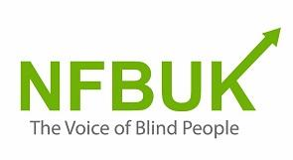
Above is the NFB UK logo
The photo below, shows a Christmas tree decorated by Berin, from London Branch, with her clever knitted decorations surrounded by homemade cards.
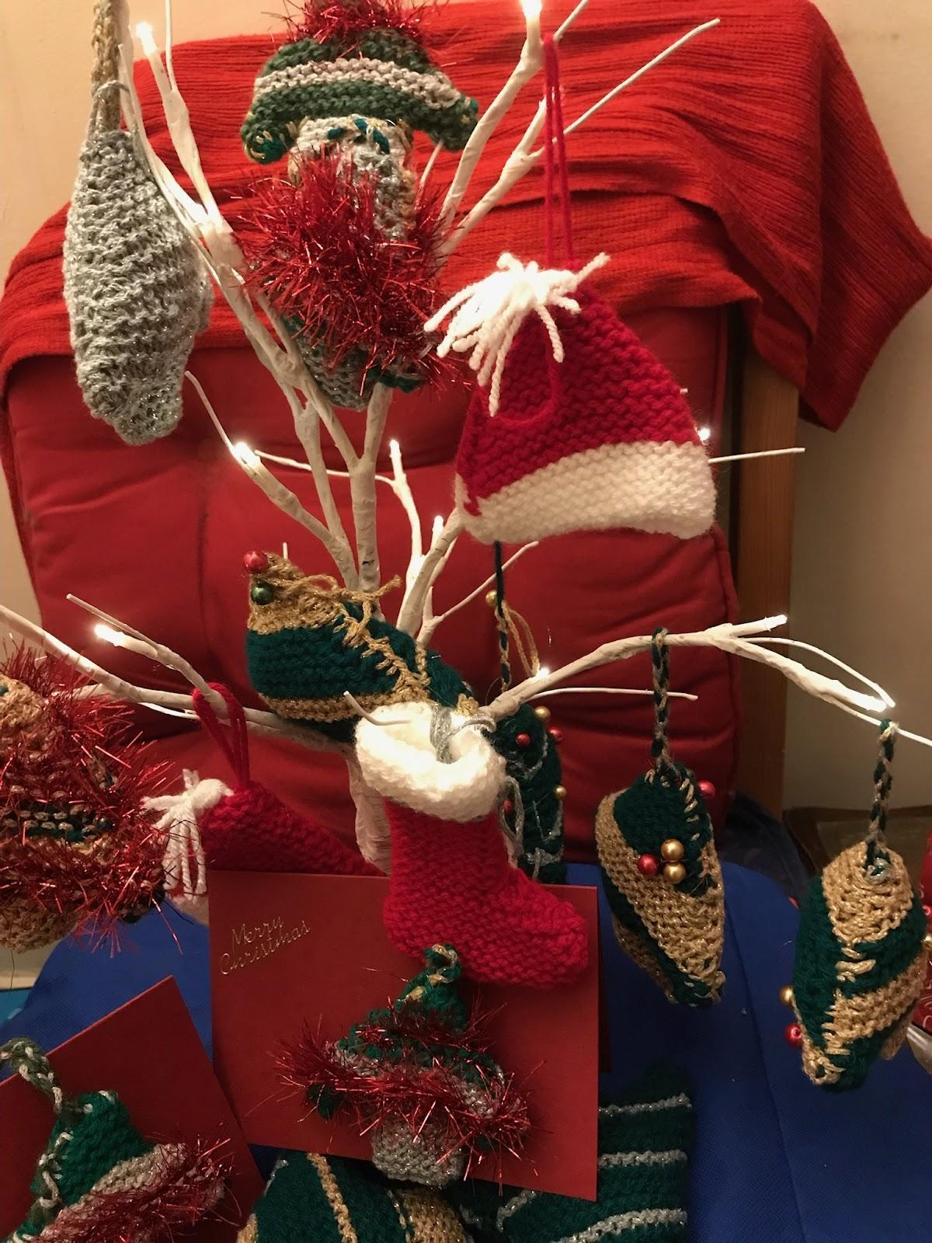

Welcome to edition 51 of Fed News. We wish you a merry Christmas and fantastic New Year. All around the country we are aware branches are enjoying their annual Christmas dinners with members. Please don’t forget to send us some photos and articles for our next edition. If you want to read any past Fed News publications just log into the members section of our website or contact Louisa for support: admin@nfbuk.org. If you would like to submit an article or share an experience you had with other members of your branch, please email: fednews@nfbuk.org. If you would like to be removed from this mailing list, please also contact us.

This edition includes:

Editorial by Karl Farrell
Meet the Team by Fiona Musgrove
Executive Council Report by Karl Farrell
NFBUK 75th Anniversary Weekend 23rd and 24th September 2022 by Andrew Hodgson with Contributions from other members
Pride of Britain Lifetime Achievement Award by Jill Allen-King OBE
Greetings from Eastbourne (taken from London Life edition 49
Campaigns Update
Summary of Work Update by Sarah Gayton
"Not a Blind Bit of Notice" – Update by Karl Farrell part 1
NFB helps Ukrainian blind people
New branch Executive Council links allocated
News from our branches
Why Volunteering Is Empowering by Fiona Musgrove
"Not a Blind Bit of Notice" – Update by Karl Farrell part 2
Other ways to keep in touch with NFB UK
NFB circulars and notices list

Editorial
By Karl Farrell

I am very happy to have with me Fiona Musgrove and Liz Silver to help produce this special ‘catchup’ edition of Fed News. Currently as Vice President and Acting Treasurer, I have simply not had the time to provide Fed News since November 2021. But people have pointed out the lack of information coming to members and so much of that lack is the non-appearance of Fed News to bring our diverse NFBUK picture together.

Talking about pictures, a significant difference in the presentation of this edition is the inclusion of several photos that reveal more about us. Many of us with sight loss have usable vision so let’s use it! I personally can’t see those photos, but I can enjoy hearing from the picture descriptions just what people are up to around the Christmas tree or at our AGM.

I hope this edition will help you to catch up on what is happening in NFBUK. It will show that a lot more people are coming forward to enable us to do more. There’s simply not space to cover what should have been said in five missing editions so we are focusing on what is most important.

With more hands-on deck, we should be able to produce regular Fed News editions and provide more links and events. News of that will come in the new year.

In the meantime, we are working to make visiting our website a more enjoyable experience. Your feedback will help us to achieve this so please visit www.nfbuk.org and tell us how you got on. The more you tell us, the better, such as: whether you were using a screen reader, magnification or none of these, what you read there and how you got on. When you arrive at our website, you can set it to be screen reader friendly. If you personally can’t get on the internet, would you like to ask one of your friends to give it a go? All feedback is useful as our website is very much like a shop window that any ‘surfer’ might visit.

Meet the Team
By Fiona Musgrove

At our Annual General Meeting (AGM) in September, Pardy Gill and Yemi Dada stepped down from the Executive Council (EC). EC members are elected for a three-year term. Steve Springthorpe and Liz Silver, both from Nottingham Branch, were elected in their place as Ordinary EC members. We thank both Pardy Gill and Yemi Dada for all their hard work and commitment on the EC and wish them well in their future successes.

EC members are also the Trustees of NFBUK, which is a Registered Charity. We are registered in England and Wales, Charity Number 236629, and in Scotland, SC040134.

The current EC members are:
- Andrew Hodgson president
- Devaki Sivasubramanian General Secretary
- Karl Farrell Acting Treasurer/Vice President
- Fiona Musgrove Ordinary Member
- Karina Gregory Ordinary Member
- Steve Springthorpe Ordinary Member
- Liz Silver Ordinary Member

Current staff employed by the charity:

Louisa Pouncett NFB Administrator/Communications Co-Ordinator
Sarah Gayton Research and Campaigns Officer and Street Access
Campaigns Coordinator
Carol Hudson Fundraiser (freelance)

To contact any of the above please email: admin@nfbuk.org
Click here to find out more about your EC members/Trustees: https://www.nfbuk.org/about-nfbuk/trustee-profiles/

Executive Council Report – December 2021 to November 2022
By Karl Farrell

The Executive Council (EC) normally meets every six weeks and more frequently if required. The President, Vice President, General Secretary and Treasurer deal with the day-to-day running of the Charity and the Ordinary EC members assist in this work from time to time.

Branches hold their annual general meetings by the end of January and the EC needs to receive details of membership and income and spending from Branches for the previous year. Our Examiner is the accounting firm that verifies our financial records and presents our report to the Charity Commission and OSCR in Scotland. The Examiner requires the financial information and Branch books in one batch so any late returns from Branches holds up this process.

The normal work of the EC includes preparing for the holding of elections for EC and other positions up for re-election this year. The EC also has to prepare the Federation’s Annual Report and Accounts for the year just gone so that members can raise any questions on them at our national AGM.

The EC decides where and when the national AGM will be for the year. This year it was the seventy-fifth anniversary of the founding of NFBUK in 1947. It was decided to make this year’s AGM a special celebrative event, as you will read in another article.

The EC formed the AGM Forum which included several EC members and several Branch members from Nottingham and Leeds who volunteered to help. This Forum made it possible to launch a great weekend to celebrate our big seventy-five.

Over the past dozen years charities have been pressed to adopt a wider range of policies, some of which will require enhancements to our rules. Fiona Musgrove provided drafts of policies that might be updated for NFBUK that she had encountered in her work with other charities. The EC has now published our Volunteer Policy and further documents will be published in early 2023. Engaging and valuing our volunteers will be priority for the charity over the next few months and beyond.

At this year’s AGM the EC posed the question whether NFBUK should become a charitable incorporated organisation. Earlier in the year the EC had spoken with other charities who have become CIOs and we think that making NFBUK a CIO will allow us to modernize and operate more effectively. A couple of EC members are now working on plans for this.

In 2022 Sarah Gayton resumed providing regular reports on our Campaigning issues as Sandy Taylor was no longer doing this. The EC aims to make campaigning and determining its strategy more at the heart of the organisation. So there was much discussion as to how to achieve this. Members must be able to express their views and concerns to the EC and compare notes with each other.

So, communication has to be vastly improved by holding regular meetings open to members, on Zoom and in the flesh, regular magazines, circulars and using IT. In addition, the EC will set up a campaigns forum where it can be informed on campaigning issues so that they can put campaigning policy into practice.

In 2021 Carol Hudson was engaged as a Fundraiser for NFBUK. We are now in a position where we can create projects that Carol can go out and seek funding for – that’s a challenge to us! Carol was delighted to be invited to Eastbourne to meet many of the members (please see article below for more information).

After serving as President for 6 years (two terms), Andrew Hodgson was due to step down in September this year. However due to some irregularities in the course of the presidential election, this election was subsequently suspended, and the alleged irregularities are now being investigated. Our President remains in post until a fresh election can be held.

In September, Liz Silver and Steve Springthorpe joined the EC and they are already making their presence felt. It is hoped this new look EC will now take the charity, its staff, volunteers and members forward to a better future.

(I wish to acknowledge the help of Fiona Musgrove in the preparation of this report – KF).

NFBUK 75th Anniversary Weekend 23rd and 24th September 2022
By Andrew Hodgson with Contributions from other members

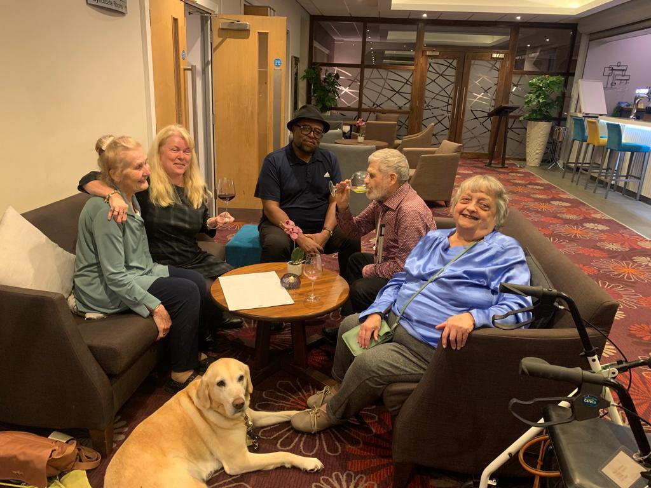
The above photo shows Rasheed, Karl, Mary, Fiona, Hilary and Guide Dog together in the lounge bar at Loughborough.

Our 75th anniversary weekend, which included our Annual General Meeting (AGM), took place at Burleigh court, a modern well-equipped conference centre attached to Loughborough University.

The Executive Council had felt for a number of years that we ought to have an AGM in the Midlands, particularly as we now have four branches based in that area. During the last two years Covid has caused us to meet via Zoom and there was much anticipation and optimism in being able to meet face to face again with some of the EC never having met each other.

We were anxious for all members who wished to do so to be able to celebrate our 75th anniversary and although funds are still limited, we wanted to make this occasion more elaborate and lengthier than had been the 70th. Because this was a more complex task than usual, we formed a forum consisting of EC and non-EC members to plan all the various aspects of the weekend. We met most Mondays over a number of months and through delegation of tasks and hard work most of what we planned came into fruition.

Pardy Gill, former EC Member, described the planning for the weekend: “Plans for organising our NFBUK AGM celebrating our milestone 75th anniversary began in January 2022 when the Executive Council tasked me to lead on identifying a suitable venue. With the support of Nottingham Branch members including Steve Springthorpe, site visits took place with management at 2 potential venues in Nottingham and Loughborough. Burleigh Court was selected by the EC given ease of access, value of conference quote and numerous Awards including coveted Mobility Free Accreditation.”

He went on: “Given the significant aspect of the milestone anniversary, we wanted member involvement in organising the celebratory aspect and Branches were invited for representation to join the AGM Planning Forum Team. The Forum met fortnightly from May and then weekly towards the weekend date, working effectively with a team-based approach to develop ideas for the Friday evening celebration structure plus ideas to produce commemorative branded items for distribution as recognition of 75 years.”

Pardy continued: “As the weekend neared, a follow-up site visit with Steve was made, where we finalised our conference structure with the General Manager. Commemorative branded items of mugs and pens displaying NFBUK 75 Years were produced by a Loughborough based Promotions Company and the EC and AGM Forum completed preparations for the business and celebratory aspects of the weekend, including producing a comprehensive Information Pack covering all aspects for the weekend including historical context. I worked with Fiona Musgrove and Karina Gregory to pre-record past Presidents and Branch representatives for our evening Presentations and confirmed Guest Speakers/Performers.”

Lisa Jones, Nottingham Branch and member of the Planning Forum 2022, added: “It was very useful to have a planning committee that met regularly and formulated an Information Pack to accompany the event. The pack could have been broken down into smaller documents specific to certain parts of the event.”

Friday Afternoon, 23rd September
The weekend began on the Friday afternoon with two forums covering our campaigns, designed to encourage member participation. The first of these was concerning our streetscapes campaigns entitled: Ensuring Safety, Accessibility and Independence in Active Travel Street Designs for Blind and Visually Impaired Pedestrians and Bus Passengers. It was led by our Research and Campaigns Officer and Street Access Campaigns Coordinator, Sarah Gayton. It centred around a forthcoming petition which we were due to hand into 10 Downing Street the following month. This was concerning the unsuitability of the bus stop bypass design. Sarah urged our branches to sign and to encourage other organisations within their area to do so as well.

The second forum focused on our Support for Sight Loss campaign. The aim of this was to reinvigorate the campaign following its disappointing reception by Central Government. The workshop therefore concentrated on hearing experiences from those working in the field and those who had lost out through lack of support, thus affecting their lives. It was drawn to a close by Martin Borrell, a new member who has worked in the rehabilitation sector for many years who brilliantly signposted the way forward for this campaign at a local level.

Leeds Branch commented: “Friday afternoon saw the commencement of Conference with the first workshop, which was given by our Campaigns Officer. This was somewhat repetitive as we had heard it many times before. It was a great pity we did not hear anything regarding other work she is undertaking. We then had a discussion regarding our ongoing campaign on Sight Loss with presentations by Professor Fred Reid, via Zoom and Martin who was present @ conference.”

Friday Evening

After the forums there was a tour of the hotel and we all gathered together at 6 pm for a celebratory dinner.

The first presentation was a welcome from the Pro-Vice-Chancellor for Diversity, Equity and Inclusion Dr Charlotte Croffy, who welcomed us to the University. She emphasized that our mission very much accorded with that of her own work in advancing opportunities for disabled people and urged us to feedback on our impressions of Loughborough University and Burleigh Court in particular. This was followed by a short Zoom presentation from Lord Chris Holmes, the former Paralympian multi-medalist, who has worked with us in the past on our campaigns, particularly on shared spaces. He emphasized the importance of teamwork and urged us to continue, saying that campaigning can be a slow business, but that perceptions can be changed over time to bring about a more equitable and fair society.

The next speaker was another Paralympian, Libby Clegg MBE, who was our designated after-dinner speaker. I had had the pleasure of sitting with her over dinner and found her to be delightful and very empathetic. In her speech she emphasised how sport had transformed her life. She outlined her athletic career, once again emphasising the importance of teamwork, with her delight at being part of the British medal-winning team in the Tokyo Paralympics.

Pardy Gill described the rest of the evening thus: “President Andrew Hodgson gave a historical context on our rich history. Our Past was recognised with an inspiring Presentation from past Presidents Professor Fred Reid, Lord Colin Low, David Mann and Douglas Gilroy, with recognition to Jill Allen-King. Our Present Presentation focused on the achievements of our Branches with representation from Berin Gem at London, Karina Gregory at Nottingham, Graham Whale at Coventry and Sheila Foster at Leeds. The Future of NFBUK was led by Fiona Musgrove with member interaction, followed by a challenging Quiz led by Steve Springthorpe with questions covering 75 years. Well done to the ‘Tactiles’ team on winning! The evening, concluded with singing and dancing from members with a musical performance live from Jörgen Hansson in Sweden that included hits from the decades including The Beatles, Elvis, Abba and of course Sweet Caroline.”

Leeds Branch filled in the important details: “The evening began with our Annual Dinner, celebrating our 75th Anniversary. Dinner was extremely good, as was the wine! (There was) a welcome speech by the Vice Chancellor of the University and then speeches from past Presidents … then the dancing began! …”

Saturday, 24th September

The main AGM business was delivered fairly smoothly, and members participated by asking questions and giving feedback. The most notable point which we took away from this was the need for better communication and the EC is currently debating ways on which we can improve this.

In the afternoon we had a short presentation, resulting from a motion from London Branch on the need to tackle the problem of e-scooters and for the need for more VI consultation when tackling the challenges of driverless vehicles and on our safety when navigating the streets. This was followed by two forums, looking ahead to important issues which will determine our work in the future. The first of these concerned the benefits of the Charitable Incorporated Organisation (CIO) Structure. The EC has for some time been debating this proposal in order to bring our charity in line with more up-to-date governance and we were gratified that this idea seemed to win the approval of those present at the AGM.

There then followed a presentation on establishing a campaigns forum. The EC feels that this is necessary to enhance the contribution of active campaigners within the organisation in the discussion of current and potential campaigns, with it having control of the overall strategy. The exact structure of this forum had been discussed internally within the EC, but it emerged from this wider discussion that more fine tuning is necessary before a structure is finalised. However, here again there seemed to be general agreement that this is a positive idea.

The evening was spent enjoying the hospitality of the hotel and convivial company of members.

Leeds Branch commented: “The following day was our AGM which, apart from problems with the microphone, continued as normal, but was somewhat lengthy. Subsequently, we were unable to engage in more discussions on certain subjects, which was a shame. Perhaps in the planning for AGM 2023 this could be considered?”

Lisa Jones, Nottingham Branch, said: “Saturday morning was the usual AGM business and during the afternoon we discussed the proposals submitted by Branches and the Executive Council. At lunch we were given pens and mugs as souvenirs. At the end of the day, we were given celebration cakes with our refreshments. Most stayed over until the Sunday, but the Nottingham contingent returned home Saturday evening.”

Darren Vicars observed the AGM via Zoom: “I found the NFB AGM by Zoom very good, there was very little talking over each other. It was nice hearing people’s voices some I did know and others I did not know. It felt as though I was there in person. A lot was packed in the weekend. I would like to say a big thank you to everyone who organised the AGM, you all did a fantastic job.”

Leeds Branch said of the hotel: “We both felt the hospitality was very good, staff pleasant, supportive and courteous. Staff in the dining room were also equally supportive as were some of the members of the NFBUK, including Louisa, in helping with the serving of our meals which were appetising. Bedrooms were very accessible for movement around with very comfortable beds.”

Lisa Jones, summing up: “It was good to meet face-to-face, what would we have done without Zoom? The Planning Committee would not have been able to meet as easily, as often or have members joining the odd meeting from overseas. More importantly, we would have missed out on Friday entertainment from Sweden, courtesy of Jörgen Hansson. This was a great finale to a very rushed evening of activities.”

Pride of Britain Lifetime Achievement Award by Jill Allen-King OBE
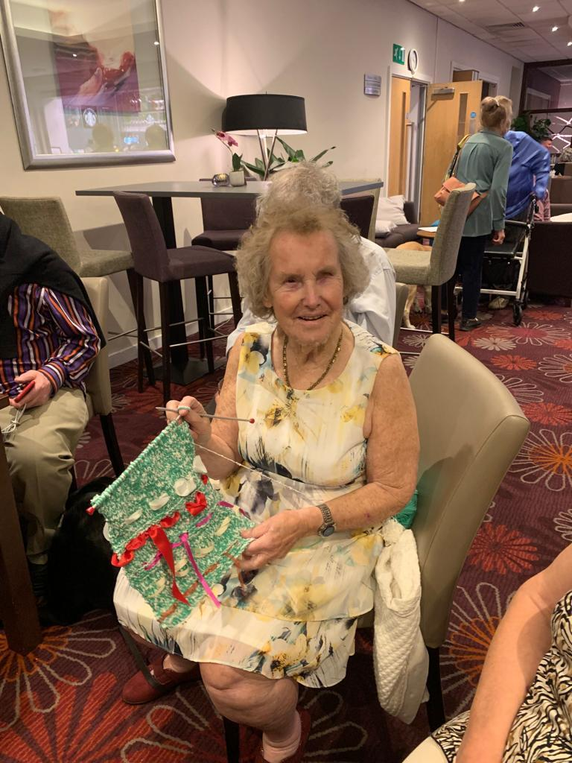
Above photo was taken of Jill at this year’s NFB AGM, in Loughborough, showing her knitting skills (taken from London Life edition 49)

Our past president Jill Allen-King has won Pride of Britain Award for her life-time achievement. We appreciate and congratulate her efforts and hard work for her contributions to the VI world. (Jill describes what happened.)

“On September 15th I was visited at home by a television crew of three
to film me for a special programme. They filmed me from 9am until 7pm but it was not until 6pm they told me that I had won the Pride of Britain Lifetime Achievement Award. The following day I was contacted by a representative from the Daily
Mirror to tell me all the details. My daughter Jacqueline and I would be picked up by car on October 23rd and taken to stay for 2 nights at the Hilton Hotel in London. On the Monday evening we would go to the Grosvenor Park hotel for the Pride of Britain event. On the Sunday night we met the other people who were also receiving awards. Ashley Banjo sat next to me at the dinner, and I had found out, only the week before, that he had just bought the old Kings Road church close to where I live. This is now his dance studio.

“When we arrived at the Grosvenor Park hotel on the Monday afternoon, we first had a rehearsal which included a walk on and off the stage and I was told who would be presenting me with my award. We then were taken by car round the block to. arrive and step out on to the red carpet. This was followed by dinner and then the recording of the programme, this took from 7.15. till 10pm.
“I was taken on to the stage by Ashley Banjo and Mo Farrow. I was presented with my award by Paul O’Grady. My guide dog Jagger also received a Pride of Britain medal with his name on it. I also met several celebrities including, Mary Berry, Ben Shepherd, Susanna Read, Peter Andre and his daughter Princess. We then went to the bar for drinks, and we arrived back to our hotel at midnight, very tired but happy.

“The event went out on October 27th, and I took part in three live morning television programmes. I am still doing interviews with various charities. It was nice to be recognised for all the campaigns I have done, since I went totally blind in 1964.
“Since returning home I have had a blood clot on my lung so have got to slow down a bit if I can. I should like to thank everyone who has helped me over these 58
years as without a lot of help I could not have achieved this award.”

Click here to see Jill being interviewed on TV:

https://youtu.be/tLR-ontNZoc

https://www.prideofbritain.com/2022-winners/lifetime-achievement-3/

Jill was also visited by one of her favourite radio show broadcasters
Justin Dealey:‬⁩

“This is regular caller Jill who has just won a Pride of Britain award. When Jill was asked who she would really like to meet she told me 😂. Sadly no one from the show contacted me. So today I made a surprise visit. The braille card was made by 7-year-old Dexter from MK ❤️”
17/11/2022, 14:43 sadly couldn’t display the smiling photograph of Jill and Justin when he turned up at her house with a bunch of flowers)

Greetings from Eastbourne (taken from London Life edition 49)

Over 70 people joined us to celebrate 45 years of London Branch visiting Eastbourne on the weekend beginning Friday 14October 2022. We were delighted to be able to offer this as an exclusive event for our Weekenders and would like to thank the Cumberland Hotel for their support throughout this project.
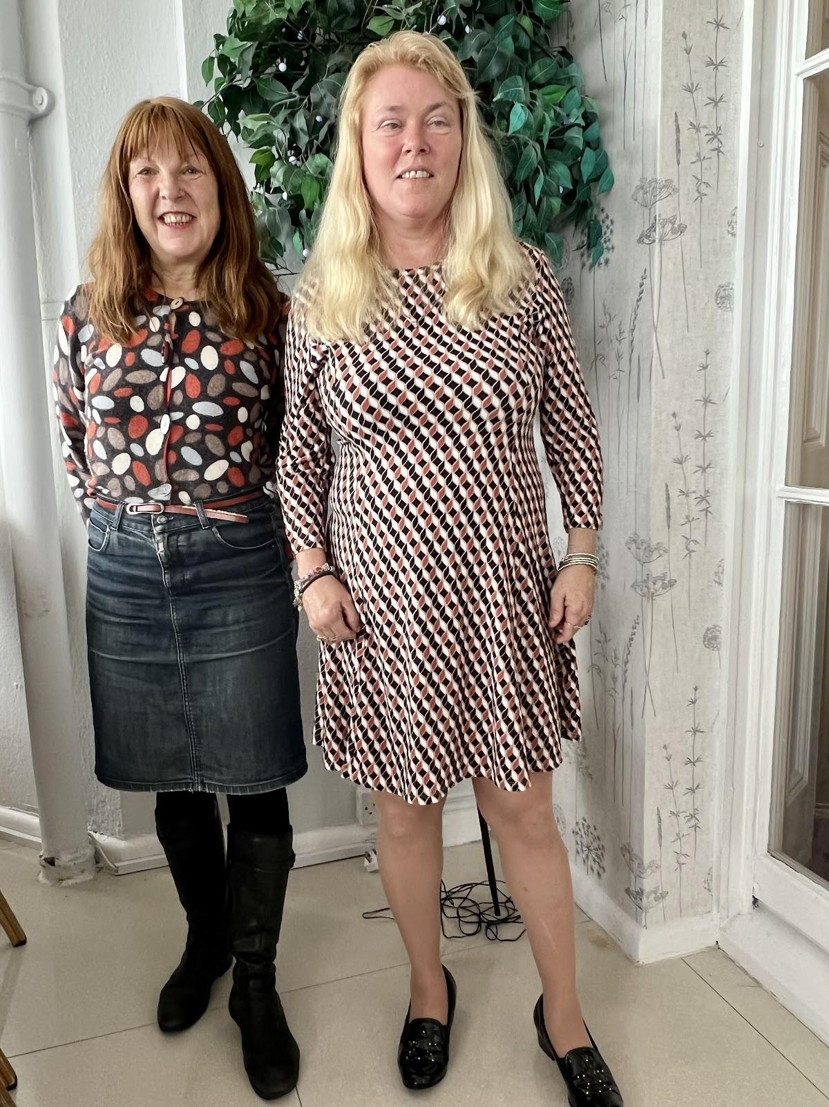

Above photo shows Fiona with NFB UK fundraiser Carol Hudson at the Cumberland hotel afternoon tea.

For some people it was their first experience of a London Branch Eastbourne weekend, but as Steve added “My first in person, however, I did attend both the virtual weekends “. For others it was a chance to catch up with old friends “Meeting up with friends I care about.” Sheila. Your feedback demonstrates how important peer support is for our members. After the past years of social restrictions and concerns about mixing, this weekend certainly lived up to its previous year’s visits to the sunny resort of Eastbourne.

One member said that by moving the date from around Remembrance Day, in November, allowed him to visit for the first time. The lovely weather played a huge part in our Weekenders making use of the beach walks and trips to the nearby shops and bars. We were so fortunate to have access to a 24-hour bar as agreed by Grace in her feedback.

A huge thanks should go to the Eastbourne Revellers Team: Jess, Pardy, Connie, Berin, Karl, Valerie, Rasheed, Jane, Priti and Fiona. Special gratitude to our Treasurer David Bamber who ensured all the activities and hotel were paid. Another recognition is to the Wizard formerly known as Jason Beal, his tech brilliance enabled us to provide the Talent show on Sunday evening and ensure the presentation was broadcast. This video was carefully produced by London member Vicky Blenco - thanks to everyone who contributed to its content.

We were so appreciative of our 7 on-site volunteers: Paul, Rosemary, Sarah, Harriet, Connie and Chris - they were so helpful throughout the whole weekend.

“It was a FABULOUS WEEKEND❤️thank you so much. I loved it.” Deborah

The weekend kicked off with a complimentary Bucks Fizz reception which after dinner sizzled into a Disco down in the Ballroom. Saturday’s sunshine gave the option for a beach walk or to participate in our dance and choir sessions.
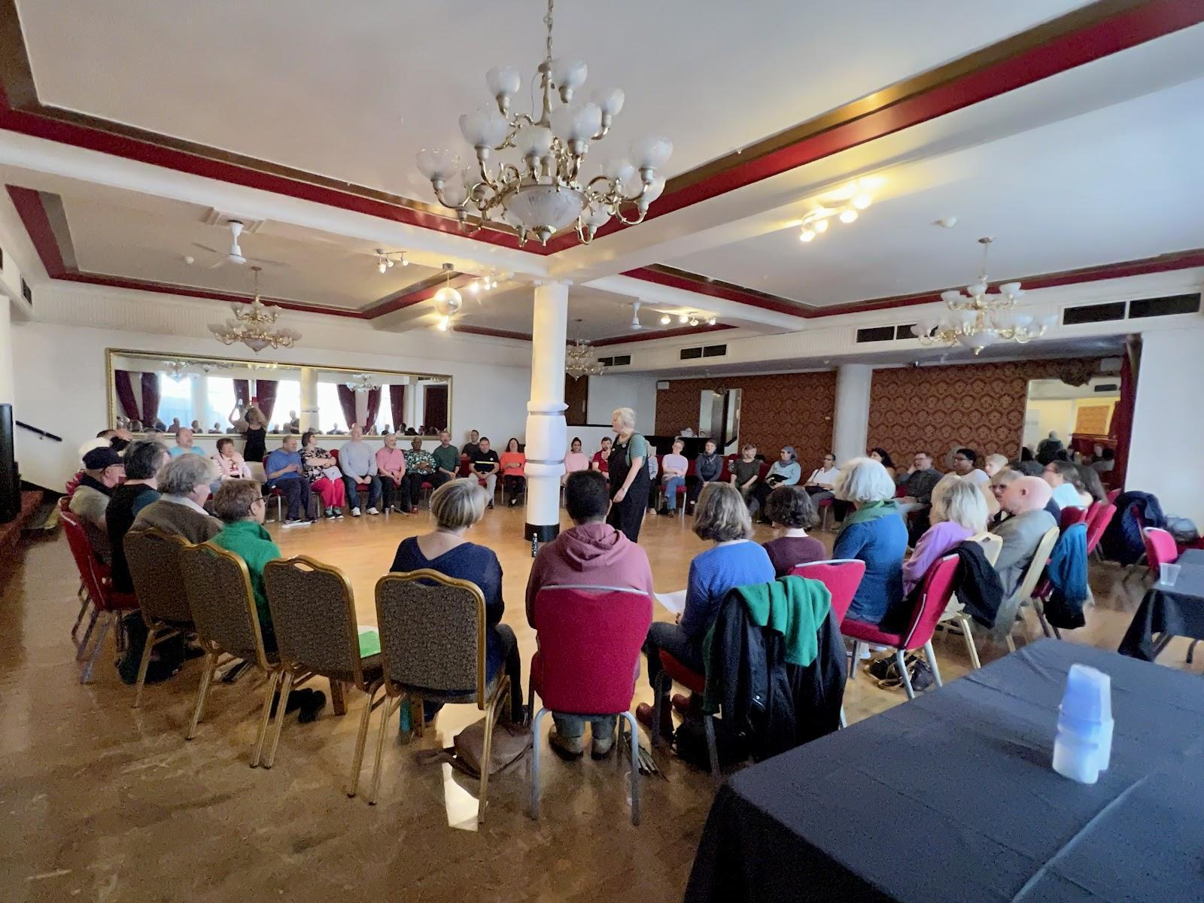

Above photo shows a large circle of seated Weekenders in the ballroom at the Cumberland Hotel joining the Angels Choir with… Having a rousing singalong session.

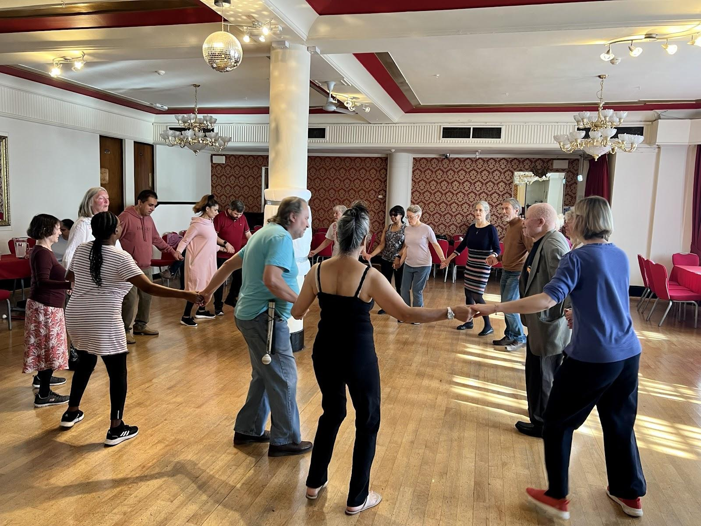
Above photo shows Weekenders in a circle around the central pillar of the ballroom at the Cumberland hotel, enjoying a Russian dance session with the Janet Douglas Dance Group.

A well attended tech talk from RNIB’s Dave Williams was followed by a piano recital from Arthur Payne. That night we were entertained by Live Element, a band who travelled all the way from Surrey and they met old friends from past events.

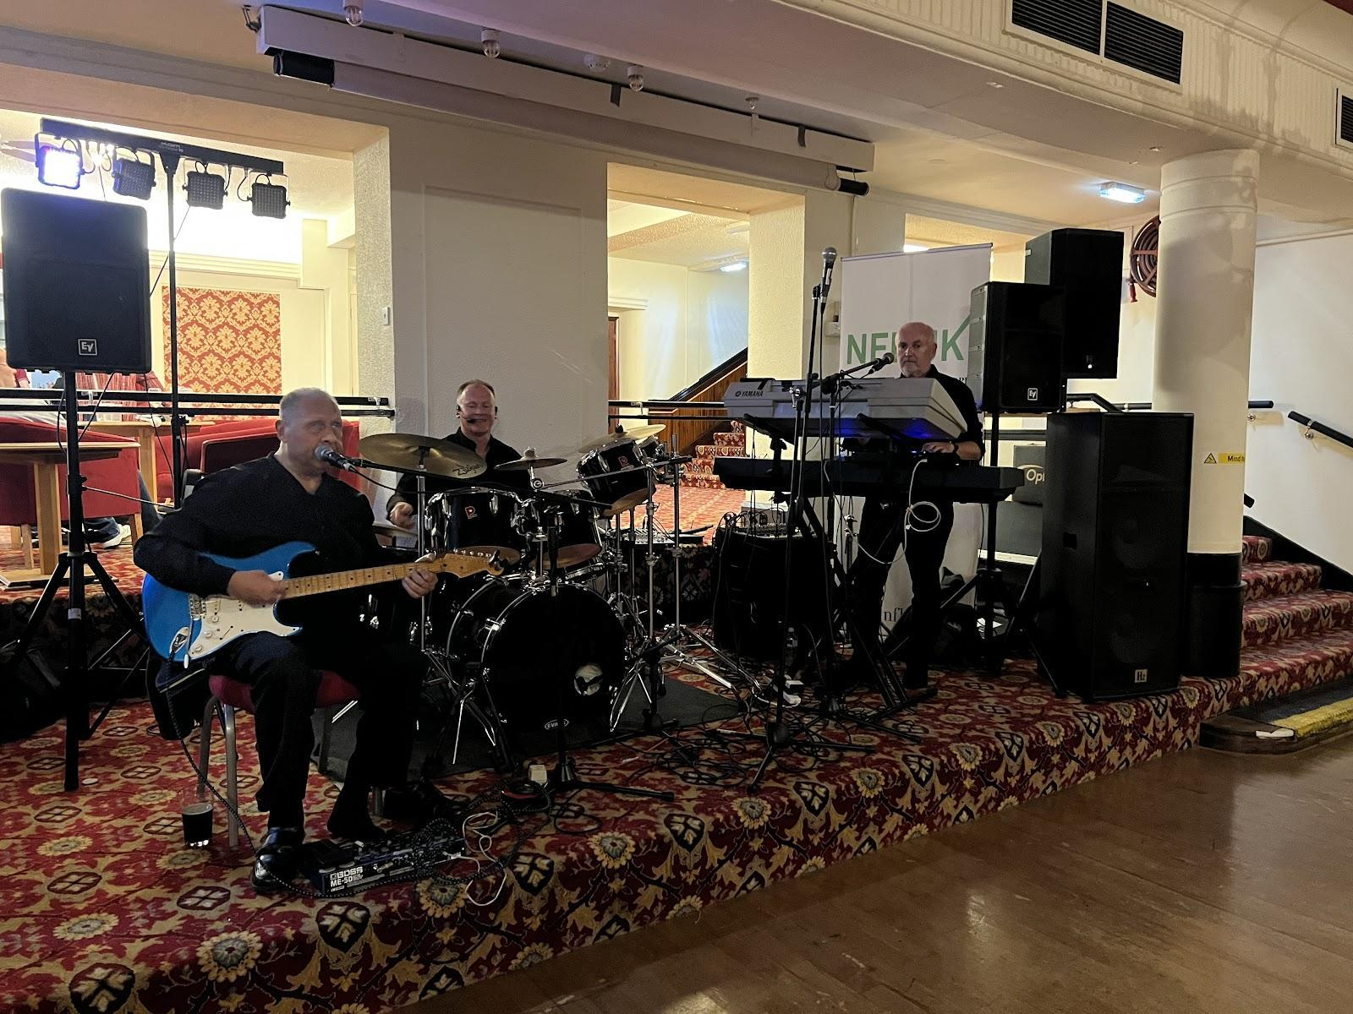
Above photo showing the fabulous band members on the Saturday evening in the boardroom at the Cumberland hotel. guitar, drums and keyboard

Sunday morning after the Hi De Hi welcome, Weekenders joined in a keep fit session and some attended a members’ forum in the Ballroom. Following Afternoon Tea in the Conservatory, Weekenders enjoyed Improv drama with Steve Reed in the Ballroom.

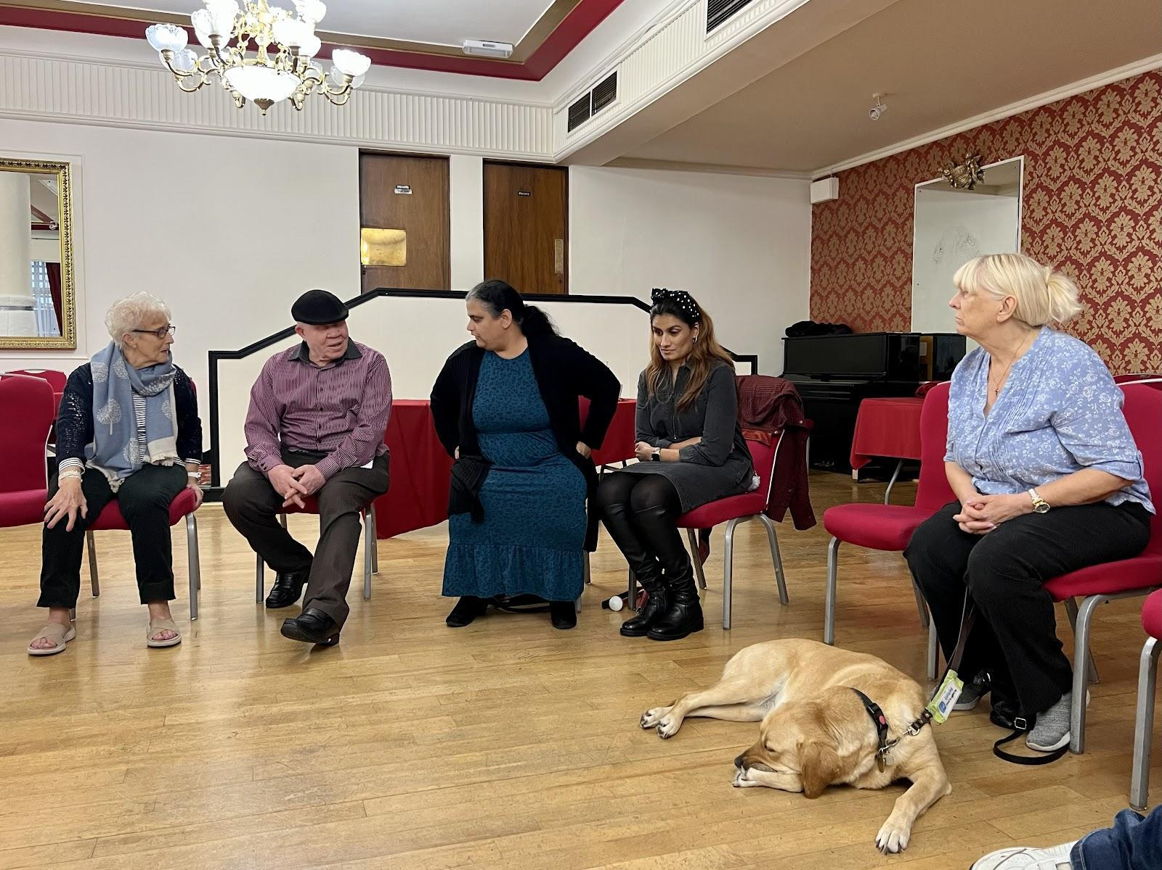
Above photo shows Five Weekenders and one guide dog sitting on chairs enjoying an interactive drama game at the Cumberland hotel.

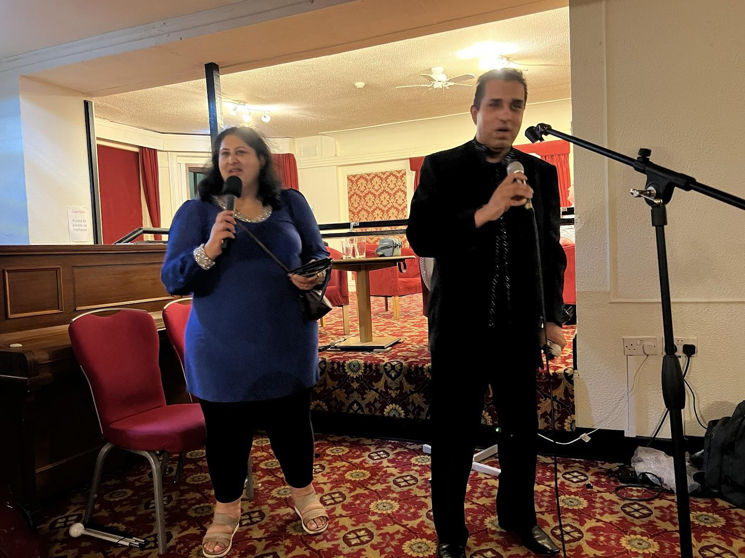
Above photo shows Priti Damania and Pardy Gill singing a duet at our talent show.

Our showcase event of our talent show was proceeded by a presentation video featuring some familiar voices. How can we forget our Rasheed as Othello, or Jane Seller’s exquisite Olivia Newton John Hopelessly devoted to you. Then we all danced to Pardy and Priti’s London Thumakda. Contributions from Ron and Sam, Peter, Jess, Drew, Terry and Berin, Steve, Peter and many others made this a momentous evening of fun and enjoyment. At the end Kalid and Michelle provided more music and we all finished with our theme tune Celebration by Kool and the Gang.

Campaigns Update

Summary of Work Update on 29 November 2022
From Sarah Gayton, Research and Campaigns Officer and Street Access Campaigns Coordinator

Worked gaining support for the NFBUK petition on safety and accessibility at bus stops from over 160 supporting organisations included emailing people and ringing organisations to get them on board with the petition. Organised the petitioning of Number 10 and press coverage for the event. The petition was covered in BBC Scotland Radio News, BBC East Midlands TV, BBC London Radio, RNIB Connect Radio, My London, Glasgow Live and Leicester Mercury. I produced social media films before and after the event that have been shared on twitter and Facebook. Sandy Taylor, Peter Monk, Hyacinth Malcolm, Sarah Leadbetter and a sighted colleague from Tamworth came down to hand the petition in.

The petition paved the way for securing the film to be shown in Parliament on 11 January 2023. My MP Craig Tracey has sponsored a room for it to be shown in the new year. Craig has a young nephew who is blind, and he was Penny Mordaunt’s Private Secretary when she undertook the Disability Summit in London. Craig came with us to Number 10 to hand the petition in, along with Amy Callaghan MP who supported Sandy Taylor who came down from Scotland to hand the petition in.

Following the petitioning of Number 10, I went with Hyacinth Malcolm to the Mayor of London’s People’s Question Time in Redbridge, where Hyacinth got the first question of the event and asked the Mayor of London if he would stop the roll out of floating bus stops as she explained they were not safe for blind and visually impaired bus users. Hyacinth got to speak with Seb Dance, Deputy Mayor, Transport and Deputy Chair, Transport for London, after the meeting to further explain the problems. Seb explained he had actually been physically hit (thumped) by another cyclist to whom he had tried to explain that they needed to stop for people on the zebra crossing at bus stop bypasses and the police are trying to track the violent person. Seb agreed to meet Hyacinth and we have finally got a meeting arranged to meet him in late January 2023. I filmed the journey to and from Tooting Bec and Redbridge, Hyacinth asking the question, the mayor’s response and Seb Dance talking with Hyacinth. The petition was also handed into Seb Dance for the Mayor of London’s attention. I made a twitter film during the night after the event and uploaded it on twitter at 6.44 in the morning and shared it on Facebook. This is the YouTube link to the event and questions start just after 34 minutes in https://www.youtube.com/watch?v=AWWoP7xcPAE.

This has paved the way for the issue to be discussed at the Greater London Assembly (just found out today about this) on 12 December 2022 at 11.00am which will be online and I am finding out details if we can go along in person as well, once I get all the details I will circulate them. Also, I found out late last week Seb Dance will meet us on this issue at the end of January 2023.

I also filmed the bus stop bypasses in Balham where Hyacinth has problems and filmed the problems with the dockless bikes. I made a film of the dockless bike problem and shared it on twitter. BBC London TV got back in contact on this issue and went to support Hyacinth being filmed at Tooting Bec Station, where they are left all over the pavement causing obstructions. The council leader at Wandsworth has pledged to start seizing the bikes if they are causing obstructions, like in Westminster. This is a start; however, this will not solve the problem of the dockless bikes. They need to be locked and docked in dedicated parking racks off the pavement. I also filmed the bus stop bypasses at St Thomas Hospital and back at Balham, as well as filming the dockless bikes in the residential areas of Tooting Bec and around Euston.

I took part in the PACTS conference on equality and road safety, attended with Sarah Leadbetter. I also took part in a panel discussion on safety, inclusion and accessibility for blind and visually impaired people and focused on the bus stop petition, as this event happened the day after the petition was handed into Number 10. A Trustee of the Bus Users Charity was chairing my session and it was the same lady from ITS Organisation who saw our film on the bus stops in Traffic in Birmingham and really supported our concerns. The session was videoed, and this is the link to the event if you would like to listen to it https://www.youtube.com/watch?v=r6noCOGCqK0&list=PLrPmaKn10glYSyMMFkhoGaBGLvAkYwXnS.

A petition on the closure of Barclays Bank in Tamworth, which was compiled to support Tim Lee, a new member of the Midlands Connect Branch was also handed into Number 10 at the same time we handed in the bus stop petition. The petition was covered by ITV Central news and Barclays Bank has offered to meet us; however, they closed the branch last week. They have kept a presence in Tamworth however this is a person for advice only who sits in a community interest company building and has no facility to accept cash or give cash out.

Went out with Tim Lee to provide film evidence to BBC Midlands Today of the problems of parking on pavements in Tamworth on the estate where he lives. During the filming we also went down a shared used pavement and a e-bike shot past him and his Guide Dog, which made him really jump, which illustrated very clearly the problems of sharing pavements with cyclists. We are just waiting to hear back to see how this can be taken forward.

Provided quotes to Sky news online about the significant jump in deaths and serious injuries from e-scooters released last week.

"Not a Blind Bit of Notice" - Update
By Karl Farrell
Part 1
Support For Sight Loss is a subject of top priority for our campaigning because it highlights the UK Government’s failure to put money into rehabilitation and mobility. In fact, Government has been providing less and less money, claiming that the country can’t afford it.

In September 2020, NFBUK produced a campaign guide that explains there never really has been enough spent to help people losing their sight as adults or those VI people facing some kind of change in their lives. The intention might have been good in the Blind Persons Act of 1920, but the money Government provided has been spread around the country just like a postcode lottery with not many winning boroughs.

During 2021, we shared our Campaign Guide with other VI organisations and put it on our website where the modern IT world can read it. Our Lord Low of Dalston arranged a meeting with the then Minister for Social Care, Helen Whately MP, accompanied by Lord Blunkett, our President, Andrew Hodgson, and the author of the Campaign Guide, Professor Fred Reid. The Minister said she had read the Campaign Guide and she set up a couple of meetings with her officials of The Department for Health and Social Care (DHSC), Fred Reid and Mary Naylor, MBE, to understand what the lack of funding means for the likes of you and me in our day-to-day living.

In December 2021, the White Paper on Adult Social Care (WPASC) was published, and Fred Reid has written his comments on it on behalf of NFBUK. The title of his commentary is "Not a Blind Bit of Notice". Once again, you can read it in full on our website, www.nfbuk.org and follow the Campaigns link, or you can direct your Councilors, your MP or anyone interested to it.

In Part 2 of this article, I will just quote from Fred Reid’s commentary selectively to give you a feel for the main points. The Government’s assumption that occupational therapy, physiotherapy and generally social workers can support people losing their sight just won’t cut it: they aren’t trained to deliver the rehabilitation and mobility support that VI people need. That is the point that our campaigning needs to make!

If you would like to get involved in NFBUK campaigns, please email: admin@nfbuk.org

NFB helps Ukrainian blind people

On February 24 Russian forces invaded Ukraine. The death toll mounted; families were torn apart as some sought refuge in other countries whilst others stayed to fight for their country ‘s freedom. One of the consequences of war is that it results in life changing impairments, including blindness. Another is that war leaves those who are already blind vulnerable.

To address this, the global blind community United in Solidarity to showcase “We’re With U”, an International Benefit Concert with proceeds supporting Blind Ukrainians through the World Blind Union Unity Fund. Music is Power and universal, so on April 16, 15 global Internet radio stations showcased over 100 gifted Blind musicians from around the world in a nine-hour marathon hosted by Jonathan Mosen in New Zealand. The Executive Council wanted to support this global effort on behalf of our members and a donation of £500 to the Unity Fund was made from NFBUK. Our tweet from Louisa pledging this was read live by Jonathan, widening our reach and profile for such a worthy cause.

The quality of the performances was exceptional and emotive, highlighting the enormous musical talent amongst our global Blind community. Among the carefully selected performances was London Thumakda, a bhangra Cover song performed by London members Priti Damania and Pardy Gill, produced by Jörgen Hansson in Sweden during the pandemic. You can listen to the song attached to this email Version of Fed News.

New branch Executive Council links allocated
By Fiona Musgrove

In November 2022, the President allocated EC colleagues to various branches. He did this to ensure members from that branch have a dedicated EC representative to communicate with and for the EC member to keep the branch informed about the charity’s national operations. Care was given to lessen the carbon footprint wherever possible:
* Coventry: Steven Springthorpe
* Leeds and District: Karl Farrell
* London: Karina Gregory
* Midlands Connect: Andrew Hodgson
* Nottingham: Devaki Sivasubramanian
* Southend and Essex: Fiona Musgrove
* Stockport: Devaki Sivasubramanian
* West Midlands: Steven Springthorpe
* West of Scotland: Liz Silver.

If you would like to contact any of these representatives, please email: admin@nfbuk.org

News from our branches

London Branch

Eastbourne thank you from Branch Secretary Jane Sellers

I really enjoyed the weekend, and it was so well organised the Eastbourne Revellers team came up trumps. With thanks to Valerie, David, Pardy, Priti, Berrin, Fiona Rashid, Connie and myself it was really well planned.

Someone has asked today that they want to know about next year’s Eastbourne weekend - Jess said we have only just recovered from Eastbourne 2022.
You were all wonderful.

I have made some new friends and met up with some old friends which is what Eastbourne is all about.

All for now and thank you all once again.

Midlands Connect Branch

In May this year, the Executive Council announced their approval of the new Midlands Connect branch nominally covering Leicestershire, Derbyshire and Staffordshire. The group of people who wished to start this branch had satisfactorily fulfilled all the requirements set out in the NFB Constitution.

Nottingham Branch
By Liz Silver

We've had quite a busy time since the last Fed News. We are still meeting via Zoom; this is partly because where we used to meet is now not available in the evening and there isn't really anywhere else that is central and fully accessible. But in addition, for members who use large wheelchairs, there is no accessible transport available in the evening apart from very expensive options. We'll be holding a post-Christmas social after our Annual General Meeting in January, that way there is no clash with Christmas crowds, and we might avoid any inflated Christmas prices. All branches have their idiosyncrasies!

Campaigning-wise, we have been raising lots of access issues. These include a lack of tactile signage at the new bus station. We did raise this at the consultation stage and although there is now a useful tactile route through the bus station, you can't tell where the toilets are, or which bus bay is which. We have also been on walks around the city centre with City Council Officers and Councillors to point out where there are access issues and potential hazards for VI folk and for other disabled people. Seems like it did 'open their eyes' (excuse the pun) to those issues.

Something else to mention is our lack of fundraising, at least the "active" sort! We've got a healthy bank balance thanks to Lloyds Bank Plc who keep paying us compensation for their poor customer service and lack of understanding and ridiculous system about the provision of info in someone's required format. We never did ask for compensation; it was just offered to our Treasurer, and she wasn't going to say no! It started when bank statements were being sent to the new Treasurer's address with the previous Treasurer's name on them. This was pointed out to the bank on numerous occasions before they managed to get that right and other things have gone on from then. We have had a complaint upheld and subsequent compensation via the Financial Ombudsman. Lloyds can send info when they choose, in large print, braille or audio CD, but they can't/won't send it in an electronic format on CD or memory stick. They said that email wasn't secure enough to send info, although they did eventually send instructions on how to use an audio cardreader via email. We couldn't imagine any security risks attached to that! There is plenty to be campaigning on without the hassle of the bank as well!

We welcome contributions from all our branches in future editions please email the team: fedmews@nfbuk.org

Why volunteering is empowering
by Fiona Musgrove

Everybody has skills and talents to share and support their peers.

Whether you can negotiate the realms of social media, can offer a guiding elbow or can sell raffle tickets, we value your time with NFBUK. All over our charity people are offering their time to be part of our local branches, involvement in campaigns and projects such as the London branch’s Eastbourne weekend. Without their time and commitment these activities would not happen. We would like to say a huge thanks to everyone who has supported 75 years of NFBUK.

We are now looking for volunteers from our membership to continue to support our activities at both local and national levels.

My Story

My experience of volunteering began in 2011 when I set up my first voluntary group in Hertfordshire. The experience transformed my confidence and enabled me to eventually gain employment. I have worked with many volunteers both sighted and non-sighted who have used volunteering for many reasons. For some younger volunteers it created a pathway into employment through encouraging a work ethic and new skills. Other volunteers had spare time during the week and wanted to donate their time to a charity.

Whether a few hours a week updating social media, admin tasks, proof reading documents for committee members or attending external activities, the sense of empowerment is immeasurable.

The EC are looking for volunteers who will embrace new ideas and support its members, volunteers and staff. Hours contributed are negotiable and role descriptions will be provided along with out-of-pocket expenses according to specific project work.

Why This Change Is Needed
For 75 years the NFB UK has provided social activities and campaigns to empower our members. Most recent campaigns have included the awareness of rainbow crossings effect on partially sighted people, continued work by the Support for Sight Loss campaign for rehabilitation review and Sarah Gayton’s work on E-Scooters. Additionally, around the UK local branches have held regular meetings, raised funds and provided various activities for their members. For 45 years members have enjoyed access to the London Branch’s Eastbourne weekend. The majority of this work has been done by volunteers, i.e., unpaid workers. The EC feel its time this contribution is valued by the charity.

Over the next few months to prepare the charity’s pathway into a CIO, various changes will need to be made, including a new on-line form for all current and new volunteers to complete, establishing new policies and more support for our unsung heroes who have worked tirelessly to improve the lives of our members for 75 years.

If you can spare a few hours to work remotely, physically at branch meetings and activities or become more involved in our various committees, please contact Fiona fmusgrove@nfbuk.org

"Not a Blind Bit of Notice” - Update
By Karl Farrell
Part 2

I am quoting selectively below from Prof Fred Reid’s commentary on recent Government white papers about their plans for health and social care. But read it all at www.nfbuk.org and follow the campaigns link.

“2 CRITICAL COMMENT ON WPASC (White Paper on Adult Social Care)

“2.1 WPASC acknowledges among many other shortcomings, the post code lottery or 'stark geographic variation' (Par. 3.6) in the provision of social care for adults living in their own homes (as opposed to long-term residential care). It goes on to present the Government's '10-year vision' for the reform of the service 'across the whole of England' The vision is for the ultimate delivery of person centred care to everyone who needs it, … (par. 2.1).

“2.2 No-one, least of all NFBUK, would quarrel with these warm words. Nor do we in any way deny that the specific proposals outlined in WPASC for a programme of specialised house building, the roll out of innovative digital care technologies, and the improvement of care delivery would make a difference in the lives of people who need care in their own homes.

“2.3 Our problem with WPASC arises from two other features of its content: first, its omission of any specific reference to blindness or serious sight loss; second, and even more important, its focus on care in the home, almost entirely to the exclusion of rehabilitation or reablement in the fullest sense outlined in 2.1 above. These two features, taken together, constitute, from the standpoint of NFBUK, a fatal flaw in the vision of WPASC.

“3 OMMISSION OF BLINDNESS

“3.1 The omission of blindness or serious sight loss from WPASC can be illustrated by reference to the 'stories' concerning four individuals, referred to by fictitious names, who are shown to have benefitted from best practice in adult social care.

“3.2 Not one of these stories concerns anyone coping with serious sight loss, far less total blindness. …”

“3.7 The failure of WPASC to include any stories of people facing the challenges of blindness or serious sight loss fundamentally limits its value as a vision of best practice across the field. A full review of care in the home would have included stories about people with blindness or serious sight loss, 45% of whom have been shown to share the impairments mentioned above. Such a comprehensive treatment would have shown in precise detail how best practice care and support requires input from a worker specialised in impairment specific rehabilitation. Instead, WPASC gives the impression that all rehabilitation needs can be met by input from occupational therapy, physiotherapy and general social work. It is well known that the training of physiotherapists, occupational therapists and general social workers lacks the content required to enable people to recover from the mental trauma of sight loss and to acquire proficiency in the use of assistive technologies. The technologies here in question are impairment specific and by no means the same as those which can be of benefit to people with vision, however serious their other cognitive or physical challenges.

“4 THE FATAL FLAW IN WPASC

“4.1 This omission of any reference to impairment specific rehabilitation, taken together with its exclusive focus on care in the home is the fatal flaw in WPASC. This claim may be illustrated by another 'story', which comes from the life and career of a distinguished member of NFBUK, sadly recently deceased. Sylvia (not her given name) was totally blind, extremely hard of hearing and her mobility severely limited by skeletal deformities acquired before birth. After leaving a special school at age eighteen, she lived at home, cared for by her parents. Approaching age thirty, she grew aware of this restrictive dependency and aspired to a measure of independence. To achieve the level of independence she attained, she received training from a vision rehabilitation worker, who trained her to use impairment specific technologies. Unable to hear synthesised speech, she used a refreshable braille display connected to her computer to access information online. Thus equipped, she was able to read philosophy and law at university and went on to employment by a local authority as an advocate on disability rights. For this she needed training in further impairment specific skills, notably the use of the long cane as a mobility aid.

“4.2 Sylvia's story serves to make the point about the fatal flaw in WPASC. This consists in using a restricted model of 'care'. As we pointed out in Support for Sight Loss (SFSL), this is the 'welfare model, inherited from the distant past, but most directly from the National Health Service established in 1947. The welfare model (referred to in WPASC as 'wellbeing' [par. 1.1) abstracts the 'care' element from the hospital service and projects it forward into the life of the patient at home.

“4.3 [This is a restrictive view of care services in at least two important respects. First: for some, perhaps many disabilities, and certainly for sight loss, it fosters dependency and limits the horizon of independence towards which rehabilitation should strive. Second (and closely related to the first): It envisages the user of adult care services as a beneficiary rather than a citizen with rights. The 'legal rights' conferred under the Care Act 2014 (regarded in WPASC as the 'foundation' of reform' par. 2.1), are not rights to independent participation in the community. They are, at best, rights to apply to designated authorities for assessment and provision of care, subject to resources of funding and trained personnel. This falls far short of the 'rights' model of 'care and support', inscribed in the Convention on the Rights of Persons with Disabilities (see SFSL, par. 4.1.2-4.2.8).

“4.4 Under the 'rights' model, rehabilitation would not be restricted to care in the home, since the rights to independence and full participation in the community clearly include mobility beyond the home and even activity in the labour market. Given the appropriate training and support, we believe that many people with disabilities, and certainly people with sight loss, are capable of pursuing these activities well into later life. This is the ambition which WPASC fails to register.

“5 ISSUES OF PROCESS IN THE PRODUCTION OF WPASC.

“5.1 Returning to the issue of process: as stated above (1.4), NFBUK was not asked to participate directly in the consultations leading to the production of WPASC. Reference to its Annex A, moreover, will reveal that reference to organisations concerned specifically with blindness or serious sight loss was extremely limited. We can find in this annex no reference to RNIB, Blind Veterans UK or to Visionary. This has clearly led to the omissions and flawed conceptualisation to which we have been drawing attention here. In the colloquial parlance of our title here, WPASC reads as though its authors had taken not a blind bit of notice of the concerns raised in SFSL.

“5.2 As also stated above, NFBUK was invited to participate in consultations regarding the White Paper on implementation of The Health and Social Care Bill now progressing through Parliament. Reid and Naylor, who represented NFBUK directly in these consultations, felt reassured that the view they presented, derived from SFSL, was carefully noted by officials present and would be considered during further work of preparation. Later, we were also assured that the views which we presented for the White Paper on The Health and Social Care Bill would be passed to officials in charge of WPASC.5.3 It now seems painfully clear that none of this has happened in the order we anticipated. Preparation of the two White Papers as described means that the important case presented by NFBUK was never considered by officials preparing WPASC. Perhaps such confusion was inevitable, given the extremely short deadline for production of the White Paper on The Health and Social Care Bill.

“5.4 Following these comments on WPASC, NFB was led to believe that the issues raised in this note would be addressed in a second White Paper on Integration of Health and Social Care. Sadly they were not, so that the Health and Social Care Bill reached the Statute book in a form quite unfit to promote the rehabilitation and independence of people with serious sight loss. In view of the foregoing, we must end this note by repeating that the omission of detailed consideration of vision rehabilitation fatally weakens WPASC as a comprehensive review of the shortcomings in current provision for care and rehabilitation. Sadly, that work remains to be done and it is to be hoped that the case presented in SFSL will be given due consideration in the promised White Paper on implementation of The Health and Social Care Bill.”

Other ways to keep in touch with NFB UK

NFBUK contact details
Address: Sir John Wilson House, 215 Kirkgate, Wakefield, West Yorkshire, WF1 1JG.
Tel: 01924 291313
Email: admin@nfbuk.org
Website: www.nfbuk.org
YouTube: https://www.youtube.com/channel/UCDZjjaPx4TQhREU16IEoLmg/videos
Twitter: https://twitter.com/NFBUK
Facebook: https://www.facebook.com/NFBUK
Fed News: fednews@nfbuk.org
Executive Council: admin@nfbuk.org

NFB circulars and notices list

BSEC-22-01 Branch Links
BSEC-22-02 Support for Sight Loss Specimen Letter for MP's
BSEC-22-03 AGM Notice 2022
BSEC-22-04 Annual Report Call for Contributions
BSEC-22-05 Call for Nominations for 2022 NFBUK Awards
BSEC-22-06 Call for Nominations for Executive Council
BSEC-22-07 Call for Contribution from Branches
BSEC-22-08 Election Memo - Call for Nominations
BSEC-22-09 Nominations for the Upcoming EC Election (Central Branch)
BSEC-22-10 Midlands Connect
BSEC-22-11 EC Election Update
BSEC-22-12 Hustings
BSEC-22-13 Candidate invitations for Hustings
BSEC-22-14 Hustings
BSEC-22-15 AGM Room Booking
BSEC-22-16 Call for Votes for Executive Council Election
BSEC-22-17 AGM Room Booking
BSEC-22-18 Important Election Notice
BSEC-22-19 Message from the President
BSEC-22-20 Annual Report and Accounts 2021
BSEC-22-21 Evidence of Use of Campaigns Account
BSEC-22-22 Virtual Registration AGM
BSEC-22-23 Programme of 2022 Annual General Weekend Events

We hope you have enjoyed this new look Fed News. If you have any comments on any of these articles or wish to submit material for our next edition, please email: fednews@nfbuk.org

Fed News aims to provide a magazine that keeps all members of NFBUK in touch with each other. We want all our members to enjoy the maximum benefit from being part of our organisation.

Disclaimer: Whilst making all reasonable efforts to provide correct information, NFBUK cannot guarantee that the data provided by this newsletter is accurate in every respect. Contents are passed on for recipient’s information only, and NFBUK does not endorse and is not responsible or liable for any content, advertising, products, or other materials on or available from included projects, websites, or resources.

