London NFB logo image: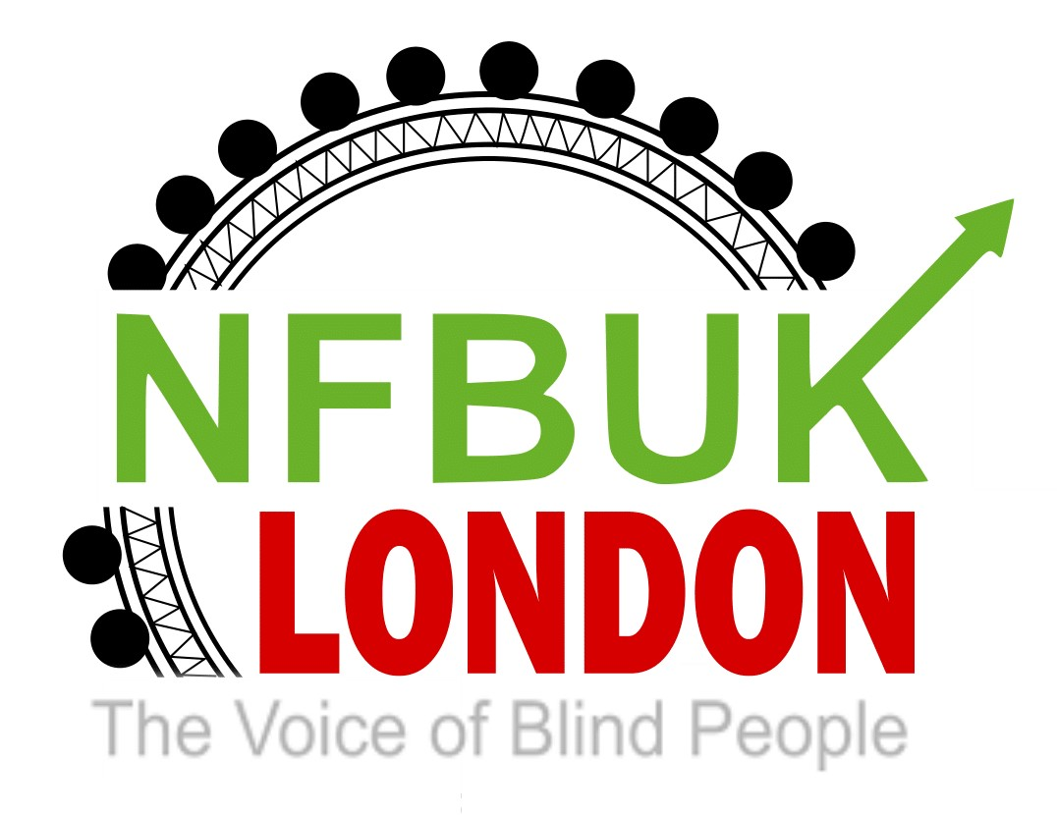

Hi London members

As we sizzle and melt, under never before seen temperatures in our region, sit back, along with your iced drink of choice and enjoy your 42nd edition of London Life.
If you would like to contribute to our next edition please email London@nfbuk.org
This edition includes:
- Next London branch meeting changed to Zoom only
- Members urgently needed to put names forward for NFB AGM in September
- Register for our 45th Eastbourne weekend!
- Saturday lunch with London NFB by member Priti Damania
- Saturday lunch with London NFB by member Arthur Payne
- Saturday lunch with London NFB by member Dolly McLoughlin
- Ahoy there sailor by London member Terry White
- Response to question from Margaret Hutchison1 Hustings 23rd June
- The very first South London Working Age Forum,
- VocalEyes: Interaction, Consent and Touch Survey
- Stargardt’s Connected are delighted to announce the return of our annual Picnic in the Park.
- Moorfields is running a project called HERCULES

Next London branch meeting changed to Zoom only

Due to the planned train strikes on Wednesday 27 July the committee has cancelled our booked meeting at the Lucas Arms, Kings Cross. This meeting will be broadcast on our usual London Zoom account at 6pm.

This meeting will include the voting session for NFB UK’s new President and two ordinary members.

If you are unable to attend in person a Proxy vote can be cast on your behalf by another member. Please email us london@nfbuk.org if this is your option.

The candidates are:

For President

Sandy Taylor - West Scotland Branch
Karl Farrell - London Branch

Ordinary members:

Two places are available.

Steve Springthorpe - Nottingham Branch
Sarah Ledbetter - Midland branch
Liz Silver - Coventry Branch

The voting process will be explained to those attending the meeting and it will contain two independent tellers recording the votes.

Members urgently needed to put names forward for NFB AGM in September

This takes place on Friday 23rd September from 1pm to Saturday 24th September 2022.

This year the AGM takes place in a four-star hotel located in Loughborough. Facilities include a spa, pool, and bars.

Starting on Friday afternoon with a welcome from the EC this will be followed by a Campaigns workshop. Over the past year members and staff have worked hard on a range of campaigns from E: Scooters, Bus stop by passes and the importance of rehabilitation Speakers from these campaigns will make presentations to engage attendees.

Friday evening will be organised by the AGM Planning Forum and will include: a three course meal, after dinner speaker (to be confirmed), Past, Present and Future presentation using technology and live interaction, a quiz followed by live music through the magic of Zoom from Sweden.

The AGM Planning Forum have worked incredibly hard to ensure all attendees needs will be met including providing an audio tour before the weekend and producing an Information Pack supporting the event. All attendees will receive a commemorative gift to celebrate our75th birthday.

The main AGM business which takes place on Saturday fall under the management of the EC supported by our staff member Louisa. Following this will be the results of the raffle and a number of other workshops and forums to be confirmed. There will also be the option to have dinner in the hotel on Saturday evening and to engage with members from across the UK as we reflect on the past 75 years of NFB UK.

Please email us london@nfbuk.org to express your interest.
The successful delegates and observers will be notified within two weeks to ensure they take advantage of lower price rail tickets.,

Register for our 45th Eastbourne weekend!

The Eastbourne Revellers Team have been working hard to deliver this year’s Let’s Celebrate Eastbourne 2022. This marks 45 years of the NFB London branch running this weekend designed by and for blind and partially sighted members.

There is still time to register your place.
Activities include a Bucks Fizz reception, all evening meals and breakfast, Friday night disco, Saturday night live band, Sunday night Eastbourne’s Got Talent, supported by RNIB this weekend provides so many activities specifically designed for you.
Please remember these activities are only free to residents of the Cumberland Hotel.

To make your reservation please complete this online for

https://docs.google.com/forms/d/e/1FAIpQLSfUb1g0voZ61zZt01tkw15OxP9qpzNZcK5iTzN3sugllyTIVA/viewform?usp=sf_link

Saturday lunch with London NFB by member Priti Damania

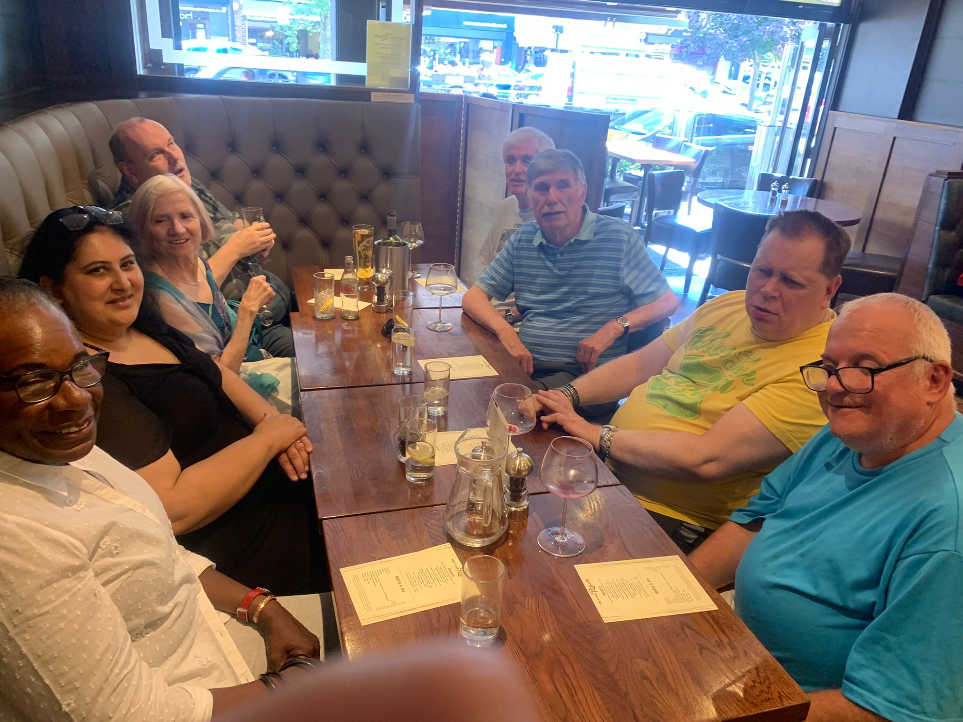
The above photo is of eight members seated at the table.

On a gloriously sunny and warm Saturday, 9th July, I waited at Hatch End overground Station for those that had requested to be met and we walked down to the restaurant together.
The staff couldn’t do enough for us, repeating what was available, cutting up food, describing where things were on the table and assisting us to the disabled toilets.
I’d previously arranged for separate bills in advance as some were ordering from the lunch menu and others from the pricier a la Carte menu. The waitress who seated us wasn’t made aware of this, but the matter was quickly resolved before we ordered so that we were able to pay as we wanted.
The meal I had was very tasty and my sirloin steak melt in the mouth. I think everyone enjoyed the food, I’d definitely go there again.
There were 8 of us altogether and I had a lovely time. One of the things I missed during lockdown was physically being amongst others and it was so nice meeting old friends and getting to know those I’ve spoken to through WhatsApp and zoom etc. there was lots of chatting and a good few hours passed before we went home.

Saturday lunch with London NFB by member Arthur Payne

On Saturday 9 July I went to the steak restaurant in Hatch End along with my friend Jimmy. We left Bexleyheath in Kent at 9.15am and caught a bus through to Abbey Wood. From there we caught the Queen Elizabeth Line to Paddington, the Bakerloo Line to Queen’s Park and the Overground to Hatch End. The assistance at each point was very good although there was some initial confusion at Paddington as they thought we were wheelchair users but this resolved itself fine We had to get helped off the train at Hatch End as the gap was very large. We met seven others and walked to the restaurant which was only just down the road a few minutes. The service was very good, but we had to make them aware that we wanted individual bills. Most people were paying in pairs with the odd one paying on their own. Anyway the quality of the food was very good. I had calamari followed by rib eye steak, chips, French beans and mushrooms. Also had a delightful sweet which was similar to an Eaton mess. Jimmy had the chicken liver pate which he really enjoyed. He too had the steak and the same dessert which he also very much enjoyed. The place was expensive, but it was made more expensive by them adding on the service. However, it was all top quality and we had some great camaraderie amongst everyone.

Coming back, we did receive ramp assistance at Hatch End and Queen’s Park. I would certainly recommend it as a visit but warn that it is expensive.

Here’s a photo of the starter - an iron basket with calamari with a wedge of lemon and aioli on the side.
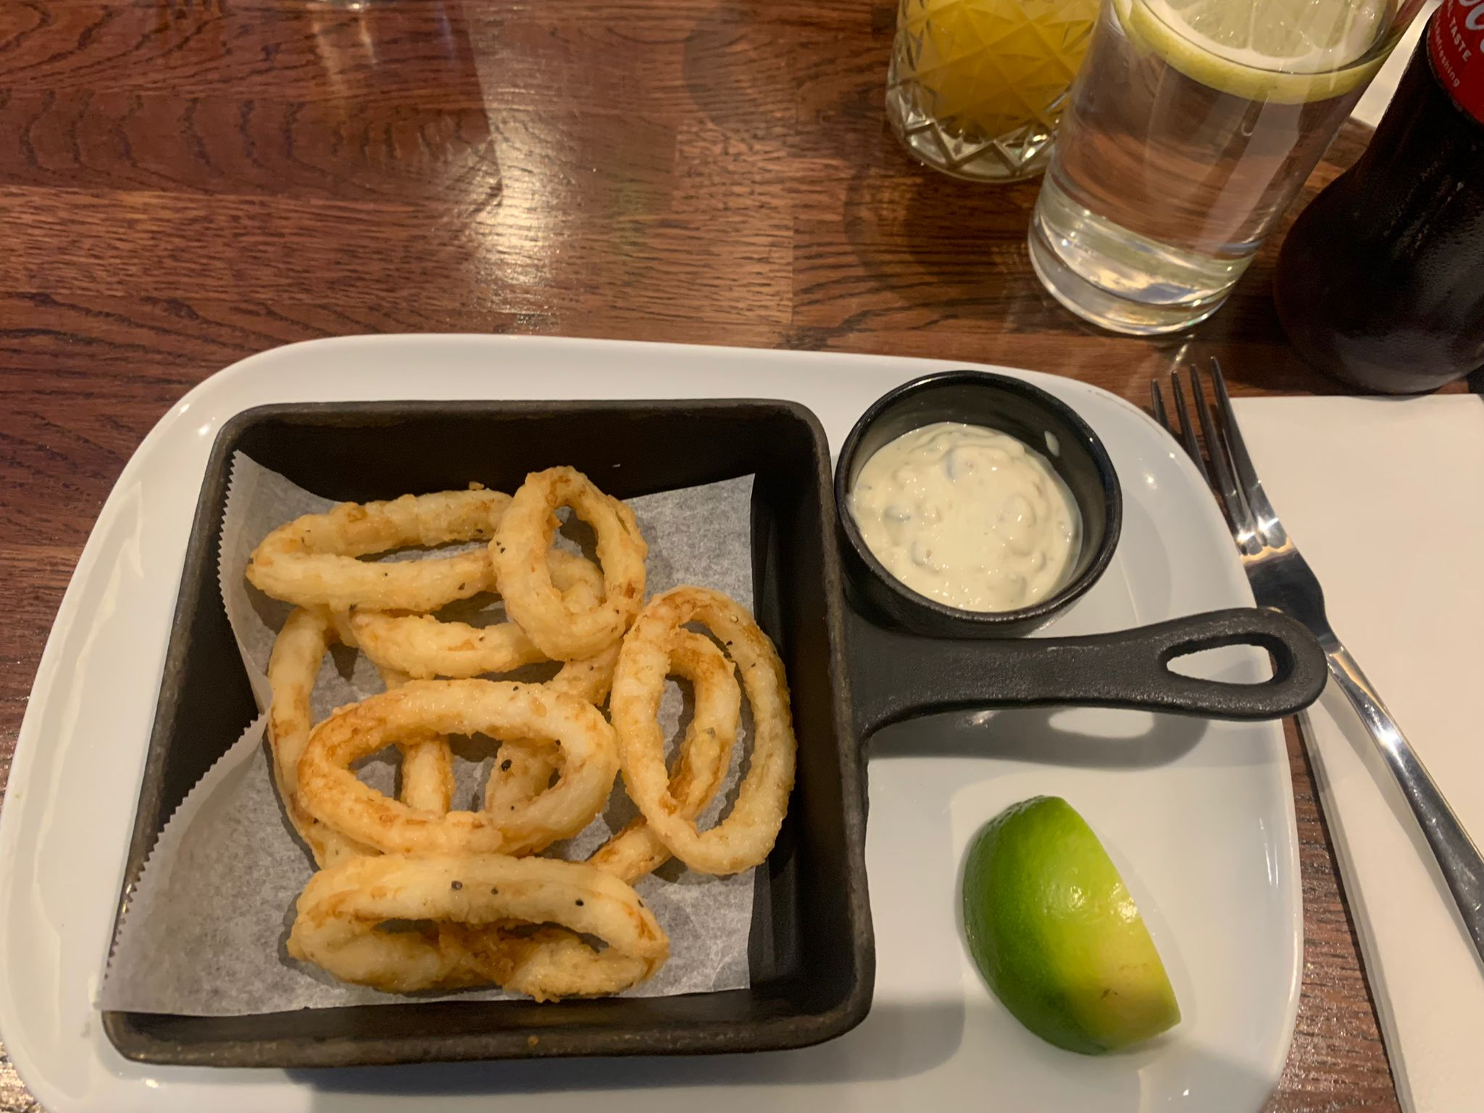

Saturday lunch with London NFB by member Dolly

A comment from a sighted friend and fellow diner on the day about the decor at the Steak Restaurant: Decor very clean and nice. For some people it might be a tad old fashioned, but it is very comfortable. Also, they still kept the plastic separation walls between the tables which makes it somehow safer to eat there. No other restaurant in the area has kept them. On my last visit to the restaurant, I had the lamb cutlets, and they were absolutely cooked to perfection.
The facilities were spotless and accessible.

Thanks to Priti suggesting The Steak House in Hatch End for this NFB Social Lunch outing. There were 8of us meeting at Hatch End station and we walked the short way to the restaurant which was on the same side. The Met line to Harrow was totally down and this may have led to several people unable to make it.

A large table was laid for us, jugs of iced water at the ready on request. The staff were very helpful, giving us plenty of time to choose from a wide variety, repeating gladly when needed and cut up the food, which I really appreciated, as well as transferring side dishes to our plate. The food was gourmet/connoisseur status in several opinions, and we all agreed that it was indeed amazing. Although the name of the restaurant is misleading in that they also offer a large and various vegetarian/vegan choice in their menu, special requests, i.e., gf are offered. The special offer is 2 courses for £16, the portions large with a large L. Two of us were totally repleted and didn’t manage a dessert.

The price for a la carte is rather higher and the speciality extra sauces can add to your bill, but very delicious. We all enjoyed each other’s company and chatted comfortably as we hadn’t been face to face since our great lunch event at NFB Christmas get-together.

The photo below is of a plate with a sirloin steak, French fries and chili, garlic and butter French beans.
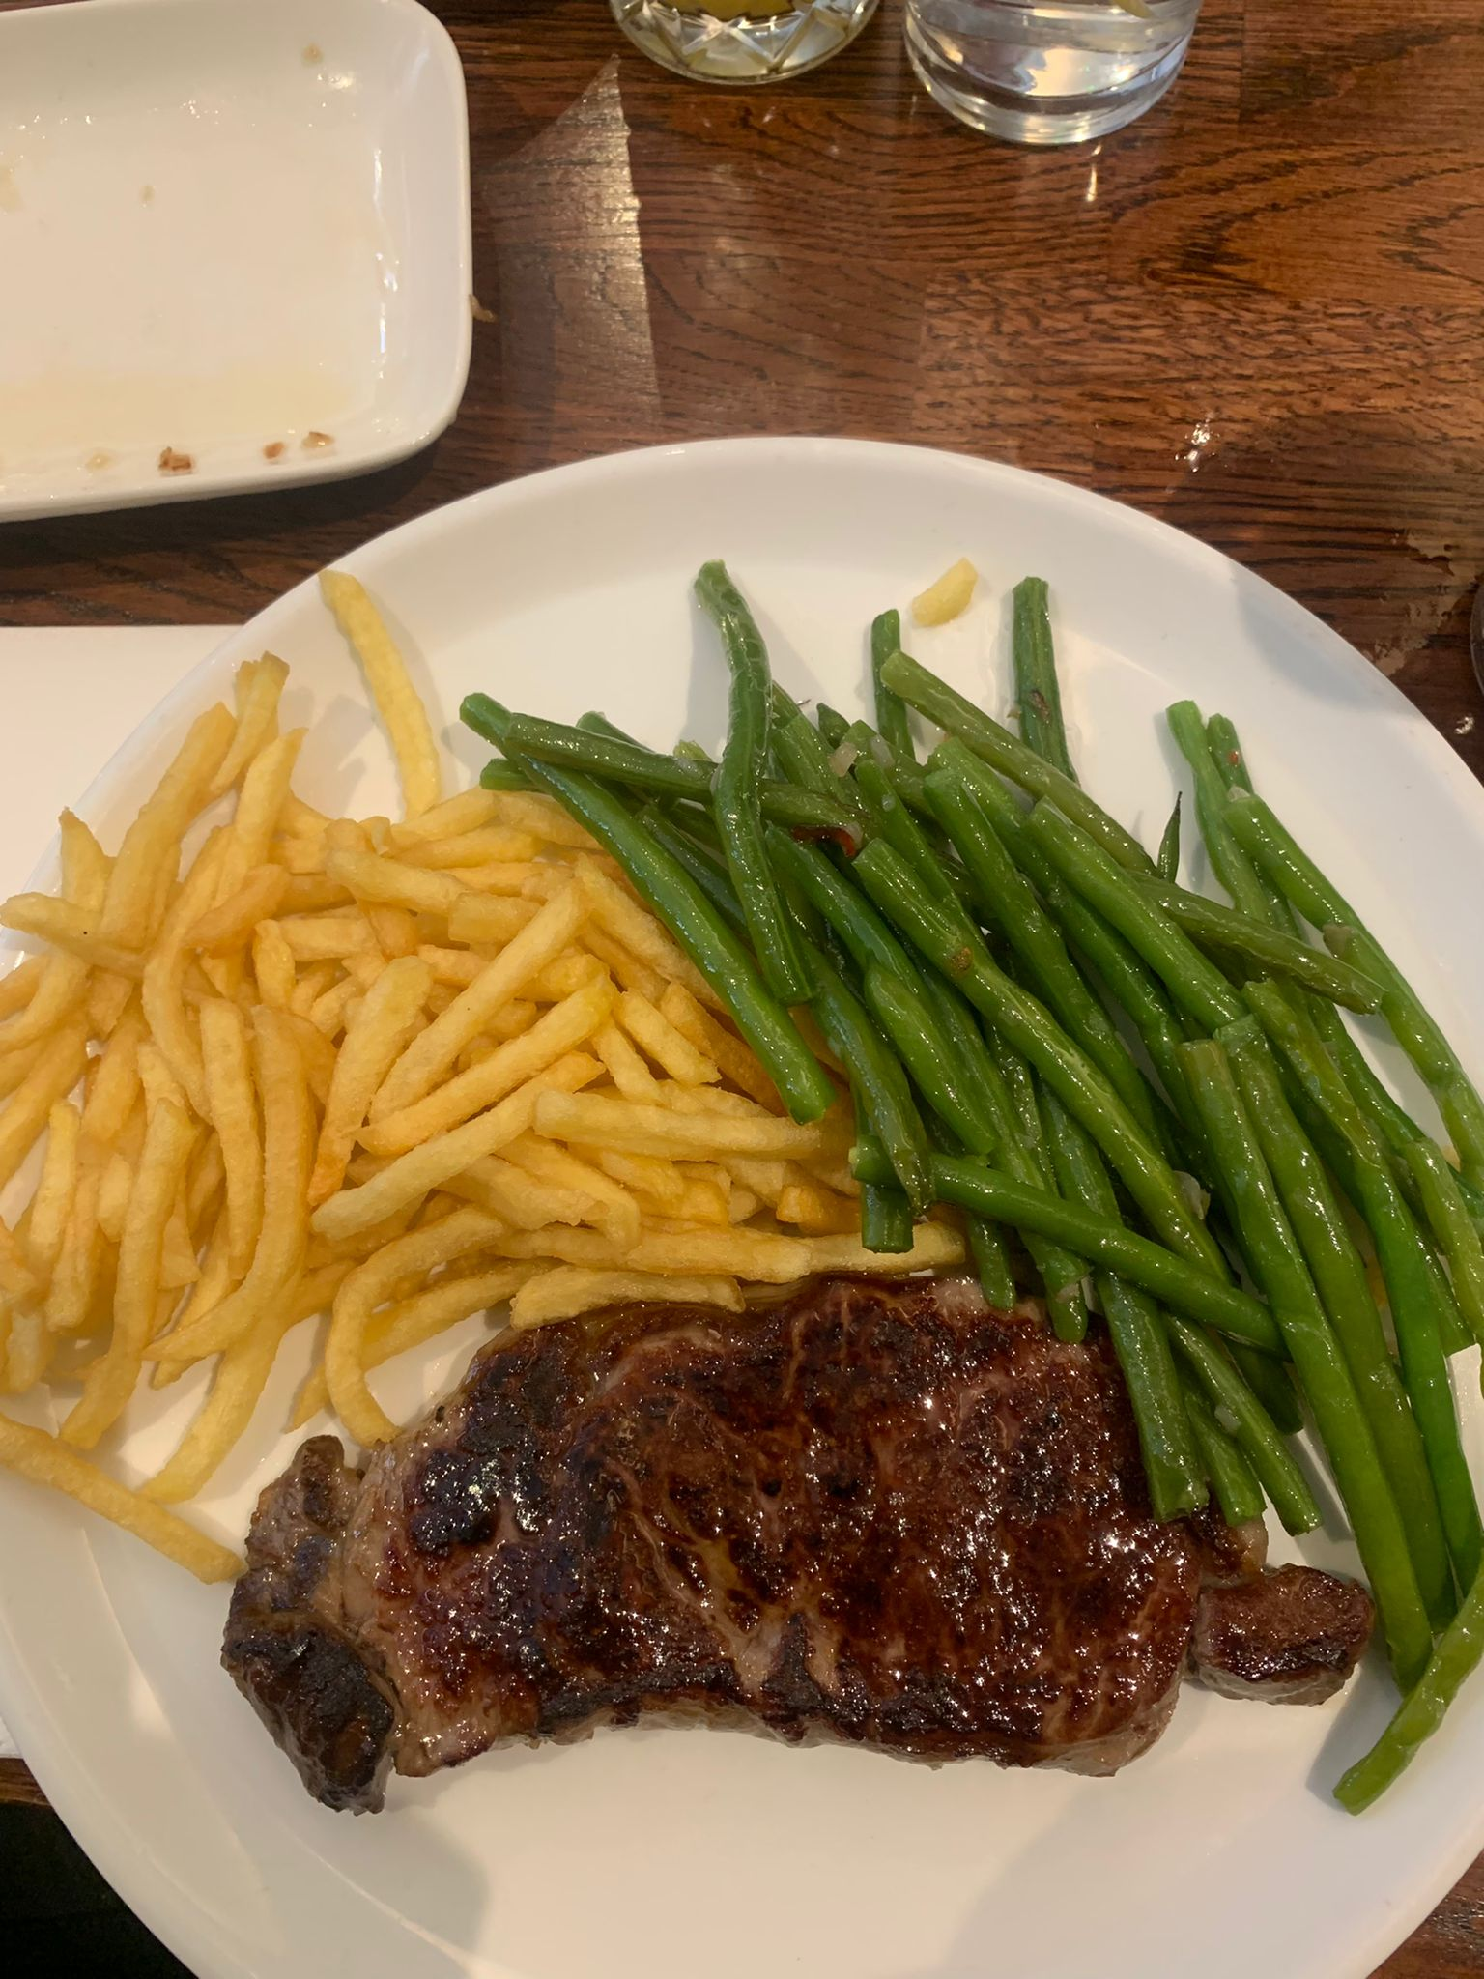

Ahoy there sailor by London member Terry White

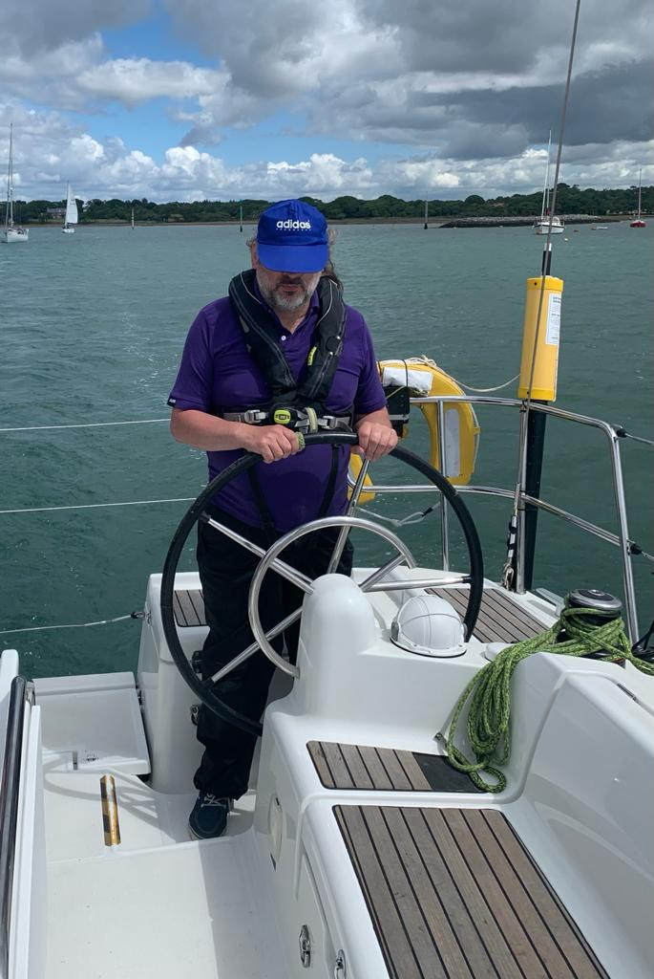

﻿Above is a photo of Terry steering the boat

After being on dry land for the last two years, NFB member Terry right couldn’t wait to go away sailing along the coastline of England.

Blind sailing week who organise this trip, always takes place on the first week of July. Boat owners with the skippers welcome blind and partially sighted people on board the boat, It starts from Southampton to sell along the Coast. The boat docks every night, wherever possible, in different ports. They have two or free passengers in every boat as well as volunteers. Everyone is encouraged to help out, cooking cleaning putting up the sales as well as being on the helm.

The video shows Terry white steering the helm on the boat out on the open sea with the sea breeze blowing on his face.

For more information please click here https://www.metroblindsport.org/visually-impaired-sailors-week-02-09-july-2022/

Response to question from Margaret Hutchison1 Hustings 23rd June

Due to time constraints of the hustings meeting and the nature of the answer needed Karl Farrell has requested all members see this response.

Question for Carl Farrell (Presidential Nominee) As a Branch member and Campaigns supporter, and in the interest of transparency, please itemize how the money in the National Campaigns Fund has been spent, in the last 2 years?
(To date, this has never been produced, despite several personal requests for this information and promises to do so)

Hello Margaret

Here is my reply to your above question. The two years I assume you are referring to are 2020 and 2021. The 2021 accounts are yet to be approved so I will use preliminary figures based on our Office records.

We can start with the 2020 figures. I present the information on spending in paragraph format which may be easier to read than a series of columns.

In 2020 the Campaigns Fund received several large donations, namely: £1000 from Leeds Branch, £1000 from an anonymous donor and donations of £1000 and
£500 from individual members, plus a number of smaller one-off and regular payments. So there was money in the Campaigns Fund to pay out.

I list the money paid out supported by the Campaigns Fund giving: date of claim, name of recipient, purpose of spending and amount: -

07 Jan 20, Andrew Hodgson, #4,5,6, £211.25.
14 Jan 20, Peter Monk, NRAC conference and Swindon Meeting, £186.40.
03 Feb 20, Andrew Hodgson, #20 Swindon SS, £42.55.
10 Feb 20, Sarah Gayton, BBC Red Button campaign, £649.25.
12 Feb 20, Sarah Gayton, #25 DFT Meeting, £30.16.
12 Feb 20, Sarah Gayton, #26 Campaigning, £41.00.
12 Feb 20, Sarah Gayton, #27 Petition London, £88.30.
12 Feb 20, Sarah Gayton, #28 Glasgow Meeting, £33.75.
12 Feb 20, Sarah Gayton, #29 Scotland Meeting, £104.05.
12 Feb 20, Sarah Gayton, #30 Preston Meeting, £74.70.
12 Feb 20, Sarah Gayton, #31 London Event, £33.00.
12 Feb 20, Sarah Gayton, #32 TFL NFBUK Meeting, £28.50.
12 Feb 20, Sarah Gayton, #33 TFL Meeting Lunch, £30.16.
12 Feb 20, Sarah Gayton, #34 Leicester Filming, £21.45.
27 Aug 20, Sarah Gayton, #96 travel to campaign meeting, £128.00.
23 Oct 20, Sarah Gayton, Expenses, £494.80.
30 Nov 20, Sarah Gayton, November Expenses, £420.79.
21 Dec 20, Sarah Gayton, November expenses, £301.08.

Total paid out in 2020: £2,919.89.

In 2021 the Campaigns Fund began the year with £2,385.87 in hand. Through the year, it received £990 mainly made up of monthly payments and also a few one-off donations. All but just over 5% of those donations came from members living south of the Wash.

Once again, I list the money paid out supported by the Campaigns Fund
giving: date of claim, name of recipient, purpose of spending and amount: -

13 Jan 21, Sarah Gayton, Dec 2020 Expense, £117.99.
23 Feb 21, Sarah Gayton, January Expenses, £118.34.
10 Mar 21, Sarah Gayton, March Expenses, £131.50.
06 Apr 21, Sarah Gayton, March 21 expense, £124.58.
19 May 21, Sarah Gayton, April 21 expenses, £109.82.
23 Jun 21, Sarah Gayton, May 21 expense, £279.81
26 Jul 21, Sarah Gayton, June 21 expenses, £233.40.
18 Aug 21, Sarah Gayton, July expenses, £383.67.
06 Oct 21, Sarah Gayton, expenses Sept 21, £250.00.
02 Nov 21, Sarah Gayton, expenses Sept 21, £247.67.
26 Nov 21, Sarah Gayton, November expenses, £246.34.
02 Dec 21, Sarah Gayton, Nov expense, 45.08.
22 Dec 21, Sarah Gayton, Expenses owed 2021, £207.21.

Total paid out in 2021: £2495.41.

I hope this adequately answers your question. I feel it could only properly be responded to in writing.

Karl Farrell
Vice President (Acting Treasurer (
NFB UK

The very first South London Working Age Forum,

I am super excited to announce the very first South London Working Age Forum, bringing together Croydon, Merton, Sutton and Kingston Associations.
The first session is taking place on Tuesday 26th July @ 6.30pm-8pm at Merton Vision.

We will be inviting inspiring guest speakers and sharing solutions, information and addressing issues faced by blind and partially sighted people looking to develop skills and get into the job market, stay in employment or develop their careers.
It is also a great space to meet likeminded people, network, meet new and old friends!

We will be rotating the meetings through the 4 boroughs; we have not yet decided if it was going to b e a monthly or bi-monthly meeting. I will keep you posted as to when the next one will take place.

The meetings are open to anyone even if from outside the named boroughs, all are welcome!

Odette Battarel
Community Dynamo
Monday - Friday 9:00- 17:00
Bedford Hall, 72 - 74 Wellesley Road, Croydon, CR0 2AR
020 8688 2486
@CroydonVision
Odette.battarel@croydonvision.org.uk
www.croydonvision.org.uk

VocalEyes: Interaction, Consent and Touch Survey
If you have attended a VocalEyes audio-described performance or experienced a touch tour at a museum or gallery we are interested in your opinions. Whether it’s feedback about sighted guiding, interacting with props and costumes or support exploring tactile art, we want to hear your perspectives. By sharing your thoughts, you will also help us develop new training and resources so that more theatres, museums and galleries can welcome blind and visually impaired visitors.
Please complete the survey via Google Forms. Alternatively, complete the attached Word version and return by email to enquiries@vocaleyes.co.uk. If you would like to submit responses via telephone, please contact Robyn Horne, Programme Officer at enquiries@vocaleyes.co.uk.
Read full details on the new project to empower blind and visually impaired people who use VocalEyes’ services at:
https://vocaleyes.co.uk/interaction-consent-and-touch-workshop-and-survey/

Stargardt’s Connected are delighted to announce the return of our annual Picnic in the Park.

● When: Sunday 24th July 2022

● Time: 1pm - 5 pm

● Where: Parade Ground, Hyde Park, London, W2 2UH

● Nearest Tube: Marble Arch 5 minutes’ walk to the park

Bring your own picnic and have the opportunity to informally network and meet other people with Stargardt’s and their families.

There will be friends from Stargardt’s Connected in the Charity yellow t-shirts and yellow banners at the picnic to help you find your way.

Let us know if you will be attending by emailing us at stargardts183@gmail.com.
We hope you can join us!
Best wishes from the Stargardt’s Connected Team

Moorfields is running a project called HERCULES

Moorfields is running a project called HERCULES which is looking at building new and efficient healthcare delivery systems in the NHS after the COVID-19 pandemic.

As part of Project HERCULES, which is a collaboration between, National Institute for Health and Care Research Biomedical Research Centre, Moorfields Eye Hospital NHS Foundation Trust, University College London (UCL), we are hoping to identify important features that people think about when deciding where to go to get their regular eye check-ups.

We are looking for people to complete a brief survey. Your input will help us identify patients most important priorities which will inform a smaller survey which will be widely distributed.

The survey is anonymous and takes approximately 15 minutes to complete and it will close on July 31st, 2022.

To participate in the survey, please click on the following link:

https://redcap.link/sfk4lj1e

If you are interested in learning more about the project, you can visit this link:

https://www.ucl.ac.uk/epidemiology-health-care/research/applied-health-research/research/health-care-organisation-and-management-group/hercules

Or contact:

Saheli Gandhi
Research Project Manager for HERCULES
Email: Saheli.gandhi@ucl.ac.uk

Wow still hot!!! Thanks to all who contributed to this edition of London Life. We love hearing your adventures and recommendation so keep sending in your articles to
london@nfbuk.org

Keep “walking on sunshine” using plenty of sun cream!!!!!!

Kind regards
Fiona

