London NFB logo image: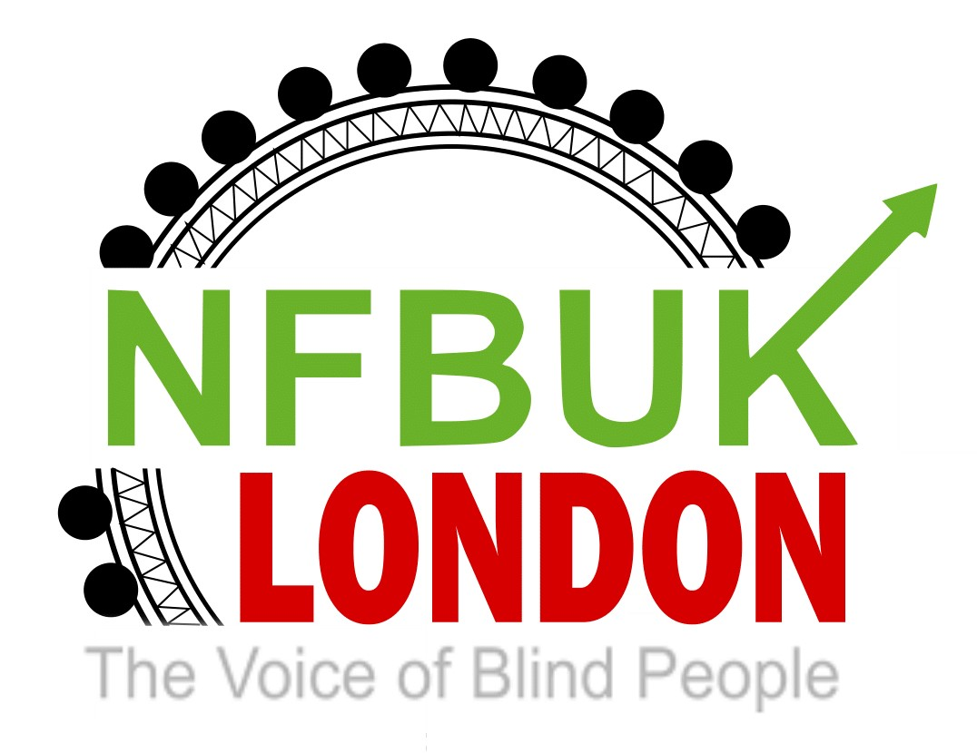

Dear London NFB members,
Welcome to edition 39 of London Life. Thanks as always to all our contributors, please do keep sending articles to include, we always love hearing from you. In this edition:
- Next London NFB branch meeting – zoom only – Wednesday 29th June
- Next Sunday social – Sunday 12th June
- Eating out with London NFB - Social lunch at The Steak Restaurant
- Book your place on our 45th Eastbourne weekend
- Transport update from Martin Wilson
- NFB UK news – new Midlands Connect branch
- Weston-Super-Mare Visit – 27-31 May 2022 by Arthur Payne
- How technology has changed our lives from NFB member Peter Wilkins
- London Travelwatch - Bus consultation - have your say
- MPs urge headphone ban for scooter riders - The Mail
An article in the Mail on Sunday featuring NFB’s Sarah Leadbetter

Next London NFB branch meeting – zoom only – Wednesday 29th June
Please join our next London NFB branch meeting on Wednesday 27th June at 6pm. Our fabulous vice-chair Berin will be stepping in to host the meeting and it will be a zoom only meeting on the regular NFB link. Our hybrid style meetings will continue again in July. We’ll be in touch with an agenda and details of our guest speaker.

Next Sunday social – Sunday 12th June
We still see value in providing streamed opportunities for our members to meet. Over the past years we have joined in Keep fit, quizzes, games and singing. Our next Sunday social for members is scheduled for Sunday 12 June live from 4pm, hosted by Fiona.
Access is by the usual London NFB Zoom link - any problems please email london@nfbuk.org

Eating out with London NFB - Social lunch at The Steak Restaurant
There are still a few places left for our next social lunch. Please contact Priti asap if you’d like to join us in July.
We are delighted to arrange a social lunch at a restaurant in Hatch End, Northwest London which serves tasty British food including fish, chicken and vegetarian options, steaks being their speciality. They have a lunch time offer of one course for £12.95 and two courses (starter and main) for £15.95.

You could opt for having either the lunch offer or going for something from the A la carte menu. Each of the menus are attached further below. The restaurant has kindly offered to do separate bills, payment to be made on the day. It’s step free and welcomes guide dogs.

When: Saturday 9th July 2022 at 12 noon
Where: The Steak Restaurant, 316 Uxbridge Road, Hatch End, London HA5 4HR
Nearest Station: Hatch End on the overground, Euston to Watford Branch, the restaurant is approximately a 5-minute walk from the station
Meeting point: Hatch End Station at 11.45am

There is a limit of 14 spaces available, so please book early to avoid disappointment. To confirm your place, please send an email to.
pritidamania11@gmail.com

Please confirm your menu choice and whether you’d like to be met at the station.

Lunch time offer menu
Special Lunch Menu – The Steak Restaurant – Hatch End

A la carte menu
A La Carte Menu – The Steak Restaurant – Hatch End

Membership renewal reminder
A huge thanks to everyone who has renewed membership for 2022. So far nearly 60 people have paid their annual subscription of £16 to the London branch of NFB UK. If you have any concerns or queries relating to your membership or need further support, please email Fiona at london@nfbuk.org
Priority will be given to all London members for limited access to our exciting Eastbourne weekend in October

New on-line Membership form for London NFB
All London members will be receiving a reminder to ensure they have completed our on -line membership form. This applies to all ordinary, associate and life members.
https://docs.google.com/forms/d/e/1FAIpQLSejGhs4xhoiiUuo9XlnpNgwTqzd-M0XcsgTpCF8TRyZ50nrew/viewform?usp=sf_link

This does not apply to members who joined after March 2021.

The committee have agreed this change to ensure you are receiving the best support possible when you attend our events. Please email us if you have any concerns or require help completing the form.

Book your place on our 45th Eastbourne weekend
We can’t wait to welcome you at our 45th annual Eastbourne weekend, this year taking place from Friday 14th to Monday 17th October at the Cumberland Hotel. The Eastbourne Revellers team have been busy planning a fun weekend of activities for you including the Angels choir, Romanian dancing, a live band, disco, raffle and more! Before booking your place, please make sure you have paid your annual NFB membership subscription, please email us if you need to check. Then complete the Eastbourne registration form to book your place for the weekend. Again, please email if you’d like help to fill in the form and a member of the team will contact you. And remember if you are sharing a room, either twin or single, both people need to complete the registration form so we have details for everyone who will be joining us.
https://docs.google.com/forms/d/1iBX7Nrx-HMtxfeVy93ro3fHnuX9n2iu8Asig1lZjG38/edit

Transport update from Martin Wilson
On the 26th of May I attended a webinar hosted by the Centre for London giving an update on the e-scooter trials in the 10 London boroughs taking part.

There were four speakers on the panel. The sight loss council reminded everyone about the dangers for vision impaired people caused by these scooters. Emma Gibson from London Travel Watch spoke about their safety campaign including the fact that they must have a built-in alert sound so we can hear them coming. Then Helen Sharp from TFL updated us on the trials and said they were learning a lot and the trial would be extended until the end of November, and this would allow time for the alert sound tests. The best speaker, in my opinion, was Chief super intendent Simon Ovens from the road traffic division of the Met Police. He really slammed the safety of these scooters, saying that they are too small, too lite not sturdy enough and must have larger wheels. He finished by saying that as they are designed now they are just not road worthy.

I intend to make contact with these speakers and think we should invite Emma and Simon to speak at a branch meeting later this year. All three scooter, Line, Tier and Dot were invited to watch the webinar, so I hope they took note of what was said by the speakers.

As a foot note Simon said he has a blind sister, and she has had several near misses with e-scooters.

Finally, if you are going to Blackpool next week with a sighted guide, they can now pay with a contactless bank card on the trams as all conductors now have handheld card readers, so they can just tap their card to pay their fare.

NFB UK news – new Midlands Connect branch
The approval letter
NATIONAL FEDERATION OF THE BLIND OF THE UK
BRANCH SECRETARIES – BSEC-22-10

From: The President

To: EC Members
Branch Secretaries
Members of Central Branch

Date: 31st May 2022

Subject: Approval of Midlands Connect branch

The Executive Council is announcing their approval of The Midlands Connect branch nominally covering Leicestershire, Derbyshire and Staffordshire. The group of people who wish to start this branch have satisfactorily fulfilled all the requirements set out in our Constitution.

Weston-Super-Mare Visit – 27-31 May 2022 by Arthur Payne
Above is the Lauriston hotel logo

On Friday 27 May I went to Weston-Super-Mare along with my friend Jimmy Jones. We went to the Lauriston Hotel for an event held by my old school Dorton House.
We left home at 12 noon and caught a bus to Abbey Wood Station. From there we caught the Elizabeth Line to Paddington which only takes 29 minutes and is totally step free. The assistance at all stations was excellent. When we arrived at Paddington, we were shown to the special assistance area and caught a direct train at 2.32pm first-class. Where a journey is direct and over two hours’ duration we like to travel first-class if heading for other seaside towns.

When we arrived at Weston-Super-Mare, we took a taxi to the Lauriston Hotel. We noticed an obstacle fairly close to the step free entrance to the hotel a plant pot and this caused Jimmy to fall over but he was fine. The hotel staff were very good and explained when mealtimes happened and showed us to our room. I thought it was going to be difficult to find as there were several corridors to go down once reaching the first floor and then having to go down some steps, but I managed the route fine. Room doors were opened with a key not a card.

The meals were very good on the whole with four choices for each course. We had to sit at the same table for every meal and opposite us were John and Sheila Garvett. This was great as we all knew a lot about 60s music so we had lots of musical conversation.

Our double room was very good in size. The bathroom was very small and realistically you could only have one person in there at a time. We had a walk-in shower, and this worked fine. The room was provided with teamaking facilities. It also had a TV.

On the first night we just stayed in the bar. All drinks were put onto a bill, and you paid at the end of the stay. If you wanted, you could pay each night at the end of the evening.

On Saturday we had a full breakfast and there was a choice of cereals. Following this as it was a lovely day, we walked along the seafront to the pier. It was quite a big pier with shops and an amusement arcade at the end. We were hoping to undertake tenpin bowling on the Monday afternoon, but the place is still being built and will be on the pier at some stage. We had fish and chips in a café there and then continued to enjoy the sunshine.

There were shops and pubs fairly close to the hotel. We managed to purchase some homemade fudge which I always like from seaside places. The whole area is very flat so easy to walk around. One of the pubs close to the hotel had an Elton John singer and this was very good as we were able to sit outside and listen.

On the Saturday evening we had other friends from the RSBC and Dorton Members Association join us for the rest of the weekend. We were given a complimentary drink of our choice using a voucher. Following dinner, we all were in the bar socialising.

On Sunday following breakfast there was a rehearsal for the talent night which was to follow later that day. A service took place in which we thought about all the people that had passed away since our last physical meeting and we sung a number of hymns including Praise my soul the King of Heaven, Majesty and our school hymn Our Father by whose Servants. A number of us gave talks on people who had passed away and I mentioned Jane and Brian.

Following the service, we had lunch at a pub just outside of the hotel. We were meant to have an Annual General Meeting of the Association, but this could not take place due to one of the principal officers not being well enough, so we just stayed around the hotel.

Following dinner on the Sunday we held a talent evening. I played the REM song Losing My Religion. I also accompanied Jimmy who sang I’ll Never Find Another You. Some people sang or read poetry. About eight people took part in what was a very good hour of variety.

On the Monday, the weather was cloudier, but we still managed to get to the seafront and went to another café.

On the Monday evening we had a singsong for about an hour, but another group had come into the hotel and interrupted our enjoyment with a combination of Irish country music and songs from the 60s.

On the Tuesday following breakfast we made our way home. The weather was very thundery by the time we reached Paddington and we went to Jimmy’s house in Stockwell by taxi so did not get wet considering most of the drive was under the thunderstorm.

I very much enjoyed the Lauriston Hotel. Most of the food was very good. One dish though was Macaroni cheese Croquettes and the filling in the middle was cold but that was the only bad meal. We told this to the staff, and they made the chef aware. I think the staff took any complaints on board and were very good to all of us. I would certainly recommend the hotel to anyone who has not visited the Lauriston before.

How technology has changed our lives from NFB member Peter Wilkins
the Opticon

Peter Wilkins explains how he regularly uses his Opticon, thanks to Brian Payne's encouragement many years ago. Peter says,
“I actually went for training on an Optacon course at Pembridge Place.”

"Yes, I can read most handwriting with the Optacon, and I have
also been able to examine diagrams with it. I will give you
three examples.

Firstly, in 1984, when I wanted to order a CD storage cabinet, I was able to
examine it in a print catalogue, choose the one I wanted, and when it came
it was exactly as I had imagined it from the picture.

Secondly, when my kitchen was being re-designed, I was able to read the
print-out of where things would be, and this even showed up the circles
representing the rings on the cooker.

Finally, I am a member of the customer appeals panel for my
housing association. In one of the cases I had to judge, I
needed to look at print-outs of work done in a customer's home, before and
after the job was done, so I could judge whether the work had been done
properly.

The Optacon really is a great thing.
Peter"

Click here for more information: https://en.wikipedia.org/wiki/Optacon
We would love to hear more about how early technology assisted you. Please email us with details of any of your assistive technology devices.
Here’s an image of the opticon taken from the Wikipedia page.
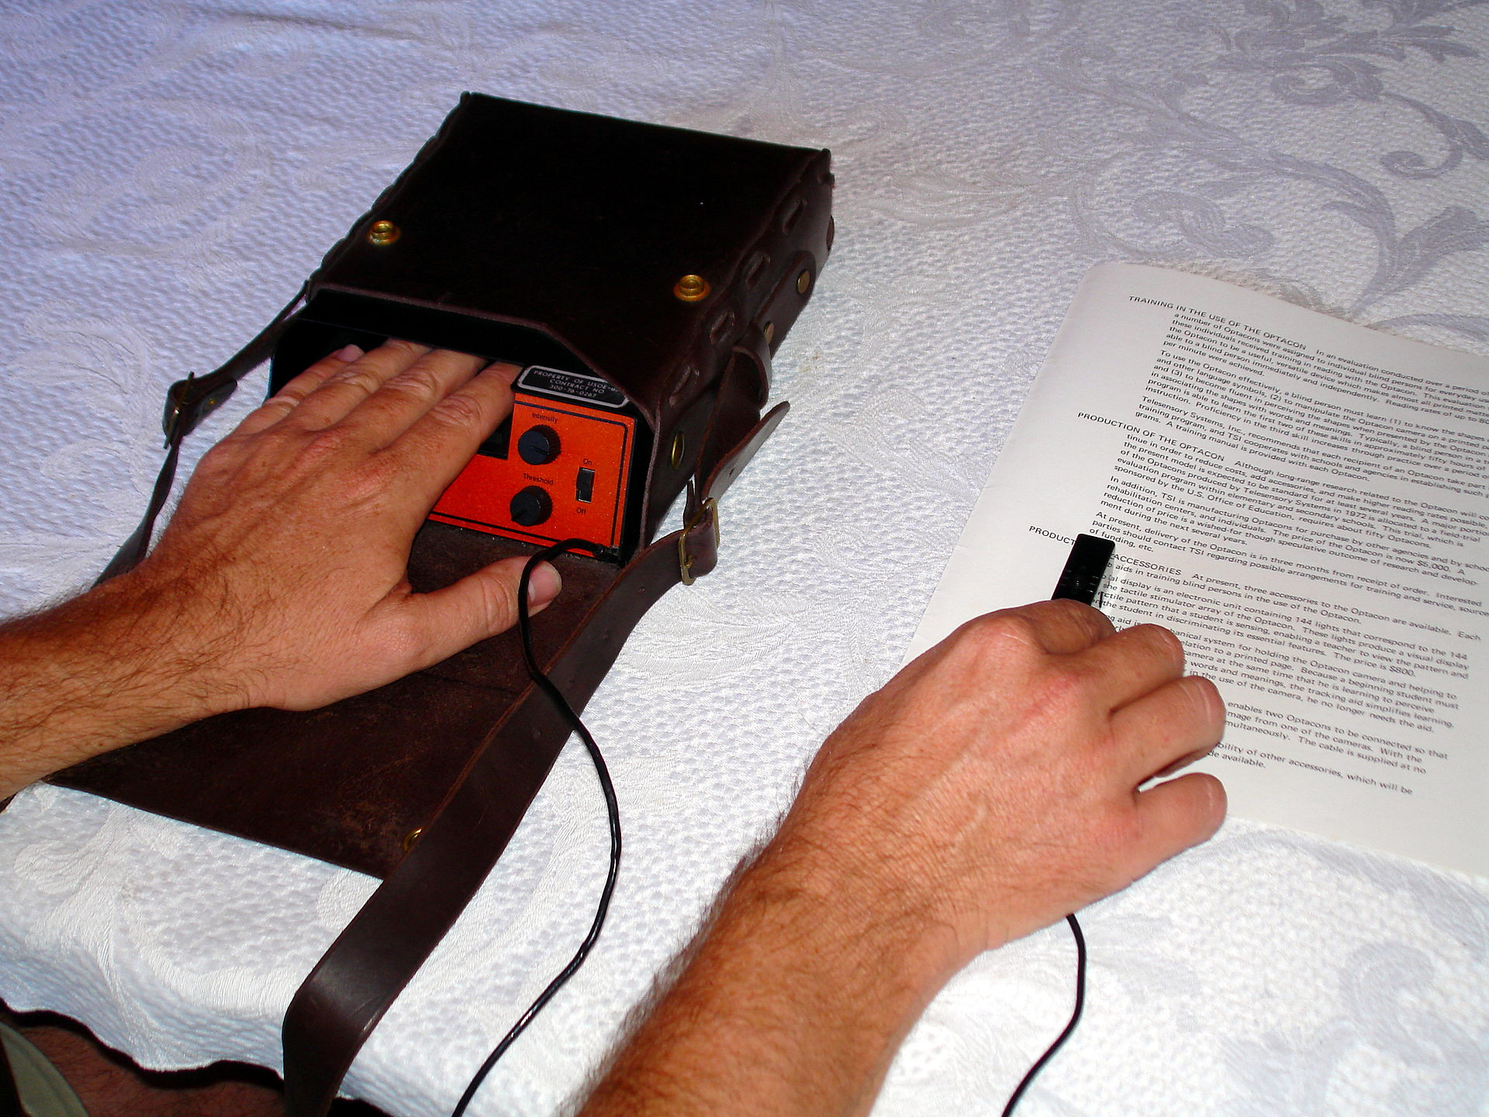

London Travelwatch - Bus consultation - have your say
We know how important the bus is to Londoners every day, with more people using it than the Tube or train.

So we wanted to let you know that Transport for London (TfL) have launched a public consultation which proposes big changes to bus services into central London. This includes proposals to withdraw some services and change the routes of others.

We encourage you to look through the proposals and tell TfL what you think. You can find out more details of TfL’s plans and how to give your feedback here.

How will these changes affect you?

We’ll be carefully considering the proposals, ahead of sending in our own response. But to help us better represent London’s bus passengers, we’re also keen to hear how you’ll be affected by the changes.

You can tell us your thoughts by emailing your comments to bus.consultation@Londontravelwatch.org.uk by Friday 24 June.

Thank you for your help

The London TravelWatch Team

MPs urge headphone ban for scooter riders - The Mail
An article in the Mail on Sunday featuring NFB’s Sarah Leadbetter
CYCLISTS and e-scooter riders should be banned from wearing headphones after a series of fatal accidents, say campaigners and MPs.
Despite headphone users being unable to hear other vehicles properly, the dangerous practice is not against the law.
Labour MP Barry Sheerman, chair of the parliamentary advisory council for road safety, said: ‘I believe urgent action has to be taken. Scooter users and cyclists are increasingly becoming victims of fatal and near-fatal accidents.’
France and Spain outlawed the wearing of headphones while cycling many years ago, while Portugal and Italy allow one ear only. In the US, rules differ from state to state.
The calls for a UK ban come after a series of deaths caused by riders wearing headphones, including Peter McCombie, 72, who died of head injuries after being hit by cyclist Ermir Loka, who was listening to music.
Loka, 23, was captured on CCTV running a red light and ploughing into Mr McCombie before fleeing the scene. He was found not guilty of manslaughter but jailed for two years for causing bodily harm by ‘wanton or furious driving.’
Last June, 19-year-old e-scooter rider George McGowan was killed after he was hit by a car while listening to music on his headphones. Neil Greig, policy and research director at the road safety charity IAM RoadSmart, said: ‘Being plugged in to headphones is the ultimate distraction, as it completely shuts you off to your surroundings, creating a potential road safety risk to yourself, pedestrians and other road users.’
He described changes to the Highway Code earlier this year as a ‘missed opportunity’ to tackle the issue, adding: ‘We would be keen to see at least, as a minimum, a major education campaign, and if that didn’t work we would be supportive of a ban.’
In 2013, Boris Johnson, then Mayor of London, said: ‘It makes me absolutely terrified to see them [cyclists] bowling along, unable to hear the traffic.’
Sarah Leadbetter, of the National Federation of the Blind, said a ban would ‘not only make life safer for the visually impaired but also for many other vulnerable pedestrians and the riders themselves.’

Well you’ve made it to the end of another bumper London Life! We’ll be back in a fortnight with more news and articles for you so please keep sending them in and any feedback on our newsletter is always appreciated.
Best wishes,
Jess
London NFB Chair

