London NFB logo image: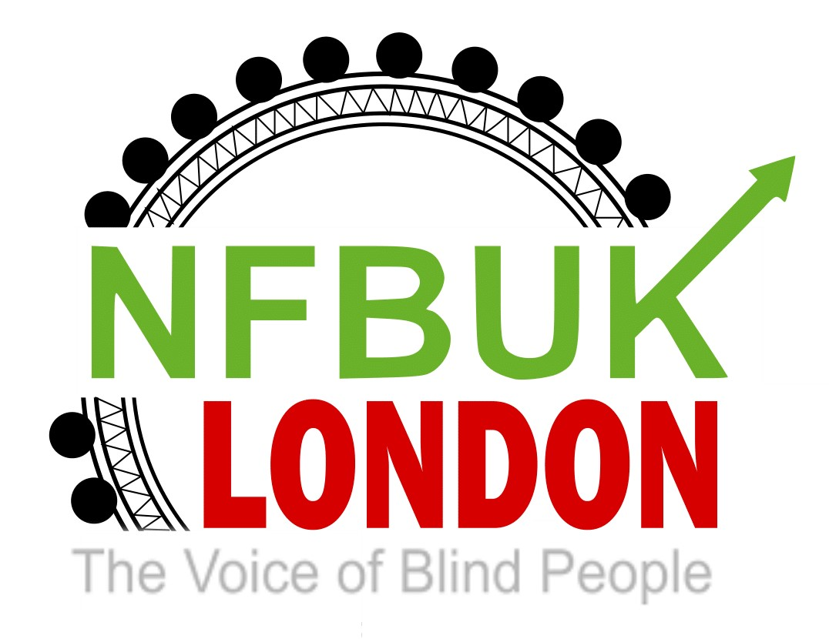

Dear London NFB members,
Welcome to your 36th edition of London Life. We really enjoy receiving articles of interest from our members which helps make this publication so exciting. A huge thanks to everyone who submitted content. Whilst you dust off your sun hats, please enjoy the following:
- Date of next Sunday Social
- Eating out with London NFB
- Looking for speakers for our monthly branch meetings from London members and Secretary Jane Sellers.
- Independent Blackpool Break in June from Pardy Gill
- Support London member Stephen appearing at the 2022 Brighton Fringe Festival
- Message from EC Trustee Karina re: new email group for NFB UK members
- NFB UK supports blind and partially sighted Ukrainian people
- Creation of AGM Forum
- Greater London Authority Pre-meeting with Inclusion London - May 3, 2022, 2 pm to 3pm
- RNIB now offers a variety of tech support
- Closure of the London Vision Information Forum
- The National Institute for Health and Care Excellence (NICE) public consultation
- Action for Happiness: Optimising Sleep - with Dr Nerina Ramlakhan - Weds 4 May, 7pm on Zoom

Date of next Sunday Social
Our next Sunday Social is planned live on Zoom on Sunday 8 May with our great friend Pardy. It will be a slightly later start time than usual so please join us at 5pm.Please check in with the usual London Zoom link for an hour of fun.

Eating out with London NFB
The Social Secretaries are pleased to announce two dates to meet and eat for London NFB members. Join us on Saturday 21st May at Kervan Sofrasr, a Turkish restaurant in Wood Green or Saturday 9th July at The Steak Restaurant in Hatch End. Thanks to Berin and Priti for organising these two fantastic lunches.

Social lunch at a Turkish restaurant, Wood Green
Saturday 21st May 2022 at 1.00pm
Kervan Sofrasr
183, hi Road
Would Green, N22 6BA

The meeting point will be at Would Green tube station at12.30pm. It is just three minutes walking distance to the restaurant.
Everyone will get separate bills

If you are interested please email Berin Beringem53@icloud.com
As she will need to let the restaurant know numbers in advance and there may be a limit on availability. Please also keep a note of your menu choices to make it easier for the restaurant to manage.
Check out the menu at:
https://kervan-sofrasi.co.uk/

Social lunch at The Steak Restaurant
It seems like a long time since we’ve met up socially so are delighted to arrange a social lunch at a restaurant in Hatch End, North West London which serves tasty British food including fish, chicken and vegetarian options, steaks being their speciality. They have a lunch time offer of one course for £12.95 and two courses (starter and main) for £15.95.

You could opt for having either the lunch offer or going for something from the A la carte menu. Each of the menus are attached further below. The restaurant has kindly offered to do separate bills, payment to be made on the day. It’s step free and welcomes guide dogs.

When: Saturday 9th July 2022 at 12 noon
Where: The Steak Restaurant, 316 Uxbridge Road, Hatch End, London HA5 4HR
Nearest Station: Hatch End on the overground, Euston to Watford Branch, the restaurant is approximately a 5-minute walk from the station
Meeting point: Hatch End Station at 11.45am

There is a limit of 14 spaces available, so please book early to avoid disappointment. To confirm your place, please send an email to.
pritidamania11@gmail.com

Please confirm your menu choice and whether you’d like to be met at the station.

Lunch time offer menu

Special Lunch Menu – The Steak Restaurant – Hatch End

A la carte menu

A La Carte Menu – The Steak Restaurant – Hatch End

Looking for speakers for our monthly branch meetings from London members and Secretary Jane Sellers.
Just to let you all know I have been busy asking people to be our speakers.
So far, I have contacted the Sight loss council and asked if Jackie could bring a colleague with her, and I also trailed the Moorfields web site and have submitted a question asking if they could come and give an update. I have suggested June 29 for Moorfields and July 27 I have asked if Jackie Thomas could attend then.

If you have any other suggestions for speakers or areas of interest, please contact Jane on the NFB London email address.

Independent Blackpool Break in June from Pardy Gill
The independent Blackpool social week is returning in June at a great value preferred rate. In 2019, some 60 VIPs including 30 from London enjoyed the break. So whether it’s a trip to nearby Lytham St Anne’s, the Pleasure Beach, Tower Ballroom and various attractions, a walk along the Promenade, a ride along the Tramway to Fleetwood or just socialising and connecting with old and new friends, the choice is yours.

Need to Know
• Dates: Monday 13th to Friday 17th June 2022, flexible stay up to 4 nights.
• Price including breakfast and evening meal per person per night: £40.50 sharing a double or twin room, £50.50 single occupancy room.
• Hotel: Comfortable and modern 3* seafront hotel on South Promenade situated in quieter part of town but with convenience of tram stop opposite plus nearby bus stops. Very helpful and efficient VI aware staff. Grassy area opposite for any guide dogs. Fully accessible with spacious restaurant and bar, evening entertainment provided.
• This is not an organised NFB UK Break and there are no organised group activities., so you have full flexibility to do what you want.
• This is a mainstream hotel so regrettably I cannot provide any sighted volunteer guides. If you require sighted guiding during your stay, please bring a companion with you, as you are responsible for your own safety.
• Rail travel and assistance must be booked independently. Avanti operates regular direct services from London Euston to Blackpool North. A flexible Standard Off Peak return with Disabled Railcard is £69.20, Limited cheaper Advance tickets may be available.

Sounds Great, How to Book
The hotel reopens for bookings on Friday May 6th with payment required on arrival. Please email Pardy Gill for details of how to book using a unique code, at psgill@btinternet.com. This is a special offer for NFB London members, so kindly refrain from promoting this out externally unless you wish to bring a Guide with you as availability is limited.

Support London member Stephen Portlock appearing at the 2022 Brighton Fringe Festival

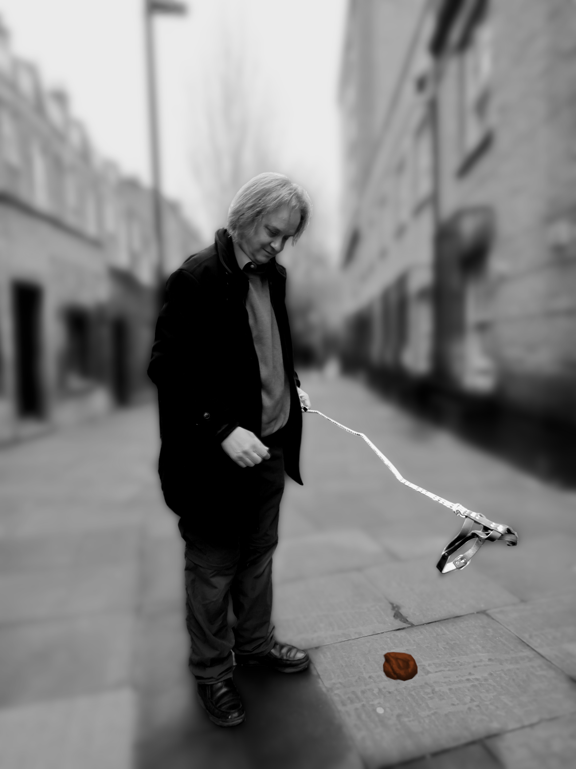

Above is Stephen Portlock’s promotional poster

I'm doing a solo show (free and un-ticketed) on two dates at the Brighton
Fringe this year and it would be wonderful if any of you can make it. Do
also let friends and acquaintances know about these shows. If you have any
related queries then do contact me either by mobile on 07563 442 338 or by
email at stephen.portlock@gmail.com. There's also stuff about my comedy,
including videos on my website www.stephenportlockcomedy.com.

Stephen and Hamlet: Blind and Mad

Let's face it, we're all nuts. When you're a middle-aged, blind
obsessive-compulsive, though, life can be particularly odd, not to mention
confusing and more than a little rude.

Having previously traipsed around Edinburgh, Hove and Plymouth, London's
gentlest comedian, Stephen Portlock, accompanied by his impeccably
well-behaved dog Hamlet, and bringing a cuddly Minion in tow, returns once
again to the Brighton Fringe to leave residents and visitors bewildered,
befuddled and bemused as he delivers a very ramshackle guide through the
highways and byways of life's weirdness.

Sweet, sometimes filthy, often embarrassing and surprisingly often true,
this is one sentimental journey you will definitely remember.

06 May 2022 22:45 Caroline of Brunswick, 39 Ditchling Road, Brighton BN1
4SB, Free

04 June 2022 12:00 The Temple Bar, 121 Western Road, Brighton BN1 2AD, Free

https://www.brightonfringe.org/whats-on/stephen-and-hamlet-blind-and-mad-160718/
Age suitability: 18 +

Message from Trustee Karina: new email group for NFB UK members
One of the EC’s aims is to improve communication with branches. In order to achieve this, a new e-list has been created specifically to enable members of the National Federation of the Blind of the United Kingdom to have timely discussions as well as to enable members to share information amongst each other. The new e-list is entitled activeNFBUK. If you would like to join this list, please either email kgregory@nfbuk.org or contact Head Office. Please specify which branch you are a member of.

Once you have been sent an invitation by email to join the list, you will need to reply to the email and then you will be subscribed.

We look forward to welcoming you to the activeNFBUK e-group.

NFB UK supports blind and partially sighted Ukrainian people
Dear National Federation of the Blind of the UK:
My name is Marc Workman. I am the CEO of the World Blind Union. I’m writing to thank you for your very generous donation toward the Ukrainian Unity Fund. It was an incredibly kind gesture that will no doubt do a lot of good.
Regarding the fund, I just wanted to let you know all funds raised will go to supporting the relief efforts. As part of our contribution to this effort, the WBU will bear 100% of the costs associated with managing and disbursing the funds.
We are in conversation with blindness organizations such as the European Blind Union and various associations of the blind in the region, and we hope to work with mainstream relief organizations such as the Red Cross as well.
I offer my heartfelt thanks for your generosity and would like to assure you we will use these funds to assist blind and partially sighted Ukrainians who are suffering due to this terrible war.
Yours sincerely,
Marc
Marc Workman (he/him)
World Blind Union
Chief Executive Officer

Creation of AGM Forum
The Executive Council has begun planning our AGM at Burleigh Caught in Loughborough on the weekend of Friday, September 23, 2022. As part of this, we will be commemorating the 75th anniversary of NFBUK and the EC welcomes representation and input from members on how to celebrate this significant milestone within our organisation, reflecting on the successes of our past, present and future. An AGM forum has been created to facilitate this, with Andrew Hodgson, Karl Farrell, Karina Gregory, Pardy Gill, Fiona Musgrove and Yemi Dada joining from the EC.

The Aims and Objectives of the AGM forum are:

• To consider and develop ideas from members on marking our 75th anniversary as part of our celebrations on Friday evening, as well as ideas for connectivity on Saturday evening following the AGM.

• Engaging with members on our plans for the AGM weekend and feeding back on enhancing your AGM experience, which will be a hybrid event.

• To explore innovative ways of raising the profile and widening the reach of NFBUK as part of the event.

Our secretary Jane Sellers will be representing London branch on this planning forum.

Greater London Authority Pre-meeting with Inclusion London - May 3, 2022, 2 pm to 3pm
Hello,

You are invited to a Zoom meeting on May 3, 2022, at 2 pm

Register in advance for this meeting here
https://us02web.zoom.us/meeting/register/tZwpceyppzkpGNd26HVGecLpG57MaK5iwUaL

Inclusion London invites all DDPOs to join a DDPO Forum pre-meeting on May 3 (2 pm – 3 pm) ahead of the DDPO Forum engagement with the Greater London Authority (GLA) on May 10. This will be an opportunity for DDPOs to have a say on the latest policy developments at the London level, including the expansion of the Ultra-Low Emissions Zone (ULEZ) to Greater London and the cost-of-living crisis in London.

Inclusion London has developed some policy recommendations targeted at the GLA that can be implemented to address the cost-of-living crisis in the city. You can find our recommendations in our latest briefings. In this pre-meeting, DDPOs will better understand what the GLA can do to address the cost-of-living crisis and share their views on the policy asks included in these briefings.

If you have any access needs, including the need for BSL interpreters and palantypists, please let us know, and we will make sure to accommodate all your needs.

If you have any questions about this meeting or cannot attend the meeting on the day and would still like to provide feedback on our policy recommendations, please email Laura Vicinanza, Policy and Stakeholder Engagement Manager, at laura.vicinanza@inclusionlondon.org.uk

Best wishes

Jon Abrams
Campaigns and Justice Coordinator

Tel: 0207 237 3181
Office SMS: 0771 839 4687
Jon.Abrams@inclusionlondon.org.uk

RNIB now offers a variety of tech support
Check out the large range of products aimed at supporting our lifestyles and the many ways RNIB can support you in this world of ever-changing technology

https://www.rnib.org.uk/practical-help/technology-hub/technology-support

Closure of the London Vision Information Forum
Dear LVIF member
As you remember, in February we announced that we will no longer be able to run the LVIF. Unfortunately, no other organisation has opted to take over the forum as yet and it seems unlikely that anyone will.

We would like to thank you for your support of the LVIF over the years, whether it be reading the bulletins or attending the meetings, and we are grateful for your contributions to the forum and the feedback many of you have given to us.

If you would like to be informed about London Vision’s work, we invite you to receive our monthly email update which will contain details of our various projects.

If you are interested in receiving the new monthly update, please let us know by sending an email with your details.
Please email info@londonvision.org

We hope very much to keep in touch with all of our colleagues in the sight loss sector.

Thanks again for all your support in the past

Kind regards
Liam
London Vision Info
info@londonvision.org
www.londonvision.org

The National Institute for Health and Care Excellence (NICE) public consultation
The National Institute for Health and Care Excellence (NICE) will be consulting on the safety and efficacy of IP1862 - Ab interno canaloplasty for open-angle glaucoma as part of its Interventional Procedures Programme (IPP). Public consultation is for four weeks and runs between Monday 25 April 2022 and 5pm, Tuesday 24th May 2022.

We would be very pleased to receive any comments that you may have on our provisional recommendations and information on recently published literature not included in the procedure overview. If you would like to comment, then please do so via our website. [NICE]

Through its guidance NICE is committed to promoting race and disability equality, equality between men and women, and to eliminating all forms of discrimination. One of the ways we do this is by trying to involve as wide a range of people and interest groups as possible in the development of our interventional procedures guidance. In particular, we aim to encourage people and organisations from groups who might not normally comment on our guidance to do so.

In order to help us promote equality through our guidance, we should be grateful if you would consider the following question:

Are there any issues that require special attention in light of NICE’s duties to have due regard to the need to eliminate unlawful discrimination and promote equality and foster good relations between people with a characteristic protected by the equalities legislation and others?

Please note that NICE reserves the right to summarise and edit comments received during consultations, or not to publish them at all, where in the reasonable opinion of NICE, the comments are voluminous, publication would be unlawful or publication would otherwise be inappropriate.

For more information about NICE's IP programme you can visit www.nice.org.uk/ip

Kind regards,
Deonee Stanislaus (Miss)
Coordinator - Interventional procedures
National Institute for health and Care Excellence
Tel: 020 7045 2307
www.nice.org.uk
Meetings held in public: https://www.nice.org.uk/Get-Involved/Meetings-in-public

Action for Happiness: Optimising Sleep - with Dr Nerina Ramlakhan - Weds 4 May, 7pm on Zoom
Join a special event with sleep expert Dr Nerina Ramlakhan about how to optimise your sleep for greater health and happiness. How can optimising our sleep help us to thrive?
Today’s world moves so fast, and it can be hard for us to find peace. Many of us are stuck in survival mode and trying to cope with fatigue, insomnia, stress or burnout. If we want to move from surviving to thriving, we need to make conscious choices.
At this special event, Dr Nerina Ramlakhan will share why sleep is vital for wellbeing and how to sleep better. She'll explain how, by optimising our sleep, we can get more out of life - and also contribute more to our loved ones, colleagues and communities too.
Dr Nerina combines science, philosophy and practical ideas to explore profound concepts in a light-hearted way. She'll help you learn how to thrive, by sleeping more deeply and living more joyfully.
Book your place:
https://www.eventbrite.co.uk/e/optimising-sleep-with-dr-nerina-ramlakhan-tickets-290395449607

Phew! You read it all! Thanks to our contributors and we look forward to meeting you in person or through Zoom at one of our events in 2022.

Keep “Walking on Sunshine”
Kind regards

Fiona
London NFB UK

