London NFB logo image: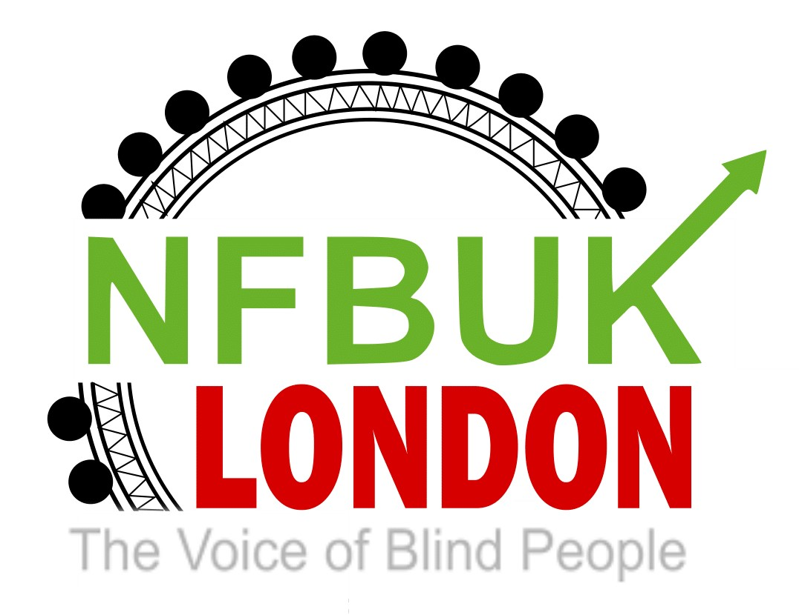

Hello London NFB members,
Another fortnight has flown by and its time for your London Life edition 37! Thanks for all your contributions, please keep sending them to us at London@nfbuk.org. In this edition:
- Join us for lunch on Saturday 21st May in Wood Green
- Next branch meeting – Wednesday 25th May 6pm at The Lucas Arms & on zoom
- Nominations for EC, motions, and nominations for NFB UK AGM
- Brian Payne’s funeral arrangements
- V&A message from Mark Pampel
- Moorfields, Oriel update' exciting milestones reached
- TFL update: Elizabeth line to open on 24 May 2022
- Opportunity to make a difference with Google
- RNIB Argentine Tango opportunity
- Support London member Alex Henderson on his Three Peaks fundraising challenge
- Blind Ambition is pleased to announce that it will be taking over the running of the Working Age Forum

Join us for lunch on Saturday 21st May in Wood Green
Come along and join us on Saturday 21st May at Kervan Sofrasr, a Turkish restaurant in Wood Green.
Saturday 21st May 2022 at 1.00pm
Kervan Sofrasr
183, hi Road
Would Green, N22 6BA

The meeting point will be at Would Green tube station at12.30pm. It is just three minutes walking distance to the restaurant.
Everyone will get separate bills

If you are interested, please email Berin Beringem53@icloud.com
As she will need to let the restaurant know numbers in advance and there may be a limit on availability. Please also keep a note of your menu choices to make it easier for the restaurant to manage.
Check out the menu at:
https://kervan-sofrasi.co.uk/

Next London NFB branch meeting
We’re returning to in-person meetings from May. Don’t worry if you can’t join us, there’s still the option to join on zoom too. The next meeting is on Wednesday 25th May at The Lucas Arms, 245A Grays Inn Rd, London WC1X 8QY. The meeting will start at 6pm and as this is our first time back in person, we’re allowing an hour and a half so potentially finishing at 7:30pm. We’ll be sending out a separate email with details of meeting point and time if you’d like assistance getting to the pub from Kings Cross station. Please do let us know if you plan to attend in person as space is limited. Really looking forward to seeing those of you who can make it to the venue.

Nominations for EC, motions, and nominations for NFB UK AGM
Just a heads up that at the branch meeting we need to decide on our nominations for the EC positions, any nominations for the awards and agree any motions to put forward as a branch.
As a reminder the awards are:
Grimshaw Award
This award is presented either to a blind or sighted person with some particular achievement to his/her name or to a person who has contributed significantly to the welfare of blind or partially sighted people.
Paul Otten Award
Presented to the best national, local or membership Tape/CD/USB key or digital Podcast/Email magazine, produced and distributed without cost throughout the UK on a non-professional basis.
The EC positions are the President, Honorary General Treasurer and Two ordinary Executive Council members. I’ve attached again the circular sent from Head Office with all the details.
Please do get in touch in advance of the meeting if you have any suggestions for the awards, wish to nominate yourself or a fellow NFB member for any of the EC positions although please do check with them first.

Brian Payne’s funeral arrangements
As you will be aware Brian Payne sadly passed away in April. Please see below for details of his funeral arrangements including a link to watch a webcast on the day.

Hi All,
Brian’s funeral will be taking place on Wednesday May 25th 3.15pm at: -
Eltham Crematorium, Crown Woods Way, London SE9 2AZ.

The funeral cars will be leaving from our house at around 2.15pm: -
2 Old Hill, Orpington, Kent BR6 6BN.

Afterwards, we are heading to Danson Stables around 4.30pm for drinks and nibbles.

Flowers can be sent to Donna on 25/5 BY MIDDAY to: -
Francis Chappell, 89 The Walnuts, Orpington, Kent BR6 0TW.
01689 823777.

If you wish to use our local florist: -
Time For Flowers, 44B The Walnuts, Orpington, Kent.
Contact Sue by 18/5 on 01689 485044 or 07985 390463

Donations if preferred: -
https://giftofhope.bhf.org.uk/in-memory/brian-payne36

Webcast on the day: -
https://watch.obitus.com
Username: qeni4039
Password: 381824

Please feel free to dress as you wish, black is not a requirement, we are celebrating Brian’s life. Looking forward to seeing you.

Thanks
Dave and Eli x

V&A – message from Mark Pampel, London NFB member and talented musician and composer
I now have a regular slot at the V&A, and I will next be performing at the V&A restaurant this Tuesday from 11am-1.30pm and then 2 weeks later (fortnightly) either on a Sunday, Monday, or Tuesday during the lunchtime period.
The V&A have regular Touch Tours for VI people from 11am - 12pm on different days of the week, and I usually play the piano afterwards in the V&A restaurant during the lunchtime period.

At the moment the V&A Touch Tours are short on numbers. You can email disability@vam.ac.uk and ask for more details and request to be put on the mailing list.

Best wishes
Mark

Moorfields, Oriel update' exciting milestones reached
Dear all,

It has been an exciting time for Oriel recently and I wanted to update you on some important milestones which were reached in the last week.

On Thursday 5 May, we exchanged conditional sale contracts with Derwent London plc for to purchase Moorfields’ City Road site and the UCL Institute of Ophthalmology’s Bath Street site (jointly referred to as the ‘City Road Island’).

The contract remains conditional and subject to some central Government approvals, but this milestone now secures an important funding source for the delivery of Oriel.

I am also delighted to say yesterday, Monday 9 May, another crucial milestone for the project was reached when the Mayor of London approved our plans for our new centre at St Pancras.

You may remember that in June last year, Camden Council’s planning committee made a resolution to grant planning permission for our new centre, subject to approval by the GLA. This was the culmination of several years’ work, including extensive staff, patient, student and public consultation on the relocation and design of the new building.

The final part of the planning process will be for Camden Council to formally grant planning permission. We hope this will be by the end of May and we will update you then.

Best wishes

Naomi Owen
Oriel head of partnership communications

Email: moorfields.oriel@nhs.net

TFL update: Elizabeth line to open on 24 May 2022
Thanks to our Transport Officer Martin Wilson for sending the following update from TFL.

The Elizabeth line will open on Tuesday 24 May 2022, subject to final safety approvals.

The line will operate in London as three separate railways, in the east, west and through central London. When the final stage is complete, customers will be able to travel seamlessly from Abbey Wood to Heathrow and Reading, and from Shenfield to Heathrow.

From 24 May 2022:
• The central section opens, adding nine new stations to the TfL network (Bond Street will open to Elizabeth line customers soon)
• Service will start with a train every 5 minutes running between Paddington and Abbey Wood from 06:30-23:00, Monday to Saturday.
Between now and launch day we will be sending you more detailed information about the Elizabeth line, including service information, opening hours and accessibility information.

Yours sincerely,
Julie Dixon
Interim Customer & Revenue Director

Opportunity to make a difference with Google
Journeyflows: "We all know that assistive technologies are incredibly beneficial to people with disabilities but how do we know which ones to build? How do we know which ones already exist? How do we know which ones are affordable? The purpose of this project is to do a workflow analysis of life activities, connect the business to the customer, and create greater awareness required for full participation for people with disabilities. By doing this analysis, we can hopefully figure out what needs to actually be built for them. "

My name is Uma Girkar, I am currently a software engineer at Google. Together with the World Economic Forum Global Shapers Palo Alto Hub we were interested in conducting a voluntary research project with the NFBUK. For the project we would request a 1-hour session with members to learn more about the challenges that people with a certain disability face on a day-to-day basis. Based on these focus groups, we hope to come up with/ identify a list of task/s that people with disabilities are most likely to struggle with for which there is no affordable assistive technology.

The full project proposal can be found here: link.
We would end up taking 1 hour of the participants' time.

We look forward to hearing from you and hope to work with you.

Best,
Uma
Uma Girkar
Massachusetts Institute of Technology | BS'17, MEng'18
Department of Electrical Engineering and Computer Science
girkaruma@alum.mit.edu | 408 - 429 - 0289

Please let us know if you take part in this study as we all know the importance of good assistive technology

RNIB Argentine Tango opportunity
Are you interested in helping us develop an accessible way to teach the Argentine Tango to people with sight loss?
Before we hit the dance floor, the developer Mike and I would like to have a meeting with you all on Microsoft Teams on Tuesday 17th May from 6:30 to 7:30 PM. It’s the perfect opportunity for you to share your experience dancing or learning to dance as someone with sight loss and ask any questions about the Argentine Tango itself. Also, it’ll help Mike understand what it’ll be like to teach Argentine Tango to blind and visually impaired dancers, what considerations and adjustments that need to be made for you all to dance independently. We hope the meeting will allow everyone to collaborate and adapt the way Argentine Tango is taught for someone with sight loss.
To register your interest and to receive the meeting joining details please contact Nanjiba Misbah

Nanjiba Misbah
Community Connection Coordinator
RNIB (Royal National Institute of Blind people)
Please note working hours are Monday to Friday
t: 01733972497
m: 07562169490
e: Nanjiba.misbah@rnib.org.uk
w: www.rnib.org.uk

London NFB member Alex Henderson is taking on the Yorkshire 3 Peaks challenge and fundraising for The Chronicle Sunshine Fund.
On Friday 20th May 2022, Team Sunshine will take on the Yorkshire 3 Peaks Challenge, climbing 3 of Yorkshire's highest peaks in 12 grueling hours, Whernside (736 m or 2,415 ft), Ingleborough (723 m or 2,372 ft) and Pen-y-ghent (694 m or 2,277 ft).
Good luck Alex! If you’d like to support Alex and help him meet his fundraising target, please visit his Just Giving page:
https://www.justgiving.com/fundraising/AlexHendersonY3P?utm_source=facebook&utm_medium=fundraising&utm_content=AlexHendersonY3P&utm_campaign=pfp-share&utm_term=5f4409118a9e473bb9fe293a9ccd8f10&fbclid=IwAR0Daavg90zKsXkEA4DwE0bPVi6xgBNovLEsch0gWyIbO2ze-ajxn-UOqt4

Blind Ambition is pleased to announce that it will be taking over the running of the Working Age Forum
Blind Ambition is pleased to announce that it will be taking over the running of the Working Age Forum (WAF) for Visually Impaired People endorsed by the RNIB. The forum is a relaxed, sociable space for visually impaired people to meet, learn and inspire each other to achieve their best lives. The forum has been run for many years by London Vision, but recent strategic changes have required a new home. Blind Ambition is extremely grateful to London Vision for its dedication in running this valuable support network and is honoured by the opportunity to continue this work and broaden it to cover the entire UK.

Blind Ambition has been working with the RNIB, Shaw Trust and other leading disability empowerment organisations over the last two years to help blind and partially sighted people get into work with a series of employment webinars aimed at every aspect of the employment journey, from CV writing, to interview techniques and harnessing government support available. Alongside this we offer one2one coaching to help people with their employment journey. Each month there will also be a 5-minute slot in which we put the limelight upon an “VIP of the month” to share their story and success as well as, tips on technologies and other topics of interest for the forum. The WAF builds on this existing partnership to further help support blind and partially sighted people. It will continue every second Wednesday each month from 6-7pm on zoom while we consult with members on how best to develop the concept. We will be looking to develop the WAF further to enhance skills with rebuilding, revitalising, reskilling, redirecting and recruitment in your employment journey.
We hope to see you all on our exciting new webinar!

Well congratulations … you’ve made it through this edition of London Life! We look forward to receiving more articles and information from you for the next edition where we hope to be sharing the exciting promotion for our October Eastbourne weekend. Have a fantastic fortnight.
Best wishes,
Jess
London NFB Chair

