Hi London members,

A warm welcome to our 33rd edition of London Life. Spring is in the air and our members have been busy sharing their experiences and articles with us.
Thanks to everyone who has contributed and please keep sending us your emails and we will endeavour to post as many as possible london@nfbuk.org.

This edition includes:
- Date of next branch meeting
- Sensational Saturday Night Fever - From London member and Vice Chair Berin gem
- BT Directory for VIP - From London member Dolly
- Our stop/start independent travel to Tenerife - From London member and Minute Secretary Arthur Payne
- Composition and Piano Performance at the London Composers Forum Concert November 2021 by Mark Pampel
- My invitation onto the NFB Executive Council - From London member and Membership Secretary Fiona Musgrove
- Follow up from TravelHands
- Blind Parents UK
- JOY Festival are looking for 5 disabled actors to perform in a brand new play.
- Fancy giving VI rugby a try?
- GCP - Northern Area Place Based Engagement Event - GREATER CAMBRIDGE PARTNERSHIP
- Tenpin bowling with Aquabats Sports and Social Club for the Blind

Date of next branch meeting
The next Zoom branch meeting will be on Wednesday 31st March live at 5pm. Catch up with the latest news from the committee and members in our branch. A guest speaker will be invited - details to be confirmed. the link and agenda will be circulated before this date to members.

Sensational Saturday Night Fever
From London member and Vice Chair Berin gem

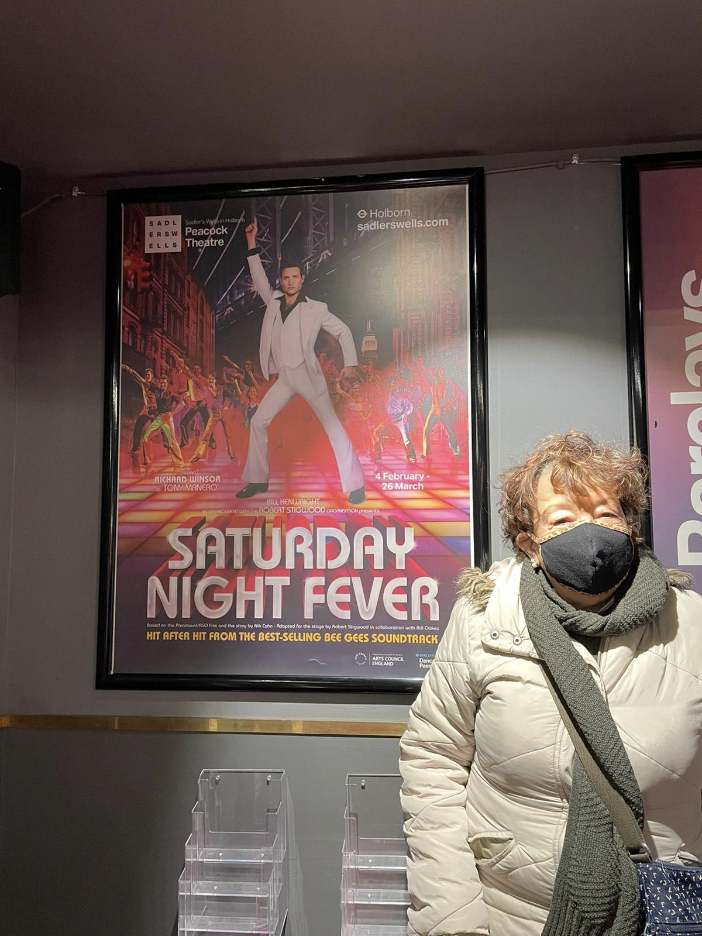

Above is a photo of Berin standing outside the Peacock Theatre, in front of the Saturday Night Fever poster

As a VIP I only go to audio described musicals and plays, I was very excited to go and see Saturday night Fever the musical as I am a big fan of the Bee Gees,

We were welcomed by Caroline and the access team who helped us to the touch tour, We all loved going on the stage knowing that the dancers will be there to perform for us it was a great feeling,

The whole production was just spectacular amazing dancers singers the story it was just fabulous. The energy from the performance was just so electrifying.

My thanks to Caroline the audio describer and all the access staff at Peacocks Theatre

Above is the iconic pose of the white suited actor playing Tony (AKA John Travolta) on the shows poster.

A huge thanks to Caroline Burn, Dance Artist -
Audio Describer Theatre/Dance, for this image and she writes “I am so pleased you enjoyed the show! The energy and excitement from your group was definitely contagious. It wasn’t the easiest set to access but I’m so pleased that we did manage too”
Enjoy: https://youtu.be/Fa9n7GirhsI

BT Directory for VIP
From London member Dolly

You probably know already but just in case:
Calling 195 to obtain a number I was asked if I’d like them to send me a text with the number, what a lovely thing to do!
Before I used to run around for pen and a slip of paper to write it down but written over it, making it illegible. for Mick to use.
Really chuffed about it.

Here is a link to the details:
https://www.scotborders.gov.uk/directory_record/10975/bt-195_free_directory_enquiries

Our stop/start independent travel to Tenerife
From London member and Minute Secretary Arthur Payne

I left my home in Bexleyheath on Friday 4 February with my friend Jimmy Jones. We took a taxi to Gatwick with a very good driver we know well. When we arrived at the airport our assistance met us and we were taken to the check in desk. However, upon producing our documents which were mostly in order we discovered that we needed the confirmation certificates that verify a person has had three jabs. We were unable to produce these and were sent home. The airport staff said they could have let us fly but the Spanish authorities would probably have sent us back on the next flight to England. So we had to go back home and telephone 119 for the correct certificates for both of us. After that I had to contact my managers at work to let them know what had happened and they fully understood and I advised them that we would now be travelling on Friday 25 February. I had to keep ringing Tui because they got Jim’s name wrong but eventually this problem was resolved.

On Friday 25 February we left our house at 5.05am and headed for Gatwick Airport. The assistance team met us, and we showed all the documentation which this time was fine. We had to go through the rigmarole of the security checks which now is a necessary evil. After that we were taken to the departure lounge where we had to wear special devices which let you know when the flight was called. The assistance then took us to the gate via a buggy. We then walked onto the aircraft step free. The flight was very good, and the stewardess showed us the equipment on the aircraft which includes oxygen masks which are used if the air cabin depressurises. The life jackets were also shown. The aircraft took off at 8.25am. We were able to have some food aboard the aircraft as the flight was just under four hours. Payment of food and drink is by cards only.

When we arrived at Tenerife the airport staff were very helpful and took us through to our Tui minibus which took us to the Hotel Grand Tenerife. This is situated in the resort of Player de las Americas. The hotel was a four star all inclusive. When we reached there the staff were very helpful firstly putting on the bracelet which we had to wear throughout the holiday and secondly they took us to the restaurant for lunch as we arrived there at about 2.20pm. We had a lovely fish lunch. After that we were shown to our room and were shown some of the equipment within it. The room was a large double room with a very large King-sized bed. There was a TV which picked up all the English main channels 1-5. A fridge was also provided which had some water and other drinks within it. We were also provided with some snacks and a bottle of wine. If you were experiencing any problems in the room, you could contact the room service. The shower in the room was a walk in one and was very easy to use. The lifts were Brailled and spoke in Spanish.

Due to the large number of people in the hotel and some limited Covid restrictions everyone had to book for dinner. However, this was done for us and we just told them we would be coming in at the same time on each day. Dinner comprised of various meat and fish courses as well as the famous Spanish dish Paella which was very nice. It contains fish and rice. Puddings were mainly various cakes which were very good although our favourite was an orange gateau, but they seem to call all gateaux cakes for some reason. We had excellent help from the staff with all meals. The only drawback was that sometimes food was served almost cold and we had to tell them to warm it up again which they did. Also, they tended to serve the same kind of meals to us as they realised what we liked and did not like so we had to ask them sometimes to let us know everything that was in the buffet.

On the same floor as the dining room there was a large room in which all the entertainment took place. The entertainment happened on each night. It mainly comprised international singers or groups as part of the music. On the first night a music quiz was held. 14 questions were asked and you had to identify the song and artist. We got 11 out of 14 but you had to write down the answers so we just did it in our heads. Other entertainment in there comprised bingo and some kind of betting game in which you had to say whether a member of the public could complete a task within a given time. These were rather visual to us. A comedy hour also happened but with four languages spoken it was a bit strange. The hotel also undertook a number of sporting activities each day. These included darts, bowls and table tennis. The winners of the various competitions were declared at the evening entertainment. This was usually around 9.50pm. The entertainment ended at around 11. 15pm.They always found out the most people who came from a particular country. England had the greatest number of people, There were also people from Germany, Sweden, France and Spain.

The hotel has three swimming pools and a pool bar. This bar was open when the restaurants were not serving breakfast, lunch or dinner. You had to wear a facemask whilst queueing anywhere. You could order various cocktails including San Francisco, pina colada and honey rum. I made use of the swimming pools which were cold even though they said one of them was heated but it was fine for me. There was also opportunity for some sea swimming and the seafront was only a short walk away. You could walk along the seafront without seeing any cars although parts of the route led you to the road for short stages. There were also a number of bars, restaurants and gift shops along the route. I was able to purchase some T-shirts with Tenerife on them. One of Jim’s friends wanted a Flamenco doll with dress and our rep managed to get one.

On the Tuesday afternoon we went on a boat trip on a boat called the Royal Dolphin. This was because on one part of the cruise we stopped close to some whales and dolphins and could clearly hear them. There is a boat that you can go on where you can swim with them, but I don’t think this was available at this time of year. I know it happens because I have been on that trip before. As we boarded the boat everyone had their photograph taken. This was because if they wanted to they could purchase their own picture along with a picture of a whale or dolphin seen that afternoon for 22 Euros which I thought was a bit excessive. On this trip we were given lots of food and drink and were looked after as it was a buffet situation, and the boat cruise was quite rough in some areas. There was a stop at a place called Cliffe Edge, but this was only for people who wanted to swim off the boat. The trip was very good value at 55 Euros each. This covered the short coach ride to the boat stop, the cruise itself and all the food and drink. The drinks included Sangria and a lovely honey rum. It lasted about five and a half hours, so it was a very good afternoon.

As we were late, we had a light meal out because we missed our booking time for that night, but this was fine. I also found that debit cards could be used fine in most restaurants. However, there was one pub which was cash only. This pub had only just started a couple of weeks ago and was run by two English people. It mainly catered for football crowds particularly Rangers fans of which there seemed to be quite a lot of out there. Another pub close by had football mainly for Chelsea fans and you could hear them cheering and chanting from across the road.

I did manage to pickup an English based radio station there called Oasis FM. However, when you ask for this with Alexa she simply comes back with music by Oasis. On the last day we had breakfast. On each morning these mainly consisted of the usual English breakfast or Spanish omelette and Continental breakfast with rolls and croissants. We then checked out of our room and left at 11.25am. Our flight back went fine. When we reached Gatwick there was a slight problem with how many disabled staff the plane was carrying, and they had to keep going backwards and forwards with the buggy to get us all back into the arrivals area. Our driver met us fine, but we were an hour later than anticipated.

The holiday was very good. This was the first time my friend Jimmy had ever gone abroad, and he enjoyed it. The service we received at the hotel was very good although at busy times we had to wait a bit longer. Sometimes I had to tell Jimmy when waiters had put food down as they did not always say. The weather for the holiday given the time of year we went was very good with the temperature on most days around 22C or 72F. We came away with very good suntans. I would definitely recommend the hotel to anyone thinking of going on a holiday abroad independently.

Click here for more info:
https://www.booking.com/hotel/es/el-dorado-arona1.en-gb.html

Composition and Piano Performance at the London Composers Forum Concert November 2021 by Mark Pampel

Listen to NFB London member mark Pampel’s piano piece, approximately 9 minutes, which was based on a recent LSO Create Orchestra composed music on the subject of climate. Mark then made some changes to this piece to incorporate The music of the orchestra into his solo piano performance.

Please read the Programme Notes before accessing the video. This composed piano piece comprises of 5 movements as portrayed below.

Title: Climate Features
5 miniatures describing 5 pictures
1. Cloudy sky
2. Aggressive developing hurricane wind patterns
on planet earth as seen from Space
3. Lightning and thunder, heavy persistent rain on
a dark orange and purple sky
4. Bright sunny day over picturesque country
landscape with flora, fauna, lush vegetation and
bubbling river
5. Same picture as no. 4 but this time clear day,
arid and barren country landscape with dried up river bed
As resident pianist of LSO Create, my above composed developed piano part taken from the LSO Create Orchestra workshop at St. Luke’s, November 2021

https://m.youtube.com/watch?v=iA7yFZG47Yk

My invitation onto the NFB Executive Council
From London member and Membership Secretary Fiona

I was immensely grateful for the support given to me by the London branch members. After winning the re-run election I was invited to join the Executive Council. This consists of London members Andrew, Pardy, Yemi and Karl alongside Central member Devaki and Nottingham Chair Karina. The Committee meets every six weeks on a Tuesday live on Zoom. Our President, Andrew leads the meeting supported by the General Secretary Devaki, who also ensures we receive the previous minutes and a set agenda. These meetings usually last from 2-3 hours and cover a range of topics received from our branches and operations of the charity.

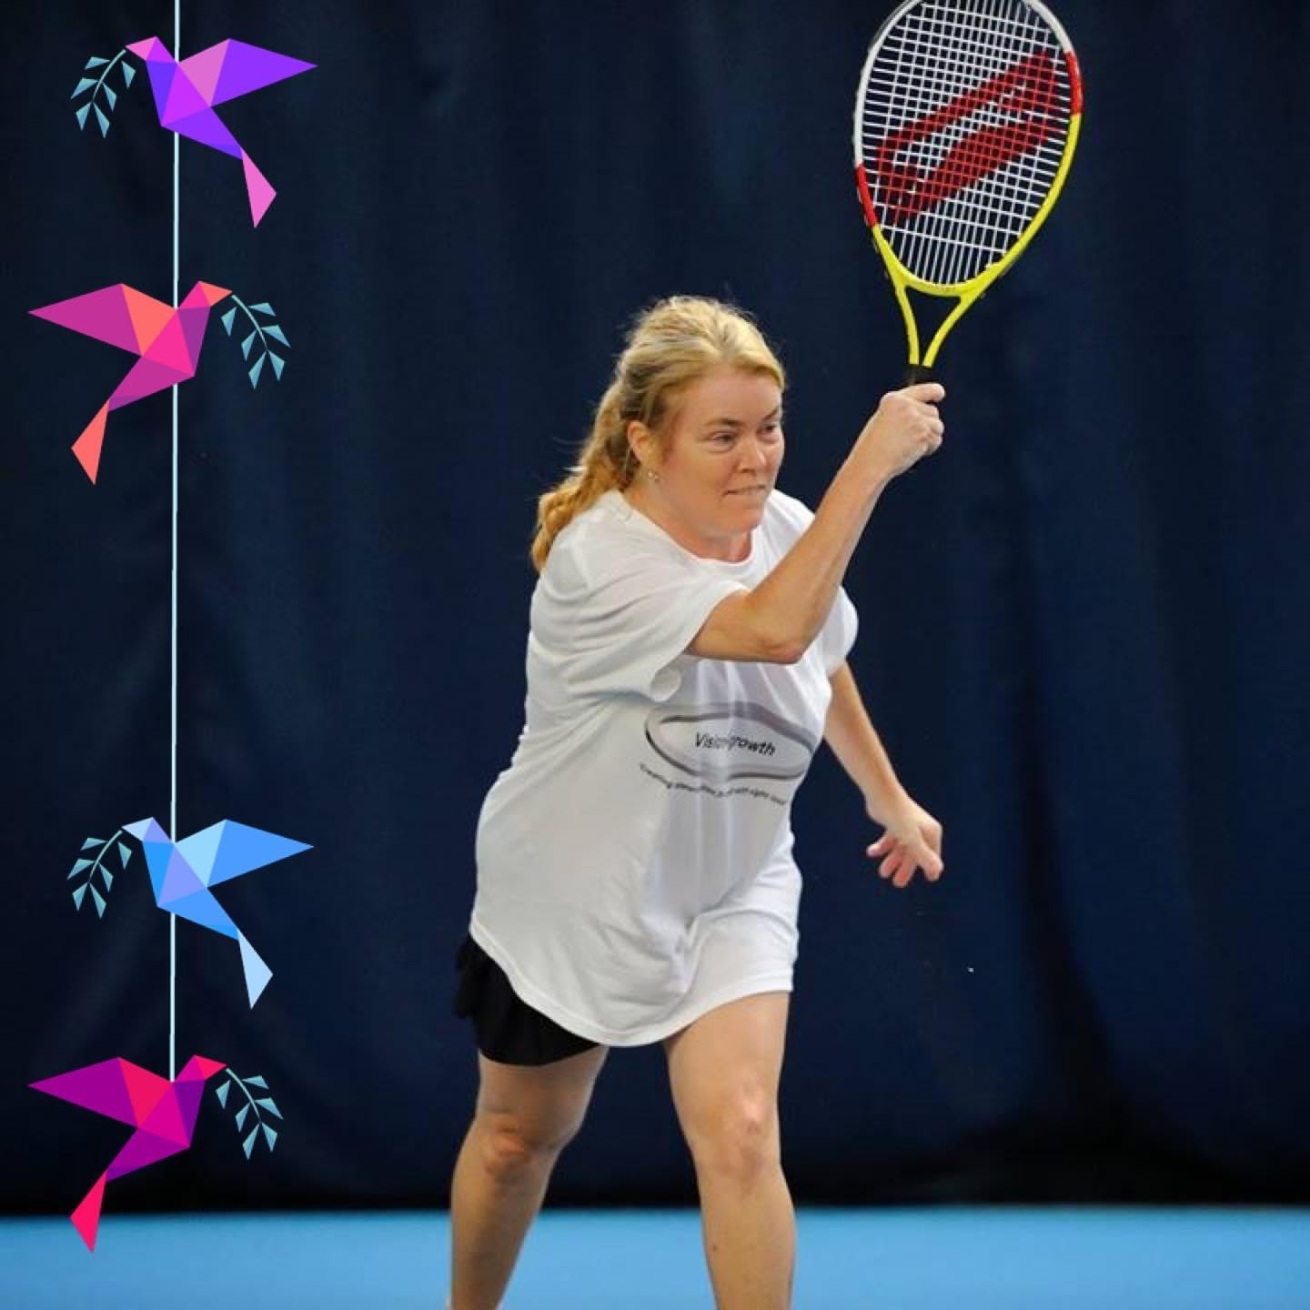

Above is a photo of Fiona playing blind tennis

The Executive Council are also the Trustees, who have sole responsibility for the charity’s operations. We currently employ two members of staff. Devaki is Louisa’s line manager and Andrew has responsibility for Sarah Gayton. Additionally, we engage Carol Hudson as a freelance Fundraiser.

Karl is the Vice President but kindly steps in as Acting Treasurer whilst this position remains vacant. The four Ordinary members are there to support the council and ensure the charity’s operations are carried through. Each member of the council is allocated as a link to a branch. I have been awarded Leeds and am looking forward to a May visit.

Currently we are discussing matters of future governance and
when we have determined what we feel should be the way forward, we will
inform the membership as a whole.

Another area I am focusing on is encouraging volunteering. I have attended a Visionary session on this and continue to develop the project. I have also discussed allowing branches to access larger pots of funding through the charity’s fundraiser for individual projects like the Eastbourne weekend in 2023. Additionally, I have been appointed to draft new policies to ensure compliance with the Charity Commission.

Some of the council members attend external meetings as representative of the charity. Karina is our European Guide Dog rep and is keen to engage as many owners as possible from the London branch. Another campaign led by Andrew looks at the lack of rehabilitation services caused by the long-standing postcode lottery. The Support for Sight Loss Committee seeks to remedy this injustice.

2022 is a big year for NFB UK as we celebrate our 75th anniversary. A weekend of celebration combined with an AGM is planned for September. The EC hope to be able to provide some exciting news for branches shortly about this.
Please click here to find out more about the Trustees

https://www.nfbuk.org/about-nfbuk/

Follow up from TravelHands

‘Our mission is to make outdoor travel easy, affordable and convenient for VIP with Travel Hands.’

Travel Hands is a new service for blind and partially sighted people living in London. Its simplicity leaves us wondering why this has never been done before. Travel hands was developed from its parent company VIP World as a way of supporting its members on journeys. As we emerge from this pandemic we may need to draw on support from others to allow us once again to continue our lives. Travel Hands provides a one-to-one service with registered volunteers for a low-cost charge.

At our last branch meeting we were delighted to be joined by Ishan Jha from Travel Hands. Many members expressed an interest in his company and London Life were soon on the case!

“About 100 VIP have used Travel Hands in London and some charities are willing to pay for their VIP users to use Travel Hands and be active”, said Ishan. This service is still only available to Lucky Londoners, but we feel reassured they will look to expand nationally as soon as possible.

“The journeys can include from going for park visits, grocery shopping or a cup of coffee nearby to dropping or picking to and from a bus stop or underground station. The journey can be anything that does not require to be indoors and is under 5 kms distance” he explained.

The first trial journey is free. Subsequent journeys are charged at £3 for up to 3 hours and £5 up to 24 hours. Journeys are discussed with volunteers before departing.

We asked what measures are in place to protect VIPs using the service. A” One Time Secret code or OTS code” is agreed by both parties only known to themselves. Ishan smiles, “it sometimes provides a natural ice breaker for conversations to begin”. Currently Travel Hands has around 60 registered volunteers working within London. Every volunteer has to pass the Travel Hand’s training programme and hold an Enhanced DBS before they are paired with a VIP.

How to contact Travel Hands

Email: iamvip@vipworldservices.com
Website link is www.travelhands.co.uk

Social Media links
Facebook page: facebook.com/vipworldservices
Facebook group: www.facebook.com/groups/vipworldcommunity
LinkedIn page: www.linkedin.com/company/vip-world-services/
AZCTTwitter handle: www.twitter.com/vipworldservice
Instagram handle: www.instagram.com/vipworldservices/
YouTube channel: https://www.youtube.com/c/VisuallyImpairedPeopleWorld
\
If you have ever used Travel Hands we would like to hear from you please email london@nfbuk.org

Blind Parents UK

I'm contacting you to tell you about Blind Parents UK.
We are a peer support organisation for blind and visually impaired parents and parents-to-be.
I have attached our leaflet which hopefully gives you an overview of what we do and I'd be very grateful if you could share it with relevant clients or your key staff.

We started as a small email group over 10 years ago. Over the past few years we have expanded to include a range of services and we are trying to reach as many VI parents as possible.
We have a friendly, thriving set of groups. Facebook groups for mums and dads, WhatsApp groups dedicated to new and pregnant mums or those who don't use Facebook.
We can provide as much or as little peer support as necessary.

Our leaflet can be provided in alternative formats if required and we're always happy to respond to queries and help where we can.

Many thanks,
Kim Randall
Blind Parents UK
01905886252
info@blindparents.uk
www.blindparents.uk

JOY Festival are looking for 5 disabled actors to perform in a brand new play.
Some experience of devising is preferable.
The play will be based on stories from local residents in Hammersmith & Fulham. The writers are currently interviewing people and writing the first draft of the script. The creative team is formed of both disabled and non-disabled artists.
Our five actors will spend one week of Research & Development devising material based on the writing. The writers will develop this into the final script. The actors will go into two weeks of rehearsals with a final script.
We are looking for both professional and aspiring actors. You must be free on the following dates:
23rd - 27th May (R&D)
6th - 10th June (Rehearsals)
13th - 17th June (Rehearsals)
20th June (Tech)
21st June (Premier)
We will be touring the show to 7 local SEN schools in June/July after the premier - exact dates will be confirmed (8 performances total).
Ideally actors need to be London based. This is a paid opportunity in line with Equity/ITC minimum rates. This is a great chance for aspiring artists to gain skills development as part of a professional team.
Auditions will be held in person in London on the 26th of March.
To be considered for audition, please email Kelly a 500-word cover letter, CV and (if you have one) a Show reel. kelly@turtlekeyarts.org.uk
Deadline Friday 18th March.

Fancy giving VI rugby a try?

We are running a VI Rugby programme in London for adults with a visual impairment between sight categories B2 and B4 which runs monthly on a Saturday. The sessions focus on fitness, ball work, game scenarios and also have a vibrant social element. Please see below the following training dates and if you would like to find out more information, please contact Daniel Lineker (daniellineker@changefdn.org.uk) / 07824 589428).

Saturday 12th March – 10 am – 12 pm
Saturday 9th April – 10 am – 12 pm
Saturday 7th May – 10 am – 12 pm
Saturday 11th June – 10 am – 12 pm
Saturday 9th July – 10 am – 12 pm
Saturday 6th August – 10 am – 12 pm
Saturday 10th September – 10 am – 12 pm
Saturday 8th October – 10 am – 12 pm
Saturday 12th November – 10 am – 12 pm
Saturday 10th December – 10 am – 12 pm

Any questions please let me know.
Kind regards,
Dan
Daniel Lineker​
| Senior Coach Mentor
M: 07824 589428
www.thechangefoundation.org.uk

GCP - Northern Area Place Based Engagement Event - GREATER CAMBRIDGE PARTNERSHIP

GCP Logo - Transparent_small
The Greater Cambridge Partnership (GCP) will be hosting an online meeting on the 23rd of March to update residents and stakeholders on the projects in the North of Cambridge including Waterbeach to Cambridge, Milton Road and the St Ives and Waterbeach Greenways.

The meeting will take place via Zoom and the registration information can be found below:

Date: Wednesday 23 March 2022

Time: 6.30-8.30pm

Please click the link below to register below:

https://zoom.us/webinar/register/WN_coX9T2QVSZmB0Y5YglRH3g

After registering you will receive a confirmation email containing information about joining the webinar.

In the meantime, if you have any questions you wish to raise now please get in touch via contactus@greatercambridge.org.uk.

Follow us on Twitter - @GreaterCambs
Follow us on Facebook - GreaterCam

Tenpin bowling with Aquabats Sports and Social Club for the Blind
The April tenpin bowling event will be on Thursday 21st April. The details are the same for meeting. Please meet at Lewisham Mainline Station at the Platform 2 exit at 6.25pm leaving at 6.40pm. Please let me know if you would like to bowl including helpers by Thursday 7 April.
Book your place by contacting Aquabats Secretary Arthur Payne – Arthur.Payne@beis.gov.uk

NMO Patient Day 2022Please see details below of an event taking place in Birmingham for patients with

Thanks for getting to the end of this bumper edition. We look forward to receiving more articles from you for our future editions.

Keep “Walking on sunshine”

Kind regards

Fiona
London NFB UK

