London NFB logo image: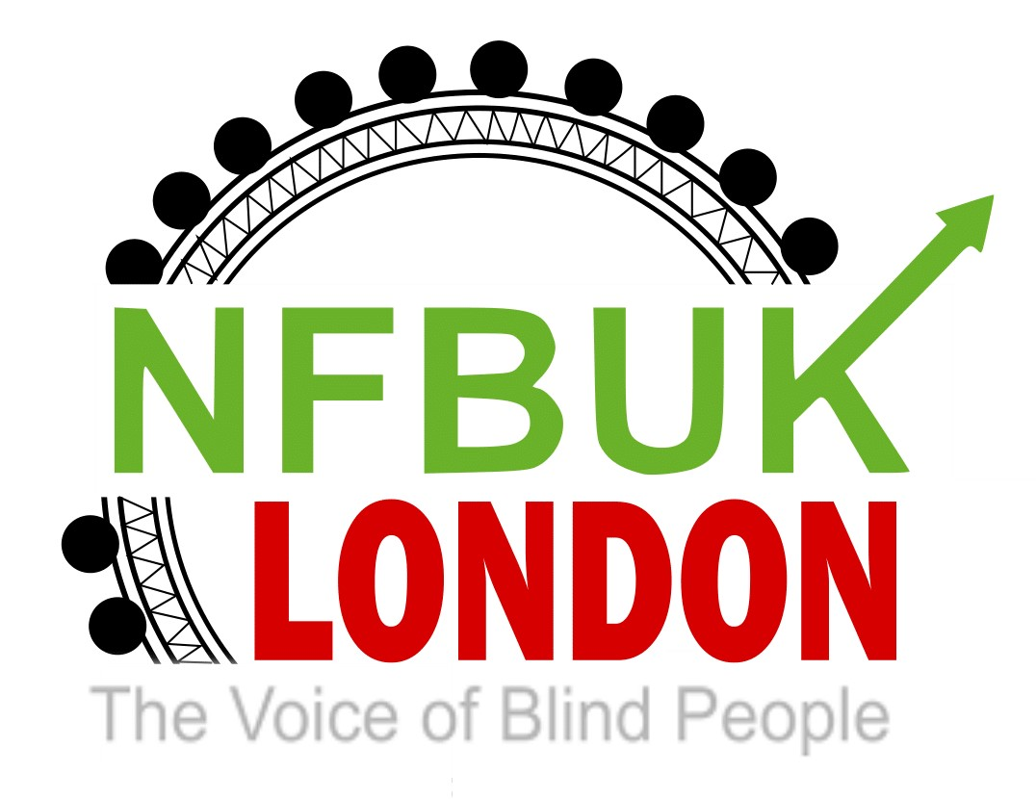

Hello London NFB Members,
Welcome to your Easter edition of London Life. Wishing you all a safe and healthy Easter weekend. As always thank you for continuing to send us articles and information to include in London Life. This edition includes:
- We’re With U. Blind performing artists’ Virtual Benefit Concert for blind Ukrainians on 16 April
- Next London NFB branch meeting – Wednesday 28th April with guest speaker David Clark from RNIB
- London Sight Loss Council e-scooter event by Martyn Wilson, Transport Officer
- Inclusion London - Innovative way of campaigning and processing trauma
- Northern Ballet Merlin in cinemas – watch the audio described trailer
- A day out with London Blind Ramblers by Jessica Beal
- RNIB's free online training session - Working with Your Local Council

We’re With U. Blind performing artists’ Virtual Benefit Concert for blind Ukrainians on 16 April

﻿Dear friends,

The intolerable atrocities in Ukraine cannot escape us and it is often the most vulnerable citizens including disabled who are most adversely affected. Please see details below of an International Benefit Concert from blind musicians around the world on Saturday, April 16 from 7 pm hosted by Jonathan Mosen, with proceeds supporting blind Ukrainians through the World Blind Union Unity Fund.

Please find attached an audio MP3 file promoting the fundraiser received from Chrissie Cochrane, Executive Director at The Global Voice Radio station with blind presenters around the world. You can listen to the event via the accessible, screen reader friendly website below with various listening options, as well as via telephone on 0330 0102922.

https://www.theglobalvoice.info

Event details

We’re With U. Blind performing artists’ Virtual Benefit Concert for blind Ukrainians on 16 April

Welcome
On 24 February, Russian forces invaded Ukraine. The death toll is mounting. Families have been torn apart as some seek refuge in other countries, while others stay to fight for their country's freedom.
One of the consequences of war is that it results in life-changing impairments, including blindness. Another is that war leaves those who are already blind vulnerable and at risk.
The situation has made many of us feel helpless and heartsick. But there are things we can do, ways we can help.
On Saturday 16 April at 2 PM Eastern time in North America, 7 PM in the UK, that's Sunday morning at 4 AM in Eastern Australia, 6 AM in New Zealand, the global online blind community is joining together for We're With U, a benefit concert to help blind people who have been affected by the atrocities in Ukraine.
If you're a blind performing artist, you know that music has power. This is your chance to perform to a worldwide audience while lending a helping hand to those who desperately need your help. If you appreciate great music in a range of styles, this is your chance to listen to some of the best the blind community has to offer, while also donating to support blind Ukrainians.
Every cent raised will reach organisations assisting blind Ukrainians, thanks to our partnership with the World Blind Union's Unity Fund. World Blind Union is the global organisation representing the estimated 253 million persons who are blind or partially sighted worldwide. They are working actively with organisations in the area who are providing support to Ukraine. With their support, you can be sure that the generous donation you make will go to a project that makes a difference.
We also thank the National Federation of the Blind for their considerable moral, infrastructural and communications support for this project.
The below sections of this page have further information and is being updated regularly. You can navigate to each section by heading.

How can I listen
In the spirit of working together that has been the hallmark of this event, many Internet radio stations and channels in the blind community will broadcast the We're With U concert. Chances are that if you listen to an Internet radio service of and for the blind community, you will hear the event there. Please check with your favourite station and encourage them to carry We're With U if they are not yet signed up to do so.
You can of course hear We're With U right here on Mushroom FM. Mushroom FM has an accessible online player on this website. It is available in all radio directories including Apple Music. It has its own Alexa skill and Google Home action. You can also tell Siri to Play Mushroom FM.

How long is We're With U set to run for?
We don't yet know. Artists have until 8 April at 11:59 PM North American Eastern time to send in a contribution, but what we can say is that it is shaping up to be a showcase of talent that will last for some hours. So, be prepared to settle back with your best speakers, a beverage or two, and a keyboard to type in your credit card number to donate to Ukraine. Consider your kind donation the price of your virtual ticket to this event.

I am an individual who wants to help blind Ukrainians, how can I donate?
Throughout the We're With U concert and a little ahead of the event, we will give you a URL where you can donate securely with all major credit cards. Everything you give goes to blind Ukrainians who need our help.

Is there a social media hashtag?
You bet! It is #BlindWithU. Note that the U is an uppercase U, and not the word Y O U. Since we can't bring everyone together in a stadium for this event, we encourage you to use the hashtag #BlindWithU during the event, and right now if you want, to discuss the concert.

I really want to donate to this, but I have trouble with credit card forms. Is there some other way?
We are working on the possibility of taking donations via phone and hope to have more to say ahead of the concert.

These details are taken from the Mushroom FM website page below which will be regularly updated prior to the event:

https://mushroomfm.com/withyou

Best wishes, Pardy

Next London NFB branch meeting – Wednesday 28th April with guest speaker David Clark from RNIB
Our Guest Speaker on Wednesday, April 27 at 5 pm via Zoom is David Clark, Chief Operating Officer and Director of Services at RNIB. David previously joined us for a Q&A session in August 2019 and NFB London is delighted to welcome him back to build on our constructive relationship with RNIB. David will offer a short presentation on his RNIB role and external interests, some of you may know that he played for the England Blind Football team. This will be followed by a Q&A session. More details will be circulated next week including his biography and an invitation for members to submit pre-tabled questions in advance of the meet

London Sight Loss Council e-scooter event by Martyn Wilson, Transport Officer

I recently attended a webinar run by the London Sight Loss Council about the latest news on e-scooters.

What interests us most is the news that the research into making these scooters emit a sound is nearly complete. The three companies will be jointly testing this in the summer. It was stated that ucl and the Sight Loss Council would be invited to take part in these tests. After the webinar, I rang the contact at the council and complained that we had not been invited and we are now on the email list for this.

The Audible Vehicle Alert Sound or avas for short will be added to all scooters in the trials in London which has now been extended for another six months, until the end of the year, to allow for this sound test.

Inclusion London - Innovative way of campaigning and processing trauma
Dear Colleagues

Would you be able to send this out to your members and promote widely, please?

Interested in exploring campaign issues through art?

Inclusion London has teamed up with Hope in the Heart, which is offering free workshops (either online or in-person), and opportunities to perform and develop an art exhibition in London.
You can find out more about the workshops via their website.
http://www.hopeintheheart.org/community-workshops.html
The art can be in any form, and is a vehicle for social change, through art-based campaign messages.
This survey is to determine how many Disabled people are interested, what issues are essential to campaign on and whether you prefer online or in-person meetings.
We want responses by 31 April, please.

We would really appreciate it if you could promote and/or send it out to your members.

Survey link (should only take a few minutes)
https://www.surveymonkey.co.uk/r/2M8WQQM

We are stronger together,
Louise Holden
Hate Crime Partnership Project Manager
Inclusion London
(usual working days Tue to Fri)

Northern Ballet Merlin in cinemas – watch the audio described trailer
Magic is in the air! Check out the audio described trailer for Northern Ballet’s Merlin. It’s going to be shown in cinemas across the UK on Sunday 24th April! https://www.youtube.com/watch?v=SEZRVmyfenM
You can also read a review of the ballet here:
https://vocaleyes.co.uk/the-magic-begins-from-the-moment-you-hear-their-voices-northern-ballet-merlin/

A day out with London Blind Ramblers by Jessica Beal

After a couple of years with no rambles its wonderful that London Blind Rambling Club can offer a full season of walks this year. On Sunday 10th April we joined West London Ramblers who acted as our guides for the day. We all met at Hammersmith station at our designated time and were paired up with guides. Marie recognized me from a previous time, and we paired up together. Sometimes we swop guides during the day but this time we stayed together. It was a warm day, just right for a walk along the river. Leaving Hammersmith we headed along the north bank of the Thames path making our way to Fulham Palace Gardens for an early lunch stop. In the afternoon we carried on along the river and finished by exploring Brompton Cemetery before ending up at Earls Court station to take our trains home. It was approximately a 7 mile walk at a leisurely pace, chatting and taking in our surroundings along the way.
It was great to see our friends from the ramblers again and Caine’s first long walk with us – happily he was well behaved and enjoyed a good run about too!
Here’s a group photo at Fulham Palace
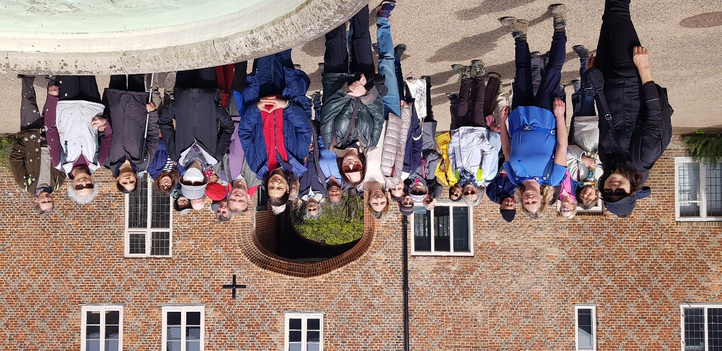
Although the club is not taking any new members at present, if you would like to find out more or be added to the waiting list for when they are able to start taking new members please contact the walks organisers valerie at Valerie@Clark.co.uk or Geetha at geethas2900@gmail.com. . Groups are still wishing to restrict numbers to 10 or under for our members needing a sighted guide. Walks take place mainly on a Sunday from March to October each year with varying distances and terrains. It’s a lovely day out, meeting new people and exploring new places and getting exercise too – what more could you want – oh and there’s often a pub stop too!
You can also find the Facebook page at

https://en-gb.facebook.com › LondonBlindRamblingClub

RNIB's free online training session - Working with Your Local Council
Would you like to learn more about how your local council works and how you can make a difference in your community?
Sign up for RNIB's free online training session - Working with Your Local Council.
The workshop will include:
  - An introduction to the structure of local government.
- *  The responsibilities of your local council.
- *  How you can influence local decision making.
    - How to work with your local council and candidates in the run up to and after the upcoming local elections.

 This training session is open to all, and you can join either online or via phone.
We are offering three different dates and times for the workshop: 
Thursday the 21st of April at 11.00am.
 Tuesday the 26th of April at 6.00pm.
 Thursday the 28th of April at 2.30pm
To sign up please contact Rebecca Swift on07852 775 124 or rswift@rnib.org.uk. Please include which session you would like to attend. We anticipate the workshop to last approximately 1.5 hours.

I’d like to wish all London NFB members, their families and friends a very happy Easter. Please keep sending us your articles for the next issue.
Best wishes,
Jess
London NFB Chair

