London NFB logo image: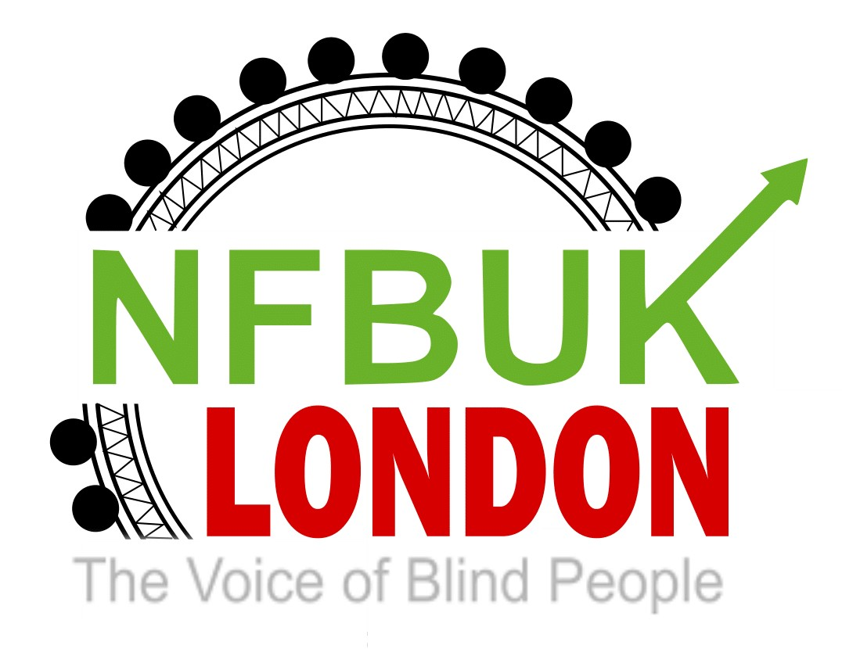

Hello London NFB Members,
Welcome to your London Life edition 32. Thanks to members for sending in their articles to include in this edition, its always great to hear from you so please do keep them coming. Whether its something you’ve been doing or sharing information. Included in this edition:
- News from NFB UK – new members area on our website
- The need for recognition of technology support within employment and education From London member: Jason Beal
- THE WINDOWS SCREEN READER PRIMER: ALL THE BASICS AND MORE -From London member: Alan Fitzjohn
- Wuthering Heights from London member and Vice Chair Berin Gem
- Awareness of the dangers posed by E: Scooters from London member Mark Pampel
- London Sight Loss Council Forum on E-scooter Safety
- TFL: Face coverings no longer mandatory but still advised
- Support NFB UK through Amazon
- VocalEyes volunteer opportunity: Heritage Access 2022
- Inclusion London: The Future of Social Care – online discussion Tuesday 8th March 6pm
- World Glaucoma Week 6th-12th March 2022

News from NFB UK: New Members Area on our website
Here’s a message from Louisa at Head Office regarding the new members area on the NFB UK website. Please contact Louisa directly for any queries – admin@nfbuk.org

Morning everyone, as some of you may know, we have been working on a members-only area on our website.

We have been testing this out to ensure it is accessible for everyone and we are now in a position to open this up to all our members.

In the members-only area, we will place circulars, newsletters and also the London Life newsletter.

There is no additional cost for anyone wishing to use this, but they must first register and await their secure password.

Please can you let all members know of this exciting and modern way of connecting with the Fed.

To register, please go to https://www.nfbuk.org/wp-login.php?action=register

Louisa Pouncett
Communication and Administration Officer

The need for recognition of technology support within employment and education
From London member: Jason Beal

I attended this online event, which was hosted by policy connect, which are an All-Party Parliamentary Group overseeing implementation of assistive technology in education.

The ATech Policy Lab will be a website that will have policies for assistive technology in the following areas Education, health, built environment, workplace.

There will be a process for bids to supply information and working relationships to the website itself.

There was over 100 people on the zoom call from MPs from the Cabinet office to assistive technology companies, universities and suppliers.

There was one MP who was from the employment department to do with access to work, unfortunately she left after her introduction, but I did ask a number of questions around from why the process is taking so long for individuals. Why are clients not being told that they can get the paperwork in an electronic format from support worker claim forms, taxi reimbursement forms and other forms that access to work require.

There is now an urgent need to make sure that technology allows everyone to participate fully in our increasingly online society. Not all digital devices, hardware and software are user-friendly for each and every one of us. Accessibility needs to be designed into technology from the start.
To find more about the website itself please visit.
https://www.policyconnect.org.uk/atpl

THE WINDOWS SCREEN READER PRIMER: ALL THE BASICS AND MORE
From London member: Alan Fitzjohn

The Windows Screen Reader Primer: All the Basics and More is a new digital book to help JAWS, NVDA, and Windows Narrator users to work more effectively with the most important PC applications—like Microsoft Office, email clients, and web browsers. These applications include the Windows operating system, the four primary Office Suite applications (Word, Outlook, Excel and PowerPoint), and the three most commonly used web browsers (Google Chrome, Microsoft Edge, and Mozilla Firefox). Dropbox and OneDrive, two popular Cloud-based file-sharing programs, are also covered. So too is Adobe Acrobat Reader for accessing PDF files. A glossary with over 100 definitions of computer-related terms and a set of practice exercises are also included. The book is intended for both beginners and intermediate users. While all the basics are covered, those already possessing a fair amount of experience using screen reader programs in the Windows environment will find useful tools and techniques to enhance their skills further.

https://carroll.org/the-windows-screen-reader-primer/#:~:text=Basics%20and%20More-,The%20Windows%20Screen%20Reader%20Primer%3A%20All%20the%20Basics%20and%20More,email%20clients%2C%20and%20web%20browsers.

Wuthering Heights from London member and vice chair Berin Gem
On a beautiful sunny day on the 26th of February, some of the members from the book club and friends, we went to see the audio described performance of Wuthering heights at the National Theatre.
There was a touch tour two hours before the play started, The National has the best access team to help visually impaired people to negotiate back of the stage and explore the props on the stage, We nearly all had one too one help, it was great to meet some of the cast members and chat to them It was also wonderful to feel and touch the costumes so beautifully created .
Having read the book and seen the film we all knew the story of Wuthering heights, The adaptation for the stage was incredible it had music and dancing and great storytelling, thoroughly enjoyed the play, and look forward to going to another audio described performance of a musical and more plays

Jess adds:
I thoroughly enjoyed my day out at the theatre, meeting friends and watching a fantastic play. I was anxious about travelling on my own (no Jason and Caine for support this time) but the excellent assistance from TFL and Southeastern staff helped me to make my journey with ease and to make me feel more confident in travelling alone next time. I wasn’t expecting such a thorough touch tour, we went on the stage to explore the set and met some of the cast, then into another area to feel beautiful costumes and props. The play was excellent, would definitely recommend a visit. So if you enjoy the theatre why not check out what you could go and see with audio description on the VocalEyes website – www.vocaleyes.co.uk
Here’s a photo of us all enjoying a drink in the bar afterwards – we had real VIP treatment high up in the private members bar area - cheers!
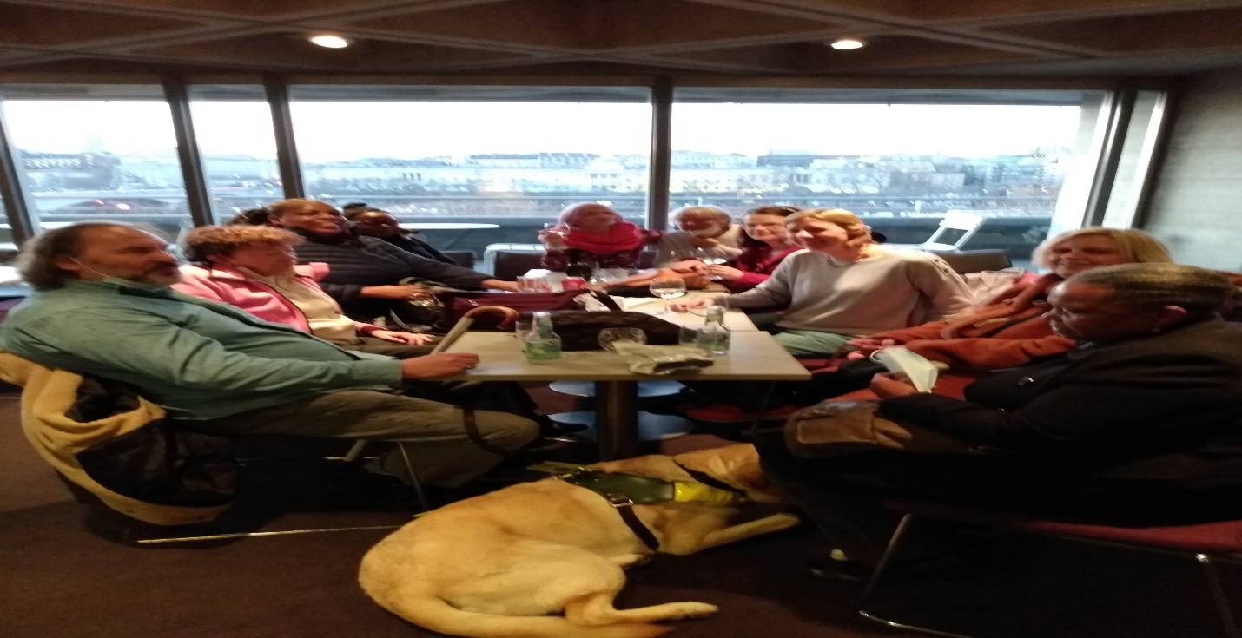

Awareness of the dangers posed by E: Scooters from London member Mark Pampel

Please see article below dated 14 February from Sarah Gayton.

https://roadsafetygb.org.uk/news/opinion-blind-people-at-the-complete-mercy-of-anti-social-e-scooter-riders/

I will be attending a Disability Oversight Panel meeting for my local Camden council which is chaired by councilors to discuss and take action on matters that affect disabled people living in my borough. On the agenda this time is a sub-heading Feeling Safe in our Borough which will give me/us the opportunity to raise our real concerns and worries about getting about safely on our streets during the e-scooter trials being undertaken in this borough and many other local authorities in the country.

Can I please suggest that members of the NFB contact their local authority to find out if there are such DOPs or focus groups which may lead to a proper debate and perhaps a deputation at a full council meeting to put a moratorium on these dangerous trials. I understand that e-scooters have already been banned in Crewe and Clacton-on-Sea.

London Sight Loss Council Forum on E-scooter Safety

London Sight Loss Council (LSLC) VI Forum
Topic: E-scooter Safety
Date: Wednesday 6 April 2022
Time: 6:00pm - 7:30pm
Venue: Virtual

Reserve your place
Fast and silent e-scooters represent a danger to blind and partially sighted pedestrians. The introduction of e-scooter trials has raised concerns amongst visually impaired pedestrians. As part of the #StreetsForAll campaign, Sight Loss Councils have been calling for:
- The installation of Acoustic Vehicle Alert Systems (AVAS) on e-scooters.
- A reduction to the current 15.5mph speed limit
- Geotagging restrictions to prevent pavement use.

Sight Loss Councils have welcomed the announcement that three leading e-scooter operators (Tier, Lime, Dott) are coming together to create a consistent audio vehicle alert system (AVAS). Introducing a universal sound could help improve safety across the entire e-scooter industry, helping road users, particularly people with sight loss, identify a rental e-scooter regardless of its operator or make.

The UK’s largest e-scooter trial has grown significantly over eight months to double the trial area, with six times the number of e-scooters now operating compared to launch.

Our e-scooter safety VI forum invites blind and partially sighted people and the wider public to hear from e-scooter providers, Dott, Lime and Tier, and representatives from TfL and the Met police. The event will allow attendees to learn more about different e-scooter safety features, how to report an issue should they encounter one, and about the progress of the London trials.

Our guest speakers want to hear about your experiences with e-scooters and invite you to submit your questions ahead of the event.
Jacqui Thomas, Sight Loss Council Engagement Manager London), said:
“The event will enable blind and partially sighted people to ask questions and raise their concerns about e-scooter safety.”

Haren Thillainathan, London Sight Loss Council member, said:
“e-scooters have the potential to be part of a more sustainable and low carbon transport future. Unfortunately, irresponsible use of them presents a significant danger to the public, particularly blind and partially sighted people. The London e-scooter trial will provide critical evidence and lessons on how they can be better regulated to ensure the safety of pedestrians as well as riders. London Sight Loss Council invites blind and partially sighted people and the public to our VI forum to learn about the trial and to raise concerns and your experiences with electric scooters in the capital.”

Registration:
Closing date to register: Sunday 27th March 2022
For more information Reserve your place or email: info@sightlosscouncils.org.uk.
Alternatively, you can contact Jacqui Thomas by email: jacqui.thomas@pocklington-trust.org.uk or call: 07966 416 210.
Please submit any questions in advance, there will be the opportunity to ask questions at the forum.

TFL: Face coverings no longer mandatory but still advised
Wearing face coverings will no longer be mandatory on our services from 24 February, but we continue to strongly recommend wearing one if you are able to.

This decision has been made after we considered a variety of factors such as the shift in the government's approach towards living with the virus and decreasing infection rates in London.

We are operating a near normal service and our enhanced cleaning regime continues to ensure that the transport network is cleaner than ever. Trains, trams, buses and stations are cleaned with hospital-grade cleaning substances that kill viruses and bacteria on contact and provide ongoing protection. Independent testing by Imperial College London has been carried out monthly since September 2020, taking swabs of touch points in stations, buses and air samples in ticket halls and has found no traces of coronavirus on the public transport network.

The transport network is also well ventilated. Train and bus doors opening frequently ensures a regular exchange of air across the public transport network, while the constant movement of trains draws fresh air into the system. In the deeper Tube lines, ventilation shafts and fans supplement this air movement.

Assessments on Tube carriages indicate that the air changes over 20 times each hour, more than the six to 12 times recommended by the Rail Safety and Standards Board. Buses, which are cleaned daily, have been modified to keep windows propped open and are also fitted with a range of air extraction and ventilation systems. These systems, in conjunction with leaving windows open and the frequent opening of doors, ensure the flow of fresh air through the vehicle.

We also strongly encourage the continued use of face coverings in taxis and private hire vehicles by both drivers and passengers, unless they are exempt. Londoners are also encouraged to use active travel options such as walking and cycling for all or part of their journey. Legible London signs across the city provides local information and potential routes for those walking and cycling. Santander Cycles docking stations are located all over the capital, and the scheme continues to break records with more customers hiring bikes each year.

Yours sincerely,

Julie Dixon
Interim Customer & Revenue Director

Support NFB UK through Amazon

Amazon Smile is a chance to donate to the NFB UK through your Amazon account. You can simply select the National Federation of the Blind UK as your chosen charity. Every purchase you then make entitles a small donation from Amazon. Please encourage your friends and family to choose the National Federation of the Blind UK and continue spending on Amazon.

Please click here to register:

https://smile.amazon.co.uk/gp/chpf/homepage?orig=%2F

VocalEyes volunteer opportunity: Heritage Access 2022
Do you love museums and heritage? Do you care about accessibility? Join a team of 50 volunteer access researchers in a large-scale digital volunteering project that will benefit over 3,000 heritage sites in the UK and their visitors.
Role: Volunteer Access Researcher (online)
Location: Online, home-based, anywhere in the UK
When: April to July 2022
Hours: Flexible. Any time of day. Volunteer for an estimated 40 to 50 hours, including focus groups, discussions and briefing sessions (all online)

For more details and how to apply please visit:
https://vocaleyes.co.uk/volunteer-opportunity-heritage-access-2022/
The deadline for the submission of expressions of interest is 9am Monday 14 March 2022.
Any questions, please email enquiries@vocaleyes.co.uk with the title Heritage Access 2022.

Inclusion London: The Future of Social Care – online discussion Tuesday 8th March 6pm

Join Us for An Online Discussion - Tuesday 8 March 6-7pm
In January 2022, Pluto published The Five Health Frontiers: A New Radical Blueprint, in which public health expert Christopher Thomas argues that we must emerge from the pandemic on the offensive – with a bold, new vision for our health and social care. He maps out five new frontiers and imagines how we can move beyond safeguarding what we have, towards a revitalisation and radical expansion of the principles put forward by Aneurin Bevan, the founder of the NHS, over 70 years ago. Christopher is a senior research fellow at the Institute for Public Policy Research (IPPR) and the author of The Five Health Frontiers

This Meeting Will Be Live-Captioned and Bsl Interpreted.

Register in advance for this meeting:
https://us02web.zoom.us/meeting/register/tZIvduuvrjgpGdyjEmjOD3p3ERdQBvgDezo2

World Glaucoma Week 6th-12th March 2022
Find out more and get involved with World Glaucoma Week, raising awareness of Glaucoma the leading cause of preventable irreversible blindness worldwide. With many people unaware they have the condition or have access to much-needed care and treatment, this is an excellent initiative to raise awareness and support around the World. All details on their website at:
https://www.worldglaucomaweek.org/
We’d love to hear from you with any ways you have got involved with this initiative or simply share your experiences of living with Glaucoma.

That’s all for this edition. Have a wonderful fortnight and we look forward to sharing your news and information in our next edition.
Best wishes,
Jess
London NFB Chair

