No Time To Trial or Legalise E-Scooters in UK
Significant Risk of Personal Injury Too Great for Britain in Time of Pandemic

Contents

1.0 Overview Page 3
2.0 Evidence Pages 3 to 11
3.0 Comments Page 12
4.0 Recommendations Page 12

Appendix A Electric Scooter Accident Injury Stories - Santa Monica Pages 13 to 78
Published on McGee Lerer & Associates Website

Appendix B Research Papers on Injuries from E-Scooters Pages 79 to 89

1.0 Auckland, New Zealand
  - ‘Impact of e-scooter injuries on Emergency Department Imaging’
1.2 ‘Electric Scooter Injuries at Auckland City Hospital’
2.0 USA
2.1 Austin, Texas, USA ‘Dock less Electric Scooter Related Injury Incidents’
September- November 2018
2.2 Dallas, Texas, USA ‘Craniofacial Injuries Seen with the Introduction of Bicycle-Share
Electric Scooters in an Urban Setting’
2.3 San Diego, California, USA ‘Severe eye injuries seen with e-scooter accidents’
2.4 Southern California, USA ‘Injuries Associated with Standing Electric Scooter Use’
2.5 Salt Lake City, Utah ‘Emergency Department Visits for Electric Scooter-Related Injuries After Introduction of an Urban Rental Program’
2.6 Indianapolis, USA ‘Facing Facts: Facial Injuries from Stand-up Electric Scooters’
3.0 Turku, Finland ‘Assessment of Craniomaxillofacial Injuries Following Electric Scooter Accidents in Turku, Finland in 2019’
4.0 Copenhagen, Denmark ‘Injury from electric scooters in Copenhagen: a retrospective cohort study’

Appendix C Example of Deaths & Serious Injuries Caused By E-Scooters Pages 90 to 120

1.0 Bike courier hit by e-scooter, Portland USA
2.0 ER doc: Stay off electric scooters Number of e-scooter-related injuries on the rise

3.0 New York, USA ‘60-year-old woman dies after being hit by e-scooter in Harlem’

4.0 Singapore ‘E-scooter rider jailed after crash causes 6-year-old to suffer brief hearing loss’

5.0 Singapore ‘S$2,400 fine for e-scooter rider who collided into 10-year-old girl’
6.0 Singapore Police arrest e-scooter rider who allegedly knocked down woman in Bedok Reservoir

7.0 Singapore ‘Family of e-scooter hit-and-run victim appeals for witnesses to come forward’

8.0 Spain ‘E-scooter rider who caused Spain’s first fatality faces fine, not prison
9.0 Many examples given – ‘Broken Bones and Missing Teeth: Scooter Injuries Are Becoming Common At Hospitals’ Katie Notopolos, 20 August 2018
10.0 Paris, France ‘Man killed and woman badly injured in latest electric scooter crash in France’
11.0 San Francisco, USA ‘E-scooter crash on SF’s Embarcadero leaves 69-year-old woman with life-threatening injuries’

12.0 Spain Calls for electric scooters to be banned in Spain after man is killed in tragic

Accident

13.0 Hobojen, New Jersey Hoboken Pulls Plug On Electric Scooter Company After Several Accidents, Mother And Infant Injured By Rider

14.0 Auckland, New Zealand -Lime e-scooter hits woman on Auckland's Fanshawe St where man died

15.0 London, UK ‘Teenager electric scooter rider in critical condition after being struck by car in London’.

16.0 London, UK Television presenter Emily Hartridge dies in electric scooter crash

17.0 Elderly Woman Injured In E-Scooter Crash On Embarcadero

Appendix D Examples of Problems of Regulating E-Scooter Use Pages 121 to 130

1.0 Spain

1.1 Malaga, Spain

1.2 Palma, Spain

2.0 Atlanta, USA (2 articles)
- Singapore
4.0 Montreal, Canada
5.0 Los Angeles, USA

Appendix E - Disabled being injured by escooters, as well as access problems due to dockless escooters blocking pavements etc. Pages 131 to 156

- California, Disability rights group sues scooter companies over clogged sidewalks

2.0 Texas, USA, Texas School for The Blind And Visually Impaired Calls On Scooter Riders To Be More Mindful

3.0 E-scooters suddenly appeared everywhere, but now they're riding into serious trouble
4.0 Auckland, New Zealand - Blind and visually impaired people want e-scooters off the footpath for good

5.0 Oslo, Norway- Oslo City Council Declares Electric Scooter Experiment in Norway As Chaos

6.0 Trip hazard for blind people: how dangerous are e-scooters?

7.0 Brisbane, Australia - Lime scooters are causing stress for Brisbane's vision impaired community

8.0 Disability advocate sues Minneapolis scooter companies

9.0 Duedin, New Zealand - Rules urged for 'hazard' scooters

Please note - warning
Some of the photos used in this evidence may cause distress, these are given in Section 2 and Section 4, and are from the McGee Lerer & Associates, Santa Monic, USA.

Submitted 4th June 2020
National Federation of the Blind of the UK, Second Edition.
No Time To Trial or Legalise E-Scooters in the UK
Significant Risk of Personal Injury Too Great for Britain in Time of Pandemic

This is the National Federation of the Blind of the UKs submission to the Department for Transport request for evidence regarding the potential regulation of e-scooters in the UK.

- Overview

The legalisation and proposed trials of rented e-scooters should be abandoned to protect the NHS, protect public health and to protect public space for people to use their mobility aids, for people to undertake active travel and to allow social distancing during these activities. All efforts should be focused on ensuring safe and accessible environments for all.

- Significant evidence exists of e-scooter riders and pedestrians sustaining serious and minor injuries. Many have required emergency treatment as illustrated in Appendices A, B, C and E.

- Many injuries are created by riders falling off e-scooters, colliding with pedestrians and other cyclists; as well as pedestrians tripping over undocked e-scooters on pavements and in public spaces.

- The NHS needs protection from a new influx of people needing emergency treatment during the ongoing Coronavirus pandemic. This will continue after the pandemic due to treatment of existing patients whose elective surgeries have been put on hold during this period and new patients who have kept away from the NHS at the time.

- Public space should be protected and used to allow social distancing for active travel, for people to walk, cycle, use their mobility aids, use blue badge parking and to access public transport and undertaking shopping in clutter free environments.

- Evidence

E-scooters have caused many serious and minor injuries, as well as some deaths, in city centres across the world where they have been deployed.

- Appendix A shows graphic details of numerous horrific personal injuries to riders, pedestrians and cyclists from law firm McGee Lerer & Associates based in Santa Monica, USA. Photos 1 to 3 below illustrate a few of these injuries.

- Appendix B details published research evidence highlights the immediate serious and minor injury risks posed by the introduction of rented e-scooters into urban areas.

- Appendix C contains just a few examples of the personal tragedies and serious injuries people are experiencing with the introduction of e-scooters in urban locations.

- Appendix D contains examples of where city authorities have tried to regulate escooter rider behaviour during and after use and have failed to ensure compliance.

- Appendix E contains examples of blind, partially sighted and disabled people being injured by escooters and having access blocked due to escooters left on pavements etc.

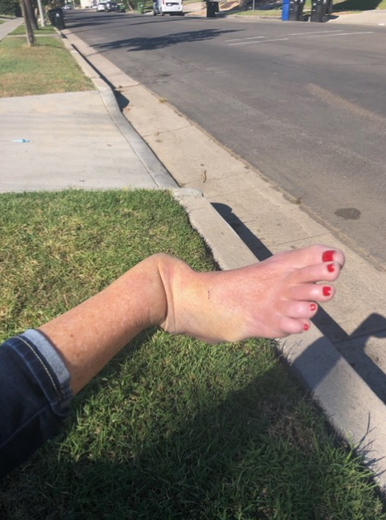
Photo 1 - McGee Lerer & Associates, Santa Monica, USA – 57-Year-Old Female E-scooter Rider Injury 10/11/18

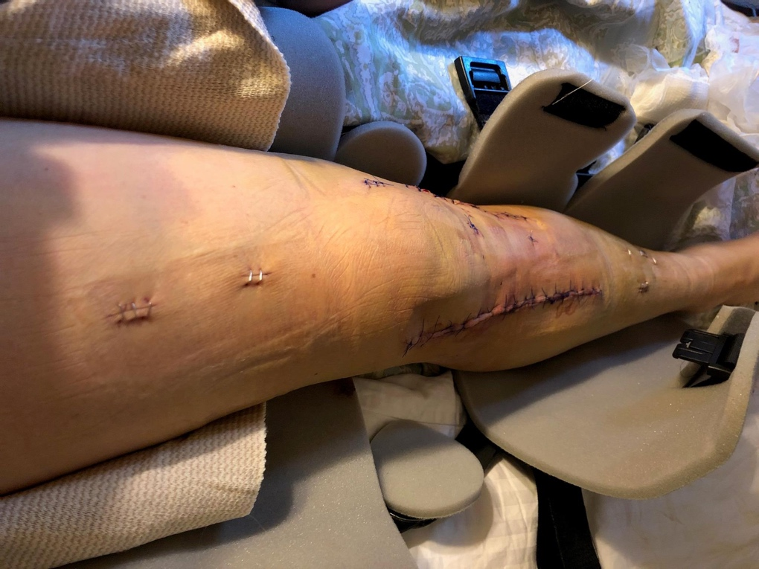
Photo 2 - McGee Lerer & Associates, Santa Monica, USA – 53-Year-Old Female E-scooter Rider Injury 05/9/18

Photo – 3 McGee Lerer & Associates, Santa Monica, USA – 71-Year-Old Cyclist Rider Injury Hit by E-Scooter September 2018

The following are extracts from three of the research papers and articles on escooter injuries:

The following extract from a research paper from Auckland New Zealand (Published 19 April 2019) clearly shows the human impact of the introduction of e-scooters:

‘Introduction of shared e-scooters has resulted in a large number of serious related injuries that have required urgent radiology imaging. Many of these patients required specialist consultation or surgery, and place an increased burden on overstretched emergency department services.

‘While the impact on valuable limited resources such as emergency department imaging is considerable, the impact on so many young lives changed by these injuries is immeasurable. With the majority of injuries occurring in the working age group, the significance of morbidity due to these injuries should not be underestimated. Disability due to injury in this age group can results in extended time away from work – affecting both the individual and also company productivity’.

The following extract is taken from Published Epidemiology and Disease Surveillance Unit, Austin Public Health, City of Austin - April 2019. Types of Injuries Sustained - From 190 recorded injuries (160 confirmed and 32 probable) the following injuries were recorded from the period 5 September to 30 November 2018:
‘Of the 190 injured riders, nearly half (48%) had injuries (e.g., fractures, lacerations, abrasions) to the head. In addition, 70% sustained injuries to the upper limbs (hands /wrist/arm/shoulder), 55% to the lower limbs (leg/knee/ankle/feet), and 18% to the chest/abdomen; multiple injuries across body regions were possible. Many individuals sustained injuries on their arms (43%), knees (42%), face (40%), and hands (37%).
Over a third (35%) of the injured riders sustained a bone fracture(s) (excluding nose/fingers/toes). Among this group, 19% had bone fractures (excluding nose/fingers/toes) involving multiple body regions. Figure 4 shows the bone fracture locations for injured riders. A high number experienced fractures on their arms and legs. Notably, six persons (3%) had fractures involving the head.
Almost half (80) of the injured riders had a severe injury. The severe injury for these riders included: bone fractures (excluding nose/fingers/toes) (84%); nerve, tendon, or ligament injuries (45%); spending more than 48 hours in the hospital (8%); severe bleed (5%), and sustained organ damage (1%).
Traumatic brain injuries include concussions and other forms of altered mental status or bleeding such as subarachnoid hemorrhage and subdural hematoma. Fifteen percent of riders had evidence suggestive of a traumatic brain injury. Less than one percent of individuals was wearing a helmet at the time of injury. Eighty-eight percent of injured riders were seen at an emergency department. Fourteen percent of all injured riders were hospitalized. None of the injured riders died during the study period’.
The following extract from the article ‘Disability rights group sues scooter companies over clogged sidewalks’(16 January 2019) . A lawyer on behalf of ‘Disability Rights California’ stated:

"The scooter companies have treated our free public walkways as their own private rental offices, show rooms and storage facilities," said Bob Frank, lawyer for Neil, Dymott Attorneys, which filed the case in conjunction with Disability Rights California. "People with disabilities need to have access to city sidewalks and their needs must come first."

"People with disabilities should not have to stay in their houses because they are afraid to venture out the door due to scooters blocking their pathway everywhere they go," Ann Menasche, lawyer for Disability Rights California, said in a statement. "They have a right to use the city sidewalks just like everyone else who lives or visits here."
This was from an article by MPR News article ‘ER doc: Stay off electric scooters’ published 16 September 2019:
Seconds after impact, Tonie Pereira knew he was hurt badly. He touched his hand to his face and saw that his bicycle glove was soaked in blood. It ran from Pereira’s forehead and nose and flowed down his throat. Blood also filled his ears and eyes.
“There was a point where I couldn’t see much because my eyes were full of blood,” said Pereria, 47, of Woodbury.
A little over a month ago, Pereira was riding his bike on a bike path around Bde Maka Ska, formerly known as Lake Calhoun. He collided with another cyclist who had slowed down to clear an electric scooter lying across the bike trail.
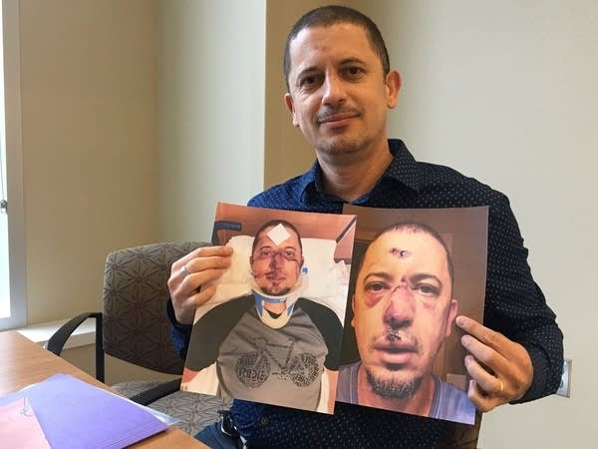
Tonie Pereira holds pictures taken of him after he was injured - Brandt Williams | MPR News
Pereira landed on his face and suffered a broken nose and lacerations to his head, nose and upper lip, which needed 12 stitches to close. He later had to have surgery on his nose. It could have been much worse, said Pereira, had he not been wearing a helmet.
One of the emergency room doctors who saw him that day counts Pereira’s injuries as e-scooter related, even though he was not riding one. Over his 33-year career as an emergency doctor, Dr. Stephen W. Smith has seen a lot. But the electric-scooter-related injuries he’s seen this summer at Hennepin Healthcare are new.
“I can’t remember if it was April, May or June, but I remember that I started seeing a lot of them. And I was amazed at how many there were,” said Smith. “This was a brand new phenomenon ... none of us had ever experienced before.”
Smith estimates at least five people are treated in the ER each day for e-scooter-related injuries. That adds up to several hundred ER visits this summer. Unlike Pereira, the wounded are usually e-scooter riders. Smith takes out his cellphone to refer to a list of cases he’s treated personally in the past month.
“A person with road rash and a finger laceration,” reads Smith. “... somebody with a tibia [shin] fracture; another person with an ankle fracture; another person with a clavicle [shoulder] fracture; another person with a mandible [jaw] fracture.”
Head injuries are also common, said Smith. When riders fall forward, they often strike the ground head first. Smith said he’s yet to see an injured rider wearing a helmet. Helmets aren’t required by law for adults, yet e-scooter providers encourage riders to wear helmets. The only way to safely ride an e-scooter, said Hennepin Healthcare emergency room Dr. Stephen Smith, is with a helmet.
But better yet, he said, just don’t ride them.
“I just tell people, ‘they’re dangerous devices,’” he said, pointing out that the other doctors and residents he works with share his opinion. “That would be a total of about 100 doctors in our emergency department. We all think they’re dangerous devices.”
The following are experiences and concerns from NFBUK members and employee:

Karl Farrell, Executive Committee Member from London,

‘I, as a severely visually impaired pedestrian, collided with a parked dockless bike late at night while walking home. The bike fell on my legs, cutting my shins and tearing my trouser leg. The bike was standing diagonally on the footway so I did not have any warning of its presence before I collided with it. I trust that an e-scooter would not be so heavy but I don't wish to trip over e-scooters discarded carelessly after their temporary users have finished with them’.

This short twitter film illustrates the injuries Karl sustained when tripping over the dock less bike in London - https://twitter.com/seaofchangefilm/status/1219320450775425024?s=21

Sarah Leadbetter, Partially sighted female Guide Dog, Leicester:

‘Escooters are quiet and can go very fast, in comparison to my walking speed. As a partially sighted person with a Guide dog, I already have to share the pavement with bikes and street furniture and now I may have to share it with escooters, as there is no way the riders will keep to roads or to cycle paths. I walk in the city where I live and I will not know that they are there and or when they will try come past me. This will happen suddenly and will be very scary and very dangerous. The person on the escooter could loose their balance and fall off to cause an accident to them, me and my Guide dog’.

Sarah Gayton, Shared Space Coordinator, NFBUK:

‘As a fully sighted visitor in San Diego, I did not relax once with e-scooters whizzing past me on the sidewalk, and I spent a lot of time trying to move the never-ending number of escooters dumped across the sidewalks. They were heavy and hard to move. There is no way a wheelchair user could move these out of the way. I witnessed e-scooters blocking crossings, sidewalks, left next to transport hubs and chaotic riding behaviour on riders’.

‘I was relieved to learn these were banned in the UK and I am now very worried that moves are being made to make them legal in the UK. Active travel will take a backstep if escooters are introduced, disabled people will face even more barriers to independent access on the pavement and many people will get seriously hurt in the process’.

This short twitter film illustrates the problems of dockless escooters https://twitter.com/seaofchangefilm/status/1061021898891554816?s=21.

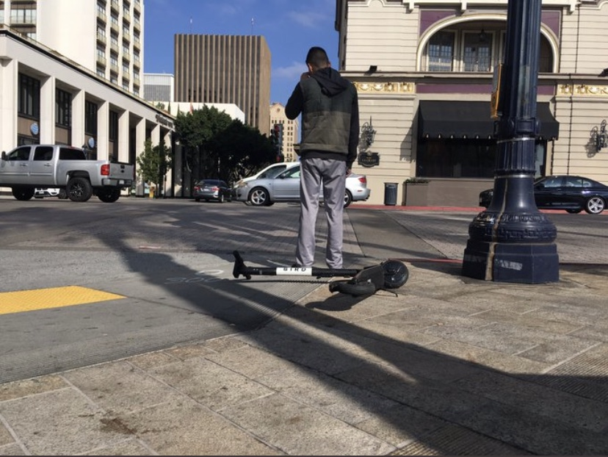

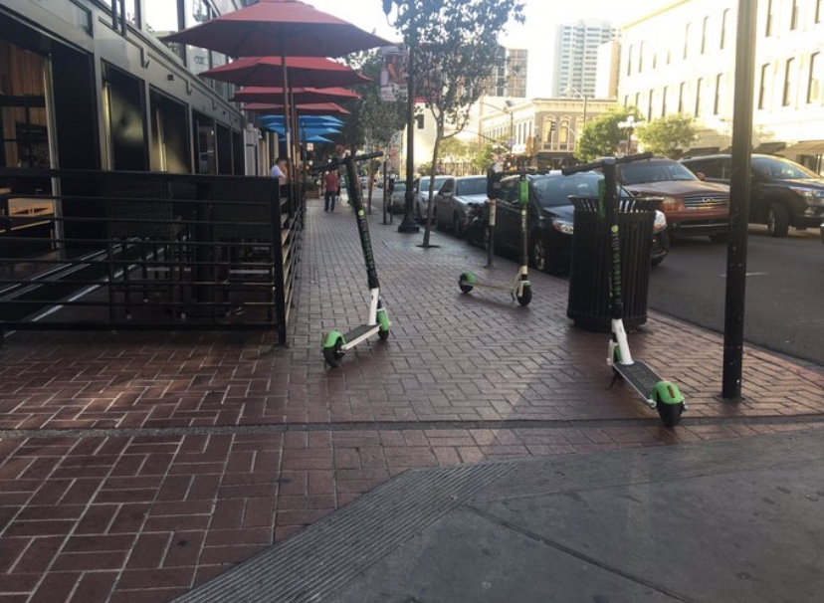

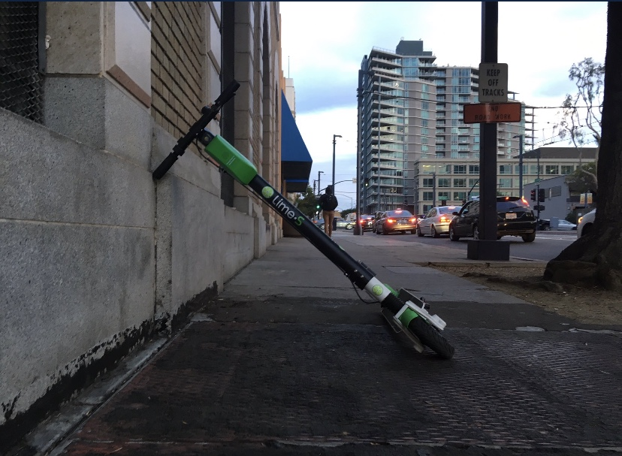

Photos 1 to 3 from site visit in San Diego, USA - November 2018 showing escooters blocking crosswalks and the sidewalks.

President of NFBUK, Andrew Hodgson stated the following:

‘During the Walk21 Conference in Rotterdam, we attended a meeting in Brussels with the European Union. There I had my first encounter with escooters which had been left across the pavements and at the entrance to road crossings. There was no way I could move them and they were left in very dangerous locations putting myself at great danger of falling over them’.

‘After learning about the accidents these escooters have caused, it is very clear to me, these escooters are not fit for purpose. Riders appear to fall from them very easily, causing serious head injuries along with many broken bones. It is also clear from practical experience, dockless escooters simply do not work as the machines can end up anywhere in the city. This causes totally random potential barriers to access across city pavement and public space for disabled and elderly people and mothers with buggies’.

‘At a time of social distancing when urgency has been placed by the Government on active travel, it is critical that all spare public space is protected for walking and cycling. Escooters will only take people away from active travel, and make those embracing walking and cycling being faced with danger and chaos if escooters were legalised in the UK. They should not be legalised in the UK’.

Photos 4 and 5 below illustrate the escooters Andrew Hodgson came up against in Brussels in October 2019.
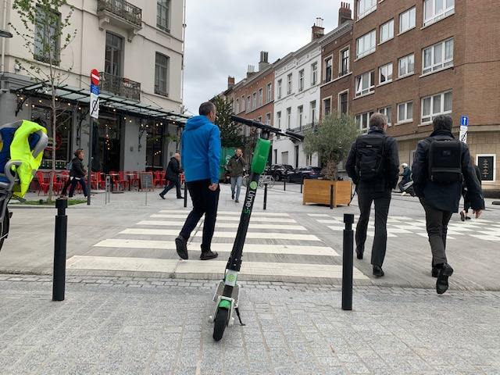

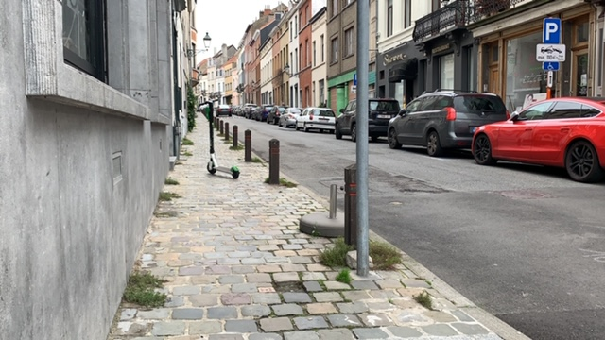
Photos 4 and 5 Illustrating escooters being left on the pavement next to a zebra crossing and on the pavement in Brussels.

3.0 Comments

There is a critical need to continue to protect the NHS, to protect the public from transport injuries, encourage more active life styles and ensure safer access for all in urban areas:

- NHS resources need to be protected during and after the pandemic, and it cannot be subjected to a new wave of preventable injuries from use of escooters.

- Injuries will add extra strain to relatives, friends, carers and rehabilitation staff who are already overstretched trying to get through the Pandemic.

- The Department for Transport has specific advise on Active Travel, to encourage more people to walk and cycle. Escooters are not active travel. They have the potential to replace many trips which could be undertaken by walking or cycling.

- Travel patterns have altered during the pandemic and there is uncertainty how people will go back to work. More people may work from home on full or part time basis, and people may use active travel options for some or part of their journey.

- All efforts should be made to ensure existing methods of transport, transport infrastructure and active travel options of walking and cycling are made safer, accessible for all and allow for social distancing.

- Regulations will not prevent rentable escooters being used on the pavements, public spaces or being left haphazardly on the pavements. Escooter riders will use dropped kerbs to ride on and off the pavements, ride all over public spaces and leave them where ever they feel like it, creating hazardous, dangerous and inaccessible public spaces. The police or local authorities do not currently have the resources, especially when the country is dealing with a pandemic, to deal with such behaviour.

- Escooters are simply not fit for purpose, many riders fall off them due to their design, operation and the poor condition of the urban environment.

Although there is concern over how people will commute once the UK returns to work from lockdown due to social distancing requirements on public transport, the solution is not to use a new form of transport in the UK during or after this Coronavirus pandemic.

4.0 Recommendations

The UK should continue to protect the NHS and protect people’s health from injury with safer and more active and accessible forms of transport and active travel infrastructure. It is therefore strongly recommended that:

- E-scooter trials are stopped and should not take place during or after the Coronavirus pandemic

- Greater focus on providing safe and accessible transport, transport infrastructure and active travel options in urban areas for all citizens.

- New regulations allowing e-scooters to be used in the UK should not be rushed through during or after the coronavirus pandemic.

- Existing regulations preventing escooters usage in the UK should remain and escooters should not be made legal in the UK.

Appendix A Electric Scooter Accident Injury Stories Santa Monica, USA. Published on McGee Lerer & Associates Website

The following examples illustrate the horrific injuries resulting in the use of e-scooters to the rider, or to a cyclist or pedestrian the e-scooter collides in. The pictures are quite disturbing.
Ever since Bird and Lime dumped their electric scooters all over Santa Monica, our personal injury law firm has been inundated with calls from people injured in electric scooter accidents. The calls come from riders as well as pedestrians. We believe everyone needs to know about the quantity of calls we are getting, the seriousness of the injuries, and the commonality of the fact patterns. Not only does the public need to know, but so do city council members in other cities who are considering allowing in electric scooters, the scooter companies themselves (Bird and Lime), and anyone considering investing in these companies or renting their scooters.
If you or a loved one was injured in an accident involving an electric scooter, please email us a brief description of how the accident happened and your injuries. We also encourage you to send us injury photos to add further validation to your account. We will contact you to verify the story, but we will not post your name. We are asking our community members to help us grow this database and spread the word of electric scooter dangers.
Below you can find brief summaries of the accidents people have shared with our law firm. Please be aware that most contain images of injuries suffered while riding an electric scooter. Some people may find the imagery disturbing or upsetting.

Date of accident: 04/17/20
35-year-old male was riding a Bird electric scooter in Hollywood, California. The scooter’s throttle malfunctioned. The scooter accelerated even though he was not pressing the throttle. He was approaching an intersection with cross traffic. In order to avoid riding into the intersection and being hit by a car, he had to crash into a building to stop. He suffered injury to his elbow, and may require surgery.

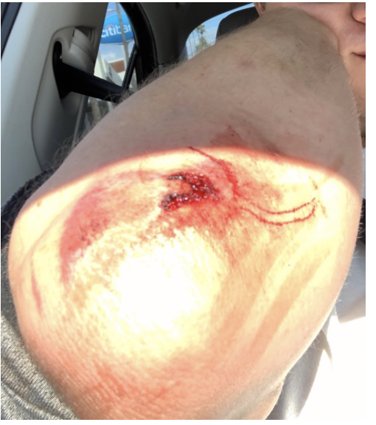
Date of accident: 03/29/19
49-year-old female was riding a Bird electric scooter in Nashville, Tennessee. The scooter malfunctioned. She was thrown over the handlebars and landed on her face. She suffered multiple jaw fractures and lost 2 teeth. Her jaw had to be wired shut and she required two implants and three root canals.

Date of accident: 12/04/19
37-year-old male was riding a Lime e-scooter in Koreatown. It had been raining earlier in the day. The scooter slipped out from under him on the wet roadway. He broke two teeth. 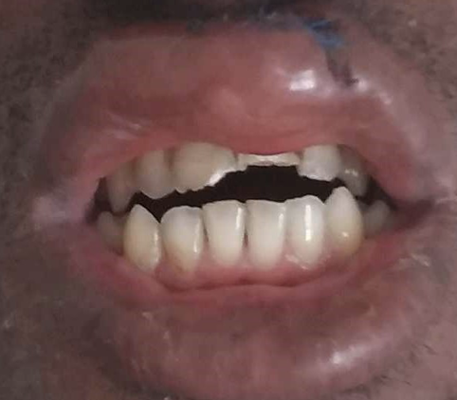

Date of accident: 08/01/18
27-year-old female was riding a Lime e-scooter in West Hollywood when the scooter malfunctioned and she was thrown off. Her chin slammed onto the pavement. She suffered a bilateral mandible fracture, temporal bone fracture, and concussion. Her jaw was wired shut for approximately six weeks.

Date of accident: 07/19/19 - 49-year-old male was riding a Bird electric scooter in Los Angeles (Koreatown). The scooter suddenly jerked and slowed down. He lost control and crashed. He suffered a broken tibia and fibula. He had to undergo two surgeries. 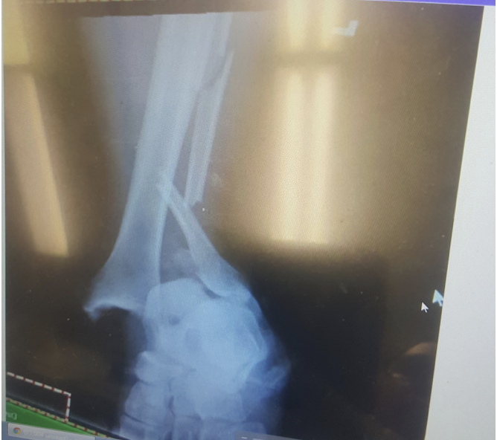

Date of accident: 04/03/19
46-year-old female was riding a Bird electric scooter in downtown Long Beach. She was in Long Beach for a work conference. This was her first time (and last) riding an e-scooter. She tried to brake but the brakes failed, causing her to lose control and crash. She suffered four broken bones in her leg and foot, including a broken tibia and fibula. She required surgery involving the insertion of 2 plates and 8 screws.
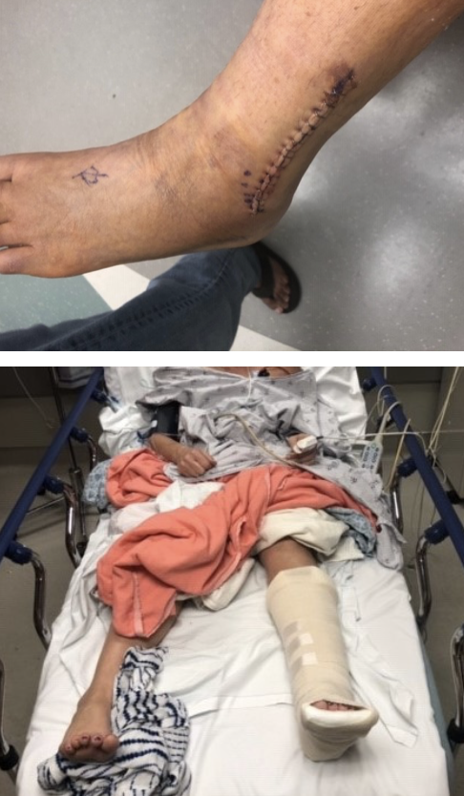
Date of accident: 1/13/19
21-year-old female was a tourist from Miami, visiting Santa Monica. She was riding a Bird electric scooter by the beach. She was going downhill when the brakes failed. She suffered a shattered left tibia, requiring surgery and hardware.
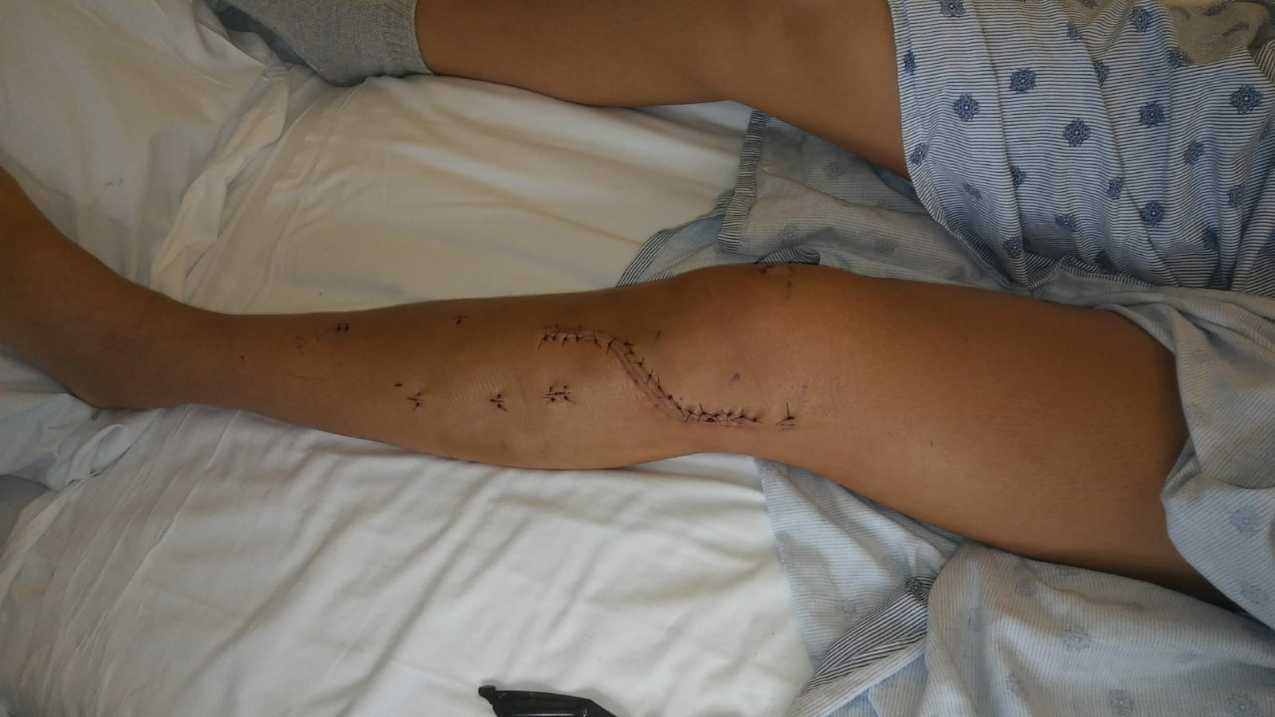

Date of accident: 12/21/19
36-year-old male was riding a Lime electric scooter in downtown Ohio. He felt a vibration, then the front wheel suddenly turned 90 degrees, launching him off the scooter. He suffered a dislocation and multiple fractures in his right elbow (“terrible triad of the elbow”). He underwent surgery involving plates and screws. He then required a second surgery to remove some of the hardware.
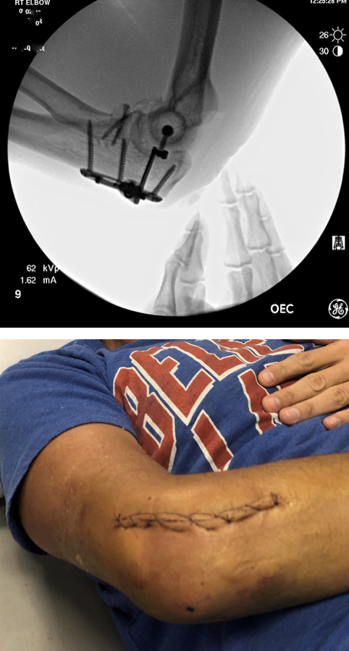

Date of accident: 11/25/18
53-year-old female was riding a Lime electric scooter while on her honeymoon in San Diego. The scooter wasn’t working properly. It wouldn’t accelerate. Suddenly, the scooter took off and she was thrown to the ground. She suffered 3 fractures: tibia, fibula and Lisfranc. She underwent surgery the next day. She was in the hospital for a week, and then a wheelchair for six months.
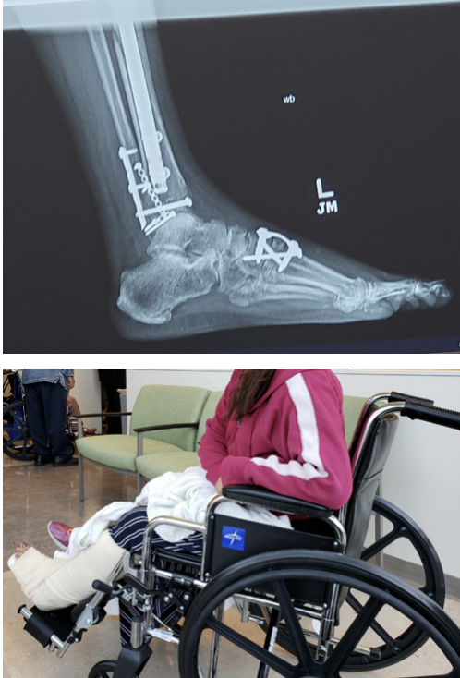

Date of accident: 10/9/19
43-year-old female was riding a Lyft e-scooter. She was in a parking lot on Washington Blvd. in Marina Del Rey. She rode over a roadway irregularity, which caused her to lose control. She was launched off the scooter. She suffered a broken right wrist, broken nose, concussion, and road rash on her face, knee, and hands.
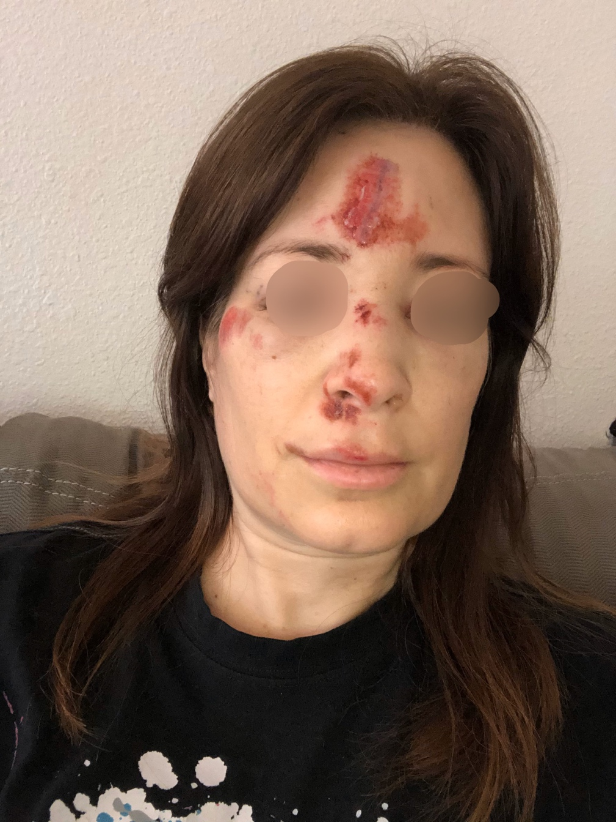

Date of accident: 08/30/19
53-year-old female was riding a Bird scooter on California Ave. in Santa Monica. After hitting an asphalt patch on the roadway, followed by a raised bump on the roadway, she lost control and was launched off the electric scooter. She suffered a tibial plateau fracture, requiring two surgeries.
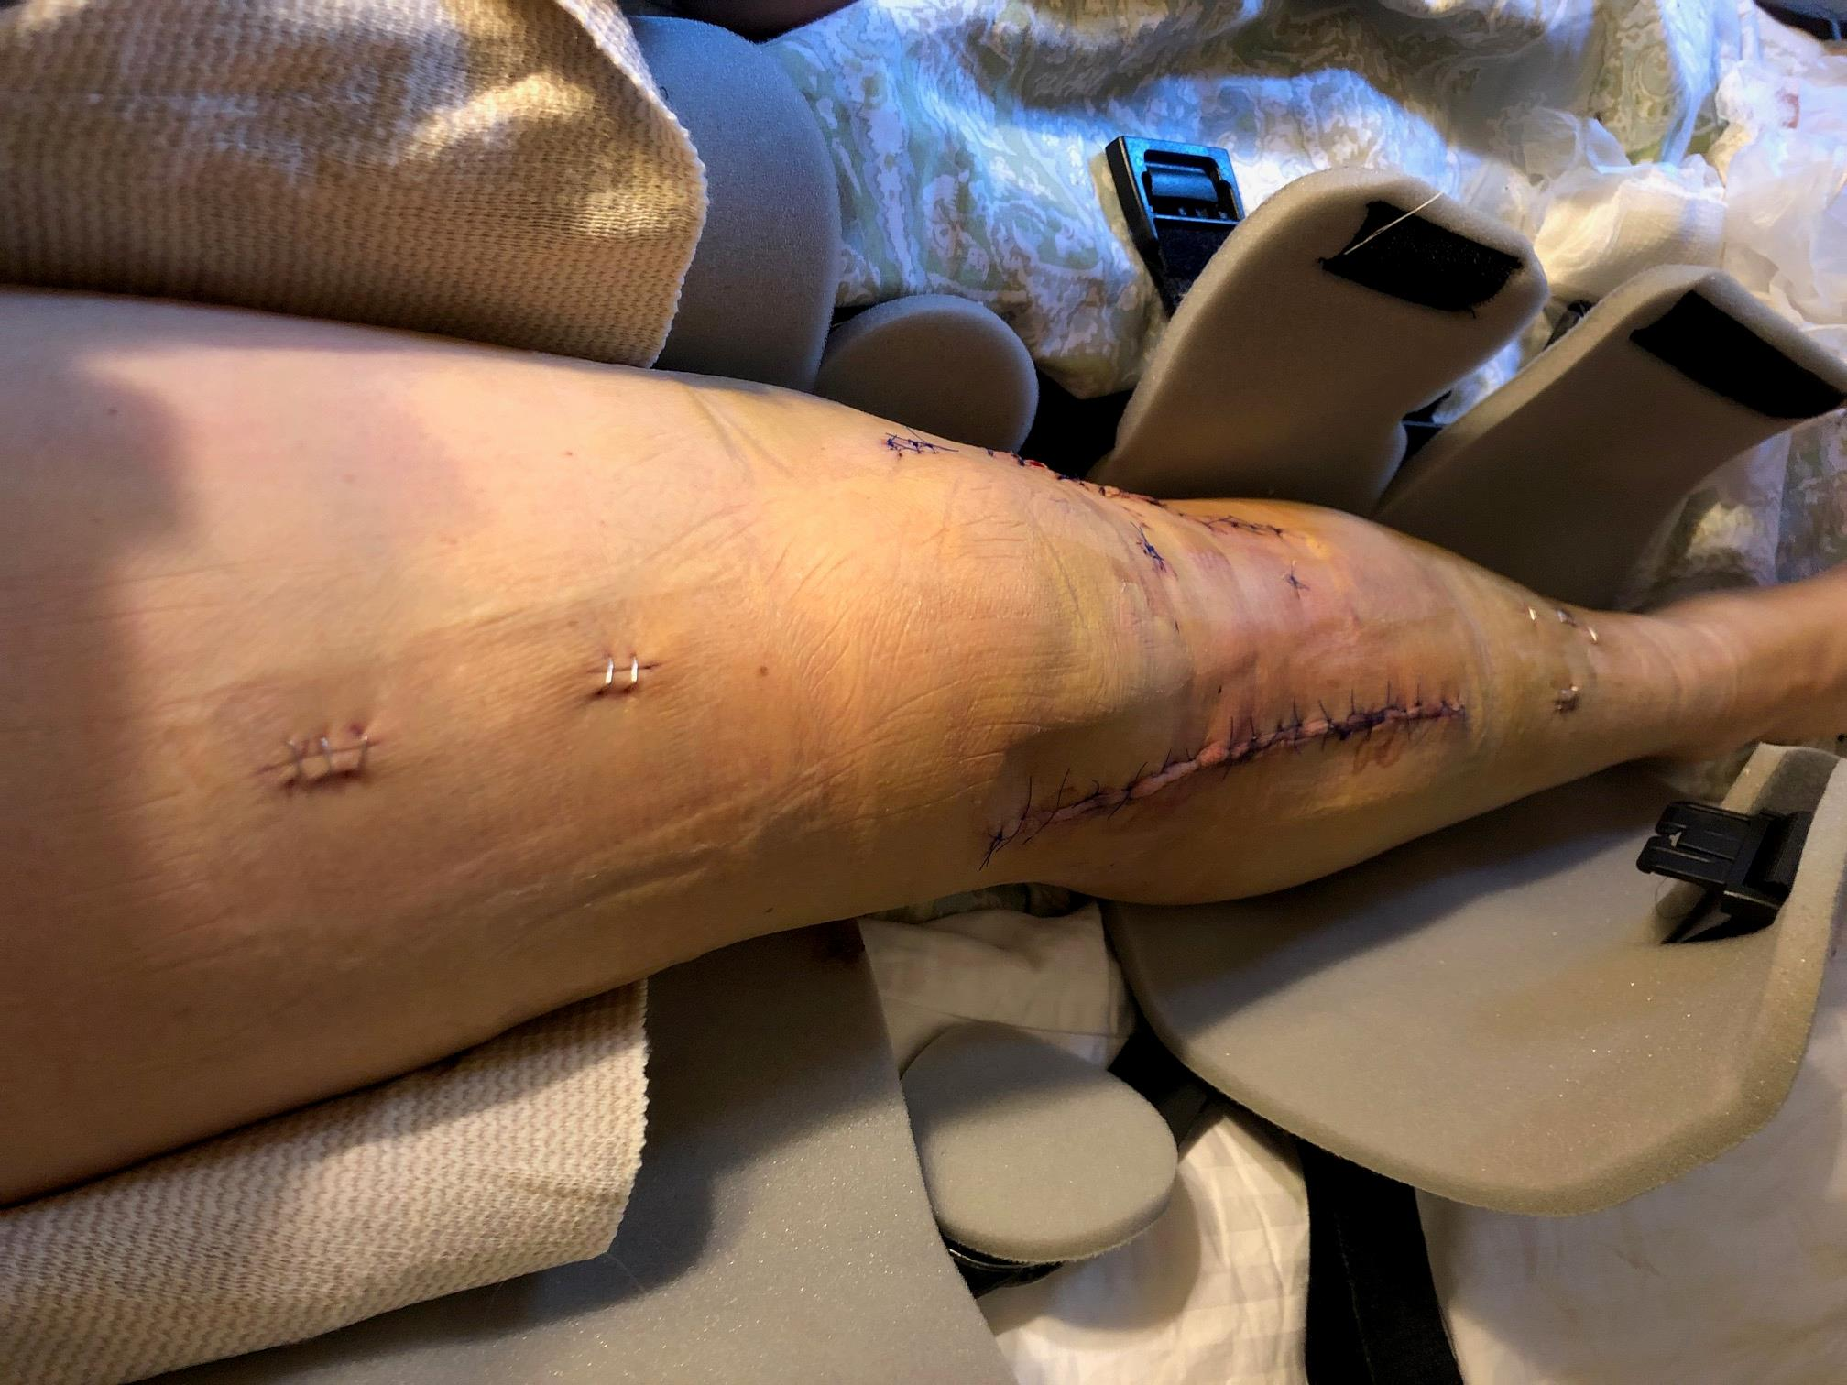

Date of accident: 11/19/19
33-year-old male tourist was visiting Santa Monica. He was riding a Bird e-scooter down a hill. He applied the brakes, but the brakes failed. He had to jump off the scooter. He suffered fractures of his tibia and fibula, and a dislocated ankle. He underwent two surgeries, involving the insertion of two plates and 10 screws.
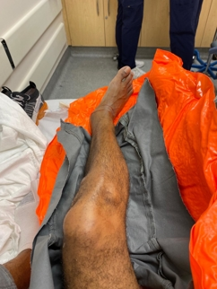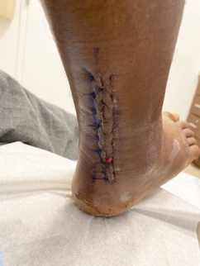

Date of accident: 11/16/19
51-year-old female pedestrian tripped on the rear of a parked Bird scooter that was sticking out onto the sidewalk. She suffered a fractured radius in her forearm. Surgery is recommended. She also suffered a laceration over her eye.
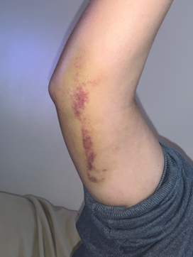

Date of accident: 9/24/19
37-year-old female was visiting from out of town. She was riding a Bird e-scooter in Santa Monica on Barnard Way, next to the beach. Though she was pressing the accelerator, the scooter kept slowing to almost a stop. She couldn’t figure out why. Then the scooter suddenly took off and she was thrown off. She suffered a 10” laceration on her leg, and has a suspected torn ACL in her knee. 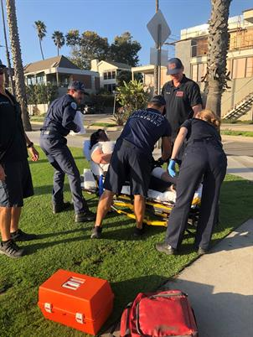

Date of accident: 08/12/18
32-year-old male riding a Bird electric scooter on the street by the beach in San Diego. He saw a divot in the roadway ahead, so he applied the brakes. The brakes were “soft and squishy." Instead of stopping the scooter, they only gradually slowed it down. He hit the divot and his right leg went under the scooter. The rear wheel then ran over his right ankle. He suffered a broken tibia and fibula, requiring surgery, involving the insertion of 2 plates and 21 screws.
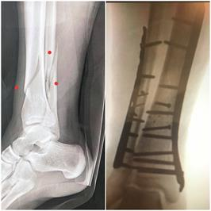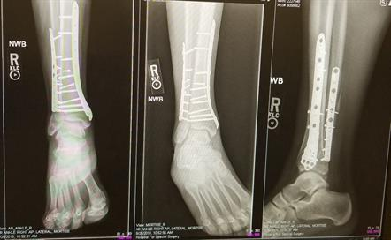

Date of accident: 08/26/18
58-year-old female was riding a Lime electric scooter in San Diego. She had just gotten on, pressed the throttle, and the scooter took off at full speed. The throttle stuck in the fully depressed position, and would not lift up. She was approaching an intersection with cross traffic, thus stepped off the scooter to avoid being hit by a car. She slammed onto the ground. She suffered a broken right arm requiring surgery (insertion of plate + 7 screws) and a broken left hand.
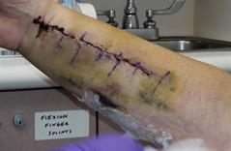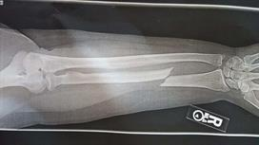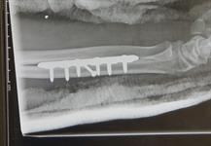

Date of accident: 10/15/18
67-year-old male was riding a Bird electric scooter on the roadway in San Diego. He was going downhill when the brakes failed. He was thrown off the scooter. He struck his head, and even though he was wearing a helmet, he lost consciousness and suffered a brain injury, as well as wounds to his hand and elbow that became infected.
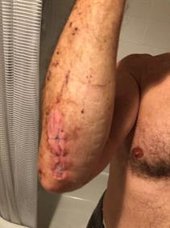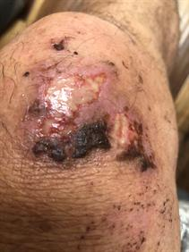

Anonymous
Date of accident: 8/10/19
33-year-old male was riding a VeoRide e-scooter in Austin, Texas. He pushed off with his foot. His ankle struck the kickstand apparatus. He suffered a torn Achilles tendon.
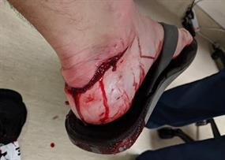

Date of accident: 10/06/18
31-year-old female was riding a Lime electric scooter in the bike lane on Ocean Ave. in Santa Monica. Her husband was riding a Lime behind her. They entered a “geo-fenced” area and their scooters' speed suddenly dropped from 15 mph to 8 mph, then shortly thereafter sped back up to 15 mph. Her husband lost control and struck the rear of his wife’s scooter. She crashed and suffered three broken bones in her ankle, requiring surgery (plate and screws).
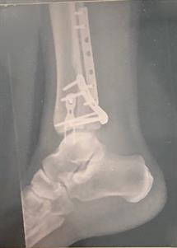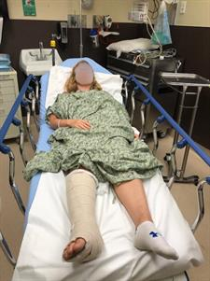

Date of accident: 10/11/18
57-year-old female was riding a Lime electric scooter on 3rd St. in Los Angeles. She had just gotten on the scooter and it kept stalling. She decided to give up and return it to the sidewalk. Suddenly, the power surged, the handlebars whipped to the left, and she was knocked to the ground. She suffered 2 broken bones in her ankle, requiring surgery (a plate and 8 pins).
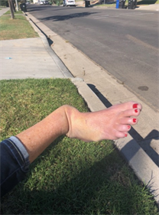
​​​​​​

Date of accident: 04/22/19
42-year-old male riding Lime e-scooter in Los Angeles. He was transitioning from the street to a driveway. When the scooter hit the edge of the driveway, the scooter stopped and he was thrown off.
He suffered a broken ankle (“malleolar fracture”), requiring surgery (plate + 3 screws). He then had to undergo a second surgery to remove one of the screws.
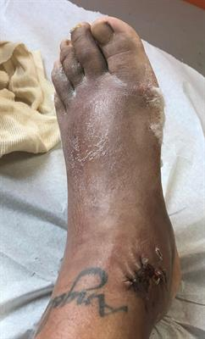

J.M.
Date of accident: 06/08/19
34-year-old male riding Lime e-scooter in San Diego while on vacation. He rode over a slight lip in the pavement, which caused him to be ejected from the scooter. He suffered a broken fibula, requiring surgery (plate + 8 screws).
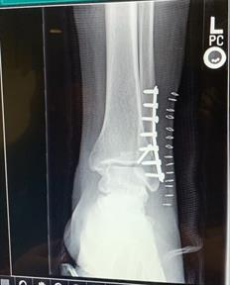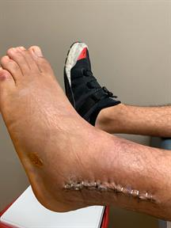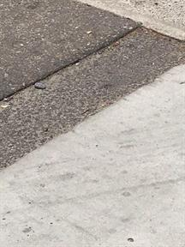

A.K.
Date of accident: 06/08/19
29-year-old female riding Bird e-scooter in West Hollywood. Ahead of her, a pedestrian entered the roadway. She applied the electric brake and turned to the left. The brakes were slow to respond and the handlebars spun 90 degrees to the left, pitching her off the scooter. She suffered a broken hip, requiring surgery (rod + screws).
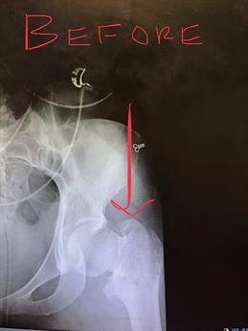

Date of accident: 08/19/18
33-year-old female was riding a Lime electric scooter in South Lake Tahoe. The brakes failed. She put her foot down to try to stop and was thrown off the scooter. She suffered a fractured right radius (surgery to forearm with plate and 6 screws), dislocated right ulnar radial joint (surgery to wrist), and dislocated right foot.
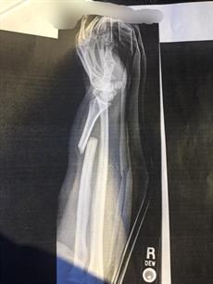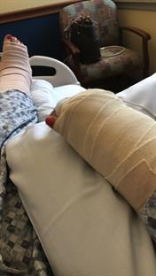

Date of accident: 01/19/19
45-year-old female was riding a Lime e-scooter in San Diego on the street. She hit a 1” to 1.5” vertical offset (height differential) in the roadway and she was thrown off the scooter. The scooter’s wheels could not accommodate the bump. She suffered a concussion, a broken front tooth, two cracked teeth, and a severely bruised pelvis.

Date of accident: September 2018
71-year-old male was riding a bicycle on the Venice Beach Bike Path. A Bird scooter rider slammed into him, knocking him off the bike. The scooter rider took off without exchanging information – hit and run. The bicyclist suffered a wound to his elbow, which became infected. He has undergone two surgeries so far, and may need a third.

Date of accident: 05/15/19
22-year-old female was riding a Lime e-scooter in San Diego’s Balboa Park. The accelerator stuck at full speed. She was coming up to a turn and she could not slow the scooter down. She stepped off the scooter and crashed. She suffered a broken leg, requiring surgery.
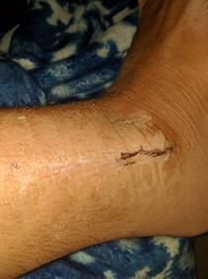

Date of accident: 07/02/19
67-year-old male pedestrian tripped on a Bird electric scooter that was laying across the sidewalk on Main St. in Santa Monica. The pedestrian is an “eggshell plaintiff” within the six months before his fall, he underwent two surgeries on his neck. He is now concerned that the fall has exacerbated his pre-existing neck condition.
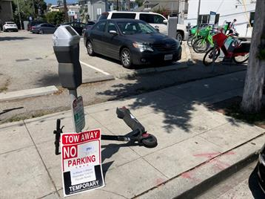

Date of accident: 08/29/18
33-year-old female was riding a Bird scooter in Santa Monica. She was transitioning from the street to the driveway of the Broad Stage parking lot. When the scooter’s front tire hit the small curb of the driveway’s apron, she was thrown off the scooter. She suffered a broken and dislocated ankle, requiring surgery.
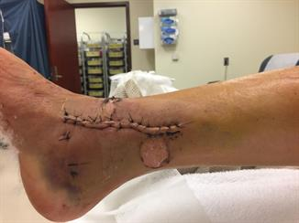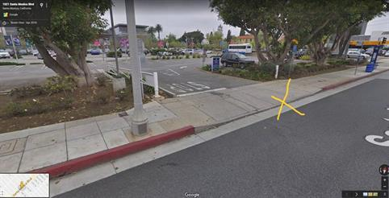

Date of accident: 12/07/18
36-year-old male was riding a Lime e-scooter in Ft. Lauderdale, FL. The accident happened at about 7 pm. He hit a pothole, lost control, hit the curb, and was thrown off the scooter. The scooter’s front headlight was insufficient to illuminate the roadway in front of him, and the front tire was unable to navigate over the pothole. He suffered a fractured left wrist, requiring surgery (plate + 8 screws).
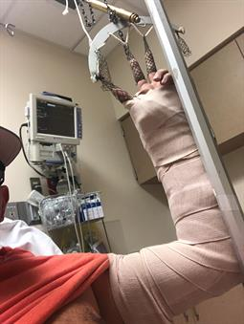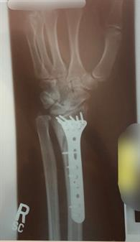

Date of accident: 05/9/18
39-year-old male was riding a Bird electric scooter in Westwood. The wheels were adversely affected by the roadway surface and he was thrown off the scooter. He suffered loss of consciousness, lacerations to his right elbow and right knee, and road rash.

Date of accident: 02/13/19
19-year-old male was riding a Lime electric scooter in Santa Ana. He was riding from the sidewalk into the intersection when he was hit by a right-turning car. He suffered a broken tibia, requiring surgery (rod + screws).
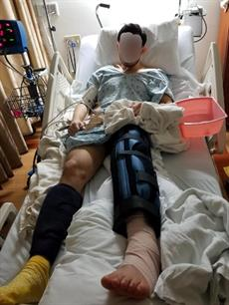

Date of accident: 08/06/18
2 ½ -year-old girl was walking on Melrose Ave. in Los Angeles with her family. As they were walking by a cluster of scooters, a Bird scooter tipped over, onto the curious child, knocking her over. She suffered injury to her right knee.
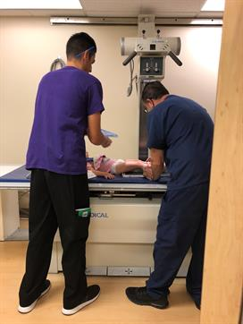

Date of accident: 10/16/18
45-year-old male was riding a Lime electric scooter in Los Angeles. The handlebar post suddenly turned 90 degrees and he topped over the front of the scooter. He suffered a tibial plateau fracture.
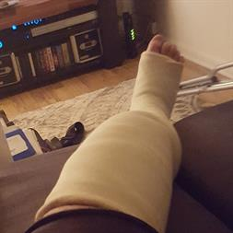

Date of accident: 10/14/18
33-year-old male was riding a Lime scooter in Indianapolis, Indiana. He was transitioning from the street to the sidewalk. The scooter’s front wheel hit the small curb of the apron and he was ejected from the scooter. He suffered a fractured neck, fractured arm (requiring 2 surgeries), and a head injury.
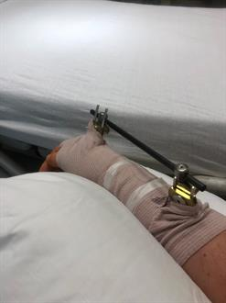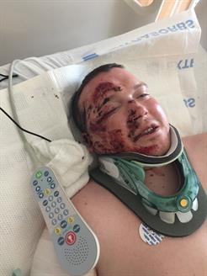

Date of accident: 10/24/18
34-year-old male was riding a Bird electric scooter in San Diego. The brakes failed. He suffered a broken left fibula, requiring surgery (plate + 7 screws).
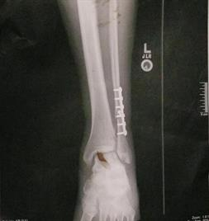

Date of accident: 06/09/18
36-year-old female was riding a Bird electric scooter in San Diego. Within seconds of getting on, she noticed that the front wheel was wobbly. The front wheel suddenly turned. She put her foot down to try to stabilize, and suffered a broken left tibia and fibula, requiring surgery (plate + rod + 13 screws).
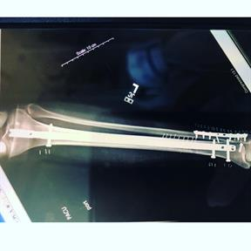

Date of accident: 10/30/18
23-year-old male was riding a Bird electric scooter in in Los Angeles. The throttle stuck and he was thrown off the scooter. He suffered a broken right fibula and road rash to his hand.
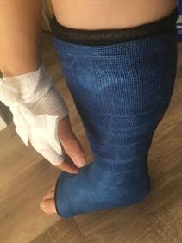

Date of accident: 10/08/18
32-year-old male was riding a Bird electric scooter in Los Angeles. Suddenly, the handlebars came off the post. He crashed and suffered a broken arm.
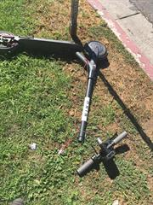

Date of accident: 10/27/18
57-year-old female was riding a Bird electric scooter in Los Angeles. She was transitioning from the street to the sidewalk. When the scooter’s front wheel hit the 1.5” lip of the apron of the driveway, the scooter threw her off. Some scooters have solid tires (not air-filled). The solid tires are less forgiving and have difficulty making it over even minor roadway imperfections. She suffered a fractured ankle, requiring surgery (plates and screws).
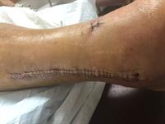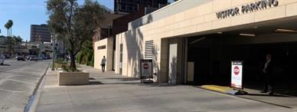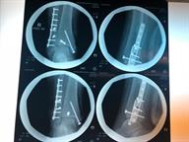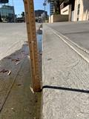

Date of accident: 12/26/18
18-year-old female was riding a Lime electric scooter in Woodland Hills. She applied the brake, but the scooter did not slow at all. She put her foot down to try and stop. She slammed to the ground and the scooter fell on top of her. The scooter’s handlebar, which was missing a rubber grip, hit her left hand, breaking her hand. She underwent surgery, involving insertion of a metal plate.

Date of accident: 11/15/18
71-year-old female was a pedestrian on the sidewalk on Melrose Ave., between Stanley Ave. and Curson Ave., in Los Angeles. A Bird scooter rider struck her and knocked her to the ground. The rider did not stop and exchange information – he kept going. She suffered three broken bones in her hand.
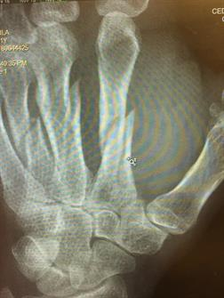

Date of accident: 10/14/18
30-year-old female was riding a Bird electric scooter on the roadway in Long Beach. As she approached an intersection, her light was red. She tried to brake. The brakes didn’t work so she put her foot down to try to stop. She flew off the scooter. She suffered six broken bones in her right wrist, and dislocated the wrist. She has undergone two wrist surgeries so far.
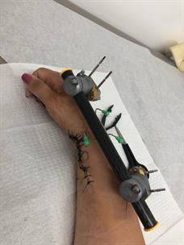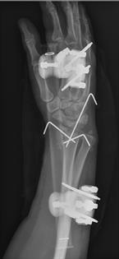

Date of accident: 10/18/18
65-year-old female was riding a Lime electric scooter on the roadway when the accelerator stuck. She suffered a broken jaw.

Date of accident: 09/19/18
33-year-old female was riding a Bird electric scooter on the roadway when the brakes failed. She suffered a laceration to her forehead and severe road rash on her arm.
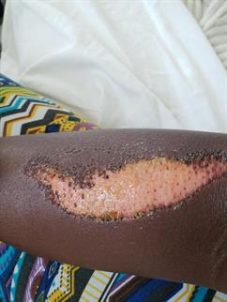

Date of accident: 10/23/18
30-year-old female was riding a Bird electric scooter in San Diego. The brakes failed and she had to jump off to avoid being hit by a car. She suffered a broken femur (upper leg bone), requiring surgery (titanium rod + screws).
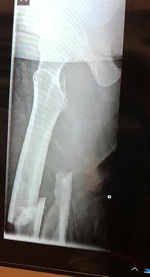

Date of accident: 07/02/18
37-year-old male was riding a Lime electric scooter in Oakland. He was transitioning from the street to a driveway. When the scooter’s front wheel hit the small lip of the driveway’s apron, the scooter, instead of going up the driveway, slid to the right, along the lip, and the rider was thrown off. He suffered 3 fractures in his forearm, requiring surgery (2 plates + 12 screws).
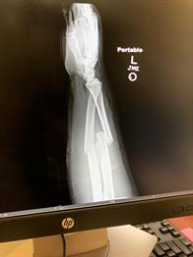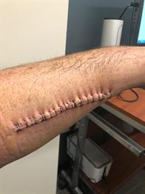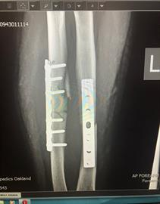

Date of accident: 09/21/18
43-year-old male rider was riding a Lime electric scooter in San Diego on the street. The handlebars suddenly started to shake violently. He tried to brake. He put his foot down onto the ground to try to stabilize, and was thrown off. He suffered a complex pelvic fracture, requiring surgery (3 plates + screws).
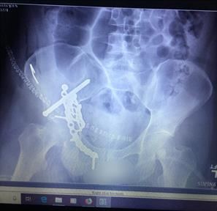

Date of accident: 06/17/18
62-year-old male was performing an act on the Santa Monica Pier. A Bird electric scooter rider slammed into the back of him. D.P. suffered a ruptured bicep in his right arm, requiring surgery (involving a cadaver graft). He also suffered a broken right radius (forearm bone). This was a hit-and-run. The Bird rider took off after the collision, without providing his contact information. Despite repeated requests by our firm, Bird Rides, Inc., has failed to provide the scooter rider’s contact information.
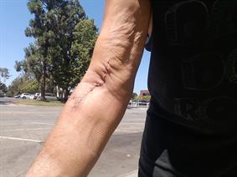

Date of accident: 08/19/18
34-year-old female was riding a Bird electric scooter on the roadway in Los Angeles when the scooter became unstable, she lost her balance, and fell off. She suffered a broken right arm, requiring surgery (insertion of two plates and 11 screws).
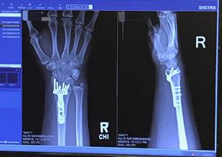

Date of accident: 09/21/18
31-year-old male was riding a Bird electric scooter. A car swerved in front of him, then braked. The scooter rider applied the brakes, but they did not work. He had to jump off the scooter to avoid hitting the car. His face slammed onto the pavement. He suffered facial injuries, including contusions, a black eye, and road rash.
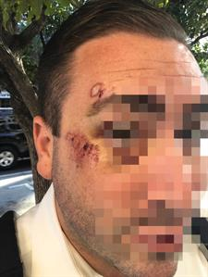

Date of accident: 05/17/2018
28-year-old male worked for Bird as a “Bird Charger.” After charging a bird, before placing it in a “Bird Nest,” he got on the scooter to make sure it worked. The brakes did not work and he was launched off the scooter. He suffered a fracture-dislocation of the left ankle, and fractures of the tibia and fibula in his left leg. He underwent surgery involving the insertion of a plate and 8 screws.
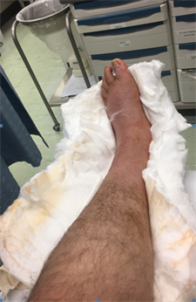

Date of accident: 07/18/2018
26-year-old female was riding a Bird electric scooter on Beverly Blvd. in Larchmont Village in Los Angeles. She was riding on the sidewalk because there is no bike lane on Beverly Blvd. and it’s a very busy street. All of a sudden, she saw a 7” offset in the sidewalk in front of her. It was like a “curb” in the middle of the sidewalk. She applied the brake, but it barely slowed the Bird down. She crashed into sidewalk defect and was thrown off the scooter. Her face slammed into a brick wall adjacent to the sidewalk. She suffered loss of consciousness, a head injury, concussion, laceration above the right eyebrow, and sprained left thumb.

Date of accident: 06/22/18
60-year-old female was riding a Lime electric scooter on the Venice Beach Bike Path. She had two back-to-back falls within 5 minutes of each other. Each time, another scooter rider tried to pass her, cutting her off and causing her to fall off. She fell on her right shoulder both times. She suffered a rotator cuff tear, requiring surgery.
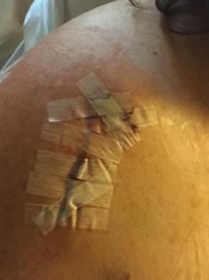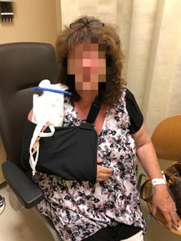

Date of accident: 07/29/18
Male riding Lime electric scooter on the sidewalk in West Hollywood. The sidewalk was rough. The scooter started to wobble. The rider braked. He was thrown over the handlebars and his face smashed on the sidewalk. He suffered 2 broken front teeth, 2 chipped side teeth, and road rash on his arms.
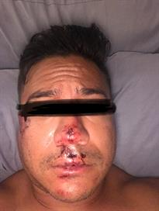

Date of accident: February 2018
25-year-old man was riding a Bird scooter in Westwood. The handlebar stem collapsed as he was going downhill. He did a face plant and broke a tooth, incurring dental bills of $9,300.

Date of accident: 06/12/2018
72-year-old woman who was exiting a Starbucks on Main St. in Santa Monica tripped trying to maneuver around 3 electric scooters parked just outside the entrance. She suffered a pelvic contusion, injury to both knees, and injuries to her left hand and low back.

Date of accident: 07/31/2018
68-year-old female was riding a Lime electric scooter on Ocean Front Walk in Santa Monica. Just as she started to go, the accelerator stuck and the scooter sped forward. She was unable to stop and was thrown off. She suffered a broken leg and broken hand.
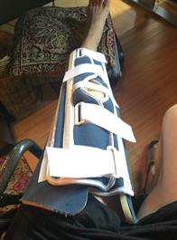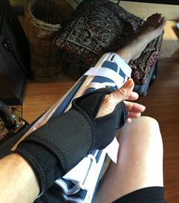

Date of accident: 08/17/2018
32-year-old male was riding a Bird electric scooter on the roadway in San Diego. He hit a roadway imperfection and was thrown off the scooter. He suffered loss of consciousness, a broken nose, road rash to the face, and dental injuries.
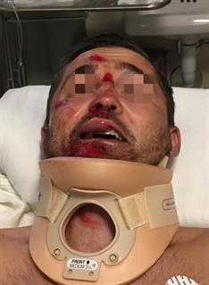

Date of accident: 07/13/2018
50-year-old female pedestrian was getting ready to cross the street in Venice, California. She tripped on Lime electric scooters which were left lying down on the sidewalk. She suffered a broken wrist, broken finger and probable broken ribs.
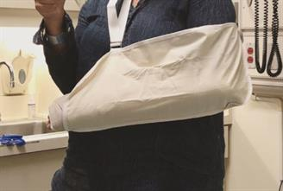

Date of accident: 05/16/18
33-year-old male was riding a Bird electric scooter in Westwood. When he pressed the brake, the rear tire locked up. He lost control and flew off the scooter. He suffered a shoulder separation, rotator cuff tear, and a shoulder labral tear.

Date of accident: 07/26/2018
Male riding a Bird electric scooter on the roadway on Speedway in Venice, California. He went over a minor road bump. The scooter’s front wheel broke, rotating about 130 degrees backwards. The Bird rider crashed and suffered severe road rash on his arm and injury to both knees.

Date of accident: 05/18/2018
56-year-old woman who was working for Bird as a “Bird Mechanic.” She picked up a damaged Bird to repair it, but Bird did not share with her what was wrong with the damaged Bird. In Santa Monica, she got on the scooter to test it out to try to figure out what was wrong with it. She started to ride the scooter and the brakes failed. She was approaching an intersection. Fearing that she would be hit by a car at the intersection, she tried to step off and her body slammed onto the roadway. She suffered a closed head injury, a scalp laceration requiring staples, a fractured clavicle, and a cervical strain.
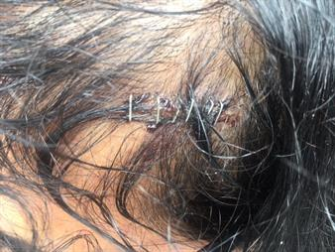

S.M.
Date of accident: 05/28/2018
16-year-old female was riding an electric scooter rented by her boyfriend. The female swerved to avoid a crack in the sidewalk. She hit a light pole and suffered loss of consciousness, two broken ones in her leg, a torn ACL in her knee

Date of accident: 06/09/18
30-year-old woman was riding a Bird in a bike lane, on Main St. in Santa Monica. A Bird rider ahead of her wiped out. She braked and put her foot down to try to stop so she could go and render aid to the other rider. She slammed to the ground. She suffered a torn ACL and a torn meniscus in her knee, requiring surgery.
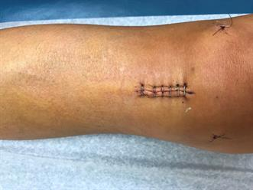

J.H.
Date of accident: 06/14/2018
72-year-old woman was exiting a Starbucks on the corner of Olympic Dr. and Main St., across the street from the Santa Monica Courthouse. She tried to step around a Bird scooter parked right outside the Starbucks entrance. She didn’t see that there were two more scooters behind the first one, until she tripped over the second two scooters. She suffered an injury to her hand, pelvis, and both knees.

Date of accident: 07/06/18
28-year-old female was riding a Bird electric scooter in West Los Angeles. She was transitioning from the street to the sidewalk because traffic ahead on the roadway was blocking safe passage. She braked, attempting to slow the scooter. The brakes didn’t work properly and she crashed. She suffered a broken finger and injury to her leg.
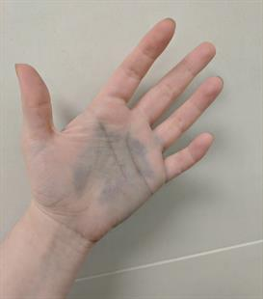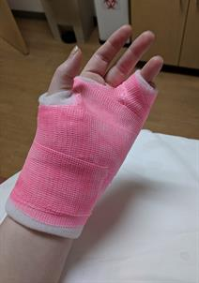

Date of accident: 06/18/2018
24-year-old man riding Bird scooter on Santa Monica Blvd. in West Los Angeles. He was riding in the far right lane, close to the curb. A car pulled out from a side street on his right, running a stop sign. The scooter rider slammed into the car’s front quarter panel. He suffered injury to both arms, both ankles, cuts on feet and bruised hip
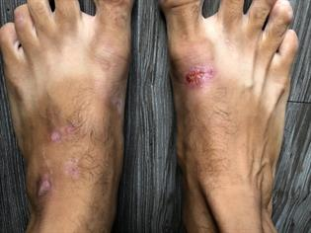

Date of accident: 06/30/2018
57-year-old female pedestrian was leaving the fireworks show at Santa Monica College. She was walking down 17th St., in a crowd of people. She tripped over a Bird scooter that was lying down on the ground, partially across the sidewalk. She suffered a fractured metatarsal (long bone in the mid foot).
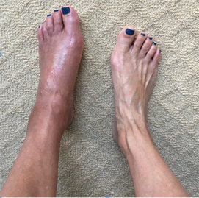

Date of accident: 07/05/2018
43-year-old woman riding a Bird scooter on the roadway on San Vicente Blvd in Los Angeles. As she approached the intersection of San Vicente Blvd. and La Brea Ave., her light was red, so she braked. The brakes failed. She flew off. She landed on the roadway, with the scooter on top of her.
She suffered a fractured wrist, injury to her neck and shoulder, and road rash on her leg.
The emergency room doctor and the pharmacist she went to later in the day both told her that they have had many patients reporting injuries from scooter brake failure.
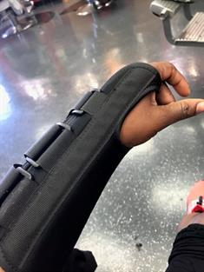

Date of accident: 06/21/2018
36-year-old male was riding a Lime electric scooter on the roadway, in a bike lane, in Oakland. The bike lane was ending so he started to tap the brakes. The scooter jerked forward and he was thrown off. He suffered a broken left arm and a broken right wrist. The right wrist required surgery, requiring the insertion of a plate and 2 screws.
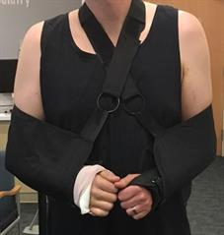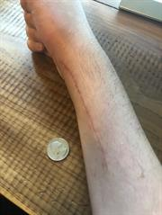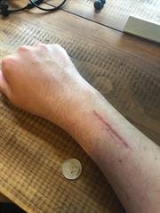

Date of accident: 08/30/18
33-year-old female was riding a Bird electric scooter on the roadway. The throttle got stuck in the fully depressed position and the scooter sped forward. As she tried to unstick it, she lost control and fell off. She suffered a shattered right wrist, requiring surgery (insertion of plate + screws), sprained fingers, a concussion and road rash. 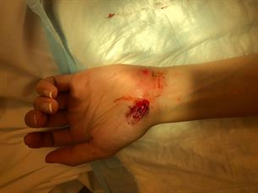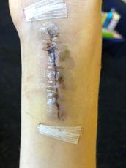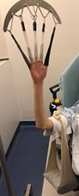

Date of accident: 10/31/19
14-year-old male was riding a Bird Scoot electric moped in Westwood, California. When he squeezed the brake, the back wheel lifted off the ground, throwing him off the moped. His face slammed into the pavement, resulting in a lost tooth, lip laceration, facial fracture, and multiple abrasions. He will require 5 root canals. Scooter companies know that minors can easily access the vehicles, yet the companies fail to implement stronger safeguards.

Appendix B Research Papers on Injuries from E-Scooters

Each paper comes with warnings of potential underreporting of e-scooter injuries due to lack of consistency of recording such accidents and other limitations due to swift nature the e-scooters have been introduced into cities

1.0 Auckland, New Zealand

  - ‘Impact of e-scooter injuries on Emergency Department Imaging’
Published Journal of the Medical Imaging and Radiation Oncology 11 April 2019

A research paper entitled ‘Impact of e-scooter injuries on Emergency Department Imaging’ came to this conclusion on the impact of the introduction of e-scooters in Auckland:

‘Introduction of shared e-scooters has resulted in a large number of serious related injuries that have required urgent radiology imaging. Many of these patients required specialist consultation or surgery, and place an increased burden on overstretched emergency department services’.

The discussion from this paper provides the human impact of these injuries:

‘While the impact on valuable limited resources such as emergency department imaging is considerable, the impact on so many young lives changed by these injuries is immeasurable. With the majority of injuries occurring in the working age group, the significance of morbidity due to these injuries should not be underestimated. Disability due to injury in this age group can results in extended time away from work – affecting both the individual and also company productivity’.

These are the injuries sustained in the 2 months following introduction of shared e‐scooters to Auckland, from the period from 15 October 2018 to 15 December 2018):

- 63 patients were referred to ED radiology for injuries caused by e‐scooters.
- Majority of injuries were orthopaedic, some of the more serious injuries included:
- 16 upper limb fractures, 10 lower limb fractures 3 joint dislocations & 1 spinal fracture
  - Multiple sprains, superficial abrasions and contusions were also reported
  - Head/facial injuries was the other major category, with some of the most serious injuries included:
- 12 patients with concussion, 3 patients with intracranial haemorrhage, 8 patients with facial fractures and 1 patient with a skull fracture
  - 25 of the 63 patients required referral to a specialty service and subsequent admission to hospital. Most of these required surgical management:
    - 13 were referred to orthopaedics, 4 to maxillo‐facial surgery, 3 to neurosurgery, 2 to plastic surgery and trauma, 1 patient to ophthalmology.
- 221 plain films and 47 CT scans were performed on these patients

1.2 ‘Electric Scooter Injuries at Auckland City Hospital’

Published in New Zealand Medical Journal 8 November 2019

Abstract
Aim: Since the introduction of shared electric scooters to Auckland in October 2018, there have been multiple reports of injuries. We aim to examine the pattern of injuries sustained while riding electric scooters in patients presenting to hospital.
Methods: We conducted a retrospective analysis of patients who presented to Auckland City Hospital Emergency Department (ED) between 15 October 2018 and 22 February 2019. Patients were firstly identified by ED staff and noted in a logbook, and secondly by searching the Trauma Registry database. Outcomes of interest were injuries, imaging, alcohol and helmet use, length of stay and interventions.
Results:
- There were 180 patients identified.
- The median length of stay was 4.0 hours, interquartile range (IQR) 18.4 hours.
- One-third of patients were admitted or transferred.
- Common injuries were contusions, abrasions and lacerations (65.6%), fractures (41.7%) and head injuries (17.2%).
- One in five patients (22.2%) required an operation.
- Only three patients wore a helmet.
- Of all patients, 23.3% had consumed alcohol, and of those with head injuries; 41.9% had consumed alcohol.
Conclusion: This study highlights the significant number of electric scooter-related injuries, including severe head injuries. While the majority of presentations are categorised as minor trauma, these cases have placed additional demand on health system resources. This mode of transport would benefit from greater regulation, including a zero-blood alcohol limit, night-time curfews, reduced speed limits and consideration of mandatory helmet use.

2.0 USA

2.1 Austin, Texas, USA

‘Dockless Electric Scooter Related Injury Incidents’ September - November 2018

Published Epidemiology and Disease Surveillance unit, Epidemiology and Public Health Preparedness Division, Austin Public Health, City of Austin - April 2019

Types of Injuries Sustained
From 190 recorded injuries (160 confirmed and 32 probable) the following injuries were recorded from the period 5 September to 30 November 2018.
‘Of the 190 injured riders, nearly half (48%) had injuries (e.g., fractures, lacerations, abrasions) to the head. In addition, 70% sustained injuries to the upper limbs (hands /wrist/arm/shoulder), 55% to the lower limbs (leg/knee/ankle/feet), and 18% to the chest/abdomen; multiple injuries across body regions were possible. Many individuals sustained injuries on their arms (43%), knees (42%), face (40%), and hands (37%).
Over a third (35%) of the injured riders sustained a bone fracture(s) (excluding nose/fingers/toes). Among this group, 19% had bone fractures (excluding nose/fingers/toes) involving multiple body regions. Figure 4 shows the bone fracture locations for injured riders. A high number experienced fractures on their arms and legs. Notably, six persons (3%) had fractures involving the head.
Almost half (80) of the injured riders had a severe injury. The severe injury for these riders included:
- bone fractures (excluding nose/fingers/toes) (84%),
- nerve, tendon, or ligament injuries (45%),
- spending more than 48 hours in the hospital (8%),
- severe bleed (5%), and
- sustained organ damage (1%).
Traumatic brain injuries include concussions and other forms of altered mental status or bleeding such as subarachnoid hemorrhage and subdural hematoma. Fifteen percent of riders had evidence suggestive of a traumatic brain injury. Less than one percent of individuals was wearing a helmet at the time of injury. Eighty-eight percent of injured riders were seen at an emergency department. Fourteen percent of all injured riders were hospitalized. None of the injured riders died during the study period’.

2.2 Dallas, Texas, USA

‘Craniofacial Injuries Seen With the Introduction of Bicycle-Share Electric Scooters in an Urban Setting’

Published in Journal of Oral and Maxillofacial Surgery, November 2019.

These injuries were recorded in the first 7 months of scooters in Dallas:

- A total of 90 patients (56 males, 34 females; mean age, 31.8 years) had presented with scooter-related trauma to the ED during the first 7 months of scooters after their introduction to the metropolitan area.

- A total of 52 admissions (58% of all admissions) involved injuries of the head and face. The patients had presented with a myriad of craniofacial trauma, ranging from abrasions, lacerations, and concussions to intracranial hemorrhage and Le Fort II and III fractures.

- Of the 52 craniofacial injuries

  - 30 (58%) were considered severe (ie, fracture, internal hemorrhage, concussion, loss of consciousness)
  - 22 (42%) were considered minor (ie, lacerations, contusion, abrasion, dental).

- Alcohol use had been involved in 18% of all scooter-related trauma admissions, and no rider had reported wearing a helmet.

Further detail

- A total of 90 patients (56 males, 34 females) had been admitted to the ED because of e-scooter–related injuries from July 1, 2018 to January 31, 2019
- The age of those admitted ranged from 13 to 60 years (mean age, 31.8 years).
- Most (64.4%) admissions had involved extremity injuries, with 18 fractures, 4 dislocations, and 10 laceration repairs.
- Eight patients (8.8%) had required transfer to the intensive care unit, 13 patients (14.4%) had been admitted to the floor, and 10 patients (11.1%) had undergone surgery.
- The male patients had experienced trauma at a greater rate (62.2%) of e-scooter–related injuries, and 7 of the patients admitted (7.7%) were younger than 18 years.
- Alcohol consumption was reported in 16 of all e-scooter–related ED visits (17.8%) at the single site during the first 7 months of their introduction
- None of the admitted patients had reported the use of protective headwear.
- Of the 90 ED visits, 60 (66.6%) had occurred between 6 pm and 6 am and 52 (57.7%) had occurred during a weekend.

- Of the 90 patients, 52 (57.7%) had presented with craniofacial trauma related to e-scooter use.
- When evaluated by region, 15 patients had presented with trauma in multiple facial regions.
- Of the 52 patients, 28 had trauma to the upper face, 28 to the midface, and 9 to the lower face. This total likely underrepresents the incidence of trauma stratified by region, because 4 patients had had craniofacial trauma to unspecified location (ie, concussion, abrasion, nonspecific facial lacerations).
- Soft tissue facial injuries were noted in 44 patients (80.8%) who had sustained craniofacial trauma, 28 (53.8%) of whom had required laceration closure.
- Extensive craniofacial injuries included subarachnoid/subdural hemorrhage in 6 patients (11.5% of craniofacial patients), 1 of whom required emergency craniotomy.
- Le Fort II and III fractures and 2 Le Fort I fractures had occurred in 3 patients, 1 of whom had sustained a bilateral Le Fort II/III and left-sided Le Fort I fracture. Surgical intervention in the form of open reduction and internal fixation was performed for these patients.
- One zygomaticomaxillary complex fracture was observed and required open reduction and internal fixation.
- Only 1 patient had experienced a mandibular fracture, including a right nondisplaced condylar head fracture treated nonsurgically.
- Dentoalveolar injuries had occurred in 6 patients (11.7% of craniofacial trauma cases). The injuries were confined to the anterior maxillary segment and had ranged from concussion to avulsion of associated teeth.

Conclusion
- In conclusion, although providing an innovative and economical method of urban “last mile” transport, e-scooters have also been shown to be significantly associated with craniofacial injuries.
- The present study found that more than one half of all trauma patients presenting to a Level I trauma ED in Dallas, Texas, for e-scooter injuries had had injuries to the head and face.
- Craniofacial injuries require specialist intervention ranging from dentoalveolar splinting to extensive facial reconstruction, highlighting the implications of craniofacial trauma risk associated with e-scooter use.
- Craniofacial trauma associated with e-scooter use could be significantly reduced by the use of proper protective equipment and access to well-regulated bicycle lanes and cyclist/pedestrian safety policies.
- Special focus on the factors contributing to traumatic events involving e-scooters, such as helmet use, pedestrian interaction, alcohol use, and policies regarding scooter use will help establish the best practices for the mitigation and treatment of such injuries.

2.3 San Diego, California, USA
‘Severe eye injuries seen with e-scooter accidents’
Published by Reuters 3 March 2020
This article refered to published research from the American Academy of Ophthalmology ‘Characterization of Facial Trauma Associated with Standing Electric Scooter Injuries’.
Highlighted specific injuries caused by e-scooter accidents to the eye. These were from patients from 2 emergency departments at the University of California, San Diego from June 2018 and May 2019.
‘The patients faced surprisingly high rates of hospitalization and need for surgery, many with complex facial fractures to the bones around the eye and damage within the eye, the study team reports in the journal Ophthalmology.
“We began to see an increasing number of ... ocular injuries and facial fractures caused by e-scooter accidents,” co author Dr. Adeleh Yarmohammad, an ophthalmology resident physician at UCSD, told Reuters Health.
“When we looked more in-depth at the numbers, we were surprised at both the severity and incidence of the injuries.”
About a fifth of patients in the study had intracranial hemorrhage, or bleeding beneath the skull, following an e-scooter accident. More than 90% had one or more facial fractures, most of them complex fractures, and 24% needed surgery. Three-quarters required hospitalization.
Oculoplastic surgeon and ophthalmologist Dr. Don Kikkawa, senior author of the current study, said while it is likely the most severe cases were included in the findings, given that UCSD houses a large urban trauma center, the data do shed light on the public health impact of e-scooter use.
“Safety should be paramount, as well as the need for additional support for continued study into the medical implications of this emerging mode of transportation.”
The research stated 74% of patients were intoxicated or impaired due to alcohol or drug use.

2.4 Southern California, USA
‘Injuries Associated With Standing Electric Scooter Use’

Published by the Journal of the American Medical Association (JAMA) Network on the 25 January 2019

This study of a a case series used retrospective cohort medical record review of all patients presenting with injuries associated with standing electric scooter use between September 1, 2017, and August 31, 2018, at 2 urban emergency departments associated with an academic medical center in Southern California.
Results
Two hundred forty-nine patients (145[58.2%] male; mean [SD]age,33.7[15.3]years) presented to the emergency department with injuries associated with standing electric scooter use during the study period.
- 228 (91.6%) were injured as riders
- 21 (8.4%) as nonriders.
- 27 patients were younger than 18 years (10.8%).
- Ten riders (4.4%) were documented as having worn a helmet
- 12 patients (4.8%) had either a blood alcohol level greater than 0.05% or were perceived to be intoxicated by a physician.
- Frequent injuries included:
  - fractures (79 [31.7%])
  - head injury (100 [40.2%]),
  - and contusions, sprains, and lacerations without fracture or head injury (69 [27.7%]).
- The majority of patients (234 [94.0%]) were discharged home from the emergency department; of the 15 admitted patients, 2 had severe injuries and were admitted to the intensive care unit.
- Among 193 observed electric scooter riders in the local community in September 2018, 182 (94.3%) were not wearing a helmet.
CONCLUSIONS AND RELEVANCE
Injuries associated with standing electric scooter use are a new phenomenon and vary in severity. In this study, helmet use was low and a significant subset of injuries occurred in patients younger than 18 years, the minimum age permitted by private scooter company regulations. These findings may inform public policy regarding standing electric scooter use.
2.5 Salt Lake City, Utah

‘Emergency Department Visits for Electric Scooter-Related Injuries After Introduction of an Urban Rental Program’

Published in The American Journal of Emergency Medicine on the 1 August 2019.

Abstract
Background: Providers in Salt Lake City emergency departments (EDs) anecdotally noted a significant number of electronic scooter (e-scooter)-related injuries since the launch of e-scooter rentals in the downtown area in June 2018. The aim of this study was to quantify and characterize these injuries.
Methods: We reviewed the electronic medical records of the University of Utah ED and the Salt Lake Regional Medical Center ED. Using a broad keyword search for "scooter," we examined all notes for ED visits between June 15-November 15, 2017, and June 15-November 15, 2018, and identified e-scooter related injuries. The 2017 data pre-dated the launch of the e-scooter share programs in Salt Lake City and served as a control period.
Results: We noted 8 scooter-related injuries in 2017 and 50 in 2018. Injury types from the 2018 period included:
- major head injury (8%)
- major musculoskeletal injury (36%)
- minor head injury (12%)
- minor musculoskeletal injury (34%)
- superficial soft tissue injury (40%)
- 24% of patients presented via ambulance
- 6% presented as a trauma activation
- 16% of patients required hospital admission
- 14% had an injury requiring operative repair
- 16% reported alcohol intoxication and none of the patients reported wearing a helmet at the time of the injury.
Conclusion: Since the launch of e-scooter share programs in Salt Lake City, we have seen a substantial increase in e-scooter related trauma in our EDs. Of particular note is the number of patients with major head injuries and major musculoskeletal injuries.

2.6 Indianapolis, USA

‘Facing Facts: Facial Injuries from Stand-up Electric Scooters’

Published in CUREUS 15 January 2020.

Abstract

Background
Stand-up electric scooters (SES) are a popular public transportation method. Numerous safety concerns have arisen since their recent introduction.

Methods
A retrospective chart review was performed to identify patients presenting to the emergency departments in Indianapolis, who sustained SES-related injuries.

Results
- A total of 89 patients were included in our study.
- The average patient age was 29 ± 12.9 years in a predominantly male cohort (65.2%).
- No patient was documented as wearing a helmet during the event of injury. Alcohol intoxication was noted in 14.6% of accidents.
- Falling constituted the leading trauma mechanism (46.1%).
- Injuries were most common on Saturday (24.7%) from 14h00 to 21h59 (55.1%).
- Injury types included: abrasions/contusions (33.7%), fractures (31.5%), lacerations (27.0%), or joint injuries (18.0%).
- The head and neck region (H&N) was the most frequently affected site (42.7%).
- Operative management under general anesthesia was necessary for 13.5% of injuries.
- Nonoperative management primarily included conservative orthopaedic care (34.8%), pain management with nonsteroidal anti-inflammatory drugs (NSAIDs) (34.8%) and/or opioids (4.5%), bedside laceration repairs (27.0%), and wound dressing (10.1%).
- Individuals sustaining head and neck injuries were more likely to be older (33.8 vs. 25.7 years, p=0.003), intoxicated by alcohol (29.0% vs. 3.9%, p=0.002), and requiring CT imaging (60.5% vs. 9.8%, p <0.001).

Conclusion
Although SESs provide a convenient transportation modality, unregulated use raises significant safety concerns. More data need to be collected to guide future safety regulations.

3.0 Turku, Finland

‘Assessment of Craniomaxillofacial Injuries Following Electric Scooter Accidents in Turku, Finland in 2019’

Published by Journal of Oral and Maxillofocial Surgery on 30 May 2020

Abstract

Purpose
Since the introduction of rental electric scooters (ES), clinicians have increasingly encountered facial trauma patients whose injuries were caused by ES use. Despite this fact, few studies have analyzed these patients, particularly in Nordic countries, where the climate may cause additional challenges. The investigators hypothesized that ESs have caused several facial trauma cases in Turku that might be related to the timing of ES use, i.e., month, day, and hour.

Methods
The medical records of all patients who had been diagnosed with craniofacial fractures or dental injuries caused by ES use at Turku University Hospital, Turku, Finland in 2019 were reviewed. The occurrence and characteristics of injuries, with special reference to time of the accident, intoxication, hospital stay, and additional injuries sustained were analyzed.

Results
A total of 23 patients were identified for the present analysis. The mean age was 30 years, and the majority (n=16) were male. Four patients had not used helmets, whereas for 19, there was no mention whatsoever about helmet use. Of the patients, 21 were intoxicated and 18 had a blood alcohol content greater than 1.0‰. A great majority of the accidents occurred in the nighttime (n=17) and during weekends (n=19). Most injuries (n=15) occurred between September and November. Craniofacial fractures were observed in 15 patients and dental injuries in 14; brain injuries occurred in 5 patients and multiple chest injuries in 1. All patients with dental injuries and 9 of the 15 patients with craniofacial fractures required interventions. An average of three days of hospitalization was required for 14 patients.

Conclusion
Injuries associated with electric scooters result from driving under the heavy influence of alcohol and occur mostly during weekend nights without helmet use.

4.0 Copenhagen, Denmark

‘Injury from electric scooters in Copenhagen: a retrospective cohort study’

Published by BMJ 6 December 2019.

Abstract

Objective To analyse injuries related to manual and electric scooter use from January 2016 up to and including July 2019.
Setting Electric scooter rental services were launched in Denmark in January 2019. The services were provided by private companies. Although rules for handling and riding scooters have been established, no reports either before or after introduction of electric scooters anticipated the full extent of use, and injuries to riders and pedestrians.
Participants All patient records mentioning manual or electric scooters. Records were reviewed, and data were stratified according to two groups: manual and electric scooters.
Interventions A predefined survey was completed in all cases where ‘scooter’ was present. This contained variables such as type of scooter, type of participant, mechanism of injury, acuity, intoxication, referral to treatment facility.
Outcome measures Among incidents involving scooters, summary statistics on continuous and categorical variables of interest were reported.
Results
- 468 scooter-related injuries were recorded.
- We found that manual scooter riders were more likely to be children under the age of 15; fall alone—involving no other party; sustain contusions, sprains and lacerations; and bruise either their fingers or toes.
- Riders of electric scooters were likely to be 18–25 years, sustain facial bruising and lacerations requiring sutures, and be under the influence of alcohol or drugs.
- Non-riders of electric scooters were mostly elderly people who tripped over scooters, consequently sustaining moderate to severe injuries.
Conclusion
- There were two different types of population sustaining injuries from manual and electric scooters, respectively.
- The proportion of non-riders injured by electric scooters were surprisingly large (17%), and while electric scooters are here to stay, several apparently preventable injuries occur as a result of reckless driving and discarded electric scooters.
- Current rules for usage might not prevent unnecessary accidents and secure traffic safety and the lives of older individuals.

Appendix C Example of Deaths and Serious Injuries Caused By E-Scooters

1.0 Bike courier hit by e-scooter, Portland USA

‘Woman suffers serious injuries in collision with e-scooter rider’
Posted by Jonathan Maus (Publisher/Editor) on December 11th, 2019 at 10:56 am
Posted by on December 11th, 2019 at 10:56 am
Candace Barboza’s injuries.
(Photo: Casey Taylor)
A Portland woman suffered facial fractures, a concussion, and other injuries after allegedly being hit by a man riding an electric scooter in the Sullivan’s Gulch neighborhood Monday night.
BikePortland reader Casey Taylor contacted us yesterday with the sad news about his partner, Candace Barboza. According to Taylor, Candace was riding home from her job as a bicycle courier and was headed northbound on NE 26th crossing NE Wasco when, “A guy on an electric scooter ran his stop sign causing Candace to hit her brakes and go over her bars.”
Candace’s face and shoulder took the brunt of the impact. Her knees and hands were also cut and bruised. After a trip to the hospital they found out she received fractures under her eyes (cheekbones) and in her nose, a broken tooth and a concussion (she was wearing a helmet).
Beyond his partner’s injuries, Casey says the big headache now is dealing with the administrative aftermath of insurance claims and bills. He’s set up a GoFundMe to help with expenses.

Get well soon Candace!
As we shared after another scooter collision back in August, collisions like this fall into a legal and insurance grey area. Casey said he was advised to treat this like a motor vehicle collision and the claim was filed against the scooter riders’ insurance. “The catch is, he’s not even old enough to drive and has no insurance. His mom is trying to file a claim with her insurance but it is not likely that will work. My insurance should help but I am not sure how much.”
Given that Candace went to the hospital and reported her injuries being caused by a scooter rider, it’s likely the crash data will be captured by the Portland Bureau of Transportation. (If not, it can be reported to PBOT via e-scooter@portlandoregon.gov.)
I haven’t confirmed whether or not a police report was filed and/or if the scooter operator will be cited for his role in the collision. I’ll update this post when/if I learn more.
Here’s that link to Candace’s donation page again.
UPDATE, 12/18: A fundraiser party for Candace is planned for Friday 12/20 at the Chrome store (425 SW 10th Ave) from 7:-9:00 pm. There will be a raffle and auction with prizes provided by Western Bike Works, Stillpour, Chrome, and N.U.T.R.I.A. and then an after-party at Wildwood 1955 W Burnside St.
@jonathan_maus on Twitter and jonathan@bikeportland.org

2.0 ER doc: Stay off electric scooters Number of e-scooter-related injuries on the rise
September 16, 2019 9:00 a.m. Brandt Williams | MPR News

Seconds after impact, Tonie Pereira knew he was hurt badly. He touched his hand to his face and saw that his bicycle glove was soaked in blood. It ran from Pereira’s forehead and nose and flowed down his throat. Blood also filled his ears and eyes.
“There was a point where I couldn’t see much because my eyes were full of blood,” said Pereria, 47, of Woodbury.
A little over a month ago, Pereira was riding his bike on a bike path around Bde Maka Ska, formerly known as Lake Calhoun. He collided with another cyclist who had slowed down to clear an electric scooter lying across the bike trail.
Tonie Pereira holds pictures taken of him after he was injured
Brandt Williams | MPR News
Pereira landed on his face and suffered a broken nose and lacerations to his head, nose and upper lip, which needed 12 stitches to close. He later had to have surgery on his nose. It could have been much worse, said Pereira, had he not been wearing a helmet.
One of the emergency room doctors who saw him that day counts Pereira’s injuries as e-scooter related, even though he was not riding one.
Over his 33-year career as an emergency doctor, Dr. Stephen W. Smith has seen a lot. But the electric-scooter-related injuries he’s seen this summer at Hennepin Healthcare are new.
“I can’t remember if it was April, May or June, but I remember that I started seeing a lot of them. And I was amazed at how many there were,” said Smith. “This was a brand new phenomenon ... none of us had ever experienced before.”
Smith estimates at least five people are treated in the ER each day for e-scooter-related injuries. That adds up to several hundred ER visits this summer. Unlike Pereira, the wounded are usually e-scooter riders.
Smith takes out his cellphone to refer to a list of cases he’s treated personally in the past month.
“A person with road rash and a finger laceration,” reads Smith. “... somebody with a tibia [shin] fracture; another person with an ankle fracture; another person with a clavicle [shoulder] fracture; another person with a mandible [jaw] fracture.”
Head injuries are also common, said Smith. When riders fall forward, they often strike the ground head first. Smith said he’s yet to see an injured rider wearing a helmet.
Helmets aren’t required by law for adults, yet e-scooter providers encourage riders to wear helmets.
A UCLA Medical Center study of stand-up electric scooter injuries between 2017 and 2018 found that head trauma made up 40 percent of injuries. According to the study, 94 percent of patients were not wearing helmets.
“Safety really has to be a multifaceted approach,” said Nico Probst, a regional manager for Lime, one of three companies participating in Minneapolis’ e-scooter share program.
That approach, said Probst, includes safety tutorials for first-time riders and improvements to the scooters designed to make them safer to ride. The tutorials instruct people to wear helmets and obey the rules of the road and show them how to properly park the scooters.
“To encourage better parking behavior, we added a new feature last year, called ‘Parked or Not,’ where an individual actually has to take a picture of where they are leaving their scooter at the end of the trip,” said Probst.
E-scooter riders are instructed to park on sidewalks near curbs so they don’t block sidewalks, driveways or doors. Lime can use the data to fine or even ban users who continually violate the rules.
The company is also testing technology that can sense when a scooter is being improperly used on a sidewalk. However, Probst said there are some users who’ve said in surveys that they ride on sidewalks because they don’t feel safe riding in the streets.
Lime is also in the process of rolling out a new generation of scooters, said Probst. The new units have wider decks to stand on and bigger wheels to better cushion scooters from the bumps, potholes and cracks in the road.
It wasn’t a white-and-green-colored Lime e-scooter that was blocking cyclist Deborah Zvosec’s way on that day in August. She said it belonged to a different company. And it wasn’t the first time Zvosec had seen a scooter obstructing the bikeway. This time, Zvosec said she wanted to do something about it.
“I’ve had to pass scooters that are lying down across the trail before and I haven’t stopped to put them off the trail,” said Zvosec. “I should stop to get this scooter off the trail, or someone’s going to get hurt.”
Someone did get hurt. Tonie Pereira smacked into Zvosec as he rode up behind her and the two were thrown from their bikes.
Between May and early September this year, there have been more than 500,000 trips on e-scooters, according to Josh Johnson, advanced mobility manager for the Minneapolis Public Works Department. During that time period, the city has received 228 complaints that identify people either improperly parking or riding either Lime, Lyft or Spin e-scooters.
Johnson said the complaints are forwarded to the companies.
The scooters were first rolled out late in 2018, but this is the first full year of the city’s experiment with motorized scooters as a non-car transportation option.
A city survey of riders who used scooters last year found that more than 40 percent chose the e-scooter for a trip instead of a car. “In this time of climate crisis, being able to take action to reduce greenhouse gas emissions by having scooters available is certainly something that aligns with our goals,” said Johnson. “But at the same time, we are conscious of the concerns about safety.”
The only way to safely ride an e-scooter, said Hennepin Healthcare emergency room Dr. Stephen Smith, is with a helmet.
But better yet, he said, just don’t ride them.
“I just tell people, ‘they’re dangerous devices,’” he said, pointing out that the other doctors and residents he works with share his opinion. “That would be a total of about 100 doctors in our emergency department. We all think they’re dangerous devices.”

3.0 New York, USA ‘60-year-old woman dies after being hit by e-scooter in Harlem’
By Olivia Bensimon Published February 20, 2020 | 12:41pm New York Post
A woman who was hit by an e-scooter in Harlem this week died from her injuries, police said Thursday.
Anette Camaya, 60, of East Harlem, was crossing Pleasant Avenue near 118th Street around 5:45 p.m. Tuesday when she was struck by a 34-year-old man driving a 2019 Wuxi Dongma Z6 electric scooter southbound on Pleasant Avenue, cops said.
Emergency responders found Camaya lying on the pavement, unconscious and unresponsive, with trauma to the head and body.
Police at the scene where a woman was struck by an electric bike. Peter Gerber
EMS rushed Camaya and the scooter driver to Harlem Hospital, where she was pronounced dead the next day, authorities said. He was treated for minor injuries and released.
There have been no arrests and the NYPD’s Collision Investigation Squad is investigating.

4.0 Singapore ‘E-scooter rider jailed after crash causes 6-year-old to suffer brief hearing loss’
Channel News Asia 07 Nov 2019 05:39PM Singapore
SINGAPORE: An electric scooter rider, who collided into a six-year-old boy near Punggol Park and caused the child to suffer fractures and temporary loss of hearing, was sentenced to five days' jail on Thursday (Nov 7).
Neo Wei Chia, 42, pleaded guilty to one charge of causing grievous hurt by a negligent act. He admitted to failing to keep a proper lookout while riding his e-scooter along a section of Punggol Park Connector along Upper Serangoon Road on the evening of Apr 12, 2018.
The court heard that Neo was riding his device "speedily" on the right side of the park connector at about 6.30pm that day. The boy was riding pillion on the back of a bicycle with his grandmother in front when they neared the Riversails condominium where he lived. He told his grandmother he wanted to get off the bike and he did so. The elderly woman continued cycling as the child ran along.
Neo had a clear view of the path that the boy was running on, but did not slow down, said Deputy Public Prosecutor R Arvindren. Suddenly, the boy crossed over from the left side of the park connector to the right. Neo did not keep a proper lookout for him and by the time he noticed him directly in front of his e-scooter, it was too late. He applied the emergency brakes, but collided with the boy from behind.
Both of them fell to the ground and were injured, with the boy bleeding from his left ear. The elderly woman rushed to her grandson as Neo waited with the boy. They were each taken to hospital. The boy suffered fractures and multiple abrasions on his shoulder, arm and knee. He also suffered a laceration on his ear and suffered temporary hearing loss, and was given 14 days of hospitalisation leave.
Neo had abrasions on his elbows, fingers and knee.
The prosecution asked for a week's jail, citing the need for pedestrian safety.
"The recent spate of accidents involving personal mobility devices (PMDs) knocking down hapless pedestrians or members of public would indicate to the courts that such negligent riding offences are prevalent," he said, adding that parliament had discussed PMD issues just this week.
"As such, there must be a sufficient measure of deterrence to ensure that PMD users who share the same space as pedestrians take extra care to ensure that they are doing so in a lawful and safe manner."
Defence lawyer K Jayakumar Naidu said he agreed to a week's jail as asked for by the prosecution.
He said his client had tried to compensate for the boy's injuries, but was told that the family would be making claims from their own insurers. His client was riding his e-scooter along a shared path and Neo was travelling along the designated lane.
"The accused was maintaining his lane when all of a sudden the child dashed across his right of way," said the lawyer.
He maintained that Neo was not speeding and did not see the boy's grandmother nearby, claiming that the child had "dashed out from the grass verge". The court heard that the victim had since recovered from his injuries and hearing loss. The judge agreed that there is a need for general deterrence in cases involving PMDs, with concern and public interest in such cases.
He ordered the e-scooter to be forfeited.
For causing grievous hurt by a negligent act, Neo could have been jailed for up to two years, fined up to S$5,000, or both.
5.0 Singapore ‘S$2,400 fine for e-scooter rider who collided into 10-year-old girl’

Published in Today on Line - Singapore 11 March 2020
SINGAPORE — While riding his electric scooter at about 30 km/h on a shared path in Pasir Ris, Tan Jia Jun collided into a young girl from behind, who fell and hit her mouth.
The 10-year-old lost a tooth from the impact and her jaws and gum had to be realigned.

Story Continues Below Advertisement
On Wednesday (March 11), Tan, 26, was fined S$2,400 for his actions. The self-employed importer and seller of e-scooter parts pleaded guilty to a single charge of causing hurt to the girl by a negligent act.
The charge was reduced from that of causing hurt by a rash act, as Tan had suffered brain damage from a 2012 accident and was not “fully aware” of the dangers of his actions, Deputy Public Prosecutor (DPP) Angela Ang told the court.
In light of that, the prosecution also sought a fine instead of jail time. Tan could have been jailed up to six months, fined up to S$2,500, or both.
The court heard that the incident took place on April 12, 2018, outside the Pasir Ris East Community Centre.
Around 8pm, Tan was riding his e-scooter while blasting music on the shared path of a pathway along Pasir Ris Drive 1. His device weighed 24.8kg and had 78cm-long handlebars.
Laws requiring e-scooters to weigh less than 20kg, not exceed 70cm in width and not go faster than 20 km/h kicked in only the following month, while e-scooters have been banned from all footpaths since November last year.
The pathway that Tan was on had two lanes: A pedestrian-only lane and a shared path, which was marked with a bicycle symbol and painted a visibly darker colour from the other lane.
Tan admitted that he was riding at about 30 km/h. His e-scooter had a digital speedometer on it.
The victim had just ended tuition lessons and was walking home alone along the pathway in between the two lanes. When Tan approached the intersection of the pathway outside the community centre, he noticed the girl walking ahead of him. She turned around when she heard his music, then instinctively moved to the side to give way to him.
However, he was going too fast and was too close to her to stop his e-scooter or change directions. He ended up colliding into her shoulder from behind, causing her to fall face-down on the pathway. She immediately began to cry, blood dripping from her mouth, and a pedestrian that Tan had passed earlier went over to help.
Several passers-by also went to help and one of them made a police report.
The girl was taken to KK Women’s and Children’s Hospital in an ambulance. She had suffered abrasions on her elbows, knees and forehead, along with some loosened teeth.
She was given a week of medical leave and followed up with private dental treatment afterwards. Tan has since paid her family S$2,000 in restitution for medical fees.
In mitigation, his lawyer Gregory Chong said that he had stayed on the shared path at all times and could not avoid the girl. Tan was a “civic-minded guy” who took pictures of issues to send to the authorities, the lawyer added.
In handing down the sentence, District Judge Sarah Tan noted that both Tan and the victim had the right to be on the shared path.

6.0 Singapore Police arrest e-scooter rider who allegedly knocked down woman in Bedok Reservoir

The Straits Times Published 15 March 2018
SINGAPORE - An e-scooter rider who allegedly knocked down a woman in Bedok Reservoir, seriously injuring her, was arrested on Wednesday (March 14), two days after the police issued an appeal for information.
The police said in a statement on Thursday that the 23-year-old man was arrested for a rash act causing grievous hurt in the incident Bedok Reservoir Road last week.
On March 7, the police received a report that a woman was knocked down by a man riding an e-scooter at about 6pm at Block 151, Bedok Reservoir Road. The rider left the scene after calling for an ambulance.
The woman, 45, identified by Chinese language evening newspaper Lianhe Wanbao as Ms Goh Lay Yong, was taken to Changi General Hospital with head injuries. Ms Goh fell into a coma after the incident, but has since woken up, Wanbao reported on Thursday.
According to preliminary investigations, the man crashed into Ms Goh just after she had stepped off an overhead bridge as he was unable to stop his e-scooter in time.
She lost consciousness immediately after she was hit.
After putting up the appeal along with a photo of a man in a blue top on Monday, officers from the Bedok Police Division found out the man’s identity through ground inquiries and the aid of police camera footage.
The man was arrested in Bedok North Street 3 on Wednesday.
If convicted, he faces a jail term of up to four years, a fine of up to $10,000, or both.
On Thursday, Ms Goh’s aunt, who gave her name only as Mrs Ong, told The Straits Times that her niece went through an operation on Sunday to remove a part of her skull so as to relieve swelling in her brain. Ms Goh opened her eyes on Thursday afternoon for the first time since the operation and can also move her right limbs, she said.
While her niece’s condition has improved, doctors are uncertain whether there will be any long-term impact on her, said Mrs Ong.
Describing her niece as cheerful and beautiful, she said “it is very painful to see her in this state”.
“We hope she will keep making improvements each day. We are keeping our fingers crossed and praying for her,” she said.

7.0 Singapore ‘Family of e-scooter hit-and-run victim appeals for witnesses to come forward’
Published by COCONUTS Singapore 28 June 2018
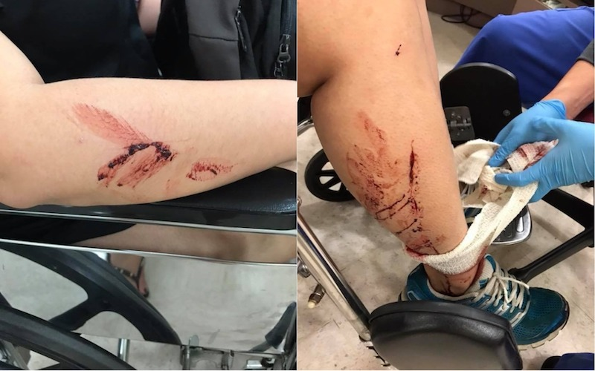Photo: Jenn Low / Facebook
The rider of an electric scooter fled the scene after knocking down a woman in Bukit Panjang, according to a Facebook post, and the victim’s sister is appealing to the public for witnesses.
Jenn Low wrote on Facebook that her sister was hit while walking at the void deck of Block 442 on Tuesday night. The rider allegedly crashed into the woman from behind, knocking her onto her right side. While she did suffer injuries to her arm, leg, and temple, Low was thankful that her sister’s injuries were minor.
“Luckily she landed on the grass patch and this kinda soften the impact,” said Low in her Facebook post.
Photos of the injuries show the victim’s scraped and bleeding limbs, but the most disturbing aspect of the incident occurred after the impact when the driver apparently sped off without even stopping.
“The bloody rider did not stop or provided any assistance,” said Low. “Instead the rider fled the scene towards the direction of Fajar Shopping Center.” The appearance of the rider was not described in the post. A police spokesman, however, noted to STOMP that it was alerted to an accident involving an e-scooter rider and a pedestrian at 10.12pm on Jun 26.
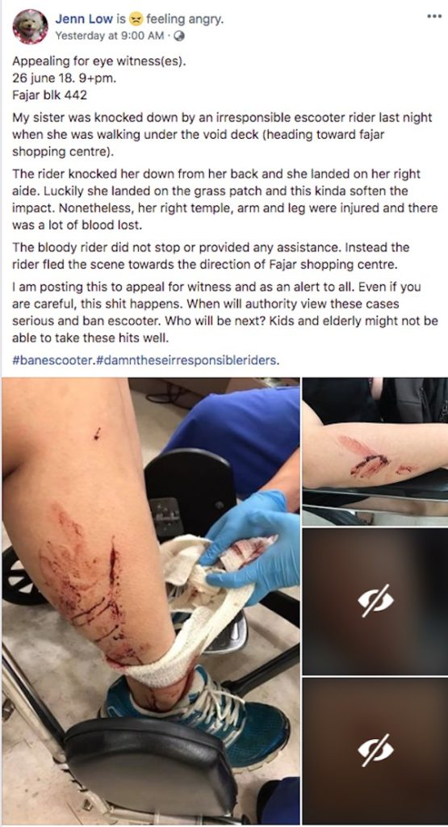Photo: Facebook screengrab
The collision that injured Low’s sister is only the latest electric scooter-related mishap to have taken place in Singapore.
In March, a man was arrested after he allegedly knocked down a woman in Bedok Reservoir, leaving her in a temporary coma.
In April, an e-scooter rider was arrested after seriously injuring a young girl in Pasir Ris. The girl, 11, had to have her jaw and gums realigned after the collision.
The government is stepping in to protect citizens from reckless riders. In March, the Land Transport Authority imposed a new regulation, requiring all e-scooters to be registered starting in the second half of this year.
“Registering e-scooters will help deter reckless behavior, accord more responsibility to the users, and facilitate enforcement officers in tracking down errant users,” said Senior Minister of State for Transport Lam Pin Min in Parliament yesterday during the Committee of Supply debate on the Transport Ministry’s budget.
On her part, Low said that she created the Facebook post about the incident in order to reach anyone who may have witnessed the collision and encourage them to come forward.
“I am posting this to appeal for witnesses and as an alert to all,” she wrote. “Even if you are careful, this shit happens. When will authority view these cases (seriously) and ban e-scooters? Who will be next? Kids and elderly might not be able to take these hits well.”
Coconuts has journalists on the ground in eight cities working hard to publish true stories that matter. You can support our work by becoming a COCO+ Member or making a Patron payment.

8.0 Spain ‘E-scooter rider who caused Spain’s first fatality faces fine, not prison’

Published by El Pais 1 August 2019 by Jesus Garcia

The young man killed a 90-year-old when he ran into her from behind as she was returning home from her morning walk. A young man responsible for the first fatality involving an electric scooter in Spain will face a fine at the most, sources close to the investigation have told EL PAÍS. Alexi, 19, will face trial for recklessness, a minor offense that means he will avoid prison time if found guilty. The judge investigating the case agreed with the public prosecutor after determining, among other issues, that Alexi was going at less than 10 kilometers per hour.
The young man testified in court and recognized the facts
On August 13, 2018, a 90-year-old woman named Berta was out for a morning stroll with her walker in the pedestrianized section of the Rambla del Carme thoroughfare, in the Catalan town of Esplugues de Llobregat. As she was heading back home, she was hit from behind by an electric scooter carrying two people. Berta fell and hit her head against the pavement. She suffered internal bleeding and died later in Moisès Broggi Hospital. Spain’s DGT traffic authority confirmed that it was the first known case of a pedestrian getting killed by an electric scooter. Berta’s death raised renewed concerns about the proliferation of alternative mobility devices in cities across Spain and the need for greater regulation.
A judge opened an investigation into whether Alexi was guilty of involuntary manslaughter. The 19-year-old testified in court and recognized the facts of the accident, which “were not the object of controversy.” But their legal classification was. According to the public prosecutor, the young man was looking at his cellphone when he ran into the 90-year-old, which is the basis of the recklessness charge. Alexi tried to save Berta after he hit her and in the following days went back to the Rambla del Carme to look for Berta’s relatives and ask them for forgiveness.
Spain’s traffic authority confirmed it was the first known case of a pedestrian getting killed by an e-scooter
Alexi’s defense called for the case to be shelved, arguing that no type of crime had been committed because there was no recklessness. The public prosecutor rejected the request and stated that, given the circumstances, the young man had committed “minor recklessness.” This is an intermediary category between a minor and serious crime – the product of a 2015 reform of the criminal code used to punish recklessness in cases where a victim has been killed or injured. The penalty for someone who “through minor recklessness causes the death of another” is the payment of a fine between “three and 18 months.”
The judge refused to shelve the case and confirmed in a recent court document that mis-demeanor charges would be pursued. It remains to be seen how the private prosecution, brought by the nephews of the victim, will respond to the news. Berta was a widow and did not have any children, which practically rules out the possibility of awarding damages to her relatives.

9 Many examples given – ‘Broken Bones And Missing Teeth: Scooter Injuries Are Becoming Common At Hospitals’
Published by BuzzFeed News 20 August 2018

Emergency rooms are seeing people injured on scooters, or by tripping over them, but there’s no hard data on how many. Officials are looking to start collecting this information as they consider scooter regulations.
Earl Wilkinson never imagined his first ride on a Bird this summer would end with him flying over the handlebars of his motorized scooter and faceplanting into the sidewalk. The 52-year-old was gliding along the street, as instructed by the app, but after seeing other riders on the sidewalk, he tried to scoot up the sidewalk ramp — which is when he suddenly lost control. Wilkinson torpedoed forward, landing on his head, breaking his arm, knocking out his two front teeth, and smashing his glasses. He took an Uber to the emergency room; the next morning, he went to a dentist.
“I cringe thinking of the impact of my nose, face, teeth, mouth, and chin on the concrete — then tasting what I thought were salt grains. In fact, they were teeth remnants,” Wilkinson said.

Earl Wilkinson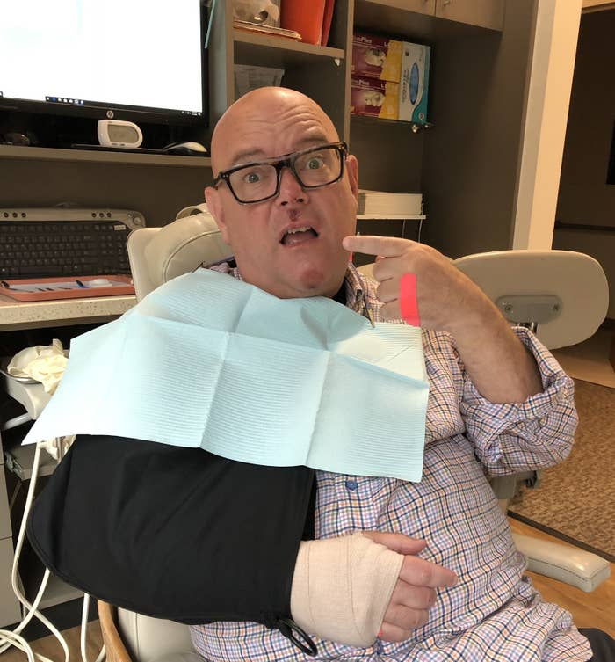
Earl Wilkinson at his dentist's office getting his front teeth repaired.
Other stories of gory e-scooter injuries — and worse — have been reported; one woman in Cleveland recently died after being hit by a car while on a scooter.
The dockless motorized scooter craze has been controversial as startups Bird and Lime have suddenly swept into more cities, without any regulation or approval from the local government. While much of the ire has been directed at how riders leave hundreds of the scooters strewn about sidewalks and streets like abandoned flotsam, there’s another scourge: Emergency rooms are taking in lots of people with scooter injuries.
“We are seeing daily injuries from users of the motorized scooters,” Dr. Wally Ghurabi, medical director of the Nethercutt Emergency Center at UCLA Medical Center in Santa Monica, California, told BuzzFeed News, “as well as some injuries to pedestrians who were hit by riders or tripped over scooters left on sidewalks.” In nearby Venice, California, Venice Urgent Care confirmed they get “a lot” of people with scooter injuries.
“We are seeing daily injuries from users of the motorized scooters.”
But the number of injuries is hard to quantify. Police in Dallas say just four people have called 911 for an electric scooter accident since Bird and Lime motorized rideshare scooters showed up in late June. The others, like Wilkinson, end up in the ER, although without a standard way to classify such injuries, it’s unclear just how many.
Despite the lack of official data, doctors, city officials, and riders that BuzzFeed News spoke with all agreed: They just don’t know how safe these things are.
Such information is now being sought as officials mull scooter regulations.
“Scooters have been off the street of San Francisco for a few months now, but you absolutely saw several people coming in to several of our centers subsequent to scooter injuries,” said Brandon Hastings, chief operating officer of Golden Gate Urgent Care, which operates several locations in San Francisco. “Most of them involving the inability to stop quickly to avoid collision.”
Some scooter victims are seeking legal representation. Personal injury attorney Catherine Lerer of the firm McGee Lerer in Santa Monica has taken on approximately 10 clients with scooter injuries such as a broken leg, a broken tooth, a torn rotator cuff, or a broken foot. Some of these involve a malfunction, like a wheel locking up or the handlebar stem collapsing, she claimed. One of her clients, a mechanic who works on repairing Birds, fell while testing a scooter that turned out to have no brakes, resulting in a broken collarbone and staples to the scalp.
Lerer also points out that there are vandals who purposely smash or break scooters because they’re unpopular. “My big concern is Bird and Lime don’t inspect them between rides,” she said. Lime says they do daily inspections and maintenance; Bird said they also repair daily.
Several of Lerer’s cases involve elderly people who tripped over parked scooters. While none of her clients have filed a lawsuit yet, she expects to ask for damages ranging between $25,000 and $250,000.
While motorized scooters are hailed by some as a fun, affordable, and environmentally friendly way to get around, many riders discover scooter-riding in traffic isn’t as intuitive as they expected (accelerate with your right hand, brake with your left), and no one seems sure how to integrate them into cities’ existing transportation infrastructures.
The tactic scooter companies like Bird and Lime have taken — flooding cities with the vehicles overnight, unauthorized — suddenly creates an army of rookie riders who, dangerously, don’t quite fit into their cities’ existing rules of getting around. By renting them out cheap and removing the bar of ownership, these companies give anyone with a smartphone the ability to get behind the wheel.
While Bird and Lime scooters are too fast for sidewalks, at a max speed of 15 mph, they are also slow for streets and bike lanes. There’s also a learning curve for car drivers to get used to seeing them and for riders to learn how to control them. Not to mention that helmet usage among users is inconsistent.
“Safety is a top priority for Bird,” CEO Travis VanderZanden said in a statement to BuzzFeed News. “The well-being of our riders is something we’ve worked to protect through concrete action, including: throttling the speed to a 15 mph maximum, requiring riders to upload a driver’s license and confirm they are 18 or older, providing an in-app tutorial on how to ride a Bird and how to park it, and posting clear safety instructions on each Bird.”
A spokesperson for Lime said, “We instruct riders to practice safe riding using helmets both through notices on the app and on the actual scooter. In order to unlock a Lime scooter for the first time, all riders must go through an in-app tutorial that includes helmet safety.”
Still, both companies’ user agreements warn that riding their scooters includes risk of injury, that the machines may malfunction, and that the rider agrees to accept full responsibility for this should anything happen. And while both Limeand Bird say in their user agreements that users should report injuries to the companies, neither provided data to BuzzFeed News about reports they had received.
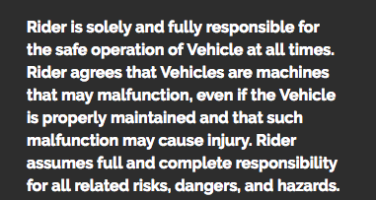
Despite these warnings, Dr. Ghurabi said that after scooters took off in popularity, “you’d see [injuries] once or twice a week at first, and now it’s almost a daily occurrence.”
Yet scooter injuries are not being tracked at emergency rooms or doctor’s offices. Dr. Ronn Berrol, medical director of the Alta Bates Summit Emergency Department in Oakland, says his hospital is “for sure” seeing people come in with injuries from scooters, although the way hospitals and emergency rooms classify injuries — using codes for “mechanical fall” or “pedestrian fall,” for instance — doesn’t include scooter accidents yet.
“That’s where we’re lagging behind and underreporting this kind of stuff,” said Berrol.
Officials are eager to get their hands on this information as they consider imposing new scooter regulations. In San Francisco, where the city has banned the scooters, health officials at are planning a way of tracking scooter injuries.
Megan Wier of the San Francisco Public Health Department told BuzzFeed News that her team is working with police and the Zuckerberg General Hospital and Trauma Center to create a way of tracking scooter accidents and injuries. The challenge is creating one uniform system. “Everyone just has their own perspective of the issue. Police have their own forms that they’ve been using,” she said. “When people are coming to the hospital, that’s different than an investigation on the scene of an accident. So hospital staff have different exposure.” Their tracking system will start running in a few weeks.
Meanwhile on the East Coast, Jan Devereux, the vice mayor of Cambridge, Massachusetts, where scooters just showed up, told BuzzFeed News she’s particularly worried about how scooters will fare on Massachusetts streets, which tend to get ripped up and perilously full of potholes from the ravages of cold winters and snowplows. Cambridge has banned the scooters until it can set a September council meeting to discuss regulation. “I don't think the injury risk is reason to ban scooters,” Devereaux said. “Remember the craze for rollerblades? People wore knee, elbow and wrist pads! But I sure hope scooter enthusiasts will realize they have to be careful.”
“I think there’s blood on the hands of every city that allows them to operate — knowing how many riders and pedestrians are being injured — and fails to enforce the laws and fails to enforce helmets or riding on the sidewalk,” said Lerer, the attorney.
Nearly a year after Bird scooters first hit Santa Monica, the city is starting a pilot program to limit and study the rideshare scooters. This week, Bird and Lime encouraged their riders to show up to City Hall to protest the proposal to limit the pilot program to just Uber’s Jump scooters.
One ardent scooter fan told a BuzzFeed News reporter on the scene that even though he had gotten badly scraped (though not enough to go to an ER) after being hit by a texting driver, he still showed up in support of Bird and Lime, carrying his own homemade “Limes Aren’t Lemons” sign.
Even Earl Wilkinson, after faceplanting, hasn't totally soured on the scooters. “Ask me to get on one now? Hell, no. I can still imagine the faceplant into the concrete sidewalk,” he told BuzzFeed News. “Ask me in a month or six months.”

10.0 Paris, France ‘Man killed and woman badly injured in latest electric scooter crash in France’

Published by The Local France – 21 October 2019
The accident brings to at least six the number of people killed in collisions involving electric scooters since the zippy devices began popping up in ride-sharing schemes around the country in mid-2019.
Sunday's incident took place in the early hours of the morning on the banks of the Garonne river in central Bordeaux.
The male scooter rider was pronounced dead at the scene. His female companion, aged 18, was rushed to hospital in critical condition.
The last few months have seen a rash of deadly accidents involving the widely popular two-wheelers, which have revolutionised urban mobility.
Nearly all the victims were scooter riders in their twenties but the first fatality was an 81-year-old man, who died after being knocked over by a scooter in the Paris suburb of Levallois.
11.0 San Francisco, USA ‘E-scooter crash on SF’s Embarcadero leaves 69-year-old woman with life-threatening injuries’

Published by San Francisco Chronicle on 14 January 2020
A 69-year-old woman was critically injured Monday when she crashed an electric scooter into a cement mixer in San Francisco, officials said. The crash occurred around 3:25 p.m. near Bay Street and the Embarcadero, according to San Francisco police.
The woman rode the scooter through an intersection and hit a cement mixer, officials said. She was taken to the hospital with life-threatening injuries.
A report released last week by UCSF revealed that e-scooter injuries are on the rise. Hospitalizations related to e-scooter accidents more than tripled over five years, according to the report.
Anna Bauman is a San Francisco Chronicle staff writer. Email: anna.bauman@sfchronicle.com Twitter: @abauman2

12.0 Spain Calls for electric scooters to be banned in Spain after man is killed in tragic accident

Published Euro Weekly News 14 February 2020
ACTIVISTS are calling for Spain’s Government to ban electric scooters after a man was killed in a tragic accident.
The 35-year-old man has attempted to climb onto the pavement from a road on his scooter in Lloret de Mar in La Selva. However, he lost his balance and hit a pillar, falling onto the floor.
His injuries were so serious that he was knocked out unconscious suffering from a severe brain injury. The young man had been be admitted into intensive care at the Trueta Hospital, however, he sadly died three days later.
The latest fatality adds to the increasing number of people who have died whilst riding electric scooters, with activists asking the government to step up their plans to regulate their use to ensure the highest level of safety, or to ban them altogether.
Officers had been deployed to the streets across Spain in recent months to crackdown on electric scooters, where anyone caught speeding, using mobiles or driving negligently would be issued with a fine of up to €200. Less serious violations resulted in a warning, with riders being informed of the regulations for driving a scooter safely.
The new rules for riding an electric scooters were introduced in June of last year and just by looking at Palma de Mallorca, by August 13, 52 people had already been fined for breaking the law. This included infractions such as riding an electric scooter on a main road or on pavements, both which carries a penalty of €40.
It is recommended that those riding a scooter should wear a helmet at all times and take out insurance, although the majority of users choose not to despite its cost of between €20 to €35 per year. Children under the age of 15 are also only allowed to ride electric scooters in bike lanes or on residential roads with a speed limit of 30 kilometres an hour.

13: Hoboken Pulls Plug On Electric Scooter Company After Several Accidents, Mother And Infant Injured By Rider

Published CBS New York 12 September 2019
HOBOKEN, N.J. (CBSNewYork) – A New Jersey mother is appealing for stricter regulations for scooters after she and her baby were hit by one.
That mother wants the city of Hoboken to take action on electric scooters and riders who won’t follow the rules of the road.
Scooters are a quick getaway, but maybe too quick.
Hoboken residents say those riding the electric vehicles since the city rolled them out ignore the rules – weaving in and out of traffic, riding on the sidewalk, and much worse.
A local mom – Katie Cohen tweeted the mayor saying “my three month old and I were struck by an @ojoelectric scooter yesterday.”
Kate Cohen@KatieBCohen

My 3 month old and I were struck by an @OjOElectric scooter yesterday in @CityofHoboken. Here is what happened.

1:11 PM - Sep 12, 2019
The OjO scooters are bulky blue vehicles you can ride standing up or sitting down.
“I screamed as he rammed into the stroller, which rammed into my right leg. The stroller was tilted on its side. My baby was screaming bloody murder,” Cohen said on social media.
Kate Cohen@KatieBCohen

Bruised leg. So fortunate that it wasn’t worse. I have zero confidence that the next victim will be as lucky as I was.
@RaviBhalla @Tiffanie_Fisher @CityofHoboken @HobokenMommies @HobokenFire @HobokenGirlBlog @HobokenPD @HobokenInc
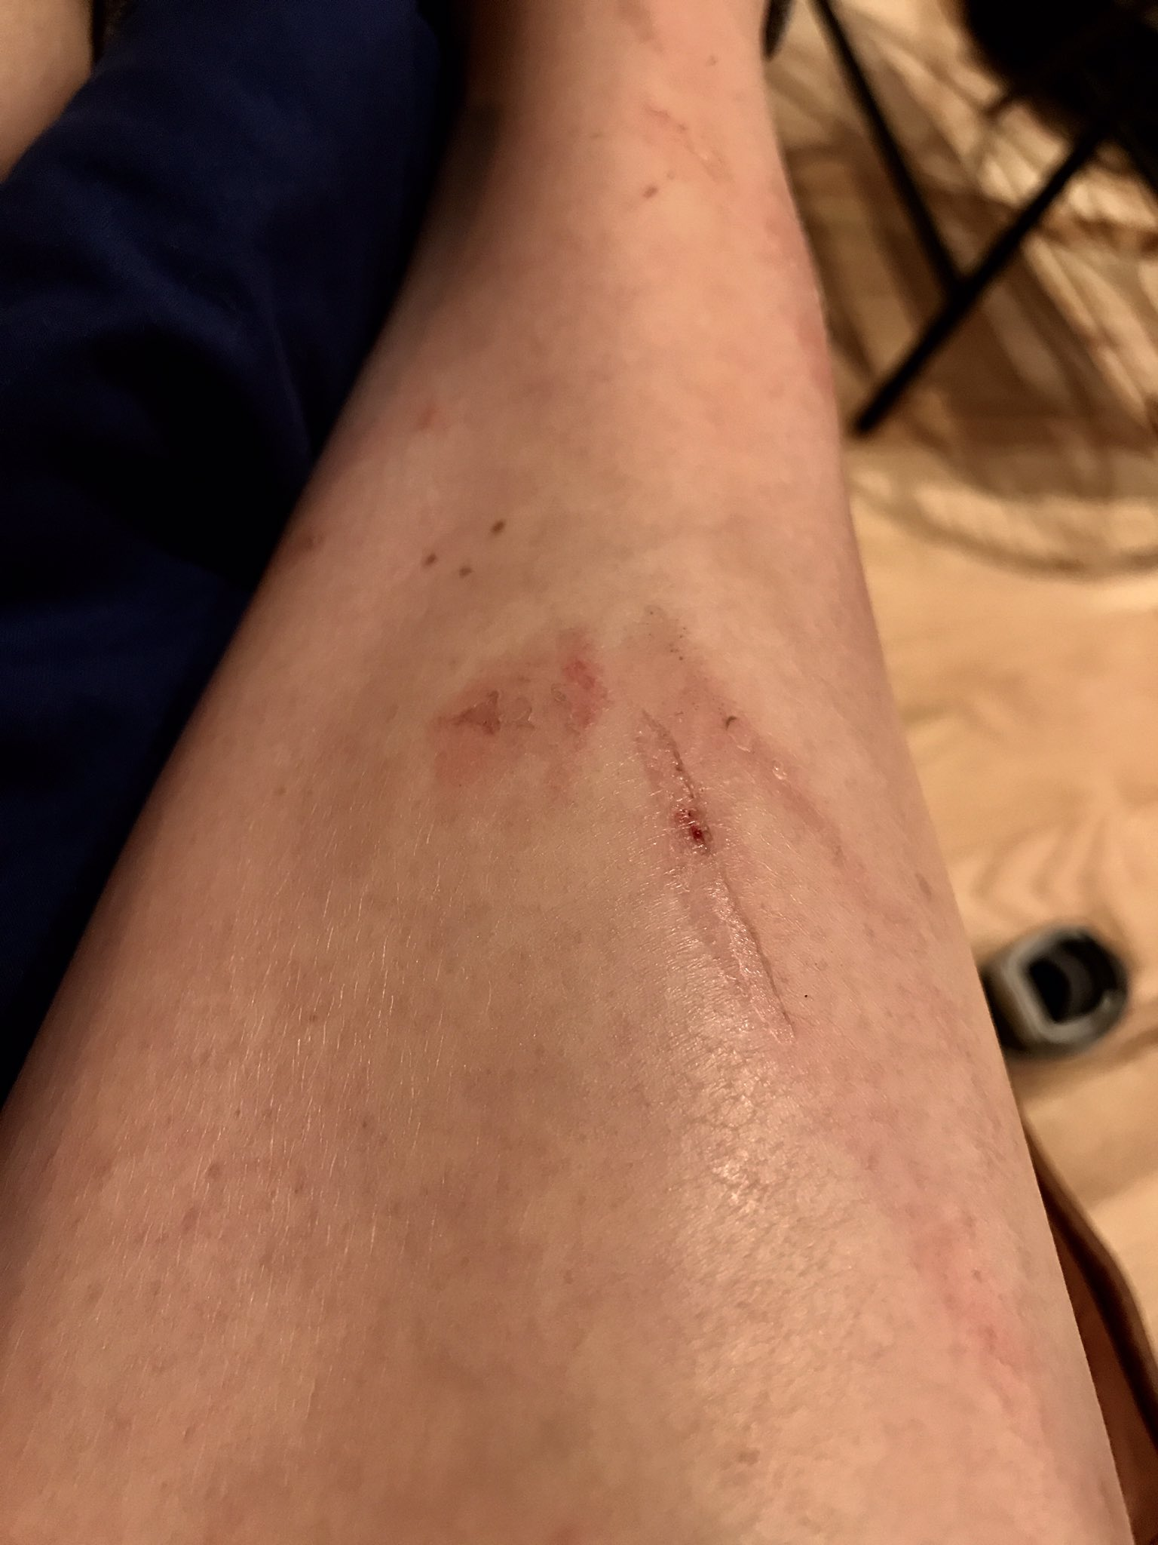
1:57 PM - Sep 12, 2019

Hoboken’s mayor says because of this and other reported incidents the city is ending its contract with OjO but will continue with the smaller Lime scooters.
The new mom says no matter the scooter, you have to watch your back.
CBS2’s Meg Baker spoke to local parents who say the electric vehicles are dangerous because many of the riders don’t know they’re doing, bumping into people, and not following the traffic laws.
MORE: Hoboken’s E-Scooter Program In Chaos After Just 3 Days, Streets Filled With Riders Breaking Traffic Laws
Others said they like the green form of transportation.
“I think it’s smart and good for environment… You have to be mindful of what you are doing at all times,” Jersey City resident Daryl argued.
The mayor says the city is increasing enforcement of scooter rules.
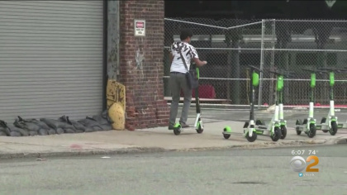
(Credit: CBS2)
If you are caught on the sidewalk, the first offense is a $250 citation – and it increases from there.
The pilot program with lime ends in November and then the city will re-evaluate keeping them. For now Lime has also agreed to help fund new bike lanes in the city.

14: Auckland, New Zealand - Lime e-scooter hits woman on Auckland's Fanshawe St where man died

Published by Stuff June 25 2019
A woman has been hospitalised after she was hit by a Lime e-scooter rider hours after a man died riding one on the same street.
Auckland Council's director of regulatory services, Craig Hobbs, said one of its staff was injured on Tuesday morning after being hit by a person riding one of the electric scooters.
The incident on Fanshawe St follows the death of a 58-year-old man, who was travelling on an e-scooter before he died further up the same road near Bradnor Lane.
Hobbs said he had visited the Auckland Council staff member in hospital and hoped she would make a quick recovery.
The injured woman's husband, Paul Charman, told The New Zealand Herald his wife, Debra Christensen, was struck by a person riding a Lime scooter as she got off a bus on Fanshawe St, opposite Victoria Park.
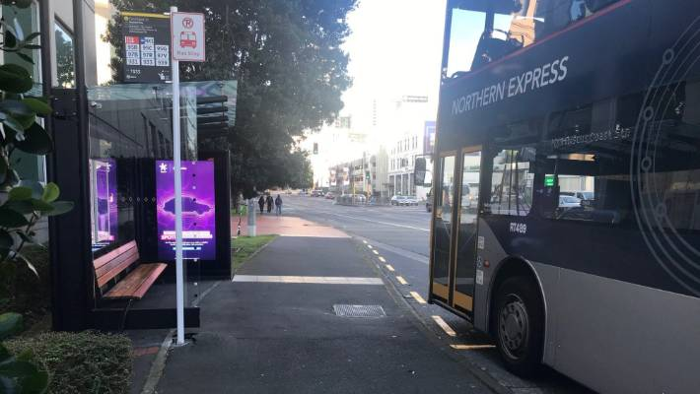
MELANIE EARLEY/STUFF
Debra Christensen was struck by a person riding a Lime scooter as she got off a bus on Fanshawe St, opposite Victoria Park.
Charman said his wife was knocked out cold and her head was under the bus.
"She doesn't remember what happened after that because she was knocked out cold," Charman said.
Christensen had lacerations to her face and skull, and potentially injured her ribs, he said.
They were waiting on head scans to see if there were anymore injuries, he said.
Charman told The New Zealand Herald the bus driver was so shaken by the incident he had to finish his shift.
A witness at the scene told The New Zealand Herald they saw Christensen lying on the ground bleeding after she was hit by a young person riding a Lime scooter.
On Tuesday, St John spokeswoman Beverley Tse said an ambulance attended the incident at 8.47am and one patient was taken to Auckland Hospital with moderate injuries.
Lime's public affairs manager Lauren Mentjox said it it was investigating the incident.
Lime did not tolerate the kind of behaviour by the rider that had been described, Mentjox added.
Auckland Transport spokesman Mark Hannan said it was aware of the incident.
On Monday evening, emergency services were sent to Fanshawe St in Auckland's CBD where a man has died after using a Lime e-scooter.
"The incident happened on the footpath when the passenger got off an NX1 bus," Hannan said.
"The bus driver stopped the bus, called for emergency services and stayed behind to assist."
A police spokesman said officers did not attend the incident.
The collision happened hours after a man died after riding a Lime e-scooter in Auckland's CBD.
On Tuesday morning, police said the circumstances of the man's death were unclear but it was not thought to be suspicious.
It is thought to be the first fatal incident involving one of the scooters in New Zealand, but the details of what had happened are not yet fully clear.
Auckland councillor Christine Fletcher, who previously shared concerns about e-scooters after she was almost knocked over by one, wants them removed from the streets until the outcome of a coroner's investigation into the man's death.

15: London, UK - Teenage electric scooter rider in critical condition after being 'struck by car' in London

Police hunt for driver of Vauxhall Zafira as teenager fights for life a fortnight after crash
Published by Independent 12 January 2020

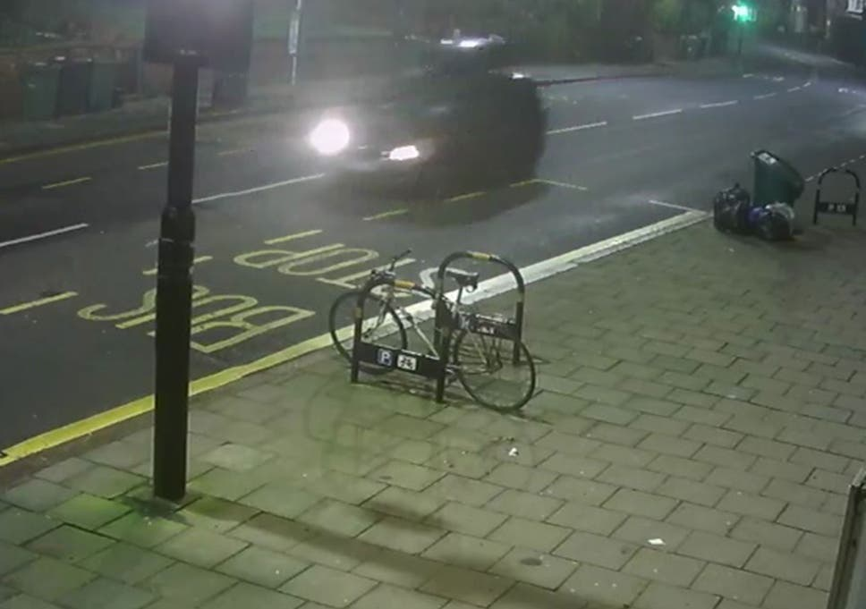
Police are appealing for help tracing the driver of a Vauxhall Zafira (pictured) ( Metropolitan Police )
A teenager is fighting for his life in hospital after colliding with a car while riding an electric scooter.
Police are appealing to track down the driver of the vehicle that struck the 19-year-old rider in Herne Hill, London.
The collision happened at around 4.30am on 31 December, at the junction of Croxted Road at the junction with Norwood Road.
“The rider of the scooter, a 19-year-old man, was taken to a south London hospital where he remains in a critical condition,” a spokesperson for the Metropolitan Police said.
“There have been no arrests and enquiries continue.”
Detective Constable Croucher, of the force’s Serious Collision Investigation Unit, appealed for any witnesses or anyone with dashcam footage to come forward.
“The dark coloured Vauxhall Zafira that struck the pedestrian on the scooter was equipped with a roof box and will have suffered damage on the front passenger side as a result of the collision,” he added.
“Did you see the vehicle before, during or after the collision? Are you the driver of the vehicle? Do you know who the driver is? If you can help please do the right thing and get in touch.” It came after a television presenter was killed while riding an electric scooter in London in July, in the first fatal accident involving riders in the UK.
Emily Hartridge, 35, collided with a lorry at a roundabout in Battersea
Several other serious accidents have been reported, including one that seriously injured a 14-year-old boy the day after Ms Hartridge’s death.
Other deaths and major accidents have been reported in cities around the world, prompting calls for bans as riders protest for legal rights and improved safety.Top ArticlesChina trying to use Huawei to 'drive a wedge’ between US and UK, senator says
No hype, just the advice and analysis you needElectric scooters are becoming increasingly popular in the UK, despite the fact it is illegal to use them on public roads, pavements or in cycle lanes.
“Any person who uses a powered transporter on a public road or other prohibited space in breach of the law is committing a criminal offence and can be prosecuted,” says government legal guidance, although no prosecutions are known to have been made.
Electric scooter accidents plague Paris as residents demand police crackdownThe government has launched a review of the laws around e-scooters and other “powered transporters” that will look at regulation and safety issues.
Anyone with information is asked to call police on 0208 285 1574 or 101, or contact Crime stoppers anonymously on 0800 555 111.

16.0 London, UK Television presenter Emily Hartridge dies in electric scooter crash
Published in the Guardian 14 Jul 2019

Emily Hartridge was riding her electric scooter in Battersea on Friday morning at the time of the accident. Photograph: Jeff Spicer/Getty Images
Tributes have poured in for a TV presenter and YouTube star after she died in an electric scooter crash – the first fatal collision involving an e-scooter in Britain.
Emily Hartridge died on Friday morning when her e-scooter collided with a lorry at a roundabout in Battersea, south-west London.
The 35-year-old was one of the first wave of social media stars, becoming famous seven years ago for her “Ten Reasons Why ...” videos that took a comic look at modern life.
After gaining 3m views a month, she began presenting TV shows including 4OD’s Oh Sh*t I’m 30 and interviewed actors including Eddie Redmayne and Hugh Jackman.
Her death was announced on her Instagram account:
“We all loved her to bits and she will never be forgotten,” the message said.
“She has touched so many lives it’s hard to imagine things without her. She was a very special person xxx.”
There were tributes to her from other TV presenters including Davina McCall and Zoe Hardman, Radio 1 DJ Chris Stark and musician Harry Gardner.
“My heart goes out to Emily’s family and friends,” McCall wrote. “Such a shock. Sending you love and prayers.”
Greg Jenner, the TV historian, said he had met her on a train five years ago. “By the end of the journey we’d shared all sorts of things about our mental health and insomnia. She was funny, kind and open-hearted.”
Police have been investigating the scene of the crash at Queen’s Circus roundabout, which was redesigned in 2015 to keep cyclists separated from other traffic. The new layout has been criticised as being confusing and last year a cyclist died after being hit by a bin lorry.
It is illegal to ride an e-scooter – or a Segway, Go-Ped or powered unicycle – on public roads in the UK as they are not considered to be roadworthy vehicles. Yet millions of people ride them in cities across Europe and the US, and growing numbers of e-scooters have been sold in the UK, prompting the government to review the law.
On Monday, transport minister Michael Ellis is due to meet Halfords and scooter share firms Lime, Bird and B Mobility to warn them that they must tell consumers about the law before they buy or hire an e-scooter.
“Micromobility products are appearing in countries across the globe and are an exciting innovation for which we know there is demand,” he said.
“However, safety must always be our top priority when considering their use on public highways in this country.
“The government is considering this as part of its regulatory review, as announced in March in the [policy paper] Future of Mobility: Urban Strategy.
“We are examining whether they can be used safely on the road – and if so, how that should be regulated to ensure the public’s safety. However, companies must understand that reviewing laws does not necessarily mean laws will change.
“People who use e-scooters need to be aware it is currently illegal to ride them on the pavement and the road.”
In 2010, the British owner of the Segway firm died after falling from one of his company’s machines in a freak accident.
Jimi Heselden had stopped the self-balancing two-wheeler at the top of a steep footpath above the River Wharfe in Yorkshire to let a walker go past him when he fell 13 metres into the river.

17.0 Elderly Woman Injured In E-Scooter Crash On Embarcadero
14 January 2020

A 69-year-old woman was severely injured Monday afternoon when she collided with a cement mixer while riding an e-scooter near the intersection of Bay Street and the Embarcadero.
The incident happened at 3:25 p.m. on Monday, and as the Chronicle reports, the woman was traveling through the intersection when she hit the cement mixer. She reportedly suffered life-threatening injuries and is now hospitalized in critical condition.
Just last week, a new report from a prominent medical association referred to e-scooters as a new "urban health scare," and found that injuries related to the scooters more than tripled nationwide between 2014 and 2018. Hospital admissions from scooter injuries doubled between 2017 and 2018 alone.
About a third of the injuries involved the head, and the report found that the rate of head injuries relative to all other injuries was more than double the average rate for cyclists.
The most commonly injured demographic, per the reports, were 18- to 34-year-olds, making the elderly woman's case on Monday an outlier.
It's not clear if she was wearing a helmet at the time of the crash, or what the exact circumstances of the collision were.

Appendix D Examples of Problems of Regulating E-Scooter Use

1.0 Spain

1.1 Malaga, Spain

Shocking figures reveal just a third of electric scooter fines were paid on Spain’s Costa del Sol last year

Published by the Olive Press 31 January 2020
ONLY a third of the electric scooter fines in Malaga have been paid.
In 2019, 1,378 fines were handed out for improperly parked electric scooters – but only 385 of those were paid.
That constitutes to just 28% of fines.
This is the first attempt by the mayor to control the phenomenon of electric scooters in Andalucía’s second biggest city.
Parking said scooters in pedestrian areas and/or outside the designated spaces results in a €200 penalty.
Most of these fines however aren’t addressed to the individuals renting them, but to the companies hiring them out.
This comes after the town hall introduced a new law in October 2019, to clamp down on the reckless and disorderly use of the scooters in the city.
The regulations meant that the controversial means of transport were banned from pavements, promenades and the city’s central historic area, and could only be used in bike lanes and on regular roads meant for vehicles.

1.2 Palma, Spain

‘Putting on the brakes on electric scooters’
Published by Euro Weekly News 24 October 2019 @ 23:00

AFTER an increasing amount of complaints from local residents, Palma police have launched a campaign to clamp down on electric scooters riders who break the law.
Officers are being deployed to the streets in the capital over the next two weeks, where anyone caught speeding, using mobiles or driving negligently could be issued with a fine of up to €200. Less serious violations will likely result in a warning, where riders will be informed of the regulations for driving a scooter safely.
More serious offenses, which includes speeding or using a mobile whilst driving, will carry a more substantial penalty.
The new regulations for electric scooters were introduced in June of this year and by August 13, 52 people had been fined for breaking the law. This included infractions such as riding an electric scooter on a main road or on pavements, both which carry a penalty of €40.
At present, it is not compulsory to wear a helmet when riding an electric scooter in the capital, however new regulations are expected to be enforced. Children under the age of 15 are only allowed to ride electric scooters in bike lanes and on residential roads with a speed limit of 30 kilometres an hour.
The rules are being strictly imposed by officers due to a general unawareness from scooter riders, who have no idea about road safety. This is putting pedestrians at risk, which is the top priority for the police.

2.0 Atlanta, USA

A) ‘Despite new policy, Atlanta has failed to collect fines for impounded e-scooters’
Published Curbed Atlanta 11 November 2019
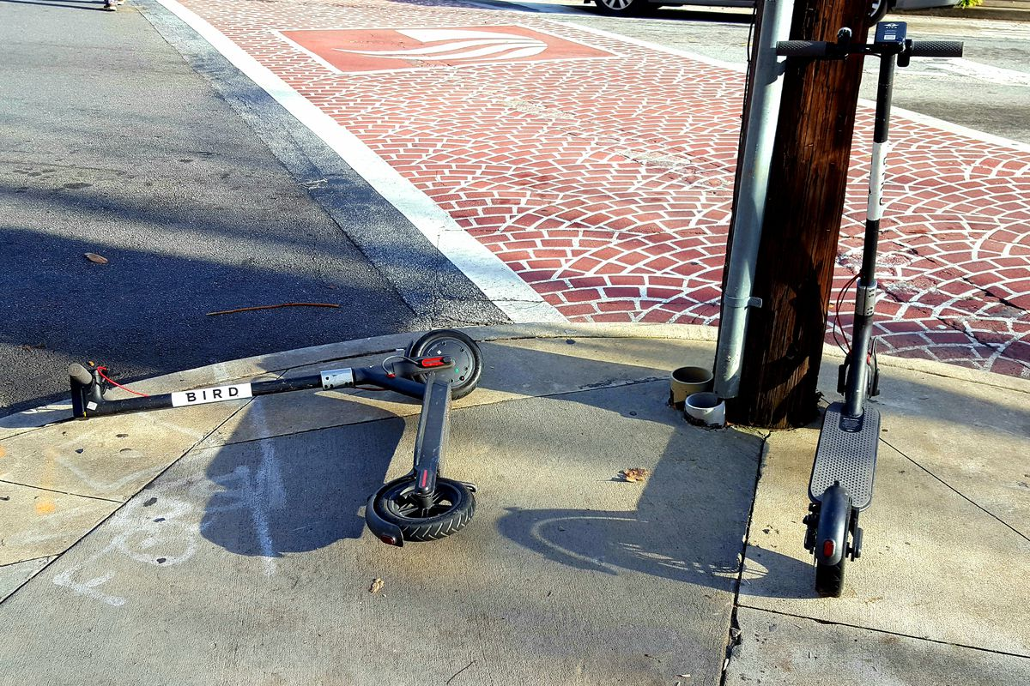It’s illegal to park dockelss e-scooters and bikes in public rights of way.Sean Keenan, Curbed Atlanta
The City of Atlanta’s Department of Public Works impounded thousands of illegally parked e-scooters this past summer, but officials reportedly neglected to collect any fees for their troubles.
In June, city officials told Curbed Atlanta that companies operating dockless mobility devices have to pay a $75 impound fee—plus $25 per day for storage—for each vehicle public works crews remove from sidewalks and public rights of way.
Once those fees are paid, those companies can reclaim their two-wheelers, according to the policy. But since the city has neglected to collect fees from nearly 3,000 impounded vehicles, it’s left more than $200,000 on the table, according to the Atlanta Journal-Constitution.
Laws regulating dockless e-scooter and bike operations were enacted in January, barring riders from parking the devices on sidewalks—unless they leave at least five feet of walking room—and public rights of way.
Even riders can be liable to pay fines of up to $1,000 for violating the new rules.
Still, though, the electric vehicles can frequently be seen littered around the city; it’s unclear whether any riders have been ticketed.
City of Atlanta officials did not respond to Curbed’s request for comment as of press time, and this story will be updated should responses be provided.
Public Works Commissioner James Jackson last week said the city is revising its impound fee collection processes, although he didn’t provide specifics, according to the AJC.
Officials, he said, are considering ways to retroactively collect the fees.

B) After period of leniency, Atlanta Police now enforcing scooter law
Published AJC Atlanta 13 June 2019
People ride LimeBike, left, and Bird electric scooters on the Embarcadero in San Francisco on April 13, 2018. MUST CREDIT: David Paul Morris/Bloomberg Photo by: David Paul Morris - Bloomberg
Photo: David Paul Morris - Bloomberg
For the past 10 months, electric scooter riders have been allowed to flout the city of Atlanta’s code by riding on sidewalks and in other areas designated for pedestrians.
But that leniency ended this week.
Atlanta Police officers have begun warning people who use scooters to get around town that they risk being fined if they aren’t riding in the street with traffic, according to a report by Channel 2 Action News
“If you’re using anything with wheels to get around Midtown or downtown Atlanta, we ask that you be in the street following the rules of the road and staying with the flow of traffic,” Atlanta police Maj. Darin Schierbaum told Channel 2.
Fines could range as high as $1,000, according to the report.
A year and a half ago, Midtown sidewalks were flooded with these scooters, forcing Atlanta politicians to create new regulations.
Many cities are left with the task of figuring out how to handle the devices after a pair of bills set to regulate e-scooters across the state was parked during this legislative session so lawmakers could negotiate more with the scooter companies.
Officials across the metro area say they don’t like how the scooters can be seemingly left anywhere, cluttering sidewalks and disrupting planned traffic flows.

- Singapore ‘E-scooters still common on footpaths, six weeks after ban’
Published by Today Singapore – 20 December 2019
SINGAPORE — It has been more than six weeks since a ban on the riding of electric scooters on footpaths took effect, but riders of these personal mobility devices (PMDs) are still zipping around on footpaths in significant numbers, TODAY has found.
TODAY went to four neighbourhoods around Singapore and found Yishun to have a particularly high number of errant e-scooter riders. In the span of just one hour, 46 e-scooters were spotted on the footpaths along Yishun Avenue 6 and Yishun Avenue 9.
The Land Transport Authority (LTA) has provided an “advisory period” till the end of the year to allow users to adjust to the rules. During this period, warnings are being given out but LTA will reserve the right to enforce the rules for more serious cases.
But from Jan 1, those caught riding an e-scooter on footpaths can be fined up to S$2,000, jailed up to three months, or both.
Pedestrians who spoke to TODAY said that since the ban was announced, they have noticed fewer e-scooters on the footpaths in their neighbourhoods but would be happier still if they were gone altogether.
They also worry that even when penalties are enforced in the new year, there will still be recalcitrant e-scooter riders on footpaths.
A LOOK AT FOUR TOWNS
Between 4.25pm and 5.25pm on Tuesday (Dec 17), TODAY spotted 13 e-scooter riders on footpaths in the area around Bedok Mall and Heartbeat @ Bedok.
On the same day, from 12.35 pm to 1.35pm, 14 e-scooters were spotted flouting the rules along Boon Lay Way and Jurong Gateway Road.
On Wednesday, from 11.45am to 12.45pm, 21 e-scooters could be seen being ridden on footpaths around Punggol Central.
And on Friday, between 11.47am and 12.47pm, TODAY spotted 46 e-scooters on footpaths along Yishun Avenue 6 and Yishun Avenue 9.
NEW YEAR, NEW RULES
Mr Mohd Aszrin, 45, uses his e-scooter for both leisure and making deliveries for Grab Food but is now “training” himself to make deliveries on a bicycle, in anticipation of the enforcement of the penalties.
Mr Aszrin had bought his e-scooter on Nov 4 — the very same day that the footpath ban was announced.
“Believe me. It was devastating. I was very very sad, very devastated. I couldn’t even believe my ears. I was so happy the day I got my PMD. I was going to make full use of it but later at night when I heard about the ban, I was like, ‘Oh no’,” he said.
“I wanted to cry. It was heartbreaking.”
But while Mr Aszrin is gearing up to switch to a bicycle, another e-scooter user, who only wanted to be known as Ms Jojo, plans to keep scooting around on footpaths even after the full force of the ban takes effect.
The 52-year-old had bought her device just a few days before the ban was announced and is still paying for it in instalments.
Asked if she was worried about the LTA giving her a fine, she said: “How to give a fine? They gave me a licence when I bought it, along with a plate number. I just got it. I paid for it, they gave me the license, I am going to use it. Why must I change?”
WHAT PEDESTRIANS THINK
Indeed, some pedestrians who spoke to TODAY expect that Ms Jojo will not be alone in her defiance.
Toa Payoh resident Alyssa Cher, 20, said she thinks e-scooter users will continue flouting rules even after Jan 1 because “they already spent quite an amount of money on their PMDs”.
“I guess (the ban) might scare some. But there still will be those who still don’t care.”
Mr Damian Lim, 22, however, thinks most, if not all, e-scooter users will respect the ban once the penalties are enforced.
“It’s something that can be easily reported so it’s not as if it’s easy to get away with. If there is any video or CCTV (closed-circuit television) footage, you will get caught.”
In the first month since the ban was announced, the LTA issued a total of 3,444 warnings to riders, it said on Dec 5.
When asked by TODAY about the scores of e-scooters it observed on footpaths this week, LTA reiterated that the advisory period was to give the e-scooter users time to adjust to the ban. It added that from Jan 1, the authorities will take a "a zero-tolerance approach" and "those caught riding an e-scooter on footpaths will face regulatory action".

Montreal, Canada

‘Montreal pulls plug on electric scooters for 2020 after rules flouted’
Published in the National Post February 19, 2020
Montreal is kicking electric scooter-sharing services off its streets after a trial run didn’t go as planned.
The city says that despite regulations, only 20 per cent of scooters were actually parked in one of the 410 designated spots reserved for them.
The sharing of public spaces by scooter users and pedestrians was also troublesome, the city says, so it will suspend the services to determine whether they can be better regulated.
Coun. Eric Alan Caldwell, who oversees mobility and urban planning, says while the city wants to encourage new forms of transport, it will consider solutions that limit nuisances.
The city’s experience with shared electric bicycles went better and they will remain with new, tighter rules, including a maximum of 1,000 bikes for the upcoming season.
The plans were announced during a weekly executive committee meeting.
This report by The Canadian Press was first published Feb. 19, 2020.

5.0 Riders Floating Laws, USA

As scooters flood Los Angeles, the number of tickets written to riders is soaring
Published Los Angles Times – 23 August 2019
As the number of electric scooters across Los Angeles has spiked, so has the number of tickets issued to their riders.
The Los Angeles Police Department wrote 800 tickets to riders on the zippy electric vehicles between January of 2018 and mid-July, and cited them for more than 900 violations, according to city data analyzed by The Times.
For the record:
9:43 AM, Aug. 23, 2019 An earlier version of this article said Bird and Lime scooters charge users 15 cents a minute to ride. After a $1 rental fee, the companies charge users by the minute, and prices can vary.
The ticketing rate rose sharply this summer as police officers targeted riders on the city’s narrow and sometimes crowded sidewalks, the data show. In June, officers wrote 249 citations, a 1,815% increase compared with the same time last year.
Nearly two-thirds of the violations cited a California law that bans motorized vehicles on sidewalks.
“If you are riding a scooter on a sidewalk, you will get a ticket,” said Paul Koretz, the most outspoken critic of scooters on the Los Angeles City Council, at a news conference Thursday in the Fairfax district. “It’s time to stop.”
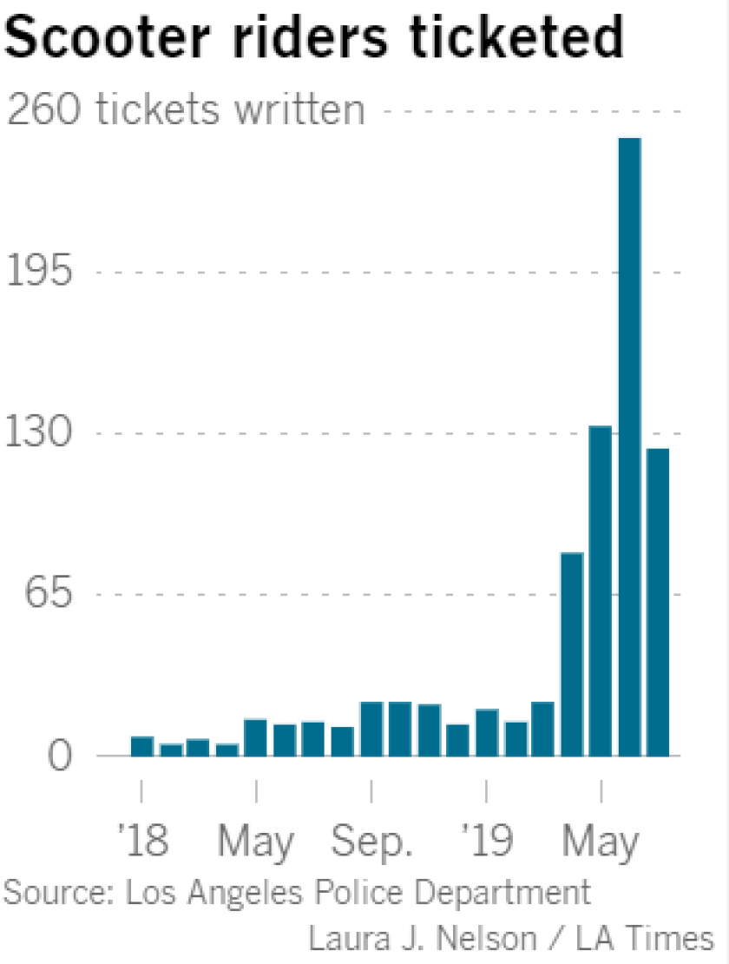
Bird, Lime and other companies have added stickers on the baseboards of their vehicles that say, “No riding on sidewalks.” But the practice is still the norm in L.A., where cars can often move at 35 mph or faster on city streets.
Riding on sidewalks is “the most dangerous violation” for a scooter rider, Koretz said, because pedestrians can be knocked over if they can’t get out of the way.
California law prohibits riding electric scooters on the sidewalk. Users can ride in the street if the posted speed limit is 25 mph or slower, as close to the right-hand curb as possible, the law says. Scooter riders can also use bicycle lanes.
As Koretz and police officials spoke, six LAPD traffic officers rode by on motorcycles near Fairfax High School.
Officers targeted scooter riders in the area for eight hours Thursday as part of the city’s effort to cut down on collisions and injuries, said Capt. Elaine Morales of the LAPD’s West Traffic Division
Of the crashes the department has analyzed, Morales said, scooter riders were at fault more than half the time.
From the start of the year through late May, the most recent data immediately available, the Los Angeles Fire Department reported a total of 160 incidents involving electric scooters. Those included 59 cases in which someone was taken to the hospital by paramedics or EMTs, and 21 cases in which a patient was treated without being transported.
The face value of a sidewalk-riding citation is $197, but that figure does not include court processing costs or other fees.
Bird and Lime scooters cost $1 to rent and charge users by the minute to ride, and typically require a credit card and a smartphone to get started.
The majority of the citations analyzed by The Times were written in downtown, Hollywood and the Westside, where many of the scooters are concentrated. Some written citations included multiple violations, such as riding on the sidewalk and riding without a valid driver’s license, The Times found.
After months of tinkering with regulations for scooter and shared bicycle companies, Los Angeles officials formally launched a one-year pilot program in April that tracks where the scooters operate and regulates how many are allowed within city limits.
About 36,000 scooters are now registered to eight companies across L.A., Transportation Department spokeswoman Connie Llanos said.
The number of scooters operating in the city has been lower. In the third week of July, the average number of vehicles citywide was closer to 21,000, according to a recent report to a City Council committee.
The council districts that include Venice Beach and downtown L.A. had nearly 8,500 scooters between them, accounting for about 40% of the scooters across the city, the report said.
Advertisement
The three districts that cover the western and northern sections of the San Fernando Valley had an average of 118 scooters available per day between them during the same time period.
At the end of July, Fairfax — where the enforcement took place Thursday — was the fourth-busiest neighborhood for scooter riding, with a daily average of 719 trips per square mile, according to the Transportation Department.
The busiest area was Venice Beach, with 1,756 trips per square mile.
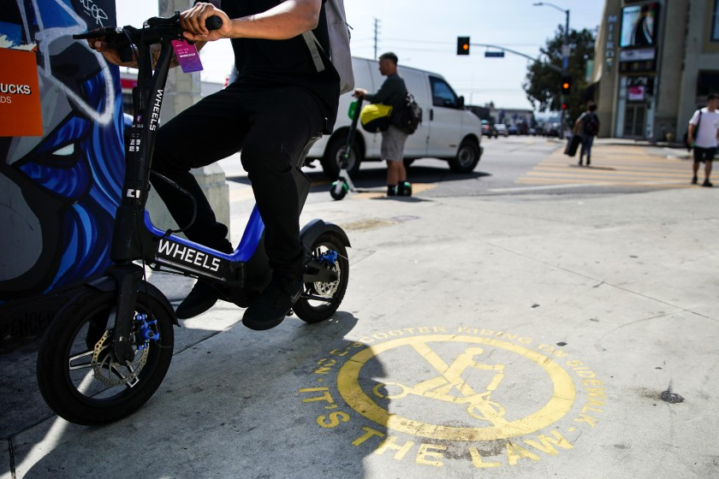
A painted sign reminds scooter operators and pedestrians that electric scooters aren’t allowed to be operated on sidewalks.
(Kent Nishimura/Los Angeles Times)

Appendix E - Disabled and elderly people being injured by escooters, as well as access problems due to dockless escooters blocking pavements etc.

1.0 Disability rights group sues scooter companies over clogged sidewalks

People with disabilities say they've tripped on scooters and nearly been hit by riders.
Published by CNET 16 January 2019 5:15 p.m. PT
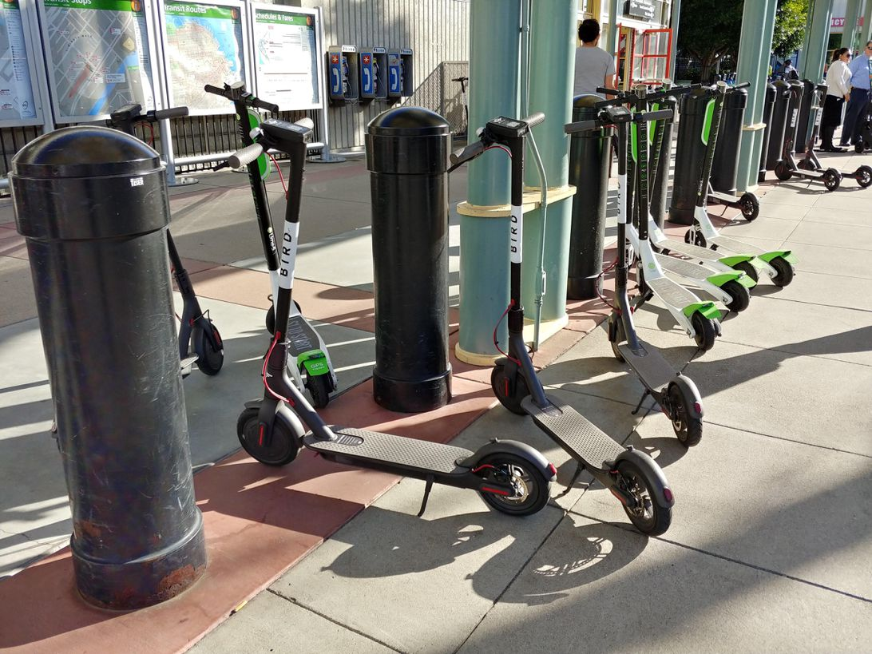
Scooters have a tendency to clog sidewalks.
Sean Hollister/CNET
Electric scooter companies Bird and Lime have scattered thousands of rentable, dockless, electric scooters across US cities over the last year. And one complaint keeps coming up: they block sidewalks.
Advocacy group Disability Rights California is now suing the two companies in federal court in San Diego for allegedly violating the Americans with Disabilities Act. The group, which is seeking class-action status for the case, says Bird and Lime are obstructing public sidewalks, making them unsafe for people with mobility and sight disabilities. Disability Rights California is also suing the City of San Diego for not maintaining accessible sidewalks.
"The scooter companies have treated our free public walkways as their own private rental offices, show rooms and storage facilities," said Bob Frank, lawyer for Neil, Dymott Attorneys, which filed the case in conjunction with Disability Rights California. "People with disabilities need to have access to city sidewalks and their needs must come first."
Electric scooters have only been around for about a year and they've exploded in popularity. More than a dozen companies have launched the vehicles in roughly 100 US cities. But the scooters have become a controversial topic. Some people love being able to zoom around on the vehicles, while others find the scooters to be a menace.
Residents' complaints have flooded lawmakers' offices saying they've tripped on scooters or been sideswiped by riders. Many complaints say riders don't follow the laws of the road, endanger pedestrians and leave the scooters wherever they feel like it -- blocking sidewalks, parking spots, bike racks and wheelchair accesses.
Disability Rights California's lawsuit isn't the first against the scooter companies. An Austin man sued Bird earlier this month after tripping on a scooter lying in the sidewalk. And another suit was filed against Bird in October by a disabled woman in Los Angeles who also claimed the company is violating the Americans with Disabilities Act.
Disability Rights California filed its suit on behalf of four people -- all of whom are scared for their safety.
Alex Montoya, for instance, wears prosthetics on both of his arms and his right leg, which means he's a bit unsteady and slower than an average non-disabled person. Before the scooters arrived he said he liked walking in his neighborhood. But now he's afraid, according to court filings. He says he constantly has to dodge scooters, which go up to 15 mph, on sidewalks and street crossings.
Another plaintiff, Aaron Greeson, has been blind for the past 10 years. He used to walk a lot, but after several incidents when he nearly tripped on scooters or was almost hit by riders he's become scared to go out, according to court filings. Greeson said he'd only walk now if someone accompanies him.
"I never leave the Blind Center anymore," Greeson said in a statement. "I've already fallen once because of the scooters. I don't want it to happen again."
In their apps, Bird and Lime tell riders not to scoot on sidewalks and to use proper parking etiquette, but there's no real enforcement mechanism. Bird didn't respond to request for comment on the lawsuit.
A Lime spokesman said the company doesn't comment on pending litigation but did say, "public safety has always been at the very core of everything we do at Lime. From Lime's 'Respect the Ride' campaign, which is focused on educating riders on responsible riding, to our development of built-in sensor technology to detect if a rider is abiding by local riding laws, we are committed to keeping our communities safe for everyone."
A spokeswoman for San Diego's City Attorney Mara Elliott said their office is reviewing the lawsuit and will respond through the courts. Disability Rights California is asking the court to declare an order to stop Bird and Lime from using sidewalks, crosswalks, curb ramps, transit stops, pedestrian crossings and other walkways in San Diego. It's also asking for statutory damages and attorneys' fees.
"People with disabilities should not have to stay in their houses because they are afraid to venture out the door due to scooters blocking their pathway everywhere they go," Ann Menasche, lawyer for Disability Rights California, said in a statement. "They have a right to use the city sidewalks just like everyone else who lives or visits here."

2.0 Texas, USA, Texas School For The Blind And Visually Impaired Calls On Scooter Riders To Be More Mindful
Published January 14, 2019
Sixty-two-year-old Joe Paschall was walking near Burnet Road and Koenig Lane last November when he almost tripped over a dockless scooter.
“I was able to catch myself, but I had no idea that it was there," he said.
Paschall has ocular albinism, a genetic condition that makes his eyes sensitive to light. He remembers it being a really bright day, so he was wearing sunglasses and squinting. He says he's worried that other people – especially those with visual impairments like him – could trip over a scooter and even fall into traffic because they're blocking the sidewalk. Complaints about dockless scooters and accessibility have grown since the scooters showed up in Austin last year. There are now more than 13,000 of the devices on city streets.
KUT's DaLyah Jones reports
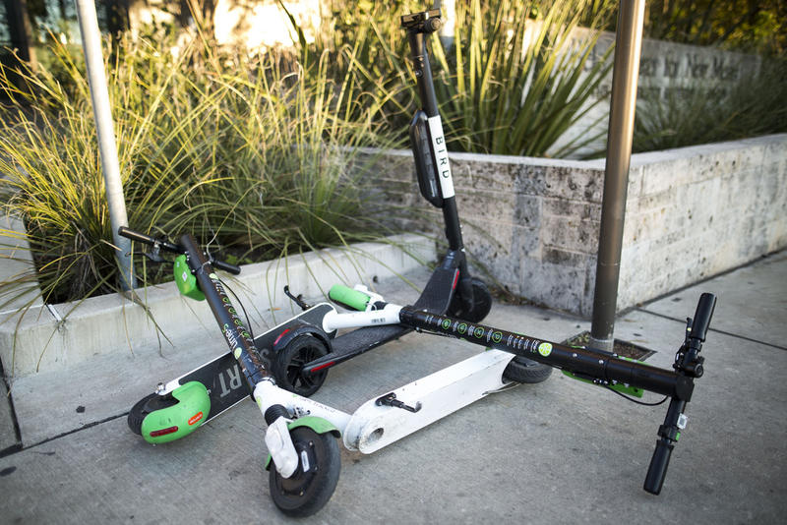
After his near fall, Paschall reached out to Toni Provost and Lisa Calaci, orientation and mobility specialists at the Texas School for the Blind and Visually Impaired. Their job is to teach students how to travel safely – things like how to use a white cane, how to cross streets, and how to use public transportation and rideshare services.
Provost and Calaci said they began to notice the scooters blocking sidewalks and ramps early in the semester last year. Calaci said they're a hazard for students who may not be able to detect them with a cane.
Students shouldn't have to negotiate around scooters just to try to find a door to a building, she said. The school delivered a petition to the city with about 180 signatures from teachers, students and parents across the state. It asks city officials to address safety problems.
The Texas School for the Blind and Visually Impaired is now working with Austin’s Transportation Department to improve safety enforcement, and the scooters are no longer allowed on campus. Jason JonMichael, an assistant director with the department, said the city can act like a middleman between the scooter companies and the school on these types of issues.
“As the permitter, we have a unique way of getting [scooter companies'] attention,” he said.
Right now, Austin is conducting the first-in-the-nation dockless mobility safety study with the Centers for Disease Control and Prevention. Findings will be used to update the city’s dockless ordinance, as well as help formulate a safety ordinance. The study will be presented to Austin City Council this spring.
In the meantime, JonMichael said his department is assessing the problem so it can "go back to the companies with not just a complaint, but a direct – ‘This is what we want to see from you around areas like the Texas School for the Blind and Visually Impaired.’”
Bird made improvements to its scooters, including a blinking light on the bottom so they can be seen in the dark even when they’re parked. Provost and Calaci said they plan to meet with executives of Lime later this month. Calaci said she hopes to see more rider training and rules enforced around other areas of the city, especially along the Drag on UT campus.
She said she thinks there should be public service announcements showing good etiquette: "When you're passing a pedestrian, slow your pace. If there are bike lanes, ride in the bike lanes not on the sidewalk.”
Patricia Pound, an advocate for people with disabilities who fully lost her vision at 14, said riders also need to give pedestrians verbal cues because the small motors can be hard to hear.
There aren't enough good sidewalks as it is for people who need accessibility, she said, “so, anything that impinges on all those things is an issue.” According to the city, Austin is missing more than 2,500 miles of sidewalk and about 80 percent of sidewalks that do exist are in poor condition.
Pound said people who are visually impaired can injure themselves beyond just tripping and falling on scooters – a cane could get caught or a guide dog could get distracted or startled because of a scooter's speed. Pound said luckily her 5-year-old guide dog, Iris, does fairly well.
“I mean, look, we're all pedestrians … we all want to go places in Austin and we may do it differently,” she said. “But, let's all do it in a way that we all can do it safely and all be happy.”
She said hopefully the dockless devices encourage the city to step up improvement of sidewalks and road crossings.
While the Texas School for the Blind and Visually Impaired works with the city to improve regulations, Calaci and Provost said they'll continue to work with their students to advocate for themselves – that includes how to call 311 to make a complaint about the scooters.
Calaci is also requesting awareness from the scooter users: “Just be more considerate of the visually impaired traveler.”
Provost said they’ll attend more mobility meetings to make sure they have more say in decisions regarding the scooters going forward.
“We're not asking them to be eliminated," she said, "but just that there will be laws regarding them that are enforced for the safety of our students and all those people who are disabled in our community.”

3.0 E-scooters suddenly appeared everywhere, but now they're riding into serious trouble

Julia Buckley, CNN • Published 22nd November 2019

(CNN) — Brussels. San Diego. Bogotá. Walk around any major tourist destination these days, and you'll see them. Electric scooters, gliding silently around city center streets, zipping through traffic signals, or abandoned -- lying on the street, propped up against trees or, in some cases, dumped in rivers.
Scooter-sharing systems similar to city bike schemes have sprung up in more than 100 cities worldwide as their popularity has grown.But this tiny-wheeled transport revolution could be about to end as quickly as it began.
While they've attracted admirers for their convenience and fun, they've also incurred the wrath of those annoyed at having to leap out of people riding across sidewalks or step over scooters lying in their path. There are also mounting safety concerns and questions about environmental claims made about using them.
This month, Singapore announced a trial prohibition of e-scooters on sidewalksthat could become an all-out ban next year. It took the decision, says Lam Pin Min, senior minister of state for transport, following the death of a cyclist who collided with an e-scooter. Local news reports said one Singapore hospital had reported six deaths of scooter riders in 2019.
Meanwhile in France, a sidewalk scooter ban was enforced in September, three months after a rider was hit by a truck and killed.
In the UK, scooters are also banned from all public roads, sidewalks and cycle lanes -- although that hasn't stopped them being a regular presence on all three. The UK now insists that retailers including Amazon put safety warnings on packaging, a measure introduced in October, after a YouTube star, Emily Hartridge, was killed riding an e-scooter in London in July.

'Disproportionately affecting' those with disabilities
The scooter revolution has been billed as a green way to get around big cities, with rental apps acting in the same way as city bike schemes. You pick them up, pay by the minute and drop them off at your destination.
Where some city bikes often have docking stations -- to which the bikes must be returned for the fees to stop -- scooters can be picked up or dropped off anywhere. And while that may be handy -- apps like Lime, Bird and countless local spinoffs have live maps showing users where the nearest scooters are -- it's causing issues for other road users.
Simon Minty, a disability and diversity consultant who presents the Ouch disability podcast for the BBC, was in Brussels this summer when he came across abandoned scooters blocking the sidewalks.

Simon Minty@simonminty
If you’re a wheelchair user, or a blind person, indeed a human being, I predict these two wheeled electric scooters, will become very annoying. They seem to be abandoned, in the middle of the pavement, everywhere I go. I saw three from the station to my hotel. #disability
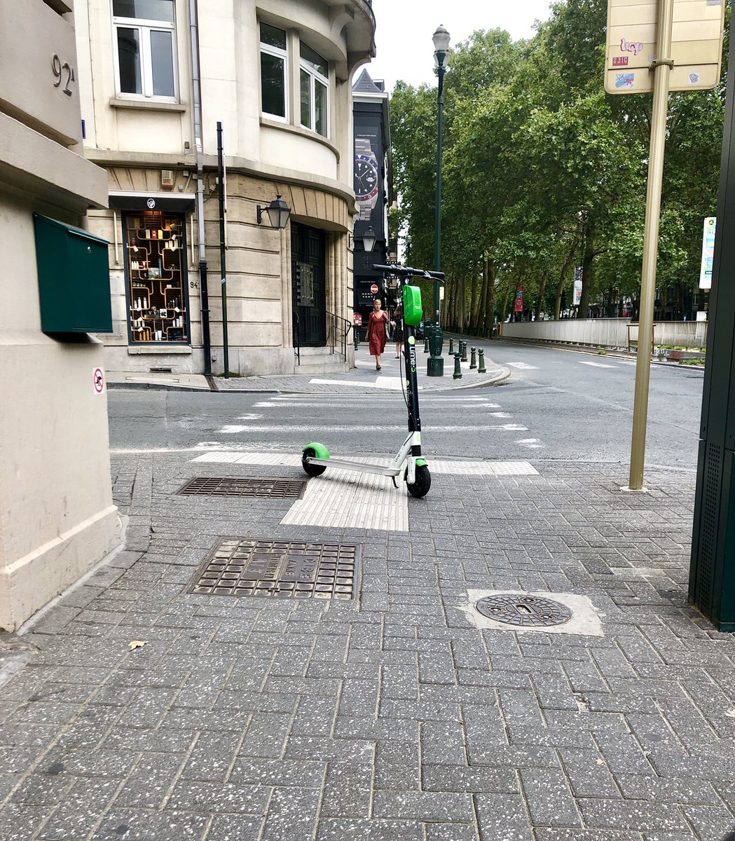
6:05 PM - Aug 4, 2019
"I predict these two wheeled electric scooters will become very annoying," he tweeted. "They seem to be abandoned, in the middle of the pavement, everywhere I go. I saw three from the station to my hotel."
Minty says that a friend who'd been to Paris said the situation in the French capital before the September ban was "exactly the same."
People with disabilities are "disproportionately affected," he says. "You're going to hit these, and you'll be absolutely stuffed."

Environmentally friendly -- if you're replacing a car
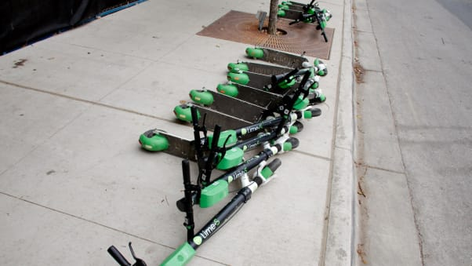
Scooters can be ditched by users wherever they like
Kelly Jobe/Shutterstock
Proponents of scooters say that they're environmentally friendly. "Cruise past traffic and cut back on CO2 emissions," trumpets Bird's website.
But an August 2019 paper by researchers from North Carolina State Universityfound that they may not be as green as you'd think.
In fact, traveling by scooter has a higher carbon footprint than going by bus or moped -- as well as on a bike or on foot, according to Jeremiah Johnson, an associate professor at NCSU who led the research published in the Environmental Research Letters journal.
Instead of looking at scooter carbon footprint per journey, Johnson and his team looked at the entire lifecycle of scooters -- crucial because they are notoriously short-lived, he says, with customers mistreating them.
The materials used to make the scooters -- an aluminum frame, lithium battery and rubber wheels -- all result in an environmental burden, he says. As does the manufacturing.
"They have a really short lifetime, especially in this application of them," he tells CNN. "Aluminum doesn't provide much service. They only last several months."
What's more, because users can ditch them wherever they like, rental apps pay third parties to round up the scooters every night, grouping them more sensibly for the morning's customers, he says.
"They receive compensation per scooter, so there'll be folks doing this as a side hustle, students trying to make money -- it's a prime source of income," he says.
"It's very competitive and done in a very short window, and they're largely driving their personal cars to pick them up. That's a pretty big share of the impact."
Some e-scooters get thrown in rivers, canals or the sea.
GERARD JULIEN/AFP via Getty Images
Lime scooters are taken to warehouses each night by a local operations team, said a spokesperson. Senior director at Bird, Caroline Hazlehurst, said that Bird's scooters are collected "regularly, but not always every day... How we collect them changes from country to country."
But she added: "Every town and city throughout the world suffers from the same two problems: too many cars creating congestion which in turn leads to poor air quality."
Of course, they also need to be charged overnight. And the final thing to take into account is what method of transport they're replacing.
If you're scootering to work instead of driving yourself solo, the scooter is a "clear environmental win," says NCSU's Johnson. But, he says, many people surveyed in Raleigh, where the university is based, said that pre-scooter, they'd cycle or walk to work.
While many people in the US drive to work -- and Johnson is clear that "in moving away from car ownership it's almost certainly a win for environmental performance" -- in European cities, where public transport is the norm, using a scooter is therefore relatively less green, he says.
The upshot?
"Scooters look innocuous but people tend not to think about the unseen cost," Johnson says.
Hazlehurst says that Bird has changed its scooters from "consumer grade" to a "vastly different" and "rugged" version since they launched. Its "Bird One" model now has a lifetime of around 18 months, she said, while its latest model Bird Two can last two years.
Lime says that its third generation model is "demonstrating a lifespan of more than 12 months." Its spokesperson says that Johnson's study "raises important issues" but "doesn't capture Lime's approach today."
"We've already taken steps to reduce our environmental impact, including streamlining our charging operations, powering our scooters with 100% renewable energy, offsetting the emissions from fleet vehicles, and establishing a robust repair and reuse program to extend the life cycle of our products," the spokesperson said.

Where are scooters legal?
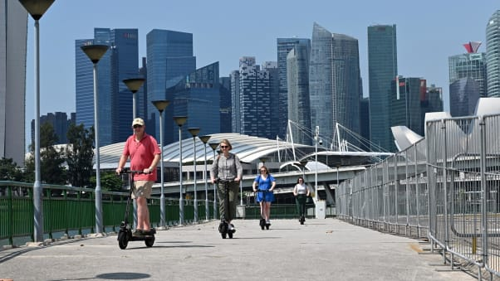
Singapore has announced a scooter sidewalk ban
ROSLAN RAHMAN/AFP via Getty Images
Rules on e-scooters vary around the world. In the UK, riding one on a road can net users six penalty points on their driving license. Riding them on the sidewalk, cyclepath or footpath is subject to a £300 ($385) fine.
A report by the UK House of Commons Library in August suggested that things could change in the future, but a spokesperson for the Department for Transport declined to comment, citing rules around the upcoming UK election.
In Paris, while you can ride them on the road, using them on the sidewalk can incur a €135 fine, while dumping them in a doorway, on a crosswalk or in another antisocial place incurs a €35 fine.
"Pavements are only for pedestrians," mayor Anne Hidalgo tweeted in March this year.
Anne Hidalgo
✔@Anne_Hidalgo
Les trottoirs, c’est uniquement pour les piétons ! Désormais, une personne roulant en trottinette électrique dessus s’expose à une amende de 135€. Afin qu’elles ne soient pas garées n’importe comment, 500 emplacements dédiés seront créés d’ici cet été. http://www.leparisien.fr/paris-75/trottinettes-sur-les-trottoirs-la-ville-de-paris-passe-a-l-offensive-26-03-2019-8040150.php …

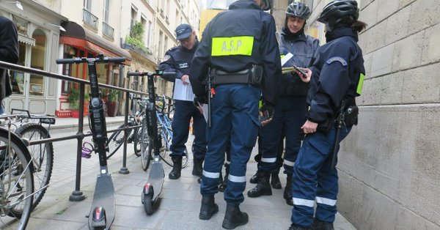

Trottinettes sur les trottoirs : déchetterie et amendes... Paris passe à l’offensive
Sans attendre la nouvelle loi sur les mobilités, les agents municipaux intensifient la verbalisation contre la circulation et le stationneme
leparisien.fr

8:55 AM - Mar 27, 2019
Germany approved e-scooter use this year, though not on sidewalks unless in "exceptional" circumstances. Bird's Caroline Hazlehurst says that "especially in Europe, we're seeing cities and countries change laws to specifically allow scooters to operate."
In Sweden, where scooters are classified as bicycles and allowed on sidewalks or footpaths, 241 accidents have been registered this year alone including one death. Tomas Eneroth, the Swedish minister for infrastructure, has called the situation "a mess."
The law in Spain was changed this year. E-scooters can no longer be used on sidewalks. Additionally, they are banned in Barcelona. Madrid authorities in October refused to grant licenses to ride-sharing companies Bird, Lime and Voi.
In the United States, over 100 cities have e-scooters, and Americans took 38.5 million trips on them, according to the National Association of City Transportation Officials.
Portland, Oregon, is midway through a year-long trial, following a four-month pilot in 2018.
The 2018 program "raised concerns about people riding e-scooters on sidewalks, in violation of state traffic laws, creating conflict with people walking and people with disabilities," says a statement from the Portland Bureau of Transportation.
The PBOT will "evaluate the program" following the pilot.
It used to be illegal to use the scooters in New York City, but a law change in summer 2019 means that you can use your own, if you have one -- although ride-sharing rentals are still banned.
And in LA, authorities this month suspended Uber's permit to rent e-scooters because of its failure to share ride-tracking data with the Los Angeles Department of Transportation. Seven other companies are licensed to rent scooters in LA though.
And in San Francisco, the scooter companies were dubbed "spoiled brats" by Aaron Peskin, one of the legislators who voted to clamp down on the companies when they were introduced in 2018.
In April 2019, however, the city granted permits to four companies: Jump, Lime, Spin, and Scoot, the last of which had previously been operating.

San Diego struggles to cope
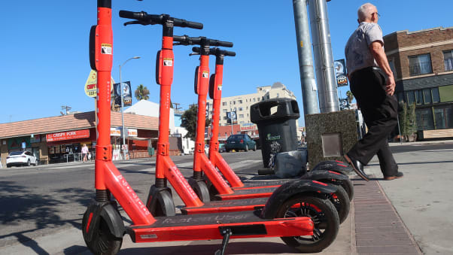
Sidewalks are being crowded with the scooters, say critics
Mario Tama/Getty Images
San Diego has been at the forefront of scooter wars since the machines arrived in February 2018. The city is awash with more than 19,000 scooters, according to the San Diego Union-Tribune -- with almost 15,000 complaints about them to the city authorities over the summer, 3,700 scooters impounded for parking violations, and almost 500 riders receiving traffic tickets.
Since April, the city has instated "corrals" -- designated parking spots by the roadside for scooters, outlined with paint on the road. Riders can be fined for dumping a scooter on the street in a block that has a corral.
In April, the council introduced new restrictions on scooters, including speed limits in pedestrian-heavy places like Balboa Park, and a parking ban in places with speed limits below 8 mph, including beachfront boardwalks and in Little Italy.
Council member Barbara Bry, a vocal critic of the scooters, called for a moratorium in July, although it has not been approved. In December, the council will debate banning scooters on the beach boardwalks entirely.
"Throughout the city, I continue to see riders using the sidewalk, multiple riders on one scooter, and scooters strewn about the sidewalks, rather than in designated corrals," she tells CNN.
"San Diego was slow to respond when scooters started showing up on our streets. While it has been inactive, other cities like Portland and Santa Monica have issued requests for proposals that include a fee structure, operational standards, data sharing and insurance requirements."
She said the City has "let a technology overtake us rather than assist and empower our communities with safe and sustainable micro-mobility options," and said that "all of downtown is experiencing cluttered sidewalks."
"The corrals are overflowing with scooters that leak out into the road and automobile parking spaces," she said.
The mayor of San Diego was not available for comment.

Victims of scooter crashes are cashing in
Catherine Lerer, a personal injury attorney based in Santa Monica, where scooters were introduced to the United States, says that over the past 18 months, she's spoken to around 400 victims of scooter injuries -- both riders and pedestrians. She believes them to be more accident-prone than bikes because of their smaller, more solid wheels and a more precarious center of gravity for users.
"It's imperative that cities get ahead of any e-scooter rollout, otherwise they will be hamstrung in terms of regulating the scooters and sanctioning the operators," she tells CNN.
Authorities should ban nighttime use, sidewalk riding and allowing the scooters on roads that have a speed limit of more than 25 mph, she argues in a list of 25 recommendations.
She says authorities should also insist that riders wear helmets, prohibit sidewalk parking, install tech that alerts the companies if a scooter isn't upright, and fit the devices with lights, reflectors, turn signals, kickstands and identification numbers.
She says the devices should emit noises that can be heard by nearby pedestrians, to help those with disabilities.
For its part, Lime says it is tailoring its scooter roll outs so that they work with specific destinations and urges careful consideration before new legislation is introducted.
"Lime is committed to partnering with cities to build the right shared mobility program for each community," a spokesperson said.
"We know the positive impact micromobility can have on communities around the globe... and we're dedicated to collaborating with our city partners to tackle these challenges together.
"We support regulations that promote safety and greater transportation access without stifling innovation or consumer choice."

Scooter fans still keen
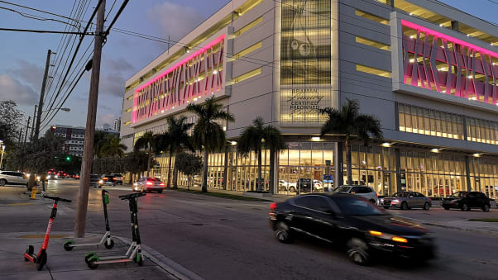
The weather in Miami makes it popular for year-round scootering
Julia Buckley
Despite the issues, though, the enthusiasm of scooter fans show no sign of waning -- and for some, replacing a putative car journey feels like the right thing to do.
Cyndi Hutchenson, a copywriter from South Florida, commutes via scooter most days -- a journey of around 10 minutes. She has a monthly pass, costing $15, which allows her 30 minutes of scootering per day.
"I don't have a car, and I don't really want one," she says. "I live downtown, and everything I want to reach is a relatively cheap Uber Pool away, if it's outside scooter limits. And I'm new to the city, so I want to get to know it better.
"I'm conscious of the environmental impact difference of riding an electric scooter versus riding in a car every day. I also know that, were I to have a car, I'd be making more unnecessary trips or traveling farther outside my neighborhood for things I can easily have a range of within a scooter ride
"The buses are not convenient (in terms of timing, cleanliness, safety, and payment methods) in my city and don't even go to my workplace."

The future of e-scooters
But as cities continue to clamp down, and the accidents mount up, scootering around the globe might not be free and easy forever.
"I don't want to be a killjoy, they do look a lot of fun," says Simon Minty. "They're exciting, new technology, they mean fewer cars on the roads -- but people have to realize that there's responsibility that comes with them.
"It's not just people with disabilities. Parents with prams, older people -- a whole bundle of people will be affected if we have to navigate round these scooters.
"I don't quite understand how people can just leave them in the street. It just blows my mind a little bit."

4.0 Auckland, New Zealand - Blind and visually impaired people want e-scooters off the footpath for good
Published by Stuff New Zealand – 6 April 2019
Low vision sufferer Alix, 25, was walking to university on Auckland's Grafton bridge when an e-scooter cracked her in the ribs, sending here flying.
"The handlebar smacked into me, knocked me over and left me in considerable pain," Alix, who didn't want her last name used, said.
She is among many in the blind and visually impaired community who want e-scooters off the footpaths for good.
Photo – Not added Blind and visually impaired people reported being crashed into by e-scooters or tripping over them on the footpath.
Their plight has been highlighted in a Blind Foundation survey of its members who live in cities with rental e-scooter ride-share schemes.
Of the 210 people surveyed, 184 said e-scooters should not be used on footpaths.
Photo – Not added -Chris Orr, the Blind Foundation’s access and awareness advisor, said e-scooters shouldn't be allowed on footpaths.
Alix said Grafton bridge was a route that she had walked many times before, but the incident had knocked her confidence so much she had started using her cane again.
"I think the rider just assumed I could see them and [would] get out of the way in time. Now I use the cane to tell other people I can't see."
Navigating the sidewalk with bad vision was hard enough without e-scooters turning it into a virtual minefield, she said.
John Pennick, a central Auckland barrister who is legally blind, said he had had numerous close calls with e-scooters since they were introduced. But he said the worst came when he was struck "glancingly" by one of several e-scooter riders who he said were racing across a Queen St intersection.
"Due to the speed and my eyesight there was absolutely no chance of my being able to get out of the way.
Photo – Not Added - Lime was the first rent-to-ride e-scooter brand to launch in New Zealand, and has since been joined by Wave and Blip in some areas.
"I am in good physical shape and was able to keep my feet, but anybody of slight build or [who was] frail would definitely have been knocked down."
​Sharon Smith, who is visually impaired, agreed scooters should not be allowed on footpaths.
"I have nearly been run over by an e-scooter on Quay St while walking to a concert at Spark Arena.
"The driver of the scooter could see my daughter and I walking towards him but he continued straight for us at speed and expected us to step out of his way."
The Blind Foundation's Chris Orr said footpaths should be prioritised as being safe places for pedestrians.
"E-scooters on footpaths are proving a real issue for pedestrians who are blind or have low vision," he said.
"We have had many people comment on how discarded e-scooters pose a real challenge as a trip hazard on the footpaths. People who are blind or have low vision will often learn a regular route that they travel, gaining confidence by knowing what to expect.
"Until now, we haven't had to anticipate the possibility of discarded e-scooters at any random point on a journey."
Orr, who is partially blind himself, said he wanted to work with policy makers to find a solution that could work for all parties.
"That involves keeping the e-scooters off footpaths."
Lime was the first e-scooter ride-share company on the New Zealand micro-mobility scene, launching hundreds of scooters in Christchurch and Auckland in October 2018. Since then fleets have popped up in Dunedin and Wellington, and competitor Wave dropped its e-scooters in Auckland earlier in the year.

5.0 Oslo, Norway, Oslo City Council Declares Electric Scooter Experiment in Norway As Chaos
Published the Nordic Page July 10, 2019
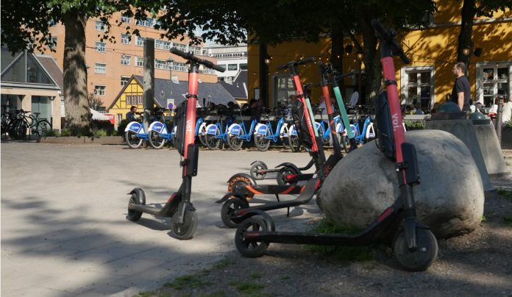Photo: TNP

Oslo City Council admits there is an electric scooter chaos in Oslo and the police asks politicians to intervene.
This year, the city allowed dockless electric scooters to begin operating in the city. In a short time, 6 different companies have started to offer shared electric scooter service. The result of this experiment in lax regulations was what the city council recently declared to be “chaos.” From May to June, the number of injured persons due to electric scooters was doubled in Oslo. In the last three months, a total of 187 people have been injured, according to NTB.As a result of several accidents, a number of European cities have introduced either total ban or stricter restrictions. The police in Oslo closely monitor developments and see the chaos due to unregulated use of electric scooters.
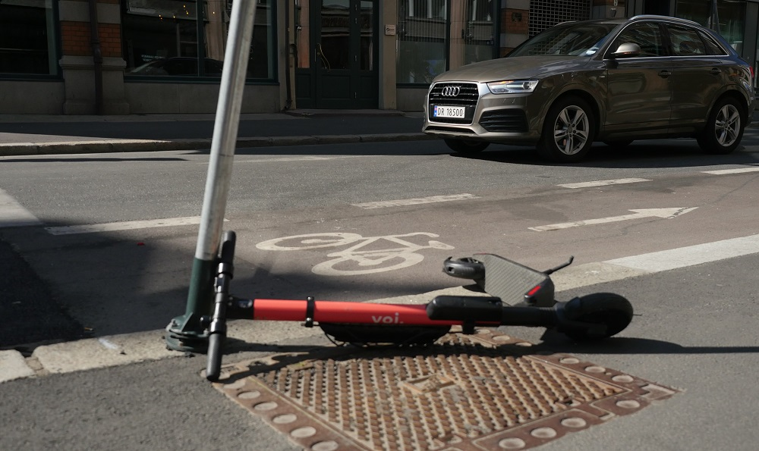
A dumped electric scooter in Oslo city center.
In April last year, the government has classified the electric scooters as regular bicycle. Thus, there is no separate regulation for scooters. This decision was criticized by Trygg Trafikk, according to NRK. Trygg Trafikk believes there was little focus on the security aspect, and too much focus on “simpler rules, less bureaucracy and a little more fun in everyday life”, as the government described in a press release. The police and Trygg Trafikk believe that it is now up to the politicians to initiate stricter measures to solve the problem. They want stricter rules for electric scooter including mandatory helmet, age limit, and clearer rules for where and when the electric scooters are used.
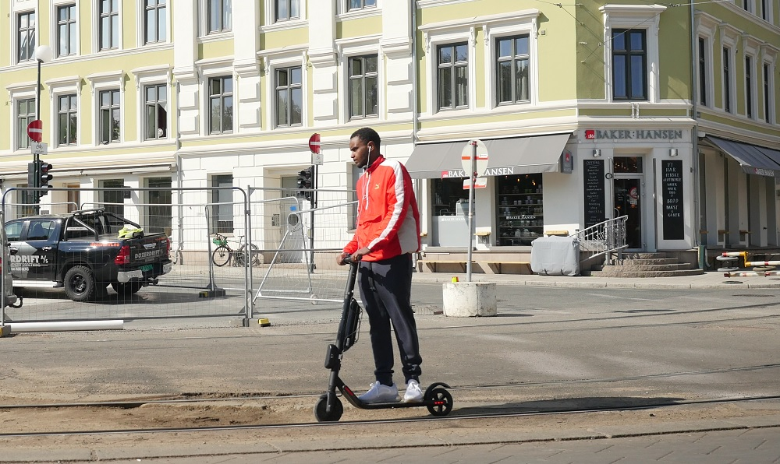
There are many companies offering shared electric scooters in Oslo.
NRK contacted the City Council for Environment and Transport in Oslo, to hear what the municipality could do about the problem.
They replied that it is not possible for Oslo or other municipalities to set their own driving requirements for scooters as they government recognize them as bicycle.
“Right now we have an electric scooter chaos, and a law introduced by the government prevents the municipalities to regulate this properly,” says the Vice Mayor for Environment and Transport in Oslo, Arild Hermstad to NRK.

6.0 Stolperfalle für Blinde: Wie gefährlich sind E-Scooter? Trip hazard for blind people: how dangerous are e-scooters?
Published - BR24 Germany 19 August 2019
Translation – from google translate
Trip hazard for blind people: how dangerous are e-scooters?
We have approved electric scooters and e-scooters since June. They roll over streets and intersections, stand on sidewalks and at train stations. We wanted to know: Is the current e-scooter wave causing problems for people with disabilities?
E-scooter in Munich.
On the way with a blind man in Munich: We encounter an obstacle just a few meters behind the meeting point: we started at the Bavarian Association for the Blind and Visually Impaired in Munich's Arnulfstrasse - and then at the main train station, the following situation: Bernhard Claus is with his cane in the Walked in the middle of the sidewalk, an e-scooter was parked on the edge of the street, with the handlebars slightly turned, and it happened: the e-scooter was touched and almost tipped against a parked car.
Do not lean the e-scooter against the wall!
Less than ten meters away, an e-scooter is parked on the sidewalk directly on the wall of the house. But such a house wall serves as a so-called inner guideline for many blind people, with which they orient themselves with the stick. So it is unfavorable if there is an obstacle.
You should hear e-scooters coming
Another problem: pedestrian and bike paths often run side by side in Munich, and if you want to cross the street as a pedestrian, you have to cross the bike path. The e-scooters are so quiet, however, that they cannot be heard even by a blind person with very well-trained hearing. This is very dangerous for the blind.
More controls, noticeable fines
Overall, people with disabilities also want more controls so that the scooters really stay on the bike paths. For violations, there should be fines that actually hurt, they say. There should also be scooter parking spaces, but not on the sidewalks, so that blind people cannot accidentally knock them over.

7.0 Lime scooters are causing stress for Brisbane's vision impaired community
ABC Radio Brisbane Posted 21 January 2019, updated 21 January 2019
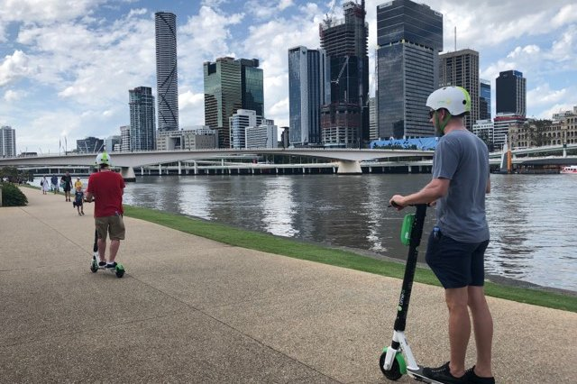
Visually impaired pedestrians say scooter users are not giving enough warning.(ABC News: Alle McMahon)
The electric scooters seen moving around Brisbane at the moment might be popular, but they are causing headaches for visually impaired people and how they move around the city.
The scooters are part of a sharing scheme brought to Australia by Californian tech start-up Lime.
More than 100,000 riders in Brisbane have downloaded the app and used the scooters since the trial began in November.
But visually impaired resident Jane Britt said the two-wheelers were causing stress and even collisions on footpaths.
"It's hard to detect scooters coming up from behind and where the scooters are dumped across the city," she told
Ms Britt said the bells equipped on the scooters were not enough to alert pedestrians.
"We're not hearing the bell and we're not getting any other auditory signals like them calling out that they're coming up from behind," she said.
"You don't detect them until they are already up on top of you and trying to overtake."
Ms Britt said riders often overtook pedestrians on both sides, making it difficult for people using canes.
"Once you realise they are there you jump to one side, but you may be jumping into their pathway," she said.
"I've been forced into gardens at the Botanical Gardens as the paths are quite narrow, and when you connect it with the cane it often pushes you forward and over the scooter, leading to injury."

Getting onto bike paths
Lime spokesman Mitchell Price said safety events teaching people how to operate the scooters were rolled out before Christmas and the company was in talks with local and state governments about safety.
"We've been having conversations with them about getting the scooters off the footpath all together," he said.
"In Brisbane's CBD there is also a low speed implemented of 30kph and there is a great network of cycling infrastructure around there.
"We want to work with the community and make this a way we move around Brisbane."
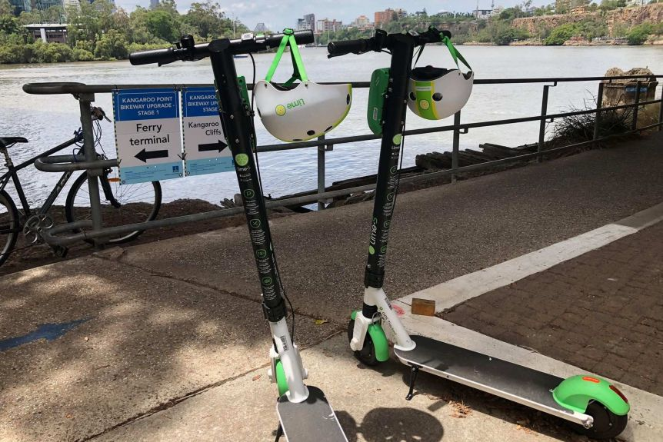
The scooters should be left near footpaths around the city to be collected.(ABC News: Dan Nancarrow)

Possible solutions
Ms Britt said a couple of changes could really help the visually impaired community, including more signalling and designated return areas to prevent people stumbling over them on footpaths.
"I would encourage people to use the bell and to call out and say, 'I'm coming up behind you to your left or right'," she said.
"I would also like to see designated spots like the City Cycles so the scooters are put back in the same spots."
She said some councils fined people for dumping shopping trolleys and believed it could also work with the scooters.
"It would be wonderful to see that implemented here so that people have an incentive to take them back to docking stations."

Opinions divided
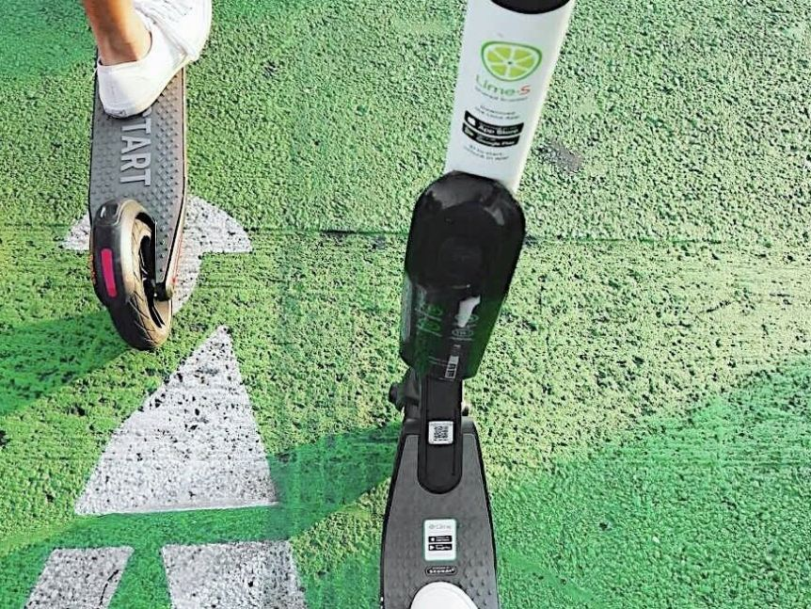
More Lime scooters could be seen on bike paths in coming weeks.(Facebook: Lime)
Mr Price said one of Lime's aims was to get scooters onto cycle and shared paths to avoid issues with pedestrians, adding that the scheme had been designed to be dock-less.
"Although dock-less, we've been talking about having parking corrals, whether that's in the CBD or near the City Cycles, which is a painted space on the footpath which we will pay for," he said.
"With our app we can get the parking locations to reflect the spot and we can drive the scooters back to those parking corrals to help avoid them being left on the footpath in the way of pedestrians."
Callers to ABC Brisbane seemed to be divided on the issue.

8.0 Disability advocate sues Minneapolis, scooter companies
Published by Smart Cities Dive 22 October 2019

Dive Brief:
- An advocate for disability rights is suing the City of Minneapolis and e-scooter companies Bird and Lime over safety and accessibility concerns related to scooters on sidewalks. The plaintiff, Nathan McCourt, has autism and a developmental coordination disorder — which he says affects his reaction times — and repeatedly has tripped over scooters left in public rights-of-way, recently sustaining a large leg bruise.
- The lawsuit says dockless scooters left in sidewalks or other rights-of-way, form barriers that prevent people with visual and mobility impairments from traveling freely, violating state laws and the federal Americans with Disabilities Act. It also notes problems with scooter users riding on sidewalks, which they are not supposed to do in Minneapolis.
- The plaintiff seeks an order preventing scooters from operating on sidewalks and rights-of-way, in addition to repayment of money "wrongfully obtained as a result of the Scooter Defendants wrongful and illegal conduct."

Dive Insight:
This lawsuit mirrors similar action in other cities. Earlier this year, a disability rights group sued the City of San Diego as well as operators Bird, Lime and Razor for e-scooters making sidewalks unsafe with dockless devices. An Austin, TX man filed a lawsuit earlier this year when he tripped over a scooter. Last year, a class action lawsuit filed in Los Angeles accused e-scooter operators of "gross negligence" and "aiding and abetting assault" for not making sure public spaces are cleared of scooter clutter.
A rather curious aspect of the Minneapolis lawsuit is that it includes Bird, which has not operated in Minneapolis since last year. However, it does not name the other current operators in Minneapolis besides Lime: Lyft, Spin and Jump.
The lawsuit says scooter companies suddenly appeared on Minneapolis' streets and "have been allowed to appropriate the public commons for their own profit, regardless of the impact on the City's residents... effectively turning them into their private retail stores, showrooms and storage facilities for their recreational dockless scooters business."
It accuses the city of not adopting or enforcing ordinances to ensure rights-of-way are kept clear of scooters. The complaint said the problem is solvable but the defendants refuse to take the necessary actions.
Minneapolis' scooter-sharing website lists a variety of tools through which it can carry out enforcement. Real-time data-sharing dashboards, public complaints and 311 complaints are named. The site says the city is "taking steps towards the possibility of City staff issuing citations for riding and parking behavior" that violates traffic code, and scooters could be impounded or companies licenses' suspended due to non-compliance. However, the site does not specify if any enforcement or punitive measures actually have occurred.
Most cities where scooters have popped up implemented regulations governing the devices' use and parking and have made it clear that offending companies — and in some cases, device users — can be fined. However, few cities have gone public with instances of levying fines. It can be difficult for citizens to determine if city governments are keeping tabs on mobility companies' adherence to regulations or if the stated enforcement measures are idle threats.
Some cities have been vocal about doling out fines to scooter companies for operating violations, although most of those have been for dropping scooterson city streets without advance permission. Chicago made it well known this summer that it fined seven of the 10 companies participating in its four-month pilot for a variety of violations; none of that enforcement was for blocking rights-of-way or riding on sidewalks.
Representatives for Bird and for Minneapolis told Smart Cities Dive they do not comment on pending litigation. Lime also declined to comment on the litigation, but offered an email statement: "Lime is committed to finding a solution that works for everyone. Dockless micromobility significantly improves the quality of life for millions of people around the world, but as we run into challenges, the onus is on us to innovate and educate. That's why we’ve engaged disability advocates and continue to educate riders and the community about proper riding and parking etiquette to ensure scooters are parked in an orderly, respectful way."

9: Duedin, New Zealand - Rules urged for 'hazard' scooters
By Chris Morris Otago Daily Times, 29 August 2019
Badly parked Lime e-scooters posing a trip hazard for the visually impaired have prompted a plea for action in Dunedin.
The call came from Simon Fogarty, a Blind Foundation member, as he addressed city councillors during this week's Dunedin City Council public forum.
Mr Fogarty told the meeting that, as a blind person, Lime e-scooters were ''a pain in the arse - and every other part of the body''.
He was still recovering from a fall about a month ago, caused by tripping over a parked Lime scooter, which left him with a sprained back and shoulders.
At present, some riders were leaving scooters parked in the middle of footpaths, and the devices could be easily knocked over, creating a trip hazard for pedestrians, he said.
More regulations were needed, and quickly, to control the use and parking of such devices in Dunedin, he argued.
Geo-fencing was already used to discourage e-scooter parking inside the University of Otago campus, and a similar approach should be required by the council to force riders to park them in other geo-fenced parts of the city, he said.
''This is Dunedin city. You guys need to come up with the rules for the city,'' he told councillors.
His views were echoed by Chris Ford, of Disabled Persons Assembly Dunedin, who said he did not want to see such transport options banned - just ''fully regulated'' for safety.
He was disappointed by the process followed to date, and said at present the devices still posed a significant risk to people.
Those capable of travelling above a certain speed should be reclassified as vehicles, riders required to wear safety equipment and operators charged a fee by the council, he added.
The council is already considering changes to e-scooter rules in Dunedin as part of a review of its mobile trading bylaw, and both men said they wanted their views to be included in that process.
Council chief executive Sue Bidrose said the council was also in regular discussions with Lime's representatives about the ideas raised by Messrs Fogarty and Ford.

https://www.nfbuk.org
https://www.gov.uk/government/consultations/legalising-rental-e-scooter-trials-defining-e-scooters-and-rules-for-their-use/legalising-rental-e-scooter-trials
https://www.santamonicainjurylawfirm.com/electric-scooter-accidents/electric-scooter-accident-stories/
https://www.santamonicainjurylawfirm.com/electric-scooter-accidents/electric-scooter-accident-stories/
https://www.santamonicainjurylawfirm.com/electric-scooter-accidents/electric-scooter-accident-stories/
Impact of e‐scooter injuries on Emergency Department imaging. First published: 11 April 2019 https://doi.org/10.1111/1754-9485.12889
https://www.austintexas.gov/sites/default/files/files/Health/Epidemiology/APH_Dockless_Electric_Scooter_Study_5-2-19.pdf
https://www.cnet.com/news/disability-rights-group-sues-scooter-companies-bird-and-lime-over-clogged-sidewalks/
https://www.mprnews.org/story/2019/09/16/er-doc-stay-off-electric-scooters
https://www.gov.uk/government/publications/reallocating-road-space-in-response-to-covid-19-statutory-guidance-for-local-authorities/traffic-management-act-2004-network-management-in-response-to-covid-19
https://www.santamonicainjurylawfirm.com/electric-scooter-accidents/electric-scooter-accident-stories/
Impact of e‐scooter injuries on Emergency Department imaging. First published: 11 April 2019 https://doi.org/10.1111/1754-9485.12889
https://pubmed.ncbi.nlm.nih.gov/31697664/
https://www.austintexas.gov/sites/default/files/files/Health/Epidemiology/APH_Dockless_Electric_Scooter_Study_5-2-19.pdf
https://www.joms.org/article/S0278-2391(19)30899-7/fulltext
https://www.joms.org/article/S0278-2391(19)30899-7/fulltext
https://uk.reuters.com/article/us-health-scooters-injuries/severe-eye-injuries-seen-with-e-scooter-accidents-idUKKBN20Q04X
https://www.aaojournal.org/article/S0161-6420(20)30165-2/pdf
https://jamanetwork.com/journals/jamanetworkopen/fullarticle/2722574
https://www.ajemjournal.com/article/S0735-6757(19)30297-9/fulltext
https://www.cureus.com/articles/26033-facing-facts-facial-injuries-from-stand-up-electric-scooters
https://www.joms.org/article/S0278-2391(20)30563-2/pdf & https://www.sciencedirect.com/science/article/abs/pii/S0278239120305632
https://bmjopen.bmj.com/content/9/12/e033988
https://bikeportland.org/2019/12/11/woman-suffers-multiple-injuries-in-collision-with-e-scooter-rider-308665
https://www.mprnews.org/story/2019/09/16/er-doc-stay-off-electric-scooters
https://nypost.com/2020/02/20/60-year-old-woman-dies-after-being-hit-by-e-scooter-in-harlem/
https://www.channelnewsasia.com/news/singapore/e-scooter-rider-jailed-punggol-park-crash-hearing-loss-12072676
https://www.todayonline.com/singapore/s2400-fine-e-scooter-rider-who-collided-10-year-old-girl
https://www.straitstimes.com/singapore/courts-crime/e-scooter-rider-who-knocked-down-woman-in-bedok-and-fled-arrested
https://coconuts.co/singapore/news/family-e-scooter-hit-run-victim-appeals-witnesses-come-forward/
https://english.elpais.com/elpais/2019/08/01/inenglish/1564648460_688055.html
https://www.buzzfeednews.com/article/katienotopoulos/e-scooter-injuries-are-becoming-common-in-emergency-rooms
https://www.thelocal.fr/20191021/man-killed-and-woman-badly-injured-after-e-scooter-crash-in-south-west-france
https://www.sfchronicle.com/bayarea/article/E-scooter-crash-on-SF-s-Embarcadero-leaves-14974263.php
https://www.euroweeklynews.com/2020/02/14/calls-for-electric-scooters-to-be-banned-in-spain-after-man-is-killed-in-tragic-accident/
https://newyork.cbslocal.com/2019/09/12/hoboken-electric-scooter-accidents/
https://www.stuff.co.nz/national/113761193/lime-escooter-hits-woman-on-aucklands-fanshawe-st-where-man-died?rm=m
https://www.independent.co.uk/news/uk/home-news/electric-scooter-crash-london-teenager-e-scooter-deaths-police-a9280181.html
https://www.theguardian.com/uk-news/2019/jul/13/tv-presenter-emily-hartridge-dies-in-scooter-crash
https://sfist.com/2020/01/14/elderly-woman-injured-in-e-scooter-crash-on-embarcadero/
https://www.theolivepress.es/spain-news/2020/01/31/shocking-figures-reveal-just-a-third-of-electric-scooter-fines-were-paid-on-spains-costa-del-sol-last-year/
https://www.euroweeklynews.com/2019/10/24/putting-on-the-brakes-on-electric-scooters/
https://atlanta.curbed.com/2019/11/11/20959134/uncollected-e-scooter-impound-fees-atlanta
https://www.ajc.com/news/crime--law/after-period-leniency-atlanta-police-now-enforcing-scooter-law/ESlkRcyuz8dachyU3yJS0I/
https://www.todayonline.com/singapore/e-scooters-still-common-footpaths-six-weeks-after-ban
https://nationalpost.com/pmn/news-pmn/canada-news-pmn/montreal-pulls-plug-on-electric-scooters-for-2020-after-rules-flouted
https://www.latimes.com/california/story/2019-08-22/electric-scooters-sidewalk-helmet-los-angeles-bird-lyft-lime-jump-tickets-lapd
https://www.cnet.com/news/disability-rights-group-sues-scooter-companies-bird-and-lime-over-clogged-sidewalks/
https://www.kut.org/post/texas-school-blind-and-visually-impaired-calls-scooter-riders-be-more-mindful
https://edition.cnn.com/travel/article/electric-scooter-bans-world/index.html
https://www.stuff.co.nz/national/111820308/blind-and-visually-impaired-people-want-escooters-off-the-footpath-for-good
https://www.tnp.no/norway/panorama/oslo-city-council-declares-electric-scooter-experiment-in-norway-as-chaos
https://www.br.de/nachrichten/bayern/stolperfalle-fuer-blinde-wie-gefaehrlich-sind-e-scooter,RZbS25U
https://www.abc.net.au/news/2019-01-21/lime-scooters-cause-issues-for-vision-impaired-residents/10731510
https://www.smartcitiesdive.com/news/disability-advocate-sues-minneapolis-scooter-companies/565474/
https://www.odt.co.nz/news/dunedin/dcc/rules-urged-hazard-scooters

